SE – Overview Of It Industry

* +36What is software? What is software engineering?
* Software is a set of instruction that execute the particular instruction.
* Software used to operate computers and execute specific tasks.
* Software is directly operated by computer hardware.
* Types of software: =

1 .application software

2. system software

3. programming software

4. driver software

Etc.….

* Software written in high-level programing languages.
* Software is natural human-language translated into machine-languages.
* Software is easy to lean and easy to use.
* Many examples of software like….

Database

Multi media

Web browsers

.

Business

Education

* Explain types of software?

Programming

Application

System

Driver

Middleware

* 1.application software: =
* application program design to perform the specific task.
* Example: = NOTEPAD, FIREFOX, MS WORD, EXCEL, ETC….
* Application software programs are generally designed and developed to help task.
* 2.system software: =
* System software is responsible for managing a computer’s resources.
* The main purpose for operating system in system software.
* System software is higher-level application software.
* 3.driver software: =
* Driver software is also known device driver.
* Drive software enable to communication between hardware and os.
* Example: = USB, PRINTER, HEADPHONE, ETC…
* 4.programming software: =
* The developer in high-level language like JAVA, PYTHON, C, PHP, C++, ETC….
* The major industries rely heavily on programming software for developing application.
* 5.middleware: =
* Middleware is software that different application use to communicate with each other.
* Developers use middleware to support application development and design software.
* WHAT IS SDLC? EXPLAIN EACH PHASE OD SDLC?
* SDLC is a software development life cycle: -
* SDLC is a structured process that used to design, develop etc.…
* SDLC is defines the entire procedure of software development step-by-step.

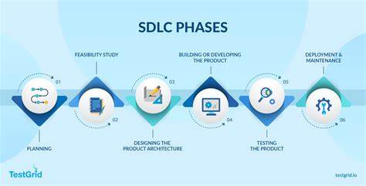

* 1.planning: -
* It is a main part and first step of SDLC phases.
* This properly decide what to make, what not to make and what to make first

And other factors.

* Once it is decided that you can move on to the next phase.
* 2. Design: -
* In the design phase a 3rd step of SDLC.
* Design phase including design of the software and requirements analysis.
* 3.developing: -
* Implements of the design begin with the coding.
* Developers have to follow the coding guidelines their management and programming tools like compilers, interpreter etc
* 4.testing: -
* The testing team tests the functionality of the entire system.
* the testing is done to ensure that the entire application works according to the customer requirements.
* 5.deployment: -
* The five phase of SDLC.
* Once the testing is done, and the product is ready for of the deployment.
* The users are help them to operate the software.
* 6.maintenace: -
* The actual problem starts when the customer starts using the developed system.
* The last phase of maintence.
* What is DFD? CREATE A DFD DIAGRAM ON FLIPKART?
* DFD is a DATA FLOW DIAGRAM.
* DFD is represents the flow of data with in information system.
* It’s easy to understand the flow of data through system with the right flow diagram software.
* This provides everything you need to know about data flow diagrams, including definition, history and symbols and notation.
* We lean the different level DFD. Like logical and physical DFD.
* CREATE A DFD DIAGRAM: =

LEVEL – 0

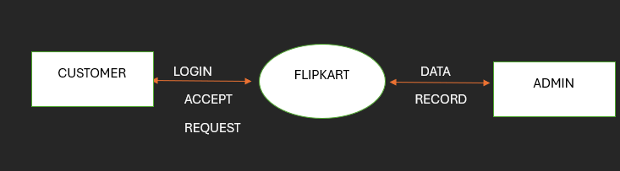

LEVEL – 1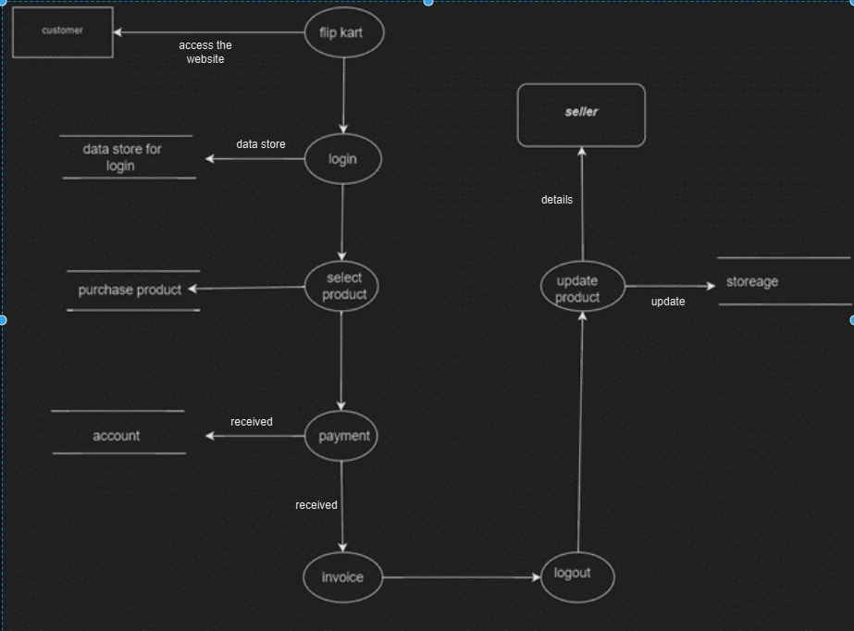

Level 2

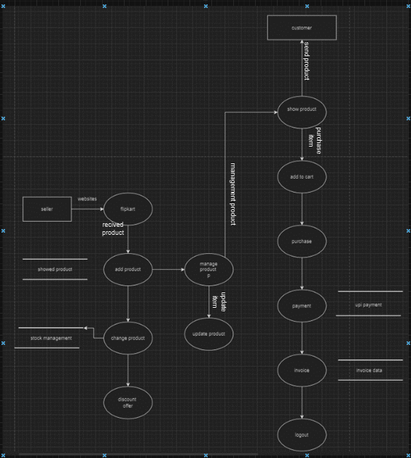

* What is flowchart? create a flowchart to make addition of two numbers?
* Flowchart is a graphical representation of the data or algorithm for better understanding of the cod visually.
* It is a step-by-step solution of the problem.
* Flowchart: -

Read number “num1”

Read number “num2”

Sum =num1 + num2

Print sum

* What is Use case Diagram? Create a use-case on bill payment On Payment.
* Represents the goal of the system and user.
* It specify system requirement.
* It's a tool used in software development to identify and organize system requirements.

