[1]

ENG 7854 Design Project Final Report Webcam Whiteboard

Michael Paul Noseworthy (200620524), Mitchell Charles Chaulk (200633006), *Student* Members, IEEE

*Abstract*—This paper describes the design of Webcam Whiteboard; an application developed using techniques learned in ENG 7854 – Industrial Machine Vision, which uses laptop webcams to perform drawing operations on a virtual canvas.

*Index Terms*—Digital cameras, Image motion analysis, Object detection, Computer graphic.

# INTRODUCTION

T

HIS document describes Webcam Whiteboard, a particular application of industrial machine vision technology using laptops equipped with webcams. This project used MacBook Pros running MATLAB equipped with iSight cameras to perform image subtraction, image filtering, image thresholding, object recognition, and data plotting operations. Webcam Whiteboard tracks the location of red, green, or blue whiteboard markers. Depending on the distance of the marker from the webcam and the marker’s position, Webcam Whiteboard will draw coloured lines based on the colour of the marker on a virtual canvas.

This application may be used to inexpensively bring whiteboard functionality to users in situations where whiteboards are impractical. For example, a user may use Webcam Whiteboard to quickly draw a diagram while seated on an airplane or train. Webcam Whiteboard also supports the saving of images for later review; this functionality is impossible when using traditional whiteboards, as they must be erased once they become full.

# Initial Project Proposal

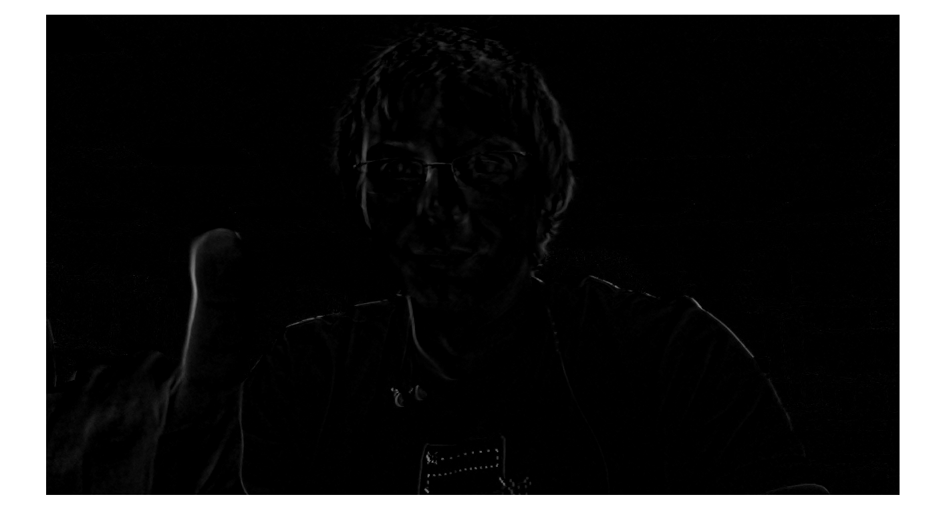

Fig. 1. Results from motion tracking through successive image differencing. Notice the index finger prominently outlined in the foreground left of the image, also notice the noise introduced from the user shifting in his chair.

## Concept Stage

At the beginning of the Spring 2011 semester we were challenged to conceive of and implement a realistic application of machine vision related to industrial inspection, grading, tracking, object recognition, metrology or robotics. A number of potential projects were considered but eventually we settled on the development of an object tracking application. We decided that a virtual whiteboard application would be a challenging and novel application with real world applicability.

It was determined that whiteboards are large, cumbersome, and relatively expensive. However, whiteboards are an extremely effective means of conveying ideas to others using diagrams and figures. We proposed to develop an application that would allow users to take advantage of the functionality of webcams while only being equipped with a webcam and a laptop.

The initial proposal described a system that would use a webcam and a laptop to track a user’s hands to create and edit virtual whiteboard drawings using hand gestures.

## Initial Design Stage

Motion tracking, background subtraction, as well as various colour tracking techniques were considered as potential solutions to track the user’s hands.

The first technique attempted was motion tracking. Motion tracking performed a difference operation on two successive frames. The result of this operation was an image which only contained objects that moved position every frame. This method was fast, and worked well when static single colour backgrounds were used, but when used on a laptop where the webcam is pointed toward the user, significant noise was introduced by the user shifting in their chair or from slight movement in the background. This technique was also unsuitable in the case of quick movement. Blur greatly decreased the effectiveness of the image differencing technique. Successive image differencing was also limited in that the object recognition relied on movement. If the user stopped moving their finger, the object was lost.

Another solution that was tested was an attempt at background subtraction. This technique is similar to successive image differencing, however rather than subtracting two successive images, an initial clean background shot is subtracted from each successive frame. The results from the background subtraction technique were comparable to those obtained from successive image differencing. Noise was generated whenever the camera was displaced, the user moved their position in front of the camera, or if there was any movement in the background. The only advantage this method posed over successive image differentiation was that when the user’s finger stopped moving, the object was not lost.

The final method of object tracking attempted was colour based tracking. Using a captured image of a finger, an average colour value for human (Caucasian) skin was calculated. Using the red, green, and blue channels of this calculated value, only pixels coming within 10% of this value were isolated.

Using this technique resulted in a thresholded image where skin tones were highlighted but shadowing and background objects greatly reduce the effectiveness of the technique. In addition to the ineffectiveness of this technique to isolate the hands in the image, it was computationally expensive when being performed in MATLAB, slowing down drawing to an unacceptable rate.

After researching and experimenting with a number of different techniques for tracking user’s hands, it was determined that there didn’t exist a simple, effective and computationally efficient method of isolating user’s hands within a captured image.

To solve this problem we decided to modify the scope of our project to include the tracking of specifically coloured objects, and to use these objects for drawing on the virtual whiteboard. It was found that red, green, and blue whiteboard markers were convenient for this purpose. The markers also worked as excellent pointers for increasing immersion within the application since users were familiar with drawing using a whiteboard marker.

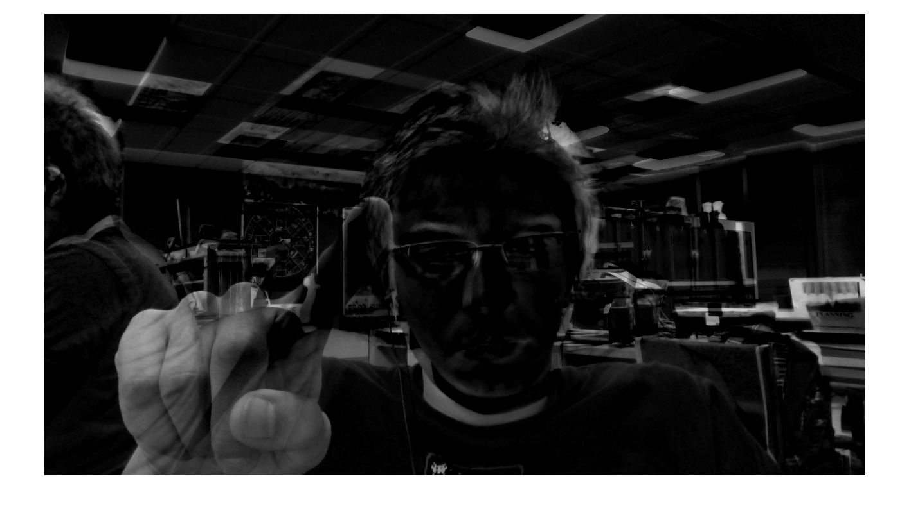

Fig. 2 Resultant image from background subtraction. Notice raised index finger in the foreground left of the image. See also the noise resulting from camera displacement or movement in the background of the image.

# Final Design Scope

# Units

Use either SI (MKS) or CGS as primary units. (SI units are strongly encouraged.) English units may be used as secondary units (in parentheses). **This applies to papers in data storage.** For example, write “15 Gb/cm2 (100 Gb/in2).” An exception is when English units are used as identifiers in trade, such as “3½-in disk drive.” Avoid combining SI and CGS units, such as current in amperes and magnetic field in oersteds. This often leads to confusion because equations do not balance dimensionally. If you must use mixed units, clearly state the units for each quantity in an equation.

The SI unit for magnetic field strength *H* is A/m. However, if you wish to use units of T, either refer to magnetic flux density *B* or magnetic field strength symbolized as µ0*H*. Use the center dot to separate compound units, e.g., “A·m2.”

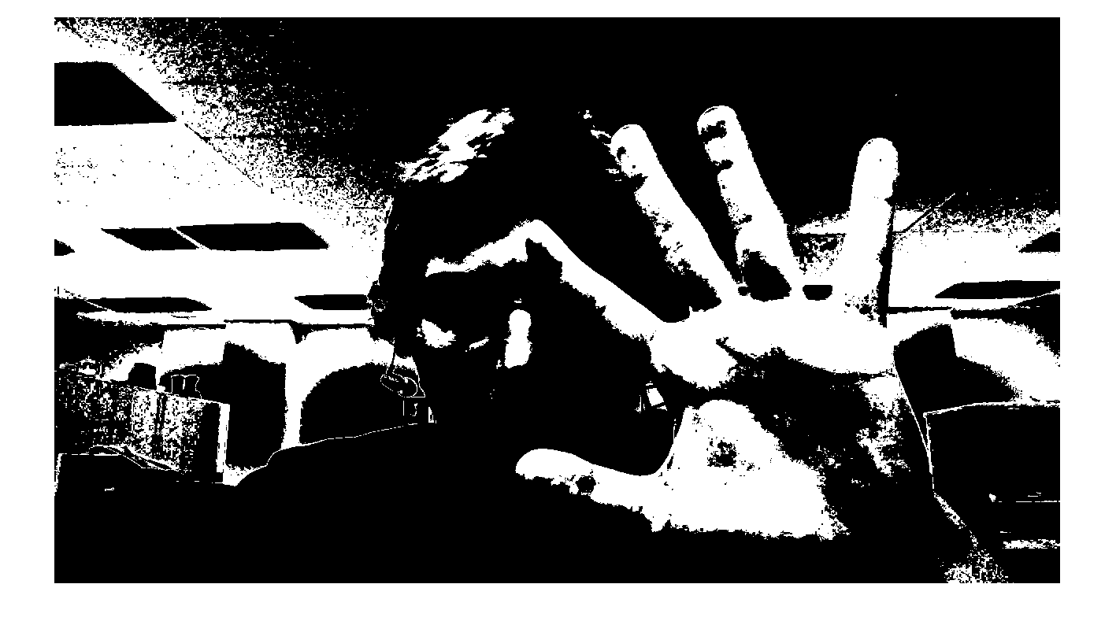

Fig. 3 Resultant image from skin tone isolation. Notice how the shadows in the image greatly reduce the effectiveness of the filtering, also notice how there is a great amount of noise in the background.

# Helpful Hints

## Figures and Tables

Because IEEE will do the final formatting of your paper, you do not need to position figures and tables at the top and bottom of each column. In fact, all figures, figure captions, and tables can be at the end of the paper. Large figures and tables may span both columns. Place figure captions below the figures; place table titles above the tables. If your figure has two parts, include the labels “(a)” and “(b)” as part of the artwork. Please verify that the figures and tables you mention in the text actually exist. **Please do not include captions as part of the figures. Do not put captions in “text boxes” linked to the figures. Do not put borders around the outside of your figures.** Use the abbreviation “Fig.” even at the beginning of a sentence. Do not abbreviate “Table.” Tables are numbered with Roman numerals.

Color printing of figures is available, but is billed to the authors. Include a note with your final paper indicating that you request and will pay for color printing. Do not use color unless it is necessary for the proper interpretation of your figures. If you want reprints of your color article, the reprint order should be submitted promptly. There is an additional charge for color reprints. **Please note that many IEEE journals now allow an author to publish color figures on Xplore and black and white figures in print. Contact your society representative for specific requirements.**

Figure axis labels are often a source of confusion. Use words rather than symbols. As an example, write the quantity “Magnetization,” or “Magnetization *M*,” not just “*M*.” Put units in parentheses. Do not label axes only with units. As in Fig. 1, for example, write “Magnetization (A/m)” or “Magnetization (Am−1),” not just “A/m.” Do not label axes with a ratio of quantities and units. For example, write “Temperature (K),” not “Temperature/K.”

Multipliers can be especially confusing. Write “Magnetization (kA/m)” or “Magnetization (103 A/m).” Do not write “Magnetization (A/m) × 1000” because the reader would not know whether the top axis label in Fig. 1 meant 16000 A/m or 0.016 A/m. Figure labels should be legible, approximately 8 to 12 point type.

## References

Number citations consecutively in square brackets [1]. The sentence punctuation follows the brackets [2]. Multiple references [2], [3] are each numbered with separate brackets [1]–[3]. When citing a section in a book, please give the relevant page numbers [2]. In sentences, refer simply to the reference number, as in [3]. Do not use “Ref. [3]” or “reference [3]” except at the beginning of a sentence: “Reference [3] shows ... .” Please do not use automatic endnotes in *Word*, rather, type the reference list at the end of the paper using the “References” style.

Number footnotes separately in superscripts (Insert | Footnote).[2] Place the actual footnote at the bottom of the column in which it is cited; do not put footnotes in the reference list (endnotes). Use letters for table footnotes (see Table I).

Please note that the references at the end of this document are in the preferred referencing style. Give all authors’ names; do not use “*et al*.” unless there are six authors or more. Use a space after authors’ initials. Papers that have not been published should be cited as “unpublished” [4]. Papers that have been accepted for publication, but not yet specified for an issue should be cited as “to be published” [5]. Papers that have been submitted for publication should be cited as “submitted for publication” [6]. Please give affiliations and addresses for private communications [7].

Capitalize only the first word in a paper title, except for proper nouns and element symbols. For papers published in translation journals, please give the English citation first, followed by the original foreign-language citation [8].

## Abbreviations and Acronyms

Define abbreviations and acronyms the first time they are used in the text, even after they have already been defined in the abstract. Abbreviations such as IEEE, SI, ac, and dc do not have to be defined. Abbreviations that incorporate periods should not have spaces: write “C.N.R.S.,” not “C. N. R. S.” Do not use abbreviations in the title unless they are unavoidable (for example, “IEEE” in the title of this article).

## Equations

Number equations consecutively with equation numbers in parentheses flush with the right margin, as in (1). First use the equation editor to create the equation. Then select the “Equation” markup style. Press the tab key and write the equation number in parentheses. To make your equations more compact, you may use the solidus ( / ), the exp function, or appropriate exponents. Use parentheses to avoid ambiguities in denominators. Punctuate equations when they are part of a sentence, as in

 (1)

Be sure that the symbols in your equation have been defined before the equation appears or immediately following. Italicize symbols (*T* might refer to temperature, but T is the unit tesla). Refer to “(1),” not “Eq. (1)” or “equation (1),” except at the beginning of a sentence: “Equation (1) is ... .”

## Other Recommendations

Use one space after periods and colons. Hyphenate complex modifiers: “zero-field-cooled magnetization.” Avoid dangling participles, such as, “Using (1), the potential was calculated.” [It is not clear who or what used (1).] Write instead, “The potential was calculated by using (1),” or “Using (1), we calculated the potential.”

Use a zero before decimal points: “0.25,” not “.25.” Use “cm3,” not “cc.” Indicate sample dimensions as “0.1 cm × 0.2 cm,” not “0.1 × 0.2 cm2.” The abbreviation for “seconds” is “s,” not “sec.” Do not mix complete spellings and abbreviations of units: use “Wb/m2” or “webers per square meter,” not “webers/m2.” When expressing a range of values, write “7 to 9” or “7-9,” not “7~9.”

A parenthetical statement at the end of a sentence is punctuated outside of the closing parenthesis (like this). (A parenthetical sentence is punctuated within the parentheses.) In American English, periods and commas are within quotation marks, like “this period.” Other punctuation is “outside”! Avoid contractions; for example, write “do not” instead of “don’t.” The serial comma is preferred: “A, B, and C” instead of “A, B and C.”

If you wish, you may write in the first person singular or plural and use the active voice (“I observed that ...” or “We observed that ...” instead of “It was observed that ...”). Remember to check spelling. If your native language is not English, please get a native English-speaking colleague to carefully proofread your paper.

# Some Common Mistakes

The word “data” is plural, not singular. The subscript for the permeability of vacuum µ0 is zero, not a lowercase letter “o.” The term for residual magnetization is “remanence”; the adjective is “remanent”; do not write “remnance” or “remnant.” Use the word “micrometer” instead of “micron.” A graph within a graph is an “inset,” not an “insert.” The word “alternatively” is preferred to the word “alternately” (unless you really mean something that alternates). Use the word “whereas” instead of “while” (unless you are referring to simultaneous events). Do not use the word “essentially” to mean “approximately” or “effectively.” Do not use the word “issue” as a euphemism for “problem.” When compositions are not specified, separate chemical symbols by en-dashes; for example, “NiMn” indicates the intermetallic compound Ni0.5Mn0.5 whereas “Ni–Mn” indicates an alloy of some composition NixMn1-x.

Be aware of the different meanings of the homophones “affect” (usually a verb) and “effect” (usually a noun), “complement” and “compliment,” “discreet” and “discrete,” “principal” (e.g., “principal investigator”) and “principle” (e.g., “principle of measurement”). Do not confuse “imply” and “infer.”

Prefixes such as “non,” “sub,” “micro,” “multi,” and “ultra” are not independent words; they should be joined to the words they modify, usually without a hyphen. There is no period after the “et” in the Latin abbreviation “*et al.*” (it is also italicized). The abbreviation “i.e.,” means “that is,” and the abbreviation “e.g.,” means “for example” (these abbreviations are not italicized).

An excellent style manual and source of information for science writers is [9]. A general IEEE style guide and an *Information for Authors* are both available at <http://www.ieee.org/web/publications/authors/transjnl/index.html>

# Editorial Policy

Submission of a manuscript is not required for participation in a conference. Do not submit a reworked version of a paper you have submitted or published elsewhere. Do not publish “preliminary” data or results. The submitting author is responsible for obtaining agreement of all coauthors and any consent required from sponsors before submitting a paper. IEEE TRANSACTIONS and JOURNALS strongly discourage courtesy authorship. It is the obligation of the authors to cite relevant prior work.

The Transactions and Journals Department does not publish conference records or proceedings. The TRANSACTIONS does publish papers related to conferences that have been recommended for publication on the basis of peer review. As a matter of convenience and service to the technical community, these topical papers are collected and published in one issue of theTRANSACTIONS.

At least two reviews are required for every paper submitted. For conference-related papers, the decision to accept or reject a paper is made by the conference editors and publications committee; the recommendations of the referees are advisory only. Undecipherable English is a valid reason for rejection. Authors of rejected papers may revise and resubmit them to the TRANSACTIONS as regular papers, whereupon they will be reviewed by two new referees.

# Publication Principles

The contents of IEEE TRANSACTIONS and JOURNALS are peer-reviewed and archival. The TRANSACTIONS publishes scholarly articles of archival value as well as tutorial expositions and critical reviews of classical subjects and topics of current interest.

Authors should consider the following points:

1. Technical papers submitted for publication must advance the state of knowledge and must cite relevant prior work.
2. The length of a submitted paper should be commensurate with the importance, or appropriate to the complexity, of the work. For example, an obvious extension of previously published work might not be appropriate for publication or might be adequately treated in just a few pages.
3. Authors must convince both peer reviewers and the editors of the scientific and technical merit of a paper; the standards of proof are higher when extraordinary or unexpected results are reported.
4. Because replication is required for scientific progress, papers submitted for publication must provide sufficient information to allow readers to perform similar experiments or calculations and use the reported results. Although not everything need be disclosed, a paper must contain new, useable, and fully described information. For example, a specimen’s chemical composition need not be reported if the main purpose of a paper is to introduce a new measurement technique. Authors should expect to be challenged by reviewers if the results are not supported by adequate data and critical details.
5. Papers that describe ongoing work or announce the latest technical achievement, which are suitable for presentation at a professional conference, may not be appropriate for publication in a TRANSACTIONS or JOURNAL.

# Conclusion

A conclusion section is not required. Although a conclusion may review the main points of the paper, do not replicate the abstract as the conclusion. A conclusion might elaborate on the importance of the work or suggest applications and extensions.

Appendix

Appendixes, if needed, appear before the acknowledgment.

Acknowledgment

The preferred spelling of the word “acknowledgment” in American English is without an “e” after the “g.” Use the singular heading even if you have many acknowledgments. Avoid expressions such as “One of us (S.B.A.) would like to thank ... .” Instead, write “F. A. Author thanks ... .” **Sponsor and financial support acknowledgments are placed in the unnumbered footnote on the first page, not here.**

References

1. <http://www.cs.toronto.edu/~smalik/downloads/2503_project_report.pdf>
2. G. O. Young, “Synthetic structure of industrial plastics (Book style with paper title and editor),” in *Plastics*, 2nd ed. vol. 3, J. Peters, Ed. New York: McGraw-Hill, 1964, pp. 15–64.
3. W.-K. Chen, *Linear Networks and Systems* (Book style)*.* Belmont, CA: Wadsworth, 1993, pp. 123–135.
4. H. Poor, *An Introduction to Signal Detection and Estimation*. New York: Springer-Verlag, 1985, ch. 4.
5. B. Smith, “An approach to graphs of linear forms (Unpublished work style),” unpublished.
6. E. H. Miller, “A note on reflector arrays (Periodical style—Accepted for publication),” *IEEE Trans. Antennas Propagat.*, to be published.
7. J. Wang, “Fundamentals of erbium-doped fiber amplifiers arrays (Periodical style—Submitted for publication),” *IEEE J. Quantum Electron.*, submitted for publication.
8. C. J. Kaufman, Rocky Mountain Research Lab., Boulder, CO, private communication, May 1995.
9. Y. Yorozu, M. Hirano, K. Oka, and Y. Tagawa, “Electron spectroscopy studies on magneto-optical media and plastic substrate interfaces (Translation Journals style),” *IEEE Transl. J. Magn.Jpn.*, vol. 2, Aug. 1987, pp. 740–741 [*Dig. 9th Annu. Conf. Magnetics* Japan, 1982, p. 301].
10. M. Young, *The Techincal Writers Handbook.* Mill Valley, CA: University Science, 1989.
11. J. U. Duncombe, “Infrared navigation—Part I: An assessment of feasibility (Periodical style),” *IEEE Trans. Electron Devices*, vol. ED-11, pp. 34–39, Jan. 1959.
12. S. Chen, B. Mulgrew, and P. M. Grant, “A clustering technique for digital communications channel equalization using radial basis function networks,” *IEEE Trans. Neural Networks*, vol. 4, pp. 570–578, Jul. 1993.
13. R. W. Lucky, “Automatic equalization for digital communication,” *Bell Syst. Tech. J.*, vol. 44, no. 4, pp. 547–588, Apr. 1965.
14. S. P. Bingulac, “On the compatibility of adaptive controllers (Published Conference Proceedings style),” in *Proc. 4th Annu. Allerton Conf. Circuits and Systems Theory*, New York, 1994, pp. 8–16.
15. G. R. Faulhaber, “Design of service systems with priority reservation,” in *Conf. Rec. 1995 IEEE Int. Conf. Communications,* pp. 3–8.
16. W. D. Doyle, “Magnetization reversal in films with biaxial anisotropy,” in *1987 Proc. INTERMAG Conf.*, pp. 2.2-1–2.2-6.
17. G. W. Juette and L. E. Zeffanella, “Radio noise currents n short sections on bundle conductors (Presented Conference Paper style),” presented at the IEEE Summer power Meeting, Dallas, TX, Jun. 22–27, 1990, Paper 90 SM 690-0 PWRS.
18. J. G. Kreifeldt, “An analysis of surface-detected EMG as an amplitude-modulated noise,” presented at the 1989 Int. Conf. Medicine and Biological Engineering, Chicago, IL.
19. J. Williams, “Narrow-band analyzer (Thesis or Dissertation style),” Ph.D. dissertation, Dept. Elect. Eng., Harvard Univ., Cambridge, MA, 1993.
20. N. Kawasaki, “Parametric study of thermal and chemical nonequilibrium nozzle flow,” M.S. thesis, Dept. Electron. Eng., Osaka Univ., Osaka, Japan, 1993.
21. J. P. Wilkinson, “Nonlinear resonant circuit devices (Patent style),” U.S. Patent 3 624 12, July 16, 1990.
22. *IEEE Criteria for Class IE Electric Systems* (Standards style)*,* IEEE Standard 308, 1969.
23. *Letter Symbols for Quantities*, ANSI Standard Y10.5-1968.
24. R. E. Haskell and C. T. Case, “Transient signal propagation in lossless isotropic plasmas (Report style),” USAF Cambridge Res. Lab., Cambridge, MA Rep. ARCRL-66-234 (II), 1994, vol. 2.
25. E. E. Reber, R. L. Michell, and C. J. Carter, “Oxygen absorption in the Earth’s atmosphere,” Aerospace Corp., Los Angeles, CA, Tech. Rep. TR-0200 (420-46)-3, Nov. 1988.
26. (Handbook style) *Transmission Systems for Communications,* 3rd ed., Western Electric Co., Winston-Salem, NC, 1985, pp. 44–60.
27. *Motorola Semiconductor Data Manual,* Motorola Semiconductor Products Inc., Phoenix, AZ, 1989.
28. (Basic Book/Monograph Online Sources) J. K. Author. (year, month, day). *Title* (edition) [Type of medium]. Volume (issue). Available: <http://www.(URL>)
29. J. Jones. (1991, May 10). Networks (2nd ed.) [Online]. Available: <http://www.atm.com>
30. (Journal Online Sources style) K. Author. (year, month). Title. *Journal* [Type of medium]. Volume(issue), paging if given. Available: <http://www.(URL>)
31. R. J. Vidmar. (1992, August). On the use of atmospheric plasmas as electromagnetic reflectors. *IEEE Trans. Plasma Sci.* [Online]. *21(3).* pp. 876–880. Available: http://www.halcyon.com/pub/journals/21ps03-vidmar

**First A. Author** (M’76–SM’81–F’87) and the other authors may include biographies at the end of regular papers. Biographies are often not included in conference-related papers. This author became a Member (M) of IEEE in 1976, a Senior Member (SM) in 1981, and a Fellow (F) in 1987. The first paragraph may contain a place and/or date of birth (list place, then date). Next, the author’s educational background is listed. The degrees should be listed with type of degree in what field, which institution, city, state, and country, and year degree was earned. The author’s major field of study should be lower-cased.

The second paragraph uses the pronoun of the person (he or she) and not the author’s last name. It lists military and work experience, including summer and fellowship jobs. Job titles are capitalized. The current job must have a location; previous positions may be listed without one. Information concerning previous publications may be included. Try not to list more than three books or published articles. The format for listing publishers of a book within the biography is: title of book (city, state: publisher name, year) similar to a reference. Current and previous research interests end the paragraph.

The third paragraph begins with the author’s title and last name (e.g., Dr. Smith, Prof. Jones, Mr. Kajor, Ms. Hunter). List any memberships in professional societies other than the IEEE. Finally, list any awards and work for IEEE committees and publications. If a photograph is provided, the biography will be indented around it. The photograph is placed at the top left of the biography. Personal hobbies will be deleted from the biography.

1. Manuscript received July 26, 2011. This work was a requirement for graduation from ENG 7854 – Industrial Machine Vision.

   M. P. Noseworthy is an undergraduate student with the faculty of Engineering and Applied Science at Memorial University of Newfoundland, St. John’s, Newfoundland and Labrador, Canada (michael.noseworthy@mun.ca)

   M. C. Chaulk is an undergraduate student with the faculty of Engineering and Applied Science at Memorial University of Newfoundland, St. John’s, Newfoundland and Labrador, Canada (n74mcc@mun.ca)
2. It is recommended that footnotes be avoided (except for the unnumbered footnote with the receipt date on the first page). Instead, try to integrate the footnote information into the text.