Chauncey Smith

LAB ONE FILE

This file will contain the screenshots as proof of my work.

HERE IS MY PROOF THAT I HAVE INSTALLED JAVA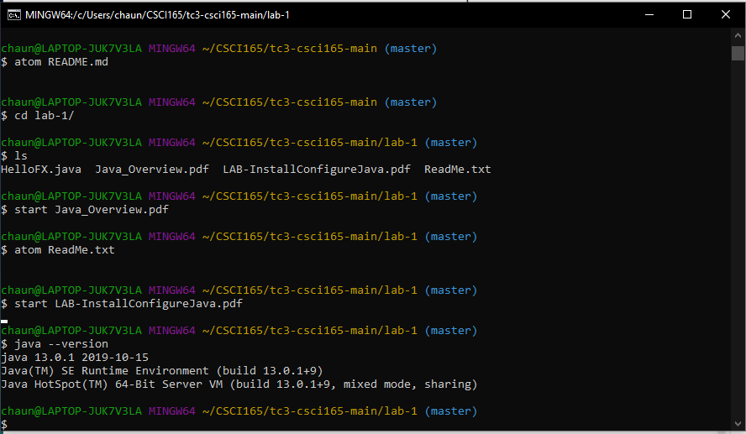

HERE IS MY PROOF THAT I HAVE CREATED THE JAVA HOME VARIABLE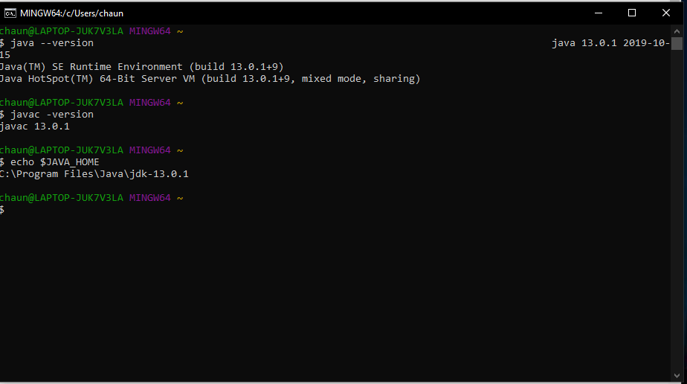

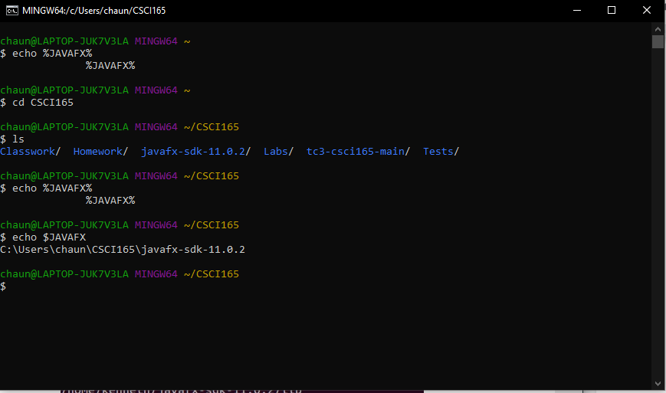

HERE IS MY PROOF THAT I HAVE INSTALLED JAVA FX

IT WORKS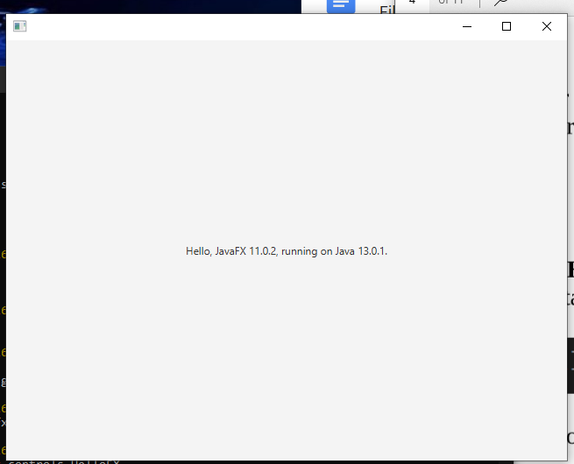

Here is proof that I have compiled and ran the HelloWorld file correctly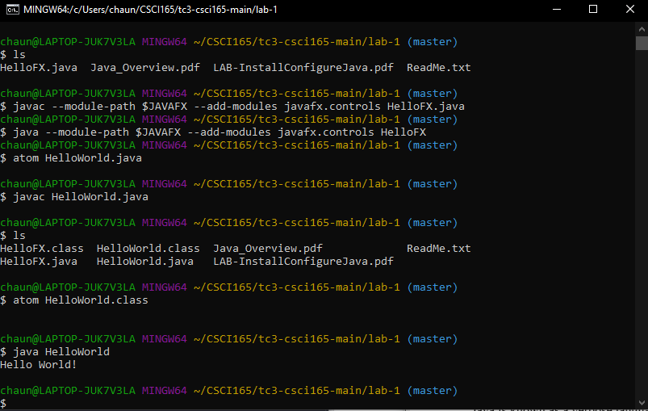

Additional problems

1. An algorithm that she can use to find the average of 10 homework grades would be adding all the results of her 10 homework grades and dividing by 10. This is a basic average problem. So add each homework, then divide by 10 (or by the amount of numbers added together).
2. To create a Caesar encoded message with a shift of 5, we would first add 5 to the index of the alphabet. Example A’s numerical value would be one, so add 5 to that, and it would be f, so every letter would have 5 added. Now the max numerical value would be 26, so we would loop around to a at .
3. To decode the message lets look at how far each letter is from P, so lets take the distance from each letter to P to solve the message. So the message says Dinning mfi hib. You take the difference from each letter to P to crack the code.
4. So grades are only to 100, that being said we can infer that every grade is a 2 digit number, unless its 100. So add up two grades at a time, he reads 2 grades and you add those up, 4 digits. Then write that two digit number on one side, then he reads the next grade and you add it to that number that already has two grades added to it. Then you count the amount of times you added and divide by that number.
5. If N was 15 and using the algorithm then the number would be 46, but this is even so we divide by 2, which is 23 then triples and add one which is 70, divide by 2, 35, triple it so on and so forth
6. If N was 6 then the output would be 3, triple add one, 10, divide by 2, 5, then 16, divide by 2 8. Process keeps going

8. 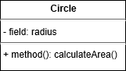

9. 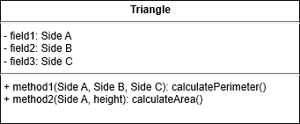

10. 