**Mobileye Project**

By: Chevi Mintzer, Sara Schimmel, Noa Cohen, and Chava Neiman

**Part-1**

**Given a picture of the view in the front of a car, the goal is to find all the traffic lights ahead. The problem is that there are a lot of green and red sources in the picture therefore there are many ways to find the right sources of lights.**

First try:

We thought that in order to find the lights we need to convolve the picture, but in order to convolve, the picture has to be 2-D therefor we converted the picture to gray-scale pixels.

The biggest problem we ran into was finding the right kernel, highpass or lowpass? What shape should it be? Etc.

We started off with a highpass 9x9 kernel – the outer cells were smaller numbers and the inner bigger numbers. The outcome was something like this:



But we wanted something that will bolden the lights a lot more. So after trying some more kernels we realized that the bigger the kernel is the more we can make a better shape of a square and a round circle inside. We tried a few more and again the outcome was not what we anticipated.

Finally we got to a 15x15 kernel which we were most satisfied from:

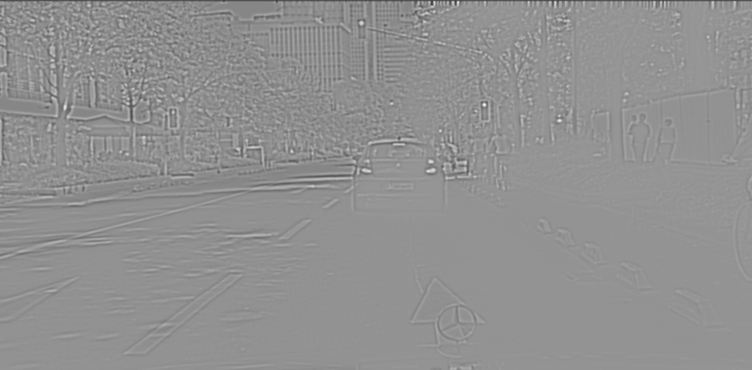

The lights are light and the rest is dark!

1. **Normalize:**

We normalized the picture by dividing its values by 255, so that each pixel value has a value between 0 and 1. It is valid for images to have pixel values in the range 0-1 and images can be viewed normally.

1. **Gray scale**

In order for the picture to be 2-d for the convolution we converted it to gray scale pixels

1. **Kernels:**

We used a 15x15 kernel for high-pass-filter in the shape of a circle, the outer is black (smaller numbers) and the inner is white (higher numbers). We didn’t use a smaller kernel as the bigger tfls weren’t found.

1. **Maximum filter:**

We performed maximum filter on the “convolved” picture in order to get the maximum pixel of the light areas. After the filtering we extracted the lightest pixels.

1. **Red and green:**

After performing the maximum filter we compared the maximum pixels with the original picture in order to differentiate between the red and green tfls.