1. Created docker file for sample node js application

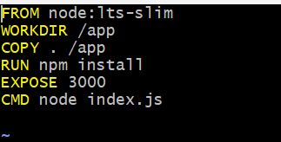

1. Created docker image



1. Deployment file

apiVersion: apps/v1

kind: Deployment

metadata:

name: nodejs-deployment

labels:

app: samplenode

spec:

replicas: 2

selector:

matchLabels:

app: samplenode

template:

metadata:

labels:

app: samplenode

spec:

containers:

- name: samplenode

image: anithapatcha/nodejs:v1

ports:

- containerPort: 3000

1. Created service to deploy node js application

apiVersion: v1

kind: Service

metadata:

name: nodejs-svc

spec:

selector:

app: samplenode

type: LoadBalancer

ports:

- protocol: "TCP"

port: 80

targetPort: 3000



1. Pods



1. 