Risk-Informed, Readiness-Aware Energy Assessment

in Upstream Oil and Gas Operations:
A Robust Decision Framework and Explainable Digital Tool Architecture
Sajib Saha¹, Mehnaz Sharna¹, Kartik Chavan², Muhammad Jujuly³, Jessica Stewart⁴, Kyle Robison⁴, Hitesh Vora⁵ *
¹ School of Industrial Engineering and Management, Oklahoma State University, Stillwater, Oklahoma, USA
² Department of Computer Science and Engineering, Vishwakarma Institute of Technology, Pune, India
³ School of Fire, Construction and Emergency Management, Oklahoma State University, Stillwater, Oklahoma, USA
⁴ Professional Development, College of Engineering, Architecture and Technology, Oklahoma State University, Stillwater, Oklahoma, USA
⁵ School of Materials, Mechatronics & Manufacturing Engineering, Oklahoma State University, Stillwater, Oklahoma, USA
* Corresponding author: hitesh.vora@okstate.edu

Abstract
Energy-efficiency measures (EEMs) in upstream oil and gas operations can interact with safety-critical equipment, yet existing assessment practice provides limited guidance on evidence sufficiency, assessment depth, and the choice among self, remote-specialist, and on-site expert assessment. This study develops a risk-informed, readiness-aware Energy Assessment Framework (EAF) and an explainable decision-support-tool (DST) architecture from a literature-supported library of 65 EEMs spanning drilling, well-fluid extraction, and surface treatment. Six interaction domains—well control, fire/explosion, electrical hazard, toxic exposure, mechanical failure, and environmental impact—are coded on a four-level ordinal scale and summarized by a Composite Risk-Interaction Score (CRIS), which is treated explicitly as an interaction-intensity indicator rather than an estimate of probability, consequence, or absolute risk. Organizational readiness is represented as a five-dimensional evidence vector and, when aggregation is useful, as a robust interval over an admissible weight set. Opportunity Priority is separated from Assessment Criticality so that energetic or economic attractiveness cannot compensate for deficient evidence or safety/direct-verification requirements. An executable Python reference implementation maps the equations and Algorithm 1 to modular functions, calculates robust RI, OP, and AC envelopes by linear programming, and records gate status, overrides, selected disposition or assessment mode, rationale, and follow-up actions. Reanalysis of the 65-EEM dataset reproduced all CRIS values and showed increasing mean CRIS from drilling (8.84) to well-fluid extraction (10.00) and surface treatment (11.19; Kruskal-Wallis H=12.62, p=0.0018). Fire/explosion had the greatest number of High interactions (13/65), and exact fixed-margin tests showed stage dependence for fire/explosion, toxic exposure, and environmental impact after false-discovery-rate adjustment. CRIS rankings remained stable under severity-emphasizing ordinal recodings (Kendall tau=0.90-0.95). Deterministic software tests reproduced the readiness interval [66.25, 73.75] and the EEM 54 case (CRIS=14, R=77.78, OP=75.0, AC=70.69), for which direct-verification requirements correctly forced an on-site expert route; a failed facility-level readiness gate instead returned a readiness-improvement/hold disposition. The framework is computationally reproducible but remains pre-calibration and requires independent expert reliability testing and multi-facility field validation before thresholds or mode-selection rules are used prescriptively.
Keywords: Upstream oil and gas; energy efficiency; energy assessment; process safety; multi-criteria decision analysis; readiness; remote assessment; decision-support system; uncertainty; implementation.

Highlights
- A 65-EEM upstream energy-efficiency library is linked to six safety, reliability, exposure, and environmental interaction domains.
- Risk interaction, organizational readiness, opportunity value, and assessment criticality are separated instead of collapsing into one compensatory score.
- Weight uncertainty is handled through admissible weight sets, linear-programming envelopes, and necessary/possible ranking logic rather than unsupported fixed weights.
- New within-dataset analyses quantify stage dependence, hazard co-occurrence, and robustness of CRIS rankings to alternative ordinal encodings.
- An executable Python reference implementation operationalizes the framework with robust envelopes, safety/evidence overrides, and an auditable decision trail.

1. Introduction
Upstream oil and gas operations combine large energy loads with operating conditions in which energy systems are tightly coupled to process integrity. Gas turbines and diesel generators support drilling and production loads; pumps and compressors move multiphase fluids and produced water; heaters, separation systems, dehydration units, vapor-recovery systems, and instrument utilities operate within hydrocarbon-containing process environments. Consequently, an energy-efficiency intervention can change not only fuel or electricity consumption but also reserve margins, pressure-control behavior, ignition exposure, equipment loading, containment, worker exposure, and emissions pathways [1], [9], [34], [37]. This coupling makes upstream energy assessment fundamentally different from a simple inventory of technically feasible conservation measures.
The literature already identifies many technically credible opportunities, including generator loading optimization, variable-frequency-drive control, artificial-lift optimization, compressor anti-surge and load matching, methane-loss reduction, heat recovery, and hybrid renewable supply [9]-[33]. Industrial energy-management and energy-audit research also provides maturity models, performance-evaluation systems, and multi-criteria prioritization methods [2], [3], [61]-[63]. Remote and virtual energy-assessment methods have further demonstrated that substantial portions of diagnosis can be performed from structured data, remote walkthroughs, and analytical models when evidence quality is sufficient [69]-[72]. What remains weakly addressed is the decision layer between identifying an EEM and determining whether it can be assessed credibly, safely, and with an appropriate level of verification at a specific facility.
That decision layer contains four distinct questions. First, does the proposed EEM interact with a safety, reliability, exposure, or environmental pathway strongly enough to require additional scrutiny? Second, is the organization ready to support a defensible assessment, including data access, competent personnel, management authorization, an interpretable baseline, and a pathway to implementation? Third, is the EEM sufficiently attractive to justify assessment effort? Fourth, which assessment mode—self, remote specialist, or on-site expert—can produce evidence of adequate quality without creating false confidence? Collapsing these questions into one weighted priority score is methodologically problematic because a large benefit score could numerically compensate for weak evidence or a safety-critical interaction. The present work therefore separates opportunity from assessment criticality and introduces non-compensatory readiness, evidence, and direct-verification gates.
This study is also motivated by the need to convert a conceptual framework into an executable and auditable research artifact. Many assessment frameworks remain diagrams or checklists; operational decisions, however, must be reproducible, updateable, challengeable, and traceable to evidence. Design-science research emphasizes explicit artifact design and evaluation for well-defined decision problems [67], [68]. In parallel, robust multi-criteria decision-aiding methods show that when decision-maker weights are uncertain, the admissible preference space should be examined and rank stability or acceptability reported rather than uncertainty being hidden behind an arbitrary point estimate [64]-[66]. These principles are adapted here to engineering energy assessment.
The resulting contribution is a risk-informed, readiness-aware Energy Assessment Framework (EAF) with a companion decision-support tool (DST) architecture. The framework does not estimate accident frequencies or replace Process Hazard Analysis (PHA), Hazard and Operability Study (HAZOP), management of change (MOC), quantitative risk analysis, or professional engineering judgment. Instead, it is a front-end triage and evidence-governance system: it determines the depth and mode of energy assessment needed before an EEM is advanced for design and implementation.

1.1 Research questions
The study addresses four research questions:
- RQ1: How can EEM-hazard interactions across upstream operations be represented consistently without mischaracterizing an ordinal screening score as absolute risk?
- RQ2: How can organizational readiness and decision-maker preferences be represented without embedding empirically unsupported fixed weights?
- RQ3: How can opportunity, hazard interaction, evidence quality, complexity, and verification needs be translated into an explainable selection among self, remote, and on-site expert assessment?
- RQ4: How can this decision logic be encoded in a digital tool so that inputs, assumptions, sensitivity, overrides, and final recommendations remain auditable?

1.2 Contributions
The study makes six technical contributions (Figure 1):
- a traceable 65-EEM library covering drilling, well-fluid extraction, and surface treatment;
- a six-domain hazard-interaction representation that retains the full interaction vector and uses CRIS only as a comparative screening summary;
- an evidence-based readiness model that reports the criterion vector and robust aggregation interval under uncertain weights;
- a formal separation between opportunity priority and assessment criticality, with non-compensatory safety/evidence overrides;
- a computational robustness analysis of stage effects, hazard co-occurrence, and alternative ordinal encodings, together with an executable Python reference implementation that reproduces the equations, optimization envelopes, and decision pathways; and
- an explainable DST architecture that operationalizes the framework, preserves evidence and decision provenance, and provides a structure for subsequent software verification and field calibration.
Figure 1 summarizes the overall research design and shows how the four principal components of the study are integrated: development of the traceable EEM evidence base, structured hazard-interaction analysis, robust readiness and assessment-decision modeling, and operationalization of the methodology through the companion explainable decision-support tool. The workflow progresses from evidence synthesis and EEM characterization to risk-informed decision analysis and ultimately to implementation-ready outputs, while maintaining traceability between the underlying evidence, analytical assumptions, assessment-mode decisions, and recommended actions.
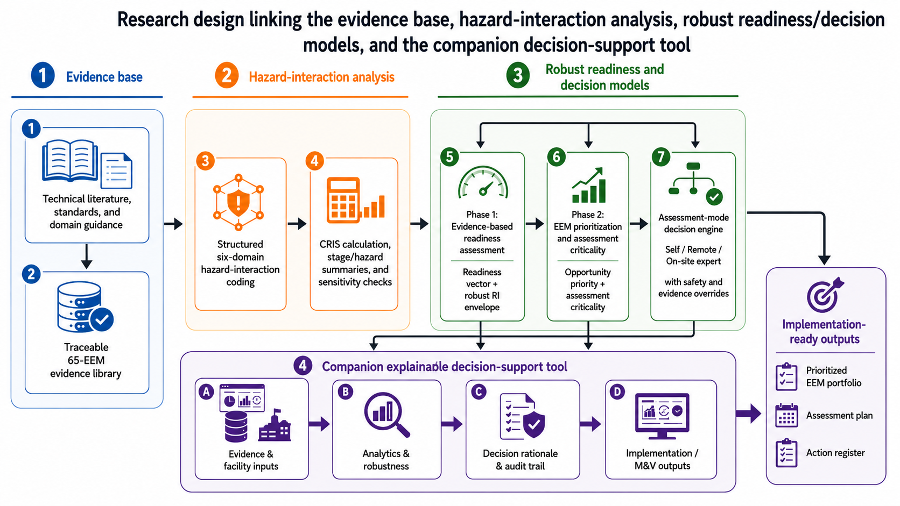
Figure 1. Overall research design linking the EEM evidence base, hazard-interaction analysis, robust readiness and assessment-decision models, the explainable decision-support tool, and implementation-ready outputs.

2. Related Work and Research Gap

2.1 Energy efficiency in upstream oil and gas operations
Upstream energy use is distributed across drilling power, circulation and hoisting, artificial lift, compression, produced-water handling, separation, heating, dehydration, utilities, and mobile equipment [4]-[9]. Offshore studies have shown substantial thermodynamic and operational opportunities associated with power generation, compression, process heating, and waste-heat recovery [9], [33]. Equipment-level literature supports variable-speed pumping [13], artificial-lift optimization [19]-[23], produced-water treatment improvements [26], [27], compressor optimization [30], methane-management measures [25], and process heat recovery [31]-[33]. The opportunity space is therefore broad but heterogeneous in data requirements, operational criticality, and interaction with safety functions.
Existing upstream energy-efficiency tools have emphasized energy benchmarking, simulation, or technical opportunity identification [1], [34]. Those approaches are necessary but not sufficient for assessment governance. The same compressor or control system that offers an efficiency opportunity can also be part of a containment, pressure-control, electrical, or reliability barrier. Process-safety literature further emphasizes that technology transitions and optimization can introduce new hazards if changes are not evaluated within the operating and safety context [37]. The central methodological problem is therefore not merely to rank savings potential, but to match assessment rigor to the evidence and risk-interaction profile of the proposed action.

2.2 Industrial energy assessment, readiness, and implementation
Industrial energy-management models address organizational maturity, management commitment, policy, data, and continuous improvement [3], [58], [61]. Energy-audit models have also combined performance indicators and multi-criteria methods to improve diagnosis and prioritization [2], [62]. Facility-level audit studies commonly integrate energy, economic, and environmental evaluation [63]. These contributions reinforce that implementation depends on organizational systems as well as equipment engineering.
For a facility to support a credible assessment, the evidence chain must include accessible energy and operating data, a defined baseline, personnel capable of interpreting process behavior, management authorization, and a practical pathway to action and verification. These needs are consistent with ISO 50001, DOE 50001 Ready guidance, IPMVP, and structured audit standards [54]-[60]. The present framework therefore treats readiness as a vector of observable evidence rather than as a broad perception survey.

2.3 Remote and hybrid assessment
Remote and virtual audits can reduce travel and expand assessment coverage, but they transfer part of the burden from physical presence to data sufficiency, digital evidence, and disciplined verification. Published virtual-audit studies have demonstrated remote analysis of industrial or building systems using historical data, simulation, photographs, remote walkthroughs, and structured methodologies [70]-[72]. A recent smart remote energy-assessment framework proposed explicit skill and data-risk matrices to determine what can be performed remotely and when escalation is needed [69].
These studies support a tiered assessment concept, but upstream oil and gas require a stronger safety and operational-interaction layer. Remote assessment can be appropriate for a well-instrumented, lower-complexity measure, whereas a technically similar energy action may require direct field verification when it changes to a safety-critical setpoint, barrier, hazardous-area installation, rotating-equipment condition, or hydrocarbon-containment function.

2.4 Preference uncertainty and robust decision support
Multi-criteria energy-prioritization methods often require criterion weights. If those weights are weakly supported, a precise ranking can imply more certainty than the evidence warrants. SMAA and related robust decision-aiding methods address this problem by exploring a weight space rather than selecting a single arbitrary vector, thereby identifying rank acceptability or preference relations that hold across admissible parameterizations [64]-[66]. The same principle is useful in energy assessment: uncertainty about the relative importance of readiness dimensions or opportunity criteria should be exposed as sensitivity, not hidden.
The present work adopts a computationally simpler robust-weight envelope suitable for a transparent engineering tool. Linear programming is used to calculate minimum and maximum additive scores over a declared admissible set, and pairwise comparisons can identify necessary and possible orderings. This is not presented as a new MCDA theory; the novelty is its integration with upstream hazard interaction, assessment-mode selection, and a traceable software workflow.
To clarify the methodological gap addressed by the present study, Table 1 compares the proposed framework with representative prior approaches in industrial energy assessment, maturity/readiness assessment, multi-criteria prioritization, and remote energy assessment. The comparison focuses on the specific functions required by the present decision problem rather than implying that the cited studies were originally designed to satisfy every criterion.
Table 1. Positioning of the proposed framework relative to representative prior approaches.
Study / approach | Primary emphasis | Upstream specific | Safety/risk interaction | Readiness/capability | Preference uncertainty | Assessment-mode logic
Colley et al. [34] | Upstream energy-efficiency tools | Yes | Limited | No | No | No integrated mode engine
Antunes et al. [3] | Energy-management maturity | No | No | Yes | No | No
Zanardo et al. [62] | Industrial audit + AHP + software | No | No | Partial | Point weights | No
Richter et al. [2] | Industrial EEM prioritization + PROMETHEE | No | No | No | MCDA | No
Vora et al. [69] | Smart remote energy assessment | General industrial | Data-risk focus | Skill/capability | Limited | Remote escalation
Present study | Upstream EEM + safety + readiness + robust decision support | Yes | Six-domain interaction | Yes | Weight-set robustness | Self / remote / on-site + overrides
Table 1 is a functional comparison rather than a claim that the cited studies were designed to satisfy every column. The identified gap is the absence of a single auditable method that jointly treats upstream EEMs, hazard interaction, readiness, preference uncertainty, evidence sufficiency, and assessment-mode escalation.

3. Evidence Base and Research Design

3.1 Research design
As summarized in Figure 1, the study follows a design-science-informed engineering workflow [67], [68]: (i) define the assessment-governance problem; (ii) structure the technical evidence base; (iii) formalize the decision constructs and equations; (iv) implement a computational reference model; (v) test internal consistency and sensitivity; (vi) demonstrate decision logic with transparent scenarios; and (vii) define an external validation program. The present manuscript completes steps (i)–(vi). Multi-facility field evaluation is intentionally reserved for the next phase.
The evidence base is a structured technical synthesis rather than a systematic review. The source corpus was assembled from peer-reviewed studies, government and industry guidance, standards, and upstream engineering references. Because a preregistered database search strategy and study-screening log were not preserved during the original collection process, this paper does not retroactively claim PRISMA-style systematic-review status. Reproducibility is instead provided at the EEM level through source citations, operational-stage assignment, the traceable library in Appendix A, and the complete hazard-interaction matrix in Appendix B.

3.2 EEM inclusion and normalization
A candidate action was retained when it met all three conditions: (1) it applied to an identifiable upstream process or equipment item; (2) it represented energy conservation, energy-efficiency improvement, energy recovery, loss reduction, or lower-energy operation; and (3) it could be assigned to drilling, well-fluid extraction, or surface treatment. Functionally duplicate actions were consolidated under the most representative equipment category. This produced 65 EEMs: 25 for drilling, 24 for well-fluid extraction, and 16 for surface treatment. The inventory is not claimed to be exhaustive; it is the complete analyzed set supported by the curated source corpus.
The distribution of the 65 analyzed EEMs across the three operational stages, together with representative equipment and systems within each stage, is summarized in Table 2. The complete traceable EEM library, including operational stage, equipment category, literature-supported energy-efficiency measure, source reference, and implementation or verification context for each of the 65 measures, is provided in Appendix A (Table A1).

Table 2. Analytical EEM dataset by operational stage.
Operational stage | EEMs | Representative equipment / systems
Drilling | 25 | GT/diesel generation; mud pumps; hoisting/rotating drives; BOP HPU; choke manifold; rig utilities
Well-fluid extraction | 24 | ESP; rod/beam pump; gas lift; pneumatics; gathering; produced-water pumps/treatment
Surface treatment | 16 | Separation; heating; gas compression; dehydration; flare/VRU; tanks; heat recovery; utilities

3.3 Hazard-interaction domains and coding protocol
Six interaction domains were selected because, collectively, they cover the principal pathways by which energy interventions in the reviewed upstream equipment can intersect process safety, worker exposure, mechanical integrity, electrical systems, and environmental performance: well control (WC), fire/explosion (FE), electrical hazard (EH), toxic exposure (TE), mechanical failure (MF), and environmental impact (EI). The domains are cross-referenced to relevant regulatory and industry frameworks including OSHA PSM, EPA RMP, API recommended practices, IOGP Life-Saving Rules, NFPA electrical/fire standards, ISO reliability data guidance, and sector environmental indicators [38]-[53]. These sources provide a governance basis for screening; they do not provide numerical risk scores for the individual EEMs.
Each EEM-domain pair was assigned High, Medium, Low, or no meaningful interaction using a mechanism-based rubric. High denotes a direct interaction with a primary hazard/failure pathway where inappropriate modification could materially affect a severe-consequence function. Medium denotes a secondary or indirect interaction that requires defined controls or MOC attention. Low denotes a limited interaction normally managed through routine engineering and preventive controls. None denotes no credible physical interaction identified at the screening level. The ratings are structured author judgment, not measured probabilities, and have not yet undergone independent multi-rater validation.
The four-level interaction coding scale and its operational interpretation are summarized in Table 3. The complete 65 × 6 EEM-by-hazard coding dataset is reported in Appendix B (Table B1), which provides all 390 EEM-domain ratings and the corresponding CRIS values used in the computational analysis.
Table 3. Hazard-interaction coding scale.
Rating | Ordinal code | Operational interpretation
High (H) | 3 | Direct interaction with a primary hazard or failure pathway; the EEM can materially change a safety-critical condition or barrier.
Medium (M) | 2 | Secondary/indirect interaction requiring explicit engineering controls, operating procedures, or MOC review.
Low (L) | 1 | Limited interaction; routine engineering and preventive controls are normally sufficient.
None | 0 | No credible physical interaction identified at this screening level.

3.4 Computational implementation, verification, and analysis plan
A Python reference implementation was developed as the executable counterpart to the mathematical framework. The code maps the manuscript equations to modular functions for readiness-vector calculation, mandatory-evidence gating, CRIS and normalized interaction intensity, robust RI/OP/AC envelopes, pairwise rank-stability analysis, and disposition/assessment-mode selection. Linear score envelopes are solved with scipy.optimize.linprog using the HiGHS backend, and NumPy is used for vector operations. Each run creates a structured assessment record containing the evidence state, computed intervals, active constraints and overrides, selected disposition or mode, decision rationale, and next actions. The reference implementation is intentionally separate from the production DST under development; its role in this study is computational reproducibility, numerical verification, and transparent testing of the decision logic.
Three analyses were added beyond the original descriptive counts. First, stage differences in CRIS were evaluated using the Kruskal-Wallis statistic with pairwise Mann-Whitney effect sizes; because the EEM set is curated rather than a probability sample, p-values are interpreted only as exploratory evidence of structure within this dataset. Second, stage concentration of High ratings was evaluated with an exact fixed-margin test: conditional probabilities of all feasible allocations of a fixed number of High ratings across the three stage sizes (25, 24, 16) were computed under the multivariate hypergeometric distribution, and allocations with Pearson chi-square statistics at least as extreme as observed were summed. Benjamini-Hochberg adjustment controlled the false-discovery rate across the six hazard domains. Third, ordinal-score sensitivity was evaluated by recomputing rankings under 4:2:1, 9:3:1, and 2:1:1 monotone recodings and comparing them with the baseline 3:2:1 ranking using Kendall rank correlation and top-10 overlap.
Software verification was performed at three levels. First, equation-level checks reproduced all CRIS values from the complete 65 × 6 hazard-interaction matrix. Second, deterministic numerical cases verified the robust-envelope calculations, including the readiness example S=(80, 70, 75, 60, 65) under bounded weights and the EEM 54 opportunity/criticality example. Third, branch tests exercised the non-compensatory logic for readiness-improvement/hold, self-assessment, remote specialist assessment, and on-site expert assessment. These checks establish that the reference software executes the stated equations and routing rules; they do not establish external validity, optimal thresholds, or superiority to qualified expert judgment.

4. Risk-Informed, Readiness-Aware Energy Assessment Framework

4.1 Design principles
The revised EAF is governed by five principles: traceability, separation of constructs, robustness to uncertain preferences, non-compensatory safety/evidence controls, and human accountability. The framework is intentionally modular because different quantities answer different questions. CRIS answers “how broadly and intensely does this EEM interact with the selected hazard domains?” Readiness answers “can this organization support a credible assessment and act on it?” Opportunity answers “is the EEM valuable enough to warrant attention?” Assessment criticality answers “how much scrutiny and verification are required?” The assessment-mode engine answers “what mode can obtain defensible evidence?” Combining these constructs only at the final decision layer prevents a favorable value in one dimension from masking a deficiency in another.

4.2 EEM-level hazard-interaction model
For EEM j and hazard domain k, let x_jk denote the ordinal interaction code:
 | x_jk ∈ {0, 1, 2, 3}, k = 1, …, K; K = 6 | (1)
The complete vector x_j = (x_j1, …, x_j6) is the primary risk-interaction representation. A scalar summary is useful for sorting and visualization, but it must not replace the vector because two EEMs can have the same total while interacting with different hazard pathways. The Composite Risk-Interaction Score is:
 | CRIS_j = Σ(k=1…K) x_jk, 0 ≤ CRIS_j ≤ 18 | (2)
For integration with 0-100 application scales, the normalized interaction intensity is:
 | R_j = 100 × CRIS_j / (3K) | (3)
CRIS and R_j do not estimate frequency, probability of failure, consequence magnitude, individual risk, societal risk, or expected loss. They are screening measures of interaction breadth/intensity used to determine assessment scrutiny and evidence requirements. Facility-level PHA/HAZOP and quantitative risk methods remain authoritative for implementation decisions.

4.3 Evidence-based organizational readiness
Phase 1 describes readiness through five dimensions: data availability (S₁), workforce capability (S₂), management commitment (S₃), baseline status (S₄), and implementation readiness (S₅). The dimensions are supported by energy-audit, energy-management, baseline/M&V, and organizational requirements in ASHRAE Standard 211, DOE 50001 Ready, IPMVP, and ISO 50001 [54]-[58]. In the upstream setting, process-safety and risk-management requirements constrain how evidence is collected and how changes are authorized [38], [41], [59], [60]. Operational definitions, evidence expectations, and examples of organizational adaptation for the five dimensions are provided in Appendix C (Table C1).
Each dimension is derived from observable checklist items. Evidence item e_ik is coded 0 = absent/not demonstrated; 1 = partial, informal, outdated, or inconsistently applied; and 2 = current, documented, accessible, and demonstrated. Items genuinely not applicable are removed from the denominator rather than scored as zero.
 | S_i = 100 × [Σ(k=1…n_i) e_ik / (2 n_i)] | (4)
The readiness vector S = (S1,…,S5) is always retained in reporting. This prevents a single aggregate from concealing a critical weakness.

4.4 Robust aggregation under uncertain readiness weights
A weighted readiness index can be useful for portfolio comparison, but the present dataset does not support a universal set of numerical criterion weights. The revised formulation therefore does not impose the original fixed ordering among readiness dimensions as a general truth. Instead, the facility or program declares an admissible weight set W. W may encode simple bounds, equal weights, direct allocation, swing weighting, AHP-derived preferences, or other linear preference constraints, but every constraint is recorded as decision input rather than presented as an empirical finding. This treatment is consistent with the logic of robust/SMAA-style decision support under incomplete preference information [64]-[66].
The additive readiness score for a candidate weight vector w is:
 | RI(w) = Σ(i=1…5) w_i S_i, w_i ≥ 0, Σ w_i = 1, w ∈ W | (5)
Because RI is linear and W is a bounded polytope defined by linear constraints, exact lower and upper envelopes are obtained by linear programming:
 | RI⁻ = min(w∈W) RI(w), RI⁺ = max(w∈W) RI(w) | (6)
The tool reports the vector S, the reference score at the declared point weights (if any), the interval [RI⁻, RI⁺], the active constraints at both extremes, and any classification whose status changes within the interval. This converts weight uncertainty into a visible robustness result rather than a hidden modeling choice.

4.5 Non-compensatory readiness and evidence gates
An aggregate readiness score must not authorize an assessment when a critical prerequisite is absent. The framework therefore adds an explicit gate. Before scoring, the operator/assessment team identifies a set C of evidence items that are mandatory for the proposed scope—for example safe access authorization, a definable assessment boundary, minimum process/energy data needed for the intended calculation, or required engineering competence. Each mandatory item l is assigned an acceptance criterion τ_l. The gate is passed only when all required items satisfy their criteria. This is a non-compensatory rule: excellent performance in other readiness dimensions cannot offset a failed mandatory item. The critical-item set, thresholds, and rationale are stored by the tool and must be set before the EEM decision is calculated.
 | G = 1 iff e_l ≥ τ_l for every l ∈ C; otherwise G = 0 | (7)

4.6 Separating opportunity priority from assessment criticality
The original Priority Index combined energy opportunity, risk interaction, and operational relevance. The revised framework separates benefit from scrutiny because risk/evidence terms have a different decision meaning. Opportunity Priority (OP) ranks where assessment effort may create value. Its facility-specific criteria can include energy-saving potential, economic attractiveness, operational benefit, emissions/product-loss reduction, or strategic relevance. Let z_jm be normalized 0-100 benefit scores and a_m the corresponding weights:
 | OP_j(a) = Σ(m=1…M) a_m z_jm, a ∈ A | (8)
The admissible preference set A is handled using the same robust-envelope logic as readiness. The source dataset does not contain validated opportunity or economic values for all 65 EEMs; therefore, this study does not report a facility-independent OP ranking. Those values are application inputs.
Assessment Criticality (AC), by contrast, describes how demanding the assessment should be. A transparent screening formulation uses four 0-100 components: normalized hazard interaction R_j; evidence deficit 100-D_j, where D_j is data/evidence sufficiency; action complexity C_j; and direct-verification requirement V_j. For q in an admissible weight set Q:
 | AC_j(q) = q_R R_j + q_D(100 − D_j) + q_C C_j + q_V V_j, q ∈ Q | (9)
 | AC_j⁻ = min(q∈Q) AC_j(q), AC_j⁺ = max(q∈Q) AC_j(q) | (10)
AC is a triage index, not a safety-acceptance criterion. The full hazard vector, mandatory evidence gates, and direct-verification overrides remain active even when AC is numerically low.

4.7 Rank stability and necessary/possible preference
For any two EEMs j and l, an opportunity ordering is necessary when it holds for every admissible preference vector and possible when it holds for at least one. The tool evaluates these relations by optimizing the score difference over A:
 | j ⪰ᴺ l iff min(a∈A)[OP_j(a) − OP_l(a)] ≥ 0 | (11)
 | j ⪰ᴾ l iff max(a∈A)[OP_j(a) − OP_l(a)] ≥ 0 | (12)
The same pairwise logic can be applied to readiness or criticality when rankings are needed. This provides a direct engineering interpretation: a necessary ordering is insensitive to all declared weights; a merely possible ordering is preference-dependent and should be presented as such.

4.8 Assessment-mode decision logic
Phase 2 is entered only after the facility-level mandatory readiness/evidence gate is satisfied (G=1); if G=0, the framework returns a readiness-improvement/hold disposition and defers EEM-specific mode selection. Once the gate is passed, Phase 2 combines the preceding constructs to select an assessment mode. The mode engine is deliberately hybrid: robust scores provide structured evidence, while non-compensatory rules control safety-critical and verification-sensitive cases. Self-assessment is appropriate when internal capability is adequate, required evidence is available and validated, action complexity is sufficiently low for the defined protocol, and no safety/direct-verification override is triggered. Remote specialist assessment is appropriate when validated digital evidence can support the analysis, field verification is not essential, and specialist interpretation is needed. On-site expert assessment is required when direct observation or measurement is necessary, when EEM-specific evidence cannot be resolved remotely, when a safety-critical interaction requires field engineering judgment, or when an explicit safety/direct-verification override is triggered.
A High interaction does not automatically prohibit an EEM or automatically require on-site assessment. A High interaction may be characterized adequately by validated instrumentation and a mature engineering workflow. Conversely, an EEM with modest CRIS may require on-site assessment if the evidence needed to establish operating condition, calculate savings, or verify a physical condition is unavailable remotely. Assessment mode is therefore a function of interaction profile, evidence, capability, complexity, and verification need—not CRIS alone.
The operational conditions used to distinguish self-assessment, remote specialist assessment, and on-site expert assessment are summarized in Table 4. The table formalizes the readiness/capability, evidence, risk-interaction, and verification conditions associated with each assessment response.
Table 4. Assessment-mode decision conditions.
Mode | Readiness / capability condition | Evidence / risk-interaction condition | Expected assessment response
Self-assessment | G=1; adequate internal competence; validated data; low/defined complexity | No required direct field verification; no safety override | Internal protocol + documented evidence + review
Remote specialist | G=1; non-critical readiness gaps may be addressed remotely; usable validated digital evidence | Specialist analysis required; field verification not essential | Remote data review, video/photographic evidence, targeted calculations
On-site expert | G=1; EEM-specific condition requires direct verification or field engineering judgment; complex physical condition | Safety/direct-verification override, or EEM-specific evidence cannot be resolved remotely | Instrumented site work, direct observation, engineering verification, MOC/PHA interface as applicable
The resulting two-phase assessment logic is summarized in Figure 2. Phase 1 establishes organizational readiness and applies the mandatory evidence gate; failure of this gate returns the case to readiness improvement rather than assigning an assessment mode. Phase 2 then combines opportunity priority, assessment criticality, evidence quality, capability, and direct-verification requirements to select self, remote-specialist, or on-site expert assessment. Safety and critical-evidence requirements therefore remain non-compensatory throughout the decision sequence.
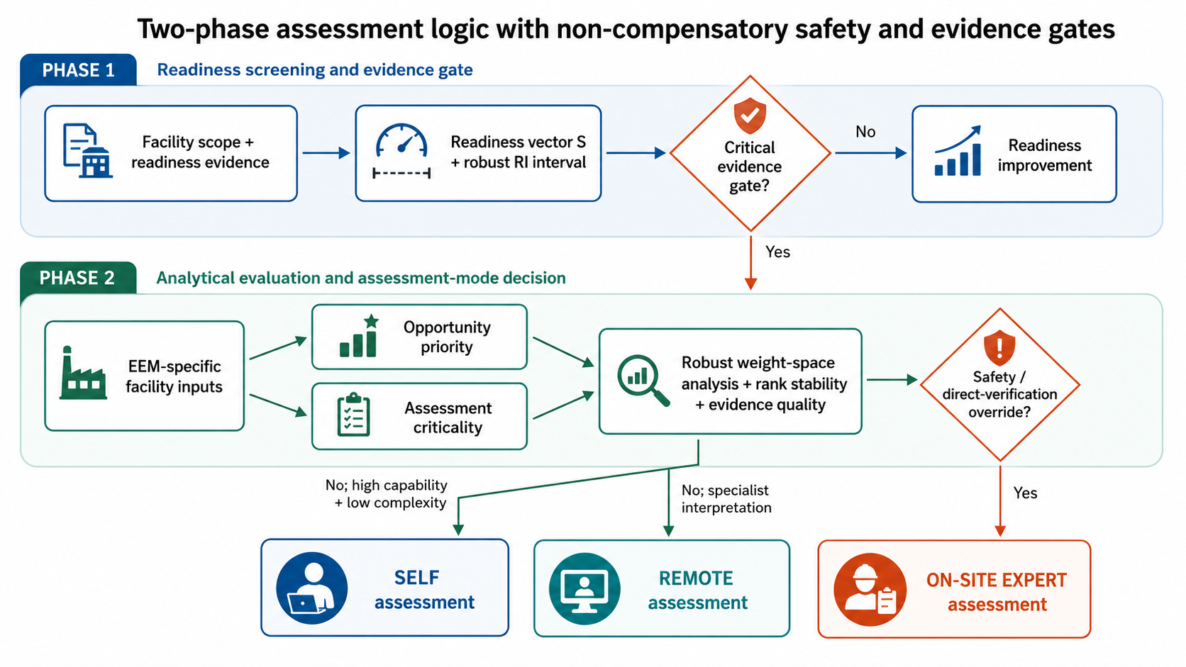
Figure 2. Two-phase decision pathway. Robust scores inform the decision, while mandatory evidence and safety/direct-verification conditions remain non-compensatory.

4.9 Companion explainable decision-support tool
The framework is being implemented as a companion digital decision-support tool. The research novelty is not simply converting equations to a spreadsheet or web form; the intended artifact is an explainable workflow that preserves the provenance of each decision. Every numerical result must be traceable to a source, facility datum, evidence item, rating, declared preference, algorithm version, and human reviewer action.
The proposed software architecture has four layers. The input/evidence layer stores the EEM library, source provenance, site operating data, readiness evidence, hazard-interaction ratings, user preferences, and assessment constraints. The analytics layer calculates CRIS, readiness vectors/envelopes, opportunity and criticality scores, weight-space sensitivity, and pairwise rank stability. The decision/governance layer applies the mode rules, safety/evidence overrides, and human review. The output/learning layer produces a prioritized EEM portfolio, missing-data request, selected assessment mode, rationale, implementation action register, and measurement-and-verification requirements. Each assessment snapshot is versioned so that later changes in data, weights, or ratings can be compared rather than overwritten.
The minimum research-grade data model required to operationalize this architecture is specified in Appendix D (Table D1). The data model links each assessment to a versioned facility scope, EEM and source provenance, six-domain hazard ratings and evidence confidence, readiness evidence, validated facility data, declared preference constraints, opportunity and criticality calculations, assessment-mode decisions and overrides, human-review records, and implementation/M&V actions. This structure is intended to ensure that every recommendation can be reconstructed from its underlying evidence, assumptions, calculations, decision rules, and reviewer actions.
The DST is intentionally human-in-the-loop. It recommends and explains; it does not autonomously authorize process changes. Safety-critical EEMs should link to the operator’s established MOC, PHA/HAZOP, electrical safety, permit, and engineering approval systems as applicable.
Figure 3 translates these methodological requirements into the proposed companion decision-support-tool architecture. The architecture links four functional layers—input and evidence, analytics and robustness, decision and governance, and output and learning—so that assessment recommendations remain traceable from source evidence and facility data through analytical calculations, safety overrides, human review, and implementation/M&V actions. Appendix E documents the implemented interface corresponding to this specification, together with three worked case studies covering all four dispositions of Table 4.
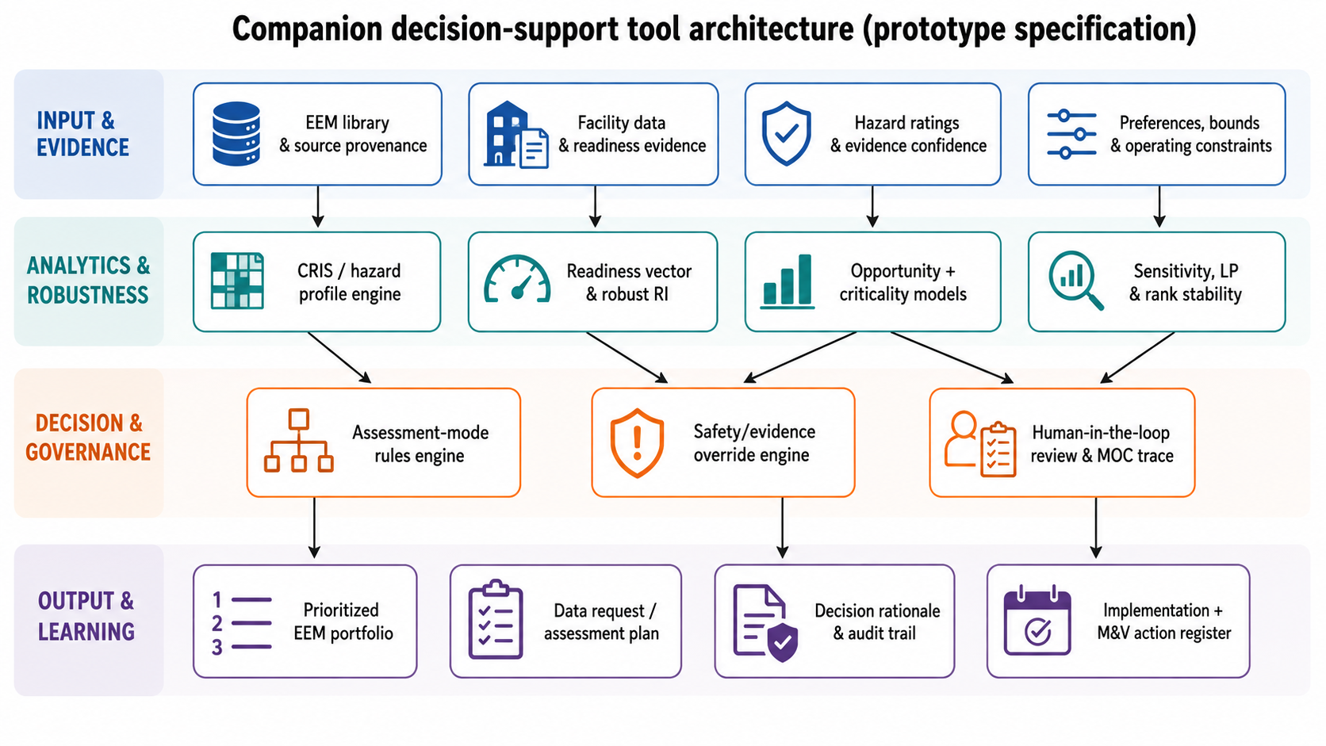
Figure 3. Prototype specification of the companion explainable decision-support tool.

4.10 Executable decision sequence
Algorithm 1 is implemented in Python as a modular reference engine rather than a monolithic score calculator. The software first validates the assessment scope and evidence structure, computes the five-dimensional readiness vector S and gate G, and, when requested, calculates the robust RI interval over the declared admissible weight set W. If G=0, the code returns READINESS IMPROVEMENT / HOLD and defers EEM-specific mode selection. If G=1, the six-domain hazard vector is retained and used to calculate CRIS and normalized interaction intensity R; facility-specific opportunity and assessment-criticality inputs are then evaluated over admissible preference sets A and Q. A separate rule engine applies safety and direct-verification overrides before selecting self-assessment, remote specialist assessment, or on-site expert assessment. Separating the readiness disposition, numerical scores, and EEM-specific hard rules preserves the non-compensatory structure of the framework in executable form.
The complete computational decision sequence is formalized in Algorithm 1, which translates the conceptual framework into an executable sequence from evidence validation and readiness assessment through robustness analysis, safety overrides, assessment-mode selection, and audit-trail generation.
Algorithm 1: Risk-informed assessment disposition and mode selection for EEM j
INPUT: facility readiness evidence; EEM j; hazard vector x_j; facility data/evidence; preference sets W, A, Q; override rules
- Validate scope, provenance, units, timestamps, and mandatory evidence fields.
- Compute readiness vector S and gate G; compute RI reference/envelope if aggregation is requested.
- Retrieve/confirm x_j; compute CRIS_j and normalized R_j; preserve the six-domain vector.
- Score facility-specific opportunity criteria z_j and compute OP_j envelope / rank stability where inputs exist.
- Score data sufficiency D_j, action complexity C_j, and verification need V_j; compute AC_j envelope.
- If G=0 => READINESS IMPROVEMENT / HOLD and stop; otherwise apply EEM-specific hard rules: required direct verification or declared safety override => ON-SITE EXPERT.
- Else if validated digital evidence is adequate but specialist interpretation is required => REMOTE SPECIALIST.
- Else if G=1, internal capability is adequate, validated evidence is available, and protocol requirements are satisfied => SELF-ASSESSMENT.
- Otherwise => escalate to REMOTE SPECIALIST or ON-SITE EXPERT based on the unresolved EEM-specific evidence requirement.
- Store inputs, ranges, active constraints, overrides, reviewer rationale, selected mode, and next evidence/actions.
OUTPUT: auditable readiness disposition or assessment-mode decision and implementation-oriented action record.

The reference code exposes these operations as auditable computational modules and returns a versionable assessment record rather than only a final label. This record forms the computational bridge between the two-phase logic in Figure 2, the data/governance architecture in Figure 3, and the implementation/M&V trace defined in Appendix D.

4.11 Illustrative computational scenarios
The following scenarios are deterministic demonstrations of the computational logic; they are not field observations and do not calibrate thresholds. Consider a facility with readiness scores S=(80, 70, 75, 60, 65). Equal weights give RI=70.0. If the facility has not elicited weights but permits 0.10≤wᵢ≤0.35 with no additional ordering constraints, linear programming gives RI∈[66.25, 73.75]. The interval exposes the consequence of unresolved preference structure rather than presenting a single unsupported readiness value. If a mandatory facility-level evidence item is absent, G=0 and the executable framework returns READINESS IMPROVEMENT / HOLD until the prerequisite is resolved or the scope is redefined.
For EEM 54 (reciprocating-compressor rod-packing maintenance and leak reduction), CRIS=14 and R=77.78. To exercise the opportunity layer, illustrative normalized benefit scores z=(80, 75, 70) with equal weights give OP=75.0. With D=55, C=70, and V=90, equal criticality weights give AC=70.69. The final route is nevertheless ON-SITE EXPERT because direct leak quantification, packing condition, and vibration/condition evidence require direct verification in the illustrative case; neither OP nor AC can compensate for that requirement. By contrast, a lower-interaction utility-control case with CRIS=6, D=90, C=25, and V=20 gives R=33.33 and AC=22.08 and can follow the SELF-ASSESSMENT route when G=1, validated evidence is available, internal capability is adequate, and protocol requirements are satisfied. A separate deterministic branch with validated digital evidence, no direct-verification requirement, and a need for specialist interpretation returns REMOTE SPECIALIST. These cases are encoded as regression checks in Supplementary Software S1 so that the published examples and executable logic share the same expected outputs.

5. Results

5.1 Python reference implementation and computational verification
The Python reference implementation reproduced all 65 CRIS values in Appendix B exactly, with no arithmetic discrepancy across the 390 EEM-domain codes. This establishes internal numerical consistency among the published hazard matrix, Equations (1)-(3), and the executable implementation. The same implementation was then exercised against deterministic envelope and routing cases to verify Equations (4)-(12), the Phase-1 readiness disposition, and the Phase-2 non-compensatory assessment-mode rules in Algorithm 1. Results are summarized in Table 5.
The deterministic tests confirmed both numerical reproduction and decision-path behavior. The bounded readiness case returned RI∈[66.25, 73.75], exactly matching the analytical result. For EEM 54, the code returned CRIS=14, R=77.78, OP=75.0, and AC=70.69 and selected ON-SITE EXPERT when direct verification was required. A lower-interaction case with CRIS=6, D=90, C=25, and V=20 returned R=33.33 and AC=22.08 and selected SELF-ASSESSMENT when the readiness gate, internal capability, validated evidence, and protocol conditions were satisfied. A separate branch returned REMOTE SPECIALIST when validated digital evidence was available but specialist interpretation was required. When the facility-level mandatory gate failed (G=0), the code returned READINESS IMPROVEMENT / HOLD and did not proceed to EEM-specific assessment-mode selection.
Table 5. Deterministic computational verification of the Python reference implementation.
Verification case | Deterministic input / condition | Python result | Interpretation
CRIS matrix reproduction | Appendix B: 65 EEMs x 6 hazard domains | 65/65 CRIS values reproduced exactly; 390 coded interactions retained | Confirms arithmetic/data consistency
Robust readiness envelope | S=(80,70,75,60,65); 0.10<=w_i<=0.35; sum(w)=1 | RI = [66.25, 73.75]; equal-weight RI = 70.0 | Confirms LP envelope calculation
EEM 54 criticality / override | CRIS=14; z=(80,75,70); equal opportunity weights; D=55; C=70; V=90; equal criticality weights; direct verification required | R=77.78; OP=75.0; AC=70.69; ON-SITE EXPERT | Override dominates compensatory scores
Lower-interaction self branch | CRIS=6; D=90; C=25; V=20; gate/capability/data/protocol adequate | R=33.33; AC=22.08; SELF-ASSESSMENT | Confirms low-scrutiny route when conditions are met
Remote-specialist branch | Gate passed; validated digital evidence; specialist interpretation; no direct verification | REMOTE SPECIALIST | Confirms evidence-matched remote route
Failed readiness gate | G=0 because one or more mandatory facility-level readiness/evidence prerequisites are not satisfied | READINESS IMPROVEMENT / HOLD | Confirms pre-assessment hold rather than forced mode selection

These tests show that executable implementation preserves the conceptual separation among readiness, opportunity, assessment criticality, and non-compensatory controls. The EEM 54 case demonstrates that even a favorable opportunity score cannot override direct-verification requirements. The lower-interaction and remote-specialist cases demonstrate that the framework avoids unnecessary escalation when evidence and capability are sufficient. The failed-gate test additionally confirms that deficient facility-level prerequisites are treated as a readiness problem rather than being converted automatically into an on-site assessment. Thus, the software reproduces the central methodological claim of the paper: assessment rigor is determined by the joint evidence state and by explicit hard constraints, not by a single compensatory score. Appendix E presents these verification cases in the implemented interface as three worked case studies, and Table E1 gives the correspondence between them.

5.2 Hazard-interaction distribution
Table 6 summarizes the frequency of High, Medium, Low, and no-meaningful-interaction ratings across all 65 EEMs for each of the six hazard domains.
Table 6. Distribution of interaction ratings across the 65 EEMs.
Domain | High | Medium | Low | None
WC | 4 | 12 | 49 | 0
FE | 13 | 22 | 30 | 0
EH | 6 | 31 | 27 | 1
TE | 9 | 19 | 37 | 0
MF | 10 | 39 | 16 | 0
EI | 9 | 26 | 30 | 0
As summarized in Table 6, fire/explosion contains the greatest number of High interactions (13), followed by mechanical failure (10), toxic exposure (9), environmental impact (9), electrical hazard (6), and well control (4). Mechanical failure is frequently rated Medium because many measures alter rotating, loaded, or pressurized equipment, whereas the strongest High interactions cluster in hydrocarbon-containment and ignition-related measures. The complete distribution across interaction levels and hazard domains is visualized in Figure 4.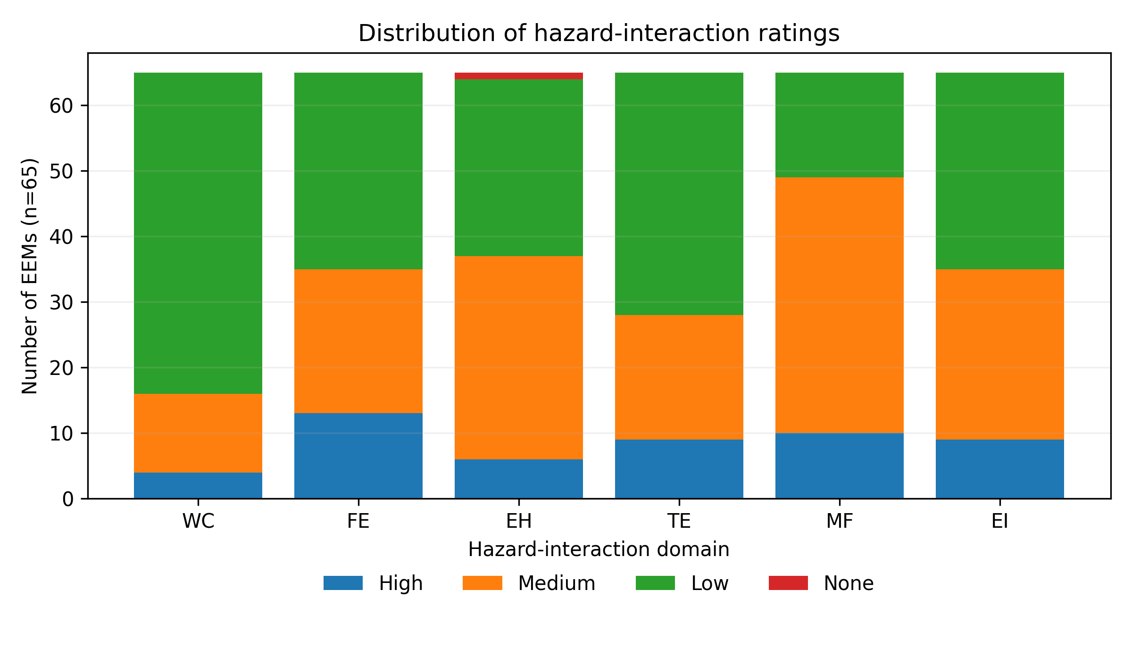
Figure 4. Distribution of High, Medium, Low, and no-meaningful-interaction ratings across the six hazard domains.

5.3 Stage structure of High interactions
To evaluate whether High interactions are concentrated differently across upstream operational stages, Table 7 reports the stage-specific High counts together with the exact fixed-margin association tests and multiplicity-adjusted results.
Table 7. Stage distribution of High interactions and exact fixed-margin association tests.
Domain | Drilling H | Extraction H | Surface H | Cramer V | Exact p | BH-FDR p
WC | 4 | 0 | 0 | 0.324 | 0.03707 | 0.0556
FE | 1 | 3 | 9 | 0.526 | 8.066e-05 | 0.0004839
EH | 2 | 4 | 0 | 0.224 | 0.1809 | 0.2171
TE | 0 | 3 | 6 | 0.422 | 0.001996 | 0.005988
MF | 4 | 4 | 2 | 0.046 | 1 | 1
EI | 0 | 4 | 5 | 0.356 | 0.01021 | 0.02042
The stage pattern is physically interpretable. Table 7 quantifies the operational-stage distribution of High interactions and the corresponding exact fixed-margin association tests, while Figure 5 provides the graphical stage-by-domain comparison. All four High well-control interactions occur in drilling. Surface treatment contains 9 of the 13 High fire/explosion interactions, 6 of the 9 High toxic-exposure interactions, and 5 of the 9 High environmental interactions. Exact fixed-margin tests retain strong stage dependence after Benjamini-Hochberg adjustment for fire/explosion (adjusted p=0.00048, V=0.526), toxic exposure (adjusted p=0.00599, V=0.422), and environmental impact (adjusted p=0.0204, V=0.356). The well-control pattern is directionally concentrated in drilling but is marginal after multiplicity adjustment (adjusted p=0.0556). Mechanical-failure High ratings show essentially no stage association (V=0.046). Because the analyzed EEM library is a curated set rather than a random sample of all possible EEMs, these tests describe structure within the evidence base and should not be interpreted as population prevalence estimates.
Figure 5 provides the corresponding graphical comparison of High-interaction counts across the three operational stages and six hazard domains, making the stage-specific concentration of fire/explosion, toxic-exposure, environmental, and well-control interactions readily apparent.
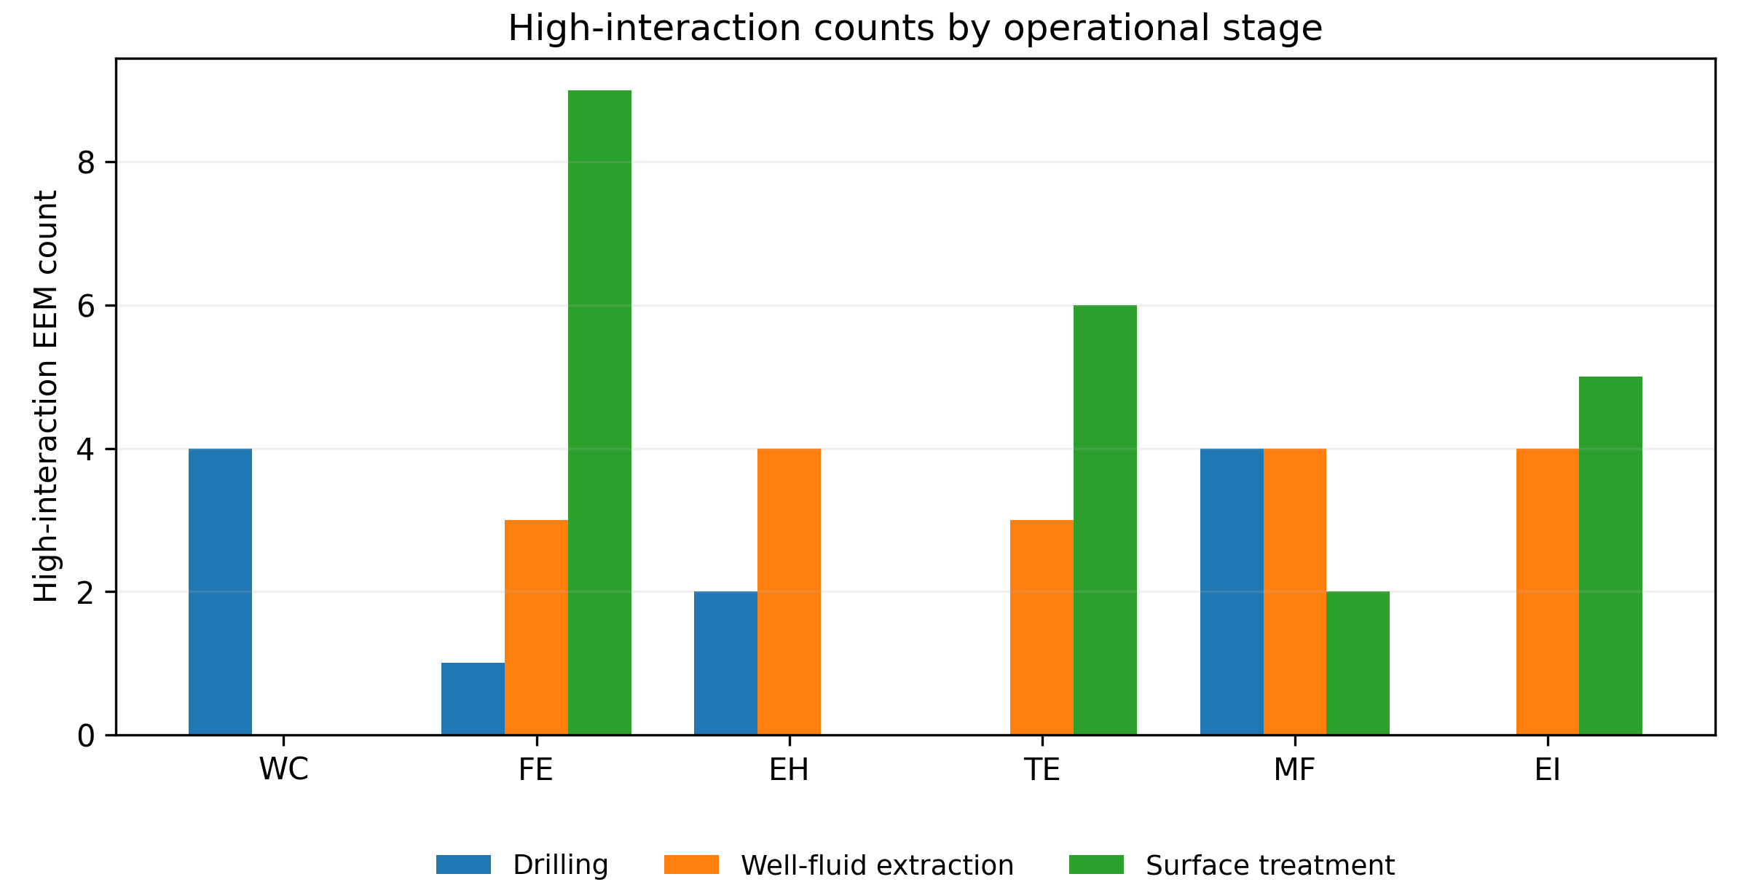
Figure 5. High-interaction counts by hazard domain and operational stage.

5.4 Composite interaction intensity by operational stage
Table 8 summarizes the central tendency and dispersion of CRIS for drilling, well-fluid extraction, and surface-treatment EEMs and provides the quantitative basis for evaluating stage-level differences in multi-hazard interaction intensity.
Table 8. CRIS summary by operational stage.
Stage | n | Mean | SD | Median | IQR | Range
Drilling | 25 | 8.84 | 1.72 | 9.0 | 7.00-10.00 | 6-12
Well-fluid extraction | 24 | 10.00 | 1.67 | 10.0 | 9.00-11.00 | 7-13
Surface treatment | 16 | 11.19 | 1.97 | 11.0 | 9.75-13.00 | 8-14
CRIS increases across the three operational stages: drilling mean 8.84, well-fluid extraction mean 10.00, and surface treatment mean 11.19. The exploratory Kruskal-Wallis statistic is H=12.625 (p=0.00181; epsilon-squared≈0.171). Pairwise comparisons show the largest separation between drilling and surface treatment (Mann-Whitney U=76.5, p=0.00090; rank-biserial effect≈-0.618), with a smaller drilling/extraction difference (U=195.5, p=0.035) and an extraction/surface comparison that does not reach the conventional 0.05 level (U=124.5, p=0.061). The practical interpretation is more important than the p-values: surface-processing EEMs in this library more often intersect multiple hydrocarbon containment, ignition, exposure, and environmental pathways simultaneously.
The stage-level CRIS distributions are shown in Figure 6, which displays the individual EEM observations together with the median and interquartile range for each operational stage.
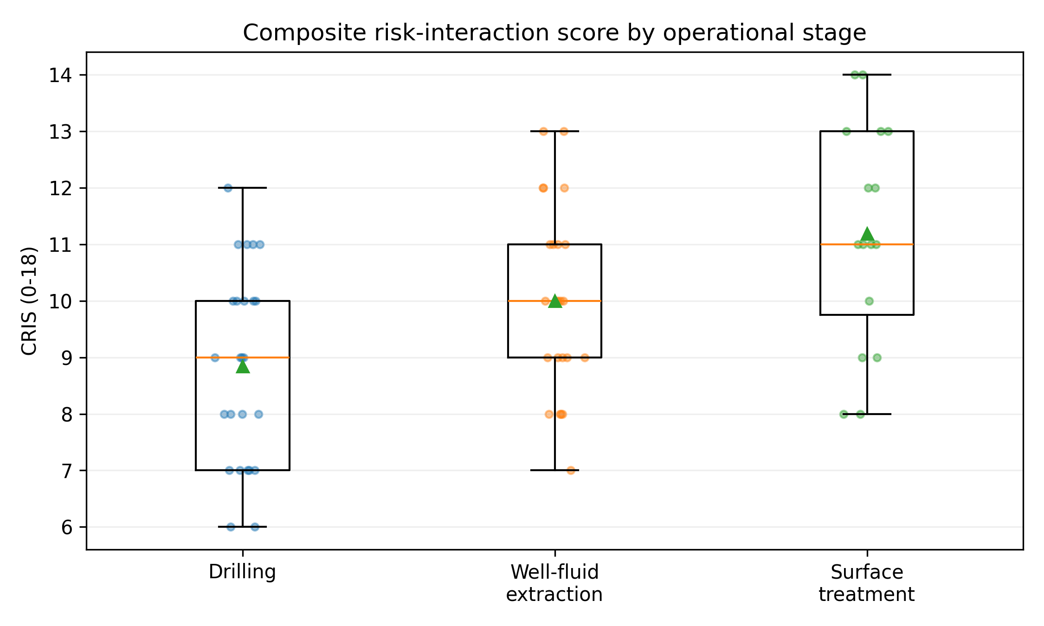
Figure 6. CRIS distributions by operational stage. Points represent individual EEMs; boxes show the median and interquartile range.

5.5 Highest multi-hazard interaction measures
Table 9 identifies the 15 EEMs with the highest CRIS values in the analyzed library, providing a measure-level view of the interventions that interact most broadly and intensely with the six hazard domains.
Table 9. Fifteen highest CRIS EEMs in the analyzed library.
No. | EEM | Stage | CRIS
54 | Rod packing maintenance and leak reduction | Surface treatment | 14
59 | Install VRU on tanks and separators | Surface treatment | 14
39 | Instrument-air or electric replacement | Well-fluid extraction | 13
40 | LDAR and repair of gas/oil leaks | Well-fluid extraction | 13
53 | Load matching and anti-surge optimization | Surface treatment | 13
58 | Flare gas recovery and purge optimization | Surface treatment | 13
60 | Floating roof/seal maintenance and vapor balancing | Surface treatment | 13
2 | Load management and auto-start/stop sequencing | Drilling | 12
34 | Injection pressure and rate optimization | Well-fluid extraction | 12
38 | Replace high-bleed with low/no-bleed device | Well-fluid extraction | 12
49 | Power control and electrode maintenance | Well-fluid extraction | 12
50 | Pressure/level control and residence-time optimization | Surface treatment | 12
64 | Convert pneumatic devices to instrument air | Surface treatment | 12
1 | Optimize GT loading and spinning reserve | Drilling | 11
3 | Spinning reserve support and peak shaving | Drilling | 11
The highest values are concentrated in reciprocating-compressor leak control, vapor recovery, pneumatic replacement, LDAR, compressor anti-surge/load matching, flare-gas recovery, and storage-tank vapor-loss control. This is not an argument against these measures. Many are attractive energy/product-loss and emissions measures. Their high CRIS instead means that implementation planning should explicitly verify containment, ignition controls, operating envelope, fail-safe behavior, exposure controls, and mechanical condition as applicable.
Figure 7 provides a graphical ranking of the highest multi-hazard-interaction EEMs and highlights the concentration of elevated CRIS values in hydrocarbon-containment, compression, vapor-management, pneumatic, and leak-control measures.
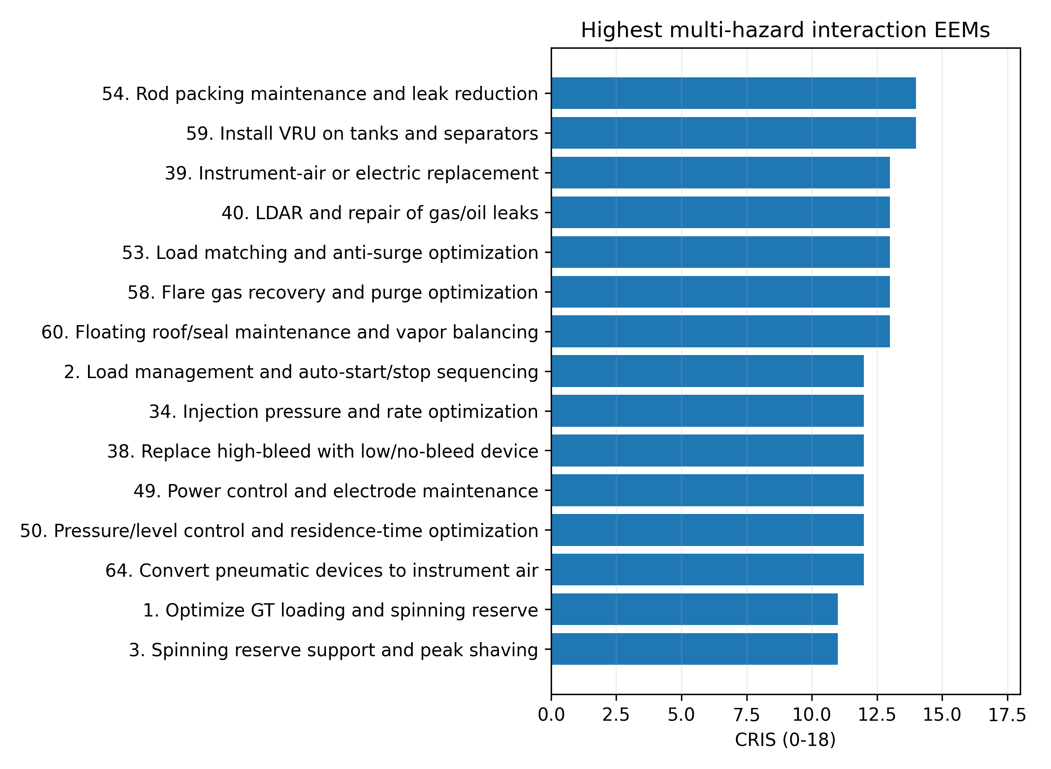
Figure 7. Highest multi-hazard interaction EEMs ranked by CRIS.

5.6 Hazard co-occurrence structure
Spearman correlations among ordinal interaction ratings reveal a clear containment/exposure/environment cluster. Toxic exposure and environmental impact are strongly associated (rho=0.705), as are fire/explosion and environmental impact (rho=0.653) and fire/explosion and toxic exposure (rho=0.584). These patterns are consistent with measures involving hydrocarbon leakage, tank vapors, pneumatic gas use, flare systems, and vapor recovery, where one physical loss pathway can simultaneously affect ignition potential, worker exposure, and emissions. Electrical interactions are moderately negatively associated with toxic exposure (rho=-0.332) and fire/explosion (rho=-0.277) in this curated set, reflecting the concentration of high electrical interactions in drives/ESP/power equipment rather than hydrocarbon-loss measures. These correlations are descriptive co-occurrence metrics, not causal relationships.
The complete pairwise correlation structure among the six interaction domains is presented in Figure 8, which highlights the fire/explosion–toxic-exposure–environmental-impact co-occurrence cluster within the curated EEM dataset.
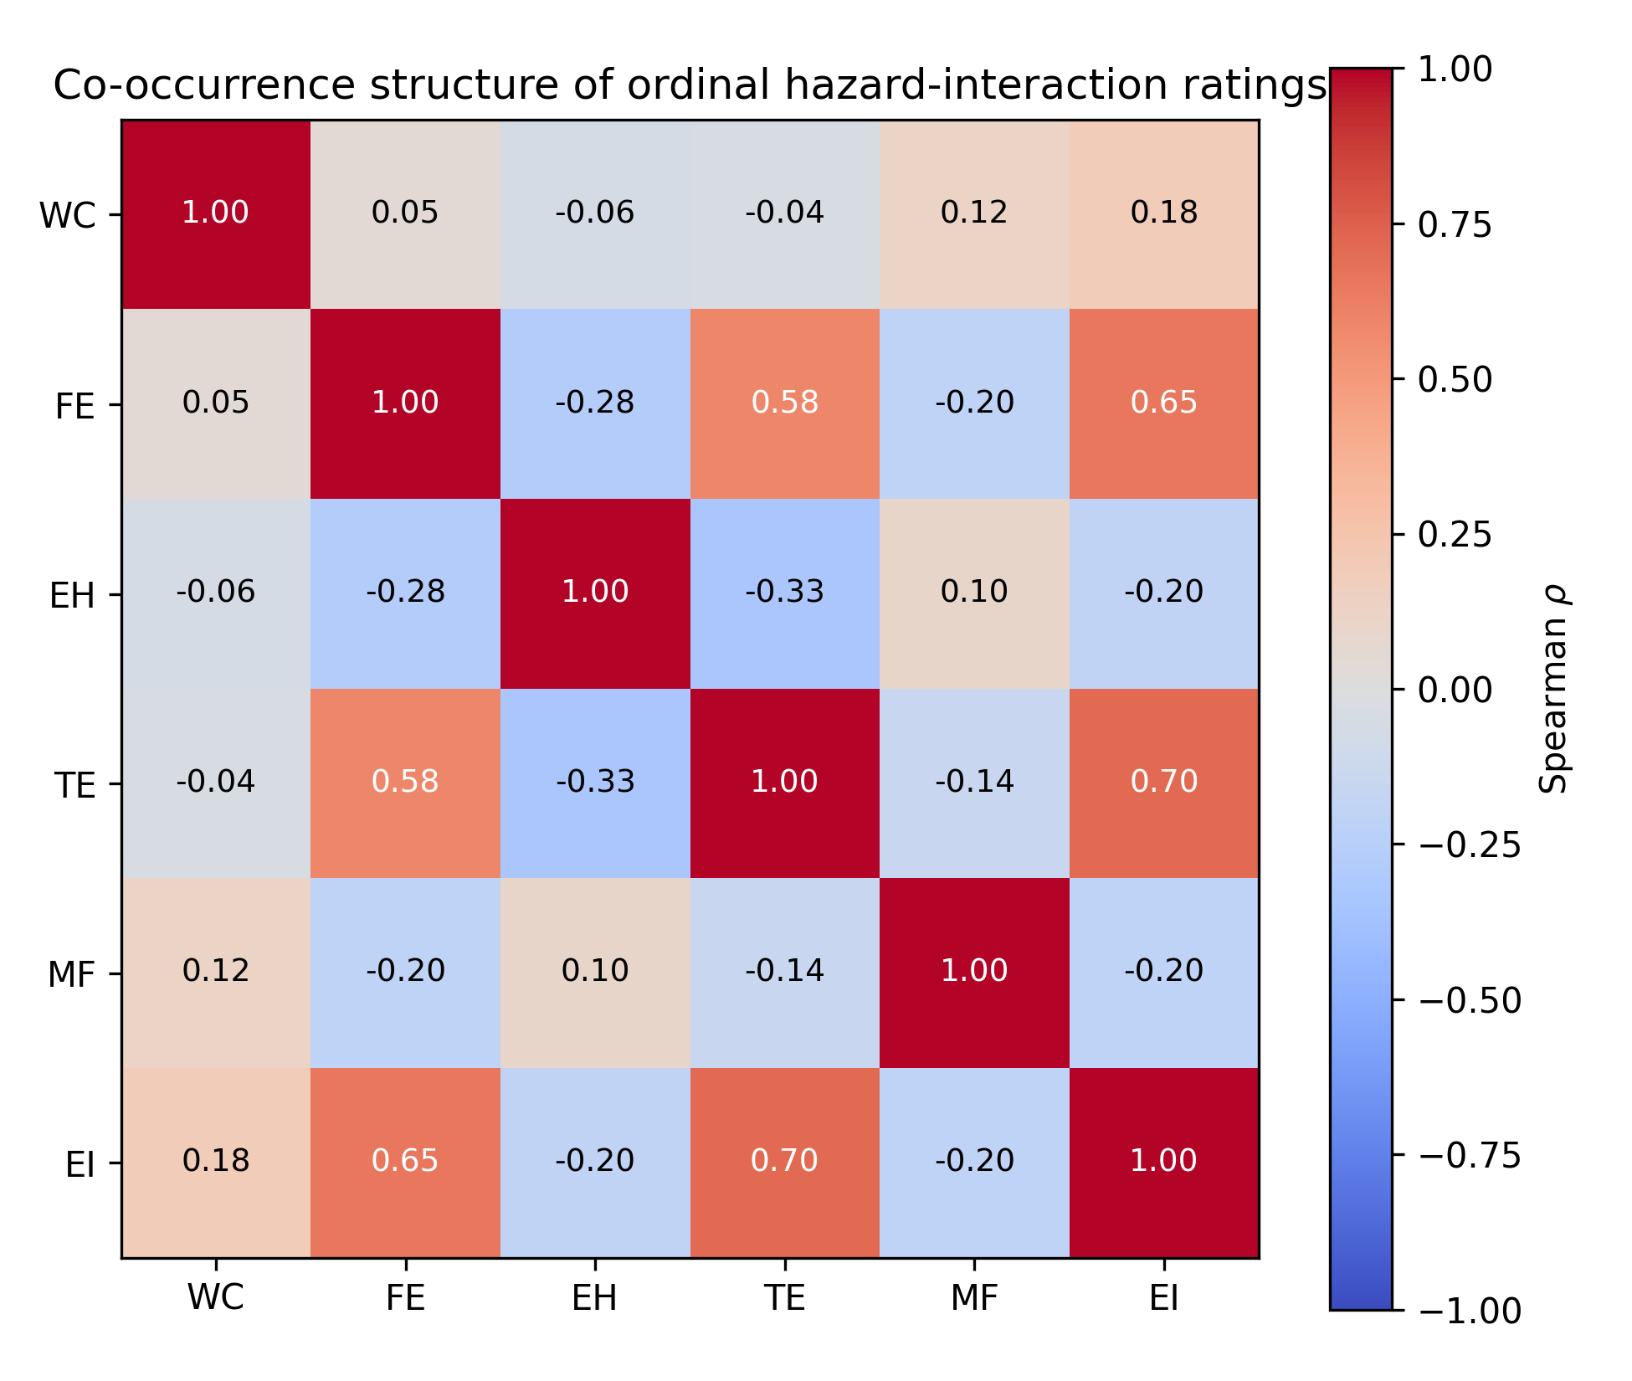
Figure 8. Spearman correlation matrix of the six ordinal hazard-interaction domains across 65 EEMs.

5.7 Sensitivity of CRIS ranking to ordinal-score encoding
Table 10 evaluates the robustness of the CRIS-based EEM ranking to alternative monotone numerical encodings of the High, Medium, and Low interaction categories using Kendall rank correlation and top-10 overlap relative to the baseline 3-2-1 scheme.
Table 10. Sensitivity of EEM ranking to alternative monotone encodings.
Encoding | Kendall tau vs. 3:2:1 | Top-10 overlap
Linear 3-2-1 | 1.000 | 10
Severity 4-2-1 | 0.952 | 9
Strong severity 9-3-1 | 0.898 | 8
Compressed 2-1-1 | 0.640 | 8
The ranking is highly stable when High interactions receive greater relative emphasis. Relative to the baseline 3:2:1 encoding, Kendall tau is 0.952 for 4:2:1 and 0.898 for 9:3:1, with 9/10 and 8/10 top-10 overlap, respectively. Figure 9 visualizes the sensitivity of the EEM ranking to alternative monotone ordinal encodings and illustrates the relative stability of the principal high-interaction measures under severity-emphasizing scoring schemes. The compressed 2:1:1 scheme reduces rank agreement (tau=0.640), as expected because it removes the distinction between Medium and Low. Importantly, the core high-interaction set—including EEMs 39, 40, 53, 54, 58, 59, 60, and 64—remains prominent across all tested schemes. This sensitivity analysis supports using CRIS as a broad screening indicator while reinforcing the requirement to retain the underlying six-domain vector.
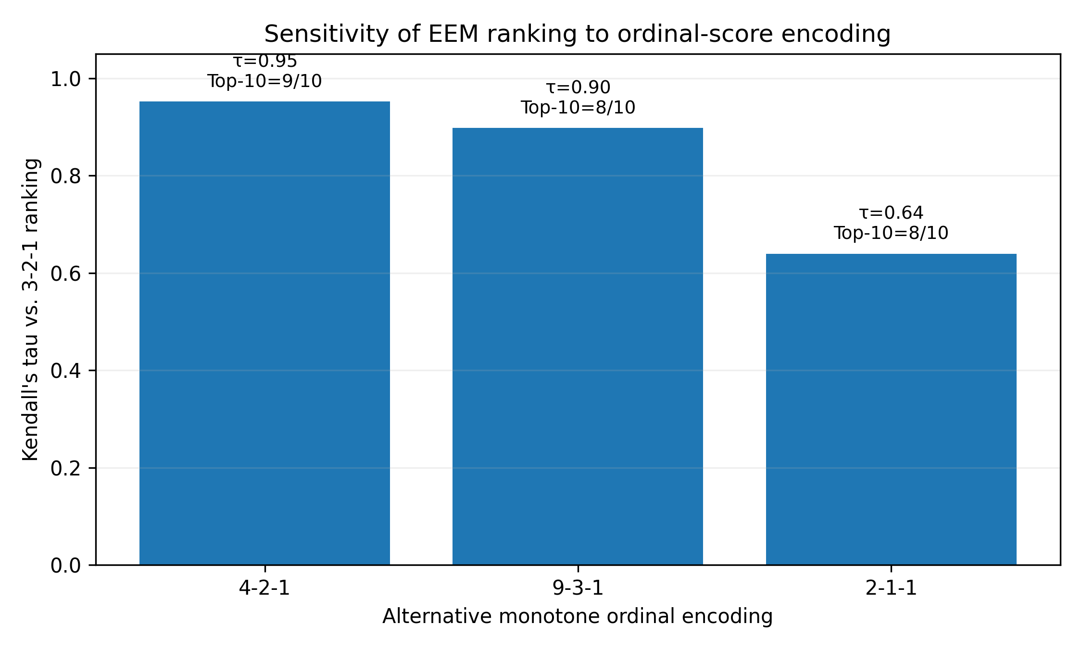
Figure 9. Rank sensitivity under alternative monotone ordinal encodings. The baseline 3:2:1 scheme is the reference.

5.8 What the present results do—and do not—validate
Taken together, the results establish internal computational reproducibility, reveal structure within the coded evidence base, and show that the principal CRIS ranking is not an artifact of one narrow ordinal encoding. They do not establish the hazard ratings as objective truth, demonstrate that readiness predicts implementation, validate universal opportunity or criticality weights, or show that the mode engine outperforms qualified expert judgment. Those claims require independent raters and prospective field outcomes, as specified in Section 7.

6. Discussion

6.1 Why the separation of opportunity and criticality matters
The most consequential redesign in this paper is conceptual rather than cosmetic: the framework no longer treats hazard interaction as a positive contributor to “priority” in the same compensatory index as energy opportunity. An EEM can be highly attractive and highly critical at the same time. Those are not contradictory observations; they demand different responses. High opportunity supports allocating resources to investigate the measure. High assessment criticality supports allocating greater evidence and engineering rigor to that investigation. Preserving both dimensions avoids a common decision-model failure in which a large benefit score masks weak evidence or a safety-sensitive modification.
This distinction also improves communication with operations and HSE personnel. The statement “this measure ranks high because it is risky” is ambiguous. The revised tool can instead say: “this measure has high opportunity value; it also has High interactions with fire/explosion and toxic exposure, and the current evidence is insufficient, so an on-site expert assessment is required before the opportunity can be quantified confidently.” That is an auditable engineering explanation rather than a black-box score.

6.2 Readiness should remain a profile, not only a scalar
Energy-management maturity literature supports organizational assessment [3], [61], but a single maturity score is potentially compensatory. A facility with excellent management sponsorship but no usable process data should not be treated as equally ready as a facility with balanced evidence. Reporting S1-S5 alongside a robust aggregate interval protects against this problem. The non-compensatory gate adds a second safeguard for scope-specific prerequisites.
The revised weight treatment is also more defensible than claiming that one ordering of readiness weights applies to every upstream organization. A small onshore producer, a drilling contractor, and an integrated offshore operator can differ materially in digital infrastructure, contractor dependence, internal engineering capability, and governance. Weight-set analysis lets the same framework represent these contexts while documenting the assumptions that differ.

6.3 Implications for self, remote, and on-site assessment
Remote assessment is not inherently lower quality; it is conditionally appropriate. When the calculation depends on reliable historian data, nameplate information, validated operating trends, and video/photographic evidence, remote specialist analysis can be efficient and technically strong. Where diagnosis depends on acoustic leakage, vibration, physical deterioration, hazardous-area compliance, field calibration, valve position, control-loop behavior, or unrecorded operating practices, remote evidence may be insufficient. The framework formalizes this boundary instead of assuming that every EEM belongs to one assessment mode.
This is particularly relevant to scalable industrial assessment programs. A digital tool can triage a large EEM portfolio so that scarce site time is focused on measures that truly need direct verification, while lower-complexity measures are handled through structured self or remote workflows. The result is not “remote instead of on-site”; it is evidence-matched hybrid assessment.

6.4 Interpretation of the stage and hazard results
The observed stage structure is consistent with equipment function. Drilling contains well-control equipment and power-reserve functions, creating concentrated well-control interactions. Surface treatment contains separators, compressors, heaters, dehydration, flaring, vapor recovery, and storage tanks, explaining the higher multi-hazard scores and concentration of fire/explosion, toxic-exposure, and environmental interactions. Produced water and artificial lift systems create a different profile dominated by electrical, mechanical, process-pressure, and environmental considerations.
The strong FE-TE-EI correlation cluster is methodologically important because it suggests that some energy measures should be reviewed as loss-pathway interventions rather than as independent energy projects. For example, leak repair, VRU installation, pneumatic replacement, flare recovery, and tank vapor control affect product loss, emissions, worker exposure, and ignition conditions simultaneously. An implementation tool should therefore permit one evidence item or engineering control to be linked to multiple hazard domains, reducing duplicate documentation while preserving traceability.

6.5 Python reference implementation and digital tool as research artifacts
The scientific value of the digital artifact depends on operationalizing the method rather than merely visualizing it. A research-grade implementation therefore requires deterministic reproduction of the equations, explicit parameter and version management, validation rules for missing or inconsistent inputs, provenance links from EEMs to sources and from scores to evidence, robust weight-envelope computation, rank-stability analysis, rule-engine logging, and exportable audit trails. It must also distinguish among 'not assessed,' 'not applicable,' and 'zero interaction,' because conflating those states would alter the meaning of the analytical dataset.
The production DST should subsequently be evaluated as a design-science artifact through formal software verification, expert usability testing, and field decision-validity studies. This distinction is important because implementation demonstrates executable utility, whereas external evaluation is required to establish whether the artifact improves real assessment decisions [67], [68].
The executable reference implementation adds a methodological contribution beyond the conceptual diagrams. First, it makes the framework computationally falsifiable: equations, admissible weight constraints, score envelopes, and routing rules can be tested against known inputs rather than interpreted only from prose. Second, it demonstrates that the non-compensatory architecture survives implementation. In the EEM 54 test, AC=70.69 and OP=75.0 do not determine the final route; the direct-verification condition controls the decision. Conversely, the lower-interaction case remains eligible for self-assessment only when the readiness gate, capability, validated evidence, and protocol conditions are satisfied. This behavior is central to avoiding false precision from a single compensatory index.
Third, the structured output record strengthens explainability and reproducibility. Rather than returning only a rank or mode label, the code preserves the readiness vector, RI/OP/AC intervals, the six-domain hazard vector, gate state, active overrides, selected disposition or mode, rationale, and next actions. These outputs create a computational audit trail that can later be compared with expert decisions, field observations, implementation outcomes, and M&V results. The same data structure supports future calibration because changes in weights, thresholds, evidence quality, or hazard ratings can be versioned and recomputed without overwriting the original decision state. Appendix E shows this record as implemented, including two completed runs that differ in a single routing-relevant condition.
Computational correctness must nevertheless remain distinct from empirical validity. The deterministic tests show that the software faithfully executes the specified framework; they do not establish that the hazard ratings, readiness construct, admissible weight bounds, criticality inputs, or mode-selection rules are optimal for industry use. This distinction directly motivates the validation program in Section 7, particularly independent coding reliability (V1), multi-facility testing (V3), mode concordance (V5), software verification (V6), and human-factors evaluation (V7).

7. Validation and Calibration Roadmap
The framework is intentionally presented as pre-calibration. Accordingly, the validation program in Table 11 separates internal computational verification from the external evidence required for prescriptive use. The staged design progresses from independent coding-reliability and content-validity studies through multi-facility piloting, predictive validation, assessment-mode concordance, production-software verification, and human-factors evaluation. This sequence allows thresholds and decision rules to be calibrated against observed outcomes rather than fixed a priori.
Table 11. Proposed validation program for the framework and digital tool.
Stage | Study design | Primary metrics | Purpose
V1. Coding reliability | Independent upstream energy, operations, and HSE experts rate a stratified subset and then the full EEM matrix. | Ordinal Krippendorff alpha / weighted agreement; disagreement map; adjudication log [73]. | Tests whether H/M/L assignments are reproducible across qualified raters.
V2. Content validity | Delphi rounds evaluate domain completeness, readiness factors, evidence rubrics, and override rules. | Content-validity indices; convergence; documented dissent. | Tests whether important constructs/hazards are missing or mis-specified.
V3. Multi-facility pilot | Apply the DST across diverse onshore/offshore/drilling/production settings. | Assessment duration, data gaps, selected mode, recommendation quality, implementation decisions. | Tests portability and operational burden.
V4. Criterion/predictive validity | Compare readiness/criticality outputs against later outcomes. | Assessment completion quality; implementation rate; realized savings; rework; unresolved HSE findings. | Calibrates thresholds/weights against measurable outcomes.
V5. Mode concordance | Blind experts independently choose self/remote/on-site mode and compare with tool. | Agreement, escalation/de-escalation errors, false self-assessment rate. | Tests the decision engine.
V6. Software verification | Automated unit, integration, regression, and boundary tests. | 100% equation reproduction; deterministic test cases; version trace. | Tests computational correctness.
V7. Human factors/usability | Assessor and facility-user testing. | Task completion, error rate, System Usability Scale or equivalent, qualitative failure modes. | Tests whether transparency survives real use.
For V1, ordinal reliability should be reported separately for each hazard domain and by EEM stage. Overall agreement alone can hide a weak domain. A useful design would intentionally oversample high-CRIS and safety-sensitive measures because disagreements there have greater operational consequence. The adjudication process should not simply force consensus; persistent disagreement is evidence that the rubric needs refinement.
For V3-V5, the study should prospectively register the assessment mode selected before outcomes are known. Otherwise, expert reviewers could retroactively rationalize the final mode. The most important error is an unsafe or technically inadequate self/remote recommendation that later requires field escalation. That error should receive greater attention than conservative escalation to on-site work.
Weights and thresholds should be calibrated only after outcome data exist. Candidate outcomes include the fraction of recommendations with sufficient evidence for investment decision, implementation rate, realized-to-predicted savings ratio, time/cost of assessment, number of major evidence gaps discovered after initial screening, and safety/operability issues identified during engineering review. Cross-validation or holdout testing should be used if a sufficiently large facility dataset becomes available.

8. Limitations
- The EEM library is literature-supported but not an exhaustive systematic-review sample. Its composition can influence the observed stage and hazard distributions.
- The 390 hazard-interaction ratings are structured expert judgments and have not yet been independently rated. The quantitative analyses therefore characterize the coded dataset, not objective industry incident risk.
- CRIS assumes a simple ordinal mapping for screening. Sensitivity analysis shows substantial ranking stability under severity-emphasizing recodings, but ordinal categories do not become interval-scale measurements merely because numbers are assigned.
- The statistical tests are exploratory because the EEMs are not a probability sample. Exact fixed-margin tests reduce small-count problems but do not create external generalizability.
- Readiness, opportunity, evidence sufficiency, complexity, verification need, and admissible weight sets require facility-specific input. No universal weights or thresholds are claimed.
- The assessment-mode rules have not yet been prospectively validated against independent expert decisions or field outcomes.
- The Python reference implementation has passed the deterministic computational checks reported in Section 5.1, but the production DST remains under development. Production software verification, cybersecurity, role-based access, data confidentiality, deployment controls, and usability evidence must be documented before operational use.
- The framework is a screening and assessment-governance method. It cannot replace PHA/HAZOP, quantitative risk assessment, MOC, code compliance review, detailed engineering, or operator-specific safety management systems.

9. Conclusions
This study reframes upstream energy assessment as an evidence-governance and decision-depth problem rather than an EEM-listing problem. A literature-supported library of 65 measures was integrated with six hazard-interaction domains, an evidence-based readiness model, robust treatment of uncertain weights, separate opportunity and assessment-criticality constructs, and an explainable assessment-mode engine. The framework is deliberately risk-informed rather than risk-estimating: the full hazard vector is retained, CRIS is used only as an interaction-intensity summary, and safety or direct-verification requirements cannot be compensated by high opportunity or readiness scores.
The computational reanalysis strengthens the internal evidence base of the framework. All 65 CRIS values were reproduced exactly; fire/explosion had the greatest number of High interactions; surface-treatment EEMs exhibited the highest average multi-hazard interaction; exact within-dataset tests showed stage dependence for fire/explosion, toxic exposure, and environmental impact; and the principal CRIS ranking remained robust under severity-emphasizing ordinal recodings. The Python implementation independently reproduced the bounded readiness interval [66.25, 73.75], the EEM 54 values CRIS=14, R=77.78, OP=75.0, and AC=70.69, and the intended readiness-hold, self, remote-specialist, and on-site decision pathways. Together, these results demonstrate internal numerical and logical reproducibility without overstating external validation.
The companion DST provides a pathway for scaling the framework while retaining traceability. Its scientific value lies in preserving evidence provenance, user-defined preference constraints, robustness intervals, rank stability, readiness-gate status, safety/direct-verification overrides, human review, and implementation/M&V actions in one auditable record. The next research priority is therefore independent expert coding, prospective multi-facility pilots, mode-concordance testing, and outcome-based calibration rather than the addition of further unvalidated coefficients. Until that evidence is available, the framework should be used as a transparent screening and assessment-planning method, not as a prescriptive industry standard.

10. Data, Calculation, and Software Availability
The supporting research artifacts are provided in Appendices A–D:
- Appendix A contains the traceable 65-EEM technical library;
- Appendix B provides the complete 65 × 6 hazard-interaction matrix and CRIS calculations;
- Appendix C provides the operational definitions and evidence requirements for the five readiness dimensions;
- Appendix D specifies the minimum data model and audit-trail requirements for the companion decision-support tool; and
- Appendix E documents the implemented companion decision-support tool and presents the Table 5 verification cases as three worked case studies.
Numerical results in this manuscript were independently reproduced with the Python reference implementation described in Sections 3.4, 4.10, and 5.1. The implementation accompanies the manuscript as Supplementary Software S1 (risk_informed_energy_assessment_algorithm_v2.py; reference implementation v1.1) and requires Python 3 with NumPy and SciPy. It contains modular functions for readiness scoring, the mandatory readiness/evidence gate, CRIS, robust RI/OP/AC envelopes, pairwise rank stability, and disposition/assessment-mode selection. The production DST remains under development and is distinct from this reference implementation. Facility-specific operator data are not included because no operator case dataset is reported in the present study.
Supplementary Software S1 also contains deterministic test cases corresponding to the numerical examples reported in the paper. These tests support computational reproducibility and regression checking; they are not field validation and should not be interpreted as calibrated operating thresholds.

11. Declaration Regarding Safety Use
The framework and companion tool are intended for screening, assessment planning, and documentation. They are not substitutes for facility-specific PHA, HAZOP, quantitative risk assessment, hazardous-area review, electrical safety analysis, MOC, detailed engineering design, or approvals required by the operator and applicable regulations.

12. Acknowledgments
The authors gratefully acknowledge financial support from the Hamm Institute for American Energy at Oklahoma State University through the Faculty Fellow Program and the FY26 Grant Program. This work was supported in part by the Faculty Fellow project, “Advancing Energy Efficiency through Technical Assistance and Workforce Development: An Integrated Approach for Rapid Deployment of Advanced Energy Technology and Energy-Focused Education and Research” (PI: Hitesh D. Vora), and by the seed-grant project, “Efficiency First: Developing a Comprehensive Assessment Framework Beyond Compliance to Enhance Safety and Risk Management in Oil & Gas” (Proposal EN-25-RS-067; PI: Hitesh D. Vora; Co-PIs: Jessica Stewart and Muhammad Jujuly). The authors appreciate the Hamm Institute for American Energy for supporting the development of the energy-assessment framework, risk-informed methodology, and related research presented in this study.
The authors also acknowledge the U.S. Department of Energy-supported Industrial Training and Assessment Center (ITAC) and Great Plains Center of Excellence (GPCoE) programs at Oklahoma State University. The technical-assistance activities, industrial energy assessments, workforce-development initiatives, and applied energy-engineering research conducted through these programs have contributed substantially to building the institutional capability, technical expertise, assessment infrastructure, and workforce capacity that enabled the present research. Experience gained through engagement with industrial facilities, development and evaluation of energy-efficiency recommendations, remote and on-site assessment methodologies, data-driven energy analysis, and implementation-oriented technical assistance provided an important foundation for the development of the risk-informed energy-assessment framework and companion decision-support approach presented in this study.
The authors further appreciate the broader support of Oklahoma State University’s College of Engineering, Architecture and Technology and the Hamm Institute for American Energy in fostering interdisciplinary collaboration among energy engineering, process safety, workforce development, and industrial assessment researchers.

13. References
[1] D. Grassian, M. Bahatem, T. Scott, and D. Olsen, "Development of an energy efficiency improvement methodology for upstream oil and gas operations," in Proc. Abu Dhabi Int. Petroleum Exhibition Conf. (ADIPEC), Abu Dhabi, UAE, Nov. 2017, p. D031S092R001, doi: 10.2118/188947-MS.
[2] B. Richter, G. Marcondes, N. Monteiro, S. E. Costa, E. Loures, F. Deschamps, and E. Lima, "Industrial energy efficiency assessment and prioritization model — An approach based on multi-criteria method PROMETHEE," Int. J. Sustain. Energy Plan. Manage., vol. 37, pp. 41–60, 2023, doi: 10.54337/ijsepm.7335.
[3] P. Antunes, P. Carreira, and M. Mira da Silva, "Towards an energy management maturity model," Energy Policy, vol. 73, pp. 803–814, Oct. 2014, doi: 10.1016/j.enpol.2014.06.011.
[4] J. R. Fanchi and R. L. Christiansen, Introduction to Petroleum Engineering. Hoboken, NJ, USA: Wiley, 2017.
[5] O. Elijah et al., "A survey on Industry 4.0 for the oil and gas industry: Upstream sector," IEEE Access, vol. 9, pp. 144438–144468, 2021, doi: 10.1109/ACCESS.2021.3121302.
[6] ABB AS, Oil and Gas Production Handbook: An Introduction to Oil and Gas Production, Transport, Refining and Petrochemical Industry, 3rd ed. Oslo, Norway: ABB ATPA Oil and Gas, 2013, ISBN 978-82-997886-3-2.
[7] D. Denehy, Ed., Fundamentals of Petroleum, 5th ed. Austin, TX, USA: Univ. of Texas, Petroleum Extension Service, 2011.
[8] W. Ozowe, A. H. Ikevuje, A. D. Ogbu, and A. E. Esiri, "Energy efficiency measures for oil rig operations," Magna Sci. Adv. Res. Rev., vol. 5, no. 1, pp. 54–68, Jun. 2022, doi: 10.30574/msarr.2022.5.1.0050.
[9] T.-V. Nguyen, M. Voldsund, P. Breuhaus, and B. Elmegaard, "Energy efficiency measures for offshore oil and gas platforms," Energy, vol. 117, pp. 325–340, Dec. 2016, doi: 10.1016/j.energy.2016.03.061.
[10] J. L. Pellegrino and N. Margolis, "Energy Use, Loss and Opportunities Analysis: U.S. Manufacturing and Mining," Energetics, Inc. and E3M, Inc. for U.S. Dept. of Energy (DOE), Washington, DC, USA, Tech. Rep., Dec. 2004. [Online]. Available: https://www.energy.gov/sites/prod/files/2013/11/f4/energy_use_loss_opportunities_analysis.pdf
[11] A. A. Adeyemo, F. Marra, and E. Tedeschi, "Sizing of energy storage for spinning reserve and efficiency increase in isolated power systems within a data-driven stochastic unit commitment framework," J. Energy Storage, vol. 111, p. 115051, Mar. 2025, doi: 10.1016/j.est.2024.115051.
[12] U.S. Dept. of Energy (DOE), "Industrial Efficiency Technologies," DOE, Washington, DC, USA. Accessed: Dec. 05, 2025. [Online]. Available: https://www.energy.gov/cmei/ito/industrial-efficiency-technologies
[13] M. A. E. Salama, N. M. El-Naggar, and S. Abu-Zaid, "Energy saving analysis for pump-motor set in water purification plant using variable speed drive," Sci. Rep., vol. 14, no. 1, p. 27728, Nov. 2024, doi: 10.1038/s41598-024-75601-z.
[14] United Nations Industrial Development Organization (UNIDO), "Industrial Energy Efficiency and Systems Optimization: Module 17 – Pump Systems," UNIDO, Vienna, Austria, 2009. [Online]. Available: https://www.unido.org/sites/default/files/2009-02/Module17_0.pdf
[15] U.S. Dept. of Energy (DOE), "Steam Systems," DOE, Washington, DC, USA. Accessed: Dec. 05, 2025. [Online]. Available: https://www.energy.gov/cmei/ito/steam-systems
[16] M. Shafiee, T. Elusakin, and E. Enjema, "Subsea blowout preventer (BOP): Design, reliability, testing, deployment, and operation and maintenance challenges," J. Loss Prev. Process Ind., vol. 66, p. 104170, Jul. 2020, doi: 10.1016/j.jlp.2020.104170.
[17] B. Xu, Z. Meng, W. Liu, X. Luo, and Y. Chen, "Improving drilling efficiency and safety based on hydraulic mechanical specific energy in the framework of economic model predictive control," SPE J., vol. 28, no. 4, pp. 1594–1610, Aug. 2023, doi: 10.2118/214292-PA.
[18] M. Baranidharan and R. R. Singh, "AI energy optimal strategy on variable speed drives for multi-parallel aqua pumping system," Energies, vol. 15, no. 12, p. 4343, Jun. 2022, doi: 10.3390/en15124343.
[19] R. Abdalla, H. Samara, N. Perozo, C. P. Carvajal, and P. Jaeger, "Machine learning approach for predictive maintenance of the electrical submersible pumps (ESPs)," ACS Omega, vol. 7, no. 21, pp. 17641–17651, May 2022, doi: 10.1021/acsomega.1c05881.
[20] L. F. Ararat, R. F. Herrera, S. A. Parra, F. J. Solano, A. C. Martinez, and E. Suarez, "Carbon footprint reduction using permanent magnet motors in artificial lift systems," in Proc. SPE Artificial Lift Conf. Exhibition – Americas, Galveston, TX, USA, Aug. 2022, p. D031S008R003, doi: 10.2118/209736-MS.
[21] C. Yang et al., "Interstage performance and power consumption of a multistage mixed-flow electrical submersible pump in gas–liquid conditions: An experimental study," J. Fluids Eng., vol. 146, no. 5, p. 051203, May 2024, doi: 10.1115/1.4064181.
[22] H. Lv, J. Liu, J. Han, and A. Jiang, "An energy saving system for a beam pumping unit," Sensors, vol. 16, no. 5, p. 685, May 2016, doi: 10.3390/s16050685.
[23] B. Hansen, B. Tolbert, C. Vernon, and J. D. Hedengren, "Model predictive automatic control of sucker rod pump system with simulation case study," Comput. Chem. Eng., vol. 121, pp. 265–284, Feb. 2019, doi: 10.1016/j.compchemeng.2018.08.018.
[24] N. Kolwey, "Energy Efficiency and Electrification Best Practices for Oil and Gas Production," Southwest Energy Efficiency Project (SWEEP), Denver, CO, USA, Rep., Aug. 2020, updated Jul. 2022. [Online]. Available: https://www.swenergy.org/wp-content/uploads/energy-efficiency-and-electrification-best-practices-for-oil-and-gas-production.pdf
[25] United Nations Economic Commission for Europe (UNECE), Best Practice Guidance for Effective Methane Management in the Oil and Gas Sector, UNECE, Geneva, Switzerland, 2019. [Online]. Available: https://unece.org/sustainable-energy/publications/best-practice-guidance-effective-methane-management-oil-and-gas
[26] E. T. Igunnu and G. Z. Chen, "Produced water treatment technologies," Int. J. Low-Carbon Technol., vol. 9, no. 3, pp. 157–177, Sep. 2014, doi: 10.1093/ijlct/cts049.
[27] M. Ibrahim, M. H. Nawaz, P. R. Rout, J.-W. Lim, B. Mainali, and M. K. Shahid, "Advances in produced water treatment technologies: An in-depth exploration with an emphasis on membrane-based systems and future perspectives," Water, vol. 15, no. 16, p. 2980, Aug. 2023, doi: 10.3390/w15162980.
[28] M. R. M. Kotb, G. M. Abdelalim, and S. M. A. Aly, "Optimization of oil-gas separation in the production stations at Abo-Sannan Field: Case study," Improv. Oil Gas Recovery, 2023, doi: 10.14800/IOGR.1263.
[29] N. Sunday, A. Settar, K. Chetehouna, and N. Gascoin, "An overview of flow assurance heat management systems in subsea flowlines," Energies, vol. 14, no. 2, p. 458, Jan. 2021, doi: 10.3390/en14020458.
[30] M. A. Alwani and M. A. Soliman, "Centrifugal gas compressors energy optimization initiatives: A way to save valuable energy at upstream operation," in Proc. Abu Dhabi Int. Petroleum Exhibition Conf. (ADIPEC), Abu Dhabi, UAE, Nov. 2020, p. D011S004R003, doi: 10.2118/203018-MS.
[31] E. Worrell and C. Galitsky, "Energy efficiency improvement and cost saving opportunities for petroleum refineries," Lawrence Berkeley National Lab. (LBNL), Berkeley, CA, USA, Tech. Rep. LBNL-56183, Feb. 2005. [Online]. Available: https://www.osti.gov/biblio/862119
[32] K. V. Nadar, N. Mullayousef, and S. N. Meqwar, "A comprehensive review on heat exchangers in crude oil refineries: Classification, degradation mechanisms, and performance optimization strategies," Next Energy, vol. 7, p. 100443, 2025, doi: 10.1016/j.nxener.2025.100443.
[33] L. Pierobon, A. Benato, E. Scolari, F. Haglind, and A. Stoppato, "Waste heat recovery technologies for offshore platforms," Appl. Energy, vol. 136, pp. 228–241, Dec. 2014, doi: 10.1016/j.apenergy.2014.08.109.
[34] D. G. Colley, B. R. Young, and W. Y. Svrcek, "Upstream oil and gas facility energy efficiency tools," J. Nat. Gas Sci. Eng., vol. 1, no. 3, pp. 59–67, Sep. 2009, doi: 10.1016/j.jngse.2009.03.008.
[35] International Energy Agency (IEA), "Multiple Benefits of Energy Efficiency," IEA, Paris, France. Accessed: Dec. 05, 2025. [Online]. Available: https://www.iea.org/reports/multiple-benefits-of-energy-efficiency
[36] QOOT, "Sustainability and Occupational Safety and Health," QOOT. Accessed: Dec. 05, 2025. [Online]. Available: https://qoot.org/sustainability-and-occupational-safety-and-health/
[37] H. Pasman, E. Sripaul, F. Khan, and B. Fabiano, "Energy transition technology comes with new process safety challenges and risks," Process Saf. Environ. Prot., vol. 177, pp. 765–794, Sep. 2023, doi: 10.1016/j.psep.2023.07.036.
[38] Occupational Safety and Health Administration (OSHA), "Process Safety Management of Highly Hazardous Chemicals," 29 CFR § 1910.119, U.S. Government Publishing Office, Washington, DC, USA.
[39] American Petroleum Institute (API), "Process Safety Performance Indicators for the Refining and Petrochemical Industries," API RP 754, 3rd ed., Washington, DC, USA, 2021.
[40] International Association of Oil and Gas Producers (IOGP), "Life-Saving Rules," IOGP Report 459, London, U.K., 2023.
[41] U.S. Environmental Protection Agency (EPA), "Chemical Accident Prevention Provisions (Risk Management Program)," 40 CFR Part 68, U.S. Government Publishing Office, Washington, DC, USA.
[42] American Petroleum Institute (API), "Blowout Prevention Equipment Systems for Drilling Wells," API RP 53, 4th ed., Washington, DC, USA, 2012.
[43] Bureau of Safety and Environmental Enforcement (BSEE), "Oil and Gas and Sulphur Operations in the Outer Continental Shelf," 30 CFR 250 Subpart D, U.S. Government Publishing Office, Washington, DC, USA.
[44] American Petroleum Institute (API), "Classification of Locations for Electrical Installations at Petroleum Facilities Classified as Class I, Division 1 and Division 2," API RP 505, 2nd ed., Washington, DC, USA, 2018.
[45] National Fire Protection Association (NFPA), "Flammable and Combustible Liquids Code," NFPA 30, Quincy, MA, USA, 2024.
[46] National Fire Protection Association (NFPA), "Standard for Electrical Safety in the Workplace," NFPA 70E, Quincy, MA, USA, 2024.
[47] Institute of Electrical and Electronics Engineers (IEEE), "Standard for Harmonic Control in Electric Power Systems," IEEE Std 519-2022, IEEE Power and Energy Society, Piscataway, NJ, USA, Aug. 2022, doi: 10.1109/IEEESTD.2022.9848440. [Online]. Available: https://ieeexplore.ieee.org/document/9848440.
[48] Occupational Safety and Health Administration (OSHA), "Air Contaminants (Permissible Exposure Limits)," 29 CFR § 1910.1000, U.S. Government Publishing Office, Washington, DC, USA.
[49] American Petroleum Institute (API), "Operations Involving Hydrogen Sulfide," API RP 55, 2nd ed., Washington, DC, USA, 2009.
[50] International Organization for Standardization (ISO), "Petroleum, Petrochemical and Natural Gas Industries – Collection and Exchange of Reliability and Maintenance Data for Equipment," ISO 14224:2016, Geneva, Switzerland, 2016.
[51] American Petroleum Institute (API), "Safety Systems for Offshore Production Facilities," API RP 14C, 8th ed., Washington, DC, USA, 2017.
[52] U.S. Environmental Protection Agency (EPA), "Standards of Performance for New, Reconstructed, and Modified Sources and Emissions Guidelines for Existing Sources: Oil and Natural Gas Sector Climate Review," 40 CFR Part 60, Subparts OOOOb and OOOOc, U.S. Government Publishing Office, Washington, DC, USA, Mar. 2024.
[53] International Petroleum Industry Environmental Conservation Association (IPIECA), "Environmental Performance Indicators," IPIECA, London, U.K., 2020.
[54] ASHRAE, ANSI/ASHRAE/ACCA Standard 211-2018 (RA2023): Standard for Commercial Building Energy Audits, American Society of Heating, Refrigerating and Air-Conditioning Engineers, Atlanta, GA, USA, 2023. [Online]. Available: https://webstore.ansi.org/standards/ashrae/ansiashraeacca2112018r2023
[55] U.S. Department of Energy, Advanced Manufacturing Office, "Task 8: Energy Data Collection and Analysis," 50001 Ready Navigator, Lawrence Berkeley National Laboratory, Berkeley, CA, USA. [Online]. Available: https://navigator.lbl.gov/guidance/task/8.
[56] U.S. Department of Energy, Advanced Manufacturing Office, "Task 11: Energy Performance Indicators and Energy Baselines," 50001 Ready Navigator, Lawrence Berkeley National Laboratory, Berkeley, CA, USA. [Online]. Available: https://navigator.lbl.gov/guidance/task/11.
[57] Efficiency Valuation Organization, International Performance Measurement and Verification Protocol (IPMVP): Core Concepts, EVO, Washington, DC, USA, 2022. [Online]. Available: https://evo-world.org/en/products-services-mainmenu-en/protocols/ipmvp
[58] International Organization for Standardization, ISO 50001:2018 — Energy management systems: Requirements with guidance for use, 2nd ed. Geneva, Switzerland: ISO, 2018. [Online]. Available: https://www.iso.org/standard/69426.html
[59] U.S. Occupational Safety and Health Administration, Process Safety Management of Highly Hazardous Chemicals, 29 CFR 1910.119, U.S. Department of Labor, Washington, DC, USA. [Online]. Available: https://www.osha.gov/process-safety-management
[60] U.S. Environmental Protection Agency, Risk Management Program Rule, 40 CFR Part 68, EPA, Washington, DC, USA. [Online]. Available: https://www.epa.gov/rmp
[61] A. S. M. M. Hasan and A. Trianni, "A Review of Energy Management Assessment Models for Industrial Energy Efficiency," Energies, vol. 13, no. 21, p. 5713, 2020, doi: 10.3390/en13215713.
[62] R. P. Zanardo, J. C. M. Siluk, F. de S. Savian, and P. S. Schneider, "Energy audit model based on a performance evaluation system," Energy, vol. 154, pp. 544-552, 2018, doi: 10.1016/j.energy.2018.04.179.
[63] I. Bosu, H. Mahmoud, and H. Hassan, "Energy audit and management of an industrial site based on energy efficiency, economic, and environmental analysis," Applied Energy, vol. 333, p. 120619, 2023, doi: 10.1016/j.apenergy.2022.120619.
[64] R. Lahdelma and P. Salminen, "SMAA-2: Stochastic Multicriteria Acceptability Analysis for Group Decision Making," Operations Research, vol. 49, no. 3, pp. 444-454, 2001, doi: 10.1287/opre.49.3.444.11220.
[65] T. Tervonen and R. Lahdelma, "Implementing stochastic multicriteria acceptability analysis," European Journal of Operational Research, vol. 178, no. 2, pp. 500-513, 2007, doi: 10.1016/j.ejor.2005.12.037.
[66] I. N. Durbach and J. M. Calder, "Modelling uncertainty in stochastic multicriteria acceptability analysis," Omega, vol. 64, pp. 13-23, 2016, doi: 10.1016/j.omega.2015.10.015.
[67] A. R. Hevner, S. T. March, J. Park, and S. Ram, "Design Science in Information Systems Research," MIS Quarterly, vol. 28, no. 1, pp. 75-105, 2004, doi: 10.2307/25148625.
[68] K. Peffers, T. Tuunanen, M. A. Rothenberger, and S. Chatterjee, "A Design Science Research Methodology for Information Systems Research," Journal of Management Information Systems, vol. 24, no. 3, pp. 45-77, 2007, doi: 10.2753/MIS0742-1222240302.
[69] H. D. Vora, A. K. Gupta, K. Bhandari, and K. Robison, "Design and Development of a Smart Remote Energy Assessment Framework: A Technology-Driven Approach for Education and Industrial Application," in Proc. 2026 ASEE Annual Conference & Exposition, Charlotte, NC, USA, 2026, ASEE Paper 59340.
[70] A. Joshi, N. Khandelwal, Y. Suryavanshi, S. Broota, M. Kurulekar, and P. Dhaneshwar, "Energy conservation: Virtual energy audit of an industrial plant," Materials Today: Proceedings, vol. 72, pt. 3, pp. 1882-1889, 2023, doi: 10.1016/j.matpr.2022.10.055.
[71] M. B. Glick, E. Peppard, and W. Meguro, "Analysis of Methodology for Scaling up Building Retrofits: Is There a Role for Virtual Energy Audits? - A First Step in Hawai'i, USA," Energies, vol. 14, no. 18, p. 5914, 2021, doi: 10.3390/en14185914.
[72] Q. Guo, A. Chiasson, and S. Almoatham, "A Framework on Performing Virtual Building Energy Audit," in ASME 2023 International Mechanical Engineering Congress and Exposition, vol. 7: Energy, V007T08A074, 2023, doi: 10.1115/IMECE2023-113116.
[73] A. F. Hayes and K. Krippendorff, "Answering the Call for a Standard Reliability Measure for Coding Data," Communication Methods and Measures, vol. 1, no. 1, pp. 77-89, 2007, doi: 10.1080/19312450709336664.

Appendix A. Traceable EEM Library
Appendix A preserves the technical recommendation and implementation context from the source manuscript. The cited reference numbers correspond to the main reference list. These entries define the analyzed measure set; they do not imply that a measure is universally applicable to every upstream facility.
Table A1. Energy-efficiency measures included in the analytical library.
No. | Stage | Equipment | Energy-efficiency measure | Implementation / verification note
1 | Drilling | Gas turbine (GT) generator | Optimize GT loading and spinning reserve [9] | Run fewer units at higher efficient load; verify reserve margin and black-start logic.
2 | Drilling | Diesel generator set | Load management and auto-start/stop sequencing [10] | Avoid low-load wet stacking and unnecessary idling; maintain emergency power availability.
3 | Drilling | Battery energy storage system (BESS) | Spinning reserve support and peak shaving [11] | Useful for GT optimization; requires battery fire protection, ventilation, and isolation.
4 | Drilling | SCR/VFD drive house | Power electronics cooling and harmonic control [12] | Improve motor control while controlling heat load, harmonics, and maintenance access.
5 | Drilling | Power distribution switchgear | Transformer loading and reactive power correction [10] | Power factor correction reduces losses; apply safe switching and lockout procedures.
6 | Drilling | Transformers | Right-sizing and high-efficiency transformer replacement [12] | Reduce no-load losses; monitor oil temperature and containment.
7 | Drilling | Mud pump | VFD control and pump efficiency tuning [13] AI-based co-optimization of VFD settings, pump combinations, and load sharing at parallel pumping stations. [18] | Match pump speed to flow requirement; inspect pulsation dampeners and relief valves. Real-time supervisory optimization further reduces power use
8 | Drilling | Mud pump liner/piston | Leakage and worn-fluid-end maintenance [14] | Prevent bypass losses and fluid leakage; maintenance improves both energy and safety.
9 | Drilling | Mud agitator | Motor right-sizing and timer/control optimization [10] | Avoid continuous agitation where not needed; guard moving parts.
10 | Drilling | Shale shaker | Efficient motors and screen condition control [10] | Maintain screen performance to reduce reprocessing and mud losses.
11 | Drilling | Desander/ desilter hydrocyclone | Pressure drop optimization [14] | Operate at target pressure; replace worn cones to lower pump load.
12 | Drilling | Drawworks motor | VFD regenerative braking and efficient motor [12] | Energy recovery possible; safety interlocks and braking redundancy are critical.
13 | Drilling | Top drive | Torque/speed optimization and condition monitoring [9] | Reduce unnecessary torque demand while protecting motor and gearbox.
14 | Drilling | Rotary table | Efficient motor and idle shutdown [10] | Reduce idling during non-rotating periods; maintain guarding.
15 | Drilling | Air compressor | Leak detection in pneumatic lines and air tools [10] | Compressed-air leaks waste power; isolate before maintenance.
16 | Drilling | Compressed-air dryer | Dew point control and pressure setpoint reduction [10] | Lower discharge pressure and regenerate only as needed.
17 | Drilling | HVAC unit | Setpoint control, economizer, filter maintenance [12] | Reduce auxiliary load while maintaining worker comfort and control-room reliability.
18 | Drilling | Lighting system | LED conversion and occupancy/daylight controls [12] | Improve illumination with lower load; preserve emergency lighting levels.
19 | Drilling | Rig camp water heater | Insulation and temperature setpoint optimization [15] | Reduce heat loss while maintaining sanitary water temperature.
20 | Drilling | Mud mixing pump | Batch scheduling and VFD control [14] | Reduce recirculation and idle pumping; use chemical PPE.
21 | Drilling | Centrifuge | Bowl speed optimization [10] | Control solids-removal energy and maintain vibration alarms.
22 | Drilling | BOP hydraulic power unit | Accumulator pressure maintenance and leak control [16] | Energy measure is secondary to safety; never compromise required accumulator capacity.
23 | Drilling | Choke manifold | Pressure drop and choke setting optimization [17] | Optimize choke settings only within well-control envelope.
24 | Drilling | Crane / lifting equipment | Idle reduction and electric/hybrid drives where practical [12] | Energy saving through idle policies; lift planning remains primary safety control.
25 | Drilling | Forklift / telehandler | Battery-electric conversion or idle reduction [12] | Lower fuel use and indoor exhaust; manage charging areas.
26 | Well-fluid extraction | Electric submersible pump (ESP) | ML/ANN speed and choke optimization [19] | Optimize pump speed to avoid overheating and reduce interventions.
27 | Well-fluid extraction | ESP motor | Permanent magnet motor upgrade [20] | Lower cable losses and operating temperature; confirm compatibility.
28 | Well-fluid extraction | ESP pump stages | Mixed-flow or wide-efficiency-range hydraulic design [21] | Improve pump efficiency across changing flow and gas fraction.
29 | Well-fluid extraction | ESP cable | Cable sizing and voltage drop reduction [10] | Lower I²R losses and heat; inspect penetrators.
30 | Well-fluid extraction | Rod pump / beam pump | Pump-off controller [22] | Avoid dry pumping and wasted run time; reduce site visits.
31 | Well-fluid extraction | Beam pumping unit | IoT stroke-speed and counterbalance optimization [23] | Reduces imbalance losses and worker exposure for manual tuning.
32 | Well-fluid extraction | Sucker rod string | Friction and wear reduction through alignment [14] | Reduced mechanical drag lowers motor load and failures.
33 | Well-fluid extraction | Progressing cavity pump | VFD torque and speed control [24] | Avoid over-torque, improve heavy-oil lifting efficiency.
34 | Well-fluid extraction | Gas lift compressor | Injection pressure and rate optimization [24] | Avoid over-injection; integrate leak detection.
35 | Well-fluid extraction | Gas lift valves | Valve tuning and surveillance [24] | Correct valve operation reduces compressor horsepower.
36 | Well-fluid extraction | Wellhead heater | Insulation and temperature control [15] | Reduce heat duty while maintaining hydrate/wax control.
37 | Well-fluid extraction | Chemical injection pump | Dose optimization and solar/electric drive [24] | Avoid over-injection; verify corrosion/hydrate protection.
38 | Well-fluid extraction | Pneumatic controller | Replace high-bleed with low/no-bleed device [25] | Cuts methane and improves air quality; maintain fail-safe action.
39 | Well-fluid extraction | Pneumatic pump | Instrument-air or electric replacement [25] | Reduces gas consumption and emissions.
40 | Well-fluid extraction | Leak points: valves/flanges | LDAR and repair of gas/oil leaks [25] | Energy/product conservation plus major HSE benefit.
41 | Well-fluid extraction | Flowline | Leakage, pressure drop and insulation management [24] | Lower pumping/compression energy and loss of containment risk.
42 | Well-fluid extraction | Multiphase pump | VFD and operating envelope control [14] | Reduce bypassing and maintain stable flow.
43 | Well-fluid extraction | Pipeline pigging system | Pigging schedule optimization [24] | Controls wax/scale pressure drop; strict isolation needed.
44 | Well-fluid extraction | Produced-water transfer pump | VFD and pump selection [24] | Large energy consumer; match duty to water cut.
45 | Well-fluid extraction | Water injection pump | Pump efficiency and pressure setpoint optimization [24] | Reduce horsepower while meeting reservoir needs.
46 | Well-fluid extraction | Disposal well pump | Friction reduction and injection pressure control [26] | Energy saving must respect permit limits and integrity.
47 | Well-fluid extraction | Hydrocyclone | Pressure ratio optimization [26] | Avoid excessive pressure drop and maintain separation.
48 | Well-fluid extraction | Membrane treatment unit | Low-energy membrane/hybrid treatment selection [27] | Can lower energy versus thermal routes when salinity/fouling fit.
49 | Well-fluid extraction | Electrocoagulation unit | Power control and electrode maintenance [26] | Useful for treatment; manage hydrogen evolution and sludge.
50 | Surface treatment | Three-phase separator | Pressure/level control and residence-time optimization [28] | Stable separation lowers reprocessing and compression/heating demand.
51 | Surface treatment | Heater treater | Burner tuning, insulation and temperature reduction [15] | Major thermal load; avoid overheating crude.
52 | Surface treatment | Crude stabilizer | Lower temperature/ pressure operation where feasible [29] | Optimize vapor pressure specs with lower heat duty.
53 | Surface treatment | Gas compressor | Load matching and anti-surge optimization [30] | Reduces specific compression energy and mechanical stress.
54 | Surface treatment | Reciprocating compressor | Rod packing maintenance and leak reduction [25] | Replace worn packing to reduce product loss and emissions.
55 | Surface treatment | Compressor cooler | Clean fin-fan/heat exchanger surfaces [10] | Lower discharge temperature and compressor power.
56 | Surface treatment | Dehydrator reboiler | Reboiler temperature and circulation optimization [25] | Reduce gas use and emissions while meeting water dewpoint.
57 | Surface treatment | Amine sweetening unit | Lean circulation and reboiler duty optimization [31] | Reduce thermal load without sacrificing H2S removal.
58 | Surface treatment | Flare system | Flare gas recovery and purge optimization [31] | Recover fuel gas; maintain safe purge and pilots.
59 | Surface treatment | Vapor recovery unit (VRU) | Install VRU on tanks and separators [25] | Saves gas and reduces VOC exposure; manage oxygen and controls.
60 | Surface treatment | Storage tank | Floating roof/seal maintenance and vapor balancing [25] | Reduces evaporative losses and emissions.
61 | Surface treatment | Tank heater | Insulation and thermostat control [15] | Maintain viscosity/flow with minimal heat input.
62 | Surface treatment | Heat exchanger | Fouling monitoring and cleaning [32] | Reduces fired-heater duty; manage corrosion/fouling.
63 | Surface treatment | Waste heat recovery unit | ORC/Rankine/heat integration from turbines/compressors [33] | Recover exhaust heat to reduce fuel for process heating.
64 | Surface treatment | Instrument air compressor | Convert pneumatic devices to instrument air [25] | Avoid methane venting; maintain dry, reliable instrument air.
65 | Surface treatment | Solar PV for well pad | Hybrid supply for low-load equipment [24] | Reduces diesel generator run hours; add battery protection.

Appendix B. Full Hazard-Interaction Matrix
The matrix below is the complete analytical coding used for CRIS and the results in Section 5. H=3, M=2, L=1, and none=0. The ratings are structured screening judgments and require independent multi-rater validation before being treated as calibrated expert consensus.
Table B1. Full 65-EEM hazard-interaction matrix.
No. | EEM | WC | FE | EH | TE | MF | EI | CRIS
1 | Optimize GT loading and spinning reserve | H | M | M | L | L | M | 11
2 | Load management and auto-start/stop sequencing | H | M | M | L | M | M | 12
3 | Spinning reserve support and peak shaving | L | H | M | L | M | M | 11
4 | Power electronics cooling and harmonic control | L | M | H | L | M | L | 10
5 | Transformer loading and reactive power correction | L | L | H | L | M | L | 9
6 | Right-sizing and high-efficiency transformer replacement | L | M | M | L | L | L | 8
7 | VFD control, pump efficiency tuning and AI-based co-optimization | M | L | M | L | H | L | 10
8 | Leakage and worn-fluid-end maintenance | M | L | L | M | H | M | 11
9 | Motor right-sizing and timer/control optimization | L | L | M | L | M | L | 8
10 | Efficient motors and screen condition control | L | L | M | L | M | L | 8
11 | Pressure drop optimization | L | L | L | L | M | L | 7
12 | VFD regenerative braking and efficient motor | M | L | M | L | H | L | 10
13 | Torque/speed optimization and condition monitoring | L | L | M | L | H | L | 9
14 | Efficient motor and idle shutdown | L | L | M | L | M | L | 8
15 | Leak detection in pneumatic lines and air tools | L | L | L | L | M | L | 7
16 | Dew point control and pressure setpoint reduction | L | L | L | L | L | L | 6
17 | Setpoint control, economizer and filter maintenance | L | L | L | M | L | L | 7
18 | LED conversion and occupancy/daylight controls | L | L | M | L | L | L | 7
19 | Insulation and temperature setpoint optimization | L | L | L | L | L | L | 6
20 | Batch scheduling and VFD control | L | L | M | M | M | L | 9
21 | Bowl speed optimization | L | L | L | L | M | L | 7
22 | Accumulator pressure maintenance and leak control | H | M | L | L | M | L | 10
23 | Pressure drop and choke setting optimization | H | M | — | M | M | M | 11
24 | Idle reduction and electric/hybrid drives where practical | L | L | M | L | M | M | 9
25 | Battery-electric conversion or idle reduction | L | M | M | M | L | M | 10
26 | ML/ANN speed and choke optimization | M | L | H | L | H | L | 11
27 | Permanent magnet motor upgrade | L | L | H | L | M | L | 9
28 | Mixed-flow or wide-efficiency-range hydraulic design | L | L | M | L | M | L | 8
29 | Cable sizing and voltage drop reduction | L | M | H | L | M | L | 10
30 | Pump-off controller | L | L | M | L | M | L | 8
31 | IoT stroke-speed and counterbalance optimization | L | L | M | L | H | L | 9
32 | Friction and wear reduction through alignment | L | L | L | L | H | L | 8
33 | VFD torque and speed control | L | L | M | L | H | L | 9
34 | Injection pressure and rate optimization | M | M | M | M | M | M | 12
35 | Valve tuning and surveillance | M | M | L | L | M | M | 10
36 | Insulation and temperature control | L | M | L | L | L | L | 7
37 | Dose optimization and solar/electric drive | M | M | M | M | L | M | 11
38 | Replace high-bleed with low/no-bleed device | L | H | L | H | L | H | 12
39 | Instrument-air or electric replacement | L | H | M | H | L | H | 13
40 | LDAR and repair of gas/oil leaks | M | H | L | H | L | H | 13
41 | Leakage, pressure drop and insulation management | M | M | L | M | M | M | 11
42 | VFD and operating envelope control | L | L | M | L | M | L | 8
43 | Pigging schedule optimization | L | M | L | M | M | M | 10
44 | VFD and pump selection | L | L | M | M | M | M | 10
45 | Pump efficiency and pressure setpoint optimization | M | L | M | L | M | M | 10
46 | Friction reduction and injection pressure control | M | L | M | L | M | H | 11
47 | Pressure ratio optimization | L | L | L | M | M | M | 9
48 | Low-energy membrane/hybrid treatment selection | L | L | M | M | L | M | 9
49 | Power control and electrode maintenance | L | M | H | M | M | M | 12
50 | Pressure/level control and residence-time optimization | M | H | L | M | M | M | 12
51 | Burner tuning, insulation and temperature reduction | L | H | L | M | M | M | 11
52 | Lower temperature/pressure operation where feasible | L | H | L | M | M | M | 11
53 | Load matching and anti-surge optimization | L | H | M | M | H | M | 13
54 | Rod packing maintenance and leak reduction | L | H | L | H | H | H | 14
55 | Clean fin-fan/heat exchanger surfaces | L | M | L | L | M | L | 8
56 | Reboiler temperature and circulation optimization | L | H | L | M | M | M | 11
57 | Lean circulation and reboiler duty optimization | L | M | L | H | M | M | 11
58 | Flare gas recovery and purge optimization | L | H | L | H | M | H | 13
59 | Install VRU on tanks and separators | L | H | M | H | M | H | 14
60 | Floating roof/seal maintenance and vapor balancing | L | H | L | H | M | H | 13
61 | Insulation and thermostat control | L | M | L | L | L | M | 8
62 | Fouling monitoring and cleaning | L | M | L | M | M | L | 9
63 | ORC/Rankine/heat integration from turbines/compressors | L | M | M | L | M | M | 10
64 | Convert pneumatic devices to instrument air | L | M | M | H | L | H | 12
65 | Hybrid supply for low-load equipment | L | M | M | L | L | M | 9

Appendix C. Operational Definitions of Readiness Dimensions
Table C1. Evidence-oriented definitions of the five readiness dimensions.
Criterion | Score | Question answered | Evidence to verify | Adaptation across organizations
Data availability | S₁ | Can the assessor obtain reliable operating and energy data? | Meter lists; electricity and fuel bills; historian tags; flow, pressure and temperature trends; run hours; production records; calibration certificates; missing-data logs; demonstration of data extraction. | Large integrated/offshore operators may rely on DCS/SCADA historians. Smaller onshore operators may use utility bills, engine-hour logs, tank tickets and manual production sheets. The evidence requirement is reliability and traceability, not a particular digital platform.
Workforce capability | S₂ | Can the site's people collect, understand and use the required information? | Interviews with operations, maintenance and engineering staff; training records; competency matrices; examples of previous energy/reliability studies; ability to explain equipment operating envelopes and abnormal conditions. | A major operator may demonstrate formal competency systems and specialist engineers. A smaller company can demonstrate equivalent capability through experienced multi-skilled personnel, contractor support and documented procedures.
Management commitment | S₃ | Is there visible authority and ownership to support the assessment? | Named sponsor; approved assessment scope; access authorization; meeting minutes; energy or operating objectives; budget route; management review records; evidence that previous recommendations were considered and closed. | Corporate companies may use formal governance and annual targets. Smaller firms may show commitment through owner/director approval, documented decisions, rapid budget authorization and clear responsibility.
Baseline status | S₄ | Is there a credible reference against which improvement can be measured? | Defined assessment boundary; historical energy and production data; normalized KPIs; operating-mode records; weather or throughput normalization where relevant; documented baseline period; explanation of major changes. | Continuous-process facilities may use normalized energy intensity. Drilling contractors may use fuel per operating hour or activity phase. Artificial-lift operations may use energy per unit fluid or oil produced. The metric changes, but the requirement for a reproducible reference does not.
Implementation readiness | S₅ | Can an accepted recommendation actually be executed and verified? | Named action owner; maintenance/work-order route; procurement path; budget mechanism; shutdown/turnaround window; MOC or permit requirements; contractor availability; schedule; measurement and verification plan. | Large operators may use formal capital-gate and MOC systems. Smaller operators may use maintenance planning and direct management approval. Readiness is demonstrated when responsibility, resources, timing and verification are identifiable.

Appendix D. Minimum Tool Data Model and Audit Trail
Table D1. Minimum research-grade data model for the companion DST.
Entity | Minimum fields | Scientific / governance purpose
Assessment | assessment_id; facility_id; scope; assessor; date; framework_version | Defines immutable assessment snapshot and scope.
EEM | eem_id; equipment; stage; source_ids; applicability status | Links opportunity to the curated/updated EEM library.
Hazard interaction | six ratings; rationale; rater; evidence; confidence; version | Preserves vector, provenance, and future multi-rater data.
Readiness evidence | criterion; checklist_item; rating; evidence URI/reference; mandatory flag | Supports S1-S5 and non-compensatory gate.
Facility data | tag/document; unit; time range; quality flag; validation status | Separates available data from validated evidence.
Preference set | method; point weights; bounds; linear constraints; participants; date | Makes weighting assumptions explicit.
Opportunity / criticality | criteria; normalized inputs; score envelope; pairwise stability | Stores both value and assessment-depth constructs.
Decision | recommended mode; override; rationale; reviewer; approval status | Creates explainable human-in-the-loop record.
Implementation | owner; action; schedule; cost/savings fields; M&V method; status | Connects assessment to implementation and later validation outcomes.

Appendix E. Implemented Companion Tool and Worked Case Studies
Section 4.9 specifies a companion decision-support tool for the framework, and Section 5.1 reports the deterministic verification of the Python reference implementation on which that tool depends. This appendix documents the tool as implemented. It describes the four working areas of the interface and then presents three worked case studies that reproduce the verification cases of Table 5 and cover all four dispositions defined in Table 4.
The interface performs no calculation of its own. It collects the readiness evidence, the hazard ratings and the criticality inputs from the assessment team, passes them to the Python reference implementation, and displays what that implementation returns. The implementation file is the one verified in Section 5.1 and was not modified for this appendix. Every readiness value, interval, score and disposition shown in Figures E1 to E6 was produced by Algorithm 1 at the moment the screen was captured. No result shown is stored in the interface or entered by hand.

E.1 Structure of the interface
The interface is divided into four working areas that follow the order of the framework itself.
Input and evidence collects the five readiness dimensions of Section 4.3 using the evidence items of Appendix C, the six hazard-interaction ratings of Section 4.2, and the four assessment-criticality inputs of Section 4.6. Each readiness dimension is entered as a list of checklist items rather than as a single figure, so the dimension score follows from Equation (4) applied to items the team can actually evidence. Section 4.5 requires the assessment team to define its own item set, so items may be added, and an item that does not apply to the facility is recorded as not applicable rather than as zero, which is the distinction Appendix D requires.
Analytics and robustness reports the readiness interval of Section 4.4, the composite risk-interaction score of Section 4.2, and the opportunity priority and assessment criticality of Section 4.6. Readiness is reported as the lower and upper bounds returned by the two linear programs over the declared weight set rather than as a single value, so that the effect of weight uncertainty stays visible to the reader of the assessment.
Decision and governance applies the two-phase logic of Section 4.8. It reports the readiness gate of Equation (7) item by item, then lists the mode-selection rules of Table 4 in the order they are tested, recording which rule applied and which rules were therefore never reached.
Output and learning holds the assessment record specified in Appendix D and allows two completed runs to be displayed side by side.
Table E1 relates the three case studies to the verification cases of Table 5 and to the dispositions they return.
Table E1. Correspondence between the worked case studies of this appendix and the verification cases of Table 5.
Case study | Corresponding verification case in Table 5 | Condition that decides the outcome | Disposition returned
E.2 Facility not yet assessable | Failed readiness gate | One mandatory evidence item is below its threshold, so G = 0 | Readiness improvement / hold
E.3 First run of EEM 16 | Lower-interaction self branch | Internal capability is adequate, evidence is validated, and no specialist reading is needed | Self-assessment
E.3 Second run of EEM 16 | Remote-specialist branch | Digital evidence is validated and specialist interpretation is required | Remote specialist
E.4 EEM 54 once the gate passes | EEM 54 criticality and override; robust readiness envelope | Direct field verification is required, and no score can offset it | On-site expert

E.2 Case study 1: a facility that cannot yet be assessed
The first case study concerns a gas gathering station at which replacement of reciprocating compressor rod packing, EEM 54, is under consideration. Four of the readiness items in Appendix C are mandatory, and Equation (7) sets the gate G to 1 only if every one of them meets its threshold. At this station a deck access permit had been issued for the station boundary but not for the compressor deck itself, so the safe access authorization item was coded 1, one step below its threshold of 2.
Figure E1 shows that item as it is entered. The rest of the evidence is strong, and the five dimensions aggregate to S = (80, 70, 68.75, 60, 65). Raising the failing item to its threshold would return the third dimension to 75 and give the readiness vector S = (80, 70, 75, 60, 65) used in Section 5.1, which is the run shown in Section E.4.
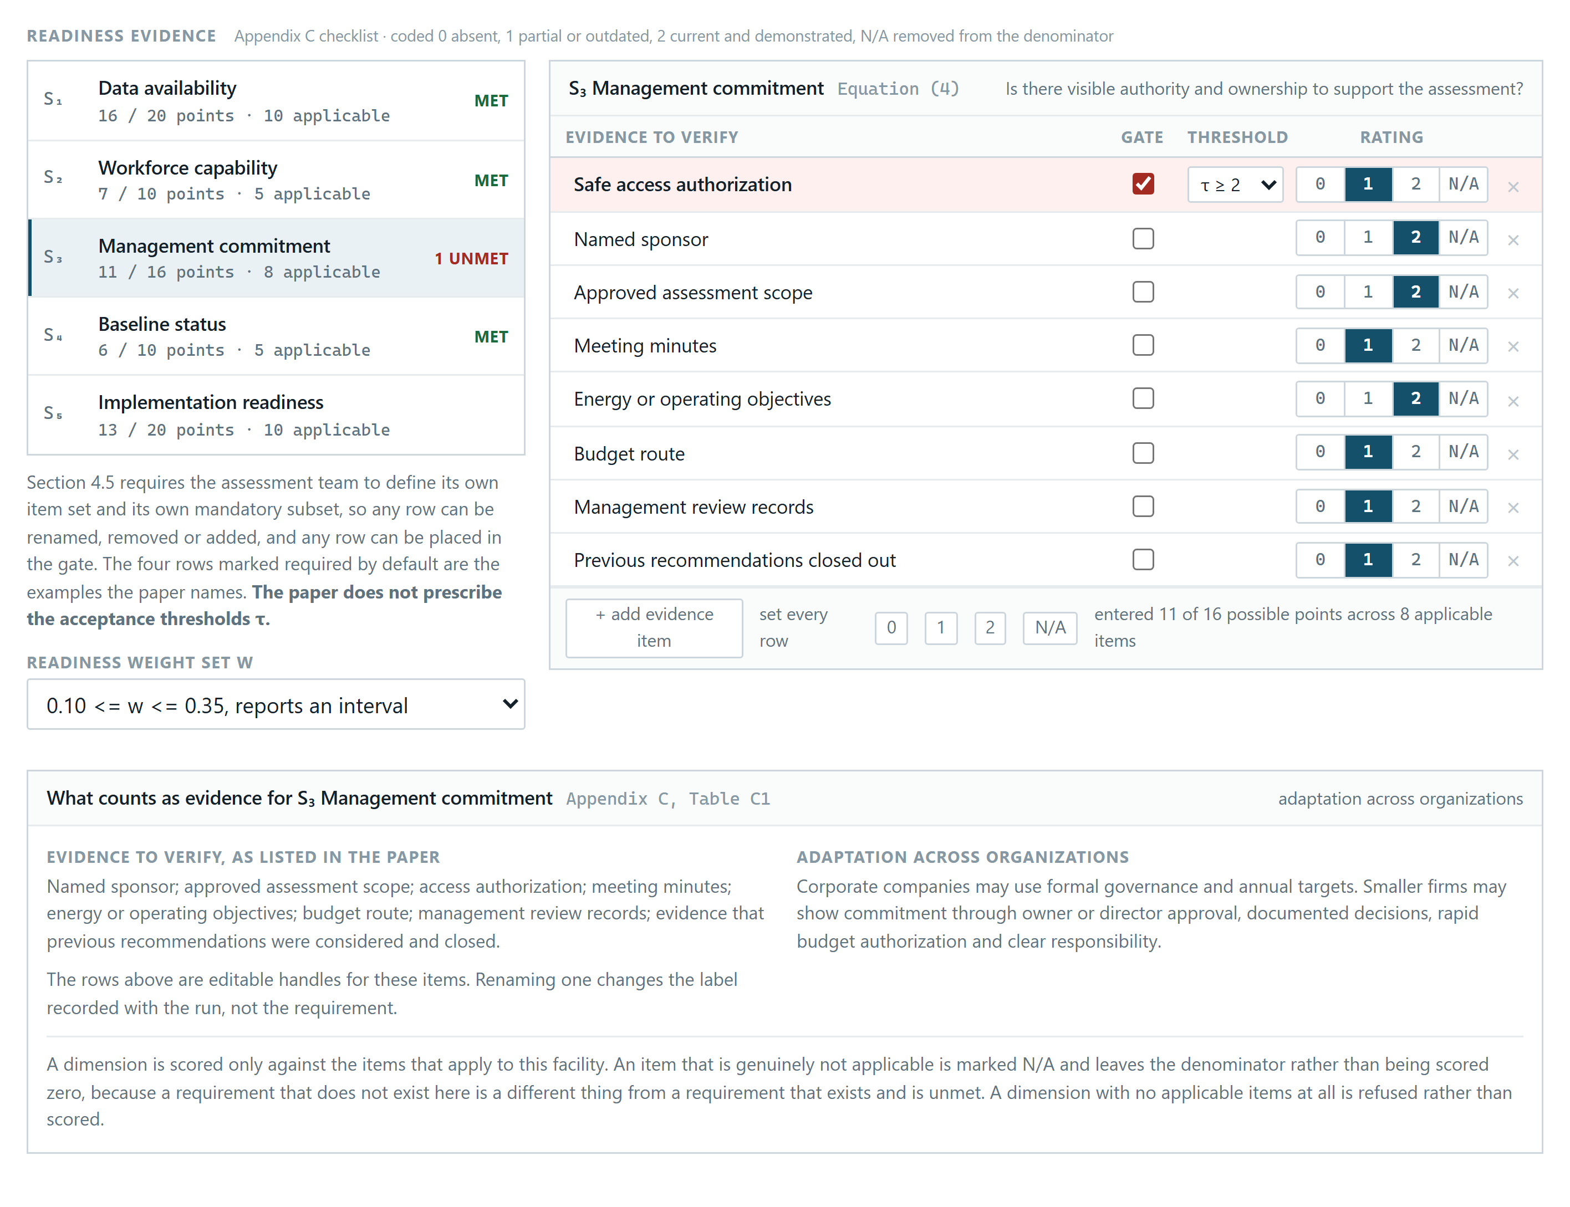
Figure E1. Readiness evidence entry for the gas gathering station. The safe access authorization item is mandatory and is scored 1 against a threshold of 2, which is the only input that differs from the cleared run described at the end of Section E.2.
Figure E2 shows the result. Readiness aggregates to the interval [65.63, 71.88], which would ordinarily be read as adequate, and the tool nevertheless returns readiness improvement and hold rather than an assessment mode. The rule list records that Phase 1 was not met and that none of the Phase 2 rules was reached. This is the intended behaviour of a non-compensatory gate. A favourable aggregate does not substitute for a missing prerequisite, and the useful output at this point is the name of the item to fix rather than an assessment that could not be carried out safely.
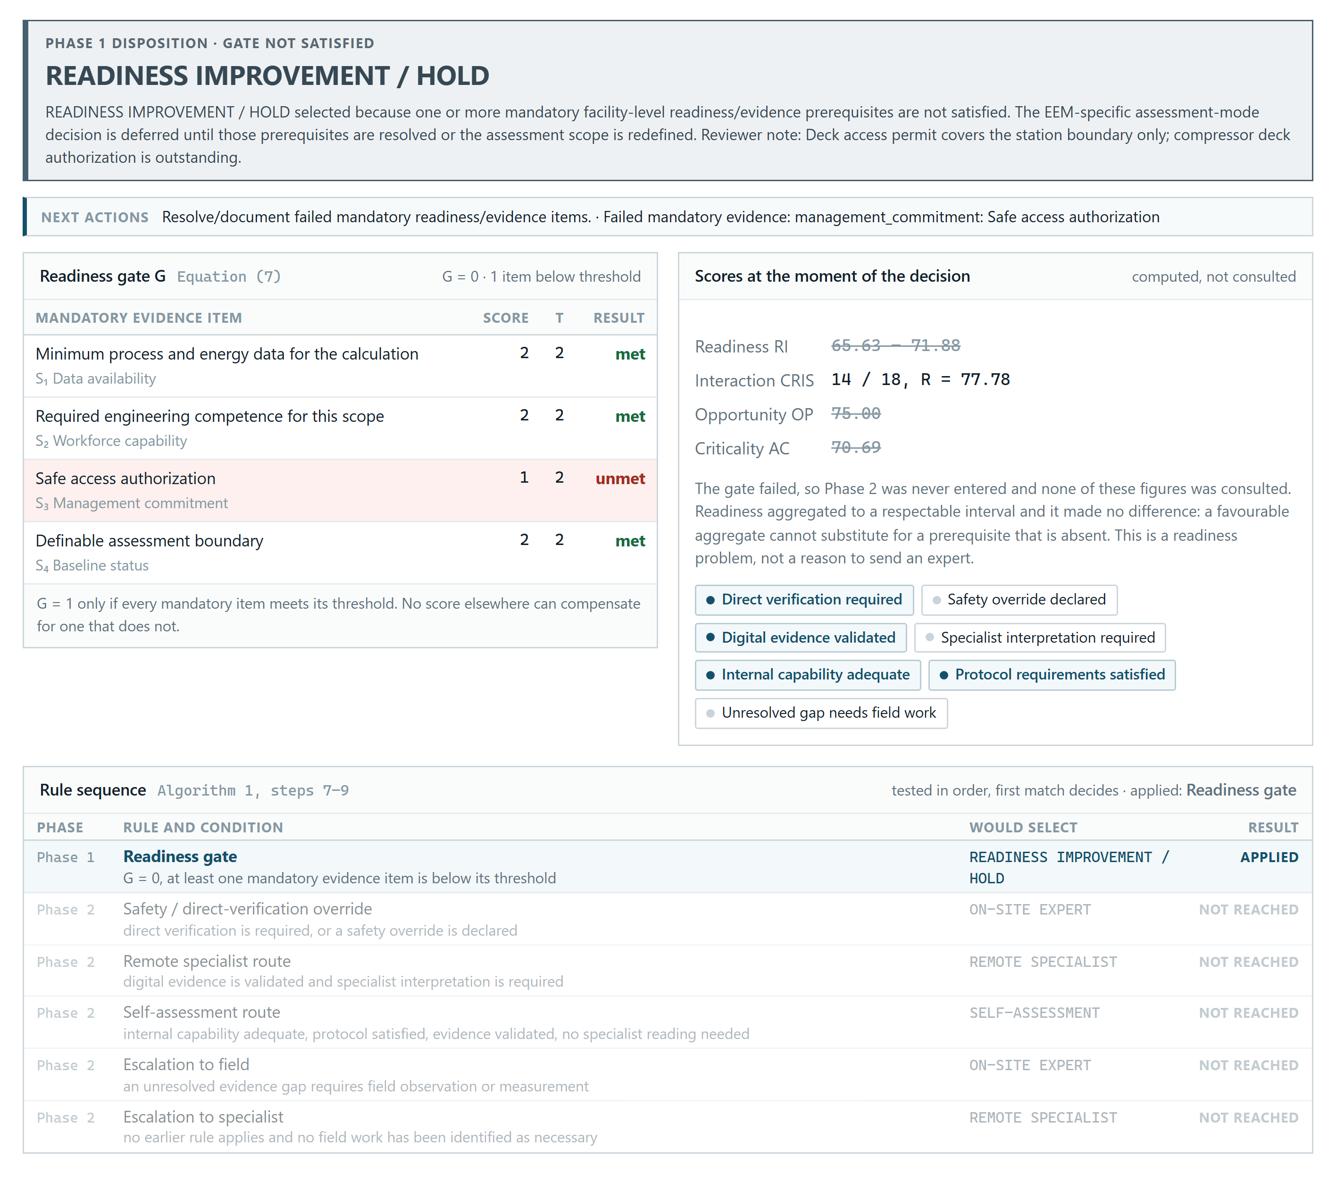
Figure E2. The hold disposition for the same facility. The gate panel identifies the failing item, and the rule sequence shows that no Phase 2 rule was tested.
Raising that single item to 2 and leaving every other input unchanged clears the gate, moves readiness to [66.25, 73.75], and returns on-site expert, which is the run discussed in Section E.4.

E.3 Case study 2: routing the same measure to different assessors
The second case study concerns an adjustment to compressed air dryer controls, EEM 16, at a drilling support utility group. Two runs were entered. Their readiness evidence, hazard ratings, criticality inputs and opportunity scores are identical. They differ in one condition: in the second run the desiccant regeneration behaviour at reduced dew point requires vendor engineering review before a setpoint is changed, so specialist interpretation is recorded as required.
Figure E3 shows the first run, which returns self-assessment. The gate passes, in-house capability is adequate, the digital evidence is validated, the internal protocol is satisfied, and no specialist reading is needed, so the rule for the self-assessment route is the first to match.
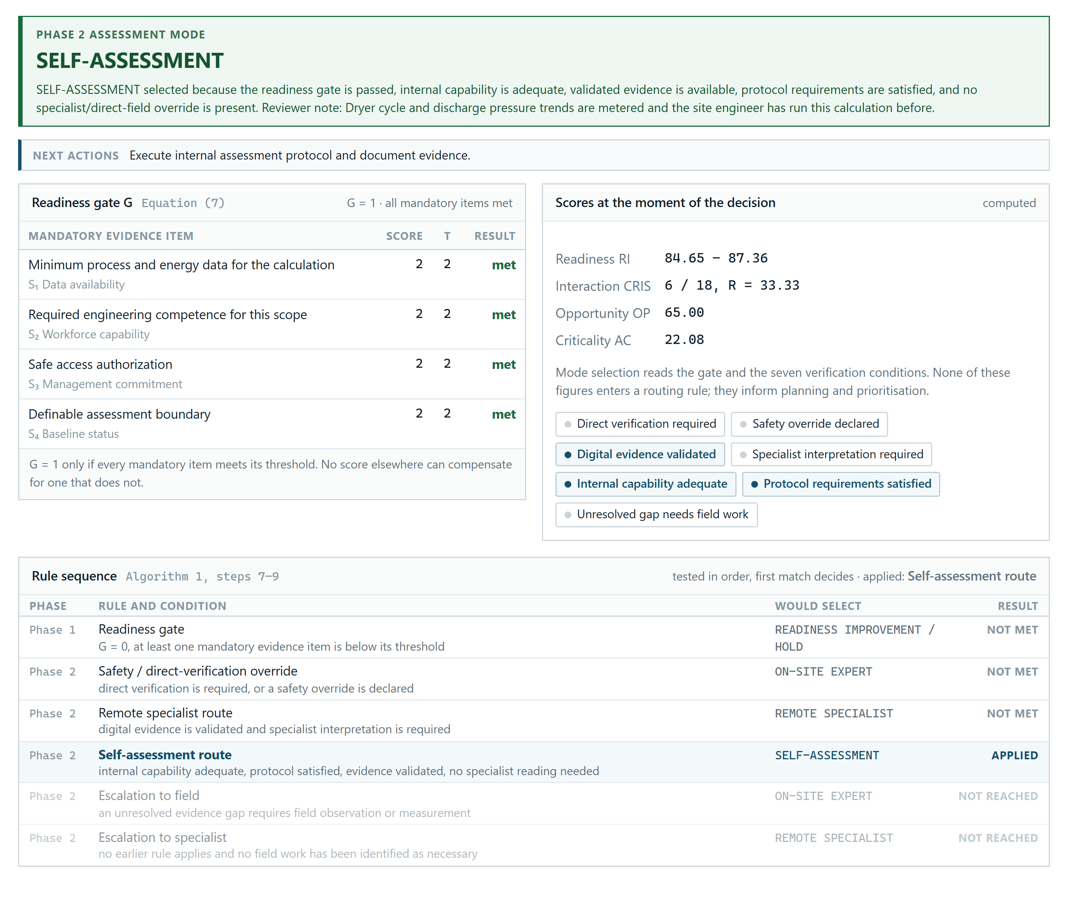
Figure E3. Self-assessment returned for EEM 16 when the site can interpret its own data. The rule sequence shows which earlier rules were tested and not met.
Figure E4 places the two completed runs side by side. The second run returns remote specialist. The disposition changes because a condition on the state of the evidence changed, and not because the measure became more hazardous or more valuable, since the hazard ratings and the criticality inputs are the same in both runs. This is the behaviour described in Section 6.3, in which the assessment mode is matched to what the available evidence can support.
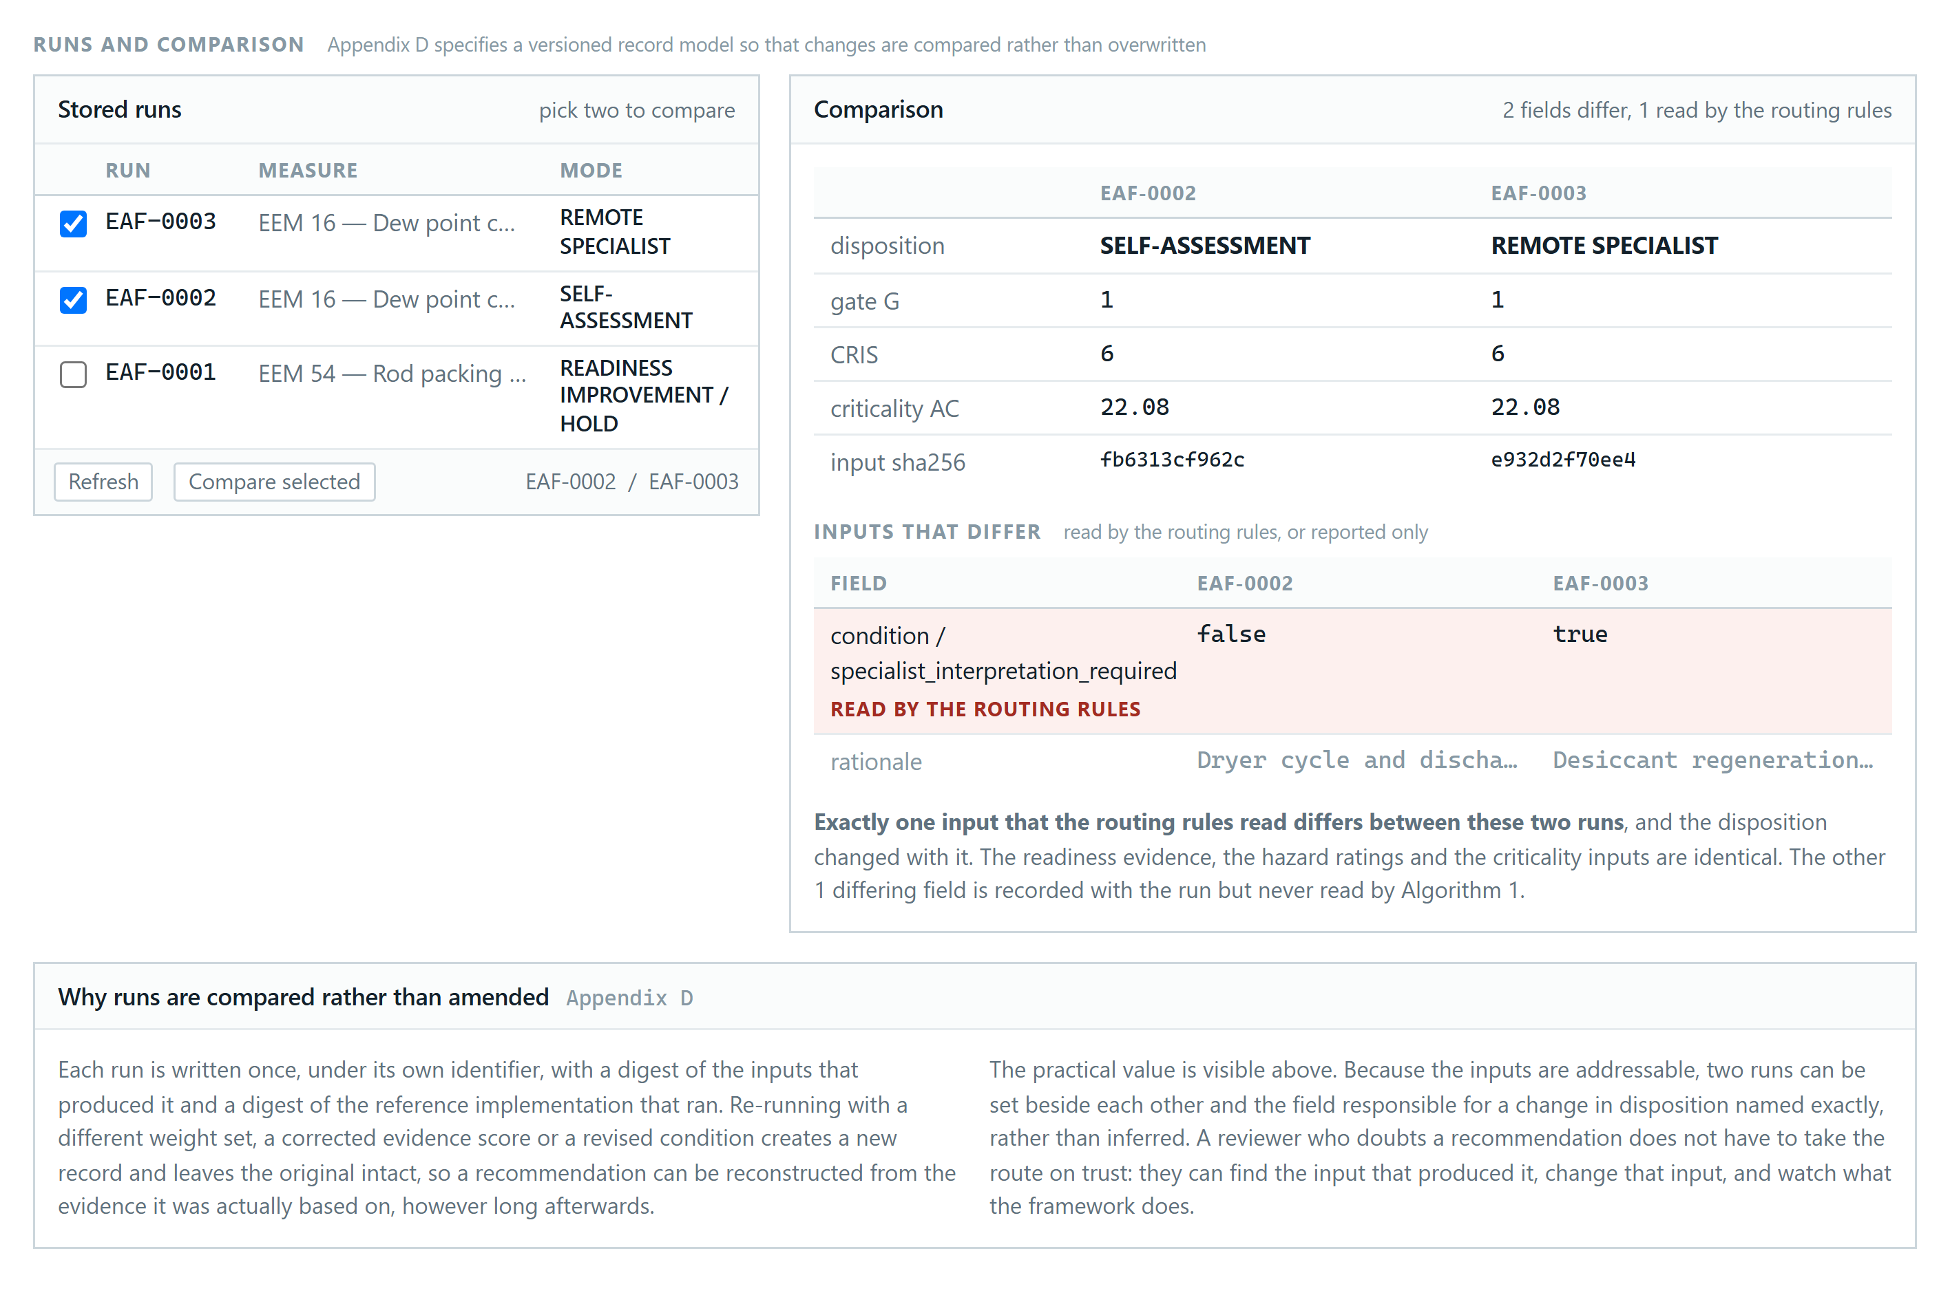
Figure E4. Two stored runs of EEM 16 compared. The inputs differ in one recorded condition, and the disposition moves from self-assessment to remote specialist.

E.4 Case study 3: a verification requirement that a strong business case cannot displace
The third case study returns to EEM 54 at the same gas gathering station, with the access permit now issued so that the gate passes. The inputs are those published for this measure in Section 5.2: the Appendix B hazard coding, data sufficiency 55, action complexity 70, verification need 90, and benefit scores of 80, 75 and 70.
Figure E5 shows the analytics for this run. CRIS is 14 out of a possible 18, giving R = 77.78. Opportunity priority is 75.00, assessment criticality is 70.69, and readiness is the interval [66.25, 73.75]. These reproduce the values reported in Sections 5.1 and 5.2.
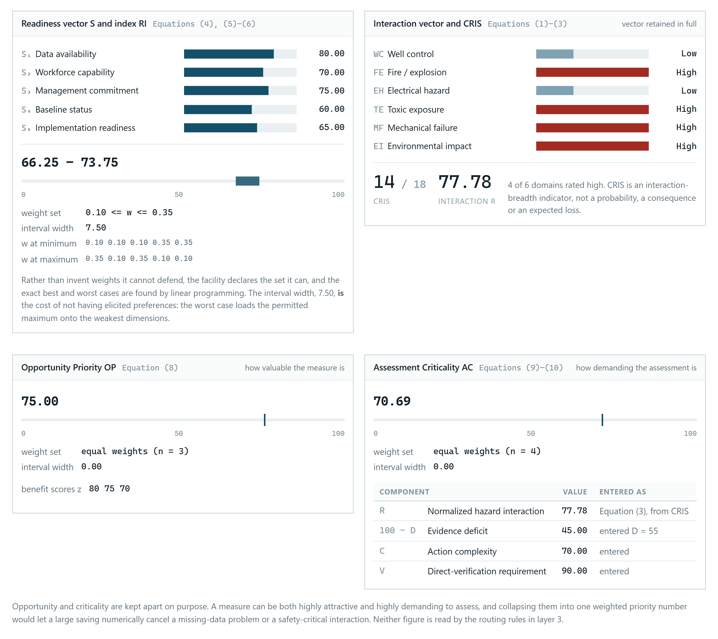
Figure E5. Analytics for EEM 54. Readiness is reported as an interval over the declared weight set rather than as a point estimate.
Figure E6 shows the decision. This measure has the strongest business case of the three case studies, and the tool returns on-site expert because leak quantification, packing condition and vibration evidence can only be obtained at the machine. The interface displays the opportunity priority and the assessment criticality together with a note that they were computed and reported but not used by the rule that applied. Section 6.1 gives the reason. The mode-selection rules read the gate and the verification conditions only, so a high opportunity priority cannot be traded against a requirement to verify something directly. Separating the value of a measure from the scrutiny its assessment demands is what allows the tool to report both without letting one overrule the other.
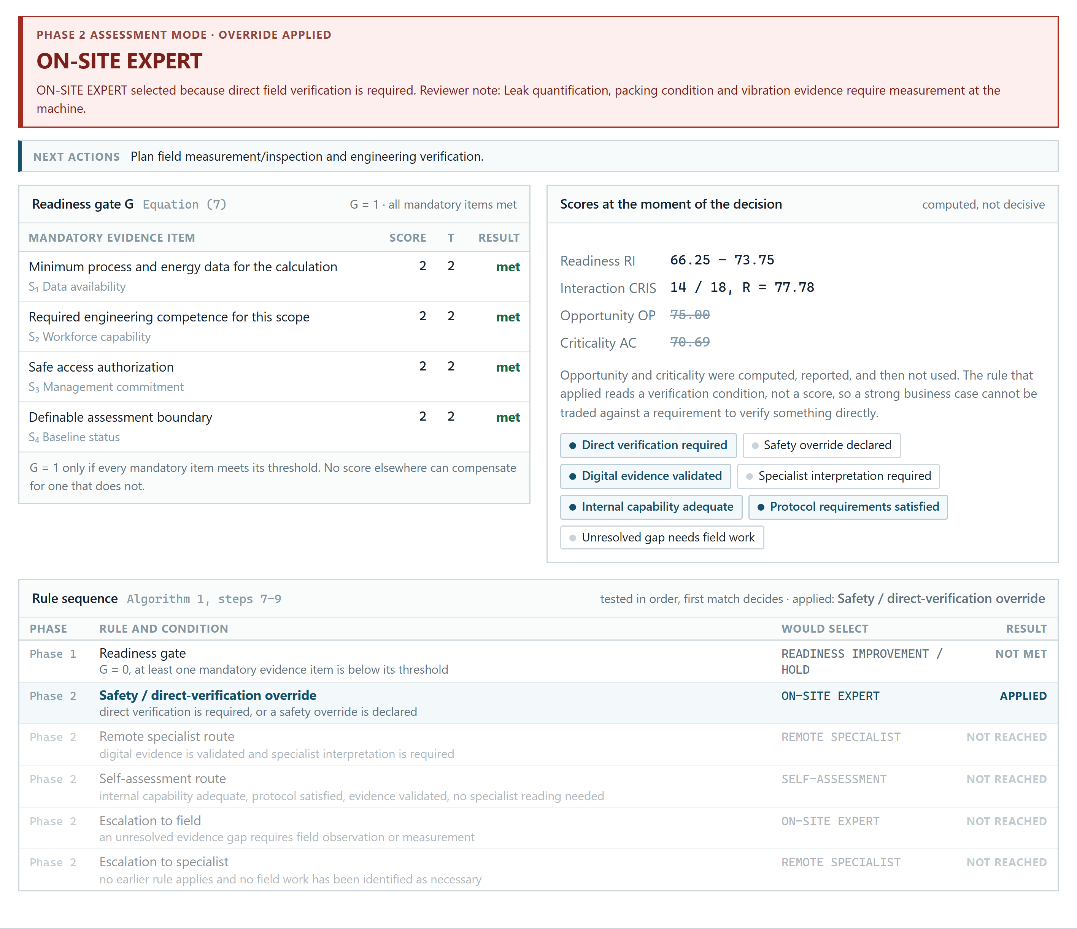
Figure E6. The override for EEM 54. Opportunity priority and assessment criticality are shown struck through to indicate that they were reported but not consulted by the rule that applied.

E.5 Reproducing the figures
The figures in this appendix are screen captures of the running tool rather than illustrations prepared for the paper. Each case study is stored as a set of input values only. Loading a case study fills the form and computes nothing, and the figures appear only after the framework has been run on those values. Reloading a case study and running it again therefore reproduces the figure from the implementation rather than from a saved result.
Where the manuscript states a value, that value is used as published, so the tool reproduces the worked example rather than a similar one. Hazard ratings are the Appendix B coding for the EEM concerned, and the data sufficiency, action complexity, verification need and benefit scores are those given in Section 5.2. The manuscript states no facility evidence item scores, so those are illustrative facility inputs. For the first and third case studies they were chosen so that Equation (4) returns the readiness vector S = (80, 70, 75, 60, 65) used in Section 5.1. Inputs of this kind are marked as illustrative in the tool and in the stored assessment record.

