Content table

1. One dimensional Partial Dependence Plot 2

2.- Bidimensional Partial Dependency Plot 2

3.- PDP to explain the price of a house. 3

## 1. One dimensional Partial Dependence Plot

The partial dependence plot shows the marginal effect of a feature on the predicted outcome of a previously fit model. In our case, we build a Random Forest model to predict the number of bikes rented using the features workingday, holiday, spring, summer, fall, misty, rain, den_temp, den_hum, den_windspeed and days since 2011.

After building the model, we can use the partial() function to learn and then visualize the relationships the model learned. Specifically, we are going to study the influence of the number of days since 2011, the temperature (den_temp), the humidity (den_hum) and the wind speed. To do so, we build the following graph:

Thanks to this figure we can compare the influence of each of this four variables on the predicted bike counts.

For instance, if we look at the top left graph we can see that the number of bikes rented increases with the temperature until the temperature is around 15. Then it remains constant until the temperature is above 30 degrees and it starts decreasing.

If we look at the top right, we can see that the humidity has almost no impact on the bike count as the number of bikes is constant except when the humidity is over 75, that makes it decrease.

The wind speed follows a similar pattern but, in this case, the number of bikes rented decreases gradually until the wind speed is above 20 when it remains constant.

Finally, we can study the influence of the number of days since 2011. In the correspondent graph we can see that the number of bikes rented increases with the number of days.

## 2.- Bidimensional Partial Dependency Plot

*EXERCISE:* Generate a 2D Partial Dependency Plot with humidity and temperature to predict the number of bikes rented depending on those parameters.

*BE CAREFUL:* due to the size, extract a set of random samples from the BBDD before generating the data for the Partial Dependency Plot.

Show the density distribution of both input features with the 2D plot as shown in the class slides.

*TIP:* Use geom_tile() to generate the 2D plot. Set width and height to avoid holes.

*QUESTION:* Interpret the results.

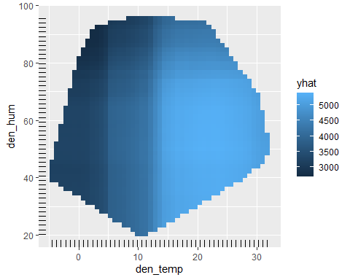

## 3.- PDP to explain the price of a house.

*EXERCISE:* Apply the previous concepts to predict the price of a house from the database kc_house_data.csv. In this case, use again a random forest approximation for the prediction based on the features bedrooms, bathrooms, sqft_living, sqft_lot, floors and yr_built.

Use the partial dependence plot to visualize the relationships the model learned.

*BE CAREFUL:* due to the size, extract a set of random samples from the BBDD before generating the data for the Partial Dependency Plot.

*QUESTION:* Analyse the influence of bedrooms, bathrooms, sqft_living and floors on the predicted price.

