OUTPUT:
Week 7: Friend Functions
- Topic 1: Secure Transaction Validator
  - Core Concept: Demonstrates how a non-member function can access private class members (like a PIN or Balance) to perform security checks.
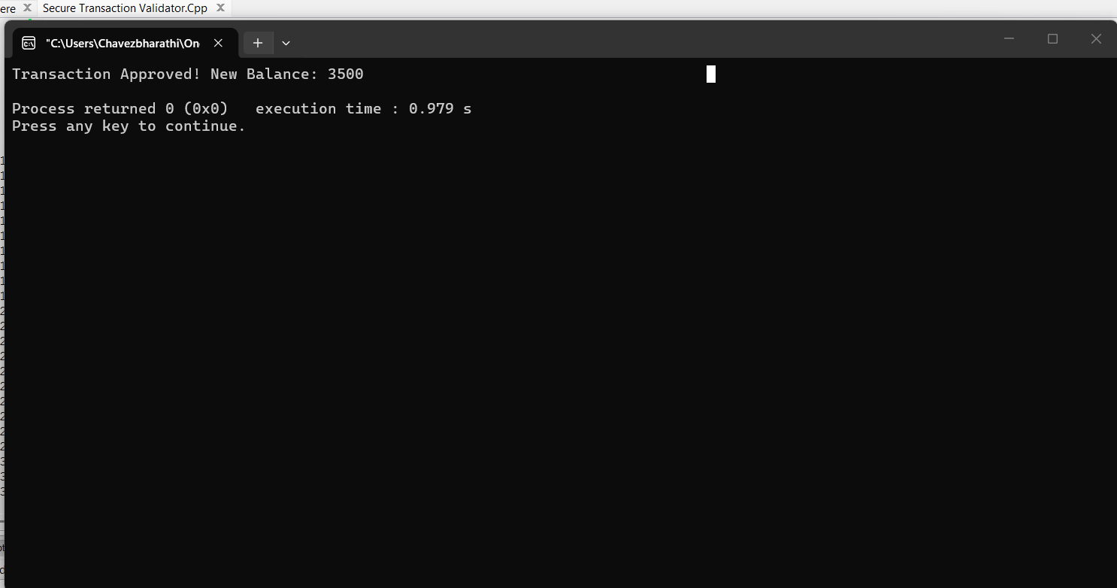

- Topic 2: Logistics Weight Checker
  - Core Concept: Shows how a single friend function can bridge two different classes (Truck and CargoShip) to compare their private data.
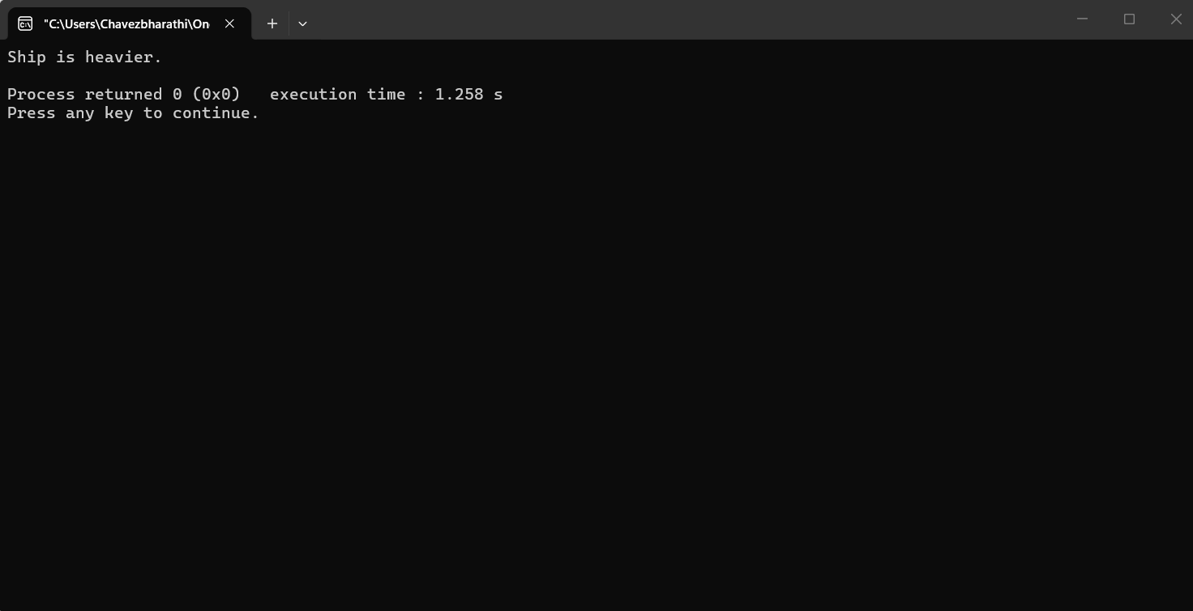

Week 8: Single Inheritance
- Topic 3: Real Estate Property System
  - Core Concept: Focuses on a simple Parent-Child relationship where the child class adds specific attributes and a mathematical formula for tax.
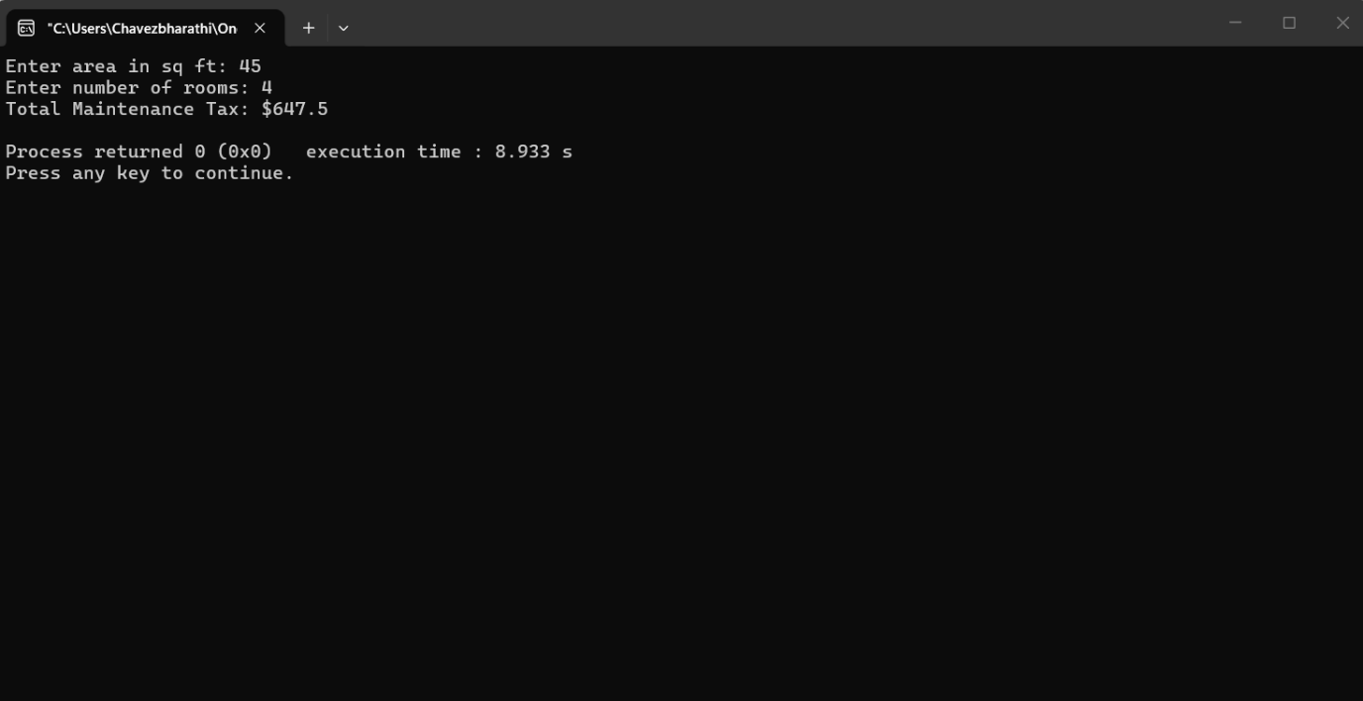

- Topic 4: Smart Home Device Manager
  - Core Concept: Uses inheritance to manage device IDs in a base class while calculating specific energy consumption in the derived class.
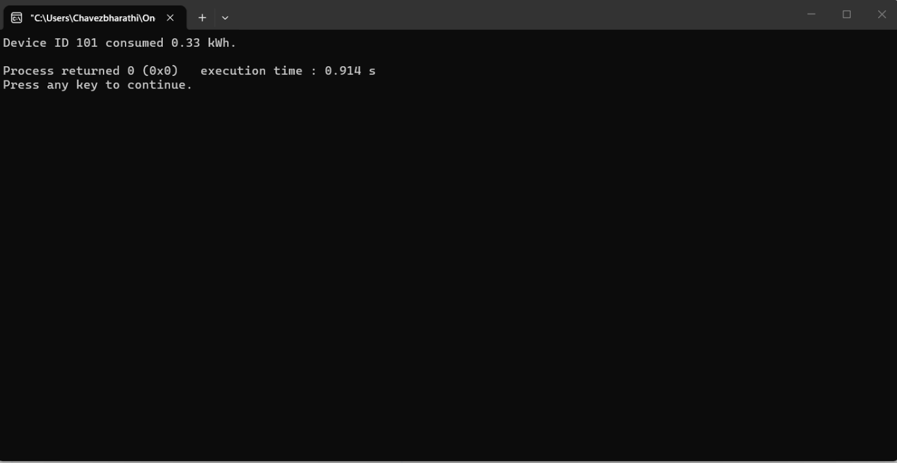

Week 9: Hierarchical & Multilevel Inheritance
- Topic 5: University Personnel (Hierarchical)
  - Core Concept: One base class (Member) branches into two separate derived classes (Student and Faculty), representing a 1-to-many relationship.
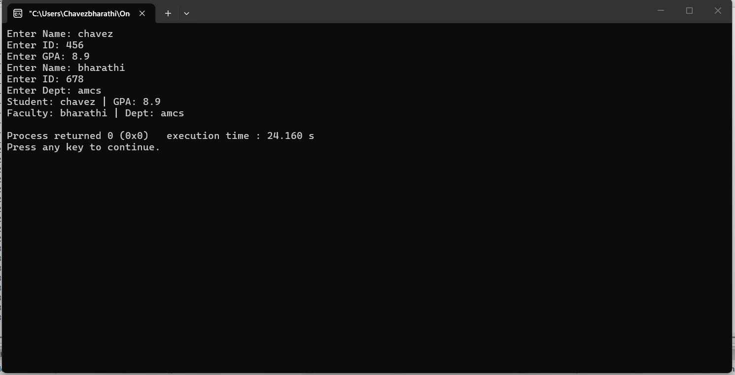

- Topic 6: Automotive Evolution (Multilevel)
  - Core Concept: A three-tier chain of inheritance (Vehicle → Car → ElectricCar) where data is passed down through multiple levels.
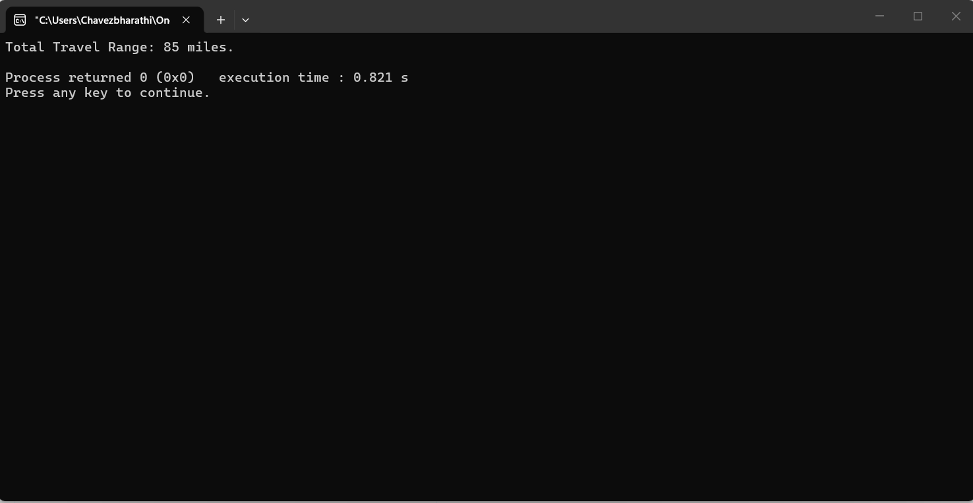

Week 10: this Pointer & Object Arrays
- Topic 7: e-Sports Tournament Rankings
  - Core Concept: Uses an array of objects to store multiple data points and identifies the "best" entry using comparison logic.
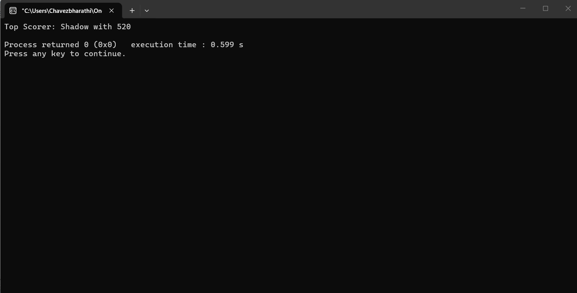

- Topic 8: Inventory Price Comparison
  - Core Concept: Demonstrates the use of the this pointer to differentiate between the calling object's member variables and the parameters of a function.
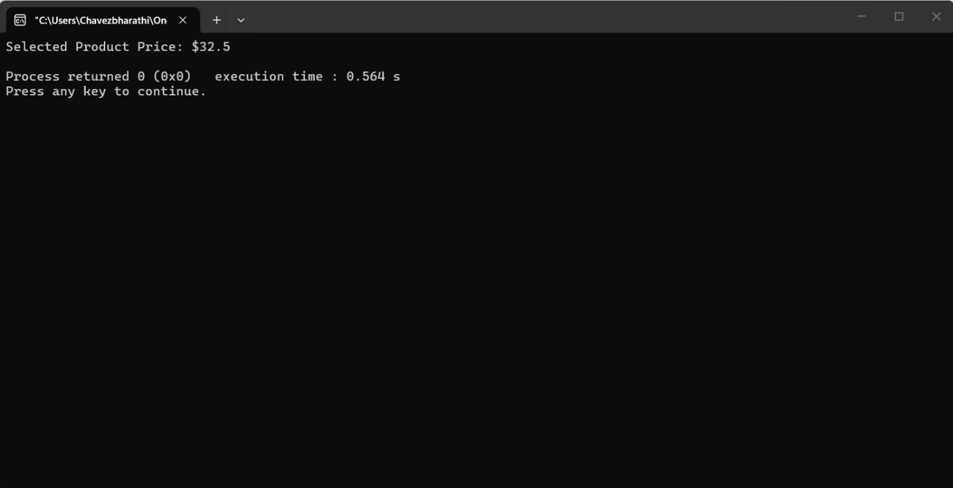

Week 11: Operator Overloading
- Topic 9: Vector 2D Addition
  - Core Concept: Redefining the + operator so that it can mathematically combine two custom class objects.
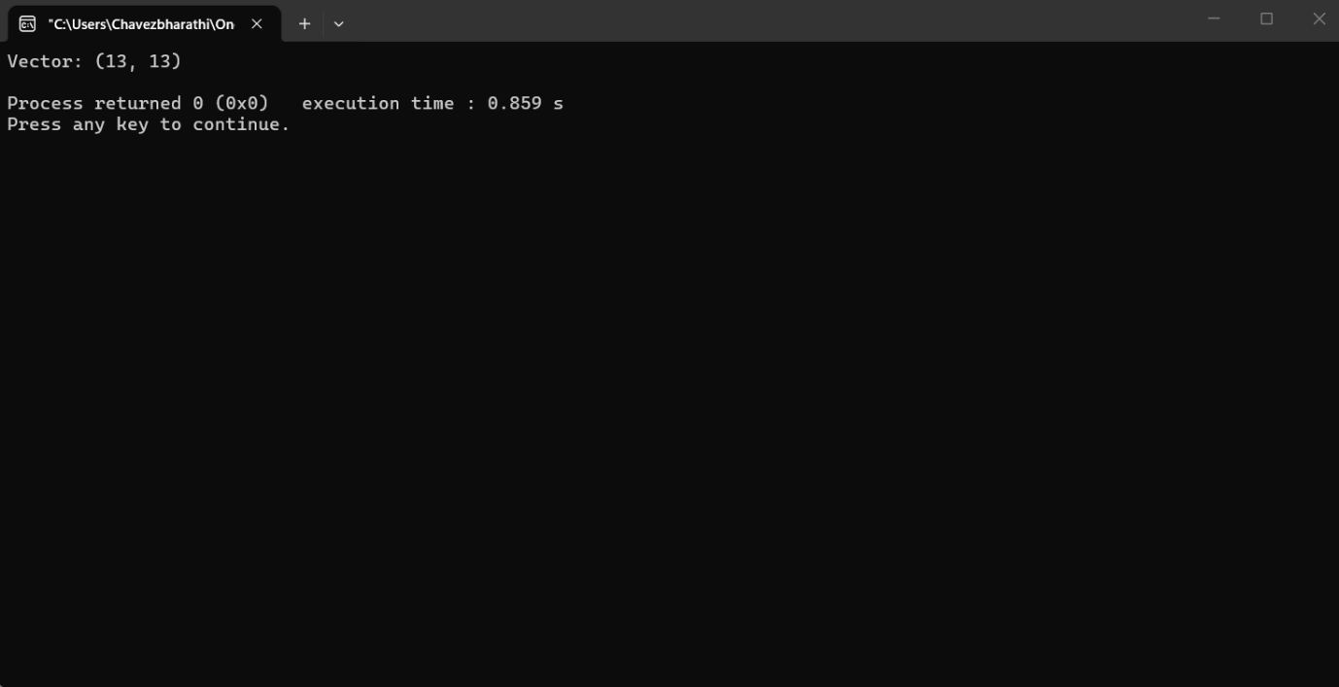

- Topic 10: String Equality Check
  - Core Concept: Overloading the == operator to allow for direct comparison between two custom string objects.
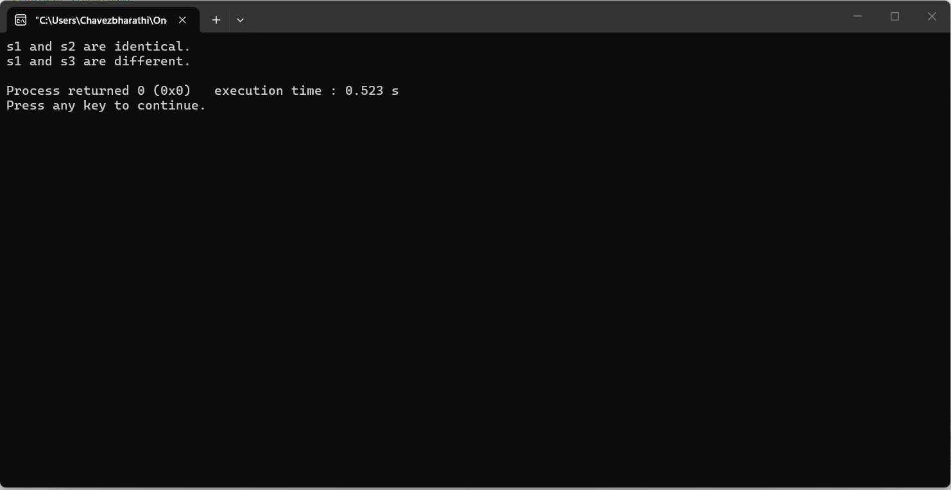

Week 12: File Handling
- Topic 11: Record Logger
  - Core Concept: Covers the basics of permanent data storage: writing data to a text file and then reading it back into the program.
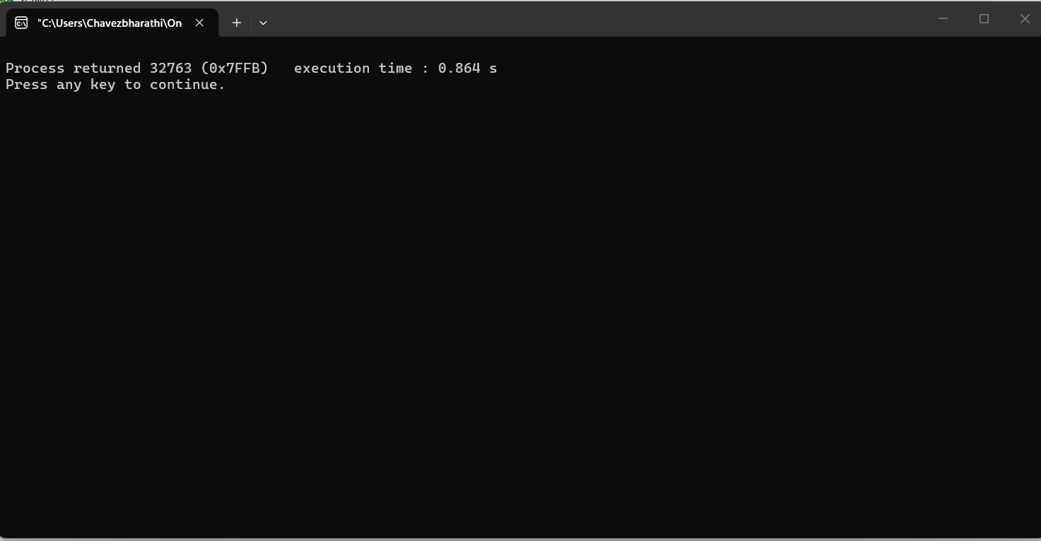

- Topic 12: Line Counter Utility
  - Core Concept: A utility-style program that parses a text file line-by-line to count and report the total entries.
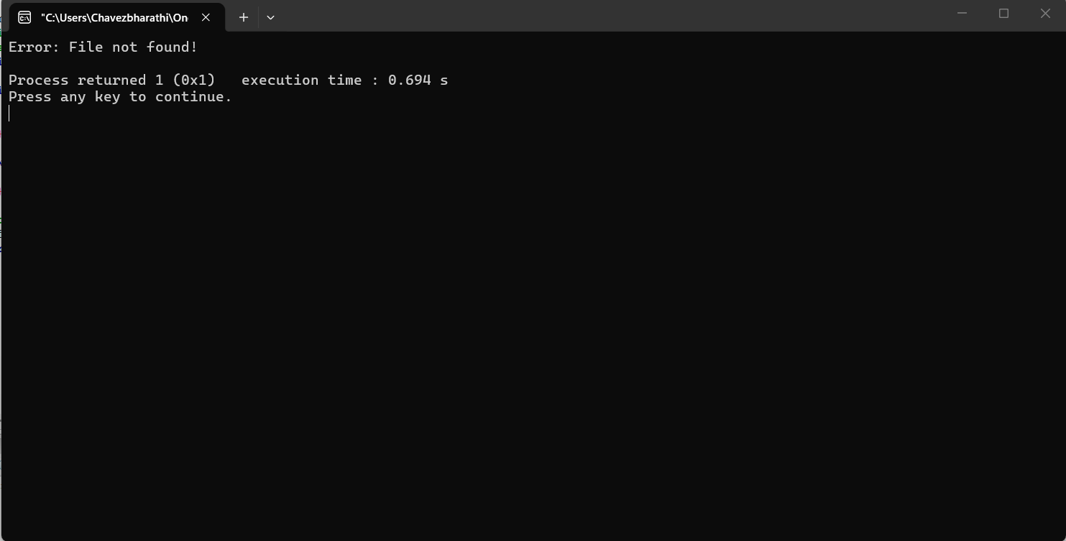

Week 13: Templates & Exception Handling
- Topic 13: Universal Swapper (Function Templates)
  - Core Concept: Creating a "Generic" function that can swap values regardless of whether they are integers, floats, or strings.
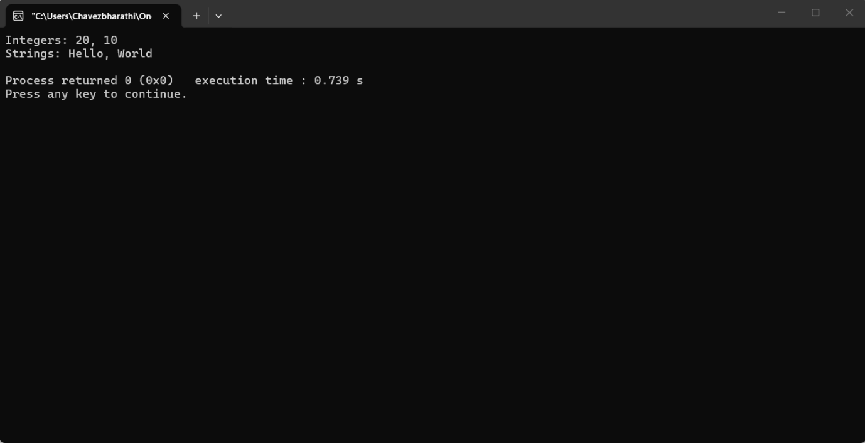

- Topic 14: Zero Division Guard (Exceptions)
  - Core Concept: Using try, throw, and catch blocks to prevent the program from crashing when an invalid mathematical operation occurs.
