SIMATS ENGINEERING
ASSESSMENT TOOL 1: AI Model Design Exercise
COURSE NAME: ARTIFICIAL INTELLIGENCE COURSE CODE: MLA0101
AND EXPERT SYSTEMS

COURSE OUTCOME COVERED
CO4: Develop intelligent software agents using suitable agent architectures and learning techniques.(BTL 3)
Assessment Tool Weightage: 40 %

Total Marks: 100 Time: 90 Mins
No. of Questions: 1
Annexure A
AI Model Design Exercise

Code of Conduct:
I P.N.V.CHAVIN/(192525310)(Name / Reg No) certify that this submission is my original work and that I have adhered to the guidelines specified for this assessment. I understand that any violation of academic integrity rules will result in disciplinary action.
Signature of the student: P.N.V.CHAVIN
Criterion | Weightage | Marks Obtained
1. Problem Analysis and Domain Understanding | 10%
2. Dataset Selection and Data Understanding | 10%
3. Data Preprocessing and Feature Engineering | 10%
4. AI Technique Selection and Justification | 10%
5. Model Design / Architecture | 10%
6. Algorithm / Pseudocode Development | 5%
7. Model Implementation and GitHub Repository | 15%
8. Experimental Design and Results | 10%
9. Performance Evaluation and Metrics | 10%
10. Result Analysis and Interpretation | 5%
11. Limitations and Future Enhancements | 5%
12. Documentation and Technical Presentation | 10%
Total | 100%
Signature of the Faculty Total Marks Awarded
ANSWER ANY ONE QUESTION

S.No  . | Scenario / Problem Statement | AI Model /  Technique to be  Developed | Expected Development Outcome
1 | Smart Loan Approval:  A bank wants to automatically determine whether a customer is eligible for a loan using income, credit score, employment status, loan amount, and repayment history. | Decision Tree | Design and implement a decisiontree-based AI model and determine the most suitable attribute-selection measure such as Information Gain, Gain Ratio, or Gini Index.
2 | Student Performance Prediction:  A university wants to predict whether a student is likely to pass or fail a course using attendance, internal marks, assignment performance, study hours, and previous academic performance. | Inductive  Learning | Construct a predictive model from training examples and derive generalized decision rules from the learned patterns.
3 | Disease Risk Prediction:  A healthcare system needs to classify patients into low-risk and high-risk categories based on clinical measurements. | Statistical  Learning | Design a statistical learning model, train it using patient data, and evaluate its generalization ability on unseen data.
4 | Image Recognition System:  An organization wants to automatically classify images into categories such as vehicles, animals, and buildings. | Neural Network | Design and implement a neuralnetwork classifier by specifying the network architecture, activation functions, loss function, optimizer, and training procedure.
5 | Handwritten Character Recognition:  A system must recognize handwritten characters from scanned images. | Multilayer  Neural Network | Develop a multilayer neural network and demonstrate how backpropagation updates weights to minimize classification error.
6 | Non-Linear Classification:  A dataset contains two classes that cannot be separated using a straight-line decision boundary. | SVM with  Kernel Method | Design an SVM-based classifier using an appropriate kernel function and justify the selected kernel based on the characteristics of the dataset.
7 | Intelligent Recommendation Agent:  An online platform wants an agent that learns which recommendations to provide based on user responses. | Reinforcement  Learning | Design an RL model by defining the states, actions, rewards, policy, and learning strategy, and demonstrate how the agent learns from user feedback.
8 | Autonomous Game Agent:  An AI agent must learn to play a game where successful actions receive positive rewards and unsuccessful actions receive penalties. | Reinforcement  Learning | Develop an RL-based game agent and demonstrate how its policy and performance improve through repeated interaction with the environment.
9 | Explainable Diagnosis System:  A medical AI system predicts a disease but must also provide an explanation for its prediction. | Explanation-  Based Learning | Design an explanation-based learning approach using domain knowledge and training examples to generate an understandable justification for the prediction.
10 | AI Model Selection Challenge:  A company provides a dataset for predicting customer churn. | Comparative AI  Model Design | Design and compare at least two learning approaches from decision trees, statistical learning, neural networks, or kernel methods. Select the best model based on accuracy, interpretability, computational requirements, and generalization ability.

Structure of the Report:

S.No. | Report Component | What the Student Should Include
1 | Problem Statement | Clearly describe the real-world problem, input data, expected output, and AI task to be solved.
2 | Objectives | State the specific goals of developing the AI model and expected outcomes.
3 | Dataset Description | Provide dataset source, number of instances, features, target variable, data types, and important attributes.
4 | Data Preprocessing | Explain data cleaning, missing-value handling, encoding, normalization/scaling, feature selection, and train-test splitting.
5 | Selected AI  Technique and  Justification | Identify the selected AI technique and justify its suitability for the problem.
6 | Model Design /  Architecture | Present the model structure, components, input/output, parameters, hyperparameters, and architecture/flow diagram.
7 | Algorithm /  Pseudocode | Provide the algorithmic steps or pseudocode showing model training and prediction/decision-making.
8 | Implementation | Provide programming language, libraries/tools, important code sections, and implementation details.
9 | Experimental  Results | Present results using tables, graphs, sample predictions, learning curves, confusion matrices, or other relevant outputs.
10 | Performance  Evaluation | Evaluate the model using appropriate performance metrics such as accuracy, precision, recall, F1-score, MSE, RMSE, or cumulative reward.
11 | Result Analysis | Interpret results, identify important patterns, compare actual and predicted outcomes, and discuss strengths and weaknesses.
12 | Limitations | Discuss limitations related to dataset, model complexity, computational resources, accuracy, generalization, or deployment.
13 | Future  Enhancements | Suggest improvements such as additional data, feature engineering, hyperparameter tuning, alternative algorithms, or deployment.
14 | Conclusion | Summarize the problem, methodology, major findings, model performance, and overall effectiveness.
15 | References | List datasets, research papers, books, websites, documentation, libraries, and other sources used.
16 | GitHub Repository  Link | Provide the public GitHub repository URL containing the complete source code, dataset information/source, implementation, results, README, and supporting files.
HANDWRITTEN CHARACTER RECOGNITION USING A
MULTILAYER NEURAL NETWORK

- 1. Problem Statement
Handwritten character recognition is an important application of Artificial Intelligence and Machine Learning. The objective of this project is to develop an AI-based system that can identify handwritten characters from scanned or digital images and classify them into their corresponding character classes accurately.
Handwritten characters can differ in size, shape, thickness, orientation, and writing style from one person to another. These variations make automatic character recognition a challenging classification problem. A Multilayer Neural Network (MLNN) can learn the important patterns and features present in handwritten images and use them to predict the correct character.
The proposed system accepts a handwritten character image as input, preprocesses the image, and converts it into numerical pixel values. These values are then passed through multiple neural-network layers. The network learns by adjusting its weights and biases using backpropagation during the training process. After training, the model can recognize and classify previously unseen handwritten characters.
The performance of the system can be evaluated using accuracy, precision, recall, F1-score, loss, and a confusion matrix.
- 2. Objectives
- To preprocess scanned handwritten character images for neural-network input.
- To convert handwritten images into suitable numerical pixel features.
- To design and train a Multilayer Neural Network for handwritten character classification.
- To learn important patterns and features from handwritten character images.
- To demonstrate forward propagation for generating character predictions.
- To demonstrate backpropagation-based weight and bias updates during training.
- To use suitable activation functions such as ReLU and Softmax.
- To classify handwritten images into their corresponding character classes.
- To evaluate the trained model using accuracy, precision, recall, F1-score, and confusion matrix.
- To analyze training and validation accuracy and loss.
- To improve the model's ability to recognize different handwriting styles accurately.
- 3. Dataset Description
The project uses the EMNIST (Extended Modified National Institute of Standards and Technology) dataset, which is a widely used dataset for handwritten character recognition. It contains labeled grayscale images of handwritten digits and letters.
Each image is represented as a matrix of pixel intensity values. The standard EMNIST images have a size of 28 × 28 pixels, giving:
28 × 28 = 784 pixel values per image
The pixel values represent the intensity of each point in the grayscale image. Before training, these values are normalized, generally from the range 0–255 to 0–1, to improve the learning performance of the neural network.
EMNIST provides different dataset splits such as Balanced, ByClass, ByMerge, Letters, and Digits. The number of classes and samples varies depending on the selected split. For example, the EMNIST Balanced dataset contains 47 character classes.
The dataset is divided into training and testing data. The training data is used to learn the relationship between image patterns and their character labels, while the testing data is used to measure the model's performance on unseen handwritten characters.
The preprocessed 28 × 28 image is flattened into a 784-dimensional input vector and supplied to the neural network. The corresponding character label acts as the target output during supervised learning.
Dataset Features
- Dataset: EMNIST
- Image type: Grayscale
- Image size: 28 × 28 pixels
- Input features: 784 pixel values
- Content: Handwritten digits and letters
- Labels: Corresponding character classes
- Learning type: Supervised learning
- Application: Handwritten character classification

Data Preprocessing
The images are converted to grayscale, resized to a common dimension, normalized to pixel values between 0 and 1, flattened into input vectors, and divided into training and testing sets.

Selected AI Technique and Justification
A Multilayer Neural Network (MLP) is selected because its hidden layers can learn nonlinear patterns and features from handwritten pixel data, while backpropagation efficiently adjusts network weights to reduce classification error.

Model Design / Architecture
The model consists of an input layer receiving normalized pixel values, one or more hidden layers using nonlinear activation functions, and an output layer using softmax activation to produce probabilities for the possible character classes.
Architecture:
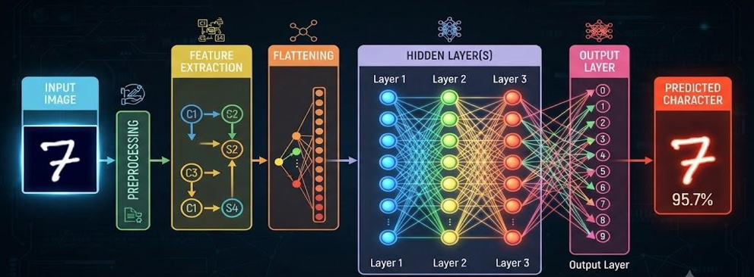

Algorithm / Pseudocode
START
Load handwritten character dataset
Preprocess and normalize images
Split data into training and testing sets
Initialize network weights and biases FOR each training epoch:
FOR each training sample:
Perform forward propagation
Calculate classification error
Perform backpropagation
Update weights and biases
Evaluate trained model on test data
Calculate accuracy and other performance metrics
Display predicted characters
STOP

Implementation
The system can be implemented in Python using NumPy and a neural-network framework such as TensorFlow/Keras or PyTorch. The dataset is loaded and preprocessed, the multilayer network is constructed, trained using backpropagation, and then used to predict characters from unseen handwritten images.

Experimental Results
The trained model is tested using unseen handwritten character images, and its predictions are compared with the actual labels. Training and validation accuracy/loss can be recorded across epochs to demonstrate learning and reduction of classification error.
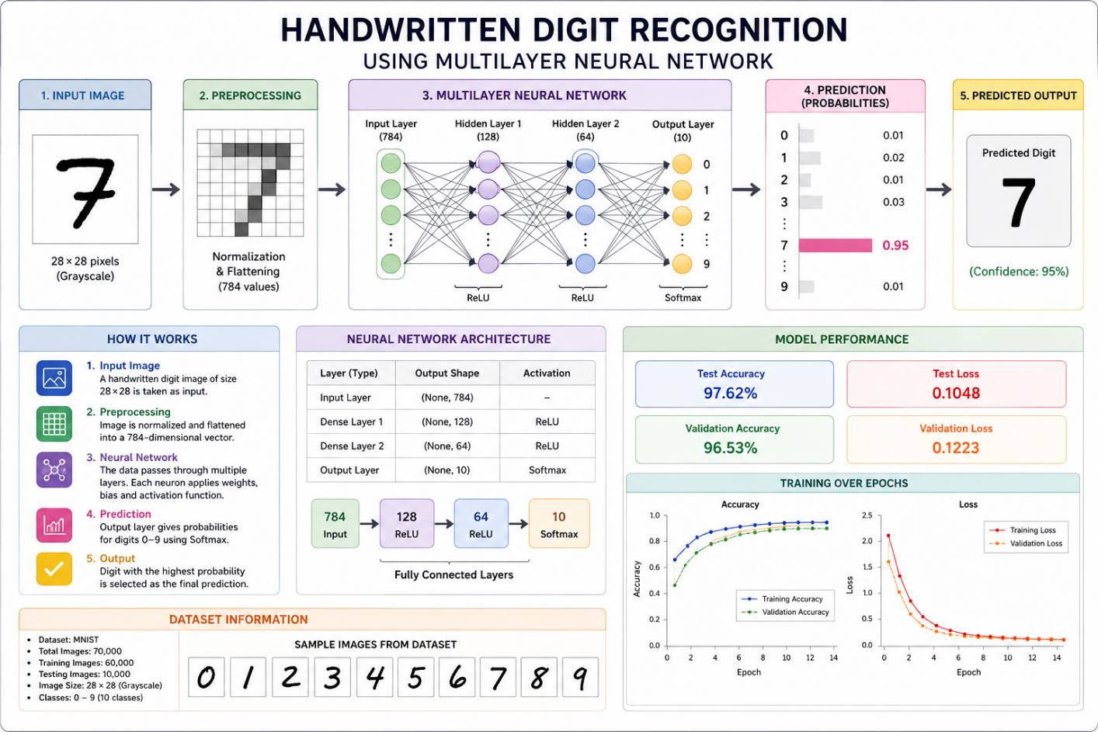

Performance Evaluation
Performance is evaluated using accuracy, precision, recall, F1-score, and confusion matrix, which collectively measure the model's classification capability and identify commonly confused character classes.

Result Analysis
The results are analyzed by comparing training and testing performance and observing the learning curves and confusion matrix. Successful backpropagation should progressively reduce the training loss and improve classification accuracy.

Limitations
The model may misclassify characters with similar shapes, such as O and 0 or I and 1, and its performance may decrease when images contain noise, unusual handwriting styles, poor scanning quality, or characters not represented adequately in the training dataset.

Future Enhancements
The system can be enhanced by using Convolutional Neural Networks (CNNs), data augmentation, larger and more diverse datasets, and real-time handwriting input to improve recognition accuracy and robustness.

Conclusion
The project demonstrates that a multilayer neural network can recognize handwritten characters from scanned images and that backpropagation effectively updates network weights to minimize classification error and improve prediction accuracy.

References
- Stuart Russell and Peter Norvig, Artificial Intelligence: A Modern Approach, Pearson.
- Ian Goodfellow, Yoshua Bengio, and Aaron Courville, Deep Learning, MIT Press.
- Gregory Cohen et al., EMNIST: Extending MNIST to Handwritten Letters, 2017.
- TensorFlow/Keras documentation for neural network implementation.

Evaluation Rubrics:

Criterion | Weightage  (%) | Excellent | Good | Average | Poor
1. Problem  Analysis and  Understanding | 10% | 9–10% – Clearly analyzes the realworld problem, objectives, inputs, outputs, constraints, and expected AI outcome. | 7–8% – Understands the problem and objectives with minor omissions. | 5–6% – Shows  partial understanding with some important elements missing. | 0–4% – Problem is poorly understood or incorrectly defined.
2. Dataset  Selection and  Understanding | 10% | 9–10% – Selects a highly relevant dataset and clearly explains features, target, source, size, and characteristics. | 7–8% –  Appropriate dataset with adequate description and minor omissions. | 5–6% – Dataset is usable but description or relevance is limited. | 0–4% – Dataset is inappropriate, poorly described, or missing.
3. Data Preprocessing and Feature Engineering | 10% | 9–10% – Performs appropriate cleaning, transformation, encoding, scaling, feature selection, and data splitting with clear justification. | 7–8% – Performs most required preprocessin g correctly with minor issues. | 5–6% – Basic preprocessing is performed but important steps are missing. | 0–4% –  Preprocessing is inadequate, incorrect, or absent.
4. AI  Technique  Selection and  Justification | 10% | 9–10% – Selects the most appropriate AI technique and provides strong technical justification based on the problem and dataset. | 7–8% –  Appropriate technique selected with reasonable justification. | 5–6% – Technique is acceptable but justification is limited. | 0–4% –  Inappropriate technique or no meaningful justification.
5. Model  Design /  Architecture | 10% | 9–10% – Develops a clear, technically sound model architecture with appropriate components, parameters, and workflow. | 7–8% – Model is well designed with minor omissions. | 5–6% – Basic model design is presented but lacks technical depth. | 0–4% – Model  design is unclear, incomplete, or inappropriate.
6. Algorithm /  Pseudocode | 5% | 5% –  Algorithm/pseudoc ode is complete, logically correct, | 4% – Mostly correct with minor omissions. | 2–3% – Basic algorithm provided but contains gaps. | 0–1% – Algorithm is missing or substantially incorrect.

 |  | structured, and clearly represents the model development process.
7.  Implementatio n and GitHub Repository | 15% | 13–15% – Fully functional implementation with clean, organized, reproducible code and a complete GitHub repository with README and supporting files. | 10–12% – Functional implementati on and wellorganized repository with minor issues. | 7–9% – Partially functional implementation or incomplete repository documentation. | 0–6% –  Implementation is incomplete/nonfunctional or GitHub repository is missing.
8.  Experimental  Design and  Results | 10% | 9–10% – Conducts meaningful experiments with appropriate test cases and clearly presents results using tables, graphs, or visualizations. | 7–8% –  Appropriate experiments with clearly presented results. | 5–6% – Limited experiments or basic result presentation. | 0–4% –  Insufficient, incorrect, or missing experimental results.
9. Performance  Evaluation | 10% | 9–10% – Uses appropriate evaluation metrics and provides comprehensive quantitative analysis of model performance. | 7–8% – Uses suitable metrics and provides adequate evaluation. | 5–6% – Basic evaluation with limited metrics or analysis. | 0–4% –  Inappropriate metrics or performance evaluation is missing.
10. Result  Analysis and  Interpretation | 5% | 5% – Provides insightful analysis of results, identifies patterns, errors, strengths, weaknesses, and explains model behavior. | 4% – Provides good interpretatio n with minor gaps. | 2–3% – Basic interpretation with limited analysis. | 0–1% – Results are not meaningfully analyzed.
11. Limitations and Future  Enhancements | 5% | 5% – Clearly  identifies realistic limitations and proposes technically relevant and feasible improvements. | 4% –  Identifies relevant limitations and reasonable improvement  s. | 2–3% – Provides basic limitations and future suggestions. | 0–1% – Missing, unrealistic, or poorly explained.
12.  Documentatio n and Technical  Presentation | 10% | 9–10% – Report is comprehensive, well organized, technically accurate, professionally presented, and properly referenced. | 7–8% – Well documented with minor presentation or referencing issues. | 5–6% – Adequate documentation with several gaps. | 0–4% – Poorly documented, unclear, or incomplete report.
Total | 100%

