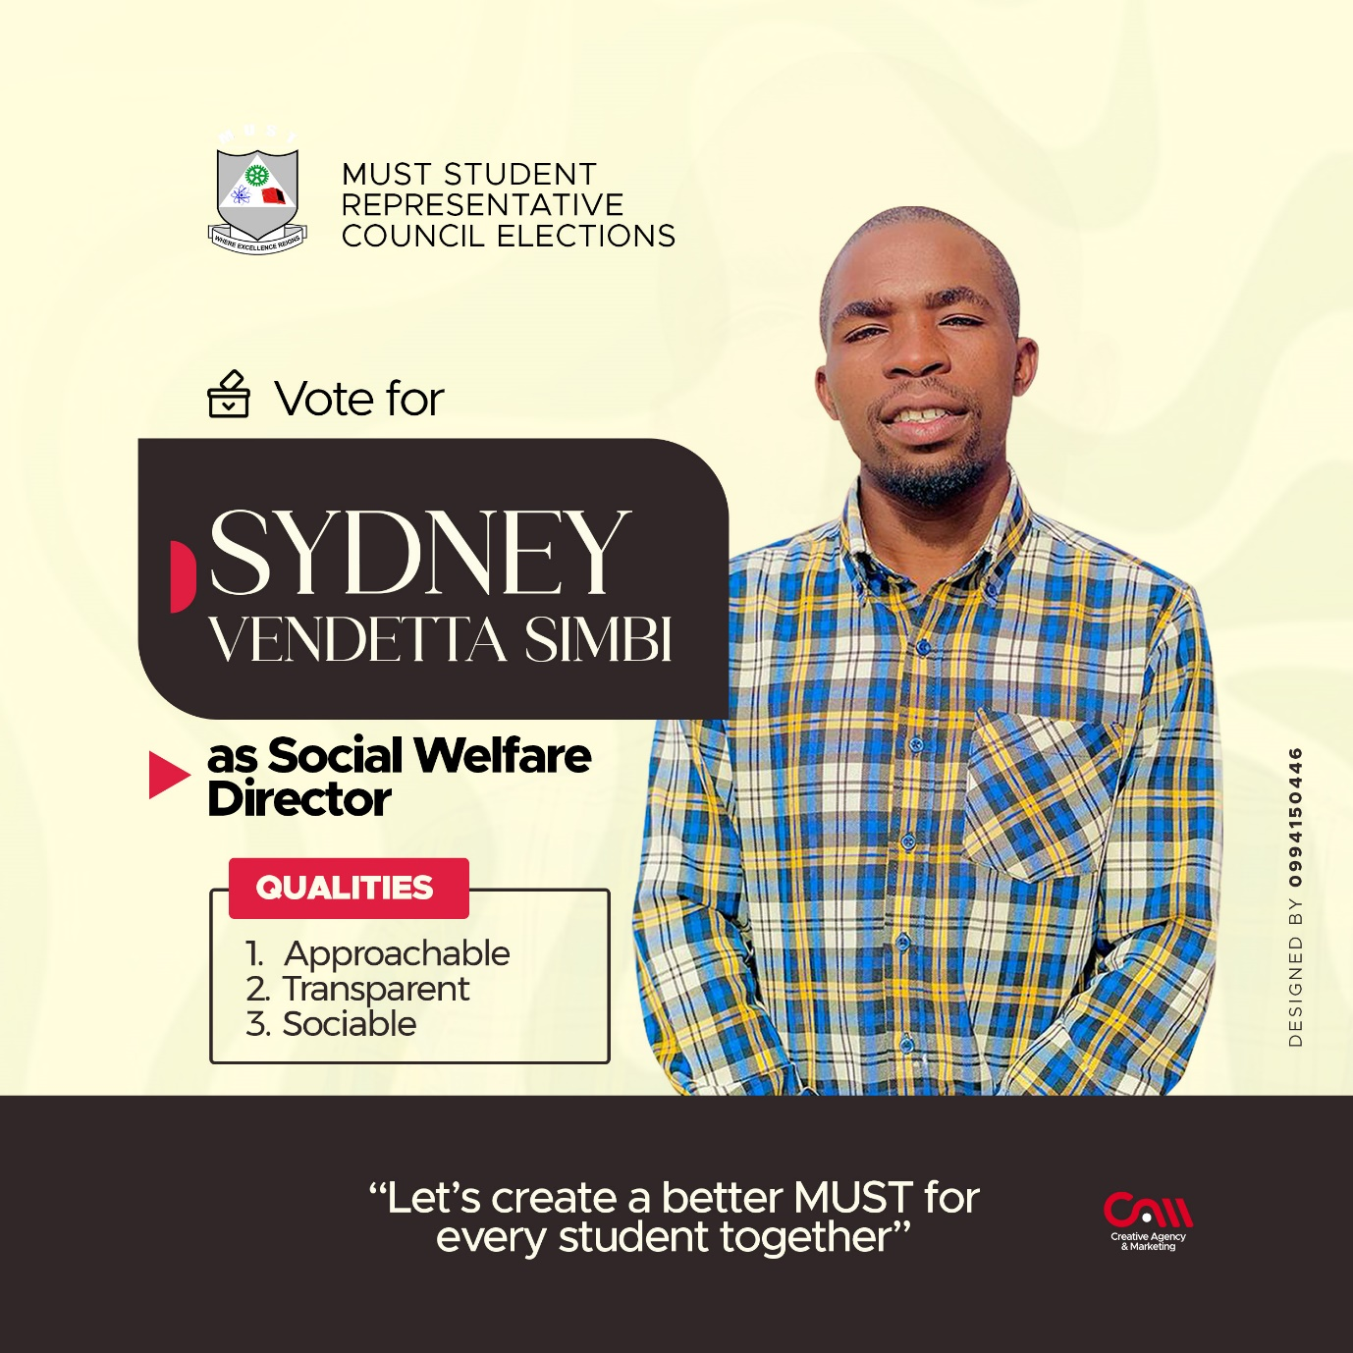

**MY MANIFESTO FOR SOCIAL WELFARE DIRECTOR**

Greetings my fellow students!

“Let’s create a better MUST for every student together” Martin Luther Jr once said and I quote “If you want peace, organize yourself as those people who want war organize themselves” This is how I Sydney has suggested some of the ways in which we can collaborate to create a more effective MUST that benefits everyone.

1. **Encouraging openness**: Making certain that financial aid and assistance designated for disadvantaged students is genuinely received by those who require it. In some instances, contributions from donors are intended for needy students, and thus, I aim to guarantee that the selection process for identifying needy students who qualify for such aid is transparent, and that the recipients are scrutinized to ensure that only those who genuinely require and merit the funds benefit from them
2. **Promoting inclusivity**: My belief is that in order to make the best decision for students in any given situation, it's important to consider the opinions of everyone involved. Therefore, my department responsible for student welfare will encourage input from all students on how to approach a specific situation. The ideas submitted will be carefully evaluated and the best one will be used to make a final decision.
3. **Advocating for social justice:** I will be a strong advocate for social justice and work to create a more equitable and inclusive campus environment.
4. **Improving Social Services**: will be my focus, specifically by enhancing facilities for students such as accommodations and addressing food security concerns. Our aim is to create policies that guarantee everyone has access to fundamental necessities and services.
5. **Re-introduction of shopping trip to Limbe through the school bus**. We don’t have many shopping malls near campus and we rely on going to Limbe township to purchase our daily needs, so we want to re-introduce monthly trips to Limbe via school bus to ease the burden students face when they want to purchase items and basic needs for our welfare.

In conclusion, I am committed to creating a society where everyone has the opportunity to thrive. Through our collective efforts, we can build a more just, equitable, and prosperous society for all.

Regards,

SIMBI SYDNEY

(ASPIRING DIRECTOR OF SOCIAL WELFARE)