**BST-BCS-23A – Data Bases**

# Project Final Report & Files

[Guideline]

|  |
| --- |
| **Project Final Report**  **Table of Contents (ToC)**   1. **Requirements Collection** 2. **Database Initial Study and Analysis**    1. **Organization**    2. **System** 3. **Database Design**    1. **Conceptual Design**       1. Initial Entity-Relationship (and/or EER) Model       2. Business Rules       3. Data Dictionary    2. **Logical Design**       1. Relational Schema (ER- and/or EER-to-Relational Mapping and Normalization applied) 4. **Physical Design/Implementation** 5. **Querying/Reporting** 6. **Work Effectively in Teams Form** (individual submission) |

**HOW TO DO?**

*1. Requirements Collection*How did you gather data? (methods, approaches, etc.)   
Briefly provide information on Data Gathering Methods used for the project.

*2. Database Initial Study and Analysis*Expand the given use case “Career Office Management Systems” in terms of *organization* (objectives, actors/roles (users), business operations) and *system* (scope, user information requirements (information -query/report- needs for various users).

*3. Database Design*

*a. Conceptual Design*

*i. Initial ER Model:*

The (Enhanced) Entity-Relationship model should contain six entities and an appropriate number of relationships. The model only displays entities, relationships, and connectivities (one-to-many, one-to-one, and many-to-many). You can use one of the following notations: Chen, Crow’s foot, or UML Class Diagrams. Just state your preference in the report. Do not add cardinalities. *(Do not add attributes to the Chen ERD*. Attributes will be in the *Logical Design* part).

*ii. Business rules*:

Describe the relationships as the following;

A VENDOR supplies one or many ITEMs.

An ITEM is supplied by only one VENDOR.

*iii. Data Dictionary*

Describe attributes in a tabular format. Use **the template** provided by the lecturer.

Example:

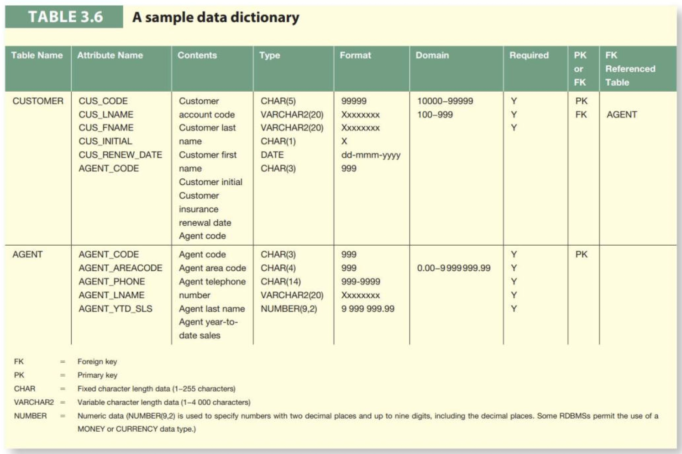

*b. Logical Design*Generate a relational database design by EER-to-Relational Mapping. (The relational schema is created). It should include normalized tables that are in the 3rd Normal Form.

Make sure that you apply the *systematic algorithm of relational mapping* and *normalization*.

Example:

*4. Physical Design/Implementation:*Implementation of the proposed design in SQLLiteStudio.

1. Organize your data into tables,
2. Establish relationships and enforce referential integrity,
3. Enter sufficient amount of data into tables so that the queries display meaningful information,

*5. Querying/Reporting:*

1. Using SQL statements, create 10 queries.
   1. List queries in the final report
      1. SQL statements

*For instance:*

**SELECT** CUS_CODE, COUNT(INV_NUMBER) AS Total_no_of_Invoices

**FROM** INVOICE

**GROUP BY** CUS_CODE;

* + 1. Screenshots after the SQL statements are run

*For instance:*

* + 1. Query specifications

Add query specifications by briefly explaining the followings:

* + - 1. what is the name of the query,
      2. who will use the query,
      3. what is the purpose of the query, and
      4. what each query displays.

Notes:

* Queries should contain *advanced features* (nested/subquery, different types of joins, group by, having, aggregate functions, etc.).
* Ensure a link between the user information requirements (*2.b*) and queries/reports *(5).* While creating queries, be creative and build scenarios relevant to the user information requirements.

*6. Work Effectively In Teams Form*

1. Use the provided template and evaluate your performance & the other team members’ performances, and
2. Send the form, in ***confidentiality***, to the instructor by e-mail. Do not attach the evaluations to your final report.

*Final report and database file submission - Due 30 June 2023, at 09:00 am*

*Project Presentations + Question & Answer – 30 June 2023, between 09:00 am - 01:00pm*

**Files to submit:**

1. The final report as a *Word* document (group submission),
2. The database file (group submission),
3. *“Work Effectively in Teams Form*” (individually).

GOOD LUCK!