*1）schematic for a single stage processor*

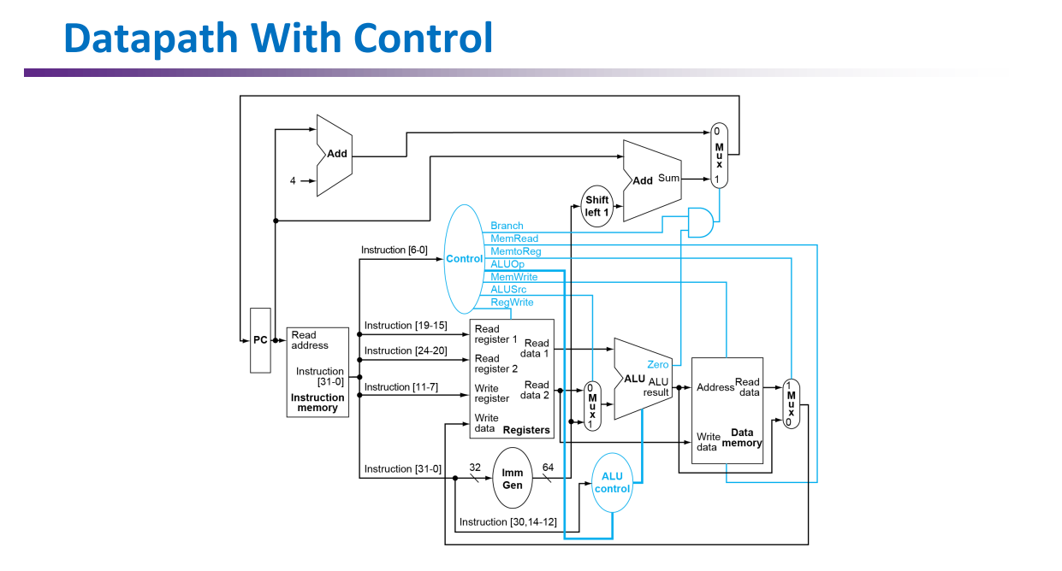

*2）average CPI, Total execution cycles, and Instructions per cycle*

You can find the code, CPI, cycles and etc. in the .zip file.

*3) What optimizations or features can be added to improve performance? (Extra credit)*

Multithreading can enhance the efficiency of a single-threaded CPU by optimizing the use of CPU resources. Essentially, when a CPU is performing a task, it may encounter waiting times, such as when it's waiting for I/O operations (like disk reads/writes or network data transfers) to complete. During these periods, the CPU is idle. Multithreading allows the CPU to switch to another thread while one is waiting, thus minimizing idle time and improving overall efficiency.

Moreover, multithreading can improve response times. In an operating system, multiple threads enable a user to continue interacting with the system even while one thread is busy with a long-running computation. This way, the system can remain responsive to user input.

Finally, multithreading can lead to better throughput of computing tasks, as it allows for more tasks to be processed in parallel or in quicker succession, depending on the context and system design.