**Experiment -1.1 - Installing Git & Creating Repository**

**Student Name: Chayan Gope UID: 22BDO10036**

**Branch: AITCSE(DevOps) Section/Group: 22BCD-1(A)**

**Semester: Fourth Date of Performance: 18/01/2024**

**Subject Name – Git and Hub Subject Code: 22CSH-293**

**1. Aim/Overview of the practical:-**

Installation of Git Software and Creating a Repository on GitHub.

**2. Task to be done:-**

1. Installation of Git
2. Creating a repository on GitHub

**3. Apparatus:-**

Computer, Wifi, Git software, GitHub

**4. Algorithm/Flowchart:-**

N/A

**5. Theme/Interests definition:-**

Version control is a mechanism that logs alterations made to a file or group of files over time, enabling the retrieval of specific versions at a later stage. Git, on the other hand, is a decentralized version control system designed to monitor modifications in any collection of computer files. It is commonly employed for facilitating collaboration among programmers engaged in joint development of source code during the software development process.

**6. Steps for experiment/practical:**

1. **Steps to download git software:-**

These are the steps to be followed while downloading the Git Software:-

1. Browse to the official Git website and download the Application.
2. Unless specified, use by default option

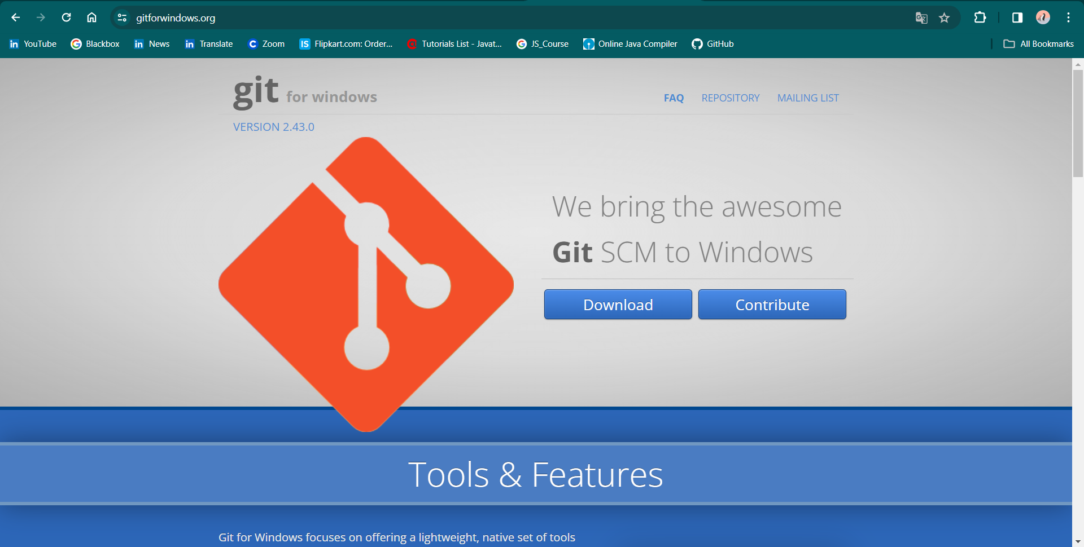

**To launch Git BASH:-**

1: Open the Windows Start menu

2: Search for git bash in the Search Menu and press Enter (or click the application icon).

3: Connecting to a Remote Repository Git Bash.

1. **Configuring GitHub Credentials:-**
2. Configure your local Git installation to use your GitHub credentials by entering the following:
   * git config --global user.name “github_username”
   * git config --global user.email “email_address”
3. We can also see the list of configurations by using the command
   * git config -- list.
4. **Cloning a GitHub Repository:-**
5. Go to your repository on GitHub.
6. On the top right above the list of files, open the Clone or Download drop-down menu.
7. Copy the URL for cloning over HTTPS.
8. Switch to your PowerShell window, and enter the following:
   * git clone repository_url
9. **Lisiting all the Remote Repositories:-**
10. Your working directory should now have a copy of the repository from GitHub.
11. Now type ‘ls’ to list the name of files available in the directory.
12. **Creating Repository on GitHub:-**
13. After successful login into your account. Click on the option (+) to add new repository to your account.
14. After clicking new repository option, we will have to initialize some things like, naming our project, choosing the visibility etc. After performing these steps click Create Repository button.
15. After clicking the button, we will be directed to the next page. After that we added some files using add files option. This is how our repository looks now.

**7. Observations/Discussions:-**

We have observed how to clone a repository in Git and how to make a repository on the GitHub

**8. Percentage error (if any or applicable):-**

N/A

**9. Calculations/ Chemical Reactions / Theorems /Formulas used etc:-**

N/A

**10. Result/Output/Writing Summary:-**

We have successfully created a repository and downloaded the Git Software into our version.

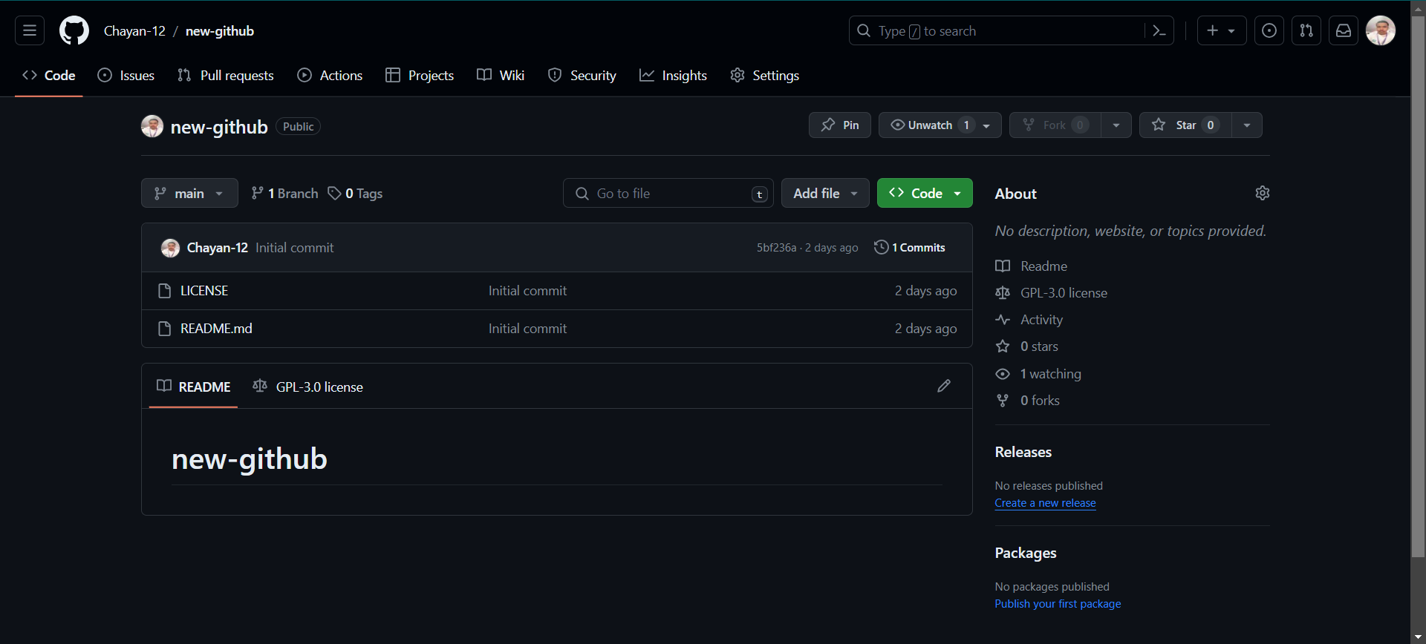

**Creating** **a Repository**



**GitBash Interface**

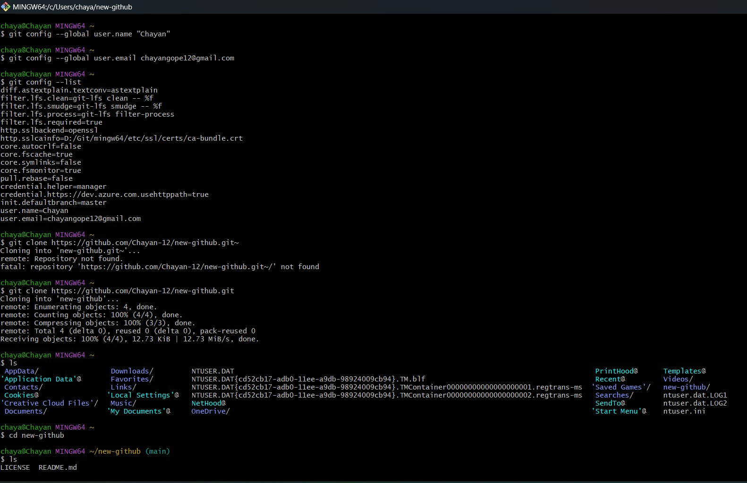

**Using basic commands on GitBash**

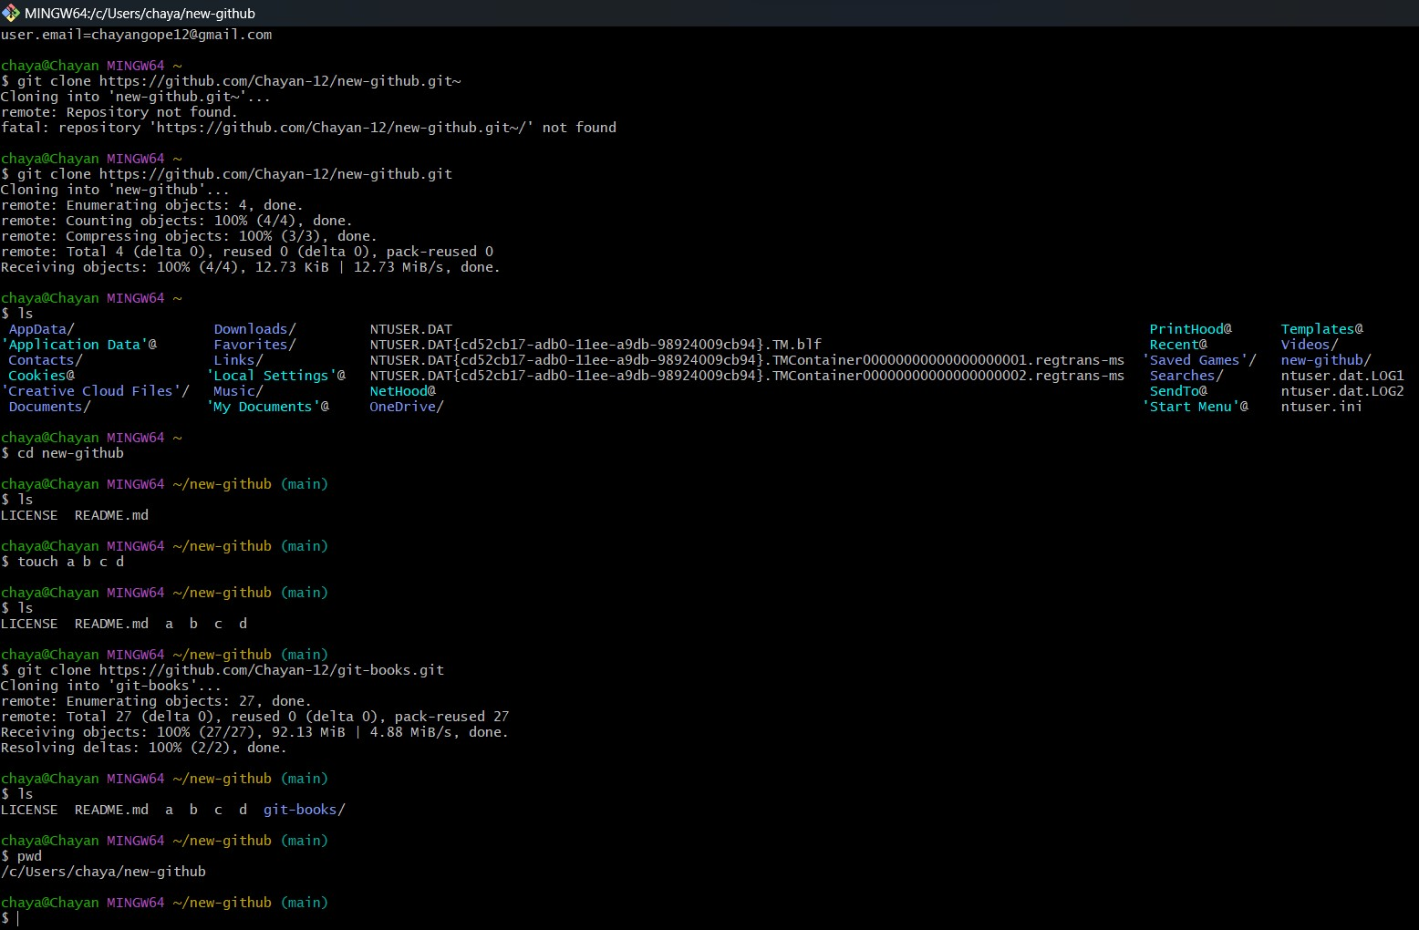

**Cloning a Repository**

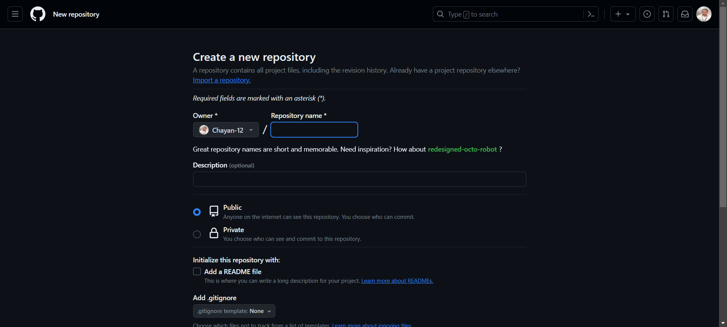

**Creating a Repository on the Github named Git and Hub**

**11. Graphs (If Any): Image /Soft copy of graph paper to be attached here:-**

**N.A.**

**Learning outcomes (What I have learnt):-**

**1.** Learnt about GitHub.

**2.** Learnt about Git.

**3.** Learnt about various git commands that can be applied on Git Bash.

**4.** Learnt about repositories.

**5.** Learnt about how to clone a repository.

**Evaluation Grid (To be created as per the SOP and Assessment guidelines by the faculty):**

|  |  |  |  |
| --- | --- | --- | --- |
| Sr. No. | Parameters | Marks Obtained | Maximum Marks |
| 1. |  |  |  |
| 2. |  |  |  |
| 3. |  |  |  |
|  |  |  |  |