**Experiment -1.2**

**Student Name: Chayan Gope UID: 22BDO10036**

**Branch: CSE(DEVOPS) Section/Group:22BCD-1(A)**

**Semester: 4TH Date of Performance: 24/01/2023**

**Subject Name: Git and Github Subject Code: 22CSH-293**

1. **Aim/Overview of the practical:** Creating branches with GitHub
2. **Software used:** Git Bash and Github.
3. **Hardware Used: Windows computer** system.

1. **Steps for experiment:**

**Creating branch using GitHub :**

* 1. Open your github profile.
  2. Select the repository where you want to create branch.
  3. Click on create file or add a new file.
  4. Name the file “calculator.java” then add the code in it.
  5. Click on **commit changes** button to commit the change.
  6. Provide **“commit message”** then click on **commit changes.**
  7. Now go to the file click on branch **“main”**.

* 1. Type a new branch name **“calbranch.java”** and click **“Create branch calbrach.java from main”**

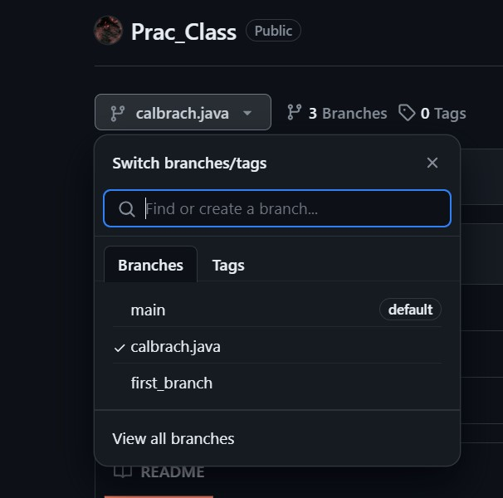

1. Click on the **edit**  button on the file and edit the code in it.

1. Ater editing the code click on **commit changes** to save the changes.

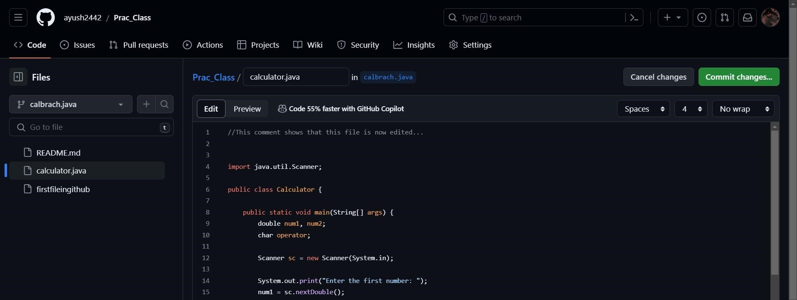

1. Add **“Commit message”** and then click on **commit changes.**

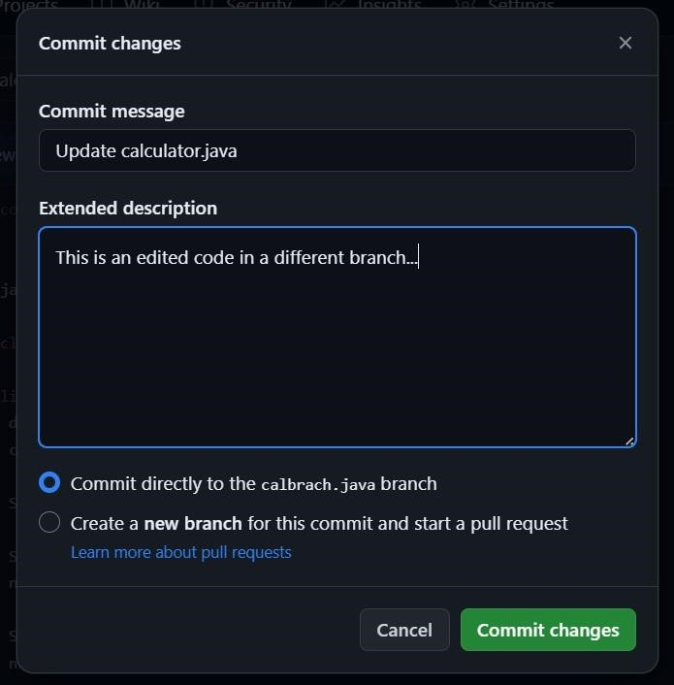

1. After commiting the changes go to **parent repository** and click on **compare nad pull request.**

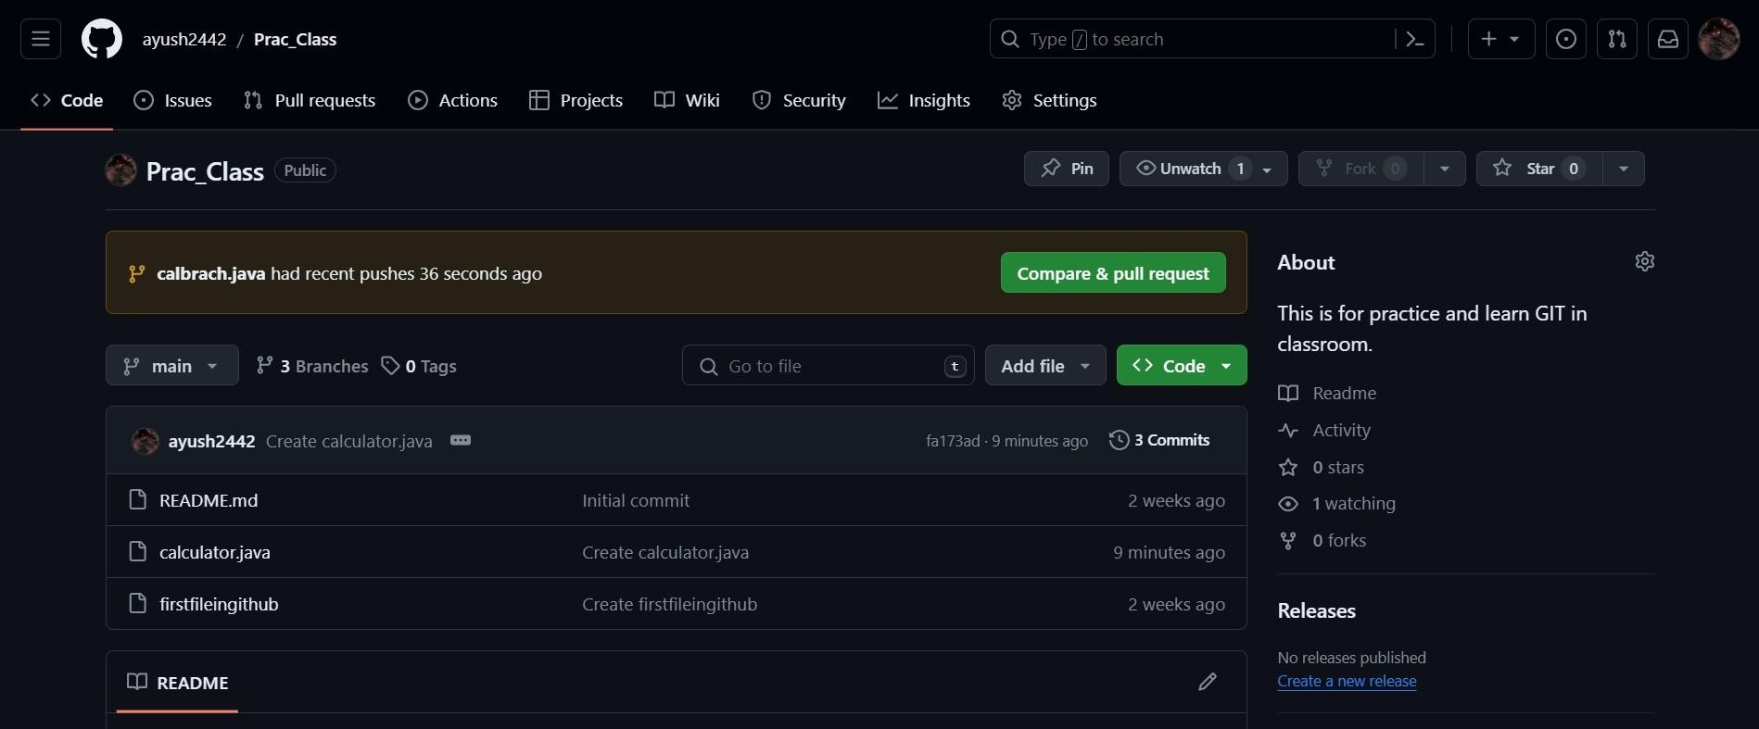

1. Compare both the code (before and after editing).

1. Click on **Create pull request.**

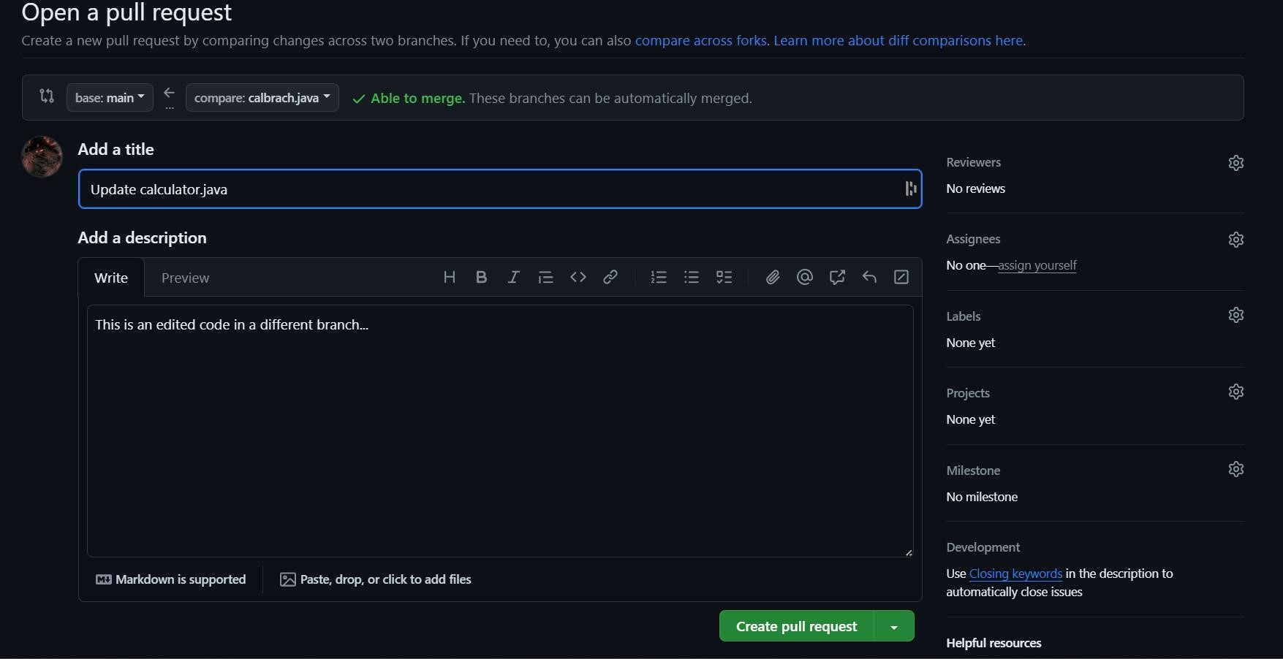

1. Click on **Merge pull request.**

1. After Merging the code Click on **“Delete branch”** if you wish to delete the branch.

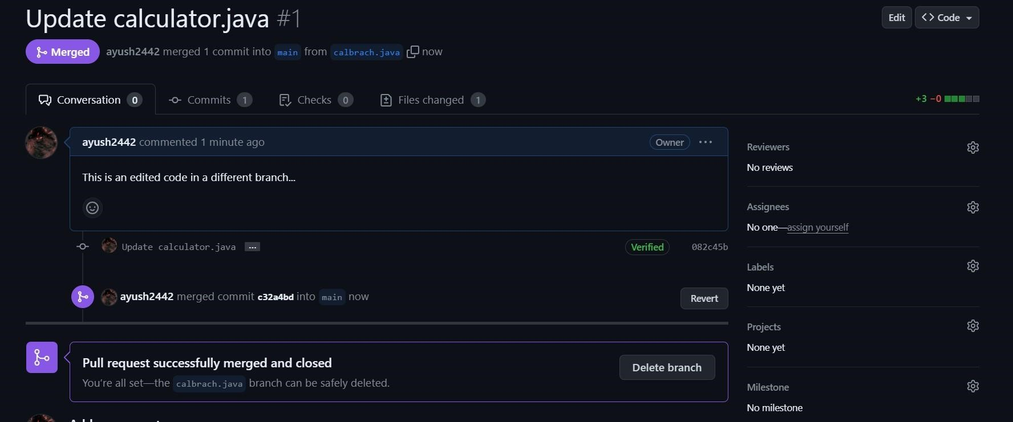

**From Creating Branch On GitBash:**

* 1. Initialize the git using *“git init”*  command.

* 1. Create a new file using vi text editor
  2. **Name the file “local_git.txt”** **4.**  Add some content .



1. Put the file in staging area using *“git add local_git.txt”*

1. Commit this file using *“git commit -m ”*

1. Create a new branch using code *“git checkout -b new”*

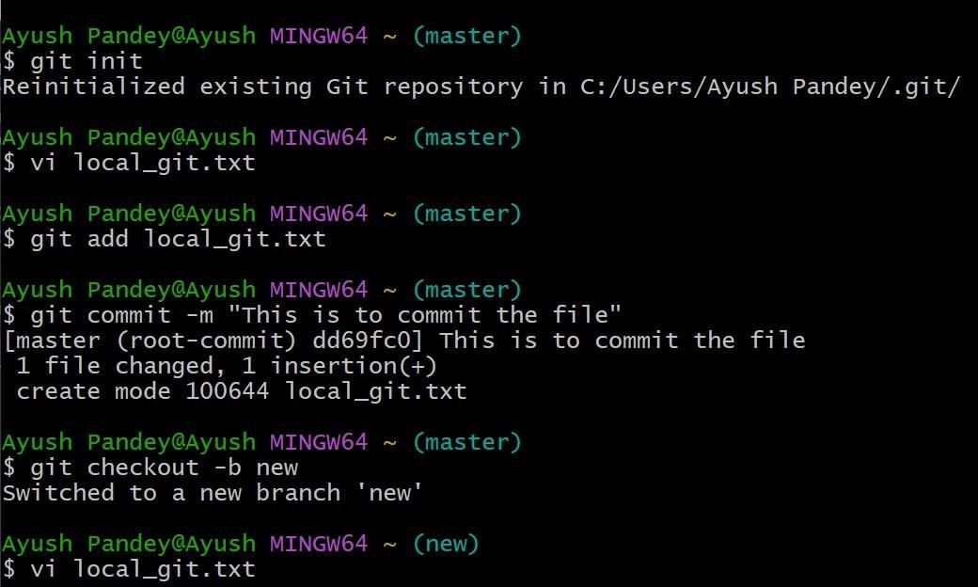

1. Open and Edit file using  *vi text editor*  and add content to it.

1. Put the file in staging area using *“git add local_git.txt”*

1. Commit this file using *“git commit -m”*

1. Move to master branch using *“git checkout master”*

1. Merge the branch using code *“ git merge new”*

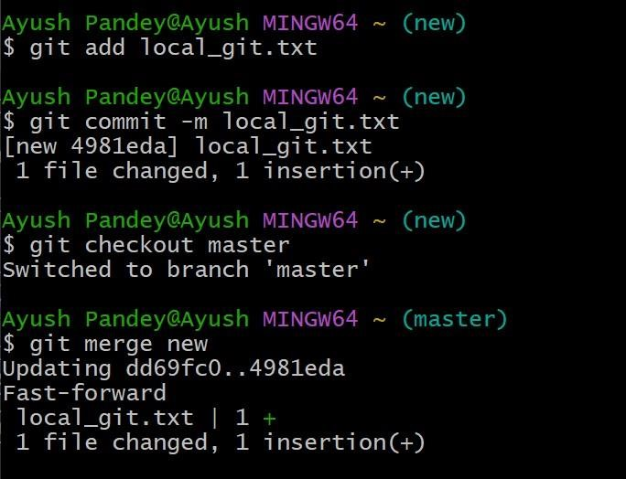

1. Show the status of file using *“git status”.*

**Learning outcomes (What I have learnt):**

* 1. Learnt about Git bash.
  2. Learnt about GitHub account.
  3. Learnt about creating branch in Local Git.
  4. Learnt about creating branching in Github.
  5. Learnt about merging and comparing of two file in Git and GitHub.

**Evaluation Grid (To be created as per the SOP and Assessment guidelines by the faculty):**

|  |  |  |  |
| --- | --- | --- | --- |
| Sr. No. | Parameters | Marks Obtained | Maximum Marks |
| 1. |  |  |  |
| 2. |  |  |  |
| 3. |  |  |  |
|  |  |  |  |