**Experiment -1.3**

**Student Name:Chayan Gope** **UID:** 22BDO10036

**Branch:** AIT-CSE(DevOps) **Section/Group**: 22BCD-1/A

**Semester:** 4th **Date of Performance:** 31/01/2024

**Subject Name**: Git and Hub **Subject Code:** 22CSH-293

1. **Aim/Overview of the practical:** To create and explore pull requests.
2. **Software Used:** Git Bash, GitHub.
3. **Steps for experiment/practical:** • Create or clone a repository on your local machine and open GIT BASH.
   * Move to the directory using the **cd** command.
   * Create a file in the master or main branch, eg, **filebranch1.txt** and add some text to the file.
   * Add the file to the staging area using **git add** and then commit the changes using the **git commit** command.
   * Create a new branch and checkout to it using the **git checkout -b** command, here git checkout -branch1.
   * Open the **filebranch1.txt** on the **vi** editor and make some changes to it.
   * Repeat step 4.
   * Merge thebranch in the **master** branch using the **git merge <branch_name>** command and resolve the merge conflict if necessary.
   * Now, push your changes in the **master** and **test** branch to the remote repository.
   * Now, Go to Git Hub, open the repository move to the **test** branch and make some changes in a file.
   * Commit the changes and move to the **master** branch. Click on the **Compare & Pull request**.
   * **Create the pull request,** resolve the merge conflicts (if any) and then **merge the pull request**.
   * After the merging, you may choose to delete your branch, i.e, branchfile
   * The master branch will now be reflecting the changes.
   * In the Git Bash, you may get the changes in your local repository using the **git pull** command and if you want the references of the commits, use **git fetch**.
   * Now, after the **git pull**, we will be seeing the changes in **filrbranch1.txt**

1. **Outputs:**

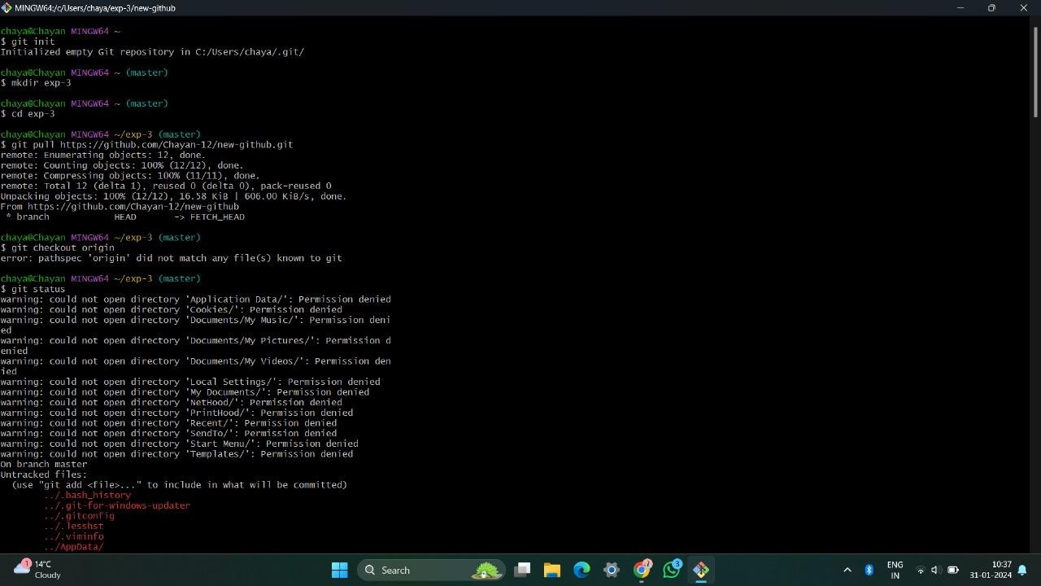

***Switching to the current directory***

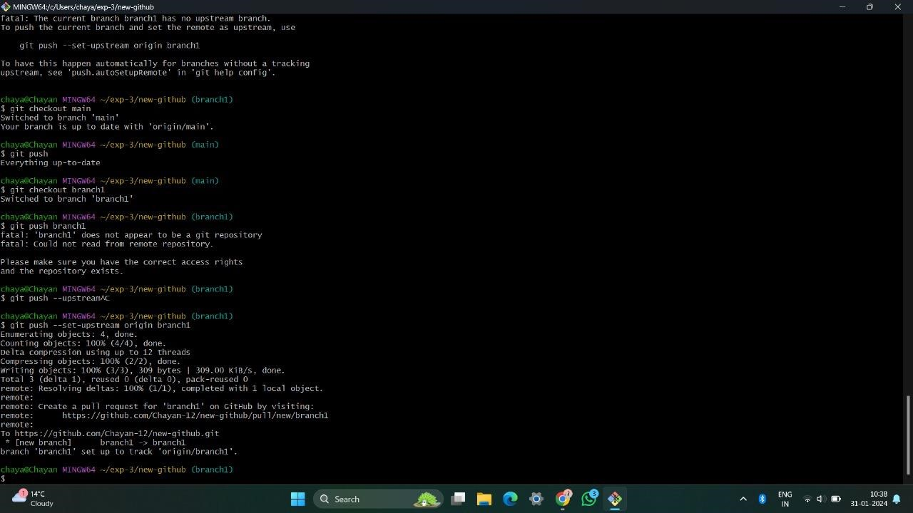

*Creating Branch*

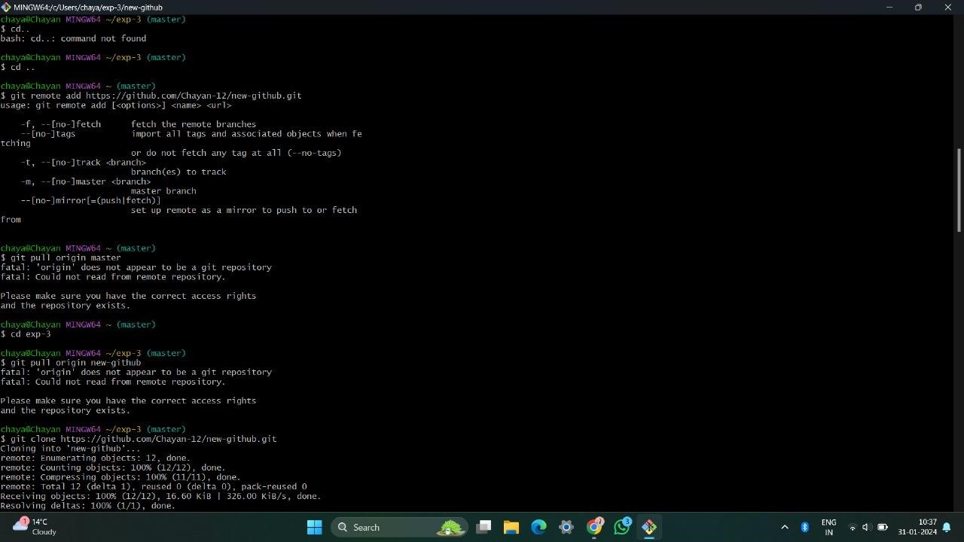

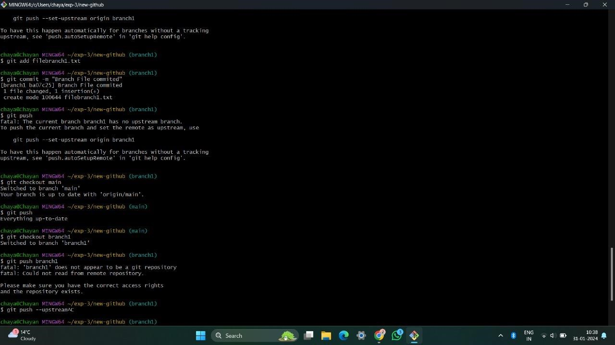

*Branch pushed*

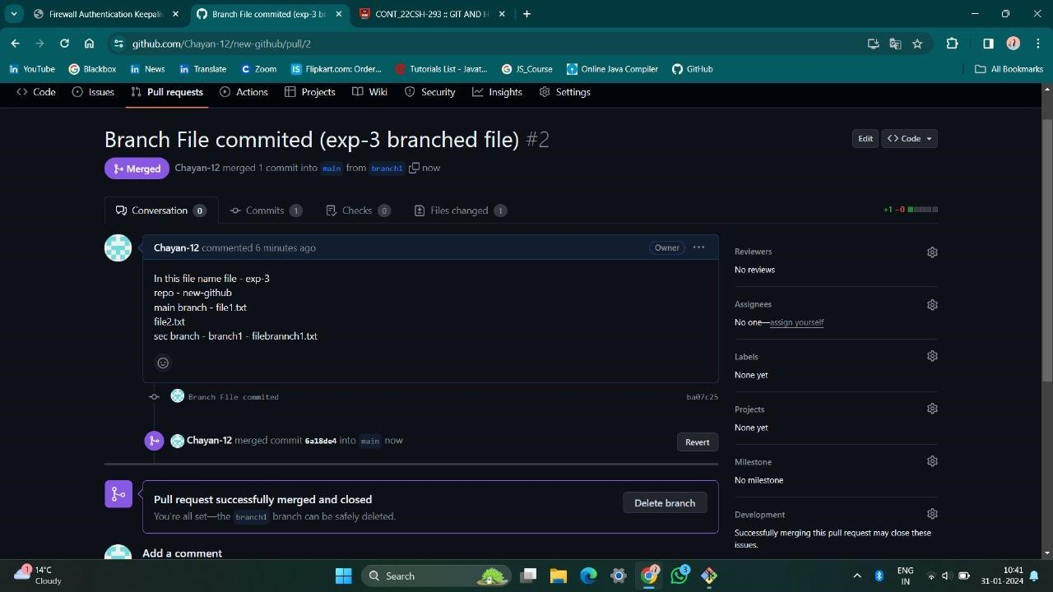

*Merging the request on the Github*

1. **Result:**

In this experiment, we have created and explored the pull requests. We created a new branch, made some changes in the files in that new branch and then merged the changes with the main branch by resolving merge conflicts by using both GitHub and Git Bash.

**Learning outcomes (What I have learnt):**

* 1. Learnt how to create a branch.
  2. Learnt how to push the changes to the remote repository.
  3. Learnt how to pull the changes from the remote repository.
  4. Learnt to merge two branches.
  5. Learnt how to resolve merge conflicts.

**Evaluation Grid (To be created as per the SOP and Assessment guidelines by the faculty):**

|  |  |  |  |
| --- | --- | --- | --- |
| Sr. No. | Parameters | Marks Obtained | Maximum Marks |
| 1. |  |  |  |
| 2. |  |  |  |
| 3. |  |  |  |
|  |  |  |  |