**Experiment -2.1**

**Student Name:** Chayan Gope **UID:** 22BDO10036

**Branch:** AIT-CSE(DevOps) **Section/Group**: 22BCD-1/A

**Semester:** 4th **Date of Performance:** 07/02/2024 **Subject Name**: Git and Hub **Subject Code:** 22CSH-293

1. **Aim/Overview of the practical:** Editing a file and committing changes on GitHub.
2. **Software Used:** Git Bash, GitHub.
3. **Steps for experiment/practical:**
   * Create or clone a repository on your local machine and open GIT BASH.
   * Move to the directory using the **cd** command.

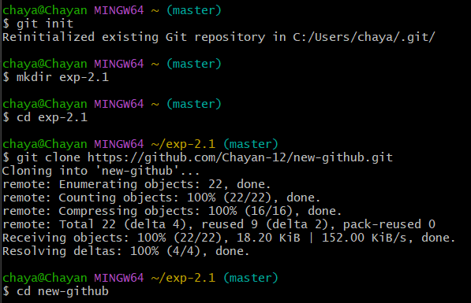

* + Create or open a file in the master or main branch, eg, **exp. c** and add some text to the file.

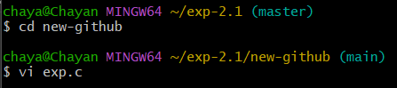

* + Add the file to the staging area using **git add** and then commit the changes using the **git commit** command.

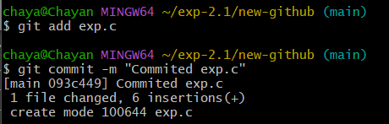

* + Push the changes to the remote repo using the command **git push**.

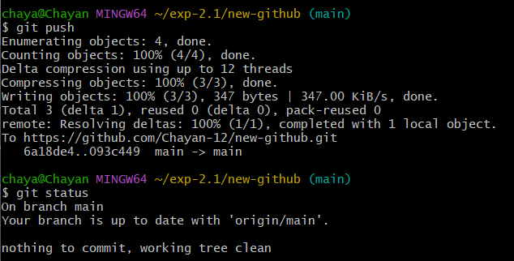

* + You will be able to see the changes in the remote repository.

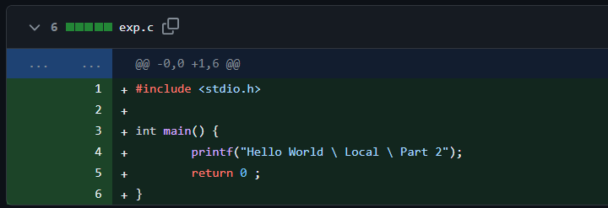

* + Now, make some changes in the file in the remote repository and pull those changes in the local repository.
  + Create a new branch and check in using the **git checkout -b** command, eg, **change1**.

* Open the **exp. c** on the **vi** editor and make some changes.

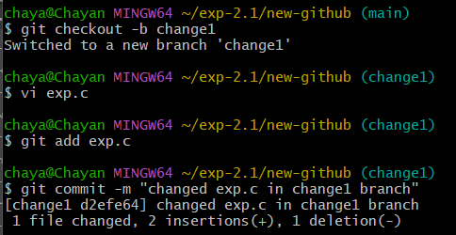

* + Merge the changes made in the **change1** branch with the **main** branch and resolve the conflicts manually if necessary.
  + Push the **main** and **change1** branch onto the remote repository.

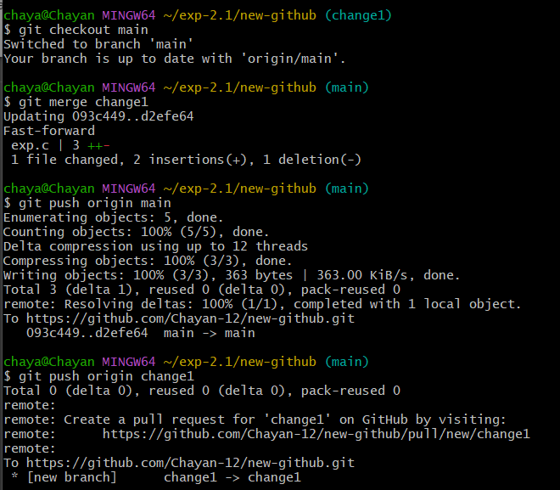

* + You will be able to see the new changes in the remote repository.

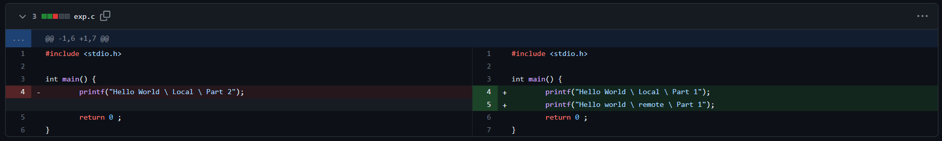

( local ) ( remote )

* + Now, Go to Git Hub, open the repository move to the **change1** branch and make some changes in a file.

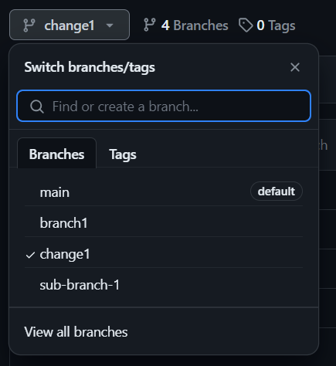 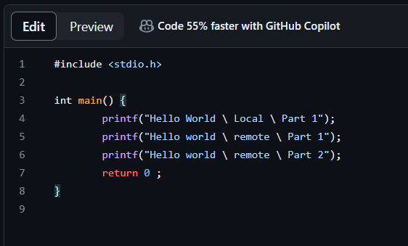

* + Commit the changes and move to the **main** branch. Click on the **Compare & Pull request**.

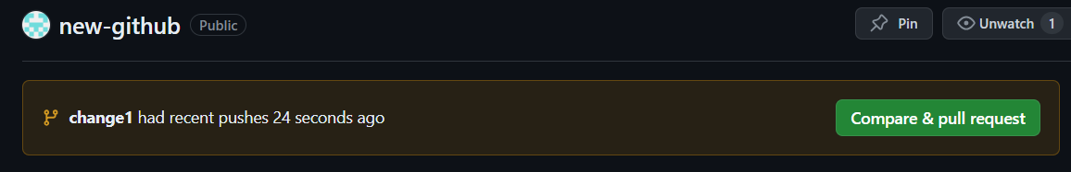

* + **Create the pull request,** resolve the merge conflicts (if any) and then **merge pull request**.

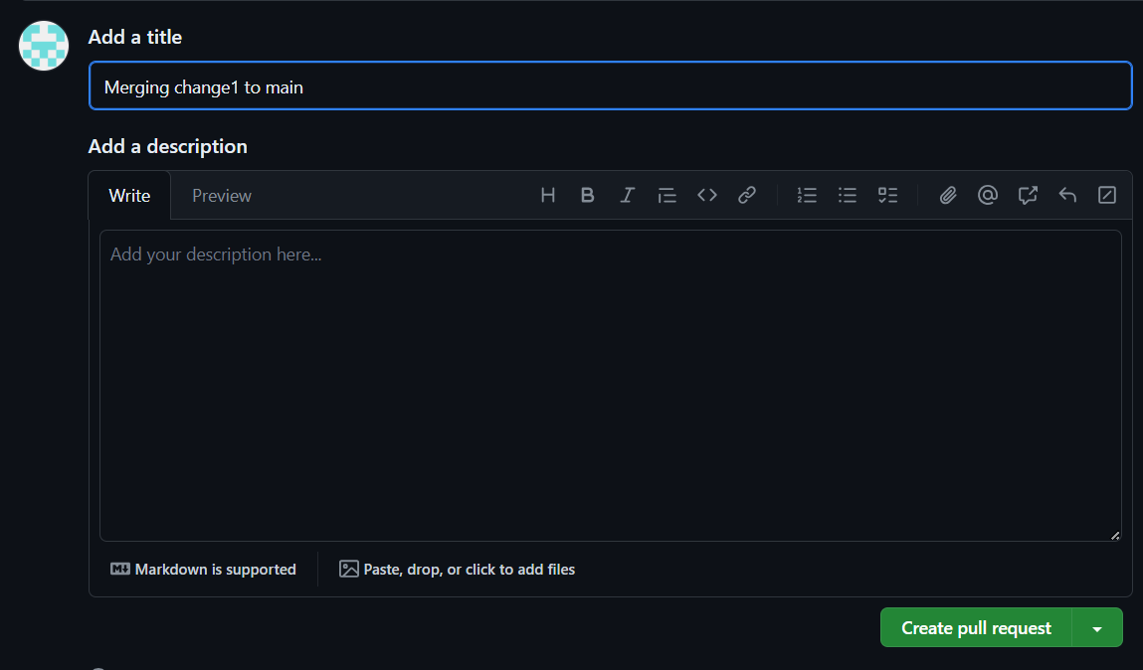 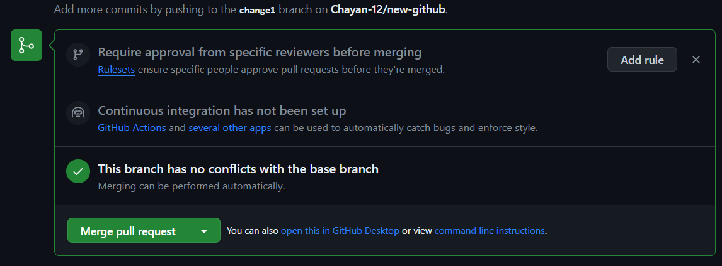

* + After the merging, you may choose to delete your branch, i.e, **change1**

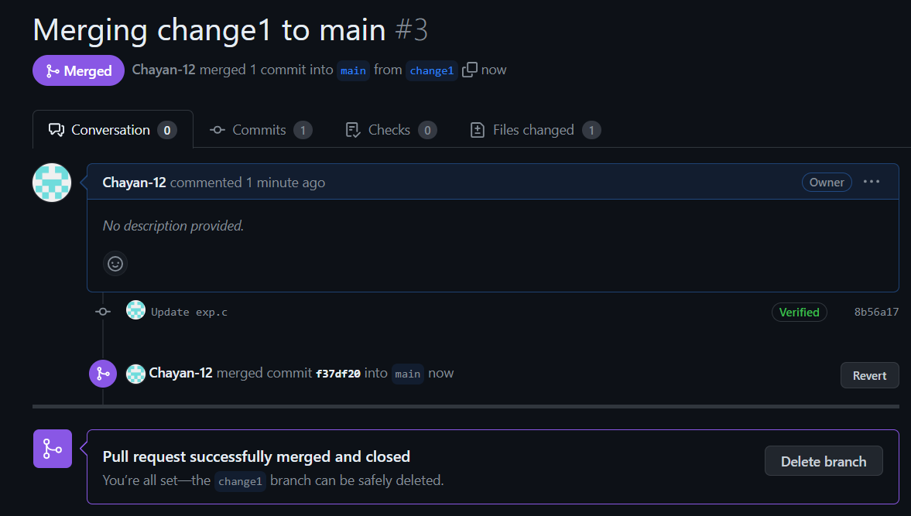

* + Now, pull the changes to the local repository using **git pull**.

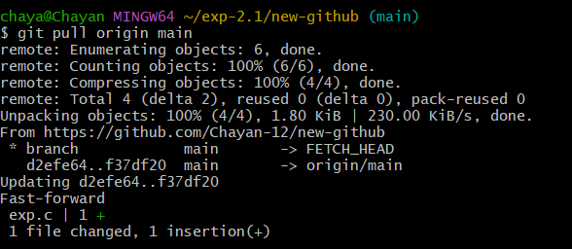

* + You will be able to see the changes in your local repository.

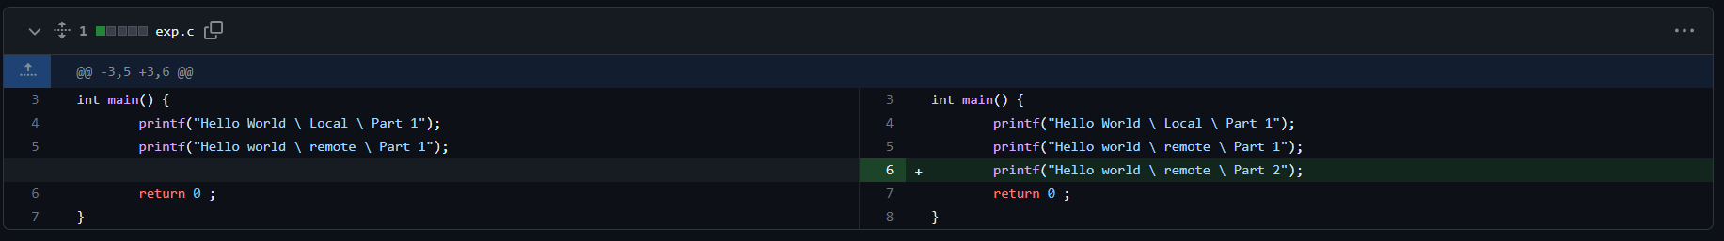

( remote ) ( local )

1. **Result/Output/Writing Summary:**

In this experiment, we have edited a file in the local repository and shown the changes on the remote repository and vice versa. For this purpose, we have made use of both Git and GitHub.

**Learning outcomes (What I have learnt):**

* + 1. Learnt how to create a branch.
    2. Learnt how to push the changes to the remote repository.
    3. Learnt how to pull the changes from the remote repository.
    4. Learnt to merge two branches.
    5. Learnt how to resolve merge conflicts.

**Evaluation Grid (To be created as per the SOP and Assessment guidelines by the faculty):**

|  |  |  |  |
| --- | --- | --- | --- |
| Sr. No. | Parameters | Marks Obtained | Maximum Marks |
| 1. |  |  |  |
| 2. |  |  |  |
| 3. |  |  |  |
|  |  |  |  |