**Experiment - 2.3**

**Student Name:** Chayan Gope **UID:** 22BDO10036

**Branch:** CSE with DevOps **Section/Group:** 22BCD-1/A

**Semester:** 4th **Date of Performance:** 21/02/24

**Subject Name:** Git and Hub **Subject Code:** 22CSH-293

1. **Aim/Overview of the practical:**

To create Forks on GitHub

1. **Software Used:**

Git Bash, Git-Hub.

1. **Steps for experiment/practical:**

1. Choose the profile of any person whose repository you want to fork on GitHub.

1. Click on the "Fork" button on the top-right corner of the repository page. This will create a copy of the repository under your own GitHub account.

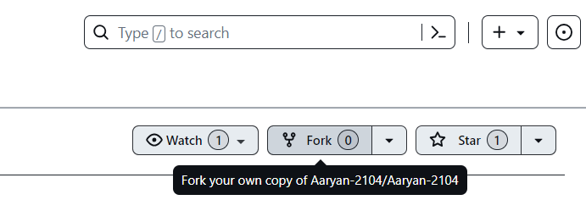

1. After forking, you'll have the option to provide a name for your forked repository and add a description if you want.

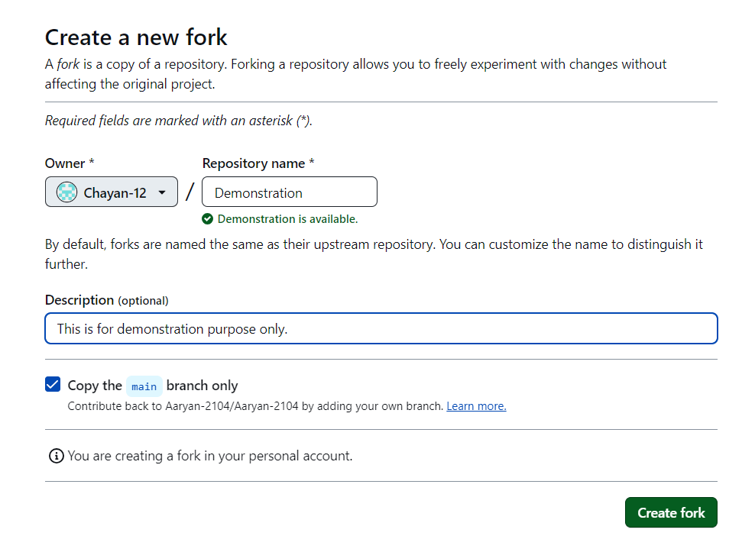

1. Once the fork is created, you'll have access to all the contents of the main branch of the repository. You can make changes to this branch and sync it with the original repository owner's repository if needed.
2. Clone the forked repository onto your local machine using the command: git clone "URL/username/repo_name.git"

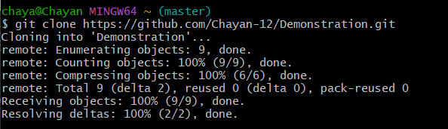

1. Create a branch “branch1”, to add the changes.

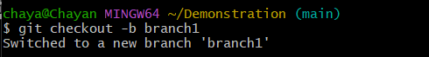

1. Create a new file or edit an existing file on the branch.
2. Enter the details or content into the file. You can also view the contents of the file.

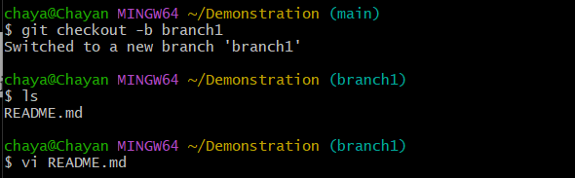

1. Add the created file to the staging area using the command: git add file_name.txt.
2. Commit the changes with a meaningful commit message using the command: git commit -m "message you want to display"

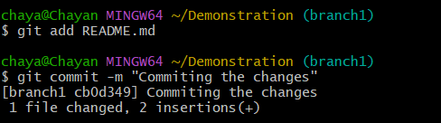

1. Push the changes to the remote repository (your fork) using the command: git push origin branch1.

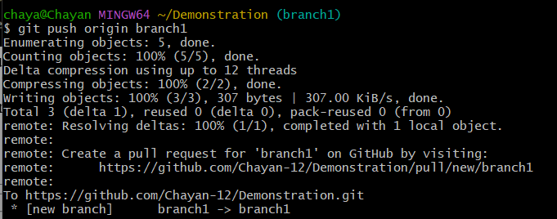

1. After pushing, you can see the changes reflected on your forked repository on GitHub. You can also compare the changes and open a pull request, but keep in mind that you won't be able to merge it as only users with write access can merge pull requests.

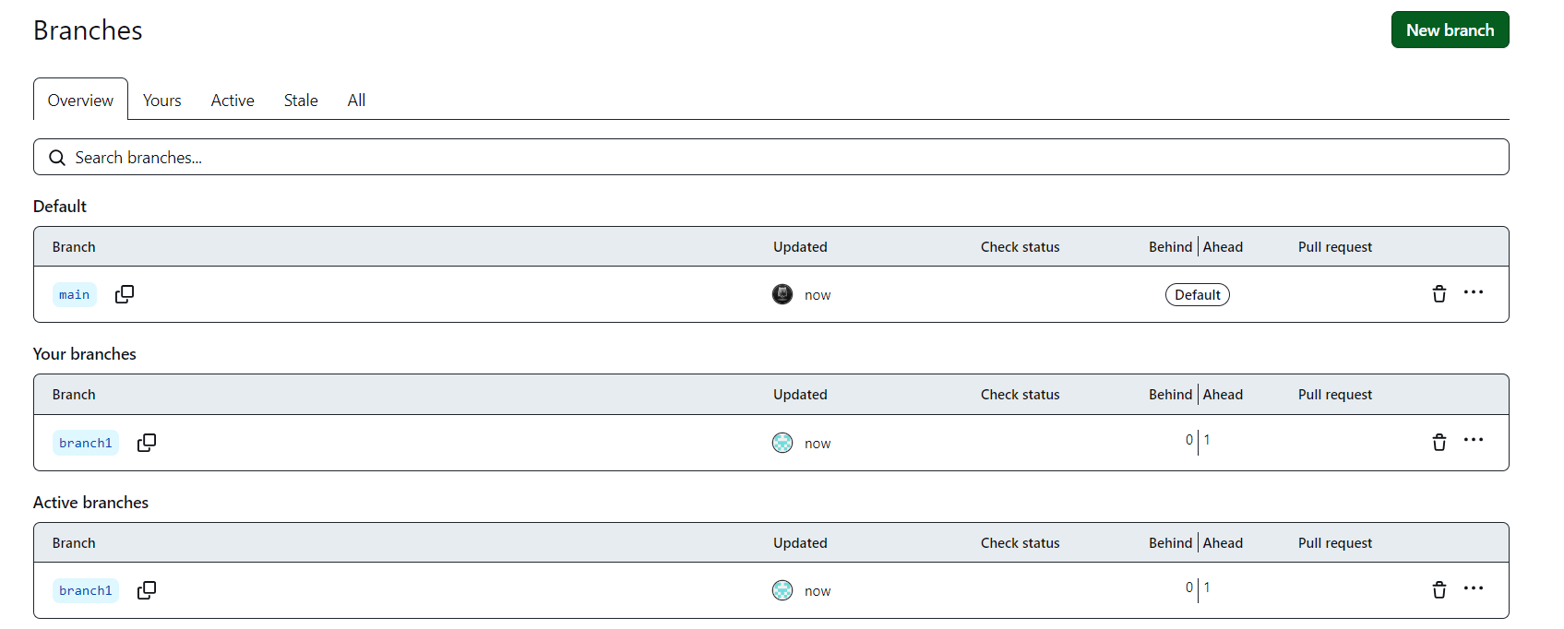

**Learning outcomes (What I have learnt):**

* 1. Understanding Git Workflow
  2. Learnt about Fork.
  3. Version Control Proficiency.
  4. Committing changes.
  5. Learnt about how to pull requests and push in git bash.

Evaluation Grid (To be created as per the SOP and Assessment guidelines by the faculty):

|  |  |  |  |
| --- | --- | --- | --- |
| Sr. No. | Parameters | Marks Obtained | Maximum Marks |
| 1. |  |  |  |
| 2. |  |  |  |
| 3. |  |  |  |
|  |  |  |  |