**Experiment -2.4**

**Student Name:** Chayan Gope **UID:** 22BDO10036

**Branch:** AIT-CSE(DevOps) **Section/Group**: 22BCD-1/A

**Semester:** 4th **Date of Performance:** 28/01/2024 **Subject Name**: Git and Hub **Subject Code:** 22CSH-293

1. **Aim/Overview of the practical:** Git merge conflicts and resolving Git merge conflicts
2. **Software Used:** Git Bash, GitHub.
3. **Steps for experiment/practical:**
   * Clone a repo from the remote to the local system and move inside it.

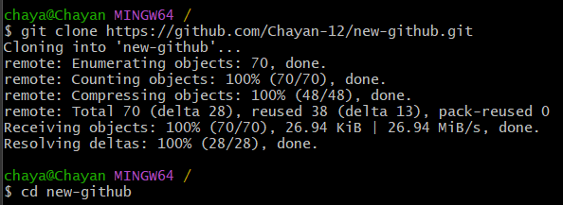

* + Create a file in the local system, add it to the staging area and commit the changes.

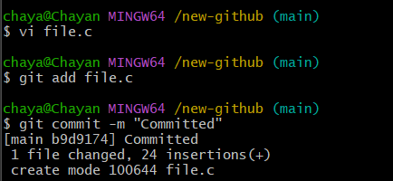

* + Create a new branch named **branch1,** checkout to it, made some changes in the file, add it to the staging area and commit the changes.

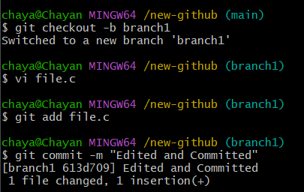

* + Checkout to the **main** branch and merge the changes using the **git merge** command and **- - no - ff** operator.

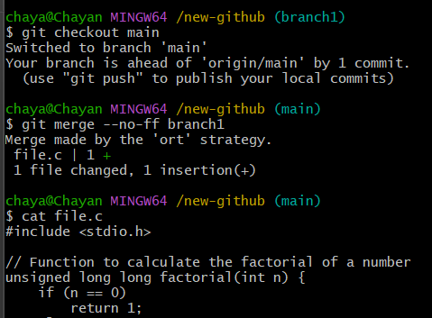

* + Push the changes to the remote repository.

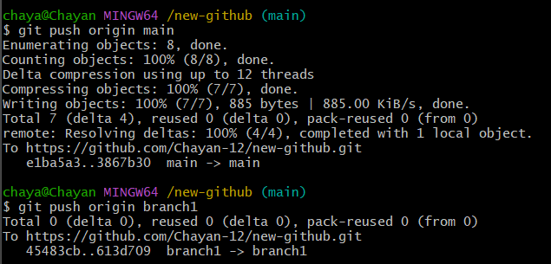

* + Now, move to the **branch1** branch on remote repo, make some changes and commit them.

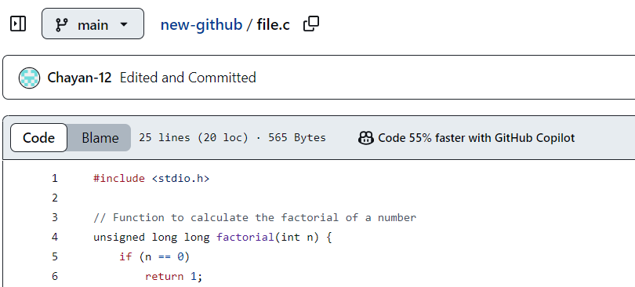

* + Move to the **main** branch, click on **compare & pull request**, and create a pull request.

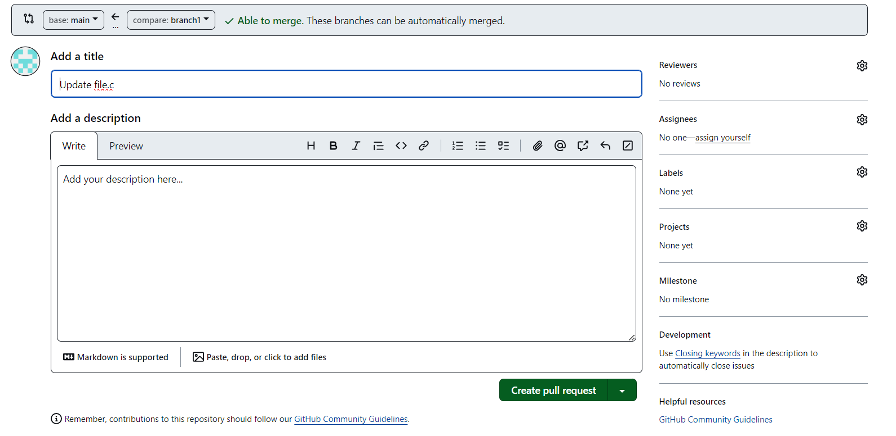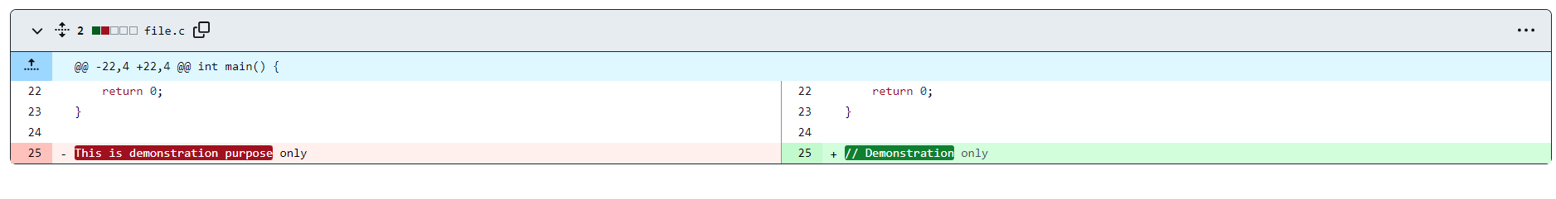

* + Now, merge the pull request and confirm merge.

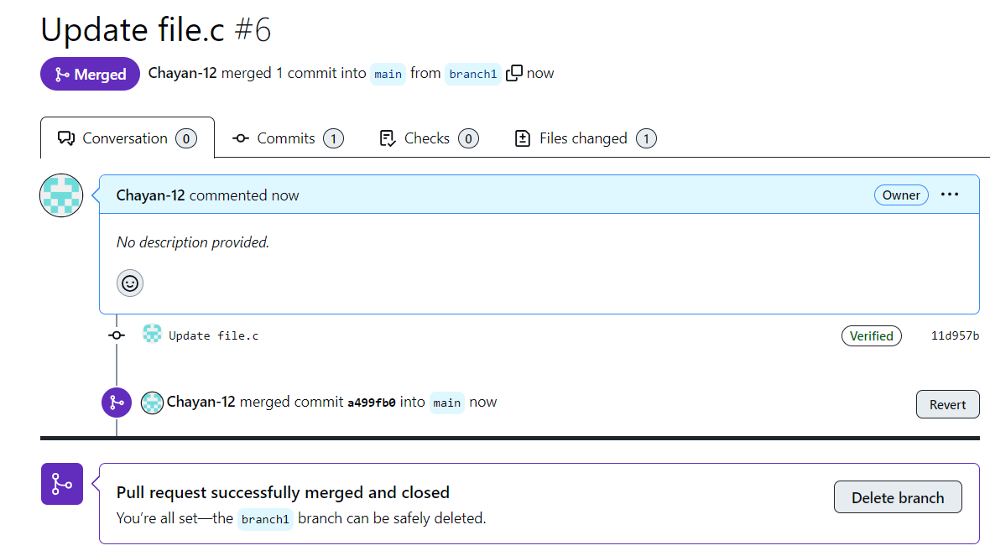

* + You can see the changes in the **main** branch.

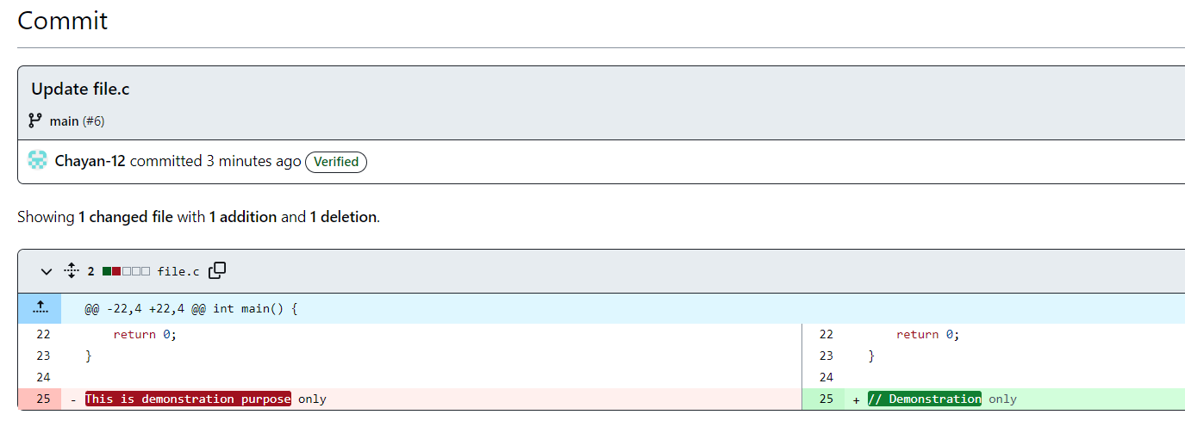

1. **Result/Output/Writing Summary:**

In this experiment, we have merge the contents of a branch to the main branch using pull request on both git bash and github.

**Learning outcomes (What I have learnt):**

* + 1. Learnt how to create a branch.
    2. Learnt how to clone a remote repo to our local system.
    3. Learnt how to create a pull request and handle their merging.
    4. Learnt to merge two branches.

**Evaluation Grid (To be created as per the SOP and Assessment guidelines by the faculty):**

|  |  |  |  |
| --- | --- | --- | --- |
| Sr. No. | Parameters | Marks Obtained | Maximum Marks |
| 1. |  |  |  |
| 2. |  |  |  |
| 3. |  |  |  |