

Software Requirements Specification

“AI-Powered Smart Expense Tracker with Budget Management and Predictive Financial Analytics”

Submitted in partial fulfillment
of the requirements of
Final Year Internship Project

Submitted By: Submitted To:
Chayan Biyani (2022BTCS015)

Introduction

Purpose
This Software Requirements Specification (SRS) document describes the functional and non-functional requirements of the AI-Powered Smart Expense Tracker with Budget Management and Predictive Financial Analytics system.
The purpose of this document is to provide a clear and detailed description of system behaviors, constraints, interfaces, and performance requirements for developers, evaluators, and stakeholders.

Scope of the System
The system is a web-based intelligent personal finance management application that enables users to:
- Securely record daily expenses
- Automatically classify expenses using AI and NLP
- Define and monitor monthly and category-wise budgets
- View analytical summaries and visual dashboards
- Receive AI-based financial advice
- Predict future expenses using machine learning models
- Detect abnormal or suspicious spending patterns
The system acts as a smart financial assistant, transforming raw expense data into actionable insights and future financial planning support.

Definitions, Acronyms, and Abbreviations

Term | Description
SRS | Software Requirements Specification
ML | Machine Learning
AI | Artificial Intelligence
NLP | Natural Language Processing
UI | User Interface
DB | Database
CRUD | Create, Read, Update, Delete
ETA | Expense Tracking Application

References
- Project Abstract & Introduction Document
- IEEE 830 / IEEE 29148 SRS Standards

Document Overview
This document is organized into sections describing:
- Overall System Description
- Functional Requirements
- Non-functional Requirements
- External Interfaces
- System Constraints
- Future Enhancements

Overall Description

Product Perspective
The system follows a multi-layer architecture:
- Frontend ~ Streamlit (Web Interface)
- Backend ~ Python (Business Logic & ML Processing)
- Database ~ MySQL (Persistent Storage)
- AI/ML Layer ~ Pandas, NumPy, Scikit-learn
- Security Layer ~ Password Hashing & Session Management
The system is a standalone web application but designed to support future integrations such as mobile apps and bank APIs.

Product Functions
Major system functions include:
- User registration and authentication
- Expense entry and storage
- Automatic expense categorization
- Budget setup and monitoring
- Expense summarization and analytics
- Financial advice generation
- Expense prediction
- Anomaly detection

User Classes and Characteristics
User Type | Description
General User | Individuals managing personal expenses
Admin | System monitoring and maintenance

Users are expected to have:
- Basic Internet usage skills
- No technical or financial expertise required

Operating Environment
- Web Browser (Chrome, Edge, Firefox)
- Operating Systems (Windows, Linux, MacOS)
- Backend Runtime (Python 3.x)
- Database Server (MySQL)

Design and Implementation Constraints
- Must use Python as backend
- Streamlit as frontend framework
- MySQL as primary database
- Open-source ML libraries only
- Internet connectivity required

Assumptions and Dependencies
- Users enter valid expense information
- ML models rely on sufficient historical data
- System performance depends on database integrity
- No direct banking integration in current version

System Features (Functional Requirements)

User Registration and Authentication
- FR-1 ~ The system shall allow new users to register using a unique username/email and password.
- FR-2 ~ The system shall encrypt user passwords using hashing techniques.
- FR-3 ~ The system shall authenticate users using session-based login.
- FR-4 ~ The system shall isolate personal expense data per user.

Expense Management
- FR-5 ~ The system shall allow users to add daily expense records.
- FR-6 ~ Expense attributes shall include:
- Amount
- Date
- Description
- Category (Auto / Manual)
- FR-7 ~ The system shall store expense data in MySQL.

AI- based Expense Classification
- FR-8 ~ The system shall automatically classify expenses using NLP and ML models.
- FR-9 ~ The system shall allow manual override of categories if needed.
- FR-10 ~ The system shall learn from historical expense descriptions.

Budget Management
- FR-11 ~ The system shall allow users to define a monthly budget.
- FR-12 ~ The system shall allow category-wise budget limits.
- FR-13 ~ The system shall track budget consumption.
- FR-14 ~ The system shall notify users when budget exceeds limits.

Expense Summarization and Visualization
- FR-15 ~ The system shall generate expense summaries for:
- Daily
- Weekly
- Monthly
- Custom Date Ranges
- FR-16 ~ The system shall display category-wise breakdowns.
- FR-17 ~ The system shall display interactive charts and dashboards.

AI-based Financial Advice
- FR-18 ~ The system shall analyze spending behavior.
- FR-19 ~ The system shall generate personalized saving suggestions.
- FR-20 ~ The system shall highlight high-spending categories.

Future Expense Prediction
- FR-21 ~ The system shall predict next month’s expenses.
- FR-22 ~ The system shall generate yearly spending trends.
- FR-23 ~ The system shall use ML models such as:
- Linear Regression
- Moving Averages
- Time Series Forecasting

Anomaly and Fraud Detection
- FR-24 ~ The system shall detect unusual high expenses.
- FR-25 ~ The system shall flag sudden spending spikes.
- FR-26 ~ The system shall notify users of detected anomalies.

Non-Functional Requirements

Performance Requirements
- System Response Time ≤ 2 seconds for normal operations.
- ML predictions generated within acceptable processing time.
- Support multiple users concurrently.

Security Requirements
- Encrypted Password Storage.
- Secure Session Handling.
- Role-based Data Isolation.
- No unauthorized access to expense data.

Usability Requirements
- Simple and Intuitive UI.
- Minimal user input required.
- Clear visual representation of data.
- Beginner-friendly navigation.

Reliability and Availability
- System Uptime ≥ 99%.
- Automatic recovery from minor failures.
- Consistent data storage and retrieval.

Scalability Requirements
- Support increasing number of users.
- Handle large historical expense datasets.
- Extendable ML models.

Maintainability
- Modular Code Structure.
- Easy Model updates.
- Well-documented Database Schema.

External Interface Requirements

User Interface
- Web-based interface built using Streamlit.
- Interactive Dashboards.
- Forms for Expense Entry and Budgeting.

Hardware Interfaces
- No specific hardware dependency.
- Standard Computer or Mobile browser sufficient.

Software Interfaces
- MySQL Database.
- Python ML Libraries.
- Authentication Libraries.

System Flow Description
- User accesses Streamlit web application.
- User registers / logs in.
- User adds expense details.
- AI classifies the expense.
- Data is stored in MySQL.
- User views dashboards and summaries.
- ML module predicts future expenses.
- AI generate financial advice for the user.
- User is alerted in case of limits or anomalies.

Use-Case Diagrams and Use-Case Scenarios

Use-Case Diagram (Textual + Diagrammatic Representation)
- Primary Actor
- User ~ A registered individual using the Smart Expense Tracker System.
- System
- AI-Powered Smart Expense Tracker System
- Main Use-Cases
- Register User
- Login User
- Logout User
- Add Expense
- Auto-Classify Expense
- Edit / Delete Expense
- Set Monthly Budget
- Set Category-wise Budget
- Track Budget Usage
- View Expense Summary
- View Dashboard
- Generate Financial Advice
- Predict Future Expenses
- Detect Spending Anomalies

- Use-Case Diagram
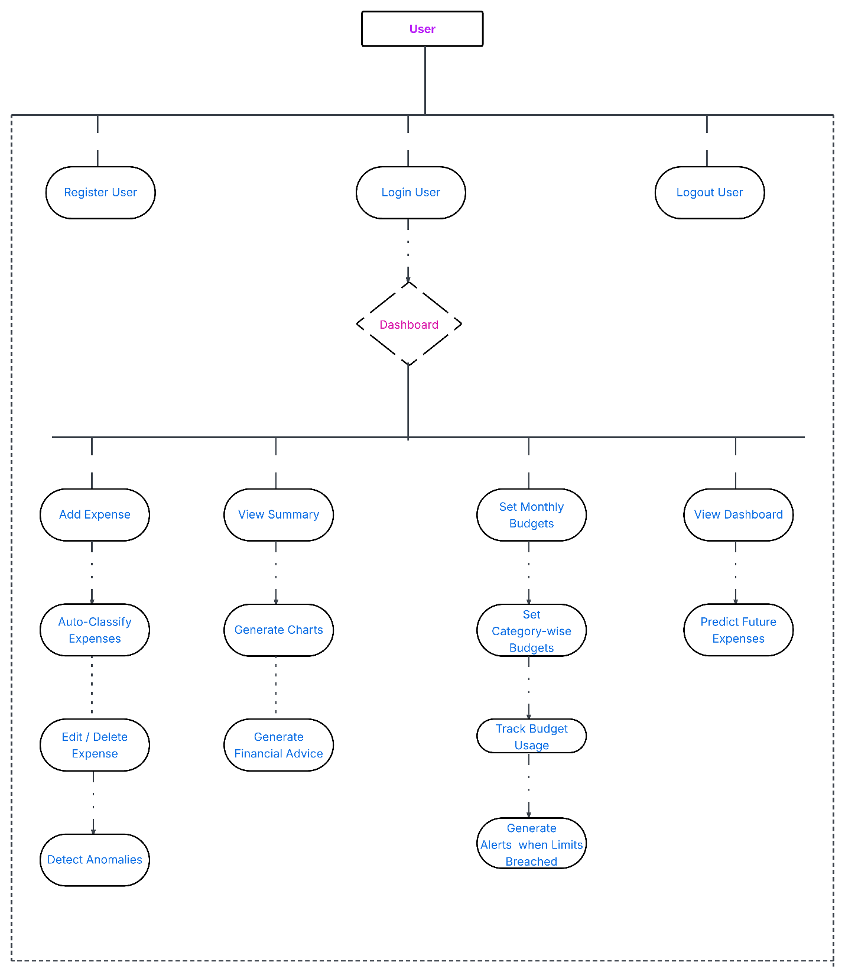

Detailed Use-Case Scenarios
- UC-01: Register User
- Actor – User
- Precondition – User not registered
- Postcondition – Account created
- Main Flow –
User opens application → Selects Register → Enters email / username & password → System hashes password → Stores data in database → Registration successful
- Alternate Flow –
User exists → Error message
- UC-02: Login User
- Actor – User
- Precondition – User registered
- Postcondition – Session created
- Main Flow –
User enters credentials → System validates details → Session started → Dashboard displayed
- UC-03: Logout User
- Actor – User
- Postcondition – Session terminated
- UC-04: Add Expense
- Actor – User
- Precondition – Logged in
- Postcondition – Expense saved
- Main Flow –
User enters amount, date, description → Submits expense → Data sent to AI engine → Stored in database
- UC-05: Auto-Classify Expense
- Actor – ML/AI engine
- Precondition – Expense added
- Postcondition – Category assigned
- Main Flow –
NLP processes description → ML predicts category → Category assigned automatically
- UC-06: Edit/Delete Expense
- Actor – User
- Precondition – Expense exists
- Postcondition – Expense updated / removed
- UC-07: Set Monthly Budget
- Actor – User
- Postcondition – Budget stored
- UC-08: Set Category-wise Budget
- Actor – User
- Postcondition – Category limits applied
- UC-09: Track Budget Usage
- Actor – System
- Postcondition – Budget usage updated
- Main Flow –
System compares expenses v/s budgets → Calculates remaining amount → Generates alert if exceeded
- UC-10: View Expense Summary
- Actor – User
- Precondition – Expenses exist
- Postcondition – Summary displayed
- Main Flow –
User selects date range → System fetches data → Displays totals and charts
- UC-11: View Dashboard
- Actor – User
- Postcondition – Insights displayed
- Includes –
Spending Charts, Budget Status, Predictions, Alerts
- UC-12: Generate Financial Advice
- Actor – System
- Precondition – Sufficient data
- Postcondition – Advice shown
- Example – “You spend 42% on Shopping. Reducing this by 10% can save ₹2500/month.”
- UC-13: Predict Future Expenses
- Actor – ML engine
- Precondition – Historical data
- Postcondition – Forecast generated
- Uses –
Linear Regression, Moving Average, Time-Series Models
- UC-14: Detect Spending Anomalies
- Actor – System
- Precondition – Expense added
- Postcondition – Alert generated
- Example – “₹15000 spent on Travel – higher than your usual average.”

Future Enhancements
- Mobile Application
- Cloud Deployment
- Bank API Integration
- Chatbot-based Financial Assistant
- Voice Input Support
- Multi-Currency Handling

Conclusion
The AI-Powered Smart Expense Tracker System provides a comprehensive, intelligent, and scalable solution for personal finance management. By integrating full-stack development, machine learning, and data analytic, the system effectively transforms raw financial data into meaningful insights and predictive financial guidance, making it ideal for real-world FinTech applications and academic evaluation.

10. Appendix

