IBM SkillsBuild Internship Program
Project Report
Healthcare Data Analysis:
Breast Cancer Diagnosis Prediction Using Machine Learning
Domain: Healthcare Analytics
Dataset: Breast Cancer Wisconsin (Diagnostic) Data Set

Submitted by
Name : Chayan Das
Internship ID: IBMUEDA2734
BTech in CSE, 3rd Year - 2026

1. Introduction
Healthcare analytics uses data-driven techniques to improve diagnosis, treatment, and patient outcomes. Early and accurate detection of diseases such as breast cancer significantly improves survival rates and treatment effectiveness. This project applies data analytics and machine learning techniques to a real-world healthcare dataset to explore patterns in cell-nuclei measurements and to build a predictive model capable of classifying tumors as Malignant or Benign.
This report documents the complete workflow followed for this project — from data understanding and exploratory analysis to model building, evaluation, and the insights derived — as part of the IBM SkillsBuild Internship Data Analytics track.

2. Problem Statement & Objectives
Breast cancer diagnosis traditionally relies on manual examination of biopsy samples, which can be time-consuming and subject to human variability. The objective of this project is to demonstrate how data analytics and machine learning can support faster, data-driven diagnostic decisions.

Objectives
- Perform exploratory data analysis (EDA) to understand the structure and characteristics of the dataset.
- Identify which cell-nuclei features are most strongly associated with malignant diagnoses.
- Build and compare classification models to predict tumor diagnosis.
- Evaluate model performance using standard classification metrics.
- Derive actionable insights that could support clinical decision-making.

3. Dataset Description
The project uses the Breast Cancer Wisconsin (Diagnostic) Data Set, a well-known public dataset originally from the UCI Machine Learning Repository and made available directly through scikit-learn's built-in datasets module.
- Total records: 569 biopsy samples
- Total features: 30 numeric features, describing the mean, standard error, and "worst" (largest) values of 10 real-valued cell-nuclei characteristics
- Feature categories: radius, texture, perimeter, area, smoothness, compactness, concavity, concave points, symmetry, and fractal dimension
- Target variable: Diagnosis — Malignant (212 cases) or Benign (357 cases)
- Missing values: None — the dataset is clean and required no imputation

4. Methodology
The project followed a structured data analytics pipeline:
- Data Loading — imported the dataset via scikit-learn and converted it to a labeled pandas DataFrame.
- Data Understanding & Cleaning — checked shape, data types, missing values, and class balance.
- Exploratory Data Analysis — visualized class distribution, feature correlations, and distributions by diagnosis.
- Preprocessing — split data into 80% training / 20% testing sets (stratified by class), and standardized features using StandardScaler.
- Model Building — trained two classification models: Logistic Regression and Random Forest.
- Evaluation — assessed models using accuracy, precision, recall, F1-score, ROC-AUC, and confusion matrix.

5. Exploratory Data Analysis
Exploratory analysis was carried out to understand the distribution of the target classes and the relationships between key features and diagnosis outcomes.

5.1 Class Distribution
The dataset is moderately imbalanced, with more benign cases (357) than malignant cases (212). This was accounted for using stratified train/test splitting.
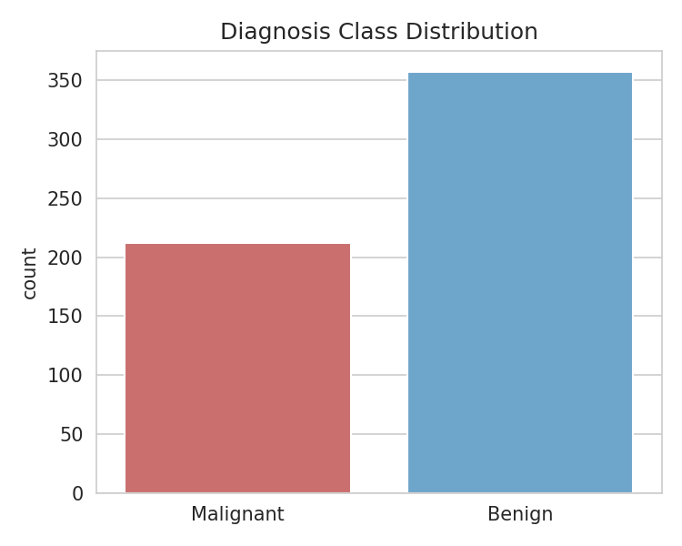
Figure 1: Diagnosis class distribution

5.2 Feature Correlation
A correlation heatmap of the top features most related to mean radius shows strong positive correlations among size-related measurements (radius, perimeter, area) and concavity-related measurements, indicating potential multicollinearity that scaling and tree-based models help address.
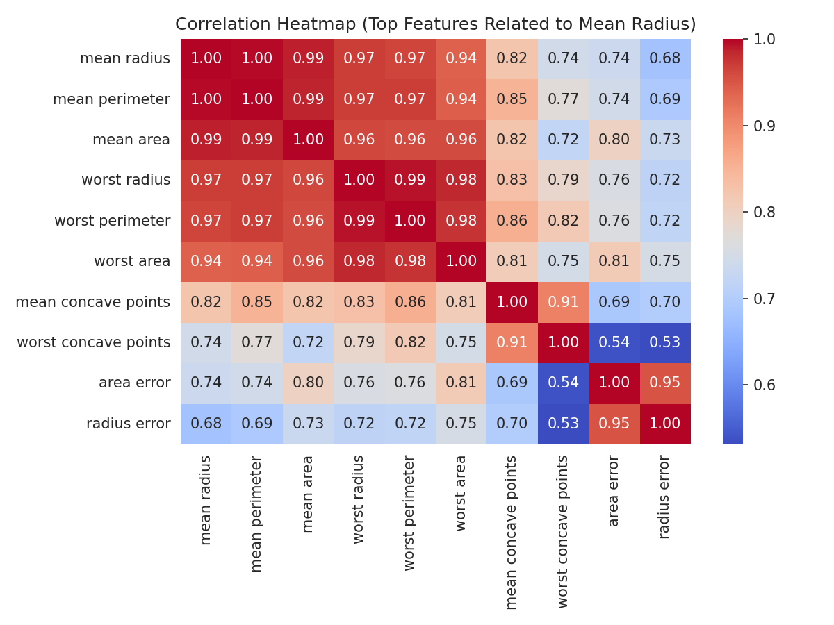
Figure 2: Correlation heatmap of top related features

5.3 Feature Distributions by Diagnosis
Boxplots comparing key features across diagnosis classes reveal that malignant tumors consistently show higher median values for mean radius, texture, concavity, and smoothness compared to benign tumors.
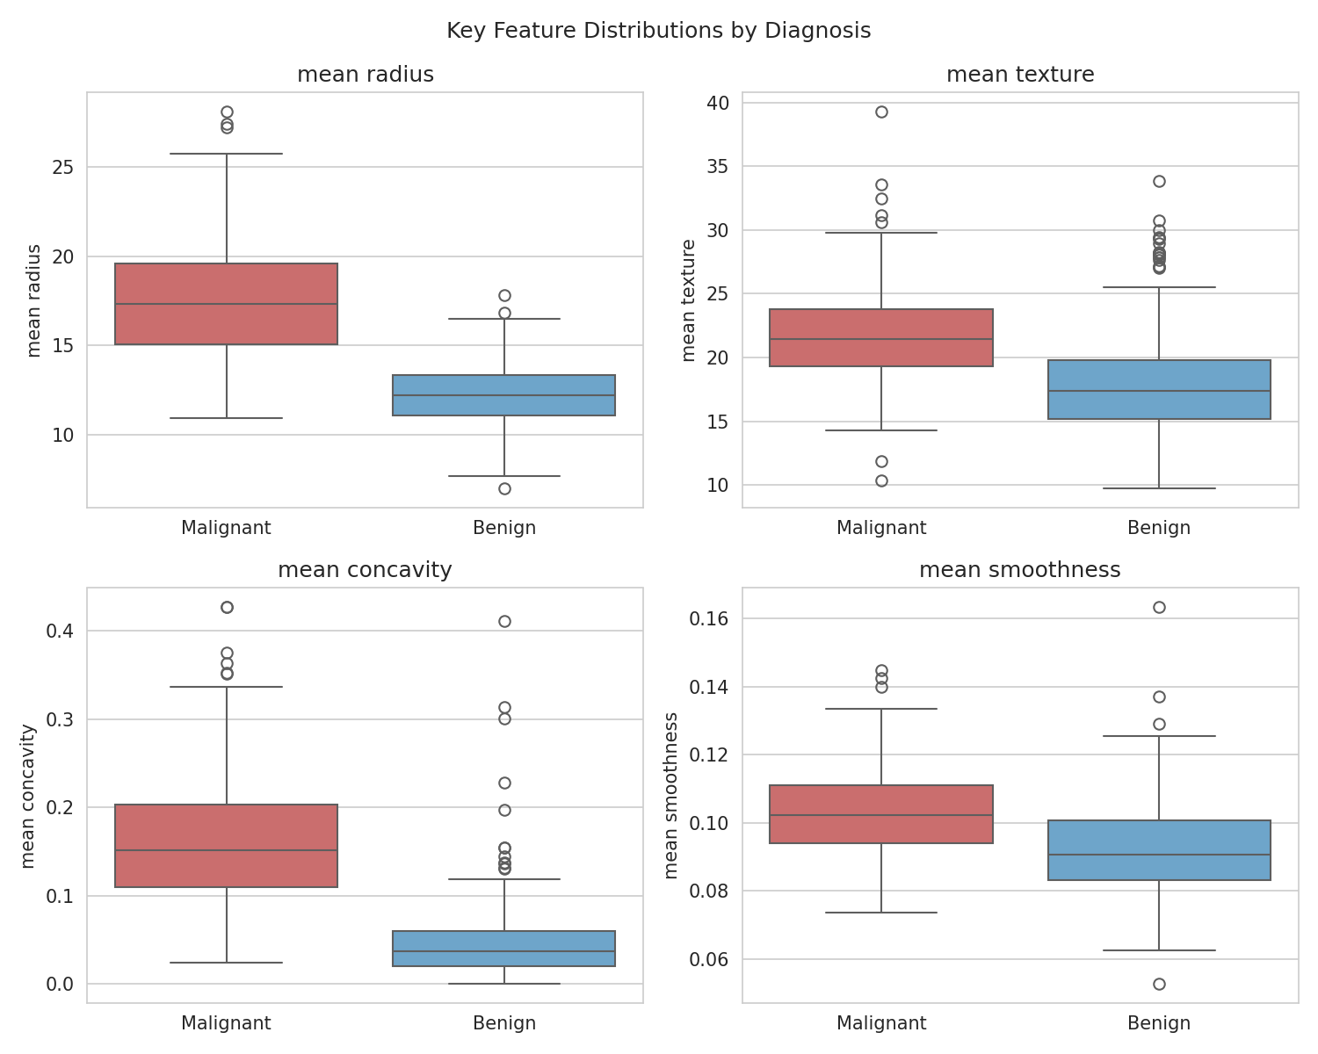
Figure 3: Key feature distributions by diagnosis

5.4 Feature Relationships
A scatter plot of mean radius against mean concave points shows a clear separating trend between the two diagnosis classes, suggesting these are strong candidate predictors for classification.
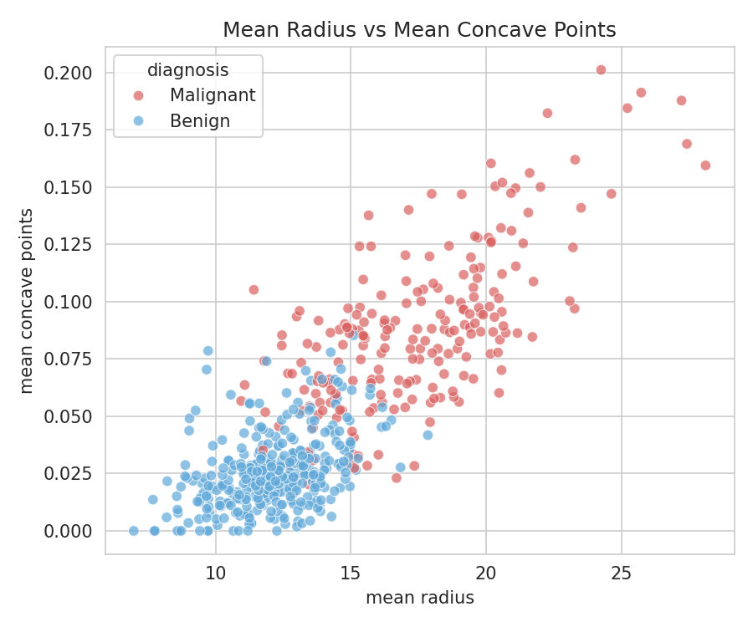
Figure 4: Mean radius vs. mean concave points, by diagnosis

6. Model Building
Two supervised classification algorithms were trained and compared on the standardized, stratified train/test split (80/20):
- Logistic Regression — a linear model well-suited to binary classification problems with interpretable coefficients.
- Random Forest Classifier (200 estimators) — an ensemble tree-based model capable of capturing non-linear relationships and providing feature importance rankings.
Both models were trained on the same preprocessed data to allow a fair performance comparison.

7. Results & Evaluation

7.1 Performance Comparison
Model | Accuracy | Precision | Recall | F1-Score | ROC-AUC
Logistic Regression | 98.25% | 98.61% | 98.61% | 98.61% | 0.9954
Random Forest | 95.61% | 95.89% | 97.22% | 96.55% | 0.9932
The Logistic Regression model achieved the strongest overall performance on the test set, with 98.25% accuracy and a ROC-AUC of 0.995.

7.2 Confusion Matrix
The confusion matrix for the Random Forest model below illustrates the number of correctly and incorrectly classified cases on the held-out test set.
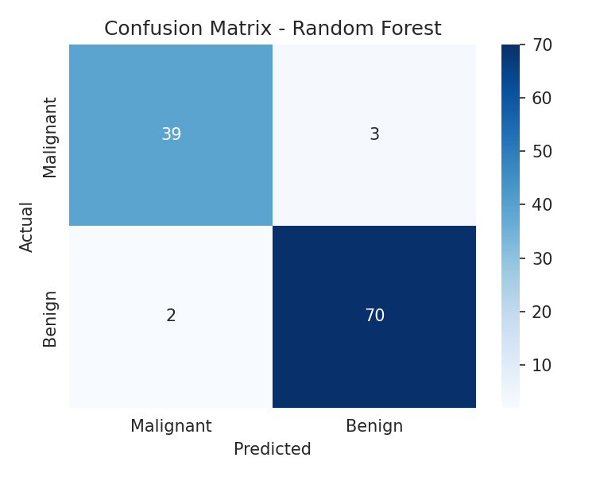
Figure 5: Confusion matrix — Random Forest

7.3 Feature Importance
The Random Forest model's feature importance ranking highlights which measurements contributed most to its predictions — dominated by features related to cell concavity, area, and perimeter.
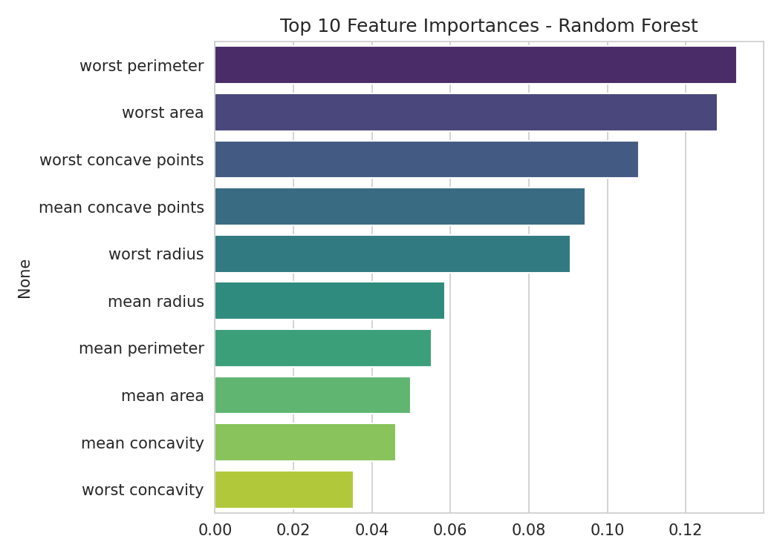
Figure 6: Top 10 feature importances — Random Forest

7.4 ROC Curve Comparison
The ROC curve comparison below shows both models achieve high true-positive rates at low false-positive rates, with AUC scores above 0.99 for both models, indicating excellent discriminative ability.
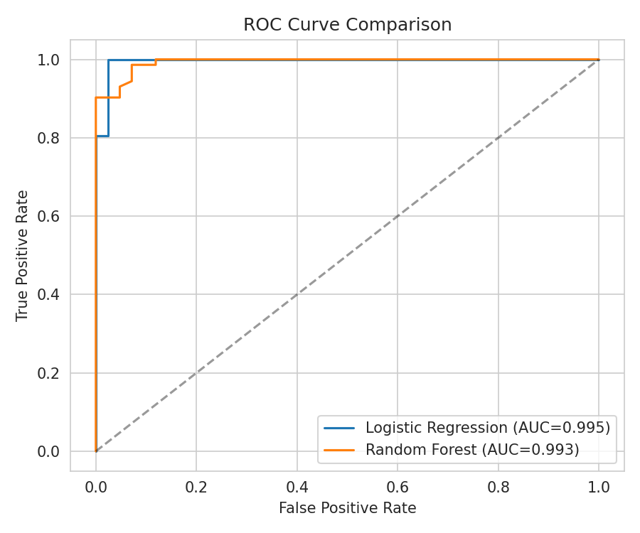
Figure 7: ROC curve comparison

8. Key Insights
- Cell concavity, area, and perimeter-related features are the strongest indicators of malignancy in this dataset.
- Both models achieved very high recall on the malignant class — critical in a healthcare setting, where missing a true malignant case (a false negative) carries far greater risk than a false positive.
- Feature scaling and stratified sampling were important preprocessing steps given the moderate class imbalance and differing feature scales.
- The high separability seen in EDA (e.g., mean radius vs. mean concave points) explains why relatively simple models like Logistic Regression performed competitively with ensemble methods.

9. Conclusion
This project demonstrated a complete healthcare data analytics workflow — from raw data exploration to a working diagnostic classification model. Both Logistic Regression and Random Forest models achieved strong, clinically promising performance (above 95% accuracy and 0.99 ROC-AUC), showing that machine learning can meaningfully support breast cancer diagnosis based on quantitative cell-nuclei measurements. The analysis reinforces the value of combining thorough EDA with model evaluation metrics that matter most in a healthcare context, such as recall on the positive (malignant) class.

10. Future Scope
- Hyperparameter tuning using GridSearchCV or RandomizedSearchCV to further optimize model performance.
- K-fold cross-validation to obtain more robust and generalizable performance estimates.
- Experimenting with additional algorithms such as Support Vector Machines, Gradient Boosting, or XGBoost.
- Validating the model on external, real-world clinical datasets to assess generalizability.
- Building an interactive dashboard or web application for clinicians to use the model in practice.

11. References
- Wolberg, W.H., Street, W.N., & Mangasarian, O.L. Breast Cancer Wisconsin (Diagnostic) Data Set, UCI Machine Learning Repository.
- scikit-learn documentation: https://scikit-learn.org/stable/datasets/toy_dataset.html#breast-cancer-dataset
- IBM SkillsBuild Internship Program — Data Analytics track guidelines.

