**Property Analysis BI Developer - On-boarding Task – 1**

Question (a). Display a list of all property names and their property id’s for Owner Id: 1426.

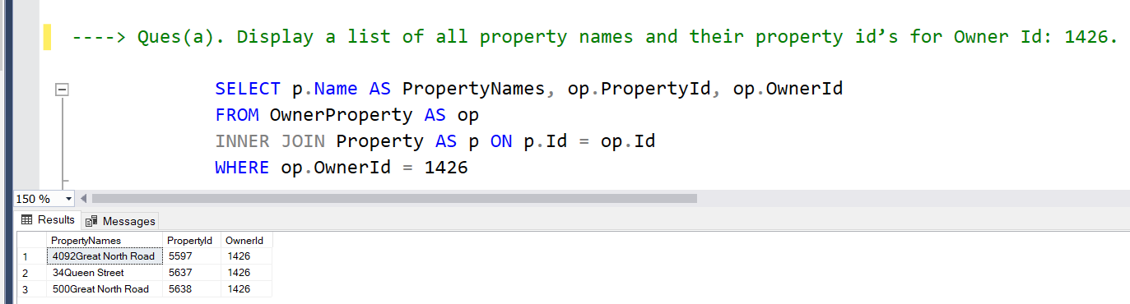

Question (b). Display the current home value for each property in question a).

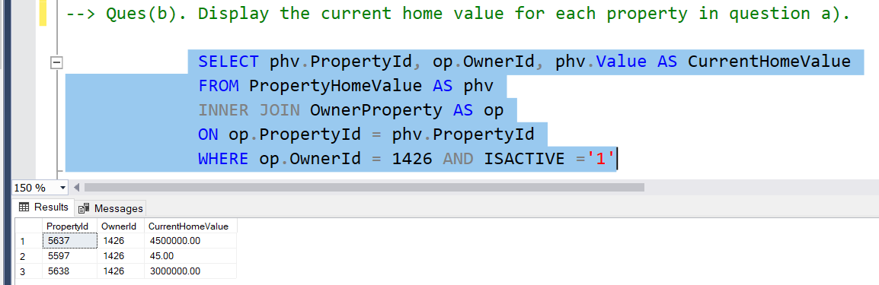

Question (c). For each property in question a), return the following:

(i).Using rental payment amount, rental payment frequency, tenant start date and tenant end date to write a query that returns the sum of all payments from start date to end date.

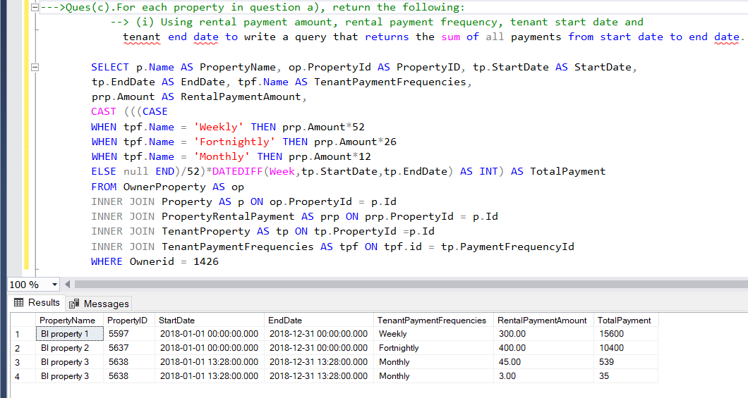

(ii). Display the yield

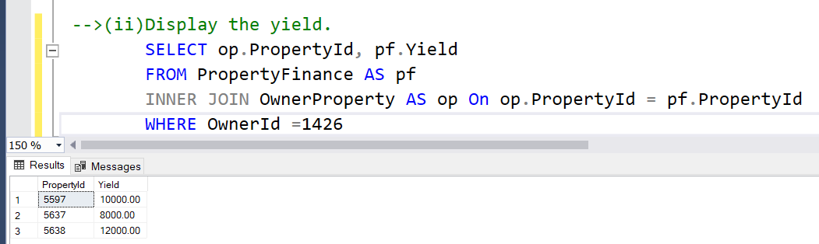

Question (d). Display all the jobs available

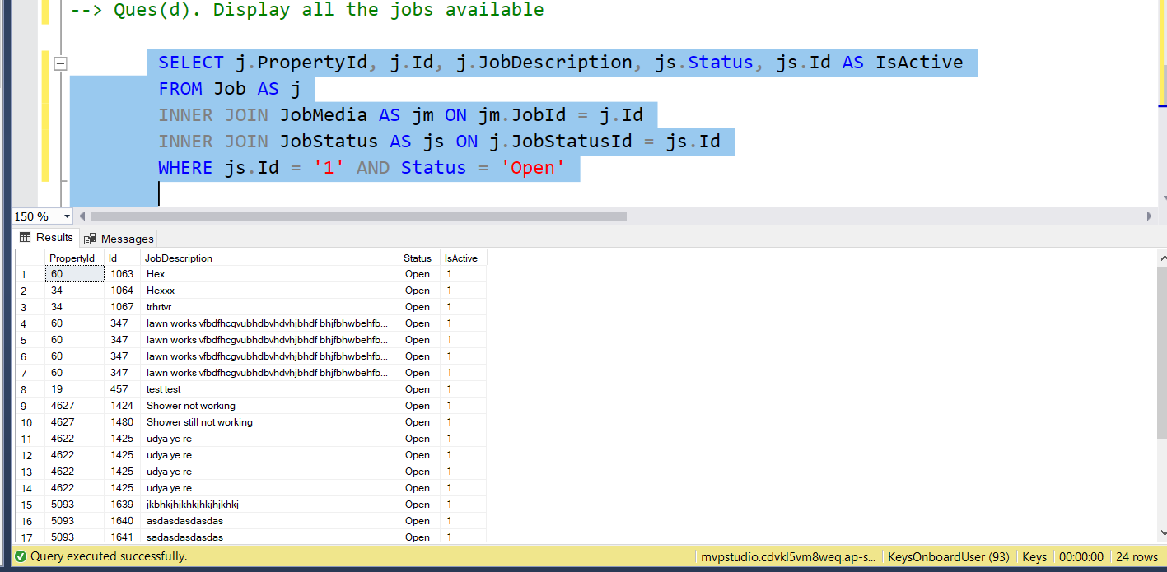

Question (e). Display all property names, current tenants first and last names and rental payments per week/ fortnight/month for the properties in question a).

