ANNEXE A

Codes sources PlantUML
des diagrammes UML du mémoire de soutenance

Plateforme Barsha — projet de fin d'études

Cette annexe contient l'intégralité du code source PlantUML utilisé pour produire les douze diagrammes UML reproduits dans le mémoire principal (Rapport_PFE_Barsha_Soutenance.docx). Pour chaque diagramme :
- Le code source PlantUML est reproduit en intégralité dans un bloc de code monospace.
- L'image rendue (PNG) est insérée à la suite, à des fins de relecture conjointe.
- Le code peut être régénéré via la commande : java -jar plantuml.jar -tpng <fichier>.puml
Tous les fichiers .puml sont également versionnés dans le dépôt source du projet, sous docs/_build/puml/. Toute modification ultérieure des diagrammes doit se faire en éditant ces fichiers et en relançant le rendu, afin de préserver la traçabilité.

Table des matières
Cliquez ici puis appuyez sur F9 pour mettre à jour la table des matières.

A.1 Diagramme de cas d'utilisation
Fichier source : docs/_build/puml/01_use_cases.puml
Code PlantUML :
@startuml use_cases
!theme plain
skinparam backgroundColor white
skinparam ActorFontSize 12
skinparam UsecaseFontSize 11
skinparam Padding 4
skinparam DefaultFontName "Segoe UI"
left to right direction
title Diagramme de cas d'utilisation — plateforme Barsha
actor "Visiteur" as V
actor "Client" as C
actor "Vendeur\n(marketplace)" as S
actor "Administrateur" as A
actor "Système IA\n(Ollama, CLIP, FastAPI)" as AI
actor "Passerelles externes\n(SMTP, SMS, CTP, TTN, Shipping)" as EXT
C -|> V
rectangle "Storefront Barsha" {
usecase "Consulter le catalogue" as UC1
usecase "Rechercher un produit\n(texte / visuel)" as UC2
usecase "Filtrer / trier" as UC3
usecase "S'inscrire / se connecter" as UC4
usecase "Gérer son compte\n& adresses" as UC5
usecase "Ajouter au panier" as UC6
usecase "Passer commande" as UC7
usecase "Payer (CTP / COD)" as UC8
usecase "Suivre la livraison" as UC9
usecase "Demander un retour (RMA)" as UC10
usecase "Gérer favoris\n& wishlist" as UC11
usecase "Discuter avec l'assistant IA" as UC12
usecase "Recevoir des recommandations" as UC13
usecase "Recherche visuelle\n(image)" as UC14
usecase "Laisser un avis / poser\nune question (Q&A)" as UC15
usecase "Souscrire newsletter" as UC16
usecase "Programme de fidélité\n& parrainage" as UC17
usecase "Demande RGPD\n(export / effacement)" as UC18
}
rectangle "Espace vendeur" {
usecase "Postuler comme vendeur" as UC20
usecase "Gérer ses produits\n& fulfillments" as UC21
usecase "Consulter ses payouts" as UC22
}
rectangle "Back-office Admin" {
usecase "Dashboard & KPIs" as UC30
usecase "Gérer commandes\n& retours" as UC31
usecase "Gérer catalogue, stock,\nentrepôts" as UC32
usecase "Gérer marketing\n(coupons, lifecycle, drops)" as UC33
usecase "Gérer marketplace\n(approbations, payouts)" as UC34
usecase "Conformité fiscale (TTN),\nRGPD, fraude" as UC35
usecase "Configurer pricing\ndynamique & règles" as UC36
usecase "Modération UGC IA" as UC37
}
V --> UC1
V --> UC2
V --> UC3
V --> UC4
V --> UC12
V --> UC13
V --> UC14
V --> UC16
C --> UC5
C --> UC6
C --> UC7
C --> UC8
C --> UC9
C --> UC10
C --> UC11
C --> UC15
C --> UC17
C --> UC18
S --> UC20
S --> UC21
S --> UC22
A --> UC30
A --> UC31
A --> UC32
A --> UC33
A --> UC34
A --> UC35
A --> UC36
A --> UC37
UC2 ..> AI : <<include>>
UC12 ..> AI : <<include>>
UC13 ..> AI : <<include>>
UC14 ..> AI : <<include>>
UC37 ..> AI : <<include>>
UC8 ..> EXT : <<include>>
UC9 ..> EXT : <<include>>
UC35 ..> EXT : <<include>>
@enduml
Rendu :
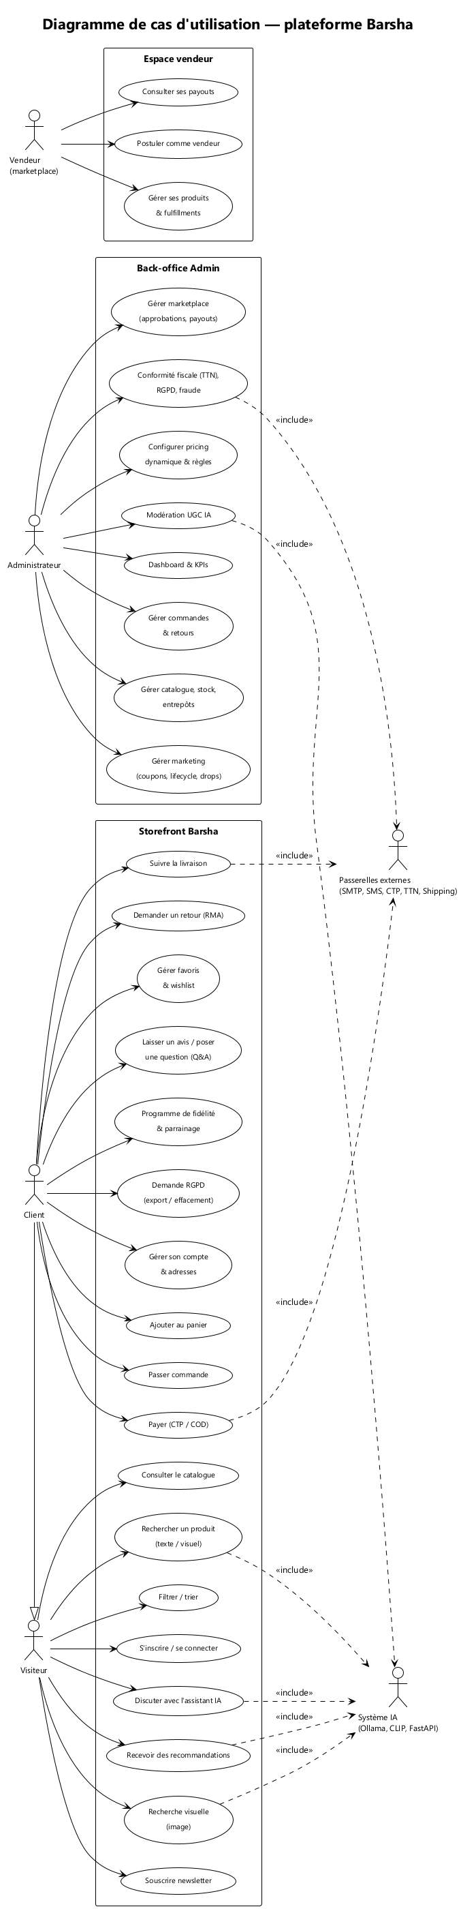
Figure 1 — Diagramme de cas d'utilisation de la plateforme Barsha

A.2 Architecture logicielle globale
Fichier source : docs/_build/puml/02_architecture.puml
Code PlantUML :
@startuml architecture
!theme plain
skinparam backgroundColor white
skinparam DefaultFontName "Segoe UI"
skinparam ComponentBackgroundColor #F5F7FA
skinparam ComponentBorderColor #4F6D8C
skinparam DatabaseBackgroundColor #FFF6E5
skinparam ArrowColor #4F6D8C
skinparam Padding 4
title Architecture globale — plateforme Barsha (vue logicielle)
actor "Client / Admin\n(navigateur)" as User
package "Couche présentation" #FAFCFE {
component "Angular 19 SPA\n(storefront + admin)" as NG
component "Service Worker\n(offline + PWA)" as SW
}
package "Reverse-proxy & CDN" #F0F8FF {
component "nginx / Cloudflare" as NGINX
}
package "Couche application" #FAFCFE {
component "NestJS 10\n(API métier — 50+ modules)" as NEST
component "Python FastAPI\n(ai-service)" as FAST
component "Ollama\n(qwen2.5:7b LLM)" as OLLAMA
}
package "Couche données" #FFF8E5 {
database "MSSQL 2022\n(base relationnelle)" as DB
database "Meilisearch\n(index recherche)" as MEI
}
package "Services externes" #F4F4FB {
cloud "SMTP" as SMTP
cloud "SMS\n(Twilio / Infobip)" as SMS
cloud "CTP / Konnekt\n(paiement)" as CTP
cloud "FirstDelivery / Aramex\n(transporteurs)" as SHIP
cloud "TTN\n(fiscal Tunisie)" as TTN
cloud "Gemini / OpenRouter\n(LLM cloud fallback)" as CLOUD
}
User --> NGINX : HTTPS
NGINX --> NG : "/" SPA
NGINX --> NEST : "/api/*"
NGINX --> NEST : "/indexes/*"
NG ..> SW : install
NEST --> DB : TypeORM
NEST --> MEI : REST
NEST --> FAST : HTTP
NEST --> SMTP
NEST --> SMS
NEST --> CTP
NEST --> SHIP
NEST --> TTN
FAST --> OLLAMA : chat
FAST --> CLOUD : fallback
FAST --> MEI : grounding produits
@enduml
Rendu :
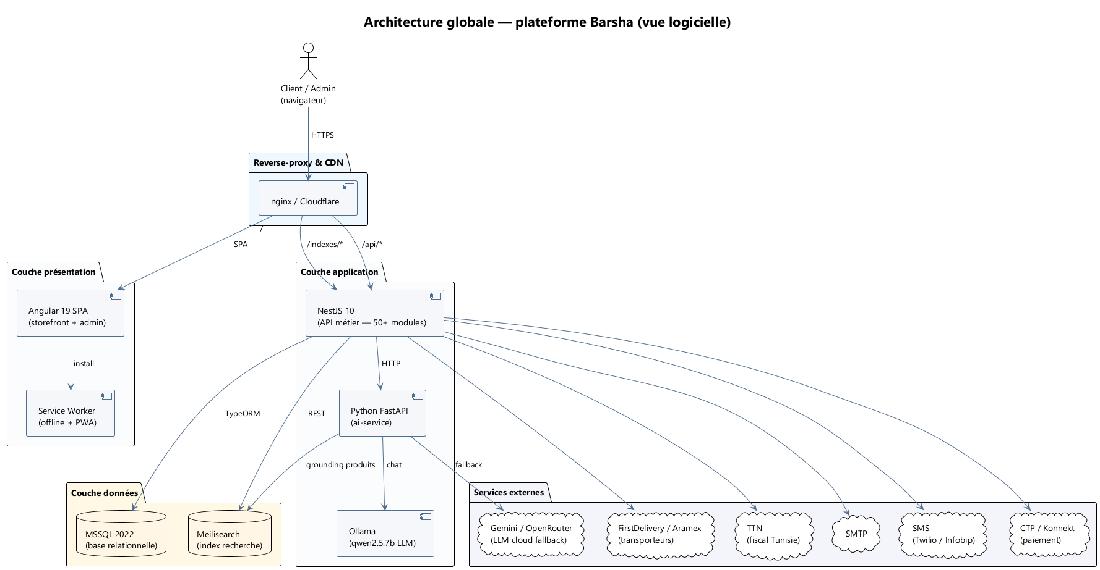
Figure 2 — Architecture logicielle globale

A.3 Diagramme de déploiement
Fichier source : docs/_build/puml/03_deployment.puml
Code PlantUML :
@startuml deployment
!theme plain
skinparam backgroundColor white
skinparam DefaultFontName "Segoe UI"
skinparam Padding 4
title Diagramme de déploiement — environnement staging single-host (docker-compose.staging.yml)
node "Poste client" as Client {
artifact "Navigateur\nChrome / Edge / Safari" as Browser
}
cloud "Internet" as Net
node "Hôte staging (Docker host)" as Host {
node "Conteneur frontend" as N1 {
artifact "nginx:1.27-alpine" as Nginx
artifact "dist/barsha/browser/\n(SPA Angular 19)" as Spa
}
node "Conteneur backend" as N2 {
artifact "node:20-alpine" as Node
artifact "dist/main.js\n(NestJS 10)" as NestApp
artifact "dist/scripts/\nrun-migrations.js" as Mig
}
node "Conteneur ai-service" as N3 {
artifact "python:3.11-slim" as Py
artifact "main.py FastAPI\n+ CLIP weights" as AiApp
}
node "Conteneur ollama" as N4 {
artifact "ollama/ollama:latest" as Ollama
artifact "modèle qwen2.5:7b" as Model
}
node "Conteneur mssql" as N5 {
database "mcr.../mssql/server:2022\n(volume mssql-data)" as Mssql
}
node "Conteneur meilisearch" as N6 {
database "getmeili/meilisearch:v1.6\n(volume meili-data)" as Meili
}
}
cloud "Services externes" as External {
artifact "SMTP — Mailtrap / SendGrid" as Smtp
artifact "Twilio / Infobip" as SmsP
artifact "CTP / Konnekt" as Ctp
artifact "FirstDelivery / Aramex" as Ship
artifact "TTN — fiscal Tunisie" as Ttn
}
Browser --> Net : 443
Net --> Nginx : 80
Nginx --> NestApp : proxy_pass /api
Nginx --> NestApp : proxy_pass /indexes
NestApp --> Mssql : tedious 1433
NestApp --> Meili : 7700
NestApp --> AiApp : 8001
NestApp --> Smtp
NestApp --> SmsP
NestApp --> Ctp
NestApp --> Ship
NestApp --> Ttn
AiApp --> Ollama : 11434
AiApp --> Meili : 7700
Mig ..> Mssql : applique migrations\nau premier boot
@enduml
Rendu :
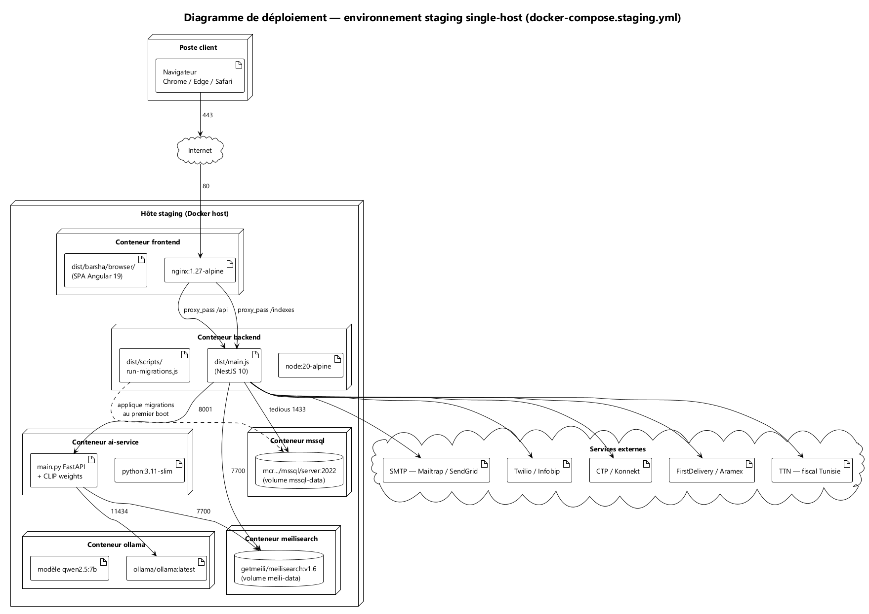
Figure 3 — Diagramme de déploiement (staging single-host)

A.4 Diagramme de classes
Fichier source : docs/_build/puml/04_class_diagram.puml
Code PlantUML :
@startuml class_diagram
!theme plain
skinparam backgroundColor white
skinparam DefaultFontName "Segoe UI"
skinparam ClassFontSize 11
skinparam Padding 4
skinparam ClassBackgroundColor #FAFCFE
skinparam ClassBorderColor #4F6D8C
skinparam ArrowColor #4F6D8C
hide circle
title Diagramme de classes (extrait — domaine commerce, IA, marketplace)
class User {
+id: number
+email: string
+password_hash: string
+role: UserRole
+first_name: string
+last_name: string
+phone: string
+is_email_verified: bool
+is_phone_verified: bool
+created_at: datetime
}
class Address {
+id: number
+line1: string
+city: string
+postal_code: string
+country: string
+is_default: bool
}
class StyleProfile {
+preferred_sizes: json
+preferred_colors: json
+occasions: json
}
class Product {
+id: number
+name: string
+slug: string
+description: text
+price: decimal
+sale_price: decimal
+total_stock: int
+seller_id: number
+meta_title: string
+is_active: bool
}
class ProductVariant {
+id: number
+sku: string
+size: string
+color: string
+stock: int
}
class ProductImage {
+url: string
+position: int
}
class Category {
+id: number
+name: string
+slug: string
+parent_id: number
}
class Cart {
}
class CartItem {
+quantity: int
+unit_price: decimal
}
class Order {
+id: number
+order_number: string
+status: OrderStatus
+total: decimal
+placed_at: datetime
+shipping_method: string
}
class OrderItem {
+quantity: int
+unit_price: decimal
+seller_id: number
}
class Payment {
+method: PaymentMethod
+status: PaymentStatus
+amount: decimal
+ctp_transaction_id: string
}
class Shipment {
+tracking_number: string
+carrier: string
+status: ShipmentStatus
}
class Coupon {
+code: string
+discount_type: DiscountType
+amount: decimal
+valid_until: datetime
}
class Seller {
+id: number
+business_name: string
+legal_name: string
+commission_rate: decimal
+status: SellerStatus
}
class SellerFulfillment {
+order_item_id: number
+status: FulfillmentStatus
+tracking_number: string
}
class SellerPayout {
+period_start: date
+period_end: date
+gross_amount: decimal
+commission: decimal
+net_amount: decimal
}
class Warehouse {
+code: string
+name: string
+city: string
+is_default: bool
}
class ProductStock {
+quantity: int
+reserved: int
+safety_stock: int
}
class ReturnRequest {
+reason: string
+status: ReturnStatus
}
class Review {
+rating: int
+body: text
}
class GdprRequest {
+type: GdprRequestType
+status: GdprRequestStatus
}
class FraudSignal {
+severity: SignalSeverity
+signal_type: string
}
class Recommendation {
+strategy: string
+score: float
}
class LifecycleSequence {
+trigger_event: string
+steps: json
}
User "1" --> "*" Address
User "1" --> "0..1" StyleProfile
User "1" --> "*" Order
User "1" --> "*" Cart
User "1" --> "*" Review
User "1" --> "*" GdprRequest
Cart "1" --> "*" CartItem
CartItem "*" --> "1" Product
Product "*" --> "1" Category
Product "1" --> "*" ProductVariant
Product "1" --> "*" ProductImage
Product "*" --> "0..1" Seller
Product "1" --> "*" ProductStock
ProductStock "*" --> "1" Warehouse
Order "1" --> "*" OrderItem
Order "1" --> "*" Payment
Order "1" --> "*" Shipment
Order "1" --> "*" ReturnRequest
Order "*" --> "0..*" Coupon
OrderItem "*" --> "1" Product
OrderItem "1" --> "0..1" SellerFulfillment
Seller "1" --> "*" SellerPayout
Seller "1" --> "*" SellerFulfillment
Review "*" --> "1" Product
Recommendation "*" --> "1" User
Recommendation "*" --> "1" Product
@enduml
Rendu :
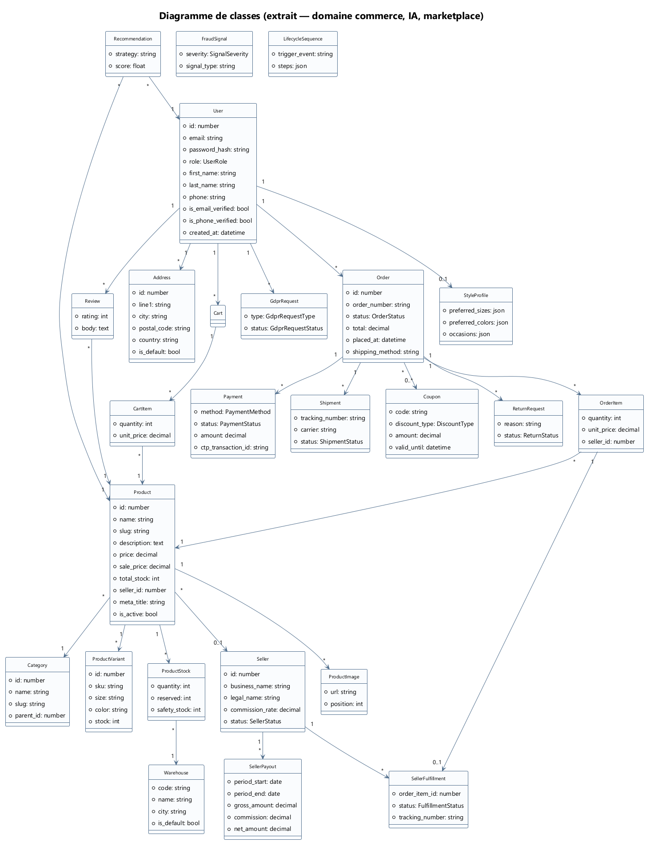
Figure 4 — Diagramme de classes (extrait — domaine commerce, marketplace et IA)

A.5 Modèle conceptuel de données (ER)
Fichier source : docs/_build/puml/05_er_model.puml
Code PlantUML :
@startuml er_model
!theme plain
skinparam backgroundColor white
skinparam DefaultFontName "Segoe UI"
skinparam Padding 4
skinparam EntityBackgroundColor #FFF6E5
skinparam EntityBorderColor #C8893E
skinparam ArrowColor #4F6D8C
title Modèle conceptuel de données (extrait — schéma relationnel MSSQL)
entity "users" as users {
*id : int <<PK>>
--
*email : nvarchar(160) <<UK>>
password_hash : varchar(80)
role : varchar(20)
first_name : nvarchar(80)
last_name : nvarchar(80)
phone : varchar(30)
}
entity "addresses" as addresses {
*id : int <<PK>>
--
*user_id : int <<FK>>
line1 : nvarchar(200)
city : nvarchar(80)
is_default : bit
}
entity "categories" as categories {
*id : int <<PK>>
--
*slug : varchar(120) <<UK>>
name : nvarchar(120)
parent_id : int <<FK>>
}
entity "products" as products {
*id : int <<PK>>
--
*slug : varchar(160) <<UK>>
category_id : int <<FK>>
seller_id : int <<FK>>
name : nvarchar(200)
price : decimal(10,3)
sale_price : decimal(10,3)
total_stock : int
is_active : bit
}
entity "product_variants" as variants {
*id : int <<PK>>
*product_id : int <<FK>>
*sku : varchar(80) <<UK>>
size : varchar(20)
color : nvarchar(40)
stock : int
}
entity "product_images" as images {
*id : int <<PK>>
*product_id : int <<FK>>
url : varchar(500)
position : int
}
entity "warehouses" as wh {
*id : int <<PK>>
*code : varchar(20) <<UK>>
name : nvarchar(120)
city : nvarchar(80)
is_default : bit
}
entity "product_stock" as ps {
*id : int <<PK>>
*product_id : int <<FK>>
*warehouse_id : int <<FK>>
quantity : int
reserved : int
safety_stock : int
}
entity "carts" as carts {
*id : int <<PK>>
*user_id : int <<FK>>
status : varchar(20)
}
entity "cart_items" as ci {
*id : int <<PK>>
*cart_id : int <<FK>>
*product_id : int <<FK>>
quantity : int
unit_price : decimal(10,3)
}
entity "orders" as orders {
*id : int <<PK>>
*order_number : varchar(40) <<UK>>
*user_id : int <<FK>>
status : varchar(30)
total : decimal(10,3)
shipping_total : decimal(10,3)
placed_at : datetime
}
entity "order_items" as oi {
*id : int <<PK>>
*order_id : int <<FK>>
*product_id : int <<FK>>
seller_id : int <<FK>>
quantity : int
unit_price : decimal(10,3)
}
entity "payments" as payments {
*id : int <<PK>>
*order_id : int <<FK>>
method : varchar(20)
status : varchar(20)
amount : decimal(10,3)
}
entity "shipments" as ship {
*id : int <<PK>>
*order_id : int <<FK>>
tracking_number : varchar(80)
carrier : varchar(40)
status : varchar(30)
}
entity "sellers" as sel {
*id : int <<PK>>
business_name : nvarchar(200)
status : varchar(20)
commission_rate : decimal(5,2)
}
entity "seller_fulfillments" as sf {
*id : int <<PK>>
*order_item_id : int <<FK>>
*seller_id : int <<FK>>
status : varchar(30)
}
entity "seller_payouts" as sp {
*id : int <<PK>>
*seller_id : int <<FK>>
period_start : date
net_amount : decimal(10,3)
}
entity "coupons" as coup {
*id : int <<PK>>
*code : varchar(40) <<UK>>
amount : decimal(10,3)
}
entity "return_requests" as ret {
*id : int <<PK>>
*order_id : int <<FK>>
reason : nvarchar(MAX)
status : varchar(20)
}
entity "product_reviews" as rev {
*id : int <<PK>>
*product_id : int <<FK>>
*user_id : int <<FK>>
rating : tinyint
body : nvarchar(MAX)
}
entity "_migration_history" as mh {
*id : varchar(120) <<PK>>
applied_at : datetime
checksum : varchar(64)
}
users ||--o{ addresses
users ||--o{ orders
users ||--o{ carts
users ||--o{ rev
categories ||--o{ products
categories }o--|| categories
sel ||--o{ products
products ||--o{ variants
products ||--o{ images
products ||--o{ ps
wh ||--o{ ps
carts ||--o{ ci
products ||--o{ ci
orders ||--o{ oi
orders ||--o{ payments
orders ||--o{ ship
orders ||--o{ ret
products ||--o{ oi
oi ||--o| sf
sel ||--o{ sf
sel ||--o{ sp
products ||--o{ rev
orders }o--o{ coup
@enduml
Rendu :
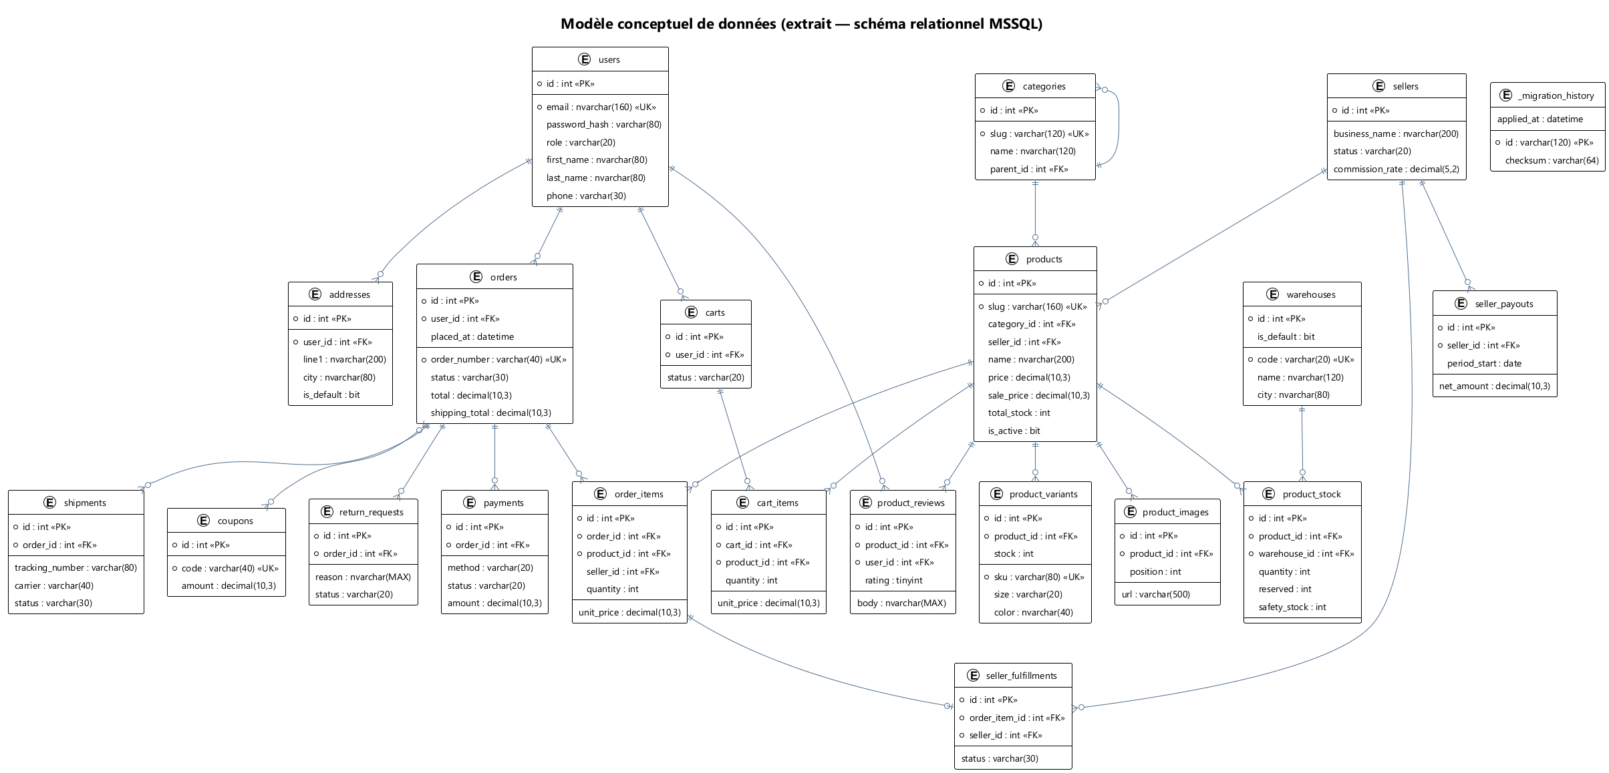
Figure 5 — Modèle conceptuel de données (extrait — schéma relationnel MSSQL)

A.6 Séquence — authentification
Fichier source : docs/_build/puml/06_seq_auth.puml
Code PlantUML :
@startuml seq_auth
!theme plain
skinparam backgroundColor white
skinparam DefaultFontName "Segoe UI"
skinparam ParticipantPadding 14
skinparam BoxPadding 8
skinparam ArrowColor #4F6D8C
skinparam SequenceLifeLineBorderColor #4F6D8C
title Diagramme de séquence — authentification (login + JWT refresh)
actor "Utilisateur" as U
participant "Angular SPA\nAuthService" as F
participant "AuthController\n(NestJS)" as A
participant "AuthService" as AS
participant "UsersService" as US
database "MSSQL\nusers" as DB
participant "JwtService" as J
U -> F : saisit email + mot de passe
F -> A : POST /api/auth/login\n{email, password}
A -> AS : login(dto)
AS -> US : findByEmail(email)
US -> DB : SELECT * FROM users WHERE email=?
DB --> US : user
US --> AS : user
AS -> AS : bcrypt.compare(password, user.hash)
alt mot de passe invalide
AS --> A : UnauthorizedException
A --> F : 401
F --> U : message d'erreur
else identifiants valides
AS -> J : sign({sub, role}, accessTTL)
AS -> J : sign({sub}, refreshTTL)
J --> AS : access_token, refresh_token
AS --> A : { user, access, refresh }
A --> F : 200 OK + tokens
F -> F : localStorage.setItem('jwt')
F --> U : redirection / dashboard
end
== Plus tard : access_token expiré ==
F -> A : GET /api/orders/me\nAuthorization: Bearer <expired>
A -> J : verify(access_token)
J --> A : TokenExpiredError
A --> F : 401
F -> A : POST /api/auth/refresh\n{ refresh_token }
A -> AS : refresh(token)
AS -> J : verify(refresh_token)
J --> AS : { sub }
AS -> J : sign(new access_token)
AS --> A : { access_token }
A --> F : 200 OK
F -> A : GET /api/orders/me\nAuthorization: Bearer <new>
A --> F : 200 + données
@enduml
Rendu :
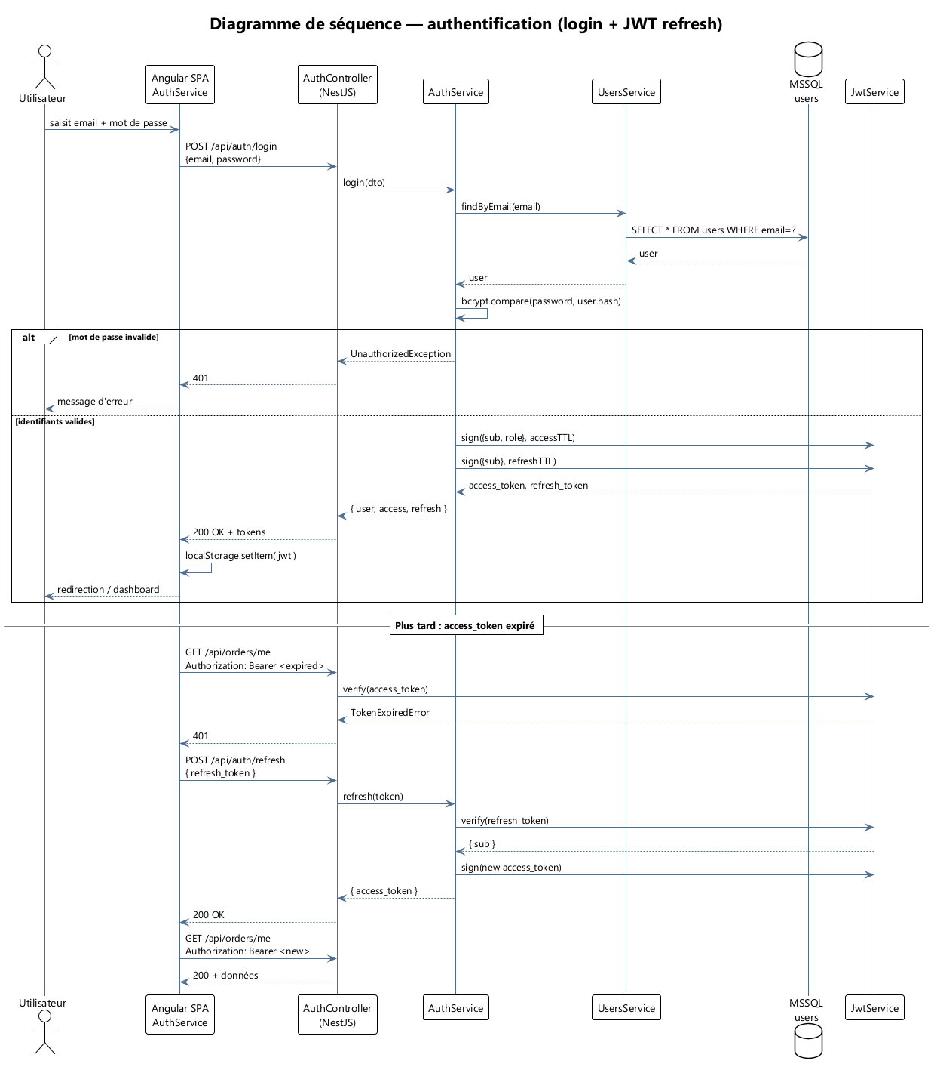
Figure 6 — Diagramme de séquence — authentification (login + JWT refresh)

A.7 Séquence — passage de commande
Fichier source : docs/_build/puml/07_seq_order.puml
Code PlantUML :
@startuml seq_order
!theme plain
skinparam backgroundColor white
skinparam DefaultFontName "Segoe UI"
skinparam ParticipantPadding 12
skinparam ArrowColor #4F6D8C
title Diagramme de séquence — passage de commande (panier → commande → paiement → notifications)
actor Client
participant "Angular\nCheckoutComponent" as F
participant "OrdersController" as OC
participant "OrdersService" as OS
participant "PromotionsService" as PR
participant "WarehousesService" as W
participant "PaymentsService" as PS
participant "CtpGateway" as CTP
database MSSQL as DB
participant "EventBusService" as EB
participant "EmailService" as EM
participant "SmsService" as SM
participant "FiscalService\n(TTN)" as FS
Client -> F : valide le panier (clic "Commander")
F -> OC : POST /api/orders\n{addressId, paymentMethod, couponCode}
OC -> OS : create(dto, userId)
OS -> PR : applyAutoDiscounts(cart)
PR --> OS : prix recalculés
OS -> W : reserveStock(items)
W -> DB : UPDATE product_stock SET reserved+=qty
W --> OS : ok
OS -> DB : INSERT orders, order_items
DB --> OS : order_id
OS -> PS : initiate(order, method)
alt méthode = CTP (carte)
PS -> CTP : POST /sandbox/charge
CTP --> PS : { authCode, txId }
PS -> DB : INSERT payment(status=PAID)
else méthode = COD (cash)
PS -> DB : INSERT payment(status=PENDING)
end
PS --> OS : payment ok
OS -> EB : emit(order.placed, {orderId, userId})
OS --> OC : order created
OC --> F : 201 + order
F --> Client : page de confirmation
== Asynchrone (event-driven) ==
EB -> EM : sendOrderConfirmation(order)
EM -->> Client : email "Commande confirmée"
EB -> SM : sendOrderConfirmationSms(order)
SM -->> Client : SMS récap commande
EB -> FS : generateReceipt(order)
alt FISCAL_TTN_ENABLED
FS -> FS : POST TTN endpoint
end
FS -> DB : INSERT fiscal_receipt
EB -> W : releaseReserved → onShipment(order)
@enduml
Rendu :
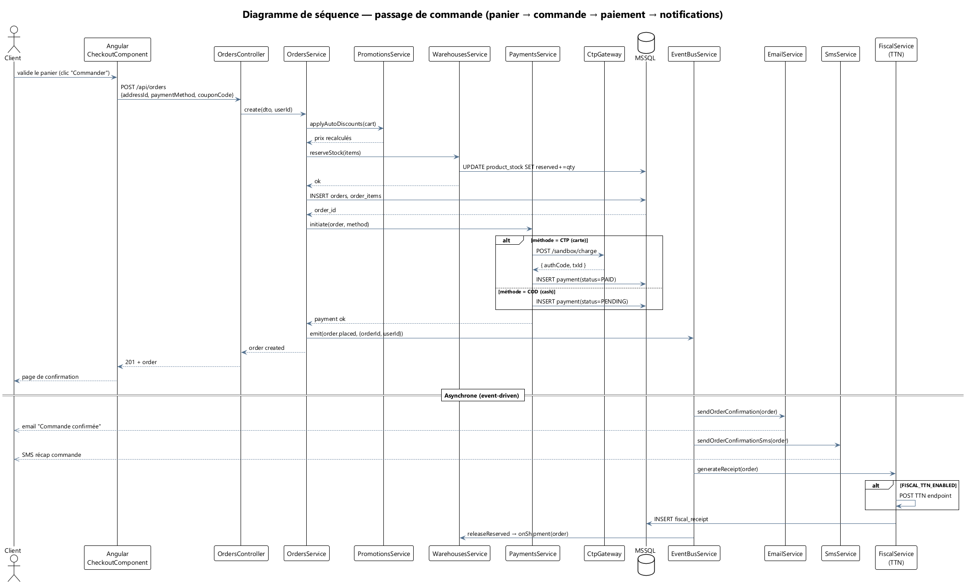
Figure 7 — Diagramme de séquence — passage de commande

A.8 Séquence — recommandations IA
Fichier source : docs/_build/puml/08_seq_recommendation.puml
Code PlantUML :
@startuml seq_reco
!theme plain
skinparam backgroundColor white
skinparam DefaultFontName "Segoe UI"
skinparam ParticipantPadding 12
skinparam ArrowColor #4F6D8C
title Diagramme de séquence — recommandations IA personnalisées
actor Client
participant "Angular\nRecommendationsService" as F
participant "RecommendationsController\n(NestJS)" as RC
participant "RecommendationsService" as RS
database MSSQL as DB
participant "AnalyticsService" as AN
participant "FastAPI ai-service" as AI
participant "Meilisearch" as MEI
participant "Recommendation\nstore" as RST
Client -> F : ouvre la page d'accueil
F -> RC : GET /api/recommendations/v3\n?strategy=personalized&userId=42
RC -> RS : recommend(userId, strategy)
RS -> AN : recentEvents(userId)
AN -> DB : SELECT user_events ORDER BY ts DESC LIMIT 50
AN --> RS : événements (vues, achats)
RS -> DB : SELECT recently_viewed, wishlist, orders
DB --> RS : profil comportemental
RS -> AI : POST /recommend\n{userId, profile, k=12}
AI -> AI : embedding utilisateur (CLIP + features)
AI -> MEI : recherche kNN (vecteurs produits)
MEI --> AI : 30 candidats
AI -> AI : re-ranking par score & business rules
AI --> RS : 12 produits triés
RS -> RST : store(userId, list, scoreVector)
RS --> RC : recommandations
RC --> F : 200 + JSON
F --> Client : carrousel "Pour vous"
== Tracking d'impression / conversion ==
F -> AN : POST /analytics/track\n{event=reco.impression, ids}
AN -> DB : INSERT funnel_events
Client -> F : clique sur produit
F -> AN : POST /analytics/track\n{event=reco.click, productId}
AN -> DB : INSERT funnel_events
@enduml
Rendu :
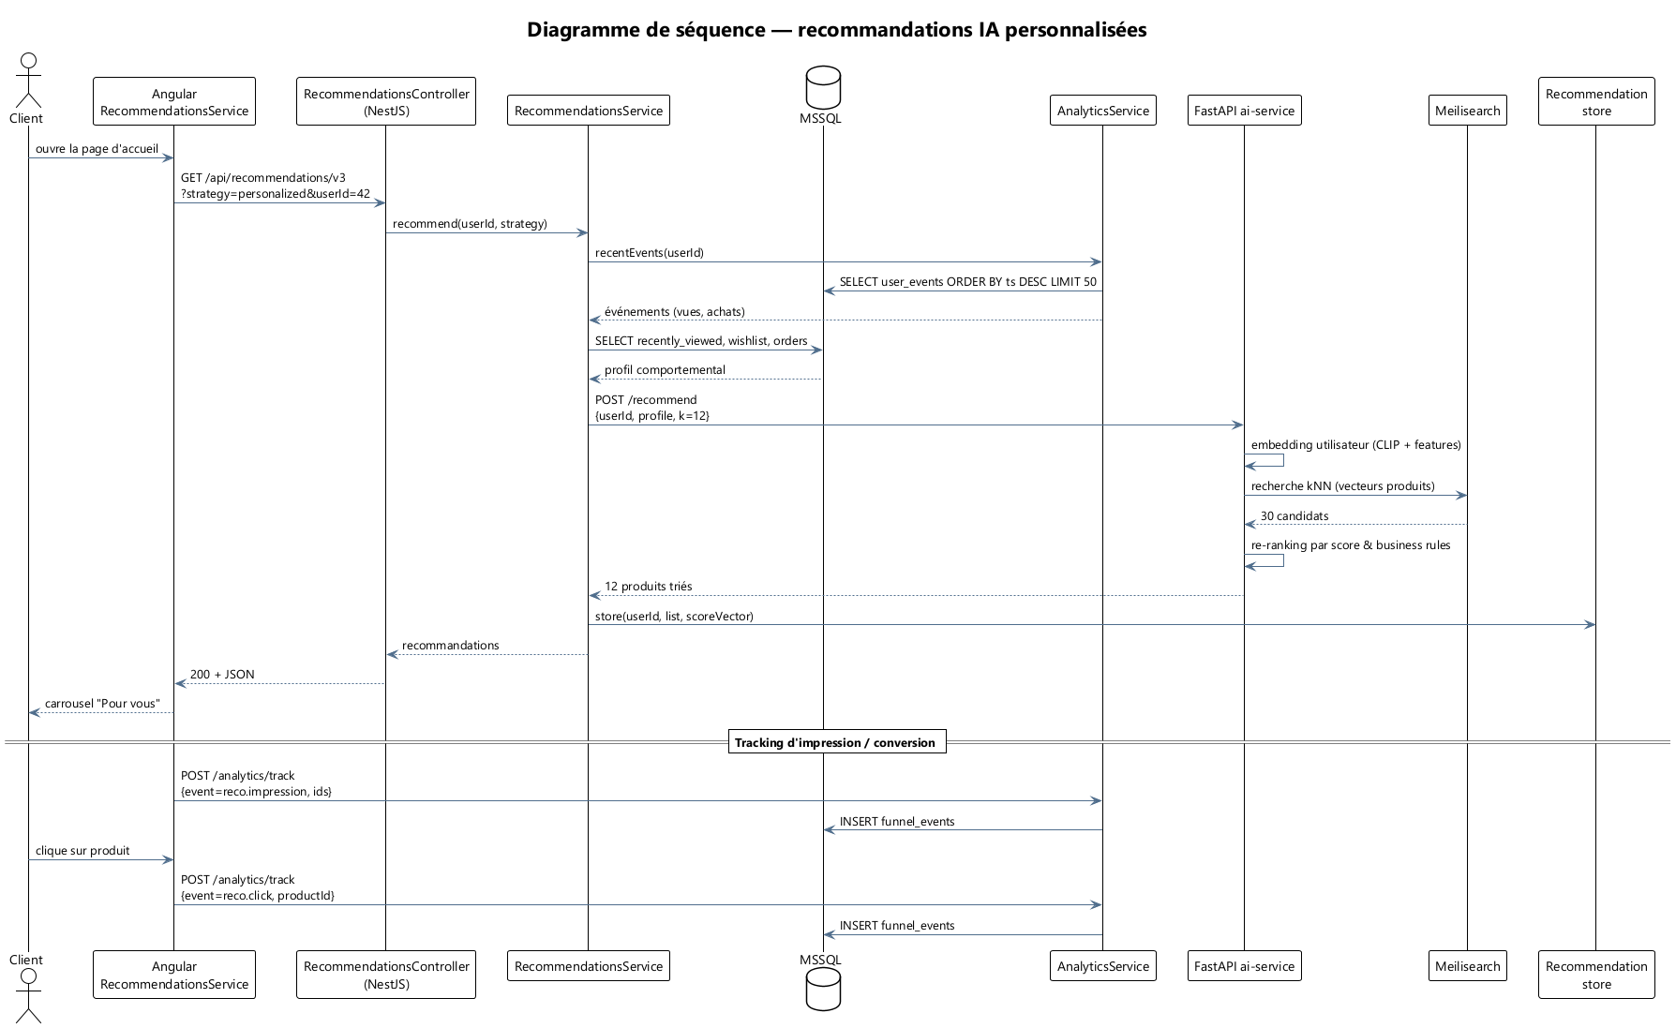
Figure 8 — Diagramme de séquence — recommandations IA personnalisées

A.9 Séquence — recherche visuelle
Fichier source : docs/_build/puml/09_seq_visual_search.puml
Code PlantUML :
@startuml seq_visual
!theme plain
skinparam backgroundColor white
skinparam DefaultFontName "Segoe UI"
skinparam ParticipantPadding 12
skinparam ArrowColor #4F6D8C
title Diagramme de séquence — recherche visuelle (image → produits similaires)
actor Client
participant "Angular\nVisualSearchComponent" as F
participant "AiController\n(NestJS)" as AC
participant "AiService" as AS
participant "FastAPI\nai-service /like-this" as AI
participant "CLIP encoder\n(PyTorch)" as CLIP
participant "Index vecteurs\n(numpy/Meilisearch)" as IDX
database "products" as DB
Client -> F : sélectionne une image\n(drag & drop / fichier)
F -> F : compresse en base64 (≤ 10 MB)
F -> AC : POST /api/ai/like-this\n{image_base64}
AC -> AS : likeThis(image)
AS -> AI : POST /like-this\n{image}
AI -> CLIP : encode(image) → vecteur 512d
CLIP --> AI : embedding
AI -> IDX : kNN search (cosine)
IDX --> AI : top-N product_ids + scores
AI --> AS : { products: [...] }
AS -> DB : SELECT products WHERE id IN (...)
DB --> AS : produits enrichis
AS --> AC : résultats triés par score
AC --> F : 200 OK + JSON
F --> Client : grille "Produits similaires"
note over AI
fallback : si Ollama / GPU
indisponibles, l'API renvoie
un message "indisponible" et
l'UI passe en mode dégradé
end note
@enduml
Rendu :
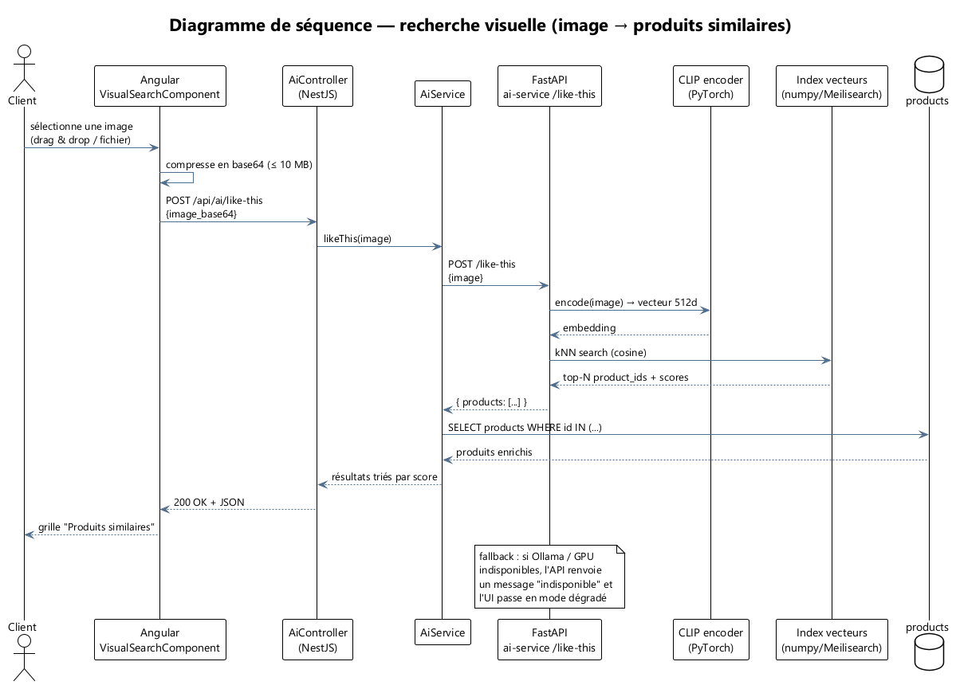
Figure 9 — Diagramme de séquence — recherche visuelle

A.10 Séquence — expédition et suivi
Fichier source : docs/_build/puml/10_seq_shipping.puml
Code PlantUML :
@startuml seq_shipping
!theme plain
skinparam backgroundColor white
skinparam DefaultFontName "Segoe UI"
skinparam ParticipantPadding 12
skinparam ArrowColor #4F6D8C
title Diagramme de séquence — expédition & suivi de livraison
actor Admin
participant "Admin\nShippingComponent" as F
participant "ShippingController" as SC
participant "ShippingService" as SS
participant "FirstDeliveryClient\n/ AramexClient" as PRV
database MSSQL as DB
participant "EventBusService" as EB
participant "EmailService" as EM
participant "SmsService" as SM
actor Client
participant "Angular\nOrderTrackingComponent" as TF
Admin -> F : sélectionne commande\n→ "Marquer expédiée"
F -> SC : POST /api/admin/shipping/:id/dispatch\n{carrier, weight}
SC -> SS : createShipment(orderId, dto)
SS -> PRV : createLabel(order)
PRV --> SS : { trackingNumber, labelUrl }
SS -> DB : INSERT shipments\nstatus=DISPATCHED
SS -> DB : UPDATE orders.status=SHIPPED
SS -> EB : emit(shipment.dispatched, {orderId, tracking})
SS --> SC : ok
SC --> F : 200 + tracking
F --> Admin : étiquette PDF + numéro
EB -> EM : sendShippingEmail(order, tracking)
EM -->> Client : email "Votre commande est partie"
EB -> SM : sendShippingSms(order, tracking)
SM -->> Client : SMS suivi
== Suivi côté client ==
Client -> TF : ouvre /compte/commandes/:id/suivi
TF -> SC : GET /api/shipping/track/:tracking
SC -> SS : track(trackingNumber)
SS -> PRV : GET status
PRV --> SS : { events[], status }
SS --> SC : timeline
SC --> TF : 200 + JSON
TF --> Client : timeline visuelle
== Webhook livraison ==
PRV -> SC : POST /api/shipping/webhook\n{tracking, status=DELIVERED}
SC -> SS : onWebhook(payload)
SS -> DB : UPDATE shipment.status=DELIVERED
SS -> DB : UPDATE order.status=DELIVERED
SS -> EB : emit(order.delivered)
EB -> EM : sendDeliveryConfirmation
EM -->> Client : email "Commande livrée"
@enduml
Rendu :
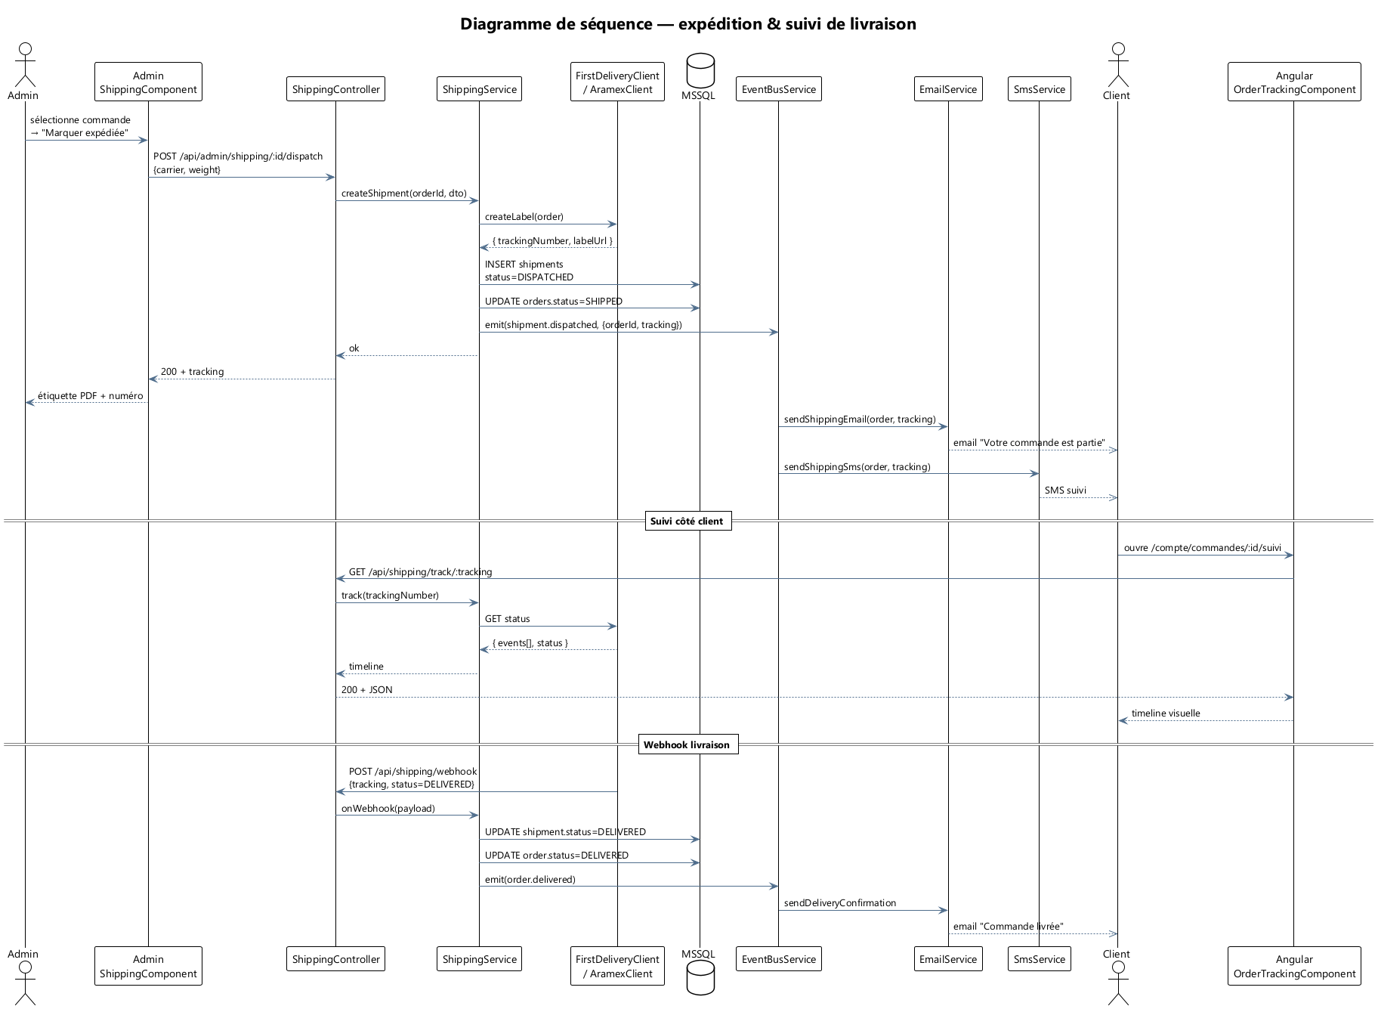
Figure 10 — Diagramme de séquence — expédition et suivi de livraison

A.11 Séquence — gestion administrateur
Fichier source : docs/_build/puml/11_seq_admin.puml
Code PlantUML :
@startuml seq_admin
!theme plain
skinparam backgroundColor white
skinparam DefaultFontName "Segoe UI"
skinparam ParticipantPadding 12
skinparam ArrowColor #4F6D8C
title Diagramme de séquence — gestion admin (création produit + indexation Meilisearch)
actor Admin
participant "Angular\nAdminProductsComponent" as F
participant "AdminController" as AC
participant "ProductsService" as PS
participant "WarehousesService" as WH
participant "MediaService" as MS
participant "SearchService" as SR
database MSSQL as DB
database "Meilisearch" as MEI
participant "EventBusService" as EB
Admin -> F : ouvre /admin/produits → "Nouveau"
F -> MS : POST /api/media/upload\n(images multipart)
MS --> F : { urls[] }
Admin -> F : remplit nom, prix, catégorie, stock
F -> AC : POST /api/admin/products\n{ name, slug, price, ..., images, stockByWarehouse }
AC -> PS : create(dto)
PS -> DB : INSERT products
DB --> PS : product_id
PS -> DB : INSERT product_images, product_variants
PS -> WH : initStock(product_id, stockByWarehouse)
WH -> DB : INSERT product_stock par warehouse
WH -> DB : UPDATE products.total_stock
PS -> EB : emit(product.created)
EB -> SR : indexProduct(product)
SR -> MEI : POST /indexes/products/documents
MEI --> SR : 200 (queued)
PS --> AC : product
AC --> F : 201 + produit
F --> Admin : confirmation + produit listé
== Mise à jour de prix dynamique ==
Admin -> F : règle de pricing dynamique
F -> AC : POST /api/admin/dynamic-pricing/sweep
AC -> PS : applyDynamicRules()
PS -> DB : SELECT eligible products
loop pour chaque produit
PS -> DB : UPDATE products.sale_price
PS -> EB : emit(product.priceChanged)
EB -> SR : reindexProduct
end
PS --> AC : { changedCount }
AC --> F : 200 + résumé
@enduml
Rendu :
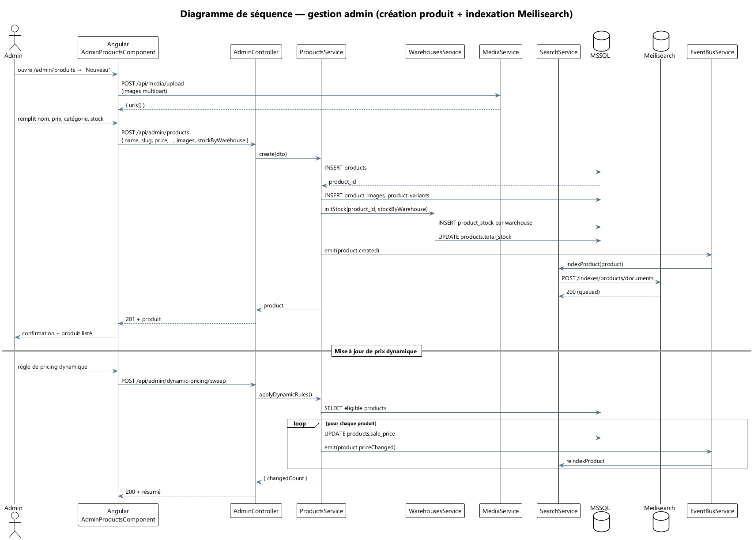
Figure 11 — Diagramme de séquence — gestion admin (création produit + indexation)

A.12 Activité — tunnel d'achat
Fichier source : docs/_build/puml/12_activity_checkout.puml
Code PlantUML :
@startuml activity_checkout
!theme plain
skinparam backgroundColor white
skinparam DefaultFontName "Segoe UI"
skinparam Padding 4
skinparam ActivityBackgroundColor #FAFCFE
skinparam ActivityBorderColor #4F6D8C
title Diagramme d'activité — tunnel d'achat Barsha
start
:Visiteur ajoute des produits au panier;
if (Compte existant ?) then (oui)
:Connexion;
else (non)
:Inscription rapide;
endif
:Saisie / sélection adresse de livraison;
if (Code coupon saisi ?) then (oui)
:Validation du coupon;
if (Coupon valide ?) then (oui)
:Application réduction;
else (non)
:Message d'erreur;
endif
else (non)
endif
:Sélection mode de paiement\n(CTP / COD);
:Récapitulatif final;
if (Validation client ?) then (oui)
partition "Backend NestJS" {
:Calcul prix final + règles auto;
:Réservation stock multi-entrepôt;
if (Stock disponible ?) then (oui)
:Création commande + items;
if (Méthode = CTP ?) then (oui)
:Appel passerelle CTP (sandbox/live);
if (Paiement OK ?) then (oui)
:Statut PAID;
else (non)
:Annulation, libération stock;
stop
endif
else (non — COD)
:Statut PENDING (paiement à la livraison);
endif
:emit(order.placed);
partition "Asynchrone" {
fork
:Email confirmation;
fork again
:SMS confirmation;
fork again
:Génération reçu fiscal (TTN);
fork again
:Lifecycle drip post-achat;
end fork
}
else (non)
:Page "Stock insuffisant";
stop
endif
}
:Page de confirmation client;
else (non)
:Retour panier;
stop
endif
stop
@enduml
Rendu :
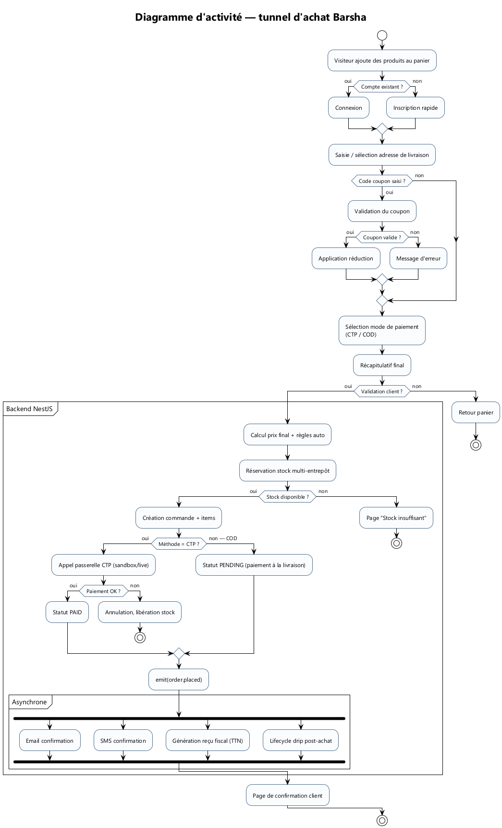
Figure 12 — Diagramme d'activité — tunnel d'achat Barsha

