To edit the data in the HTML page
1. Look up to the slide that need to be edit. Each of <div> with mySlides class is consider one slide.
2. h5 tag is used for the title of that slide.
3. p tag is used for the text content.
4. lang attribute represent the language of that text.
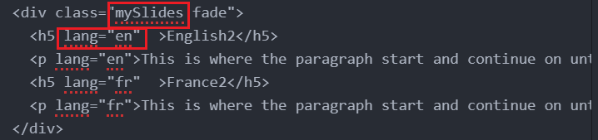

To edit the image Content
1. Copy the image into the respective folder inside the /img/ with that particular title
2. Name the image with the description of that image to show the description
3. Check the output.

To edit the title content
1. open index.html
2. edit the content in lang="en" to change the english content and "fr" for French Content

For timeline,
1. The content in the timeline is in index.js
