{%p for r in recipients %}
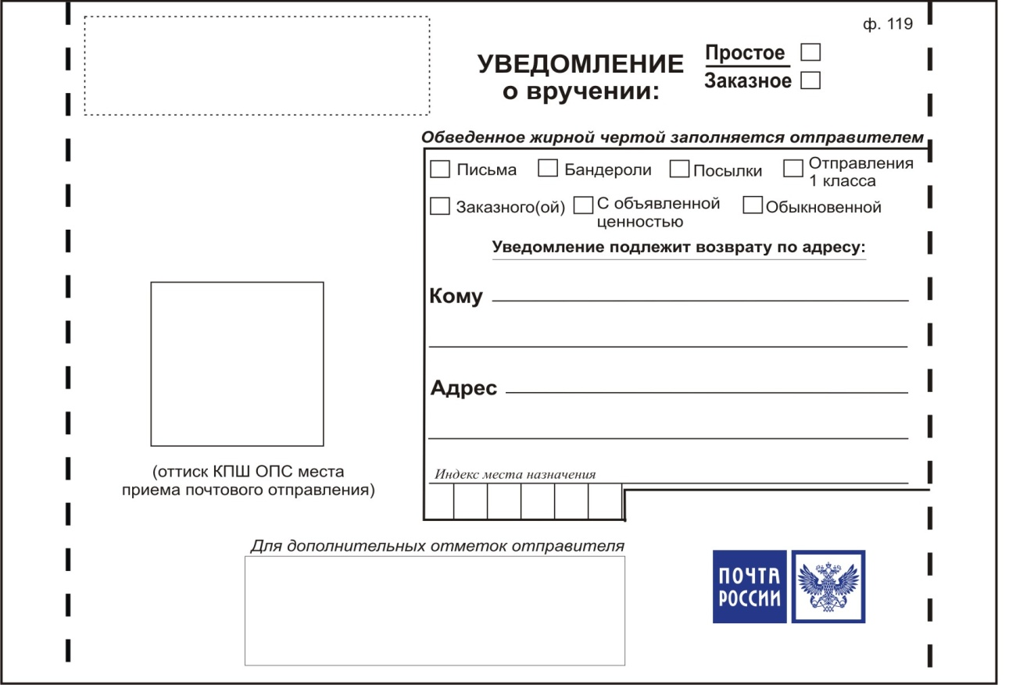

{{ sender_name }}
{{ sender_address }}

{{ sender_zip }}

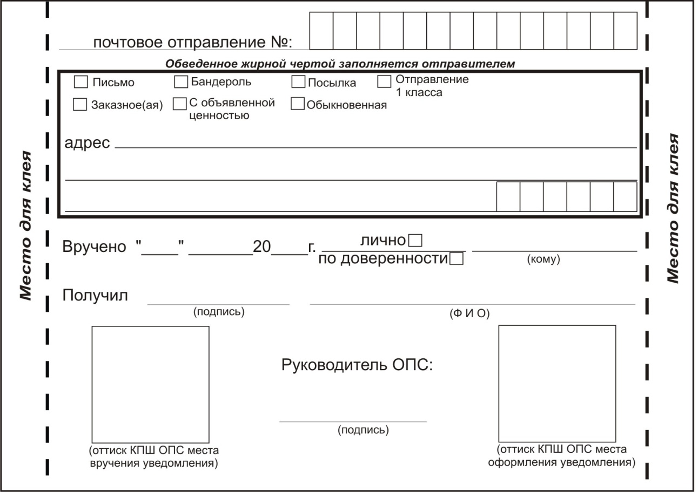
{{ r.zip }}
{{ r.name }}
{{ r.address }}

{%p endfor %}

