Technologies for Web

Applications 300582


Session 2 2018: Web Application Assignment

Due by 7:00 pm on Friday 28 September 2018 Assessment Weight: 30%

- Requirements

  - ALL instructions given in this document MUST be followed in order to be eligible for full marks for the Web Application Assignment. This document has 6 pages.

  - This assignment is NOT a group assignment; collusion, plagiarism, cheating of any kind is not acceptable. As part of your submission you MUST certify that all work submitted is your own. If you cannot honestly certify that the work is your own then do not submit the assignment. Breaches of the Misconduct Rule will be dealt with according to the university policy (see the learning guide for more information).

  - All assignment submissions will be checked for academic misconduct by the use of the MOSS program from Stanford University. Details on MOSS can be obtained from the MOSS web site http://theory.stanford.edu/~aiken/moss/

  - Design the web pages with ease of navigation and operation, attractiveness and accessibility in mind.

For the problem definition described in section B you must

- include your authorship details at the top of each file in coded comments;

- Reference all sources that you used for inspiration of your solution as per Section C of this document;

- Ensure that your web application renders correctly in Chrome and runs correctly from the TWA SCC web server.

B (i) Web Application Assignment Details

Western Sydney Pizza Store has decided to open an ordering system to accept customers’ orders online.

Technologies for Web

Applications 300582

This assignment asks you to build an Online shopping cart using HTML5, CSS, Javascript and PHP.

B (ii) – Functional Requirements

Your web application must

- Be coded using HTML5, CSS, Javascript & PHP

- Provide easy-to-use navigation based on the following design elements

- HTML home page:

  - You need to design an HTML webpage that acts like a homepage using HTML5 & CSS.

  - An image that acts as a link from the homepage should take Customers to an online shopping page.

- Online Pizza Ordering Page:

  - On the Online Shopping page, Customers can browse online looking through a variety of pizzas ( you are required to display at least five varieties such as Supreme, meatlover, Hawaii, etc)

- Detailed sauce and quantity page:

  - When a pizza image is clicked, information about sauces must be displayed in a new page (you are required to display at least three sauces such as BBQ, pesto, salsa etc).

  - Next to the each sauce image must be an option to ‘Add this sauce to Pizza’ button.

  - There should be an option for customers to order up multiple number of such pizza.

- Shopping Cart page:

  - When ‘Add this sauce to Pizza’ button is pressed (on Detailed sauce and quantity page), it needs to be directed to a page that shows the shopping cart so far.

The following links should be provided on this page.

  - Using one link, the Customers must be able to go back to the Online Pizza Ordering Page and be able to add more pizzas onto the cart

  - Using the other link, Customers must be able to go to Checkout page.

- Checkout page:

  - When Customers click on Checkout option, all pizzas along with their sauces and description and individual price must be displayed. Also, total price must be displayed.

  - At this stage, Customers must be asked to enter their given name, last name, Email and Phone Number.

  - After customer information is filled, he can go to confirmation page by clinking one link called “confirm” at the bottom of the checkout page.

  - If customer’s email and phone number is not in the correct format, prompt to customer for re-entry on the client side. The acceptable format of an email address

is local-part@domain for this assignment. The acceptable format for a Sydney phone number is (00)123456768 for local line numbers in this assignment. If the customer given and last names don’t exist in the customer table, prompt to customer for re-entry on the client side.

- Confirmation page:

This will be just a page that displays the ‘Order Confirmed!’ message along with Customer’s full name and total charge for the order.

C. Submission Details

You are required to submit a .zip/.tar file with the following files in vUWS and SCC server:

HTML5, Javascript, CSS, PHP files & images for pizzas and sauces

D. Marking Criteria and Standards

The marking criteria and standards for the Web Application Assignment are published in Section 2.5.1 of the Learning guide and will be used to assess your assignment submission according to the specific weightings identified in the table below:

Code Functionality/Correctness | 55%
Web Page Design | 30
Form Design | 10%
Code Readability | 5%

Appendices start on the next page.

Appendix:

1. Entity Relationship Model

The ER-diagram is provided to assist you with database creation.

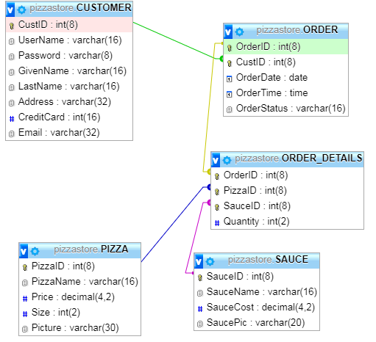

Figure 1: Entity-Relationship Diagram for pizzastore Database

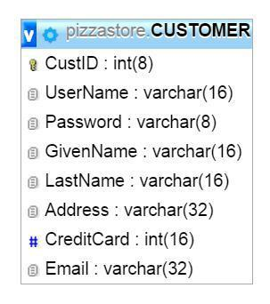
2. Design View of Tables

Figure 2: CUSTOMER TABLE

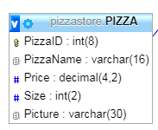

Figure 3: PIZZA TABLE

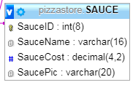

Figure 4: SAUCE TABLE

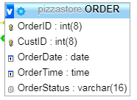

Figure 5: ORDER TABLE
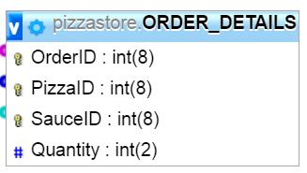

Figure 6: ORDER_DETAILS TABLE

3. Sample Data Populated for All Tables
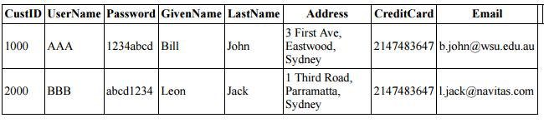

Sample Data for CUSTOMER Table

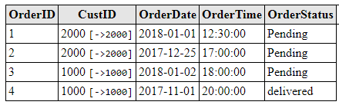

Sample Data for ORDER Table ([->] is the foreign key)

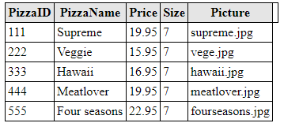

Sample Data for PIZZA Table

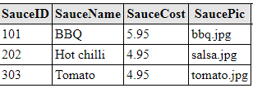

Sample Data for SAUCE Table

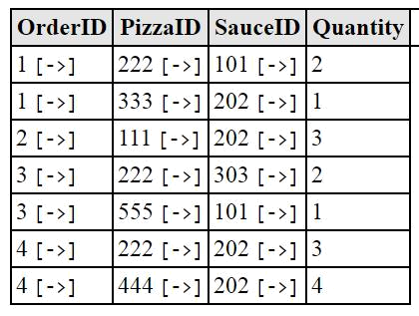

Sample Data for ORDER_DETAIL table ( [->] is the foreign key)

4.SQL script to create the database and sample data (script provided as pizzastore.sql in assignment folder)

-- phpMyAdmin SQL Dump
-- version 4.0.10.19
-- https://www.phpmyadmin.net
--
-- Host: localhost
-- Generation Time: Jan 18, 2018 at 02:42 PM
-- Server version: 5.1.73
-- PHP Version: 5.3.3

SET SQL_MODE = "NO_AUTO_VALUE_ON_ZERO";
SET time_zone = "+00:00";

/*!40101 SET @OLD_CHARACTER_SET_CLIENT=@@CHARACTER_SET_CLIENT */;
/*!40101 SET @OLD_CHARACTER_SET_RESULTS=@@CHARACTER_SET_RESULTS */;
/*!40101 SET @OLD_COLLATION_CONNECTION=@@COLLATION_CONNECTION */;
/*!40101 SET NAMES utf8 */;

--
-- Database: `pizzastore`
--
-- --------------------------------------------------------

--
-- Table structure for table `CUSTOMER`
--

CREATE TABLE IF NOT EXISTS `CUSTOMER` (
`CustID` int(8) NOT NULL,
`UserName` varchar(16) NOT NULL,
`Password` varchar(8) NOT NULL,
`GivenName` varchar(16) NOT NULL,
`LastName` varchar(16) NOT NULL,
`Address` varchar(32) NOT NULL,
`CreditCard` int(16) NOT NULL,
`Email` varchar(32) NOT NULL,
PRIMARY KEY (`CustID`)
) ENGINE=InnoDB DEFAULT CHARSET=utf8;

--
-- Dumping data for table `CUSTOMER`
--

INSERT INTO `CUSTOMER` (`CustID`, `UserName`, `Password`, `GivenName`, `LastName`, `Address`, `CreditCard`, `Email`) VALUES
(1000, 'AAA', '1234abcd', 'Bill', 'John', '3 First Ave, Eastwood, Sydney', 2147483647, 'b.john@wsu.edu.au'),
(2000, 'BBB', 'abcd1234', 'Leon', 'Jack', '1 Third Road, Parramatta, Sydney', 2147483647, 'l.jack@navitas.com');

-- --------------------------------------------------------

--
-- Table structure for table `ORDER`
--

CREATE TABLE IF NOT EXISTS `ORDER` (
`OrderID` int(8) NOT NULL,
`CustID` int(8) NOT NULL,
`OrderDate` date NOT NULL,
`OrderTime` time NOT NULL,
`OrderStatus` varchar(16) NOT NULL DEFAULT 'Pending',
PRIMARY KEY (`OrderID`,`CustID`),
KEY `CustID` (`CustID`)
) ENGINE=InnoDB DEFAULT CHARSET=utf8;

--
-- Dumping data for table `ORDER`
--

INSERT INTO `ORDER` (`OrderID`, `CustID`, `OrderDate`, `OrderTime`, `OrderStatus`) VALUES
(1, 2000, '2018-01-01', '12:30:00', 'Pending'),
(2, 2000, '2017-12-25', '17:00:00', 'Pending'),
(3, 1000, '2018-01-02', '18:00:00', 'Pending'),
(4, 1000, '2017-11-01', '20:00:00', 'delivered');

-- --------------------------------------------------------

--
-- Table structure for table `ORDER_DETAILS`
--

CREATE TABLE IF NOT EXISTS `ORDER_DETAILS` (
`OrderID` int(8) NOT NULL,
`PizzaID` int(8) NOT NULL,
`SauceID` int(8) NOT NULL,
`Quantity` int(2) NOT NULL,
PRIMARY KEY (`OrderID`,`PizzaID`,`SauceID`),
KEY `PizzaID` (`PizzaID`),
KEY `SauceID` (`SauceID`)
) ENGINE=InnoDB DEFAULT CHARSET=utf8;

--
-- Dumping data for table `ORDER_DETAILS`
--

INSERT INTO `ORDER_DETAILS` (`OrderID`, `PizzaID`, `SauceID`, `Quantity`) VALUES
(1, 222, 101, 2),
(1, 333, 202, 1),
(2, 111, 202, 3),
(3, 222, 303, 2),
(3, 555, 101, 1),
(4, 222, 202, 3),
(4, 444, 202, 4);

-- --------------------------------------------------------

--
-- Table structure for table `PIZZA`
--

CREATE TABLE IF NOT EXISTS `PIZZA` (
`PizzaID` int(8) NOT NULL,
`PizzaName` varchar(16) NOT NULL,
`Price` decimal(4,2) NOT NULL,
`Size` int(2) NOT NULL,
`Picture` varchar(30) NOT NULL,
PRIMARY KEY (`PizzaID`)
) ENGINE=InnoDB DEFAULT CHARSET=utf8;

--
-- Dumping data for table `PIZZA`
--

INSERT INTO `PIZZA` (`PizzaID`, `PizzaName`, `Price`, `Size`, `Picture`) VALUES
(111, 'Supreme', '19.95', 7, 'supreme.jpg'),
(222, 'Veggie', '15.95', 7, 'vege.jpg'),
(333, 'Hawaii', '16.95', 7, 'hawaii.jpg'),
(444, 'Meatlover', '19.95', 7, 'meatlover.jpg'),
(555, 'Four seasons', '22.95', 7, 'fourseasons.jpg');

-- --------------------------------------------------------

--
-- Table structure for table `SAUCE`
--

CREATE TABLE IF NOT EXISTS `SAUCE` (
`SauceID` int(8) NOT NULL,
`SauceName` varchar(16) NOT NULL,
`SauceCost` decimal(4,2) NOT NULL,
`SaucePic` varchar(20) NOT NULL,
PRIMARY KEY (`SauceID`)
) ENGINE=InnoDB DEFAULT CHARSET=utf8;

--
-- Dumping data for table `SAUCE`
--

INSERT INTO `SAUCE` (`SauceID`, `SauceName`, `SauceCost`, `SaucePic`) VALUES
(101, 'BBQ', '5.95', 'bbq.jpg'),
(202, 'Hot chilli', '4.95', 'salsa.jpg'),
(303, 'Tomato', '4.95', 'tomato.jpg');

--
-- Constraints for dumped tables
--

--
-- Constraints for table `ORDER`
--
ALTER TABLE `ORDER`
ADD CONSTRAINT `ORDER_ibfk_1` FOREIGN KEY (`CustID`) REFERENCES `CUSTOMER` (`CustID`) ON UPDATE CASCADE;

--
-- Constraints for table `ORDER_DETAILS`
--
ALTER TABLE `ORDER_DETAILS`
ADD CONSTRAINT `ORDER_DETAILS_ibfk_1` FOREIGN KEY (`PizzaID`) REFERENCES `PIZZA` (`PizzaID`) ON UPDATE CASCADE,
ADD CONSTRAINT `ORDER_DETAILS_ibfk_4` FOREIGN KEY (`OrderID`) REFERENCES `ORDER` (`OrderID`) ON UPDATE CASCADE,
ADD CONSTRAINT `ORDER_DETAILS_ibfk_5` FOREIGN KEY (`SauceID`) REFERENCES `SAUCE` (`SauceID`);

/*!40101 SET CHARACTER_SET_CLIENT=@OLD_CHARACTER_SET_CLIENT */;
/*!40101 SET CHARACTER_SET_RESULTS=@OLD_CHARACTER_SET_RESULTS */;
/*!40101 SET COLLATION_CONNECTION=@OLD_COLLATION_CONNECTION */;

