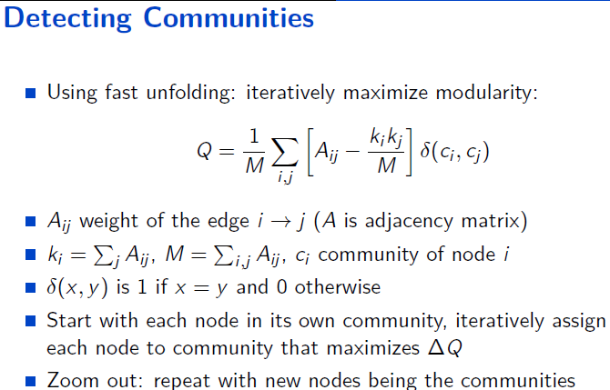

In this Explanation , correct me if im wrong:

Aij = Weight of the edge i to j means path cost from node i to j ?

Ki =∑ j Aij =  LIKE = Ai1 j1 + Ai1 j2+ Ai1 j3+ Ai1 j4+…… ?

kj=∑ i Aij =  LIKE = Ai1 j1 + Ai2 j1+ Ai3 j1+ Ai4 j1+…… ? //as it is not written here

M=∑i j Aij =  LIKE = Ai1 j1 + Ai2 j2+ Ai3 j3+ Ai4 j4+…… ?

Ci = Comunnity of node i = c is a neighbor node of node i ?

Comunnity means neighbor nodes?