

**Mobile Communication**

**Summer Semester 2016**

**Solution for**

**Practical Assignment 01**

Done by:

**Che-Hao, Kang,** 2840977

**Ahmad, Hemid,**9027822

Question (1). Plot the link quality for each node pair over the time.

* Combine all node pair plots into a single (easy to compare) plot.
* Add a visualization of the median, mean, and quantils for each node pair. Give reasons for your quantil choice.

Answer (1):

For the first part of the question, the following is a plot which shows all node pair plots into a single graph as it is depicted by Figure 01. It shows the link quality values starting from 0 to 1 corresponding to timestamp in seconds between node pairs.

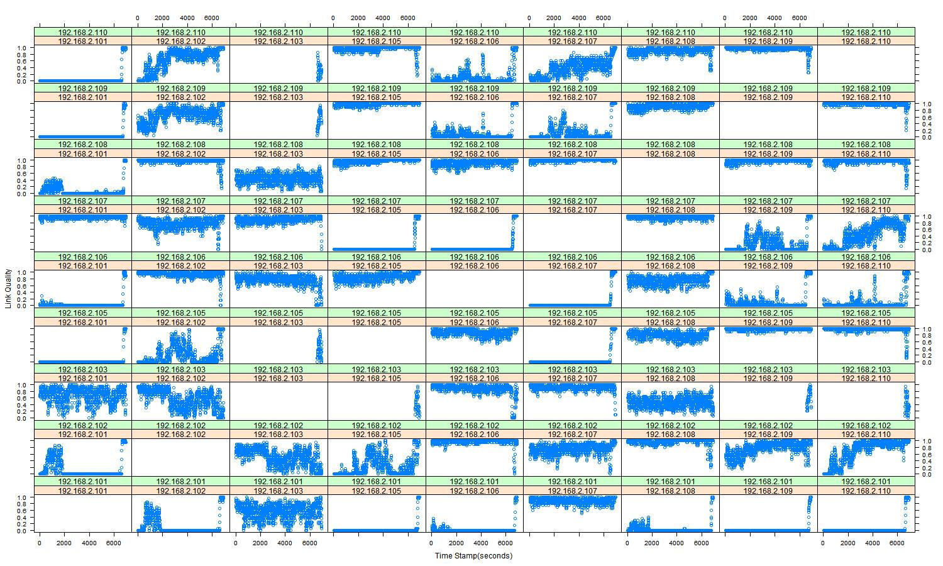

**Figure 01: The Link Quality for all node pairs in a single graph**

It is clearly seen from Figure 01 that node pairs could have different states of link quality: (1) showing good connection almost of the experiment time, (2) fluctuation between low and high (but still the link is fine), (3) staying with lower or dead link for a long time but suddenly goes up to a good quality.

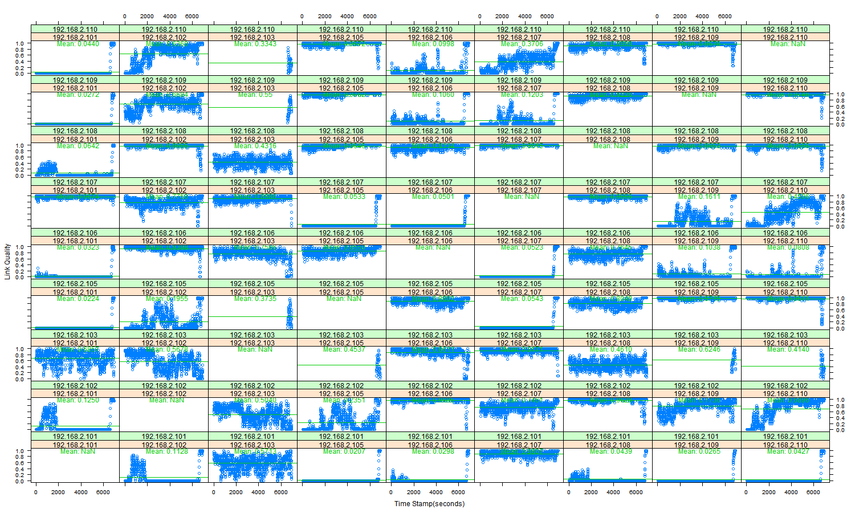

**Figure 02: Mean of the Link Quality for all node pairs in a single graph**

Figure 02 shows the mean value for the link quality for each node pair. In the meanwhile, the next coming Figure 03 highlights the median values.

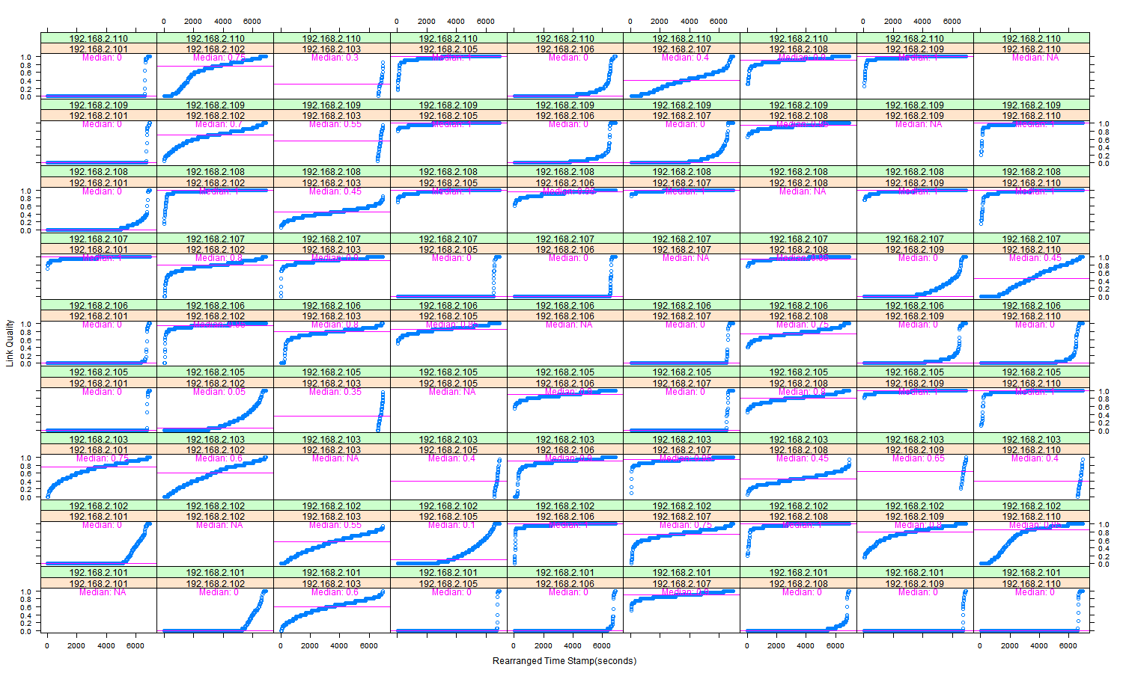

**Figure 03: Median of the Link Quality for all node pairs in a single graph**

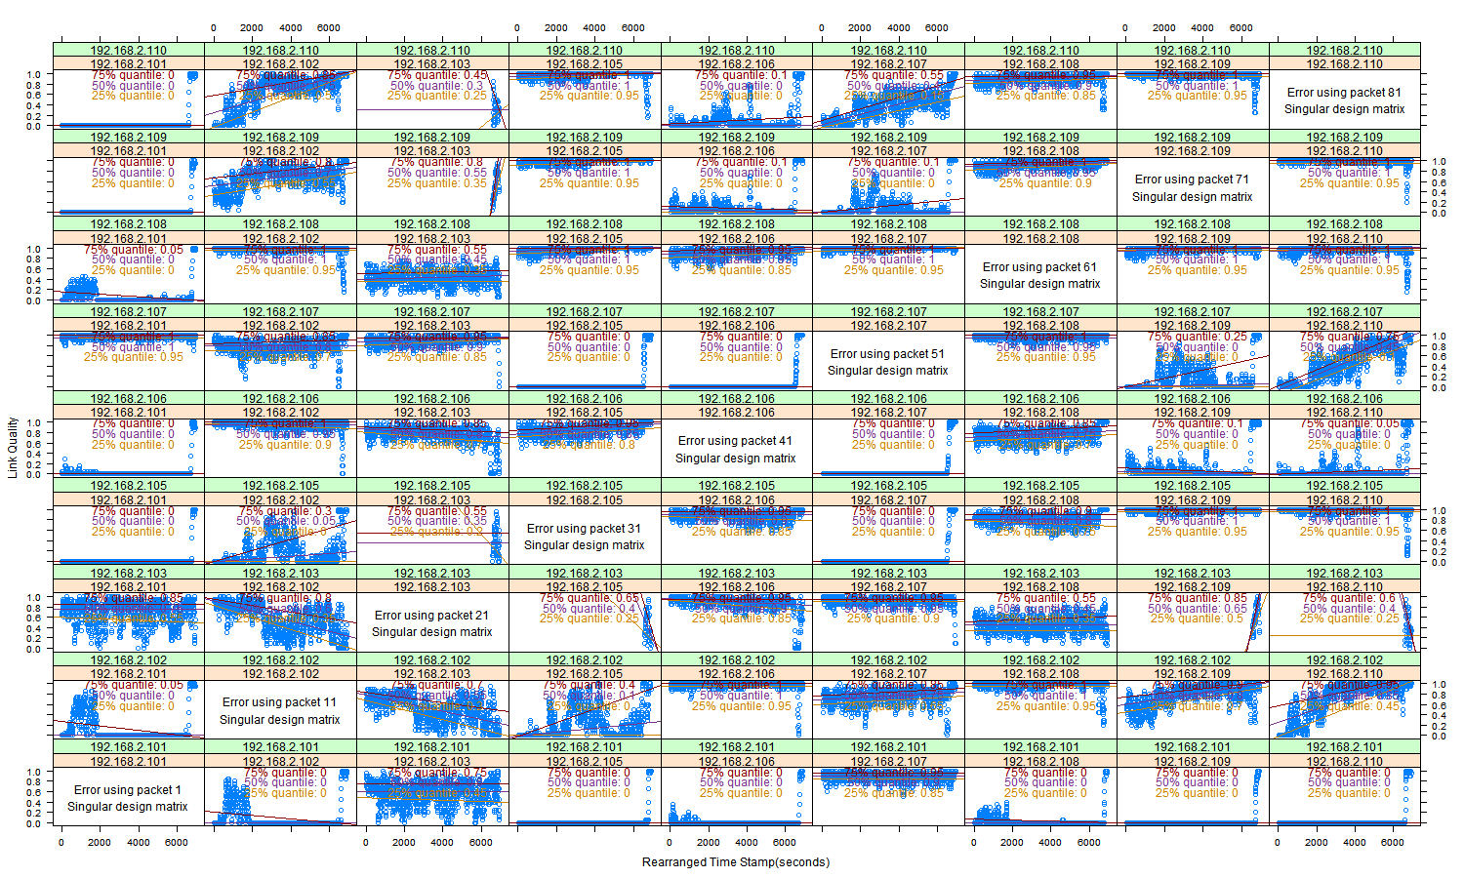

**Figure 04: Quantile of the Link Quality for all node pairs in a single graph**

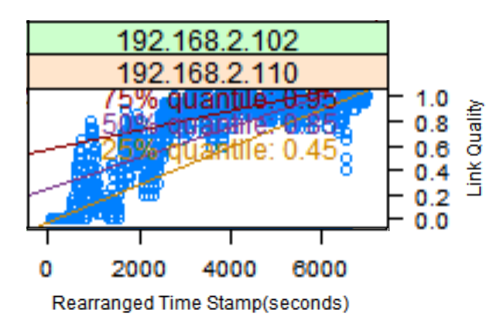

**Figure 05: One Quantile of the Link Quality between two nodes**

Figure 04 shows 3 different quantiles (Q1=0.25, Q2=0.50, Q3=0.75). As we can see, three lines of quantiles are depicted in this figure. Below the 25% quantile line is the distribution of one-fourth of link quality values; below the 50% quantile line is the distribution of one-second of link quality values; below the 75% quantile line is the distribution of three-fourth of link quality values.

In Figure 05, the quantiles of the node pair are highlighted. We can see the 25% quantile is about 0.45 which means the distribution of link quality of one-fourth of this node pair is under or equal to 0.45. Similarly, the area below the 50% quartile line is showing the distribution of link quality under or equal to 0.85 and the link quality of 0.95 is for the 75% quantile.

We choose these values to identify node pairs’ link qualities trends on the following percentages 25%, 50%, and 75%. So we can have an idea about the overall of link quality at these stages according to what is shown on the Figure 05.

Question (2). The link quality information can be used to estimate the relative node positions.

* Give a graph representation of a possible network topology after {10; 20; : : : ; 100}% of the measurement time.

Answer (2):

In Figure 06, we divide timestamp into ten parts (each part for 10% of experiment time). Focusing on the red rectangle in the figure, we can see connections from **192.168.2.101** to **192.168.2.105**, **192.168.2.109** and **192.168.2.110** have no link quality for a long period of time, but in the end, their link qualities soar up to almost 1.0; for **192.168.2.101** to **192.168.2.102**, **192.168.2.106** and **192.168.2.108**, the link qualities are with certain values at the beginning. After a while, their link qualities plummet to almost zero. In the end, the link qualities come back to life again; for **192.168.2.101** to **192.168.2.103**, the link quality fluctuates during the experiment time; for **192.168.2.101** to **192.168.2.107**, the link quality keeps on high values.

With the above information, for **192.168.2.101** to **192.168.2.105**, **192.168.2.109** and **192.168.2.110**, there might be obstacles coming between them which result in shadowing or reflection of connection signals. In the end of the experiment time, their link qualities become very good. This is maybe caused by obstacles moved or removed; for **192.168.2.101** to **192.168.2.102**, **192.168.2.106** and **192.168.2.108**, the link qualities are in certain values, but after a while, they all go down to very low values. We think this phenomenon is due to scattering or diffraction; for **192.168.2.101** to **192.168.2.103**, the fluctuation of the link quality is produced by attenuation of the connection signal; for **192.168.2.101** to **192.168.2.107**, there is no influence between them. That’s why the link quality stays high.

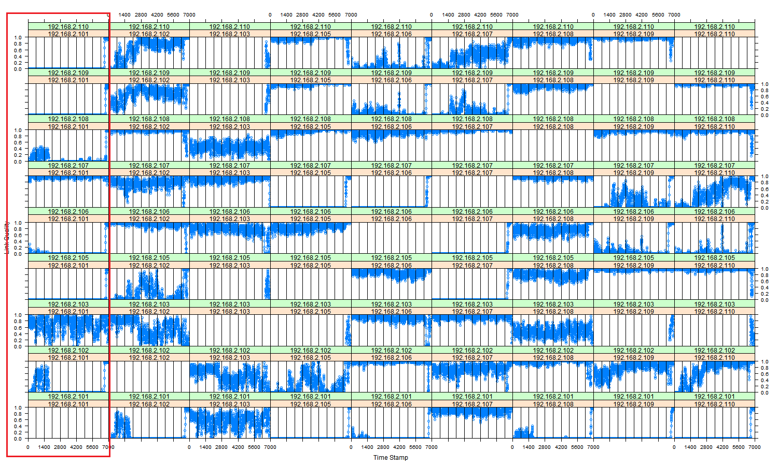

**Figure 06: The Link Quality for all node pairs in a single graph for each 10% of experiment time**

In the following figures, Figure 07 and Figure 08, the link connectivity graphs are shown starting from 10%, increased by 10% for time interval of the measurement. Figure 07 shows the first half (10% - 50%) of the time interval and Figure 08 is showing the next half (60% - 100%).

The figures (Figure 07, 08) present the link quality of each node pairs and the status of such link based on each 10% of time interval of the test. We tried to feature the link quality with colors based on the value recorded from the results according to the following colors:

* Green: It simulates a high link quality, we assume when the value above 0.66, will be in this category
* Orange: It shows a fair or medium link quality, we have programed all the values lower than 0.66 and higher than 0.33 to be in this category
* Blank: It visualizes lower values of the link quality or those pairs with no connections, all the values under 0.33 go to this class
* Give reasons why the network topology has changed, although, the nodes are static.

The reasons behind the network topology changing could be because of several factors one of them is the instability of the wireless link since the wireless signal flies in the air and any different reasons could affect its quality such as obstacles which could damage the signals or reflect it which declines the link quality between node pairs to different categories (medium or no connectivity) as was explained in the previous paragraph of classification of the link quality.

We can see that clearly in figure 07 and 08, the link for **192.168.2.101** to **192.168.2.110 nodes** was for about 90% of the time Blank (no connection), then suddenly convers to Green in the last 10% of the time. We have the mentioned assumption which makes such behavior to the link connectivity. In the meanwhile, some node pairs’ links show high connectivity all the time, which are colored with green, and others fluctuate between all the colors Green, Orange, and Blank, to indicate the instability of the link, again here the above reason is assumed.

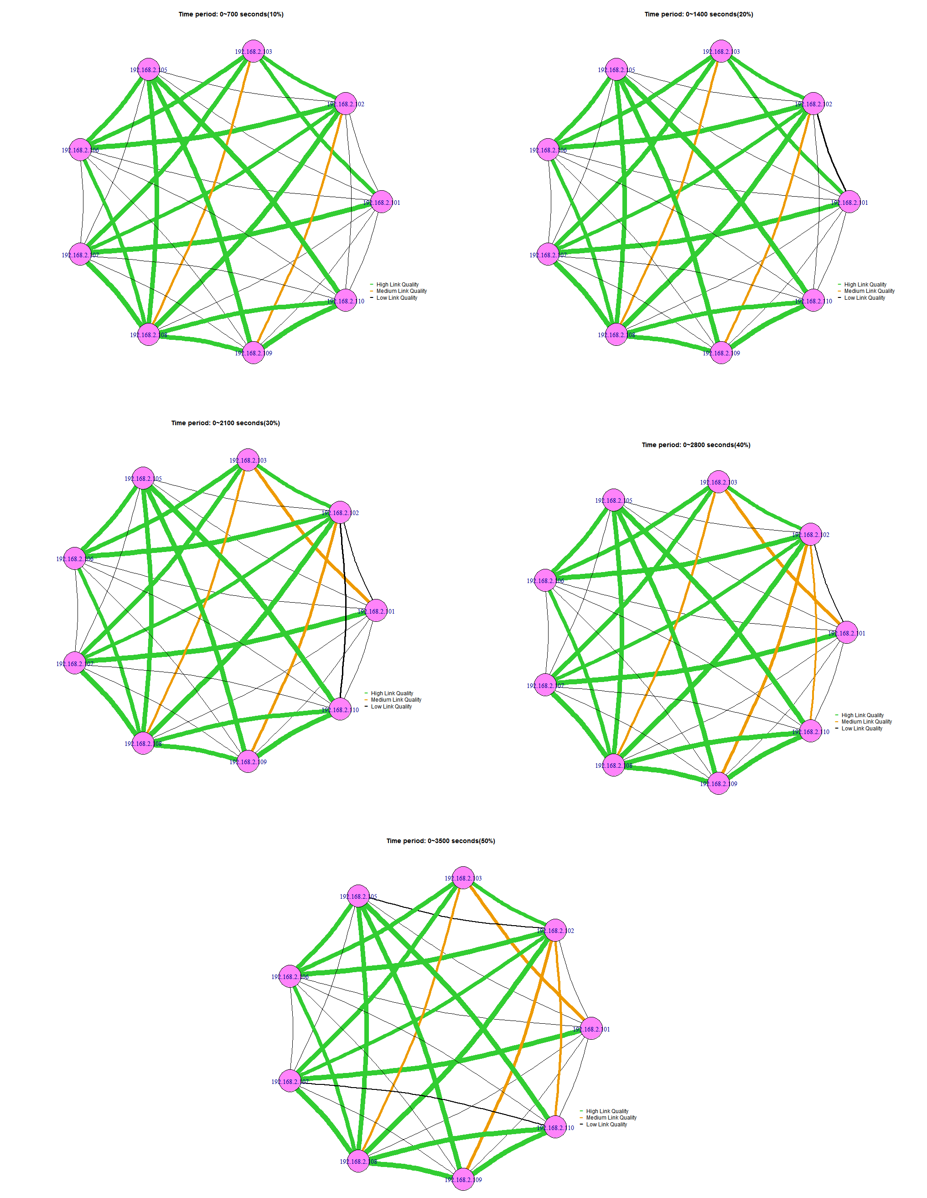

**Figure 07: A graph represents the link quality between all node pairs from 10% to 50% of the time measurement**

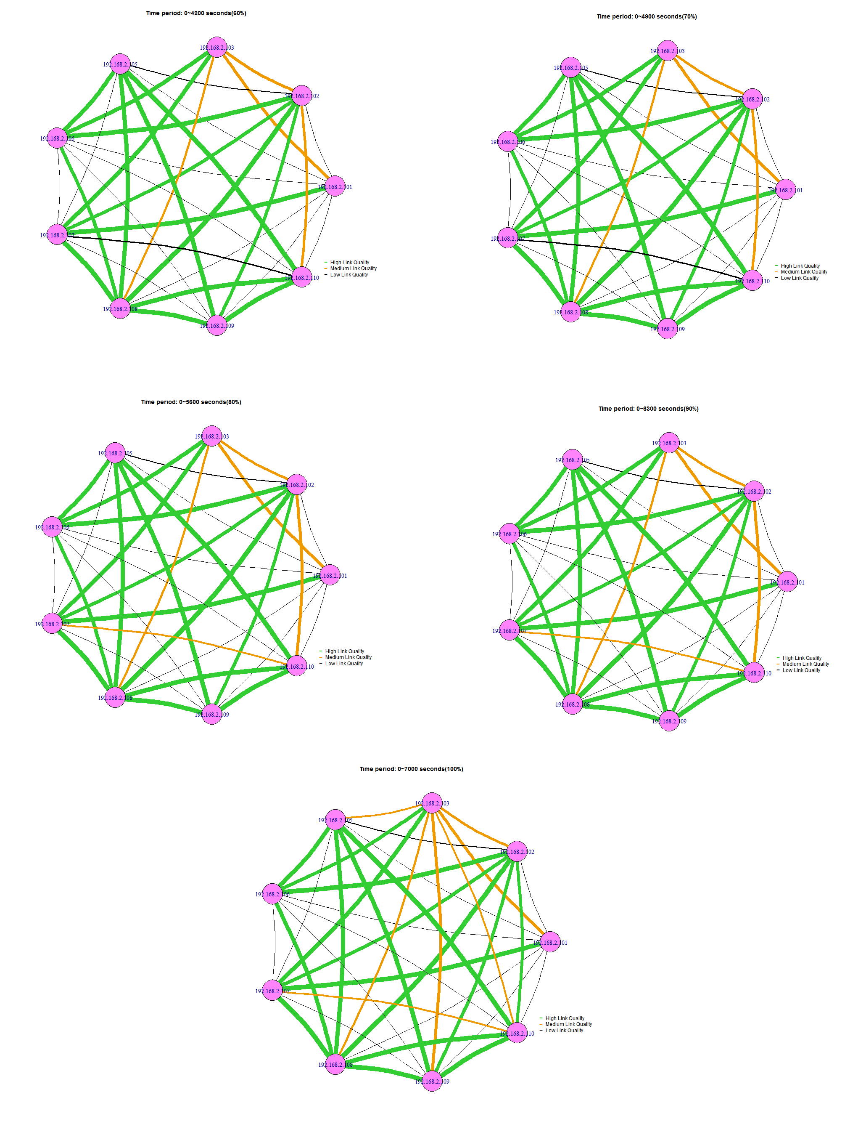

**Figure 08: A graph represents the link quality between all node pairs from 60% to 100% of the time measurement**

Question (3). The link quality values of some node pairs show some abnormalities. Which node pairs show these abnormalities? Give reasons for your choice.

Answer (3):

There are four different kinds of abnormalities:

* The red ones: in this group, the link quality stays almost zero from the beginning of the experiment time. Around the end of the experiment, it soars up to nearly 1.0. We can infer from this abnormality that between these node pairs, some signal influences happen such as shadowing or reflection.
* The yellow one: the link quality is with some values at the beginning. After some time, it goes down to almost zero. However, in the end, it sharply goes to nearly 1.0 because attenuation happens during the experiment time which results in this abnormality.
* The purple ones: for most of the time, the link quality stays at a high level. Around the end, it suddenly shows lower values of the link quality. It could be some obstacles showing up (attenuation).
* The brown ones: the link quality for this group is totally zero for most of the time. In the end, the link quality appears to such high values. This is very likely that barriers exist between these node pairs which block signals.

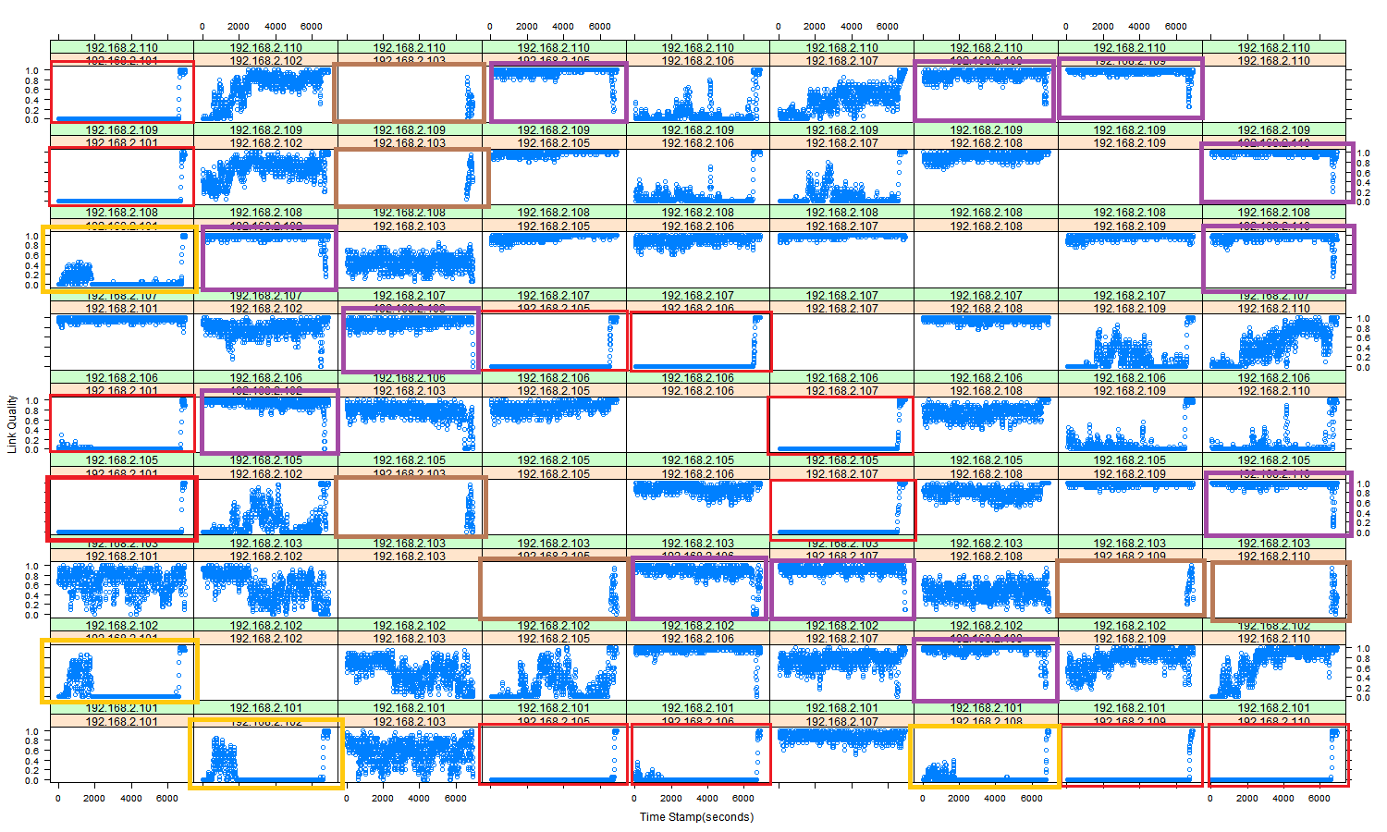

**Figure 09: Abnormalities showing on Link Quality for node pairs differentiated with colors**

Question (4). Some signal propagation models, e.g., the Friis Free Space Path Loss Model, assume a symmetric signal propagation. Performed a correlation analysis of some node pairs. Is this assumption correct?

Answer (4):

It is clearly seen from Figure 01 that the node pair plots with the same nodes with different direction (Up and Down) show a nearly similar figures. This due to the signal propagation mode which is used and since here we assume the existence of symmetric signal propagation on both directions we can say that assumption is true based on the plots which proved that in Figure 08.

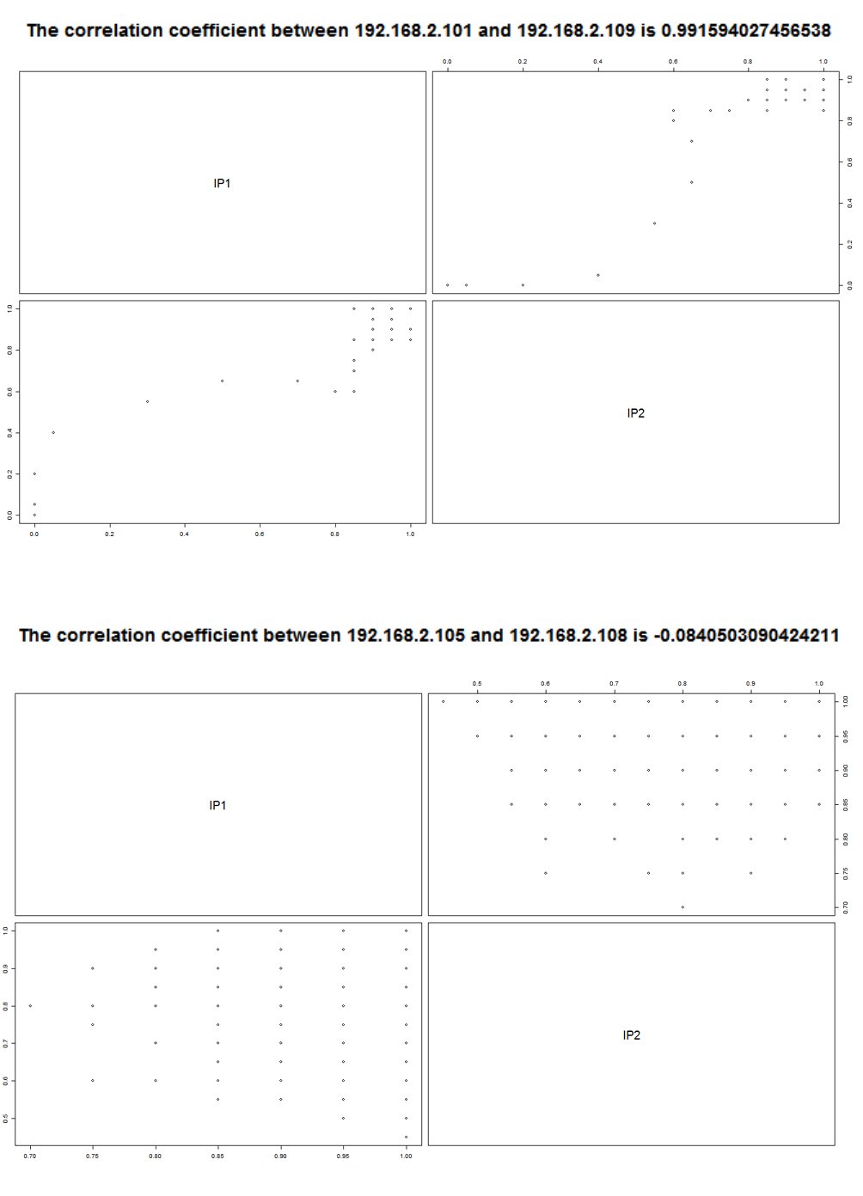

**Figure 10: Correlation coefficients between 192.168.2.101 - 192.168.2.109 and 192.168.2.105 - 192.168.2.108 (all pairs are in the folder plots\Plots4Question4\AllPairs_correlation)**

From Figure 10, the correlation coefficient between 192.168.2.101 and 192.168.2.109 is almost 1 which means this node pair is in a **perfect positive linear relationship**. As for the node pair of 192.168.2.105 - 192.168.2.108, its correlation coefficient is -0.084 which indicates no linear relationship.

Although -0.084 (no linear relationship) exists, we scan all node pairs and 95% of them have positive linear relationships. This proves that the symmetric signal propagation is right.

Question (5). Plot the link quality for node pairs 192.168.2.101 - 192.168.2.102, 192.168.2.102 - 192.168.2.108, and 192.168.2.107 - 192.168.2.110 as boxplots. Compare these plots with those from (1). Judge the significance of the boxplots in comparison to the plots from (1).

Answer (5):

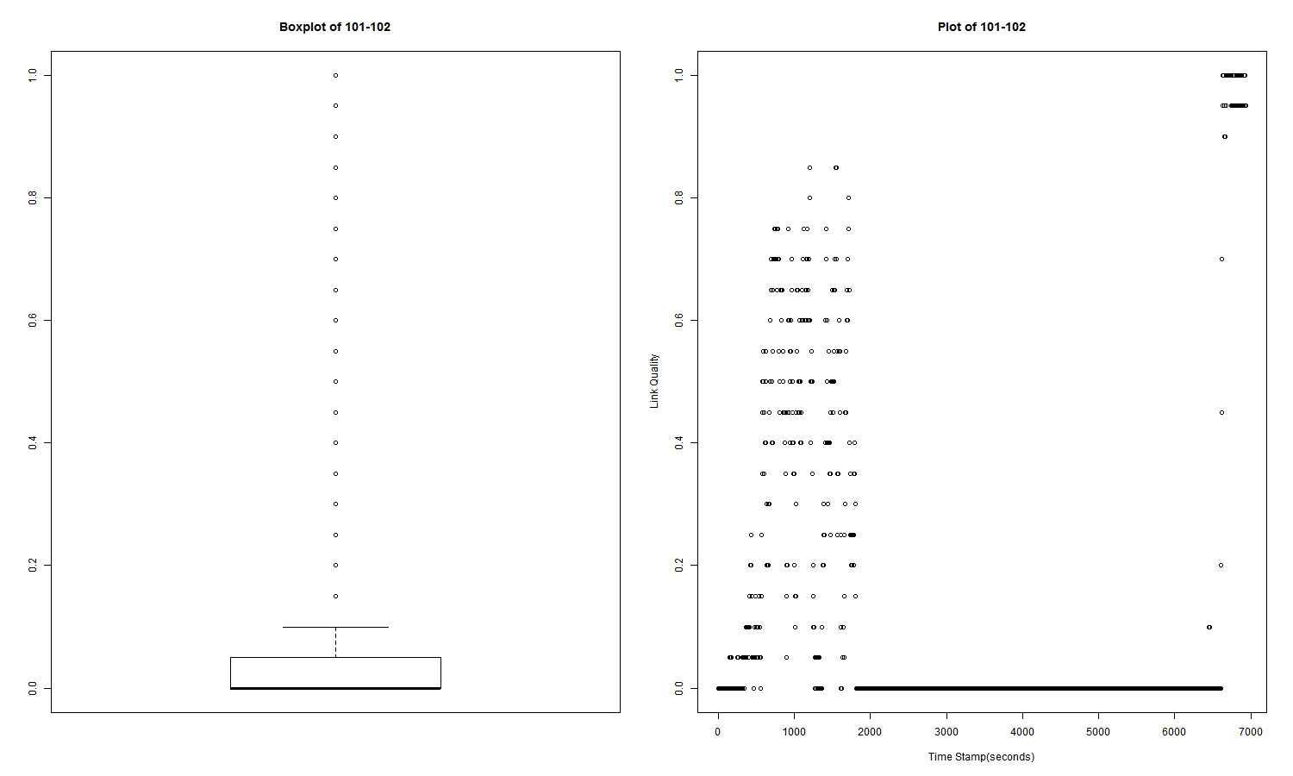

**Figure 11: Comparing Boxplot and Plot of the link quality for node pairs 192.168.2.101 - 192.168.2.102**

From the boxplot of 192.168.2.101-192.168.2.102, we can see the median is zero which indicates during 50% of the experiment period, the link quality remained zero.

Also, many outliers in the boxplot are observed ranging from 0.1 to 1.0. Although the link qualities of outliers have better performance, it doesn't mean the connection of whole period is acceptable. Because the maximum of the whisker is only 0.1 (1.5 IQR from Q3), it shows that most of the time the link quality kept low. The outliers are only a few and it doesn't affect the general link quality much.

Compared with the XY-plot on the right, the boxplot is more able to show the general trend of link quality. We can understand if this node pair presents a good link quality distribution or not.

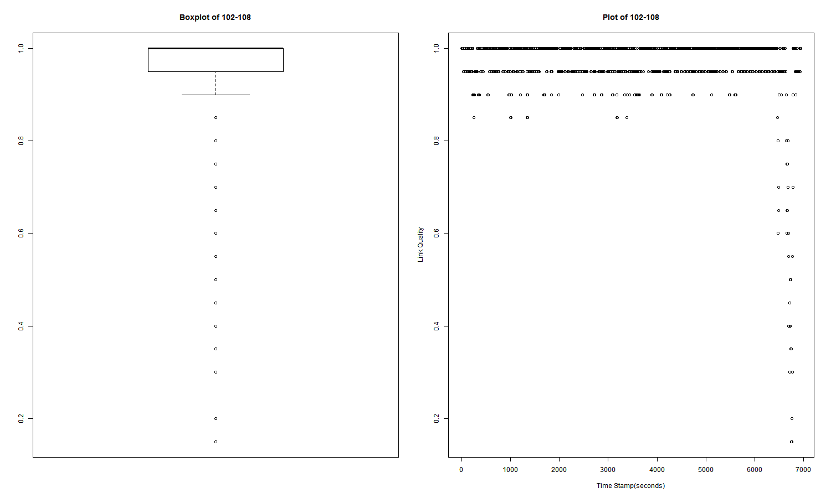

**Figure 12: Comparing Boxplot and Plot of the link quality for node pairs 192.168.2.102 - 192.168.2.108**

From the boxplot of 192.168.2.102-192.168.2.108, it is observed that the minimum of the whisker is around 0.9 and the box’s range is from 0.95 to higher values. Thus, we know this node pair has a very good link quality. Even though some outliers have bad link qualities, it doesn’t influence the connection quality.

In the XY-plot on the right, we can see the link quality plummets to almost 0 in the end. This intrigues us wondering if this descent affects the whole process. But, it is hard to decide only by the XY-plot. That is, with the help of the boxplot, it is easier for us to distinguish general trends from temporal ones.

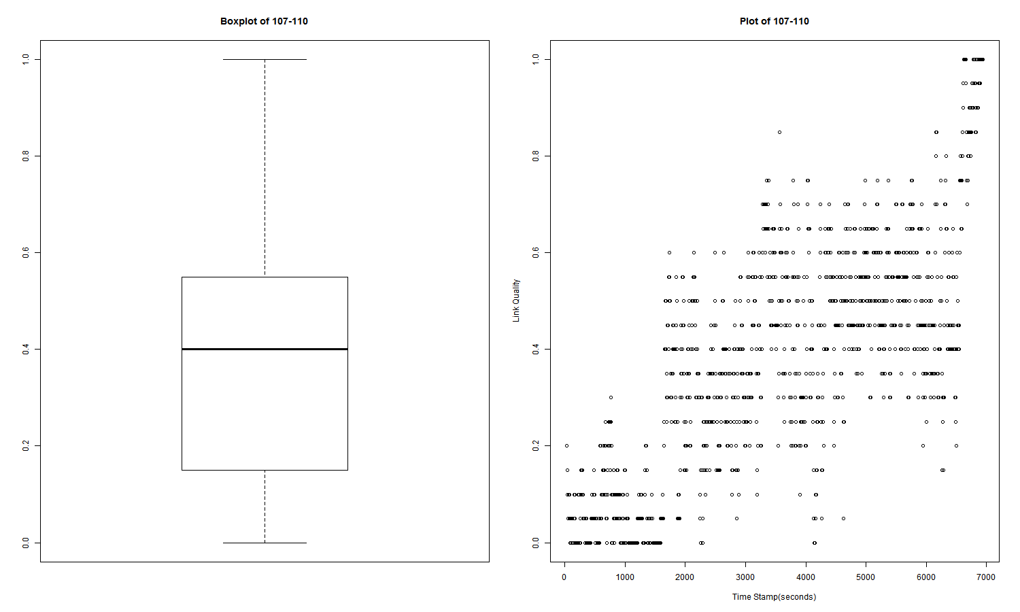

**Figure 13: Comparing Boxplot and Plot of the link quality for node pairs 192.168.2.107 - 192.168.2.110**

From the boxplot of 192.168.2.107-192.168.2.110 which is unlike the above two, we are able to spot the minimum, Q1, median, Q3 and maximum. This indicates that the distribution of link qualities is diverse. With Q1 (0.15), median (0.4) and Q3 (0.55), we can say the general link quality is not good because most of the time the link quality is only within 0.15 and 0.55. Two things worth noticing are that **the median is located at 60% of the box indicating the values between median and Q3 are more condensed than between median and Q1** and **no outliers are observable meaning the distribution of link qualities has a good manner**.

In this case, XY-plot only shows an overview of link qualities but unable to display more meaningful information.

To sum up, boxplot is a standardized way to displaying distribution of data with minimum, Q1, median, Q3 and maximum. Combined with XY-plot, we can have not only general but also detailed information of link qualities.

Question (6). Give a link quality histogram for node pair 192.168.2.102 - 192.168.2.108, and 192.168.2.103 - 192.168.2.108. What do you observe?

Answer (6):

Figure 14(a) shows link quality histogram for node pair 192.168.2.102 - 192.168.2.108. It is clear that the values of the link quality maintain stable with 1 value almost the time, just for a few second, it drops to 0.8. In the meanwhile, Figure 14(b) shows how the link quality fluctuates between 0.2 and 0.8 values, showing instability of the wireless link for node pair 192.168.2.103 - 192.168.2.108.

Compared with XY-plot which only shows general trends, in histograms, we are able to observe the amounts of different link quality values and distinguish which value stayed for how long precisely.

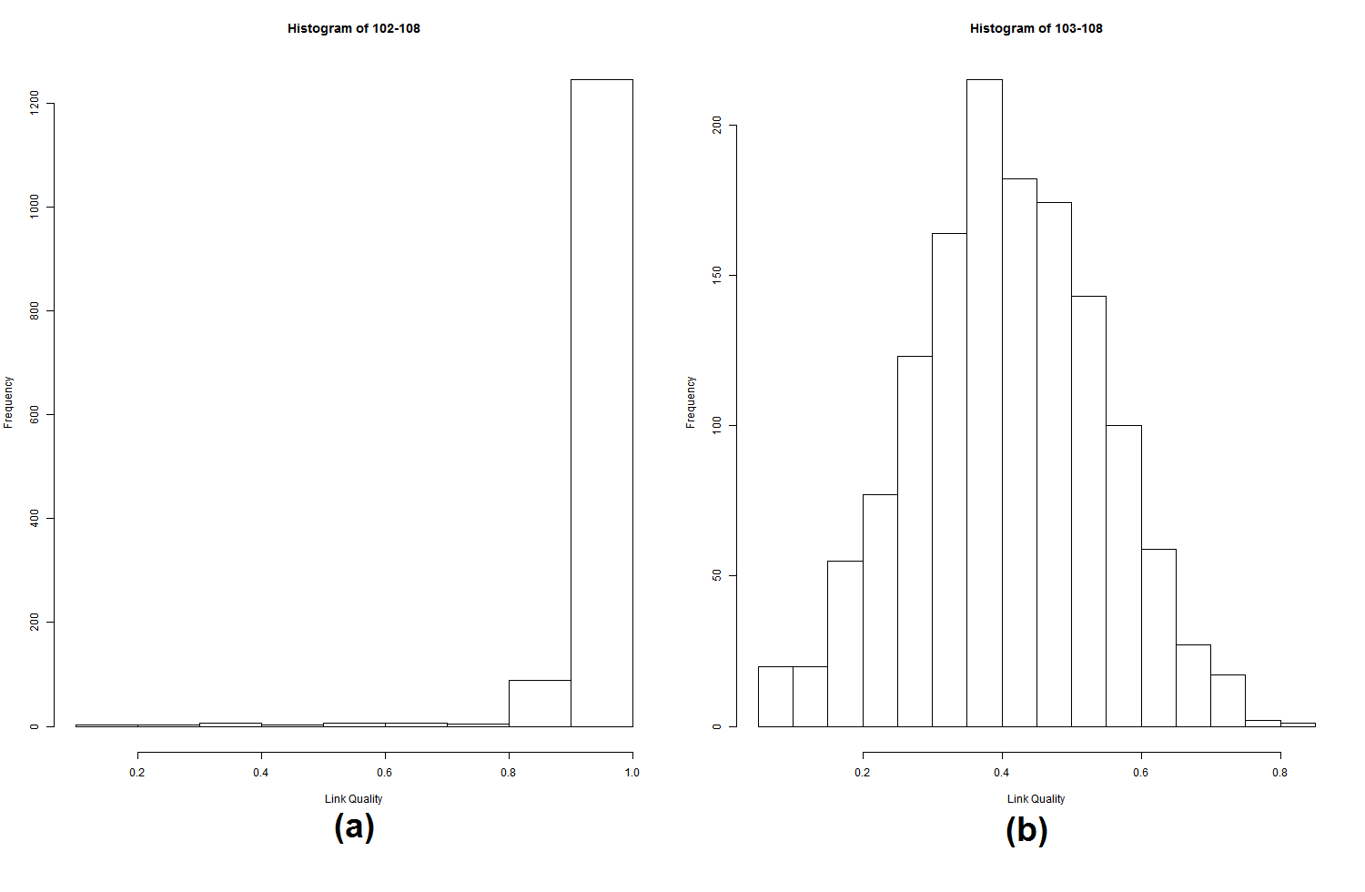

**Figure 14: link quality histogram for node pair 192.168.2.102 - 192.168.2.108 on (a) and**

**for node pair 192.168.2.103 - 192.168.2.108 on (b)**