Information Retrieval and Security Assessment
SkillScout AI Assignment 2 Final Executed Assessment
Sanali Sudugodage - IT22557742 | IT3041 Information Retrieval and Web Analytics | 28 September 2026

Executive Summary
This assessment checks whether SkillScout AI retrieves relevant existing course records and protects the gateway-worker communication boundary. The retrieval tests cover exact-term search, no-match queries, BM25 length handling, keyword stuffing, stale offers and reproducible metrics. The security tests verify HTTPS source validation, worker authentication with X-Agent-Key, gateway validation of run IDs and agent identity, and employee denial on admin APIs.

Execution Evidence
Automated test file: tests/test_assignment2_sanali_ir_security.py
Command run: .venv/bin/python -m pytest -q
Overall result: 113 passed, 2 warnings
Git evidence commit: f386810 Add Sanali IR security assessment tests
Scope note: Tests were run against temporary local databases and mocked agent/model transports where needed. They do not modify the student's real demo account database.
Live system proof: The screenshot below was captured after checking the gateway, four worker agents and frontend on the local machine. It also records the automated checks used as assessment evidence.
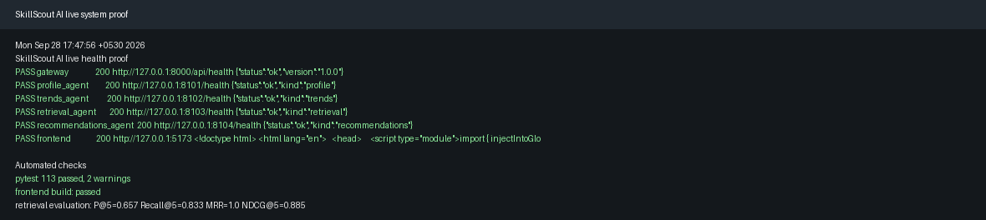

Executed Test Cases
ID | Case | Expected behaviour | Result | Actual evidence
TC01 | Relevant exact-term retrieval | Search should return traceable existing courses. | PASS | Python query returned existing catalogue IDs and matched Python.
TC02 | No-match query | Invented query should not create a fake course. | PASS | No sources were returned for zzzznonexistent.
TC03 | BM25 length manipulation | Long irrelevant padding should not dominate. | PASS | Short focused document scored at least as high as padded one.
TC04 | Keyword stuffing attack | Repeated keywords should not bypass skill coverage. | PASS | Stuffed Docker course was not recommended for Python need.
TC05 | Source URL reliability | Unsafe source URLs should be rejected. | PASS | HTTP admin course URL returned 422.
TC06 | Forged course identifiers | Gateway should reject unknown course IDs. | PASS | Validation raised unknown course error.
TC07 | Worker without X-Agent-Key | Worker should reject missing internal key. | PASS | POST /execute returned 401.
TC08 | Wrong worker key | Wrong key should be rejected without leaking the real key. | PASS | POST /execute returned 401 and did not expose the secret.
TC09 | Run ID substitution | Mismatched run_id should be rejected. | PASS | Gateway raised unexpected agent response.
TC10 | Agent kind substitution | Wrong agent identity should be rejected. | PASS | Gateway raised unexpected agent response.
TC11 | Employee admin API access | Employee should not access admin catalogue writes. | PASS | Admin course write returned 403.
TC12 | Retrieval query injection | Search text should not become SQL. | PASS | Injected query returned safely and course table remained accessible.
TC13 | Stale course offer | Expired offers should not be active. | PASS | Expired NLP course reverted to original price.
TC14 | Source poisoning in description | Unverified course text should remain demo evidence. | PASS | Recommendation explanation retained provider verification warning.
TC15 | Reproducible retrieval metrics | IR metrics should be runnable. | PASS | Evaluation returned 7 queries, MRR 1.0 and NDCG 0.885.

How To Explain This In The Viva
- Information retrieval means finding and ranking relevant items from a collection.
- Our prototype uses lexical retrieval: BM25 plus TF-IDF cosine, with skill coverage.
- The system returns existing catalogue courses; it should not invent new course IDs.
- The gateway checks worker identity, run ID and course IDs before saving agent results.

Limitations
These tests provide local regression evidence for the prototype. They are not a production penetration test, not an independent user study, and not proof that the system is ready for deployment on a public network.
The LinkedIn and commercial provider integrations were not tested because the project uses local demonstration data and no paid API keys. In a company deployment, licensed provider APIs and approved professional-content feeds would need separate integration and security review.

Conclusion
The assessment cases were converted from the individual report plan into executable pytest tests. The relevant suite passed locally, and the complete project test suite passed with 113 tests. This gives the team evidence to discuss in the viva while still being honest about prototype limitations.

