Weather and Next-Day PM2.5 Prediction at Six Stations in Taiwan

1. Motivation and decision context
Next-day PM2.5 estimates can help an air-quality monitoring agency plan public communication about pollution. Adding weather observations may improve these estimates, but it also requires joining two monitoring networks and managing missing or inconsistent records. Our practical question is whether that extra information produces a useful improvement beyond what can already be predicted from today's PM2.5, the station, and the season. We consider both overall accuracy and whether the result is consistent across locations.
The potential impact is a more defensible decision about using weather data in a simple prediction approach. A small average gain that disappears at some stations would not, by itself, justify using one weather-augmented model everywhere. This project evaluates prediction, not the causal effect of weather on pollution or the cost of deploying a system.
2. Objective and research questions
Our objective is to assess the additional predictive value of current-day meteorological observations for the following calendar day's average PM2.5 at six selected monitoring stations. The statistical task is supervised regression: one station-day is used to predict the next day at that station.
RQ1. How much does adding weather change next-day PM2.5 prediction error relative to a persistence baseline and a PM-only linear regression?
RQ2. How does the incremental value of weather vary across the six stations?
RQ3 (planned). Which individual weather variables add predictive value after accounting for today's PM2.5, station, and month?
3. Related work and our scope
Lee et al. (2020) combined Taiwan air-quality and nearby weather-station data in a gradient-boosting model for 24-hour PM2.5 prediction. They also examined geographic differences. We therefore do not claim that using weather to predict PM2.5 is new. Our narrower, decision-oriented comparison asks whether four daily weather measures add enough value over simple, interpretable baselines at six selected stations during 2021–2024. Their hourly forecast setting and our next-calendar-day average are different tasks, so their error values should not be compared directly with ours [1].
The midterm provides an initial comparison on 2024 data. We reserve 2025 for the final evaluation and have not used it to choose a model.

4. Data: sources, rows, and observation process
Source | Original observations | Fields used here
Ministry of Environment air-quality archive | Hourly measurements at air monitoring stations | PM2.5, station, date and hour
CWA CODiS | Daily observations at meteorological stations | Temperature, relative humidity, precipitation, wind speed
Taiwan Open Data, dataset 6075 | Air-quality station metadata | Station location for matching

The six intentionally selected air-quality stations are Tamsui and Zhongshan (north), Zhongming and Nantou (central), and Pingtung and Chaozhou (south). Government monitoring networks observed the data; the team did not assign weather or pollution conditions. Air-quality and weather readings are collected at different physical sites, so matched weather values are nearby proxies. The stations are not a random sample of Taiwan.
What one modeling row looks like
Key | Information available at the end of day t | Outcome
Air station + date t | PM2.5 average on t; temperature, humidity, rain, wind speed on t; station and target month | PM2.5 average on calendar day t+1 at the same air station

The merged panel contains 1,826 dates per station from January 2021 through December 2025: 10,956 station-days before modeling exclusions. Consecutive days at the same station are repeated measurements, not independent random draws. The target population is future station-days at these six locations under comparable conditions.
5. Cleaning already completed and remaining data risks
Hourly PM2.5 files were reshaped to station-hours. Non-numeric quality-control symbols were treated as missing; a daily mean was accepted only with at least 16 valid hourly readings. Among the six stations, 74 daily PM2.5 values did not meet the requirement. Weather files were reshaped from day-by-month grids into station-days. Trace rain was coded as 0.25 mm with a separate trace indicator; invalid symbols remained missing. Wind speed and direction were separated, though direction is not in the initial models.
We checked station-date duplication and joined weather to air data by date and a documented station pairing. All 10,956 expected station-dates matched, with no duplicate station-dates in the merged set. Pingtung uses Linluo for temperature, humidity, and rain but Changzhi for wind, because Linluo wind records were mostly invalid. The combined weather panel has two missing humidity values and eight missing precipitation values.
Remaining risks include weather-station moves or instrument changes, distance between paired stations, and missingness that may vary by season or pollution level. We will review these before making a location-wide recommendation.

6. What the training data look like
After requiring valid PM2.5 today and on the next calendar day, 10,849 station-days were eligible for the initial date split. For fair model comparison, rows with missing weather predictors were excluded from both regressions and the baseline. The resulting modeling comparison has 6,498 training and 2,181 validation observations; the 2025 test period remains untouched.
2021–2023 training variable | Mean | Median | Missing
Daily PM2.5 (µg/m³) | 15.395 | 12.917 | 0 of 6,500 before complete-case filtering
Temperature (°C) | 24.513 | 25.6 | 0
Relative humidity (%) | 76.841 | 76.0 | 2
Precipitation (mm) | 4.997 | 0.0 | 0
Wind speed (m/s) | 1.579 | 1.4 | 0

PM2.5 is right-skewed (mean above median), and rain is strongly right-skewed with a median of zero. PM2.5 also changes across stations and seasons. The chart below uses training data only: summer values are generally lower, especially at the southern stations. These patterns motivate station and month controls in the regression models; they are descriptive and do not show causation.
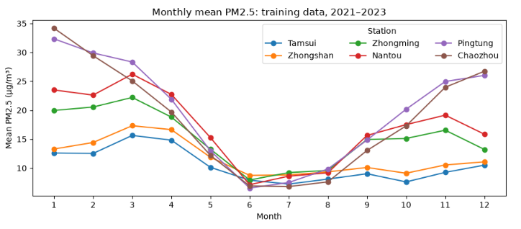
Figure 1. Monthly mean daily PM2.5 at six stations, 2021–2023 training data. Source: team calculations from Ministry of Environment measurements.
7. Model and evaluation plan
Persistence: predict tomorrow's PM2.5 to equal today's. This no-fit baseline is plausible because adjacent days are related and it uses no weather. PM-only linear regression: add today's PM2.5, station indicators, and target-month indicators to account for location and season. Weather regression: add today's temperature, relative humidity, precipitation, and wind speed to the same PM-only specification. The two fitted models differ only in those four weather predictors.

8. Fair temporal evaluation and initial results
We split by target date: 2021–2023 for training, 2024 for validation, and 2025 for an untouched final test. This ordering better reflects prediction into the future than a random split of repeated station-days. All three approaches below were evaluated on the same 2,181 complete 2024 observations. Mean absolute error (MAE) measures typical absolute error; root mean squared error (RMSE) gives more weight to large errors. Both are in µg/m³, and lower is better.
Approach | MAE ↓ | RMSE ↓ | What it adds
Persistence | 4.131 | 5.844 | No fitted model or weather
PM-only regression | 3.922 | 5.331 | Station and target month
Weather regression | 3.904 | 5.315 | Four current-day weather variables

The PM-only regression lowered MAE by about 5.1% versus persistence. Weather then lowered MAE by only 0.46% (3.922 to 3.904) and RMSE by 0.30% (5.331 to 5.315) versus PM-only. These are preliminary validation differences, not evidence that weather caused the change.
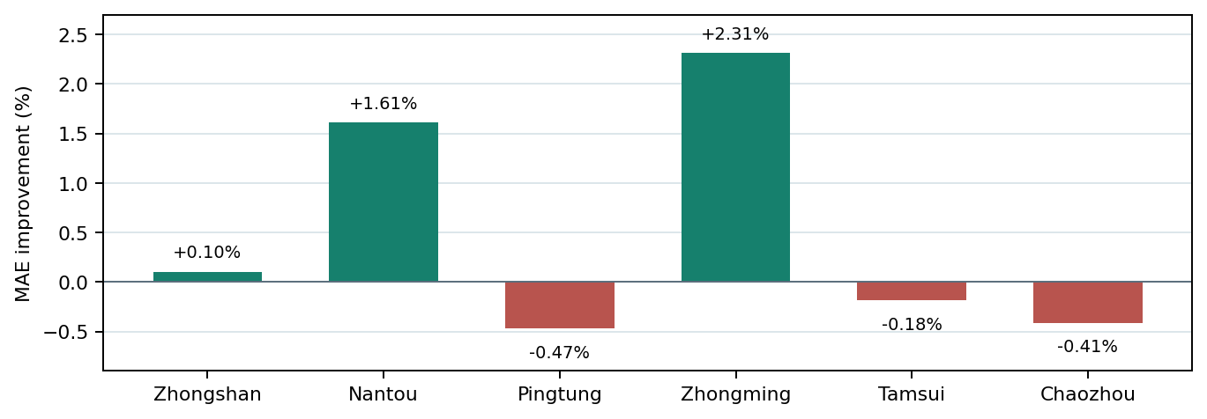
Figure 2. Relative change in 2024 validation MAE when weather is added to PM-only regression. Positive values mean lower error. Source: team calculations.
Weather reduced MAE at only three of six stations, with the largest changes at Zhongming and Nantou. It reduced RMSE at five of six stations, but those gains were also small. Both regression models tended to overpredict the lowest-pollution observations and underpredict the highest-pollution observations. The high-pollution error matters for an agency considering operational use.

9. Preliminary interpretation and limits
The validation data support three bounded claims: today's PM2.5 predicts tomorrow's PM2.5 well at these six locations; the PM-only regression improves on persistence; and the four weather variables together add only a small, geographically uneven gain. Current evidence does not support a claim of uniform benefit, causal weather effects, deployment readiness, or generalization to every Taiwan monitoring station.
Our prediction is available after the current day's observations are complete, not as a morning forecast. Paired meteorological readings are proxies from nearby stations. Repeated daily observations may be temporally correlated, and one pooled weather model assumes shared weather coefficients across all six locations. Linear regression may miss nonlinear effects and weather-location interactions. We have not yet estimated uncertainty around the small error differences or examined the untouched 2025 outcomes.
10. Plan for the remainder of the project
RQ3: Compare the PM-only model plus each weather variable separately, using identical training and validation rows. Then remove one variable at a time from the full weather model to check whether predictors carry overlapping information. Coefficient sizes alone are not a fair importance ranking because the predictors have different units and correlations.
Robustness: Inspect errors by station, season, and pollution level; review station histories and missing-data patterns; and quantify uncertainty with an approach that respects repeated dates. Consider simple weather-location interactions or nonlinear terms only if training diagnostics justify them. Specify any final choices before evaluating once on the 2025 test period.
Decision: On current validation evidence, we would hold off on adding all four weather measures uniformly at all six stations. The measured gain is below one percent overall and is not consistent across locations. This is a preliminary predictive recommendation; processing costs and operational requirements have not been estimated.
References
[1] Lee, M., Lin, L., Chen, C.-Y., et al. (2020). Forecasting air quality in Taiwan by using machine learning. Scientific Reports, 10, 4153. https://doi.org/10.1038/s41598-020-61151-7
[2] Taiwan Ministry of Environment. Historical Air-Quality Monitoring Data. https://airtw.moenv.gov.tw/cht/Query/His_Data.aspx
[3] Central Weather Administration. CODiS Meteorological Station Data. https://codis.cwa.gov.tw/StationData
[4] Taiwan Government Open Data Platform. Air-Quality Monitoring Station Metadata, dataset 6075. https://data.gov.tw/en/datasets/6075

