

ព្រះរាជាណាចក្រកម្ពុជា

ជាតិ សាសនា ព្រះមហាក្សត្រ

Course: Mobile App Dev

Lab01 - Intro to Flutter

Name of Students ID of Students Score
MA SOVITCHEA e20221575 ………

Group: I4-GIC-C

Lecturer: Mr. HOK Tin

Academic year: 2025 ~ 2026
Lab01’s Solution
### Exercise 1 — Environment Validation
- Command run:
flutter doctor
- Initial output issues found:
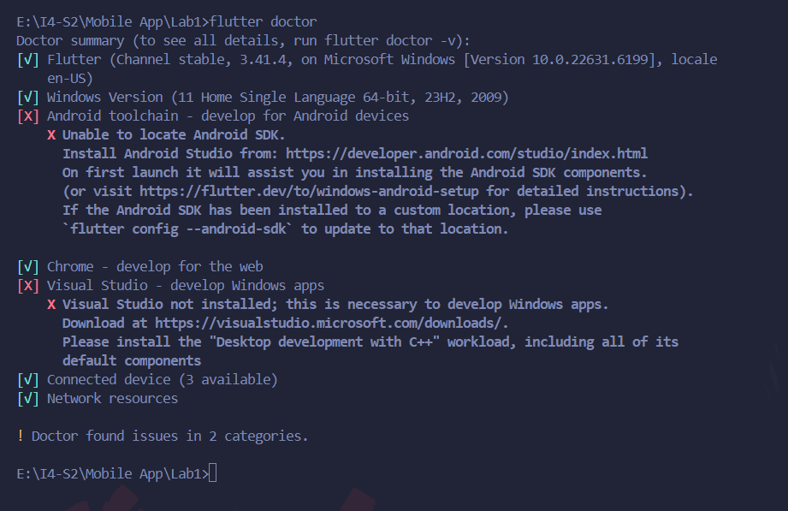
- Issue 1: Android toolchain
- Problem: Flutter could not locate the Android SDK.
Steps to resolve:
- Visited developer.android.com/studio
- Downloaded android-studio-panda2-windows.exe (Windows 64-bit, Recommended)
- Ran the installer with default settings, ensuring Android Virtual Device was checked
- Completed the Android Studio setup wizard using Standard install type
- Let Android Studio download and install the Android SDK components
- Ran flutter doctor android-licenses and accepted all licenses by typing y
- Re-ran flutter doctor – Android toolchain now shows ✅
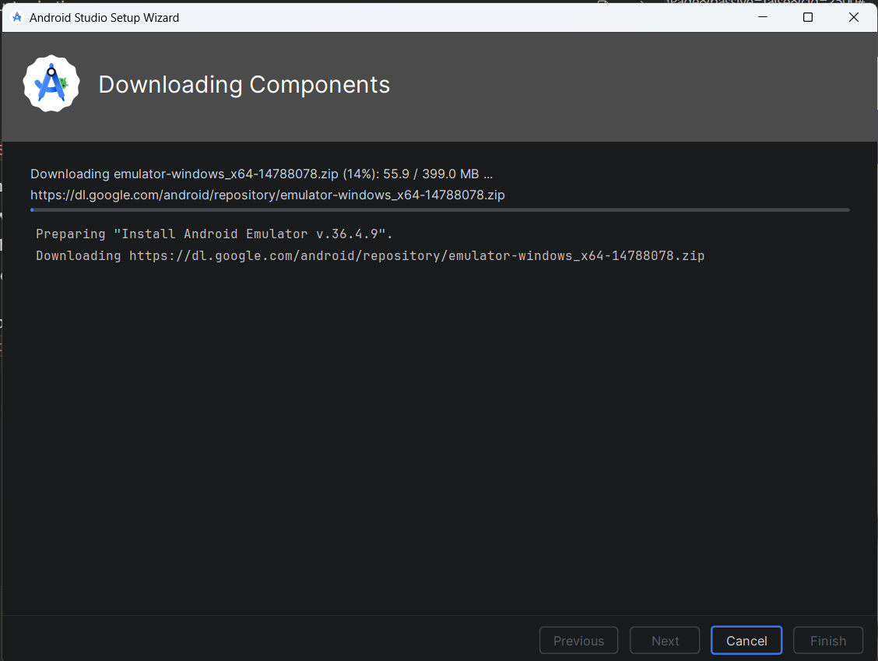

- Issue 2: Visual Studio
- Problem: Visual Studio not installed, which is required for Windows desktop app development.
Steps to resolve:
- Visited visualstudio.microsoft.com/downloads
- Downloaded Visual Studio Community (free)
- Ran the installer
- Selected the “Desktop development with C++” workload
- Clicked Install and waited for the download to complete (~7-8 GB)
- Re-ran flutter doctor – Visual Studio now shows ✅
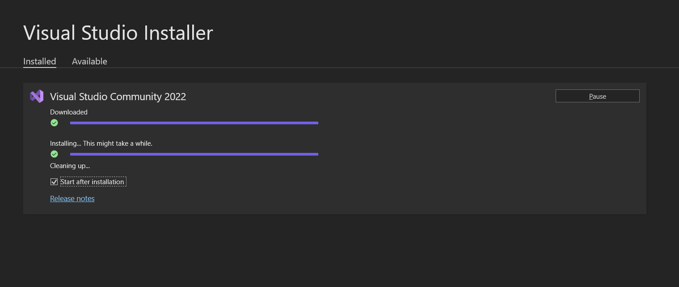
- Resolved issues Output:
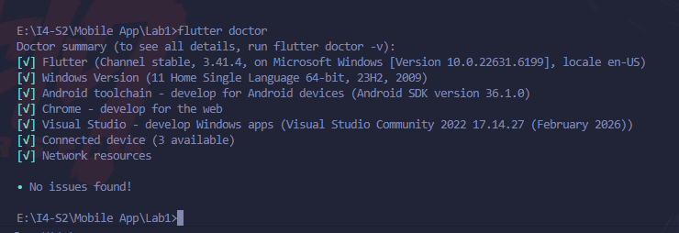

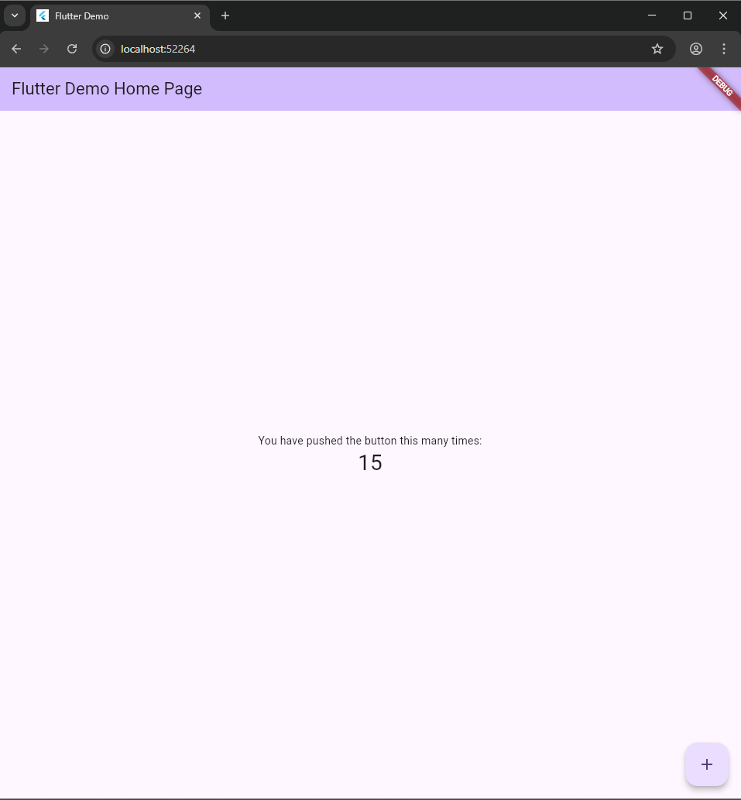
### Exercise 2 — First Project
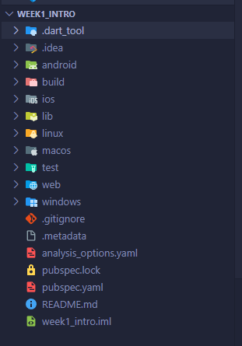

### Exercise 3 — Customize the Home Screen
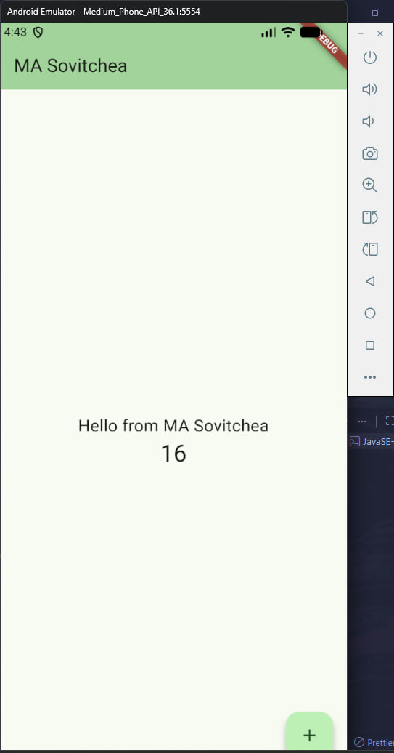
### Exercise 4 — Explore pubspec.yaml
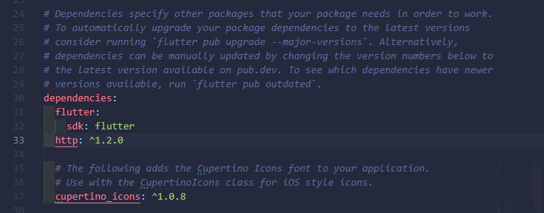
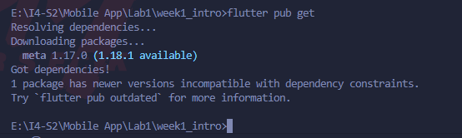
### Exercise 5 — Widget Exploration
