

ព្រះរាជាណាចក្រកម្ពុជា

ជាតិ សាសនា ព្រះមហាក្សត្រ

Course: Mobile App Dev

Lab03 - Dart Control Flow, Advanced OOP & Essential Flutter Widgets

Name of Students ID of Students Score
MA SOVITCHEA e20221575 ………

Group: I4-GIC-C

Lecturer: Mr. HOK Tin (Course)

Academic year: 2025 ~ 2026
Lab03’s Solution
Exercise 1 – Control Flow
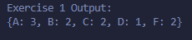
Exercise 2 – OOP Design
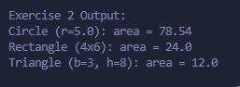
Exercise 3 – Profile Card UI
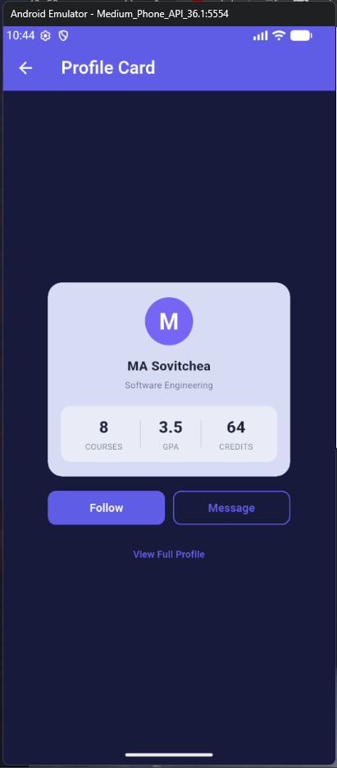

Exercise 4 – Product Card UI
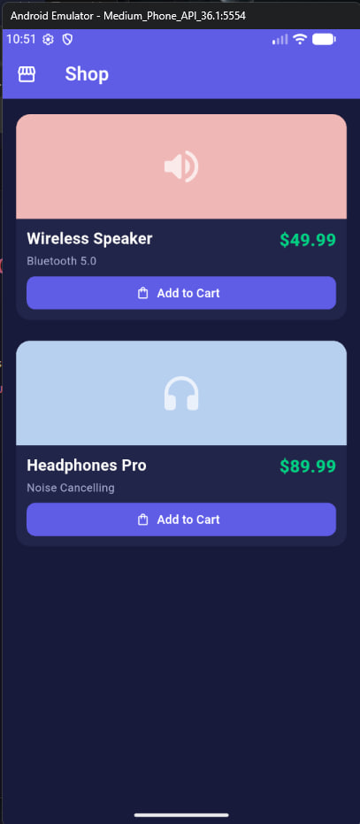

Exercise 5 – Two-Column Dashboard
