Creating the deck

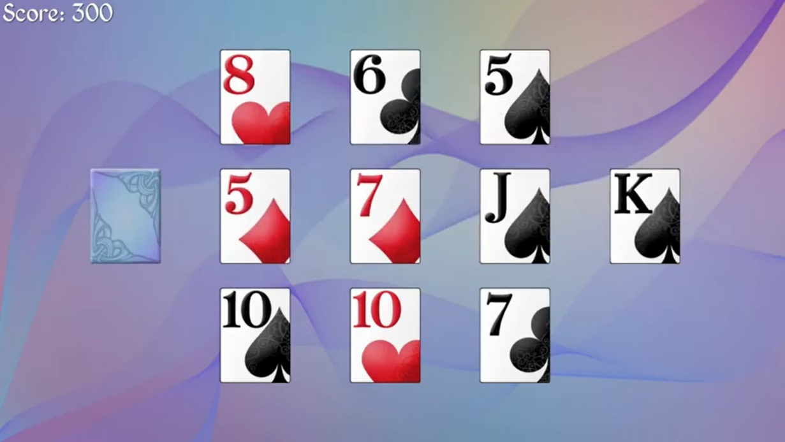

**Why Stack was chosen for the original (Deck on the left) deck**

For the original deck I decided to use a stack. The reason behind this was that I could simply pop() from the top of the deck. I felt a ArrayList was unneeded for this deck and I had no reason to access any other card aside from the top one. I did not use a Queue as a queue pulls from the front, not the back of the deck. Taking the first entry first and last entry last.

**Why ArrayList was chosen for the playedCards (Deck in the middle)**

For the second middle deck, I used an ArrayList. This is the set of cards that the player sees. Since I would need to access all of the entries in this deck, I thought a linked implementation would be best. I felt as though this would make the cards easier to work with and manipulate depending on the circumstance.

**Why Queue was chosen for the dismissed cards (Deck on the right)**

I decided to use a queue for this deck as when it used the FIFO method. Meaning the first card put into the queue would be the first card removed from it. This was useful to me to make my replayGame() function in which it was needed to replay the user’s moves in order. A stack would not help me in this regard as the most recent item added to a stack is what is removed first.