# CP2403 Project Part 1

# Data Exploration, Management & Visualization

**First Name: Caleb**

**Last Name: Webster**

1. Box plot

|  |
| --- |
| Question: How does the Silicate concentration of the water change as water depth increases up to a depth of 1000m?  categorical variable: Depthm (converted to categorical by cutting)  quantitative variable: Si03uM |

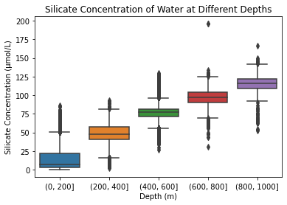

What is conclusion can you draw from the box plot?

|  |
| --- |
| Generally, silicate concentration increases with water depth. The increase appears to be linear up to 1000m. |

1. Histogram

|  |
| --- |
| Question: What is the frequency distribution of temperature recordings for water depth of up to 50m?  quantitative variable: T_degC |

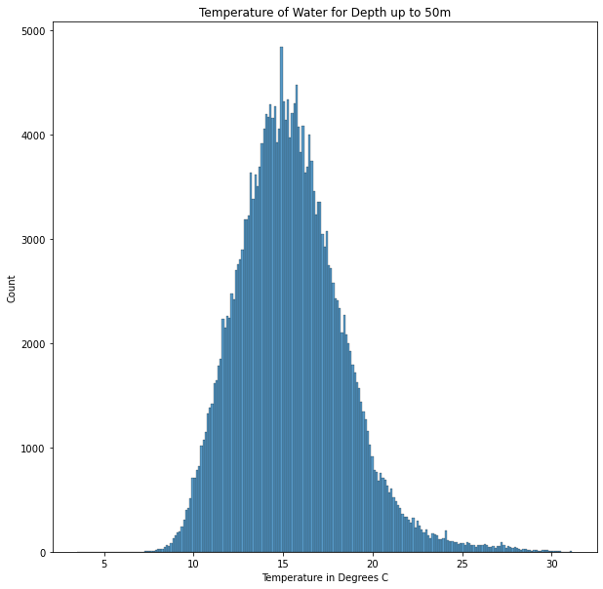

What is conclusion can you draw from the histogram?

|  |
| --- |
| The distribution of water temperature is unimodal and slightly skewed to the right. The highest peak (most frequent value) occurs at around 15 degrees. |

1. Line chart

|  |
| --- |
| Question: what is the relationship between water depth and oxygen concentration for water depth of up to 500m?  quantitative variable: Oxy_µmol/Kg |

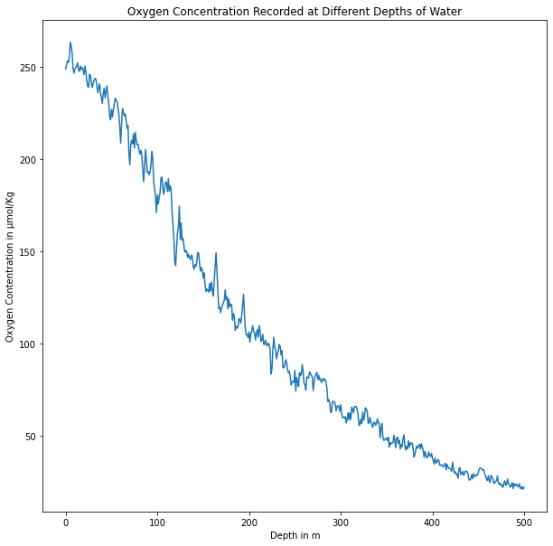

What is conclusion can you draw from the line chart?

|  |
| --- |
| Generally, as water depth increases, the oxygen concentration of the water decreases for depths of up to 500m. |

1. Bubble.

|  |
| --- |
| Question: What is the correlation between Nitrite, Nitrate, and Ammonium Concentration for water depths of up to 50m?  quantitative variable 1: NO2uM  quantitative variable 2: NO3uM  quantitative variable 3: NH3uM |

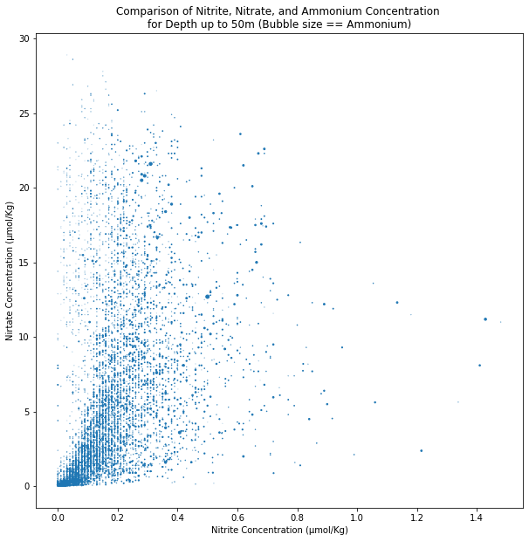

What is conclusion can you draw from the bubble chart?

|  |
| --- |
| Generally, there is a positive correlation between nitrite concentration and nitrate concentration for water depths up to 50m. Ammonium concentration also seems to increase with higher values of nitrite and nitrate. |

1. Selected Chart.

|  |
| --- |
| Selected Chart: HeatMap  Question: How many phosphate concentration readings were above the mean phosphate value for water depths of up to 250m?  Variables used:  Variable 1: Depthm  Variable 2: PO4uM  Variable 3: Counts |

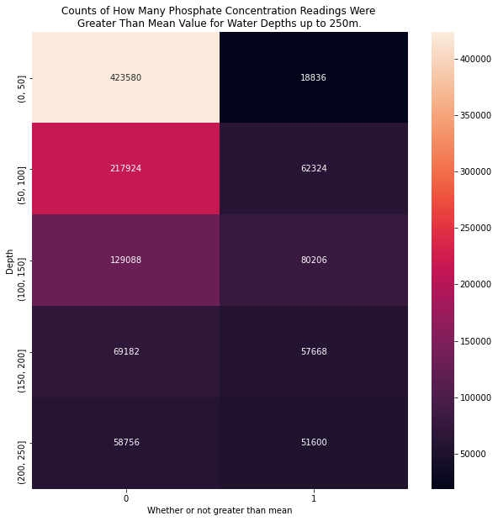

What is conclusion can you draw from your selected chart?

|  |
| --- |
| More phosphate measurements were taken in shallow water than deep water, and most phosphate concentration values are below the mean value than above. The ratio of values above the mean to values below the mean decreases as water depth increases (the two values get closer together). |