1. Vector recycling

It is used when there is an operation between 2 or more different length vectors, but there is a condition to be satisfied which longer length vector is the multiple of the short length vector.

Ex:

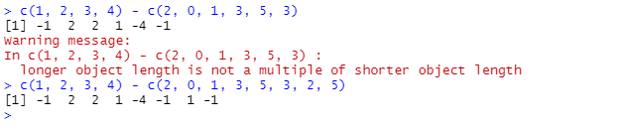

1. Inner multiplication

This operation is used for matrix multiplication and both of the matrices have the same number of rows and columns.

Ex:

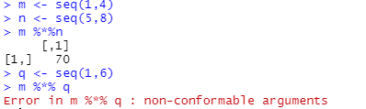

1. Outer multiplication

This operation is used for matrix multiplication, but both of the matrices don’t need to have the same number of rows and columns.

Ex:

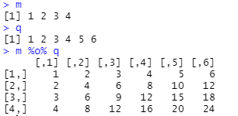

1. Functions
   1. sample(): it returns back the sequence of random numbers between 2 specified numbers.
   2. seq(): it generates the sequence of the elements. There are 2 arguments which are noticeable. They are step and length.out. Step argument is about the step size and length.out is about the length of the vector to be generated.
   3. rep(): it replicates specific vectors n times.
   4. round(): it rounds up decimal numbers.
   5. factorial(): it is used to calculate factorial number.
   6. ls(): it returns back the object that you have created.
   7. mean(): it calculates the average value between 2 numbers.
   8. set.seed(): it helps to generate the same sequence of random numbers.

Ex:

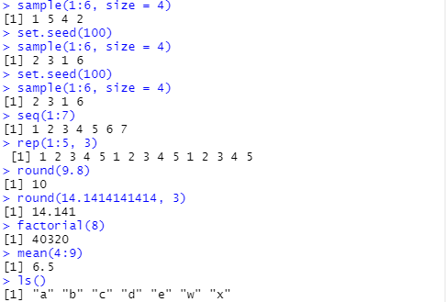

1. Subset

In vector, subset is used to return the value at specified position and also to delete or remove value at the specified position.

Ex:

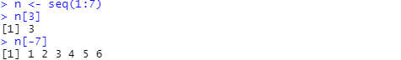

1. Write a program to calculate the BMI rate? Get the user input & Result should be in integer.

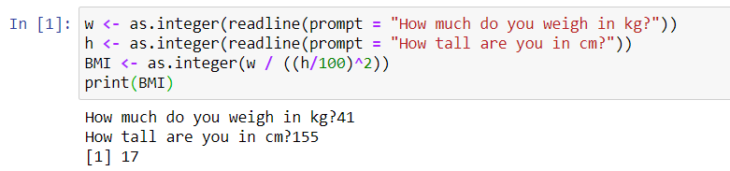

1. Create a function to calculate the BMI Rating? Result should be in integer?

