1. Construct a 5x3 matrix for the value of x

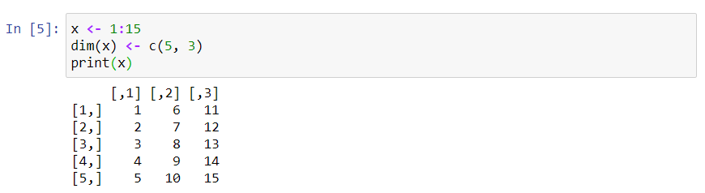

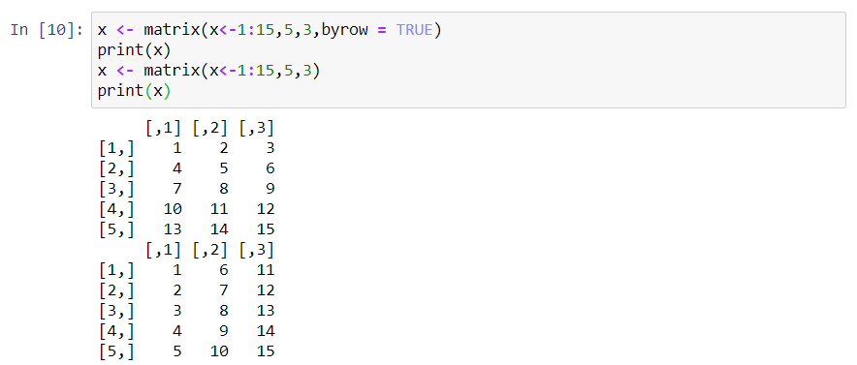

1. Program to generate the following 4x4 matrix

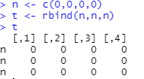

1. Program to generate the 3x8 matrix using "cbind(), rbind(), rev(), rep()"

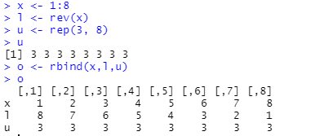

1. Perform arithmetic operations

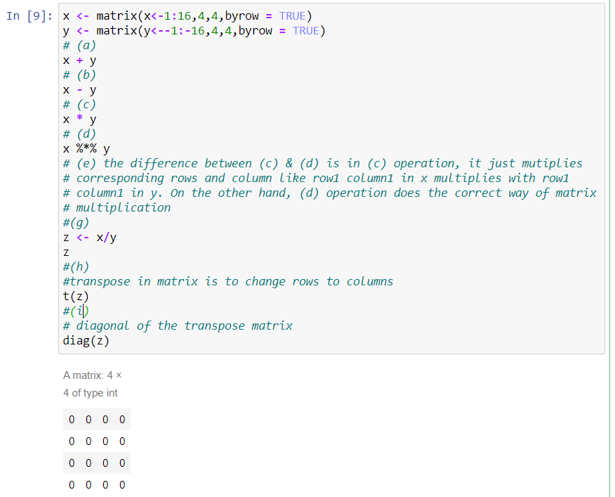

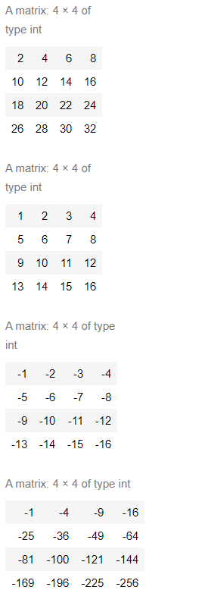

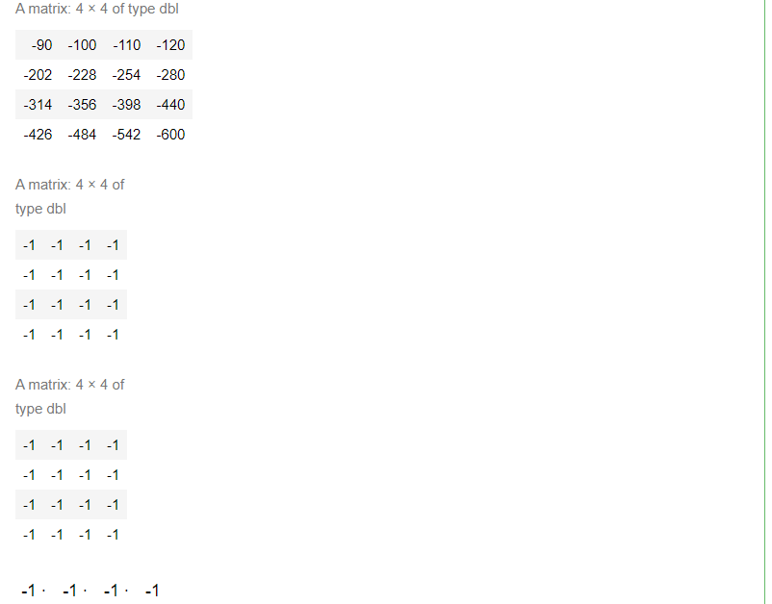

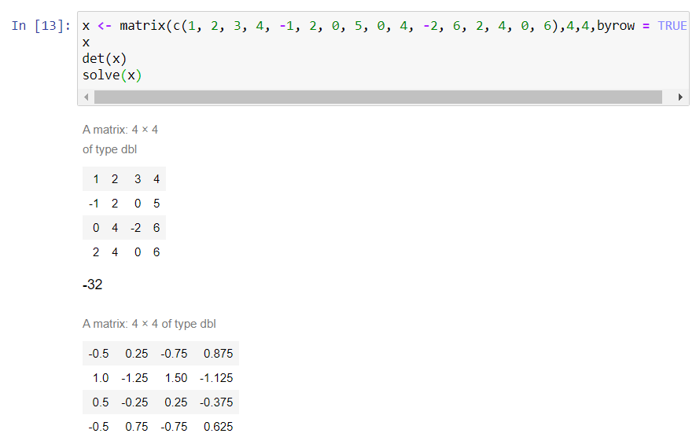

1. The difference between (i) & (ii)

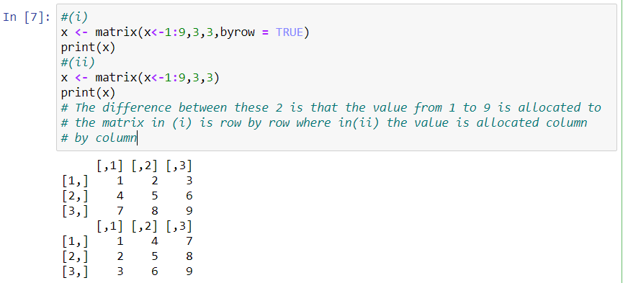

1. Function can use for inner product and outer product in matrix calculation

inner:

1. 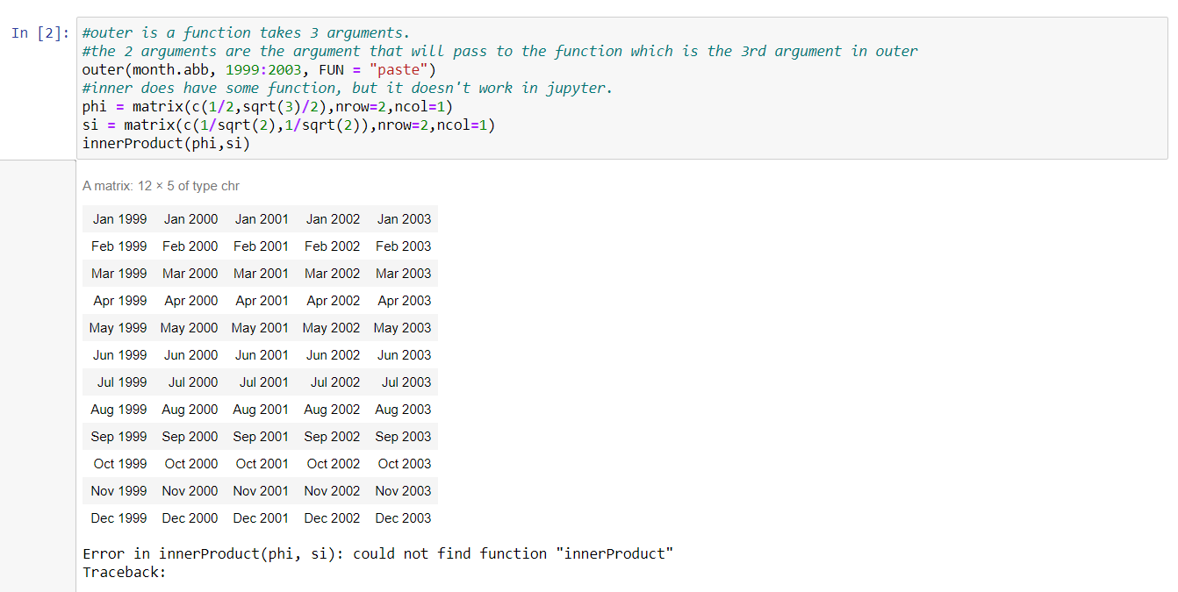The use of all.equal() function in Matrix with sample program

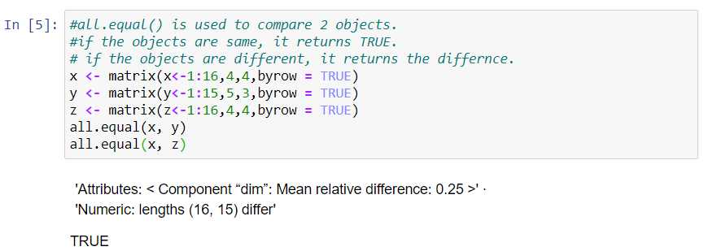

1. The use of dim() function with sample program

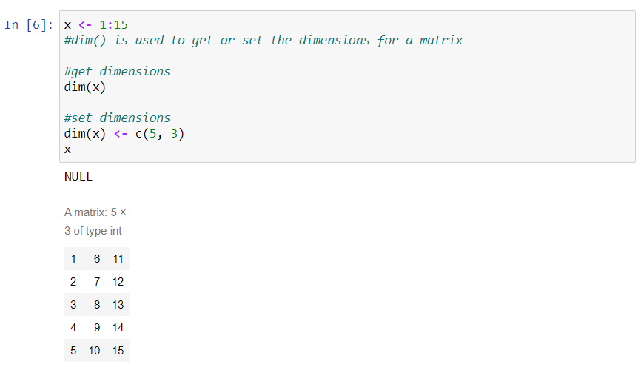

1. Use of $ operator and square brackets [] in list with program

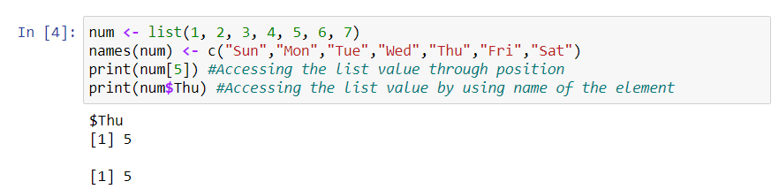

1. ifelse() with example

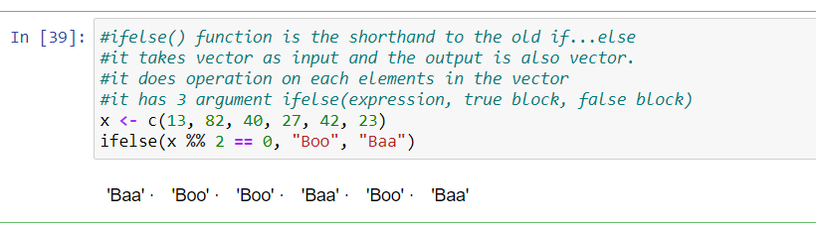

1. BMI program with cases

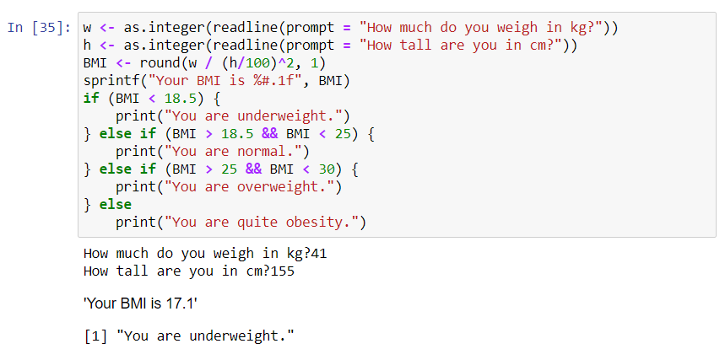

1. Difference between List and Data frame with program

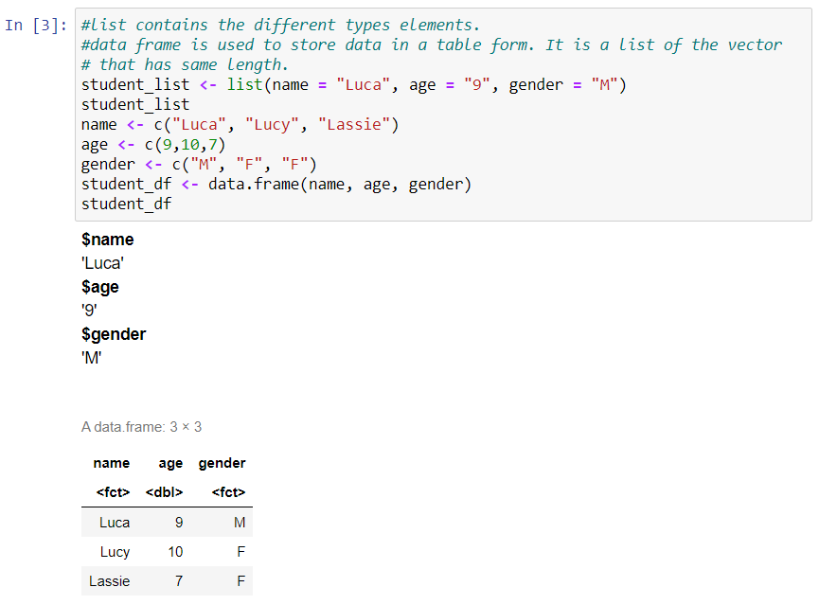

1. Difference between repeat and while loop with program

