CHAPTER FOUR
SYSTEM IMPLEMENTATION AND DOCUMENTATION

4.0 Introduction
This chapter presents the implementation of MemorAid, the Intelligent Memory Reinforcement System (IMRS), designed to support everyday memory practice among elderly users aged 51 years and above. It describes the development environment, system architecture, major modules, input and output formats, information flow and software testing. The implementation follows the Object-Oriented Analysis and Design Methodology (OOADM), supported by prototyping, as established in Chapter Three.
MemorAid goes beyond passive information storage. A user records an everyday memory, attempts to retrieve it when prompted, reveals the stored reference, and rates the difficulty of recall. The rating informs the SM-2 review schedule. The application also provides guided memory exercises, analytics, notifications, accessibility settings and a conversational companion. It is a memory-practice aid, not a medical diagnostic or treatment device.

4.1 Choice of Development Environment
The development environment was selected to support browser access, separation between the user interface and server-side logic, persistent data storage, and integration with a generative AI service. The front end uses HTML, CSS and JavaScript through a React single-page application built with Vite. Python and Flask provide the REST API. PostgreSQL is the specified relational database, accessed through SQLAlchemy. Gemini supports selected language-generation tasks, with deterministic fallback logic where configured.
Component | Technology | Purpose
User interface | HTML, CSS, JavaScript; React 19 | Renders pages, forms, recall, exercises, chat and analytics.
Build tooling | Vite 8 | Builds and bundles the React application.
Back end | Python and Flask | Implements authentication, memory operations, recall, exercises, chat, analytics and notifications.
Communication | REST API and JSON | Transfers structured requests and responses between browser and server.
Database layer | SQLAlchemy ORM | Maps application objects to relational data.
Database | PostgreSQL | Stores users, memories, questions, schedules, sessions, patterns, chat and notifications.
Authentication | JWT and bcrypt | Protects API routes and stores password hashes.
AI service | Google Gemini API | Generates questions, exercise guidance, chat responses, check-ins and motivational text.
Scheduled jobs | APScheduler | Runs check-ins, confidence decay and inactivity checks.
Email | smtplib or console mode | Delivers family alerts when SMTP is configured; console mode supports development.
Testing | pytest; front-end build and lint checks | Tests application logic and checks front-end compilation.

The selected technologies separate presentation, application logic and data persistence. This makes the system easier to maintain and allows the user interface to change without rewriting the scheduling logic. Python supports the SM-2 algorithm, confidence scoring, analytics and scheduled jobs. The REST interface defines the communication boundary between the browser and server.

4.2 Implementation Architecture
MemorAid uses a client–server architecture. The browser renders the React interface and sends REST/JSON requests to the Flask API. Authenticated requests include a bearer JWT. The Flask application validates requests, invokes the relevant service and database operation, and returns structured responses. Where language generation is required, a service calls Gemini; deterministic fallback logic is used for generation tasks where configured. Scheduled jobs process stored data for check-ins, confidence decay and family inactivity alerts.
Layer | Components and responsibilities
Presentation | React/Vite browser application: landing, login, sign-up, dashboard, log memory, recall, exercises, chat, analytics, profile and notifications.
API | Flask route groups for authentication, profile, memories, recall, exercises, chat, analytics, check-in and notifications.
Services | AIQuestionGenerator, ExerciseGuide, ChatCompanion, CheckInGenerator, PatternConfidence, SM2Scheduler, StreakManager, AnalyticsEngine and EmailSender.
Persistence | SQLAlchemy models and PostgreSQL tables for user and activity records.
External/scheduled services | Gemini API, SMTP/console email and APScheduler jobs.

Figure 4.1: Logical architecture of MemorAid. Insert a formal block diagram based on the actual deployed architecture.
[INSERT SYSTEM ARCHITECTURE DIAGRAM SCREENSHOT HERE]
Show Browser/React → Flask REST API → services and database, with separate connections to Gemini API and SMTP/family email.

4.2.1 Front-End Modules
The front end is divided into pages and reusable components. Shared layout, routing, authentication state and a central API client reduce duplicated navigation and request-handling code.
Page/module | Function and main output
Landing, login and sign-up | Introduces the application and handles account access; outputs validation or authentication status.
Dashboard | Shows the greeting/check-in, due memories, recall and exercise streaks, recent memories and next-review information.
Log Memory | Accepts category, memory content and optional context note; returns a saved-memory confirmation, question and next review date.
Recall | Presents one question at a time; accepts a typed answer and 0–5 quality rating; displays a session summary.
Exercises | Guides the user through a selected technique one step at a time and records completion.
Chat | Presents the Aria companion and personalised text responses.
Analytics | Shows accuracy, forgetting frequency by category, accuracy trend, streaks and motivational text.
Profile | Maintains age group, family contact, check-in time, inactivity threshold and accessibility preferences.
Notifications | Lists notifications and supports read/delete actions.

The signed-in shell uses shared navigation and a header with notifications, settings and profile controls. Accessibility preferences include text-size presets and high-contrast mode. The interface refinements were intended to reduce visual density and make primary actions easier to identify.
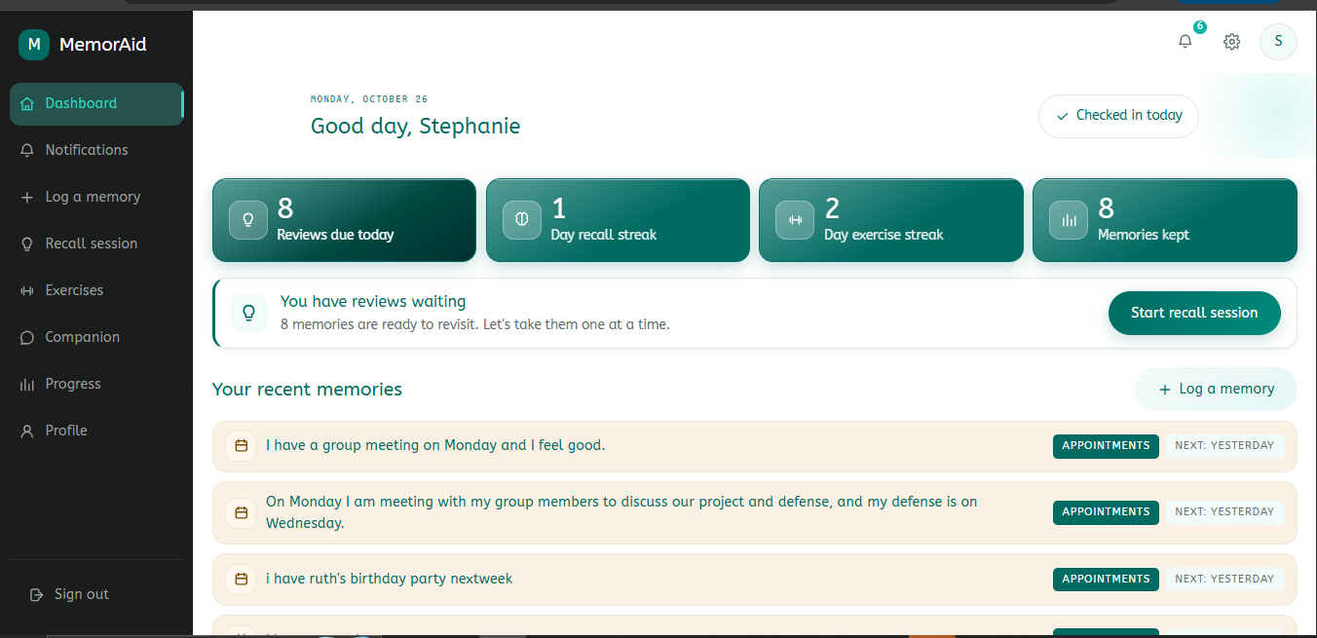
[INSERT DASHBOARD PAGE SCREENSHOT HERE]
Use a genuine screenshot of the current dashboard with tespersonal data removed where appropriate.

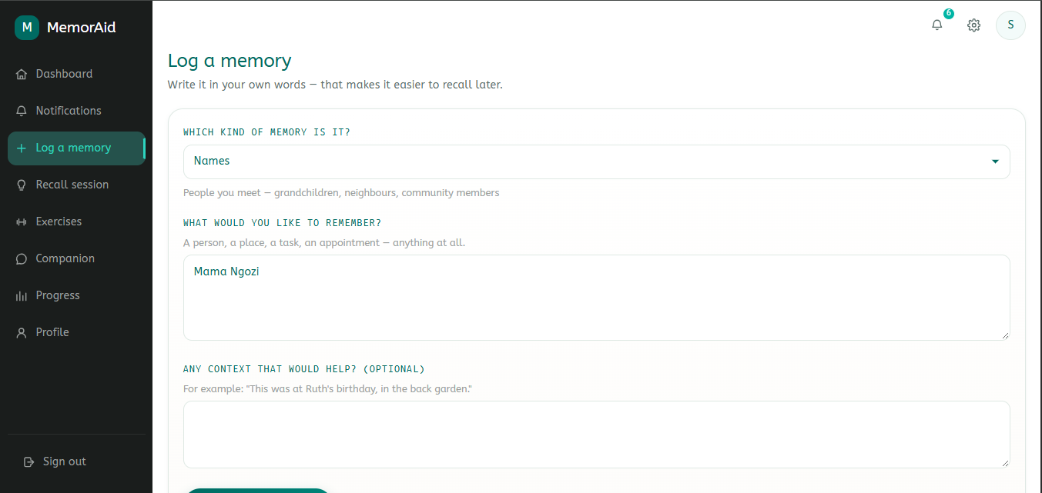
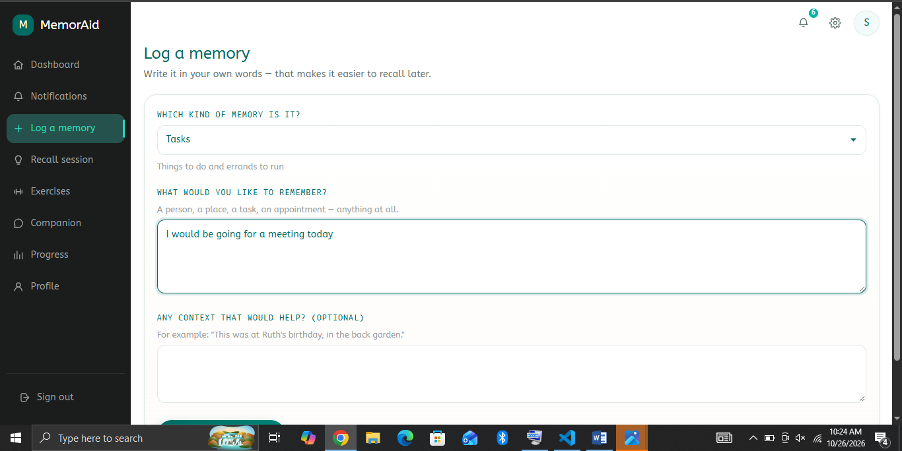
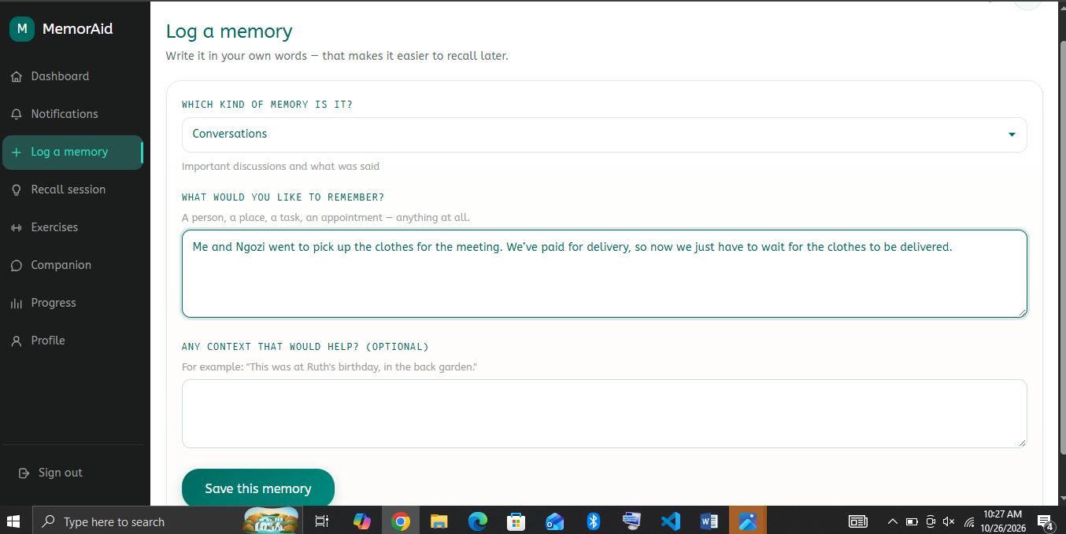
[INSERT LOG MEMORY PAGE SCREENSHOT HERE]
Show the five categories, memory-content field and optional context-note field.

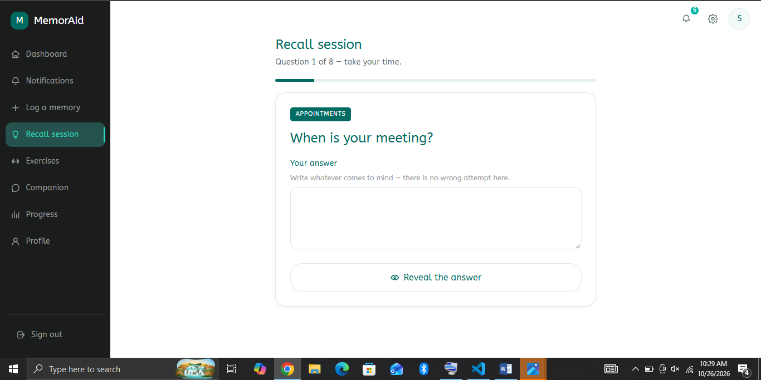
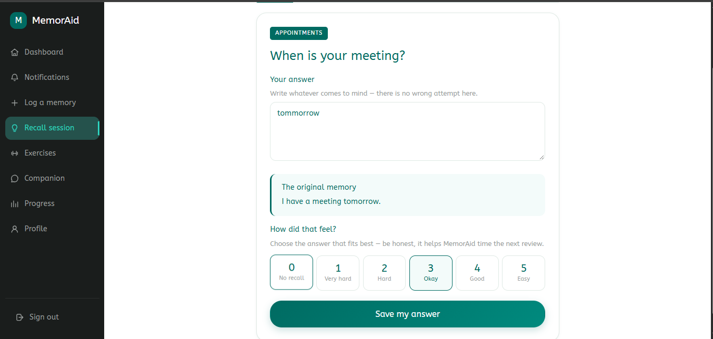
[INSERT RECALL PAGE SCREENSHOT HERE]
Show one question, the typed-answer area and Reveal action.
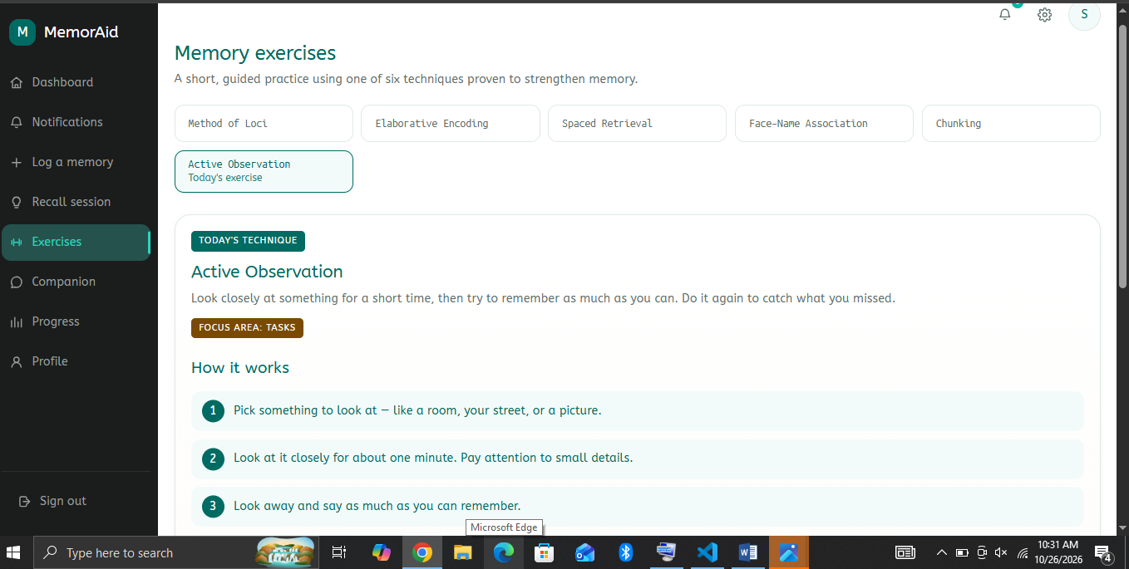
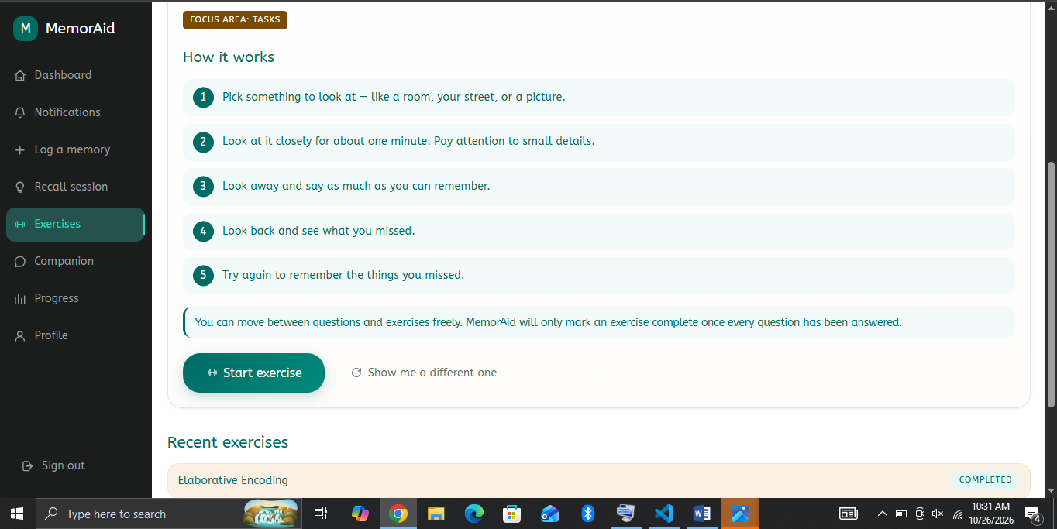
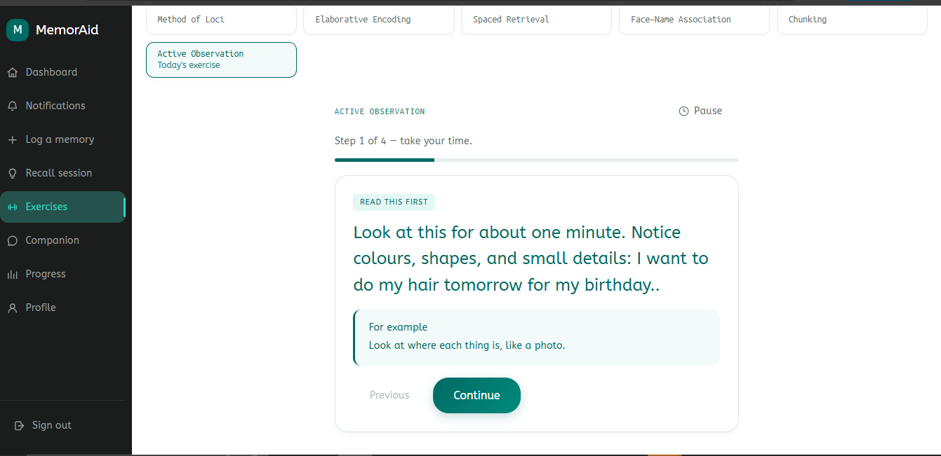
[INSERT EXERCISE TUTOR PAGE SCREENSHOT HERE]
Show a guided exercise step and progress indicator.

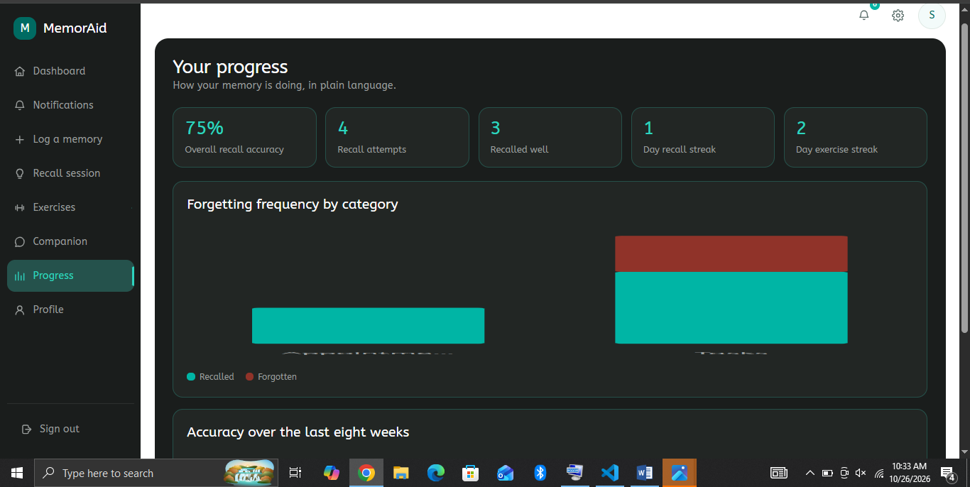
[INSERT ANALYTICS PAGE SCREENSHOT HERE]
Show real analytics values and charts from the running application.

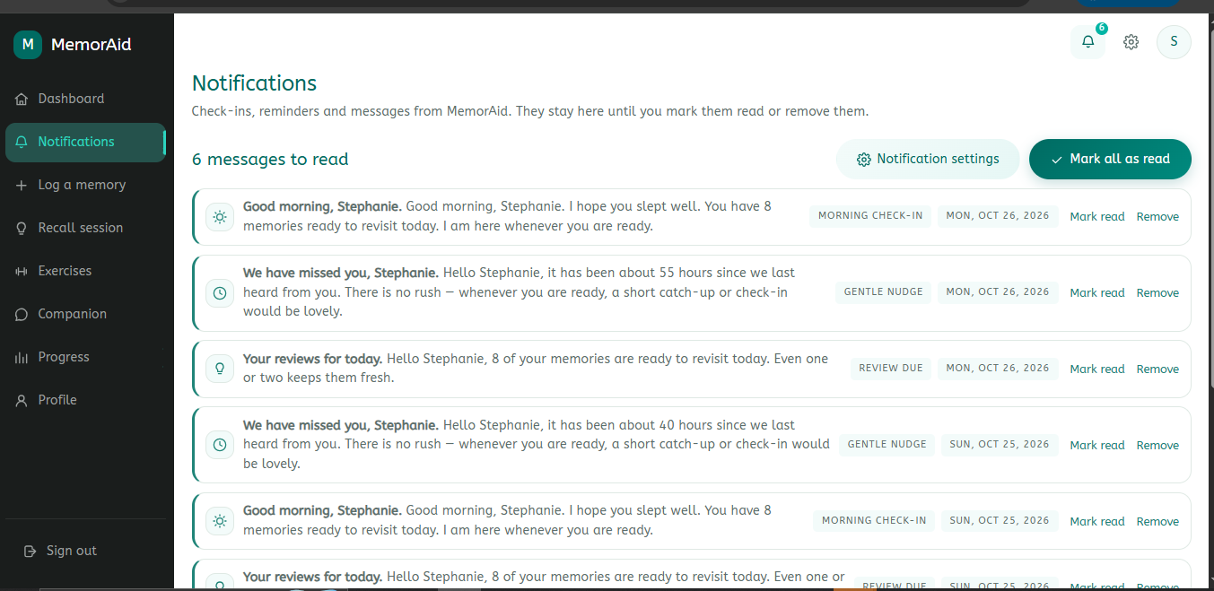
[INSERT NOTIFICATIONS PAGE SCREENSHOT HERE]
Show the dedicated notification list and its read/unread states.

4.2.2 Back-End Modules and Services
Module/service | Responsibility
Authentication/profile | Registers users, verifies credentials, issues JWTs and manages profile/accessibility preferences.
Memory service | Validates the three-field form and saves memory entries.
AI question generator | Builds a structured prompt from content, category, context and difficulty; records whether a question was AI-generated or fallback-generated.
SM2Scheduler | Updates repetition, interval, ease factor and next review date from the quality rating.
Recall service | Returns due questions, records attempts, adjusts difficulty and updates analytics and streaks.
ExerciseGuide | Selects a technique and provides step-by-step guidance, using Gemini or configured fallback content.
ChatCompanion | Builds a context pack and generates personalised responses with age-based tone and pattern-confidence constraints.
PatternConfidence | Scores observed patterns, increases confidence when reinforced, decays unreinforced patterns and marks stale patterns.
AnalyticsEngine | Computes accuracy, category-level failure counts, trends and weakest category from recorded sessions.
StreakManager | Maintains separate recall and exercise streaks.
Check-in/notification services | Generate morning greetings, save notifications and expose read/unread status.
EmailSender/scheduler | Checks inactivity and attempts family alert delivery; console mode supports local demonstration.

The Pattern Confidence Module is deterministic Python logic rather than a model trained on user data. It assigns confidence scores to observed patterns and decays scores when they are not reinforced. Only patterns above the configured threshold are eligible for AI context, and they must be phrased as possibilities requiring confirmation. The system should not state an unconfirmed event as a fact.
Deterministic fallbacks are provided for generation tasks where configured. When a fallback question is used, the system should identify it as such rather than misrepresent it as AI-generated.

4.2.3 Database Structure
The data model separates user-entered memories from the questions used to test recall and from the schedule controlling the next review. Each memory has one current recall question and one review schedule, while session tables preserve the history of attempts and ratings.
Table/entity | Purpose
users | Identity, password hash, age group, accessibility preferences, family contact, check-in time, streaks and activity dates.
memorycategories | Five categories: Names, Appointments, Tasks, Conversations and Medications.
memoryentries | Memory content, category, optional context note, creation time and active/archived status.
recallquestions | Current question linked to a memory, answer reference, difficulty, generation source and date.
reviewschedules | Next review date, interval, repetition count, ease factor and last review date.
recallsessions | Attempt response, quality rating, pass/fail state, difficulty and session date.
exercisesessions | Technique, target category, guidance, completion state, score and session date.
analyticsrecords | Recall totals and accuracy values by user, category and period.
behaviorpatterns | Pattern data, confidence score, reinforcement date and status.
chatmessages | User and assistant messages with role and timestamp.
notifications | Check-in, due-review and family-alert messages, recipient, status and timestamp.

Operational fields for check-in time, last check-in, last activity and inactivity threshold support the engagement features. The notification implementation notes also describe soft deletion, allowing deleted rows to be excluded from lists while preserving a deduplication record. Verify the exact deployed schema against the migration and model files.
[INSERT DATABASE SCHEMA OR ER DIAGRAM SCREENSHOT HERE]
Insert the actual entity-relationship diagram showing the deployed tables and relationships.

4.2.4 Input and Output Formats
MemorAid accepts information through browser forms and JSON API requests. Responses are returned as JSON and rendered as readable page content, confirmation messages, charts or notifications.
Operation | Input | Output
Registration/login | Identity and credential fields; registration also captures required profile preferences. | Validation result and authenticated session on success.
Memory logging | Category, memory content and optional context note. | Saved-memory confirmation, generated/fallback question and next review date.
Recall submission | Question identifier, typed response and quality rating 0–5. | Stored attempt, updated schedule and next question or summary.
Exercise | Responses to guided steps and completion action. | Tutor feedback, summary, score where applicable and streak update.
Chat | User text and authenticated context. | Assistant response subject to personalisation and safety constraints.
Analytics | Authenticated request; no manual input required. | Accuracy, category failure counts, trend, streaks and motivational text.
Check-in | Authenticated request for the current day’s check-in. | Greeting and due-review information where available.
Notifications | List, mark read, mark all read or delete request. | Updated list or unread count.

The memory form contains exactly three fields: category, memory content and optional context note. It does not require a title or user-authored flashcard. During recall, the user types an answer before revealing the stored memory and then selects a quality rating. The rating informs scheduling and is not a clinical measurement.

4.2.5 Information Flow and Product Flow
For this software project, product flow is interpreted as the movement of information from a user action through the application to a stored record, scheduled activity or displayed result.
- The user registers or logs in; the back end validates credentials and creates an authenticated session.
- The user records a memory by selecting a category, entering content and optionally adding a context note.
- The memory service stores the entry and requests a question from Gemini or the configured fallback. It stores the question and initial next-day review schedule.
- When recall is opened, the system retrieves memories whose review dates are due and displays one question at a time.
- The user types an answer, reveals the reference memory and selects a quality rating. The system records the attempt and updates SM-2, difficulty, analytics and recall streak.
- The user may complete a guided exercise; completion is recorded and the exercise streak is updated.
- The dashboard and analytics page read stored activity and display due items, trends, forgetting frequency and streaks.
- Scheduled jobs create check-ins, decay unreinforced patterns and identify inactivity. Where a family contact is configured, a qualifying inactivity event is recorded and email delivery is attempted.
Figure 4.2: Overall Data Flow Diagram (DFD). The formal diagram should use consistent DFD symbols: rectangles for external entities, circles or rounded shapes for processes, open-ended shapes or parallel lines for data stores, and labelled arrows for information flow.
DFD element | MemorAid representation
External entities | E1 Elderly User; E2 Family Contact; E3 Gemini API; E4 Scheduler.
Processes | P1 Authenticate/manage profile; P2 Log memory/generate question; P3 Conduct recall/update SM-2; P4 Conduct exercise; P5 Generate chat/check-in; P6 Compute analytics/notifications.
Data stores | D1 Users; D2 Memory entries/categories; D3 Questions/review schedules; D4 Recall/exercise sessions; D5 Behaviour patterns/chat messages; D6 Analytics/notifications.
Data flows | User input to API; API prompts to Gemini; generated content to application; ratings to scheduler and analytics; scheduled events to notifications and family email.

[INSERT OVERALL DATA FLOW DIAGRAM SCREENSHOT HERE]
Insert a formal DFD with E1–E4, P1–P6, D1–D6 and labelled directional arrows.

4.2.6 Core Algorithms and AI Integration

4.2.6.1 SM-2 Spaced Repetition
The SM-2 algorithm schedules future reviews based on the user’s quality rating from 0 to 5. A rating below 3 resets the repetition count and schedules another review after one day. A rating of 3 or more advances the repetition count: the first successful repetition uses a one-day interval, the second uses six days, and later intervals are calculated by multiplying the previous interval by the ease factor.
The ease factor is updated using EF′ = EF + [0.1 − (5 − q) × (0.08 + (5 − q) × 0.02)], where q is the quality rating. The ease factor is not allowed to fall below 1.3. The resulting interval determines the next review date. The supplied implementation notes state that the Python implementation was tested against the existing JavaScript version; include the reproducible test output in the final evidence.

4.2.6.2 Progressive Difficulty
Each question has difficulty level 1, 2 or 3. Level 1 uses direct what/when questions; level 2 connects a detail with context; level 3 uses more inferential why/how questions or partial information. A rating of 4–5 increases difficulty by one level up to 3. A rating of 3 leaves it unchanged. A rating of 0–2 resets difficulty to 1 and regenerates the current question in place, while preserving earlier attempts in recall history.

4.2.6.3 AI Questions and Fallback
The question generator sends the memory content, category, optional context note and difficulty to Gemini and requests one plain-language question. The question is stored against the memory and the initial review is scheduled for the following day. If the API is unavailable, the configured deterministic fallback is used and the generation-source field identifies the fallback.

4.2.6.4 Guided Exercises
The exercise module supports Method of Loci, Elaborative Encoding, Spaced Retrieval Training, Face–Name Association, Chunking and Active Observation. A session proceeds through an introduction, guided steps, optional pause/resume and a completion summary. Scores are based on self-test steps where available; reflection-based exercises use completion percentage. The session is saved as completed only after the final step.

4.2.6.5 Chat and Pattern Confidence
The companion builds a context pack from available age group, recent memories, recall performance, streaks, difficulty and sufficiently confident behaviour patterns. Tone is adapted to age group, with simpler and more patient wording for users above 65. Unconfirmed events must not be asserted as facts. The companion is not intended to diagnose or treat medical conditions.

4.2.6.6 Analytics and Streaks
The analytics engine calculates recall accuracy from recorded attempts, counts failed attempts by category and prepares an accuracy trend. A category is considered weak only when it has a sufficient number of attempts. Separate recall and exercise streaks are derived from completed activity rather than fixed demonstration values.

4.2.6.7 Scheduled Engagement and Family Alerts
The scheduler creates a morning check-in at the user’s configured time, decays unreinforced behaviour-pattern confidence daily and checks inactivity hourly. Where a family contact is configured and the inactivity threshold is exceeded, an alert is recorded and email delivery is attempted. Console output may be used during development when SMTP credentials are absent. These are adherence-support features, not the direct memory-training mechanisms.

4.3 Software Testing
Testing checked the main application functions, scheduling and scoring rules, API access control, notification handling and front-end build. The implementation notes report a successful front-end build and passing automated backend tests during the described verification runs. Include the actual test output, environment and execution date in the final report so these statements are independently verifiable.

4.3.1 Unit Testing
Test area | Purpose | Evidence to include
SM-2 | Check intervals and ease-factor changes for ratings 0–5, including minimum ease factor. | pytest output and parity test results.
Streak manager | Check increments and day-boundary/reset behaviour. | Relevant test output.
Pattern confidence | Check decay calculations and stale threshold. | Test cases and output.
Difficulty adjustment | Check increase, no-change and reset/regeneration rules. | Test cases and output.
Analytics | Check accuracy, category failures and trend calculations against known records. | Fixtures and output.

4.3.2 Integration and API Testing
Integration tests check whether routes, authentication, database operations and services work together. Protected routes should reject requests without a valid token. Memory creation should persist the memory, question and schedule; recall submission should persist the attempt and update scheduling; exercise completion should update the session and streak; notification operations should be restricted to the authenticated user.
Test case | Expected result
Protected endpoint without JWT | Request rejected with an authentication error.
Valid registration | User record created; password is not returned in plain text.
Valid memory creation | Memory saved and question/review date returned when generation succeeds.
Rating outside 0–5 | Input validation rejects the request.
Valid recall submission | Attempt stored; schedule and related metrics updated.
Access another user’s notification | Request does not expose or modify that notification.
Notification deletion | Deleted row excluded from list/unread count; deduplication remains effective.

4.3.3 AI and Fallback Testing
AI tests should verify prompt structure and service behaviour rather than require a particular generated sentence. A mocked client can check the fields supplied to question generation, exercise guidance, chat and check-in. The fallback path should be tested with the API unavailable or the key absent. Fallback output must not be incorrectly labelled as AI-generated.

4.3.4 Scheduler and Notification Testing
Scheduled functions can be invoked directly with controlled test data. A check-in test should confirm creation of a notification for the correct user and date. A confidence-decay test should confirm the configured score reduction and stale status. An inactivity test should confirm that a qualifying user creates a family-alert record and that email is either sent through configured SMTP or printed to the development console.

4.3.5 Front-End and Accessibility Testing
Check | Expected result / reported verification
Production build | React/Vite build completes without build errors.
Routes and assets | Routes and referenced assets load in the tested local environment.
Field labels | Inputs and textareas have visible labels above them.
Text-size presets | Normal, large and extra-large settings visibly scale text.
High contrast | High-contrast mode covers the main surfaces and controls.
Responsive layout | Desktop and narrow layouts avoid horizontal overflow/clipped primary content.
Recall flow | Typed answer is entered before reveal and rating.
Exercise flow | Guided steps complete and the session is recorded only at the end.

Automated software tests establish whether specified code paths behave as expected. They do not prove that MemorAid improves memory retention among elderly users. Such claims require a separate user evaluation with a defined protocol.

4.3.6 Sample Input and Output
The following is an illustrative example of the intended memory-logging flow, not a claim that this entry was collected from a participant or generated during a specific evaluation.
Field | Illustrative value
Category | Appointments
Memory content | My clinic appointment is on Thursday at 10 a.m.
Context note | The appointment card is beside the television.
Example question | What day and time is your clinic appointment?
Initial next review | The following day after the memory is saved.

[INSERT SAMPLE INPUT AND OUTPUT SCREENSHOT HERE]
Insert actual screenshots of the form before submission and the real response showing question and next review date.

4.4 Chapter Summary
This chapter described the development environment, architecture, interface and back-end modules, database structure, input/output formats and information flow. It explained the SM-2 algorithm, progressive difficulty, AI question generation and fallback, guided exercises, chat personalisation, confidence scoring, analytics, streaks and scheduled engagement features. It also outlined unit, integration, AI-fallback, scheduler, notification, front-end and accessibility testing.

CHAPTER FIVE
SUMMARY, CONCLUSION AND RECOMMENDATIONS

5.0 Summary of Achievements
The study focused on designing and implementing MemorAid, an Intelligent Memory Reinforcement System intended to support everyday memory practice among elderly users. Unlike conventional note-taking software, MemorAid prompts the user to retrieve information before revealing it, schedules future review and provides structured exercises to practise different memory skills.
- A browser-based interface was organised using React components and routes, with shared layout, authentication context and a central API client.
- A Flask REST API was specified for authentication, profile, memory, recall, exercise, chat, analytics, check-in and notification operations.
- The memory-logging form was aligned with the three-field design: category, memory content and optional context note. Five categories are used: Names, Appointments, Tasks, Conversations and Medications.
- The recall flow supports one question at a time, typed answer before reveal, and a quality rating from 0 to 5.
- The Python SM-2 implementation schedules reviews from quality ratings and includes a minimum ease-factor rule; the implementation notes report parity testing against the JavaScript version.
- Progressive difficulty uses three levels and adjusts after recall ratings.
- The guided exercise flow covers Method of Loci, Elaborative Encoding, Spaced Retrieval Training, Face–Name Association, Chunking and Active Observation.
- Analytics are designed to derive accuracy, category-level forgetting frequency, trends and streaks from recorded activity rather than hardcoded demonstration values.
- The chat companion uses age-based tone adaptation and a context pack; the rule-based Pattern Confidence Module limits use of uncertain behavioural assumptions.
- Adherence features include morning check-ins, notification management and family inactivity alerts.
- Accessibility work addressed larger controls, visible field labels, readable type sizes, text-size presets, high-contrast mode and responsive layout.
- The supplied implementation notes report successful front-end builds and passing automated backend tests during development; reproducible output should be included in the final evidence.
These are software-design and implementation achievements. The supplied materials do not provide verified participant-level questionnaire results or a completed elderly-user effectiveness study. Consequently, this chapter does not claim a measured improvement in memory retention or a confirmed usability score.

5.1 Conclusion
MemorAid demonstrates how active recall, spaced repetition, guided memory exercises and AI-assisted personalisation can be combined in a browser-based system for elderly users. Rather than only storing information, the system asks the user to attempt retrieval and uses the quality rating to schedule future reviews. The exercise module adds six structured techniques, while analytics and streaks make practice history visible.
The modular interface, Flask REST API and relational data model provide a structured foundation for the application. The SM-2 scheduling logic, difficulty rules, context-building service and Pattern Confidence Module make core behaviour explicit and testable. Deterministic fallbacks can preserve basic flows when the external AI service is unavailable, provided those paths are configured and tested.
MemorAid is a software prototype for everyday memory practice, not a clinical device. It does not diagnose dementia or Alzheimer’s disease and should not be represented as a substitute for professional assessment. Automated tests alone do not establish clinical effectiveness or prove that users’ memory improved. Those claims require a properly designed evaluation with real participants and transparent reporting.
Within these limits, the project provides a technical foundation for an accessible and personalised memory-practice tool. The next stage should prioritise evidence-based evaluation, accessibility testing with the target population and verification of the deployment environment.

5.2 Recommendations
- Conduct a usability evaluation with elderly participants aged 51 and above, including participants with different levels of digital literacy. Ask participants to complete registration, memory logging, recall, exercise and notification tasks.
- Use a real and documented questionnaire dataset if the survey objective is reported as completed. Preserve the instrument, sampling procedure, anonymised responses, analysis method and summary tables. If no survey was administered, revise the relevant claims in Chapter Three rather than presenting simulated responses as genuine findings.
- Run the system against the intended PostgreSQL environment and verify migrations, authentication, API permissions, scheduled jobs and email configuration before demonstration or deployment.
- Keep Gemini and SMTP credentials in environment variables and never commit secrets to the repository. Test fallback behaviour so API outages do not cause false success messages or incorrectly labelled AI output.
- Use real session records to assess engagement and recall patterns. Avoid hardcoded analytics values and state the sample size and observation period whenever results are reported.
- Maintain the distinction between memory-training features and adherence features. Check-ins, streaks and family alerts may encourage engagement but do not prove cognitive improvement.
- Provide clear consent and privacy information for users and linked family contacts. Restrict access to memories, chat history and family-contact information.
- Conduct a final accessibility review covering readability, control sizes, error messages, keyboard operation, contrast and the typed-answer/reveal sequence.
- Include reproducible evidence in the appendix: build output, automated test summaries, selected source listings, real input/output screenshots and final database/DFD diagrams.

5.3 Suggestions for Further Work
- Conduct a longer pilot and analyse recall accuracy, session frequency and adherence over time using a defined protocol and appropriate consent.
- Evaluate the interface with elderly users with different literacy, language, visual and motor-accessibility needs, and revise it based on observed task difficulties.
- Explore optional Nigerian language interfaces and culturally familiar examples, with translations reviewed for clarity and respectful tone.
- Evaluate speech input and simplified voice output for users who have difficulty typing, while retaining text-based alternatives.
- Consider external scheduling or a persistent job store, delivery monitoring, and backup/restore procedures for production deployment.
- Provide understandable controls for reviewing, correcting or disabling inferred behaviour patterns and explain how they affect AI responses.
- Evaluate generated questions for relevance, ambiguity, readability and cultural suitability; measure fallback frequency and test that uncertain patterns are not asserted as facts.
- After collecting sufficient real usage data, study category-specific difficulty and the relationship between practice regularity and recall performance.
- Conduct a dedicated privacy and security review of authentication, access control, retention, data deletion and secret management.
- Deploy gradually, beginning with a controlled pilot. Continue to describe MemorAid as a memory-practice aid rather than a diagnostic or treatment tool.

5.4 Limitations of the Present Evaluation
The available implementation record supports a description of the architecture, features and software-testing activities. It does not contain verified questionnaire responses from the proposed 50 respondents, a completed usability study with elderly participants or a controlled assessment of memory-retention outcomes. These are treated as evaluation tasks still requiring evidence, not completed results. Any final report claiming survey or user-evaluation findings must be supported by the actual dataset and methodology.
AI-generated content depends partly on an external Gemini service, whose quality, latency and availability may vary. Deterministic fallbacks reduce dependence on the service but are not equivalent to personalised generative output. Further evaluation is required to assess the suitability of generated questions and guidance in real use.

References
Merge this section with the complete, verified APA-style reference list already used in Chapters One to Three. The entries below must be checked against that list before submission.
Booch, G., Rumbaugh, J., & Jacobson, I. (2007). The Unified Modeling Language user guide (2nd ed.). Addison-Wesley.
Ebbinghaus, H. (1885/1913). Memory: A contribution to experimental psychology (H. A. Ruger & C. E. Bussenius, Trans.). Teachers College, Columbia University.
Wozniak, P. A. (1990). Optimization of learning. [Verify the exact publication details and source cited in Chapter Two before submission.]
Do not submit this abbreviated list as the final reference list. Preserve and alphabetise the verified references cited in Chapters One to Three, and add entries only when they are cited in the completed report.

Appendices to Prepare
Appendix A: Selected source-code listings for authentication, memory creation/question generation, SM-2 scheduling, recall submission, exercise completion, analytics, confidence decay and notifications. Include readable excerpts rather than the entire repository.
Appendix B: Genuine screenshots of registration/login, memory logging, recall, guided exercise, dashboard, analytics and notifications, plus selected test output. Label demo-account or test-fixture data as sample data.
Appendix C (if required): Test-case matrix and actual automated test summary, including command, environment, execution date and number of tests passed/failed.
Appendix D (only if collected): Questionnaire instrument and actual anonymised findings. Do not present synthetic responses as participant data.

