CHAPTER ONE
INTRODUCTION

1.1 Background to the Study
Memory is the cognitive process by which the human brain encodes, stores, and retrieves information acquired through experience and daily interaction. For an individual to remember something whether a name, an appointment, or the details of a conversation that information must first be properly encoded, meaning the brain must register and process it at the moment of experience. It must then be stored in a form accessible for future use, and successfully retrieved when required. When any one of these three stages is disrupted, forgetting occurs. Understanding this foundational process is essential to appreciating why so many elderly individuals struggle with everyday memory and why intelligent intervention at the right stage of this cognitive cycle can meaningfully reduce the impact of forgetfulness on their daily lives (Atkinson & Shiffrin, 1968).
Among elderly populations, the challenge of forgetfulness is particularly consequential. Studies indicate that episodic memory the ability to recall specific events and personal experiences begins to deteriorate significantly from the sixth decade of life, affecting an individual's independence, safety, and overall quality of life (Salthouse, 1991). While clinical conditions such as dementia represent severe cases of memory impairment, a significant proportion of the elderly population experiences mild-to-moderate forgetfulness that falls outside clinical intervention yet meaningfully disrupts daily functioning. For this group, the need for accessible, non-medical cognitive support tools is both urgent and largely unmet. Everyday lapses forgetting the names of grandchildren, missing medical appointments, losing track of medication schedules may appear minor in isolation but accumulate into a pattern that significantly diminishes an elderly person's sense of confidence, dignity, and independence.
Existing solutions to address everyday forgetfulness have largely taken the form of passive tools: note-taking applications, digital calendars, and reminder systems. While these tools serve a storage function, they do not address the cognitive dimension of memory retention. They provide information on demand but do not train the brain to actively recall stored information which cognitive science identifies as the most effective mechanism for strengthening memory traces over time (Craik & Lockhart, 1972). The principle of active recall the deliberate effort to retrieve information from memory without first being shown the answer has been extensively validated in research as superior to passive review for consolidating long-term memory (Roediger & Karpicke, 2006). When combined with spaced repetition, a technique that schedules review sessions at optimally increasing intervals based on an individual's recall performance, the effectiveness of memory retention is significantly enhanced (Cepeda et al., 2006).
Furthermore, cognitive psychology and neuroscience have identified several additional memory training techniques with strong empirical support: the Method of Loci, Elaborative Encoding, Spaced Retrieval Training (SRT), Active Observation, Face-Name Association, and Chunking. These techniques reviewed in detail in Chapter Two form the scientific foundation of the exercise session feature within the Intelligent Memory Reinforcement System (IMRS), which goes beyond simple review scheduling to actively train the elderly user's memory capacity through structured, technique-driven practice.
A useful way to conceptualise the role of the IMRS is through the analogy of physical exercise. Regular physical activity such as jogging does not merely maintain the body in its current state it actively strengthens cardiovascular endurance, muscle memory, and physical resilience over time through consistent, repeated effort. In the same manner, the IMRS is not designed simply to store or retrieve information on a user's behalf. Rather, it functions as a cognitive training system one that exercises the elderly brain's recall ability through regular, structured retrieval practice and dedicated exercise sessions. This principle is grounded in the neuroscientific concept of neuroplasticity the brain's capacity to reorganise and strengthen its neural pathways through repeated use which holds that memory pathways can be strengthened even in elderly individuals through consistent retrieval practice (Merzenich, 2013).
Recent advancements in Artificial Intelligence (AI), particularly in the domain of Large Language Models (LLMs), present an unprecedented opportunity to apply these cognitive principles intelligently and adaptively. AI-powered systems can dynamically generate personalised recall prompts from a user's logged memories, learn individual usage patterns and forgetting profiles, adapt their communication tone based on the user's age and context, and engage users in natural conversation that deepens personalisation over time. This creates a proactive, intelligent memory reinforcement experience that no static tool has previously offered.
The Nigerian context presents a particularly compelling case for the development of such a system. Nigeria is experiencing a growing elderly population, with individuals aged 60 and above projected to increase significantly as life expectancy rises. Yet Nigeria has very limited geriatric care infrastructure few hospitals have dedicated elderly care units or neurologists specialising in memory conditions, and formal cognitive support services for the elderly are largely unavailable outside major urban centres. Most elderly Nigerians experiencing memory difficulties receive no clinical assessment or structured support, and the condition is frequently dismissed as an inevitable consequence of old age rather than a manageable cognitive challenge.
The cultural context compounds this gap in a significant way. In Nigerian society, elderly individuals are traditionally cared for by their adult children and extended family networks rather than placed in care homes or residential facilities. This means that an elderly person experiencing memory decline is largely dependent on family members who may be geographically distant particularly as younger generations migrate to urban centres for employment and who may lack the knowledge, time, or resources to provide consistent structured cognitive support. An elderly parent or grandparent living in Enugu while their children work in Lagos, Abuja, or abroad represents a growing and common scenario in which the social safety net for cognitive support is stretched or absent entirely.
Furthermore, specific memory challenges carry particular cultural weight in the Nigerian elderly context. Forgetting the names of grandchildren, neighbours, or community members is deeply embarrassing in a culture where remembering people is considered a fundamental mark of respect and social awareness. Missing medical appointments is a serious health risk given that many elderly Nigerians manage chronic conditions such as hypertension and diabetes. Forgetting medication schedules can be life-threatening. Losing track of financial commitments to family members creates social tension in a culture where inter-generational financial obligations are a significant part of family life. These are not abstract cognitive concerns they are daily, consequential, and under-addressed.
It is against this background that this study proposes the design and implementation of an Intelligent Memory Reinforcement System (IMRS), commercially named MemorAid a web-based software system designed specifically for elderly Nigerian users that leverages active recall, spaced repetition, scientifically validated memory exercises, AI-generated questioning, and adaptive personalisation to help elderly individuals manage and overcome everyday forgetfulness. MemorAid is designed not merely to compensate for a failing memory, but to actively train and strengthen it treating the elderly user as someone capable of improvement rather than someone in inevitable decline.

1.2 Statement of the Problem
Despite the widespread availability of digital productivity tools, a significant gap exists between the passive information storage that these tools provide and the active cognitive reinforcement that effective memory retention requires. Current applications such as note-taking platforms, calendar reminders, and task managers operate on the premise that retrieving stored information on demand is sufficient to address forgetfulness. However, this approach fails to engage the brain's natural memory consolidation mechanisms and therefore offers no lasting improvement to a user's recall ability.
For elderly users, this limitation is particularly consequential. The progressive nature of age-related memory decline means that without active cognitive engagement, recall abilities continue to deteriorate. Yet the tools designed to compensate for this decline are largely passive and do not stimulate the neural pathways associated with memory retrieval. Furthermore, these tools were not designed with elderly users in mind they assume technological comfort, small screen interaction, and complex navigation that many elderly individuals find difficult. There is therefore a critical need for a system that moves beyond storage and actively reinforces the elderly user's memory through guided recall exercises, structured cognitive training, and an accessible interface.
In the Nigerian context specifically, this need is compounded by the near-total absence of formal geriatric cognitive support services. Elderly Nigerians experiencing memory difficulties have no meaningful institutional alternative no cognitive therapy services, no structured memory clinics, and no technology-based intervention designed for their specific cultural context and needs. Their family caregivers, who represent the primary support system, equally lack tools to help monitor or support their elderly relatives' cognitive health from a distance.
Furthermore, no existing general-purpose system has been designed to combine Artificial Intelligence (AI)-generated recall questioning, spaced repetition scheduling, scientifically validated memory exercise techniques, conversational AI personalisation, and adaptive elderly support features in a unified platform targeted at everyday forgetfulness among elderly users. This study therefore addresses the following core problem: the absence of an intelligent, proactive, and culturally appropriate system — the Intelligent Memory Reinforcement System (IMRS), commercially named MemorAid capable of reinforcing everyday memory retention for elderly Nigerians through scientifically grounded active recall, adaptive spaced repetition, validated cognitive training exercises, and AI-powered personalisation.

1.3 Aim and Objectives of the Study

1.3.1 Aim
The aim of this study is to design and implement an Intelligent Memory Reinforcement System (IMRS), commercially named MemorAid, that leverages Artificial Intelligence (AI), spaced repetition, and scientifically validated cognitive training techniques to proactively reinforce everyday memory retention among elderly users.

1.3.2 Objectives
The following specific objectives guide the achievement of this aim:
To investigate the nature and impact of everyday forgetfulness on the daily functioning of elderly individuals and their family caregivers through a structured questionnaire survey.
To design a system architecture that integrates AI-generated recall prompting, the SM-2 spaced repetition algorithm, six validated cognitive training techniques, conversational AI personalisation, and elderly-specific engagement features.
To implement a functional MemorAid system that enables elderly users to log everyday memories, receive AI-generated recall sessions, complete structured memory exercise sessions, and interact with a personalised AI companion.
To evaluate the usability and accessibility of the system specifically for elderly users with varying levels of technological literacy.
To assess the effectiveness of MemorAid in supporting everyday memory retention through system testing and user evaluation.

1.4 Significance of the Study
This study makes a meaningful contribution to the intersection of cognitive science, Artificial Intelligence (AI), and human-computer interaction, specifically within the underserved context of elderly cognitive support in Nigeria.
From an academic perspective, the study demonstrates the practical application of large language model APIs in building intelligent, adaptive, personalised cognitive support systems contributing to the growing body of knowledge on responsible AI integration in everyday software development. The system operationalises six scientifically validated memory training techniques within a single unified platform, demonstrating how cognitive psychology research can be translated into accessible digital interventions.
From a social perspective, the study directly addresses a gap in Nigeria's elder care landscape. By providing a structured, AI-powered cognitive support tool accessible via a standard web browser, MemorAid extends cognitive support to elderly individuals who currently have no access to formal memory assistance. It also supports family caregivers particularly those living at a distance from elderly relatives by providing them visibility into their relative's activity and engagement through the family connection mode.
An important distinction must be acknowledged: the three elderly-specific engagement features incorporated into MemorAid morning check-in, simplified AI voice, and family connection mode are designed as adherence support features rather than direct memory-strengthening mechanisms. The actual memory-strengthening mechanisms are the recall sessions and exercise sessions, grounded in validated cognitive science. Adherence whether elderly users consistently engage with the system is consistently identified in health behaviour research as a greater barrier to benefit than whether the intervention itself works. MemorAid addresses both dimensions: the training mechanism and the engagement mechanism that ensures elderly users return to it consistently.

1.5 Scope of the Study
This study focuses on the design and implementation of a web-based Intelligent Memory Reinforcement System (IMRS), commercially named MemorAid, targeting everyday forgetfulness among elderly individuals in Nigeria. The system encompasses the following functional components: user registration and profile management; memory logging across five categories Names, Appointments, Tasks, Conversations, and Medications; AI-generated recall question delivery with progressive difficulty levels; spaced repetition scheduling using the SM-2 algorithm; structured memory exercise sessions incorporating six validated cognitive training techniques; a conversational AI chat companion with personalisation context built from user data; a streak system tracking exercise and recall consistency; a forgetting pattern analytics dashboard; daily morning check-in notifications; family connection mode for elderly user monitoring; and age-based AI tone adaptation.
To validate the problem and inform the system design, a structured questionnaire was administered to a mixed sample of fifty respondents comprising elderly individuals and their family caregivers. For technologically comfortable respondents, the questionnaire was distributed via Google Forms. For elderly respondents with limited digital access, printed paper copies were used, with a research assistant reading questions aloud where necessary and responses manually entered into the digital dataset.
The study is limited to the development and evaluation of a prototype system accessible via standard desktop and mobile browsers. The system targets elderly users aged 51 and above as its primary user group, with family caregivers as a secondary stakeholder group.

1.6 Limitations of the Study
The following limitations are acknowledged:
- The system does not constitute a clinical or medical intervention and is not designed to diagnose, treat, or manage clinical memory conditions such as Alzheimer's disease or dementia.
- Elderly users may have limited familiarity with smartphones, web browsers, or digital interfaces. While the system is designed with simplicity and accessibility as core principles, the level of technological comfort among elderly participants cannot be fully controlled.
- The questionnaire distribution process for elderly respondents introduces logistical and financial costs associated with printing and manual data entry that do not arise with online distribution a limitation that may affect the speed and completeness of data collection from this group.
- The effectiveness evaluation is constrained by the size of the user testing sample and the limited duration of the evaluation period.
- The quality of AI-generated recall questions, exercise guidance, and chat responses is contingent on the capabilities and availability of the third-party Claude API, which is an external service outside the team's direct control.
- Meaningful personalisation through the pattern confidence module requires sustained user engagement over time the system's personalisation depth increases with usage, meaning early interactions will feel less tailored than those after several weeks of consistent use.
- The system's effectiveness in improving long-term memory retention beyond the study period cannot be fully assessed within the project timeframe.

1.7 Definition of Terms
Active Recall: A memory retrieval technique in which the user deliberately attempts to retrieve information from memory without first being shown the answer. Proven to strengthen long-term retention more effectively than passive review.
Artificial Intelligence (AI): A field of computer science concerned with the development of systems capable of performing tasks that typically require human intelligence such as understanding language, generating contextually appropriate responses, and learning from data.
Spaced Repetition: A learning technique that schedules review sessions at gradually increasing intervals based on the user's demonstrated recall performance, exploiting the spacing effect to maximise long-term retention.
SM-2 Algorithm: A spaced repetition algorithm developed by Piotr Wozniak that calculates the optimal next review interval based on a user's self-assessed recall quality score ranging from 0 to 5.
Large Language Model (LLM): An AI system trained on vast quantities of text data, capable of generating human-like natural language responses. Used in this study to generate recall questions, power the conversational chat companion, and adapt communication tone.

Intelligent Memory Reinforcement System (IMRS): The software system designed and implemented in this study, commercially named MemorAid. Combines AI-generated recall questioning, spaced repetition scheduling, validated memory exercises, and conversational AI personalisation to reinforce everyday memory retention among elderly users.
MemorAid: The commercial product name for the IMRS developed in this study a web-based application designed specifically for elderly users to support everyday memory retention through active recall, spaced repetition, cognitive training, and AI-powered personalisation.
Neuroplasticity: The brain's ability to reorganise and strengthen its neural pathways through repeated use. The neuroscientific basis for the premise that consistent recall practice and memory exercise can improve memory performance even in elderly individuals.
Method of Loci: A memory technique in which information is mentally placed at specific locations along a familiar route. Recalling the information involves mentally revisiting those locations. Particularly effective for elderly users whose spatial memory is relatively preserved.
Elaborative Encoding: A memory technique in which new information is connected to existing knowledge, a story, or an emotional response at the point of encoding creating a deeper and more durable memory trace.
Spaced Retrieval Training (SRT): A clinically validated memory technique developed specifically for elderly populations in which the same piece of information is tested at very short increasing intervals within a single session.
Face-Name Association: A memory technique in which a person's name is connected to a distinctive physical feature or a mental image, creating a retrieval hook that improves name recall.
Chunking: A memory technique in which large amounts of information are grouped into smaller, meaningful units reducing working memory load and improving recall of complex information.

Active Observation: A memory exercise in which the user studies a set of details for a fixed period, then attempts to recall as many as possible without reference. Used in MemorAid to support attentional maintenance in elderly users.
Adherence Feature: A system feature designed not to directly strengthen memory, but to ensure the user consistently engages with the features that do such as morning check-ins, simplified AI voice, and family connection mode.
Forgetting Curve: A model proposed by Ebbinghaus (1885) describing the exponential rate at which newly acquired information is forgotten over time in the absence of active review.
Pattern Confidence Module: A backend component that silently observes user behaviour patterns, assigns each pattern a confidence score, and decays that score if the pattern is not reinforced ensuring the AI never assumes an event occurred without explicit user confirmation.

CHAPTER TWO
LITERATURE REVIEW

2.1 Introduction
The development of an Intelligent Memory Reinforcement System (IMRS) for elderly users sits at the intersection of cognitive science, neuroscience, learning theory, and Artificial Intelligence (AI). This chapter examines the theoretical and technological landscape that surrounds it, reviewing the concepts and technologies most relevant to the design and purpose of MemorAid. The chapter explores the science of human memory, the forgetting curve, cognitive load, neuroplasticity, active recall, spaced repetition, and six scientifically validated memory exercise techniques clinically relevant to elderly users. It then discusses Large Language Models (LLMs) and their application to personalised cognitive support. The chapter concludes with a review of existing systems, and an identification of the research gap that this study addresses.

2.2 Theoretical Background

2.2.1 Concepts

Human Memory: Encoding, Storage, and Retrieval
Human memory is the cognitive system through which individuals acquire, retain, and access information from experience. The most foundational model is the multi-store model proposed by Atkinson and Shiffrin (1968), which characterises memory as operating through three sequential stages: encoding, storage, and retrieval. Encoding is the initial stage in which sensory input is registered and transformed into a mental representation. Storage refers to the retention of that representation over time. Retrieval is the process by which stored information is brought back into conscious awareness when required. When any of these stages is disrupted as is increasingly common in elderly individuals due to age-related neurological changes forgetting occurs.
Craik and Lockhart's (1972) levels-of-processing framework further demonstrates that the depth of processing at the encoding stage rather than mere exposure determines how durable a memory trace becomes. Information processed superficially is rapidly forgotten; information processed deeply connected to existing knowledge, emotion, or personal meaning creates a substantially stronger and more retrievable memory trace. This principle directly informs the Elaborative Encoding exercise feature in MemorAid, which prompts elderly users to connect new information to something personally meaningful at the point of logging.

The Forgetting Curve and Spaced Repetition
The forgetting curve, first described by Ebbinghaus (1885), established that newly acquired information is forgotten at a predictable, exponential rate in the absence of rehearsal. Ebbinghaus found that approximately 50% of newly learned information is forgotten within one hour, and up to 79% within one month without any form of active review. For the MemorAid (IMRS), the forgetting curve provides the scientific justification for the SM-2 scheduling logic initiating recall sessions at calculated intervals that intercept the natural decay of memory before it degrades beyond retrieval.
The spacing effect the finding that distributing practice over time produces significantly better long-term retention than massed practice was confirmed across 317 experiments in a meta-analysis by Cepeda et al. (2006). The SM-2 algorithm, developed by Wozniak (1990), operationalises this effect by calculating the next review interval for each memory item based on the user's self-assessed recall quality score from 0 to 5. Items recalled with high confidence receive longer intervals; items recalled with difficulty are reviewed sooner. This creates a uniquely personalised review schedule for each elderly user based on their actual demonstrated memory performance.

Neuroplasticity and Cognitive Training in Elderly Populations
Neuroplasticity the brain's capacity to reorganise and strengthen its neural pathways through repeated use provides the neuroscientific basis for the system's core premise: that memory performance can be actively improved even in elderly individuals (Merzenich, 2013). Every recall session and exercise session the IMRS presents is an act of neural reinforcement, strengthening the synaptic connections associated with the recalled information. Consistent engagement with the system therefore produces cumulative cognitive benefit over time, positioning MemorAid not as a passive aid but as an active trainer of the elderly brain.

Active Recall
Active recall is the memory technique in which an individual deliberately attempts to retrieve information from memory without being shown the answer. Roediger and Karpicke (2006) demonstrated that students who studied by testing themselves retained significantly more over time than those who restudied the same material a phenomenon they termed the testing effect. For MemorAid, active recall is the primary mechanism through which elderly users strengthen memory: they are presented with an AI-generated question based on their logged memory and must retrieve the answer before it is revealed. This is fundamentally different from reminder applications, which simply surface stored information without requiring any retrieval effort.

Six Scientifically Validated Memory Exercise Techniques for Elderly Users
Beyond spaced repetition and active recall, cognitive psychology and neuroscience have identified six additional techniques with strong empirical support for improving memory performance in elderly populations. MemorAid incorporates all six as structured exercise sessions, selected adaptively based on each user's identified weak areas.
The Method of Loci, validated by Bower (1970) and traced to ancient Greek practice, involves mentally placing information at specific locations along a familiar route and recalling it by mentally revisiting those locations. It is particularly effective for elderly users because spatial memory supported by the hippocampus is relatively preserved even in early cognitive decline, providing a stable scaffold for new information.
Elaborative Encoding, grounded in Craik and Lockhart's (1972) levels-of-processing framework, involves connecting new information to existing knowledge, a story, or an emotional response at the moment of encoding. For elderly users, who may have rich existing memories and life experiences to connect to, elaborative encoding can be especially powerful — transforming a new name or fact into something personally meaningful and therefore far more retrievable.
Spaced Retrieval Training (SRT), developed by Landauer and Bjork (1978) and specifically adapted for elderly populations by Camp (1989), is a clinical variant of spaced repetition in which the same piece of information is tested at very short intervals within a single session beginning with seconds and gradually expanding to minutes and days. SRT has strong clinical evidence for improving name and face recall specifically in elderly individuals, making it the most directly applicable technique in the MemorAid exercise repertoire for the target population.
Face-Name Association, validated by Bower and Karlin (1974), involves connecting a person's name to a distinctive physical feature or a mental image. The association creates a retrieval hook that significantly improves name recall the category most commonly reported as problematic by elderly users in the Nigerian context, where forgetting names carries significant social consequence.
Chunking, established by Miller (1956) in his foundational work on working memory capacity, involves grouping large amounts of information into smaller, meaningful units. Working memory capacity declines with age, making it increasingly difficult for elderly individuals to retain multi-detail information in a single retrieval attempt. Chunking reduces this load by restructuring information into cognitively manageable groups.
Active Observation involves studying a set of details for a fixed period, then attempting to recall as many as possible without reference. In the context of elderly users, this exercise is included not primarily to address attentional distraction as it might be for younger users but to support the maintenance of attentional sharpness, which research indicates can slow age-related cognitive decline when consistently exercised (Merzenich, 2013).

2.2.2 Technologies

Large Language Models (LLMs)
Large Language Models are Artificial Intelligence (AI) systems trained on massive corpora of natural language text to generate contextually coherent, semantically appropriate output from arbitrary input. Brown et al. (2020) demonstrated in their landmark study of GPT-3 that large-scale language models could perform question generation, summarisation, and contextual reasoning through few-shot prompting alone. In MemorAid, the Claude API developed by Anthropic is used to generate personalised recall questions from logged memory entries, guide exercise sessions using validated cognitive techniques, and power a conversational AI companion that uses the elderly user's memory history, recall performance, and detected behaviour patterns as context making responses feel genuinely personalised rather than generic.
Importantly, MemorAid does not train a custom AI model. The system uses Claude an already fully trained model combined with backend logic that collects and structures user data into rich context before each API call. The personalisation deepens with sustained usage as more data accumulates in the system, directly reflecting the elderly user's individual memory profile and habits.

Spaced Repetition Software
The most widely deployed implementation of spaced repetition in software is Anki, built on the SM-2 algorithm developed by Wozniak (1990). Anki is entirely dependent on user-authored flashcard content, making it wholly unsuitable for elderly users who cannot be expected to manually design their own recall items. MemorAid addresses this by combining SM-2's proven scheduling logic with AI-generated questioning, removing the content creation burden from the user entirely and making spaced repetition accessible to elderly individuals without any technical knowledge.

REST APIs in Web Application Development
A Representational State Transfer (REST) Application Programming Interface (API) is an architectural style for designing networked software systems that communicate via standard HTTP methods. In MemorAid, all communication between the frontend (HTML, CSS, JavaScript) and backend (Python, Flask) occurs through a REST API. Each feature memory logging, recall sessions, chat, analytics, exercise sessions corresponds to a distinct API endpoint, allowing the frontend and backend to be developed and tested independently (Fielding, 2000).

2.3 Review of Related Literature
This section reviews five closely related published works on memory science, spaced repetition, active recall, and AI-driven personalised learning, evaluating their contributions and limitations in relation to the present study.

Ebbinghaus (1885) — The Forgetting Curve
Ebbinghaus produced the forgetting curve through experimental research, demonstrating that newly learned information is forgotten at a rapid, exponential rate without rehearsal. This is the empirical foundation upon which the IMRS scheduling logic is built. Ebbinghaus's work established the principle that strategic review at calculated intervals can preserve memory that would otherwise decay. However, Ebbinghaus worked under controlled laboratory conditions using artificial nonsense syllables — not personally meaningful everyday information and produced no software implementation, no application for elderly populations, and no combination with AI-generated content. The present study extends his foundational principle into a practical, personalised, AI-powered system for real elderly users in a real Nigerian context.

Cepeda et al. (2006) — Meta-Analysis of Distributed Practice
Cepeda et al. conducted a meta-analytic review of 317 experiments on distributed practice, confirming that spacing practice over time consistently produces superior long-term retention compared to massed study. This directly validates the SM-2 scheduling mechanism at the core of MemorAid. However, their work was entirely theoretical producing no software implementation and no application to everyday memory in elderly populations. The present study translates their empirical findings into a working system with adaptive scheduling driven by actual user performance data.

Roediger and Karpicke (2006) — The Testing Effect
Roediger and Karpicke demonstrated that testing oneself produces significantly better long-term retention than restudying the same material and that this advantage grows larger as the retention interval increases. Active recall is the primary mechanism through which MemorAid reinforces elderly user memory. However, their study investigated the testing effect in a controlled academic setting using student participants and standardised text passages. The present study extends active recall to spontaneous, unstructured everyday memories of elderly individuals, combined with AI-generated questioning and progressive difficulty scaling.

Camp (1989) — Spaced Retrieval Training for Elderly Populations
Camp adapted the Spaced Retrieval Training (SRT) technique specifically for elderly individuals experiencing memory impairment, demonstrating clinically significant improvements in name and face recall through short-interval repeated testing within sessions. This work is particularly relevant to MemorAid as it directly validates one of the system's six exercise techniques for the target population. Camp's work, however, was entirely clinical and manual requiring trained therapists to administer the technique in controlled settings. MemorAid operationalises SRT through AI guidance, making it accessible to elderly users in their own home without clinical supervision.
Brown et al. (2020) — Language Models as Few-Shot Learners
Brown et al. demonstrated the few-shot learning capabilities of GPT-3 across a wide range of natural language tasks. The AI-powered question generation, chat personalisation, exercise guidance, and morning check-in capabilities of MemorAid are built upon the same class of Large Language Model (LLM) technology. Their work established that a well-designed prompt providing context, examples, and a clear instruction can reliably produce specific, contextually appropriate outputs from a pre-trained language model without any further model training. MemorAid applies this principle to the domain of elderly cognitive support: carefully structured prompts, enriched with each elderly user's personal memory data and performance context, produce outputs that feel genuinely personalised and clinically appropriate. Brown et al.'s study, however, is purely a foundational AI research paper with no application to memory science, elderly populations, or cognitive support. The present study bridges that gap.

2.4 Research Gap
The studies reviewed in this chapter build a solid scientific case for how memory works and how it can be strengthened in elderly individuals. Ebbinghaus showed how quickly information is forgotten without rehearsal. Cepeda et al. confirmed that spacing practice over time improves retention. Roediger and Karpicke proved that retrieval practice outperforms passive review. Camp demonstrated that short-interval repeated testing improves name recall in elderly patients. Brown et al. established that large language models can generate intelligent, contextually relevant language from a structured prompt. The science is strong, well-established, and directly relevant to the problem this study addresses.
However, a clear and consistent gap runs through all of it. Every study was conducted in a controlled laboratory or clinical setting. None produced a working application accessible to ordinary elderly users. None asked how these findings could help an elderly Nigerian person remember the name of a grandchild, a medication schedule, or a doctor's appointment in the context of daily life. None combined AI-generated questioning, spaced repetition scheduling, six validated cognitive training techniques, conversational AI personalisation with elderly-specific tone adaptation, progressive difficulty, streak-based engagement, morning check-in, and family connection alerts in a single platform designed specifically for elderly users let alone for elderly Nigerians, for whom the cognitive support gap is compounded by absent healthcare infrastructure and a family-centred care culture that places the burden of support on geographically dispersed relatives.
MemorAid (IMRS) is designed precisely to fill this gap: translating decades of validated cognitive science into an accessible, personalised, AI-powered application that can be opened on a standard smartphone or browser by an elderly Nigerian user, and that does not require clinical supervision, technical expertise, or any prior experience with digital technology beyond the ability to type a message.

CHAPTER THREE
SYSTEMS ANALYSIS AND DESIGN METHODOLOGY

3.1 Introduction
This chapter presents the systems analysis and design methodology adopted for the development of MemorAid (IMRS). It begins by reviewing selected methodologies and justifying the most appropriate choice for this project. It then analyses the existing system, defines the proposed system requirements, and presents the full system design including UML diagrams, database schema, and interface design. The Object-Oriented Analysis and Design Methodology (OOADM), supported by prototyping, is adopted as the main methodology.

3.2 Methodology

3.2.1 Review of Selected Methodologies
Several software development methodologies were considered for this project. The Waterfall model follows a strict linear sequence of phases requirements, design, implementation, testing, and maintenance. While it produces well-documented deliverables at each stage, its rigidity makes it unsuitable for MemorAid, where the usability needs of elderly users may only become clear after prototype interaction and the personalisation layer requires iterative refinement.
The Agile methodology is iterative and user-centred, useful for accommodating evolving requirements. However, for a project requiring detailed UML modelling and formal academic documentation, Agile alone does not provide sufficient structural rigour.
Prototyping involves creating early versions of the system interface for user feedback before final implementation. This is important for MemorAid given that usability and accessibility are central to the study particularly for elderly users who may find complex interfaces confusing or discouraging.
The Object-Oriented Analysis and Design Methodology (OOADM) views a system as a collection of interacting objects with attributes, behaviours, and relationships. It supports Unified Modelling Language (UML) diagrams including use case, activity, class, and sequence diagrams. OOADM is most appropriate for MemorAid because the system naturally consists of interacting objects: User, MemoryEntry, RecallQuestion, ReviewSchedule, RecallSession, ExerciseSession, ChatMessage, BehaviorPattern, AIQuestionGenerator, SM2Scheduler, and AnalyticsDashboard (Booch et al., 2007).

Methodology | Key Strength | Key Limitation | Relevance to MemorAid
Waterfall | Clear linear documentation | Inflexible once requirements change | Too rigid for iterative UI refinement
Agile | Iterative and user-centred | Lacks formal UML documentation rigour | Useful principle but incomplete for chapter requirements
Prototyping | Enables early user feedback | Can lack design rigour | Used as complement for elderly UI/UX refinement
OOADM | Models interacting objects with UML | Requires careful class identification | Best fit adopted as main methodology
Table 3.1: Comparison of Development Methodologies

3.2.2 Adopted Methodology
OOADM, supported by prototyping, is adopted. OOADM is selected because MemorAid consists of several interrelated objects that must cooperate to achieve the system aim. Prototyping is used as a complementary approach specifically to accommodate the accessibility and usability requirements of elderly users, who require an interface simple and warm enough to be used confidently without prior technical training.

3.2.3 Research Design and Data Collection
A descriptive survey design is adopted. A structured questionnaire was administered to fifty respondents comprising elderly individuals aged 51 and above, and family caregivers of elderly individuals, using purposive sampling. For technologically comfortable respondents, the questionnaire was distributed via Google Forms. For elderly respondents with limited digital access, printed paper copies were used, with a research assistant reading questions aloud where necessary and responses manually entered into the digital dataset. This dual distribution approach ensures the data collection instrument does not exclude the very population the system is designed to serve.

Section | Focus Area | Research Question Addressed
A | Demographics — age, gender, occupation, education | Establishes respondent profile
B | Memory and daily life — frequency and type of forgetting among elderly respondents | RQ1: Extent of everyday forgetfulness
C | Causes and context — health, age, environment | Supports background argument on elderly cognitive decline
D | Current coping methods — tools used and satisfaction | Establishes gap left by existing passive tools
E | System acceptance — willingness to use MemorAid, preferred features | Validates system concept and feature priorities
Table 3.2: Questionnaire Sections and Research Questions

3.3 System Analysis

3.3.1 Description of the Existing System
The existing system of everyday memory support for elderly individuals is largely informal, fragmented, and passive. Most elderly individuals depend on their natural memory until failure occurs, then rely on family reminders, handwritten notes, or basic phone alarms — none of which train the brain or adapt to the individual's specific forgetting patterns. Digital tools available in the market include Google Keep, Microsoft To-Do, Anki, Quizlet, Google Calendar, and Lumosity. While each of these serves a partial purpose, none was designed with elderly users as the primary target group, none combines active recall with AI-generated personalised questioning, and none incorporates clinically validated cognitive training techniques in a unified platform accessible without technical expertise.

3.3.2 Weaknesses of the Existing System
- Passive storage rather than active cognitive reinforcement tools store information but never require the user to retrieve it from memory
- No AI-generated recall questioning from personal memory content
- No adaptation to individual forgetting patterns or performance history
- No scientifically validated cognitive exercise techniques for elderly users
- Interfaces not designed for elderly accessibility assume small text comfort, complex navigation, and technological familiarity
- No morning check-in or proactive engagement elderly users must remember to open the app
- No family connection or caregiver visibility features
- No personalised AI companion that uses the user's own life context in responses
- No streak system or habit-building mechanism appropriate for elderly users
- No progressive recall difficulty questions do not adapt based on demonstrated performance

3.4 Analysis of the Proposed System
MemorAid (IMRS) is a web-based application that enables elderly users to log everyday memories and later recall them through AI-generated questions scheduled by the SM-2 algorithm, practise through structured exercise sessions using validated cognitive techniques, and engage with a conversational AI companion that personalises its responses using the user's accumulated memory history, recall performance, and detected behaviour patterns. The system is analysed through four UML diagrams: use case, class, sequence, and activity diagrams.

3.4.1 Use Case Diagram
The use case diagram identifies the actors in the MemorAid system and the use cases they interact with. The primary actors are: the Elderly User, the Family Member (linked contact), the AI Service (Claude API), and the Scheduler (automated backend job). The diagram below illustrates how each actor interacts with the system.

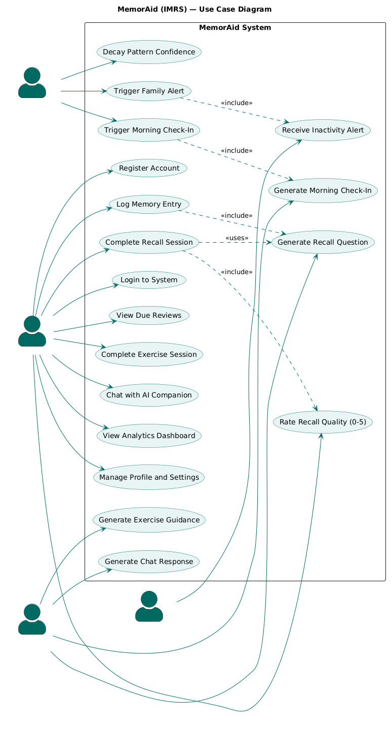
Figure 3.1 — Use Case Diagram for MemorAid (IMRS)

The Elderly User interacts with the following use cases: Register Account, Login, Log Memory Entry, View Due Reviews, Complete Recall Session, Rate Recall Quality, Complete Exercise Session, Chat with AI Companion, View Analytics Dashboard, and Manage Profile and Settings. The Family Member interacts with: Receive Inactivity Alert. The AI Service interacts with: Generate Recall Question, Generate Exercise Session Guidance, Generate Chat Response, and Generate Morning Check-In Message. The Scheduler interacts with: Trigger Morning Check-In, Update Pattern Confidence Scores, and Trigger Family Connection Alert.

3.4.2 Class Diagram
The class diagram presents the object-oriented structure of MemorAid, showing the key classes, their attributes, methods, and relationships. The primary classes in the system are: User, MemoryEntry, MemoryCategory, RecallQuestion, ReviewSchedule, RecallSession, ExerciseSession, ChatMessage, BehaviorPattern, AnalyticsRecord, and Notification.

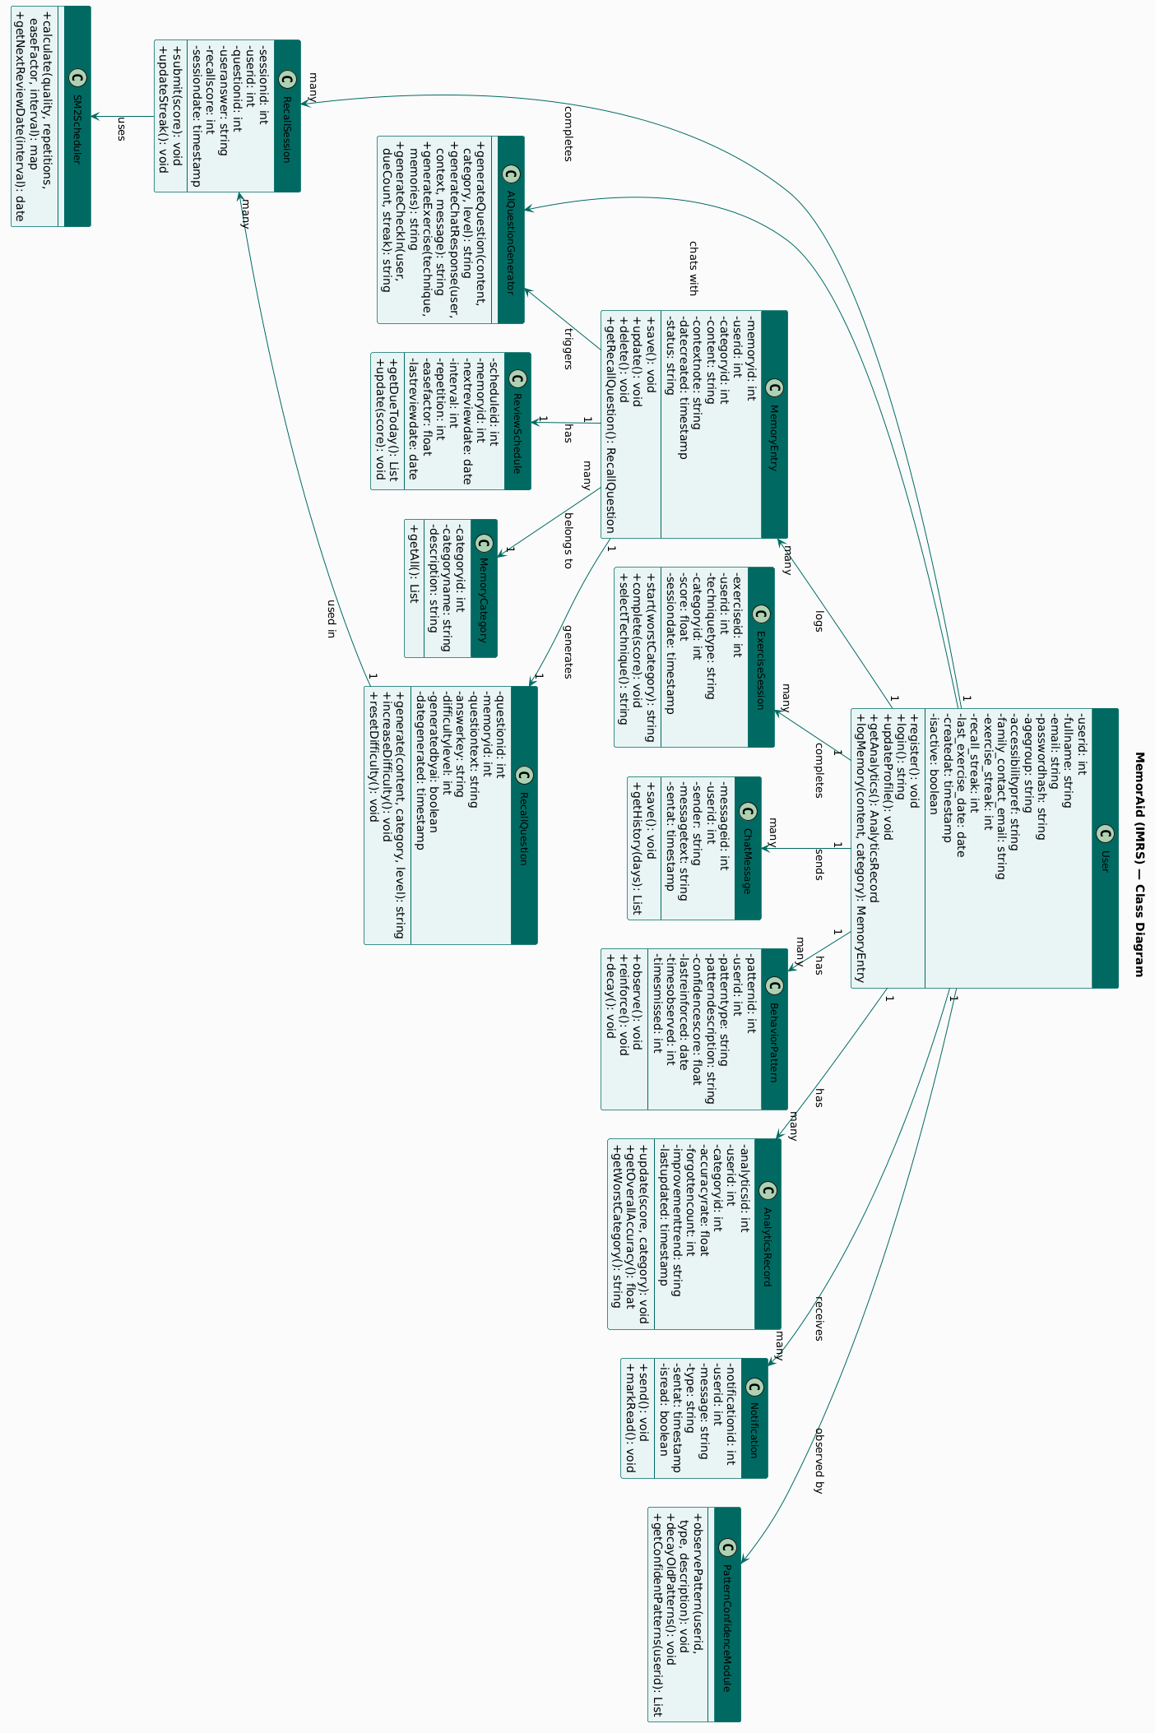
Figure 3.2 — Class Diagram for MemorAid (IMRS)
The User class has a one-to-many relationship with MemoryEntry one user can have many memory entries. Each MemoryEntry has a one-to-one relationship with RecallQuestion one entry generates one question. Each RecallQuestion has one ReviewSchedule governing when it is next presented. Each RecallSession records one user's response to one question on one occasion. The BehaviorPattern class is populated by the Pattern Confidence Module, which observes User behaviour over time and records patterns with confidence scores.

3.4.3 Sequence Diagram
The sequence diagram illustrates the step-by-step interaction between system components for the core AI recall question generation flow — the most fundamental AI-powered process in MemorAid.
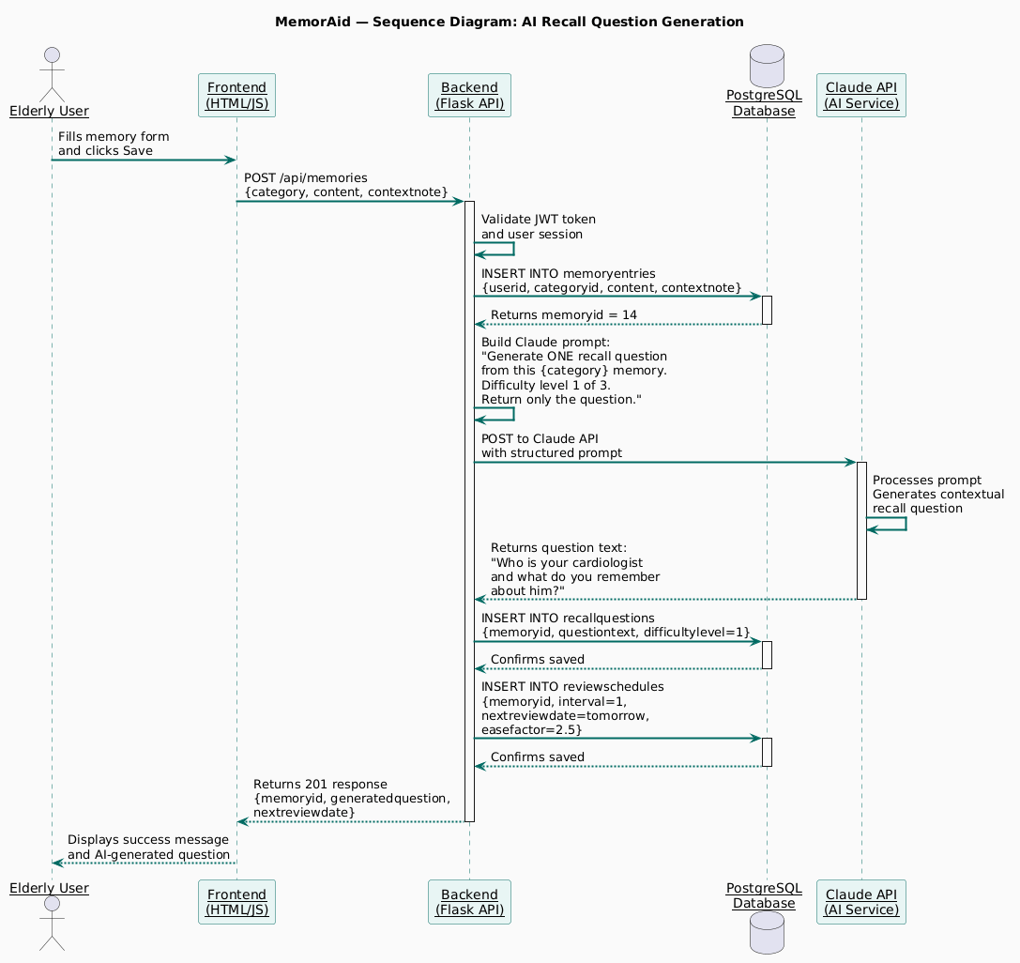
Figure 3.3 — Sequence Diagram: AI Recall Question Generation Flow
The sequence begins when the Elderly User submits a new memory entry through the frontend. The Frontend sends a POST request to the Backend API (/api/memories). The Backend validates the request and saves the memory entry to the PostgreSQL Database. The Backend then constructs a structured prompt containing the memory content, category, context note, and difficulty level (1), and sends it to the Claude API. Claude processes the prompt and returns a recall question. The Backend saves the generated question to the Database linked to the memory entry, creates an initial ReviewSchedule with a next review date of the following day, and returns a success response to the Frontend including the generated question and next review date. The Frontend displays confirmation to the Elderly User.

3.4.4 Activity Diagram
The activity diagram illustrates the complete workflow of the recall session the central user-facing feature of MemorAid showing the decision points and process flow from session initiation to SM-2 schedule update.
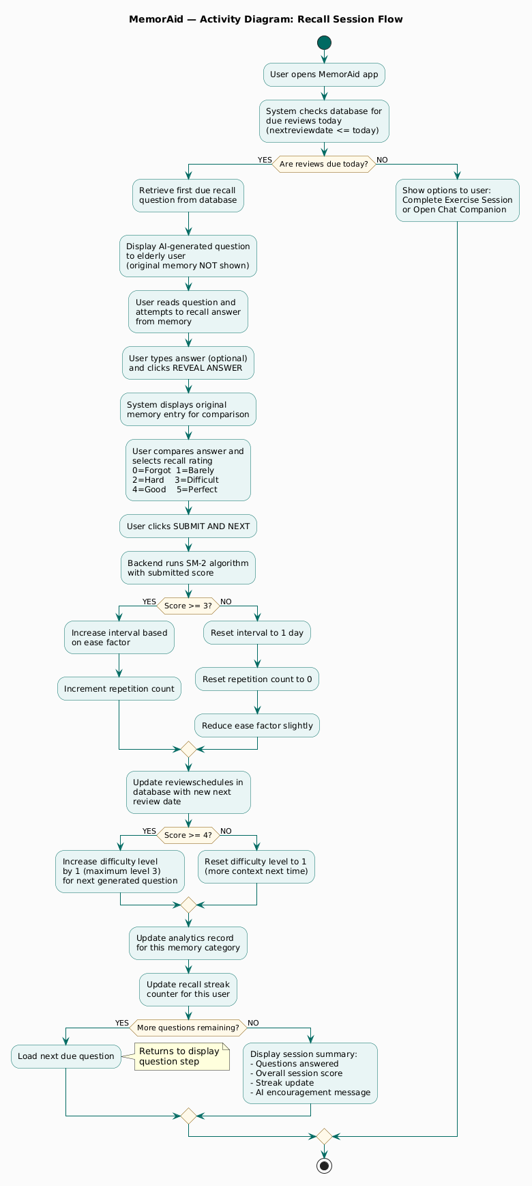
Figure 3.4 — Activity Diagram: Recall Session Flow
The recall session begins when the Elderly User opens the app and the system checks for due reviews. If no reviews are due, the system presents the option to complete an exercise session or use the chat companion. If reviews are due, the system retrieves the first due recall question from the Database and presents it to the user without showing the original memory. The user attempts to retrieve the answer from memory and types their response. The user then clicks Reveal to see the original memory and compares it to their answer. The user rates their recall quality from 0 to 5. The system submits the score to the Backend, which runs the SM-2 algorithm to calculate the new interval and next review date, updates the ReviewSchedule in the Database, adjusts the difficulty level for the next question generated for this memory, and updates the AnalyticsRecord for the relevant category. If more questions remain in the session, the next question is presented. If the session is complete, the system displays a summary and updates the user's streak.

3.5 System Design

3.5.1 Database Design
The MemorAid (IMRS) database is implemented in PostgreSQL and consists of ten tables. The tables are presented below with their fields and relationships. The Entity Relationship Diagram (ERD) illustrating the relationships between all tables is shown in Figure 3.5.
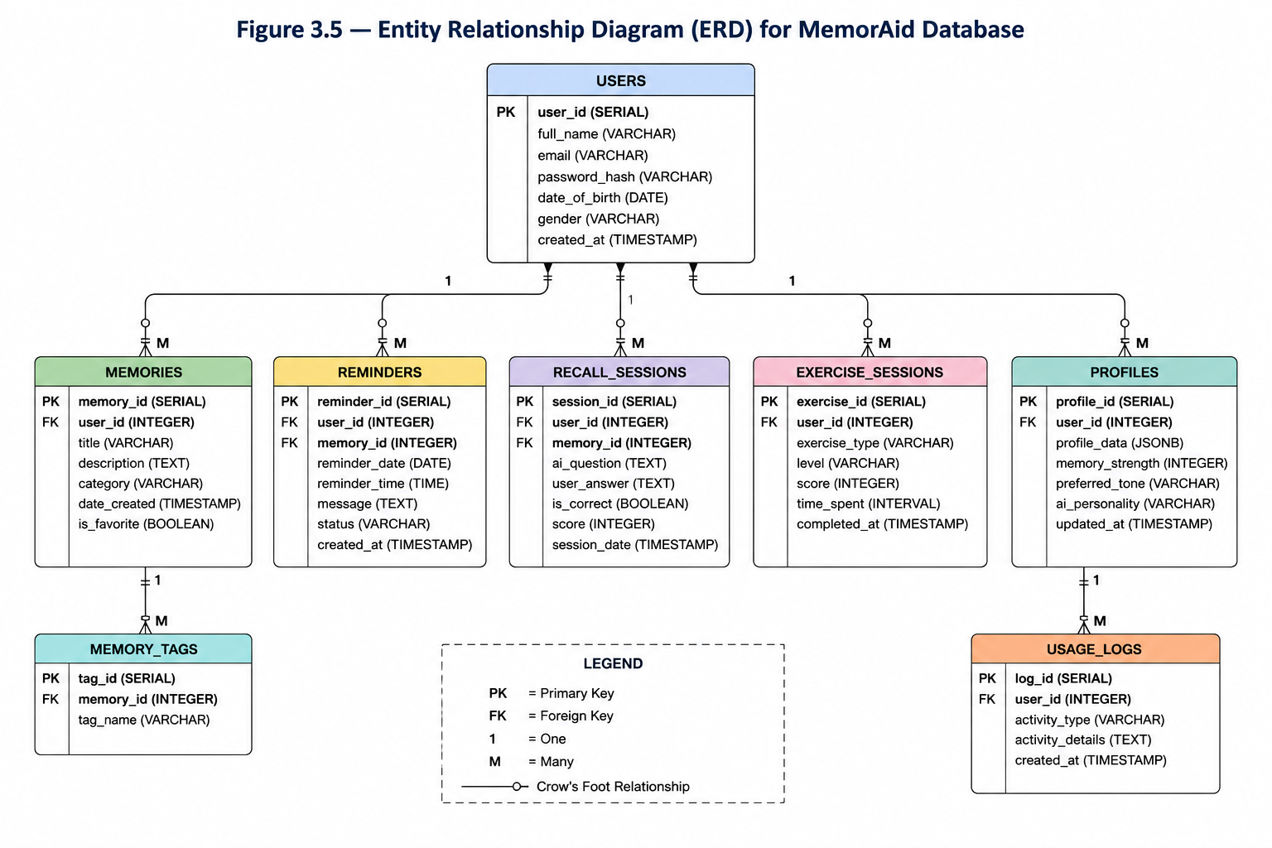
Figure X: Figure 3.5 — Entity Relationship Diagram (ERD) for MemorAid Database

Table: users
Field | Type | Description
userid | SERIAL PRIMARY KEY | Unique identifier for each user
fullname | VARCHAR(100) NOT NULL | User's full name
email | VARCHAR(150) UNIQUE NOT NULL | User's email address
passwordhash | VARCHAR(255) NOT NULL | bcrypt-hashed password
agegroup | VARCHAR(20) NOT NULL | Age group: 51-65 or above-65
accessibilitypref | VARCHAR(50) | Font size and contrast preferences
family_contact_email | VARCHAR(150) | Optional linked family member email
exercise_streak | INT DEFAULT 0 | Current exercise streak in days
recall_streak | INT DEFAULT 0 | Current recall streak in days
last_exercise_date | DATE | Date of last completed exercise session
createdat | TIMESTAMP | Account creation timestamp
isactive | BOOLEAN DEFAULT TRUE | Whether account is active

Table: memorycategories
Field | Type | Description
categoryid | SERIAL PRIMARY KEY | Unique identifier
categoryname | VARCHAR(50) UNIQUE | Name: Appointment, Task, Conversation, Medication
description | VARCHAR(255) | Description of the category

Table: memoryentries
Field | Type | Description
memoryid | SERIAL PRIMARY KEY | Unique identifier
userid | INT REFERENCES users | Foreign key to users table
categoryid | INT REFERENCES memorycategories | Foreign key to categories
content | TEXT NOT NULL | The memory content logged by the user
contextnote | TEXT | Optional additional context
datecreated | TIMESTAMP | When the memory was logged
status | VARCHAR(20) DEFAULT active | active or archived

Table: recallquestions
Field | Type | Description
questionid | SERIAL PRIMARY KEY | Unique identifier
memoryid | INT REFERENCES memoryentries | Foreign key to memory entry
questiontext | TEXT NOT NULL | AI-generated recall question
answerkey | TEXT | Original memory content as answer reference
difficultylevel | INT DEFAULT 1 | 1=easy, 2=medium, 3=hard
generatedbyai | BOOLEAN DEFAULT TRUE | Whether generated by Claude API
dategenerated | TIMESTAMP | When question was generated

Table: reviewschedules
Field | Type | Description
scheduleid | SERIAL PRIMARY KEY | Unique identifier
memoryid | INT REFERENCES memoryentries | Foreign key to memory entry
nextreviewdate | DATE NOT NULL | Next scheduled review date
interval | INT DEFAULT 1 | Current interval in days
repetition | INT DEFAULT 0 | Number of successful repetitions
easefactor | FLOAT DEFAULT 2.5 | SM-2 ease factor
lastreviewdate | DATE | Date of most recent review

Additional tables in the system include: recallsessions (recording each user's recall attempt and score), exercisesessions (recording completed exercise sessions and techniques used), analyticsrecords (storing recall accuracy and forgetting patterns by category), behaviorpatterns (storing silently observed user patterns with confidence scores), chatmessages (storing all chat interactions between user and AI), and notifications (storing morning check-in messages, due review alerts, and family connection alerts).

3.5.2 Input Design
Input design in MemorAid prioritises simplicity, accessibility, and low cognitive burden all critical considerations for elderly users who may have limited experience with digital interfaces. The following design principles govern all input screens:
- All input fields use a minimum height of 56 pixels to accommodate larger touch targets for elderly users with reduced fine motor control.
- All labels are positioned above their corresponding input fields never as placeholder text only to ensure clarity even when the field is partially completed.
- Minimum body text size is 18 pixels throughout, with headings at 24 pixels or larger.
- All error messages are displayed in plain, friendly language avoiding technical terms or alarming red text.
- Password fields include a show/hide toggle to reduce the frustration of typing errors on mobile devices.
- The memory logging form requires only three fields: category selection, memory content, and an optional context note deliberately minimal to allow an elderly user to log a memory in under 30 seconds.
- The recall session presents only one question at a time eliminating visual overwhelm and allowing full cognitive focus on a single retrieval task.



3.5.3 Output Design
Output design in MemorAid is designed to be informative, encouraging, and easy to interpret at a glance. Key output screens
- The Dashboard displays: a personalised morning greeting (from the AI morning check-in), the count of memories due for review today, the current exercise streak, the current recall streak, and a list of recently logged memories with their next review dates.
- The Recall Session output shows the AI-generated question, followed by a Reveal Answer button that displays the original memory for comparison, followed by a 0-to-5 rating scale with plain English labels.
- The Exercise Session output presents the selected technique in plain language with step-by-step guidance generated by the AI, followed by a completion confirmation and streak update.
- The Analytics Dashboard displays: overall recall accuracy as a percentage, a bar chart showing forgetting frequency by category, a line chart showing accuracy improvement over time, current streak counters, and a motivational message from the AI.
- The Chat output displays the AI's personalised response in a conversational thread format, with the AI's name and a warm tone appropriate to the elderly user's age group.

REFERENCES
Atkinson, R. C., & Shiffrin, R. M. (1968). Human memory: A proposed system and its control processes. In K. W. Spence & J. T. Spence (Eds.), The psychology of learning and motivation (Vol. 2, pp. 89–195). Academic Press.
Booch, G., Maksimchuk, R. A., Engle, M. W., Young, B. J., Conallen, J., & Houston, K. A. (2007). Object-oriented analysis and design with applications (3rd ed.). Addison-Wesley.
Bower, G. H. (1970). Analysis of a mnemonic device. American Scientist, 58(5), 496–510.
Bower, G. H., & Karlin, M. B. (1974). Depth of processing pictures of faces and recognition memory. Journal of Experimental Psychology, 103(4), 751–757.
Brown, T. B., Mann, B., Ryder, N., Subbiah, M., Kaplan, J., Dhariwal, P., Neelakantan, A., Shyam, P., Sastry, G., Askell, A., Agarwal, S., Herbert-Voss, A., Krueger, G., Henighan, T., Child, R., Ramesh, A., Ziegler, D. M., Wu, J., Winter, C., … Amodei, D. (2020). Language models are few-shot learners. Advances in Neural Information Processing Systems, 33, 1877–1901.
Camp, C. J. (1989). Facilitation of new learning in Alzheimer's disease. In G. C. Gilmore, P. J. Whitehouse, & M. L. Wykle (Eds.), Memory, aging and dementia (pp. 212–225). Springer.
Cepeda, N. J., Pashler, H., Vul, E., Wixted, J. T., & Rohrer, D. (2006). Distributed practice in verbal recall tasks: A review and quantitative synthesis. Psychological Bulletin, 132(3), 354–380.
Craik, F. I. M., & Lockhart, R. S. (1972). Levels of processing: A framework for memory research. Journal of Verbal Learning and Verbal Behavior, 11(6), 671–684.
Ebbinghaus, H. (1885). Über das Gedächtnis: Untersuchungen zur experimentellen Psychologie [Memory: A contribution to experimental psychology] (H. A. Ruger & C. E. Bussenius, Trans.). Teachers College, Columbia University. (Reprinted 1913)
Etim, A. (2021). Stress, cognitive load and memory performance in urban Nigerian adults. African Journal of Psychology and Behavioural Sciences, 8(2), 45–61.
Fielding, R. T. (2000). Architectural styles and the design of network-based software architectures [Doctoral dissertation, University of California, Irvine]. ProQuest Dissertations & Theses.
Landauer, T. K., & Bjork, R. A. (1978). Optimum rehearsal patterns and name learning. In M. M. Gruneberg, P. E. Morris, & R. N. Sykes (Eds.), Practical aspects of memory (pp. 625–632). Academic Press.
Merzenich, M. M. (2013). Soft-wired: How the new science of brain plasticity can change your life. Parnassus Publishing.
Miller, G. A. (1956). The magical number seven, plus or minus two: Some limits on our capacity for processing information. Psychological Review, 63(2), 81–97.
Roediger, H. L., & Karpicke, J. D. (2006). Test-enhanced learning: Taking memory tests improves long-term retention. Psychological Science, 17(3), 249–255.
Salthouse, T. A. (1991). Theoretical perspectives on cognitive aging. Lawrence Erlbaum Associates.
Wozniak, P. A. (1990). Optimization of learning [Unpublished master's thesis]. Poznan University of Technology.

