1. Name of Use Case

|  |  |
| --- | --- |
| **Name of the Use Case** | **IoT platform for Parkinson Disease Management** |
| **Version No.** | v0.1 |
| **Date** | 10/12/2022 |
| **Team Members (with student ids)** | Luca Barotto (s272817)  Marta Bono (s292185)  Francesco Calice (s296579)  Candela Muzàs (s306643) |

1. Scope and Objectives of Function

|  |  |
| --- | --- |
| **Scope and Objectives of Use Case** | |
| **Scope** | The proposed IoT platform aims at providing management services for patients with Parkinson’s Disease. |
| **Objective(s)** | The purpose of this IoT system is to analyse the patient’s gait through some parameters to prevent falls, freezing episodes and excessive tremor, in order to improve the quality of life of the patient. |
| **Domain(s)** | Smart health. |
| **Stakeholder(s)** | Patients, Clinicians, Caregivers. |
| **Short description** | The proposed IoT platform aims at providing a smart telemedicine management system for patients affected with Parkinson’s Disease. This IoT system will provide a monitoring and an emergency management system through some IoT devices placed on the patient’s body. It provides control strategies for some of the main symptoms, such as tremor, freezing episodes and possible falls. The overall platform provides unified interfaces (through both REST and MQTT).  Finally, the platform provides end-users with detailed knowledge of the patient’s state.  Summarizing, the main features it offers are:   * remote control of appliances; * control strategies for the main symptoms of the disease; * unified interfaces (i.e. REST Web Services and MQTT queues); * end-user applications for patient’s state monitoring. |

1. Diagram of Use Case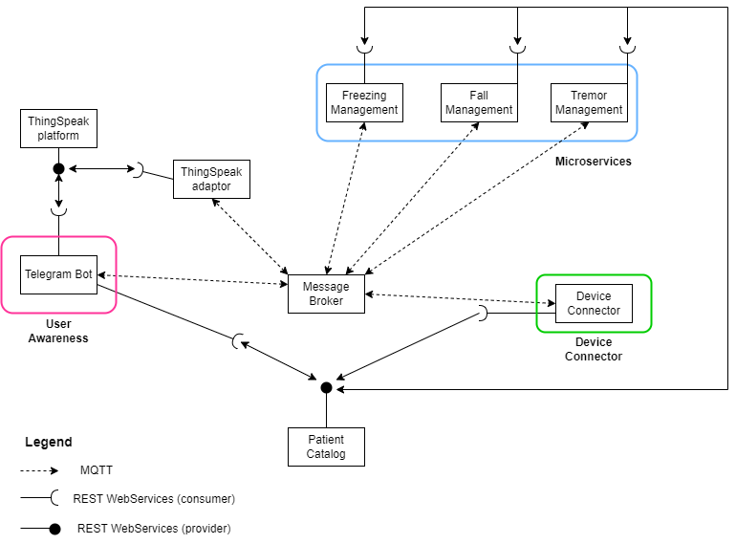
2. Complete description of the system

The proposed IoT platform for Parkinson’s Disease management follows the microservices designing pattern. It also exploits two communication paradigms: i) publish/subscribe based on MQTT protocol and ii) request/response based on REST Web Services.

In this context, ten actors have been identified and introduced in the following:

* The **Message Broker** provides an asynchronous communication based on the publish/subscribe approach. It exploits the MQTT protocol.
* The **Patient** **Catalog** works as service and device registry system for all the actors in the system. It provides information about end-points (i.e. REST Web Services and MQTT topics) of all the devices, resources and services in the platform. It also provides configuration settings for applications and control strategies (e.g. timers, list of sensors and actuators). Each actor, during its start-up, must retrieve such information from the Catalog exploiting its REST Web Services.
* The **Device Connector** is a software that simulates the behaviour of each IoT device. It simulates data from a waist accelerometer, a wrist accelerometer (in a smartwatch) and a pressure detector placed under the patient’s feet. It provides Rest Web Services to retrieve patient’s list. It also works as an MQTT publisher sending information to the microservice “Error Management”.
* The **Freezing Management** is a control strategy that manages the patient’s freezing episodes. It uses sensors measurements to detect a freezing episode, then (if present) sound feedback is emitted from the smartwatch. It works i) as an MQTT subscriber to receive information from the Device Connector; ii) as an MQTT publisher to send actuation commands to the simulated IoT Devices.
* The **Fall Management** is a control strategy that manages the patient’s possible falls. It uses sensors measurements to check pressure under the feet and time from the last peak in the waist accelerometer. If a fall occurs, then an emergency message from the TeleBot is sent to the clinician. It works i) as an MQTT subscriber to receive information from the Device Connector; ii) as an MQTT publisher to send actuation commands to the TeleBot.
* The **Tremor Management** is a control strategy that manages the patient’s tremor. It uses sensors measurements to detect the frequency of wrist tremor. If frequency is higher than a threshold, an IoT actuator (Deep Brain Stimulation) is activated. It works i) as an MQTT subscriber to receive information from the Device Connector; ii) as an MQTT publisher to send actuation commands to the simulated IoT Devices.
* The **Error Management** is a control strategy that distinguishes between correct and incorrect measurements. If the measurements retrieved are correct, it sends them to ThingSpeak; otherwise, it sends an alert through TeleBot that sensors must be replaced. It works i) as an MQTT subscriber to receive information from the Device Connector; ii) as an MQTT publisher to send actuation commands to TeleBot and correct measurements the other microservices and ThingSpeak.
* The **Thingspeak Adaptor** is an MQTT subscriber that receives measurements and upload them on **Thingspeak** through REST Web Services.
* **Thingspeak** is a third-party software (<https://thingspeak.com/>) that provides REST Web Services. It is an open-data platform for the Internet of Things to store, post-process and visualize data (through plots).
* **Telegram Bot** is a service to integrate the proposed infrastructure into Telegram platform, which is cloud-based instant messaging infrastructure. It receives commands from the “Fall Management” microservice to send Emergency Telegram messages through the MQTT protocol. It can also retrieve information about statistic trends of patient’s state from ThingSpeak using Rest communication.

1. Desired Hardware components (only among those we can provide)

|  |  |  |
| --- | --- | --- |
| **Device Name** | **Quantity** | **Needed for…** |
|  |  |  |
|  |  |  |
|  |  |  |
|  |  |  |
|  |  |  |