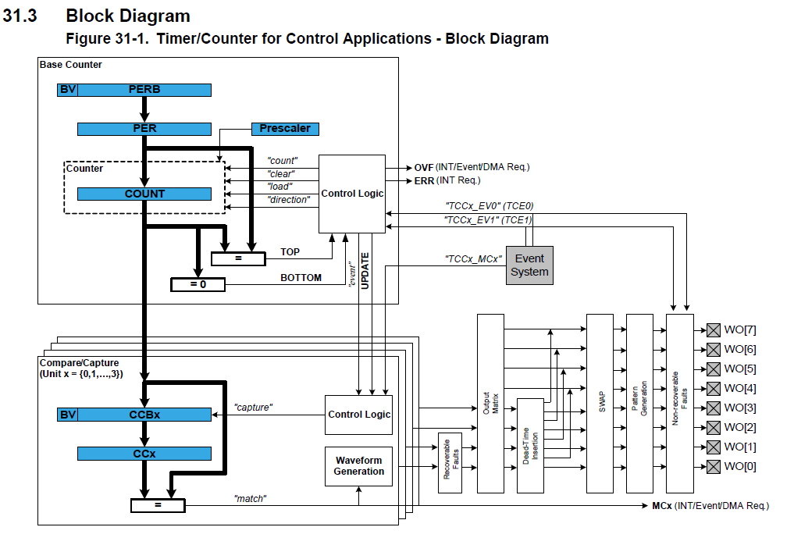

The output matrix (OTMX) can distribute and route out the TCC waveform outputs across the port pins in different configurations, each optimized for different application types. The Dead-Time Insertion (DTI) unit splits the four lower OTMX outputs into two non-overlapping signals: the non-inverted low side (LS) and inverted high side (HS) of the waveform output with optional dead-time insertion between LS and HS switching. The SWAP unit can swap the LS and HS pin outputs, and can be used for fast decay motor control.

1. Select PRESCALER setting in the Control A register (CTRLA.PRESCALER).

2. Select Prescaler Synchronization setting in Control A register (CTRLA.PRESCSYNC).

3. If down-counting operation is desired, write the Counter Direction bit in the Control B Set register (CTRLBSET.DIR) to '1'.

4. Select the Waveform Generation operation in the WAVE register (WAVE.WAVEGEN).

5. Select the Waveform Output Polarity in the WAVE register (WAVE.POL).

6. The waveform output can be inverted for the individual channels using the Waveform Output Invert Enable bit group in the Driver register (DRVCTRL.INVEN).

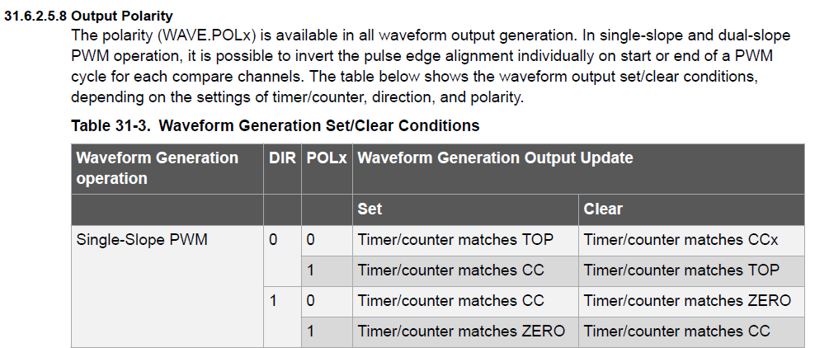

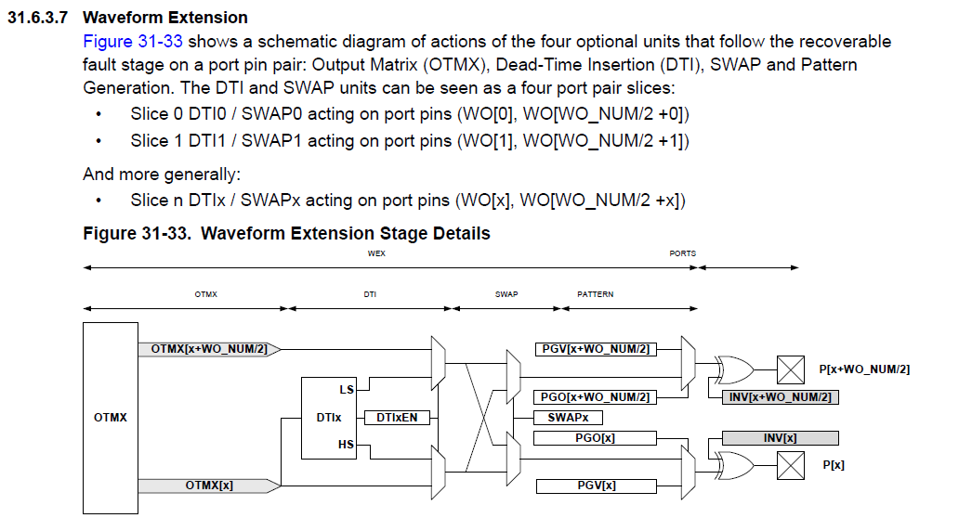

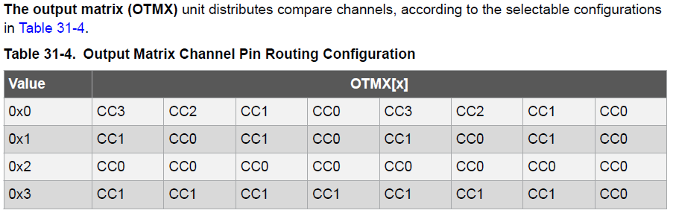

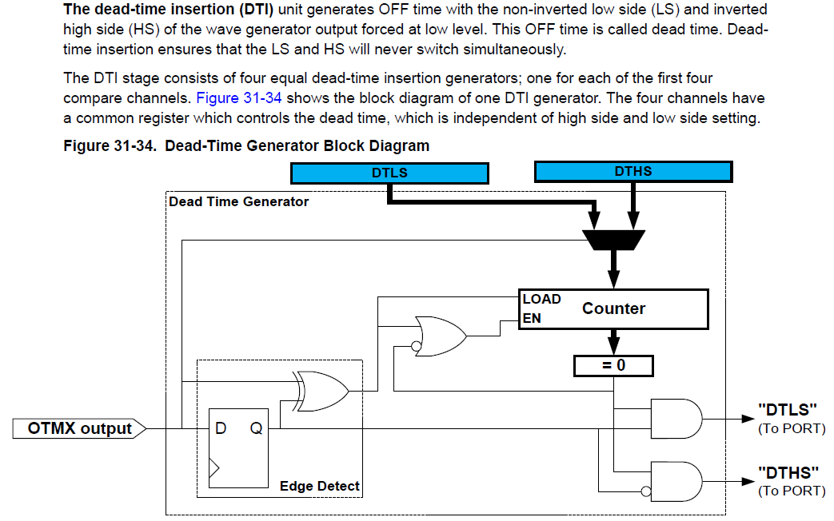

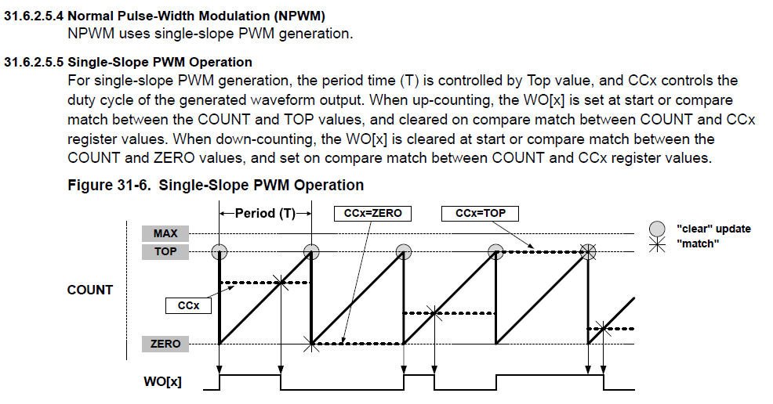

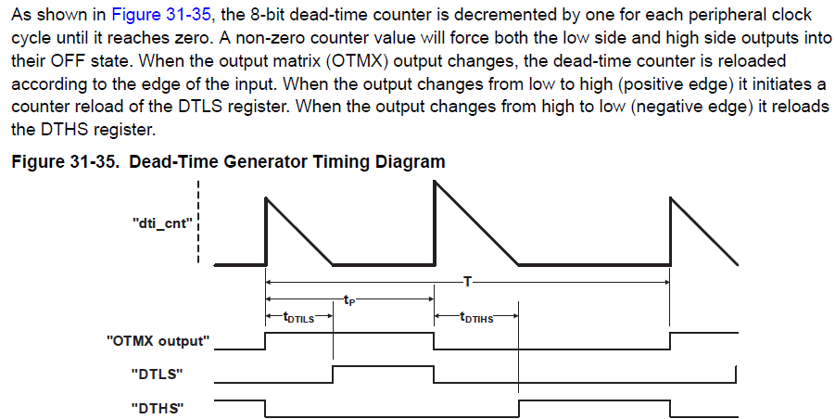

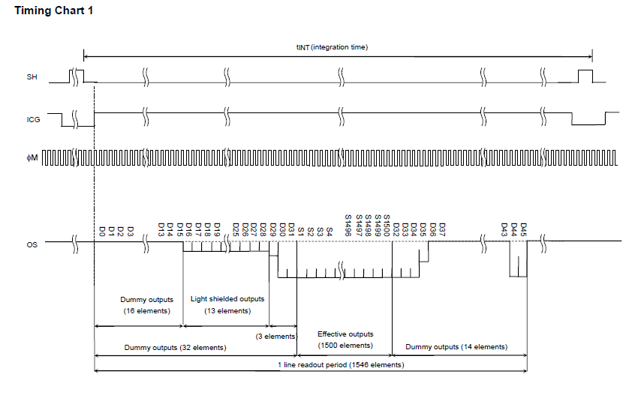

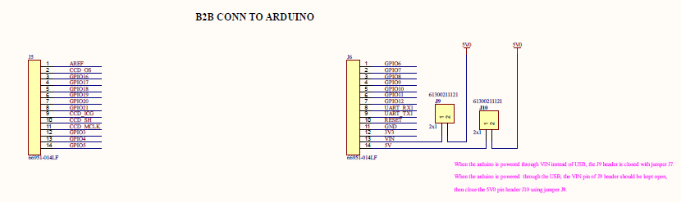

ICG

SH

MCLK





