Troubleshooting

Information requested by the Engineers and /or Consultants of Check MK

Type | How to get | Note
Log file | check_mk.log in log | Mandatory
Bakery config | check_mk.bakery.log | Mandatory, if exists
User config | check_mk.user.yml | Mandatory, if changed
Test output | Check_mk_agent test > test.txt | recommended

Short list of checks to do when something is going wrong
- Check Log File for Errors and Warnings
- Check firewall is enabled for Check MK Agent
- Check only one Windows Agent Service is running
- Check Windows Agent Service is running using appropriate account
- Check version and configuration folders
Quick log file check
Check for errors
Enter in command line
type check_mk.log | find /I ”[Err”
You should get empty output.
Check for warnings
Enter in command line
type check_mk.log | find /I ”[Warn”
Normally you should get empty output, still warnings are not so harmful

Check Firewall
Use any appropriate for you method to be sure that firewall is opened for the check_mk_agent.exe

Check Windows Agent is running as service and use correct account

Enter in command line
tasklist /V | find “check_mk_agent”

You should get something like

NT AUTHORITY\SYSTEM is default account to run service
Services is valid group
Unknown and N/A are valid for service

You should not have more than two entries with check_mk_agent.exe

Checking Automatic Updater
You may need to analyze or deliver next files from the log folder
- agent-msi.log
- cmk-update-agent.log

Cleaning Up
Current version of the Windows Agent doesn’t delete any of the user files. You may need to remove folder %ProgramData%\checkmk\agent together with all subfolders.
Attention! If you have OpenHardwareMonitor deployed, then OHM starts from this folder driver winring1_2_0 which may not be terminated during uninstall.
Just run next commands from the command line if you can’t delete above mentioned folder
taskkill /F /IM OpenhardwareMonitorCLI.exe
net stop winring0_1_2_0
And retry your attempt to delete your folder.
Good and safe alternative to the remove of the User folder remove is renaming of the folder. For example, to agent.sav.

Check Version and Configured Folders
Use command line commands:
check_mk_agent section check_mk
Typical output
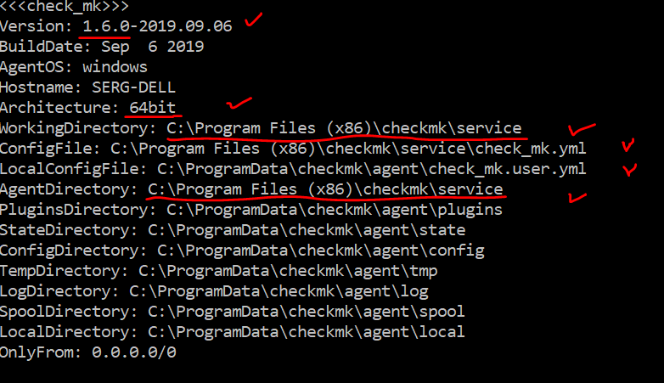

Simple and safe recover methods
Restart service:
net stop checkmkservice
net start checkmkservice
Restore bakery configuration:
check_mk_agent restore
Remove bakery configuration:
net stop checkmkservice
<rename bakery.yml to something>
net start checkmkservice
Remove user configuration:
net stop checkmkservice
<rename user.yml to something>
net start checkmkservice

Advanced Troubleshooting
WinDbg – to debug windows agent service
Dbgview - to see log messages from the realtime

You also may see log messages in realtime using command line parameter
check_mk_agent adhoc -showall

