Plugins

Plugin Default Configuration
You may use showconfig command line option to check your configuration.
Below is output last 20 lines of output from check_mk_agent showconfig plugins:
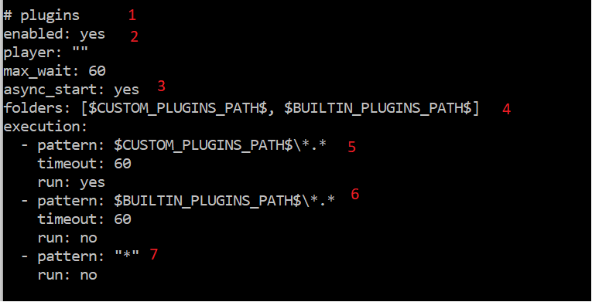
1 – section name
2 – ignore it
3 – ignore it
4 – windows folders where plugins may be located. The order is important. First folder wins and for this particular configuration a file from $CUSTOM_PLUGINS_PATH$ are more important than file with the same name but from $CUSTOM_PLUGINS_PATH$.
5 – all plugins found in the “%ProgramData%\checkmk\agent\plugins” must be executed as Synchronous plugins, because this is default state for all plugins, local plugins and mrpe checks
6 – all plugins found in the “%ProgramFiles(x86)%\checkmk\service\plugins” will be NOT executed(run: no)
7 – all other plugins will not be executed too:
- ”*” means any plugin
- run: no
Important: Patterns are estimated top-down, first pattern matching the plugin wins.
Important: Default timeout for all plugins is 60 seconds. It means that any plugin will be terminated after 60 seconds.
Important: The values like $CUSTOM_PLUGINS_PATH$ are described in the Common.

Real life Example
For example, we want to use two plugins
- win_printers.ps1
- mssql.vbs
The best method is using bakery, but let’s assume we have no bakery and we will try to get desired result manually
Plugin win_printers.ps1 is relatively fast and can be called synchronously during Monitoring Site polling.
Plugin mssql.vbs is very slow and can be used reliably only asynchronously, because default timeout for all Agent plugins is 60 seconds and this is not enough. Even more, a long wait time may create difficult to understand problems for your Monitoring Site.
- Copy above mentioned plugins to the “%ProgramData%\checkmk\agent\plugins”
- Write into the check_mk.user.yml
plugins:
- pattern: $CUSTOM_PLUGINS_PATH$\win_printers.ps1
- pattern: $CUSTOM_PLUGINS_PATH$\mssql.vbs
cache_age: 1500
async: yes
timeout: 360
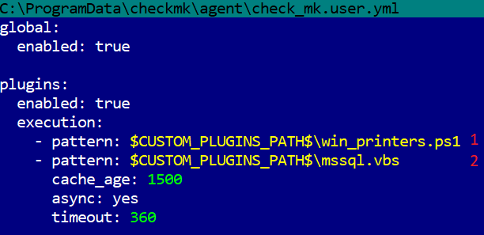

Now reload config check_mk_agent.exe with
check_mk_agent reload_config
You should get something like
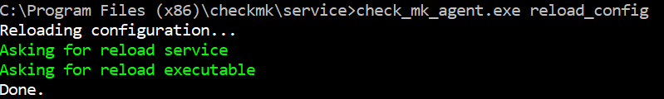
Now you can check your resulting configuration with
check_mk_agent showconfig plugins
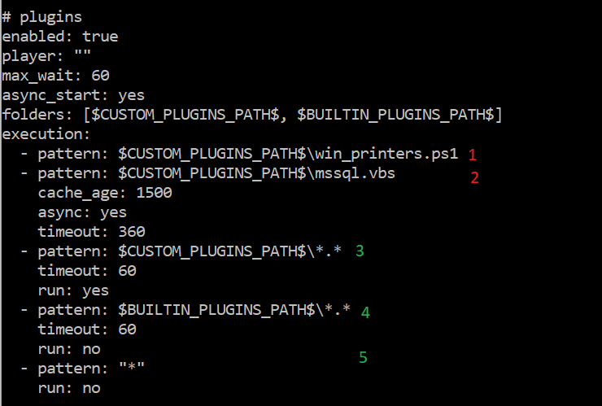
1 – new plugin
2 - new plugin
3, 4 and 5 – from original config

Now you can check output with
check_mk_agent section plugins
In my case(I have no mssql installed) it will look
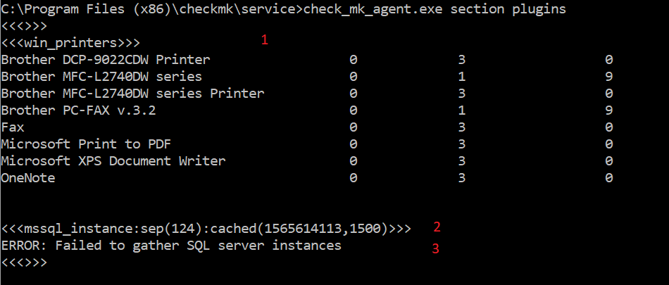
1 – is synchronous win_printers plugin
2 and 3 – asynchronous mssql.vbs plugin

Rules Priority

The Agent uses very simple algorithm to apply rules, described by execution entries:
- Find all files to execute in folders
- Apply to every found file every rule with matching pattern in the Reverse Order.
I.e. last applied/most important is first one, see example below
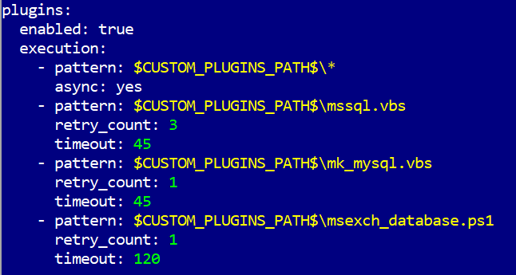
In this config all plugins in CUSTOM_PLUGINS_PATH will be executed as async.
- If you want to override default behavior, just write new rule (in execution section) with the correct pattern and desired parameters.
- For example, you need timeout 90 for all vbs scripts. You have to write at the beginning plugins.execution section in your check_mk.user.yml
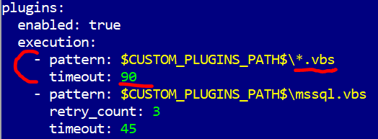
- Less important is fabric config, check_mk.yml, then check_mk.bakery.yml and most important is check_mk.user.yml

