Common
Macro names
Since 1.6.0b5

$BUILTIN_PLUGINS_PATH$ %ProgramFiles(x86)%/checkmk/service/plugins
$CUSTOM_AGENT_PATH$ %ProgramData%/checkmk/agent/
$CUSTOM_PLUGINS_PATH$ %ProgramData%/checkmk/agent/plugins
$CUSTOM_LOCAL_PATH$ %ProgramData%/checkmk/agent/local

Configuration files

The Windows Agent uses three configuration file which have identical structure
Folder | Name | Type | Editable by User
%ProgramFiles(x86)%/checkmk/service | check_mk.yml | Factory configuration | NO
%ProgramData%/checkmk/agent/bakery | check_mk.bakery.yml | Bakery Configuration | NO
%ProgramData%/checkmk/agent/ | check_mk.user.yml | User Configuration | YES

The files are loaded always in above mentioned order building simple hierarchy, from the most important to less important:
%ProgramData%\checkmk\agent\check_mk.user.yml
%ProgramData%\checkmk\agent\bakery\check_mk.bakery.yml
%ProgramFiles(x86)%\checkmk\service\check_mk.yml
Important: Normally a user should edit only check_mk.user.yml. Other configuration files, check_mk.bakery.yml and check_mk.yml can be overridden at any moment by bakery or MSI installation.
Important: in your log file you can find detailed information about loaded configuration files.
In example below you may see, that the Agent have loaded the factory check_mk.yml, NO bakery.yml and check_mk.user.yml
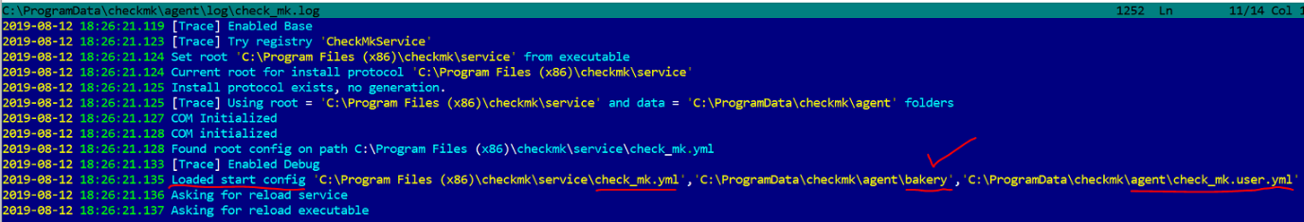

Configuration reloading
Since 1.6.0b5

The Windows Agent can reload configuration in two modes
- Manual
- Automatic
Default reload mode is manual. In this mode the windows agent will reload own configuration when
- Executable restarted, for example for service you have to run two commands
  - net stop checkmkservice
  - net start checkmkservice
- Using command line option reload_config
  - check_mk_agent reload_config
To automatically reload agent’s configuration, you have to set environment variable CMA_AUTO_RELOAD=yes.
In this mode the agent will reload configuration on every call from the Monitoring site

Deprecated Sections

The Windows Agent does not support any more logfiles section.
You must switch to mk_logwatch plugin.

