Installation

Conditions

- Windows Vista or newer OS.
  - New Agent doesn’t support Windows XP/Windows Server 2003 anymore.
- An account with Administrator Rights.
Windows Agent supports 32-bit and 64-bit Windows OS.

Typical Scenario
- Download any Windows Agent Installer MSI file from the Monitoring Site
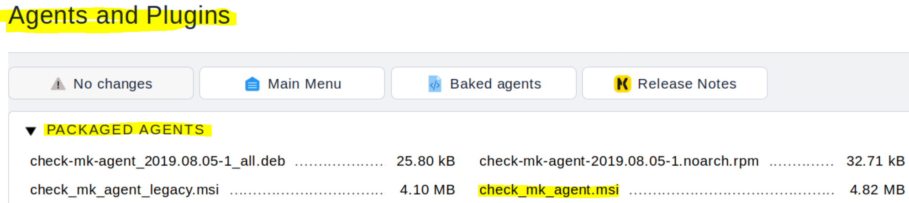
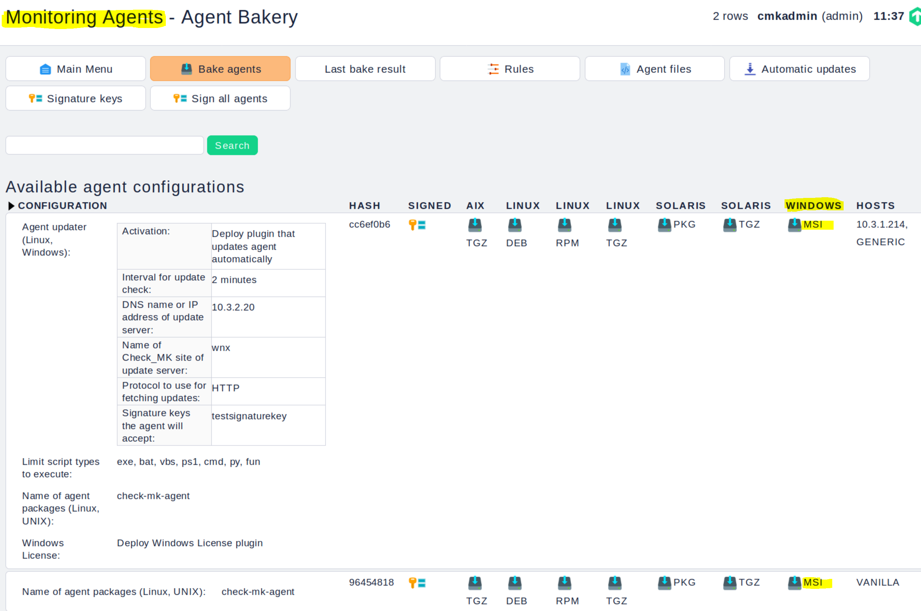
- Install it using any method you prefer
- Deal done.

Options of Installation

Change Installation Folder. This Option is disabled by default as dangerous.
You may enable the option from command line, for example, next command:
msiexec /I check_mk_agent_msi ENABLE_CUSTOM_FOLDER=1
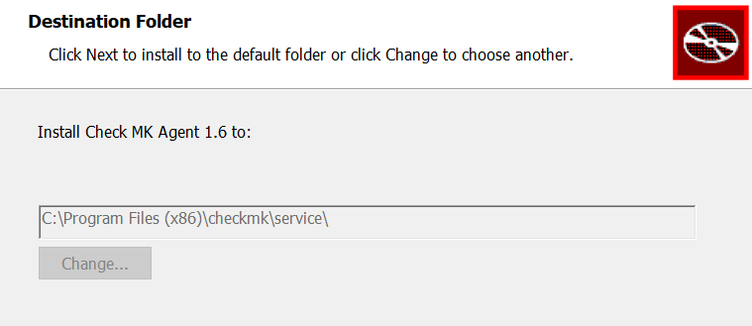

Remove Legacy Agent. If this option checked, then Legacy Agent installation will be removed after successful installation of the Agent 1.6
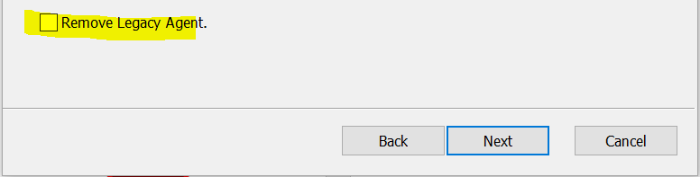

Folders
The Agent 1.6 uses two folders to install own files
- Installation Folder or Root Folder:
  - %ProgramFiles(x86)%\checkmk\service for 64-bit OS
  - %ProgramFiles%\checkmk\service for 32-bit OS
- Data Folder or User Folder: %ProgramData%\checkmk\agent
Root Folder is owned by installation(MSI and Trusted Installer)
Data Folder ownership is shared:
- Agent Service
- User

Details of Installation

The Agent 1.6 consists from the two parts
- Agent Service for Windows with name checkmkservice
The Service is placed in the Installation Folder
Name of the main executable file of the Service is check_mk_agent.exe
- User and Bakery Data files. Those files are placed in the Data Folder

Installation from command line
msiexec /quiet WIXUI_REMOVELEGACY=1 check_mk_agent.msi

Where WIXUI_REMOVELEGACY=1 is optional command to remove installed Legacy Windows Agent.
Types of Installation

We have two types of MSI to install
- The packaged MSI. This MSI is produced by the Windows Build Machine in Check MK and has no Bakery Data. The packaged MSI may be identified after installation by content of the checkmk.dat
The hash code is set to DEFADEFADEFA.
- The baked MSI. This MSI is produced by the Bakery of the Monitoring site and Bakery Data. There are two subtypes of the Baked MSI
  - The vanilla MSI. Bakery data are presented, but empty.
  - The baked MSI itself. Bakery Data are presented and not empty

Upgrade of Legacy Agent Configuration during Installation
Main difference between Bakery and Packaged Agent MSI installations is based on Legacy Agent Upgrade.
Bakery MSI (also Vanilla MSI) will NEVER upgrade Legacy Agent configuration from the Bakery
Such at first look strange behavior is based on the fact, that any Agent, which comes from WATO, has own, actual and valid configuration and upgrade of the old config from the Legacy Agent to kill actual and valid one has no sense.
This behavior is also valid for Vanilla MSI, while installing Vanilla we assume that intention of the user is Clean Bakery configuration, not an upgrade of already existing Legacy Agent config.
Attention: check_mk.local.ini and/or check_mk.ini not coming from the Bakery will be upgraded in any case
Attention: Packaged Installation will try to upgrade everything

Common recommendations:
- Normally you should only Bakery version of the MSI
- Vanilla Version is normally used for troubleshooting
- Use Packaged Agent to
- try new Agent
- upgrade complicated Legacy Agent configuration which is not supported by WATO

Potential Problems and Limitations
You may have to add Firewall Rule to open port. Usually is 6556.
It is not recommended to change default installation folder. This is just a reminder.
You may proof your installation with next command
net start checkmkservice
If Agent has been installed correctly, then you get response from the system
The requested service had been already started

Uninstallation
You can uninstall Check MK Agent 1.6 at any moment using any method.
Your data folder will NOT be removed after uninstallation. You have to do it manually.
You may have to stop OpenHardwareMonitor and driver winring0_1_2_0

