Special Plugins of the Windows Agent

Definitions
We define a plugin a Special One if true either one criteria from the list below
- Plugin executable unit is detached, i.e. independent from the Windows Agent
- Plugin is “heavy”, i.e. requires a lot of time to obtain results
- Plugin is not trivial in configuring or execution
List of the special plugins

Name | Notes | Detached | Heavy | Non-trivial
Open Hardware Monitor | Has own section. Own config in bakery | Yes | No | No
Mssql.vbs | Part of the plugins section. Own config in bakery | No | Yes | No

Plugin: open hardware monitor
In fact, this is not a typical plugin, but a normal Windows executable with own Windows ring-0 driver.
Windows Agent never gets data directly from this plugin, only through using Windows WMI.
Detailed Description:
Open hardware monitor is the Windows Application which delivers through WMI assorted parameters for computer hardware, like Frequency, Load, Temperature and so on.
Usage:
Use, please, bakery to deploy Open Hardware Monitor on your host
Configuration.
Absent
Testing.
check_mk_agent.exe section openhardwaremonitor
Important:
- This is separate Windows Process running constantly, 24/7. You may start many Open Hardware Monitor’s executable. This is also problem, because driver may(!) be not unloaded until all instances of the Open Hardware Monitor executable will be stopped.
- Open Hardware Monitor automatically installs and runs Windows driver winring0_1_2_0. This driver may interfere with install,uninstall, stop and start Windows Agent.
- Open Hardware Monitor may hang up, i.e. it is impossible to obtain data through WMI. The new Windows Agent solves this problem automatically. For Legacy Windows Agent you should use script from the treasury
openhardwaremonitor-clean.cmd
- Best possible diagnostic is using Powershell WMI script
powershell.exe -command "Get-WmiObject -query \"Select * From __Namespace Where Name='OpenHardwareMonitor'\" -Namespace \"root\""
Output must look like:
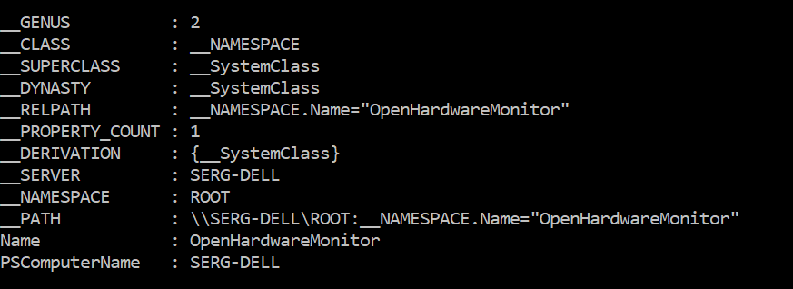
If output is empty or you get error(s), then Open Hardware Monitor is malfunctioning
- As with every WMI-based plugin you may experience “17-th minute WMI Problem”, i.e. every 17-th minute WMI requests are timeouted
- To stop Open Hardware Monitor manually and with guaranty, you may run as Administrator next two commands:
taskkill /F /IM OpenhardwareMonitorCLI.exe
net stop winring0_1_2_0
- Please, always use Open Hardware Monitor distributed as part of the Windows Agent installation

