WMI

Common Problems
- Corruption. Windows WMI database can be corrupted literally at any moment.
- Regular timeouts (every 17 minutes, for example).
- Irregular timeouts

Diagnostic
WMI Explorer tool can help you to find that something is going wrong. You may install it from the internet or use chocolatey. Typical screen is
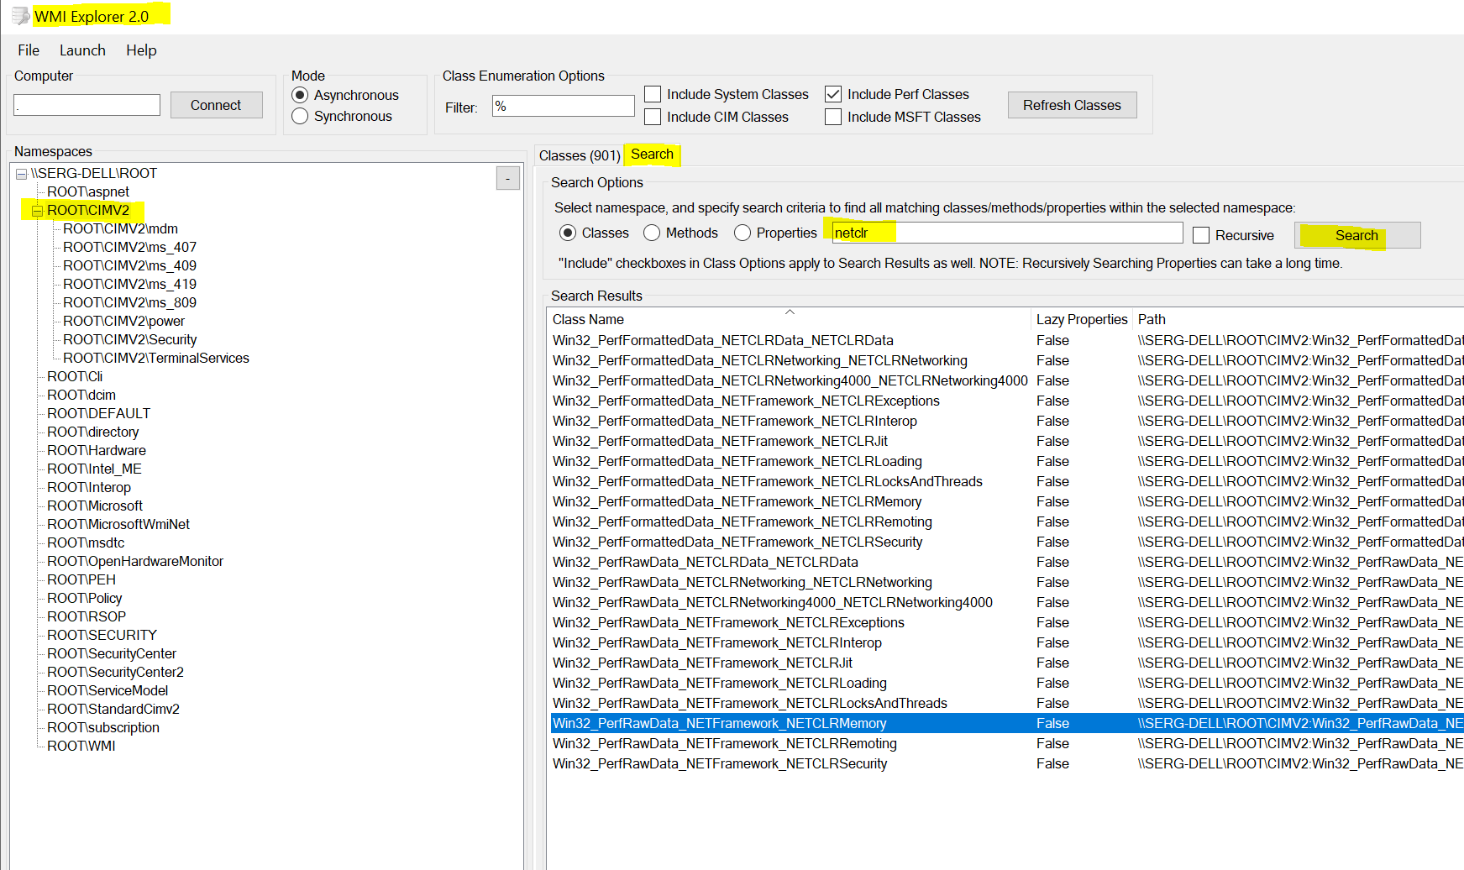
Power Shell can run WMI query thus helping to detect problems. I would suggest using IDE “Powershell IDE ISE”
Set of commands to check state of the WMI
Get-WmiObject -query "Select * From __Namespace Where Name='OpenHardwareMonitor'" -Namespace "root" | Format-Wide
Get-WmiObject -query "Select * From __Namespace Where Name='CimV2'" -Namespace "root" | Format-Wide
Get-WmiObject -query "Select * from Win32_Process Where Name = 'csrss.exe'" | Format-Wide
Get-WmiObject -query "Select * from Win32_PerfRawData_NETCLRData_NETCLRData" | Format-Wide

WMI Diag 2.2 is tool from Microsoft to scan all your WMI database to find errors. This tool is very powerful, but a bit obsolete and will report few errors even for healthy systems
Also, this tool requires a lot of time, depending from the PC up to 30 minutes to finish the job.

Corruption Troubleshooting
First thing you must know: as a rule, you can’t solve this WMI problem without restore.

The only reliable method to fix corrupted WMI database is Windows reinstallation. For VM it s relatively simple(snapshots) , for bare-metal machines backup restore in Windows is not trivial and expensive.
As a substitute you may try to reinstall Windows using System Restore Points. Just do not forget to setup your system to have enough storage for Restore Points and do it relatively regular. We are using this method often, without any special problems and always with success. The only know drawback is time. Restoration from the restore point may take up to one hour, usually 10 bis 20 minutes with at least one reboot.
Other methods, which may help in some rare cases
- Lodctr
Cd \windows\system32
lodctr /R
This method may help or may not help, but this is safe and can’t damage the system
- Microsoft WMI Fixer
Download and run
This method may help or may not help, but this is also relative safe and can’t damage the system. May require a lot of time and behavior is a bit strange (popping up command windows)

Regular Timeout Troubleshooting
First thing you must know: you can’t solve this WMI problem.
The only known solution is upgrade to the latest Windows Version. It seems, that newer Windows machines suffer less from those type of problem.
To confirm this type of problems just search your Windows Agent log for WMI timeouts. If thoses timeouts are repeating in very regular intervals, then your Windows OS is in bad state.
Fortunately, this type of problem is quite rare.

Irregular Timeout Troubleshooting
This problem in fact is not a problem, but a feature. Sometime WMI has not enough CPU power to deliver the results in time. Especially when Windows is running in VM and/or WMI requests is send together with starting heavy-weight plugins.
To slightly leverage the problem, you may call from the command line
sc config wmiApSrv start=auto
net start wmiApSrv

For some obscure reasons, this service start type in Windows is set to on demand. This may lead to unexpected delays when we are trying to get WMI data when CPU is heavy loaded. This change is absolutely safe and recommended for any Windows scenarios with WMI data usage.

