Command Line Parameters of the Windows Agent

Usage of the Windows Agent
standard command line call of the Windows Agent looks as
%ProgramFiles(x386)%\checkmk\service\check_mk_agent.exe command options
Where
command is mandatory
options are optional
List of the available Agent’s commands

Command | Meaning | Advanced | Safe
test | Displays the output of the agent | No | Yes
version | Displays version of the Agent | No | Yes
help | Usage of the Agent | No | Yes
reload_config | Reloads configuration files | No | Partly
remove_legacy | Uninstall Legacy Agent | No | No
check | Internal checks | No | Yes
exec or adhoc | Run Agent service as normal Windows Application | No | Partly
rt | Testing of the real time engine | No | Yes
showconfig | Displays current config of the Agent | No | Yes
convert | Converts legacy INI configuration file to new yml | Yes | Yes
start_legacy | Start Legacy agent if presented | Yes | Partly
stop_legacy | Stop Legacy agent if is presented and running | Yes | Partly
upgrade | Upgrade (migrate) Legacy agent configuration to new one | Yes | No
cap | Install configurations file, cap file and ini file | Yes | Yes
section | Displays output of the agent as only certain section is active | Yes | Yes
install | Installs service executable as a service | Yes | No
remove | Removes service executable from the windows services | Yes | No
restore | Tries to recover configuration obtained from WATO | Yes | Yes

Command: test
This command sends once on STDIO the output which is normally should be send to the Monitoring Site.
Usage
check_mk_agent.exe test
Important:
- To save output in the file, please, use redirection, for example
check_mk_agent.exe test > output.txt
- On windows this command may require a lot of time and Ctrl-C in Windows works not stable
- For output agent will current configuration files. This is important while changing configuration file on disk has no impact on running Agent
- The output may differ from the real, while heavy asynchronous plugins like Open Hardware Monitor, mssql.vbs, cmk-update-agent, etc. may have not enough time to provide required output

Command: version
This command sends on STDIO the string with agent version data
Usage
check_mk_agent.exe version
Typical output should look as
Check_MK Agent version 1.6.0p1

Command: help
This command sends on STDIO list of all allowed commands with corresponding descriptions.
Usage
check_mk_agent.exe help
Important:
- Magenta Color hints, that the command is recommended only for experienced users
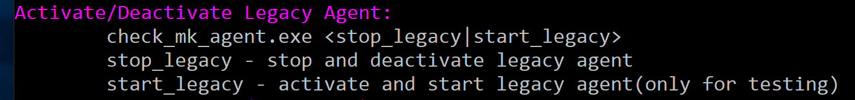
- All other commands can be used without special limitations

Command: reload_config
This command requests from running Windows Agent executable as service and running executable as application to reload all configuration files and to restart or stop asynchronous plugins(according to the configuration files).
Usage
check_mk_agent.exe reload_config
Important:
- Normally Windows Agent loads configuration files only on start
- Typical use case:
  - Start windows agent
  - Edit configuration files
  - Reload configuration
  - Estimate results
- Typical output
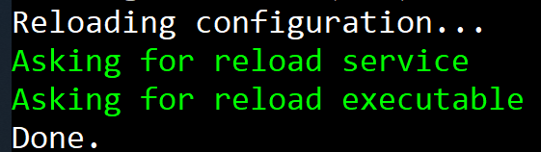
- This command asks to reload two entities
  - Windows Agent service, if presented and running as service
  - Windows Agent service, if presented and running as application(with command exec or adhoc)
- The command is safe enough to use it daily under condition, that configuration file has no errors
It is recommended before reload_config to check Windows Agent config using
check_mk_agent.exe test

Command: remove_legacy
This command uninstalls The Legacy Windows Agent.
Usage
check_mk_agent.exe remove_legacy
Important:
- Upon installation the Windows Agent doesn’t uninstall Legacy windows. This had been done intentionally to prevent occasional losing of important data. You have to use this command to remove the Legacy Windows Agent form the computer
- The operation may be really long (up to one minute).
- Typical output
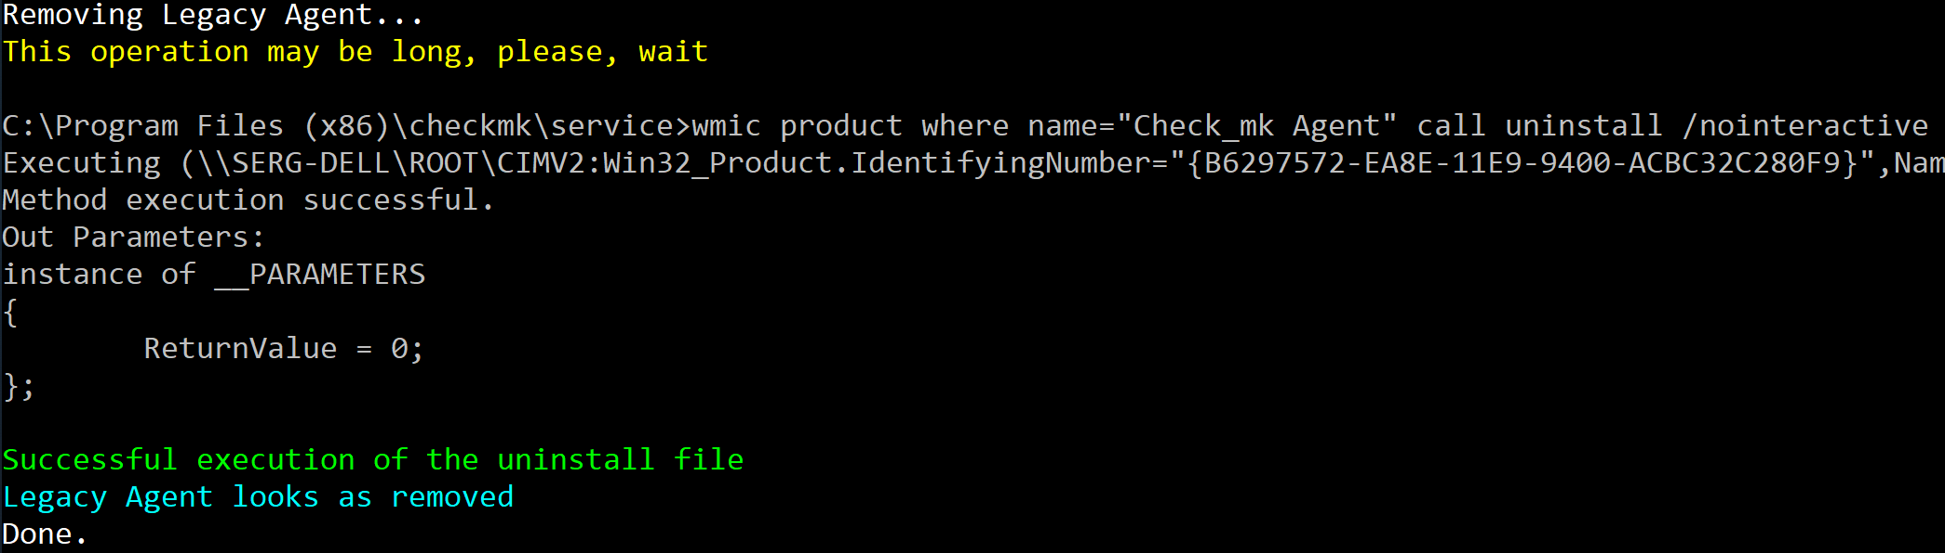
- The command is safe under condition that you have no important data in the Windows Legacy folder

Command: check
This command executes strictly internal checks of the Windows Agent.
Usage
check_mk_agent.exe check <-mt|-io|-self>
Where
-mt – check multithreading
-mt – check internal transport
-mt – check main loop
Important:
- Normally this command used to check integrity of the Windows Agent and is not very useful for normal usage

Command: exec or adhoc
This command (adhoc is just another name for exec) starts Windows Agent Executable as Windows application.
Usage
check_mk_agent.exe exec | adhoc [-show|-showall]
Where
-show – send logging output to stdio
-showall – send detailed logging output on stdio
Important:
- The application supports full functionality of Windows Agent service with next exception:
  - The application runs from the account of the current user(service runs normally NT Local Authority)
  - The working folder is %ProgramFiles(x386)%, service has %windir%\system32
- You may run more than one instance of the application but this has no sense, because port is reused and for internal communication both application will use the same id
- It is not recommended to run application and service simultaneously because of
  - Potential port conflict
  - Potential conflict of asynchronous plugins
- Typical output with logging
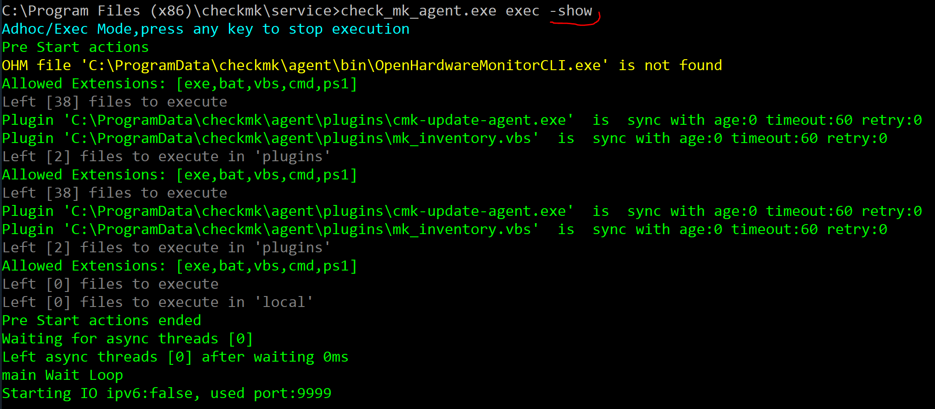
- The color coding is quite simple:
  - red color – error
  - yellow – warning
  - green – success
  - gray – trace information
- To minimize output call check_mk_agent with one parameter:
check_mk_agent.exe exec

Command: rt

This command shows every one second real time output of The Windows Agent.
Usage
check_mk_agent.exe rt
Important:
- To start testing you must press any key. To stop testing you have to press any key again
- Except additional CPU load the command is safe
- May be used to check how well work WMI
- Current version always displays three section:
  - mem
  - df
  - winperf_processor
Command: showconfig

This command displays current configuration of the Windows Agent stored in configuration files.
Usage
check_mk_agent.exe showconfig [section name]
where
section name – is the name of any section

Important:
- Output from the command is text in YML format and may be investigated with any YML software or online Parser
- There are all internal environment variables used during plugin start and names of all used YML configuration files. On the screenshot below you can see top of the Agent’s output
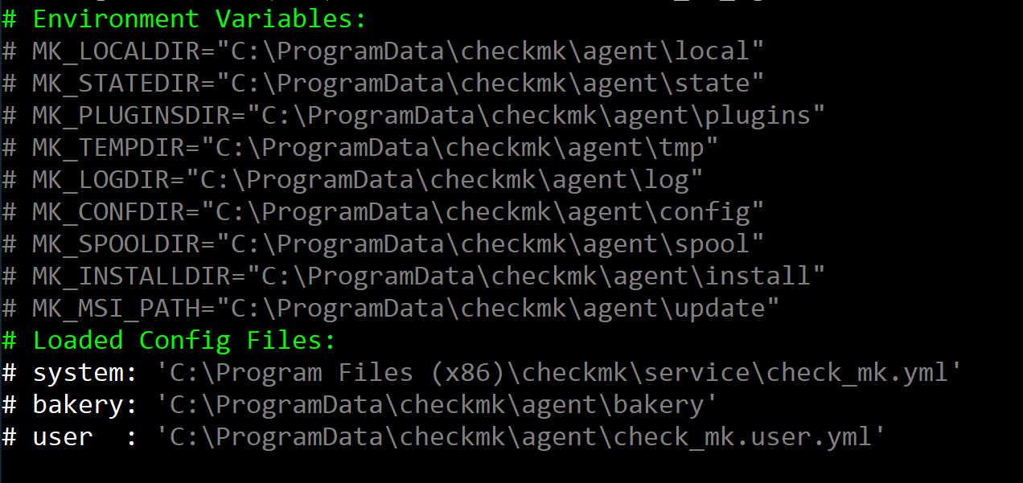
- The configuration used by currently running Windows Agent may differ from one obtained with showconfig command. The Windows Agent loads the configuration on the start, and command showconfig shows configuration, based on the current content of the configuration files
- Optional section name allows to limit configuration data to one section, for example, ps:
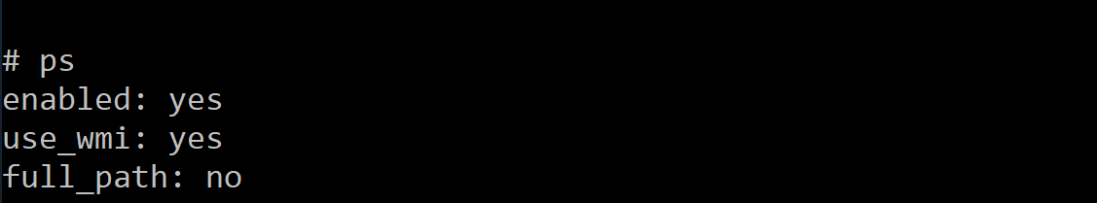
- Showconfig command displays not only configuration data, saved in the corresponding files, but also default configuration data stored in the Windows Agent executable.

Command: convert

This command converts a Legacy Agent’s INI-configuration file into the New Window Agent’s YML-configuration file.
Usage
check_mk_agent.exe convert [-show] <inifile> [ymlfile]
Where
-show – optional parameter to provide more log output on the screen, has effect only when ymlfile is supplied
inifile – mandatory filename of the INI-file
ymlfile – optional filename of the YML-file
Important:
- If ymlfile is not supplied, then Agents sends converted data on stdio
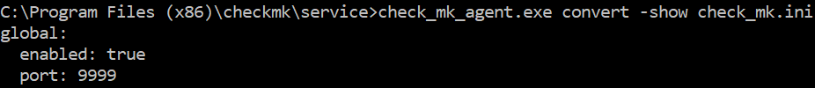
- If supplied -show and ymlfile, then output should look like:
- The command is safe and may be used to find problems with converting complicated INI-files.

Commands: start_legacy and stop_legacy
This command is used to control the Legacy Windows Agent.
Usage
check_mk_agent.exe start_legacy
check_mk_agent.exe stop_legacy
Important:
- The commands have effect only when the Legacy Agent is installed. If the Legacy Agent is absent nothing happens.
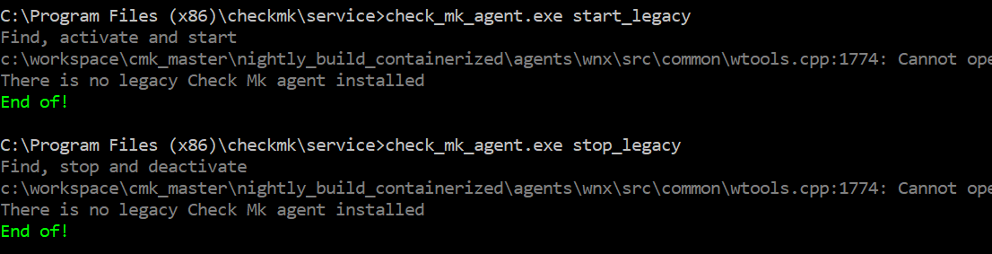
- If the Legacy Agent is disabled(deactivated) and this is normal situation after installation New Agent over Legacy one, then Legacy Agent will be enabled(activated) by start_legacy. It could be a problem for the running Windows Agent service, especially when the port is the same.
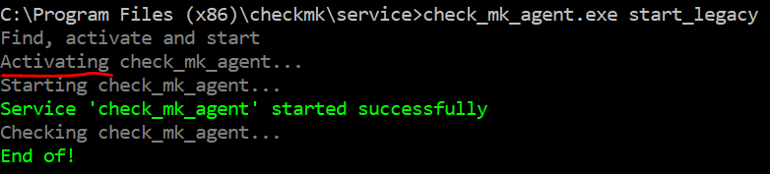
- stop_legacy disables(deactivates) the Legacy Agent, thus this command is much safer for the system with installed New Windows Agent. Also, this command stop Open Hardware Monitor
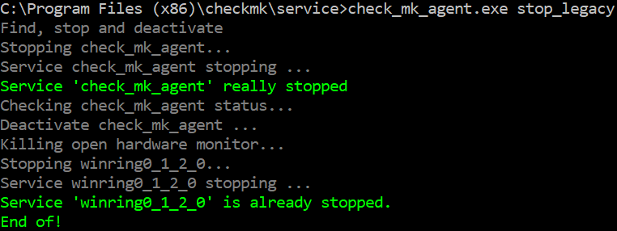
- After the command stop_legacy net start check_mk_agent doesn’t work, because the Legacy Agent is disabled
- Typical use case for the command is comparison of the output from Legacy Agent with output of the New Agent
- This command is recommended only for experienced users

Command: upgrade

This command upgrades(migrates) configuration of the Legacy Agent to the New Agent.
Usage
check_mk_agent.exe upgrade [-force]
where
-force – configuration should migrate in any case
Important:
- Functionality
  - the Legacy Agent is stooped and disabled(decativated)
  - all plugins, local plugins and mrpe scripts are copied to the new Agent
  - cmk-update-agent files are corrected
  - all files in folder config, spool and root of the Legacy Agent are copied too. Th exceptions are check_mk.ini and the agent executable.
  - Both INI files are OPTIONALLY converted to the corresponding YML files
- Normally the command without optional parameter -force should have no effect
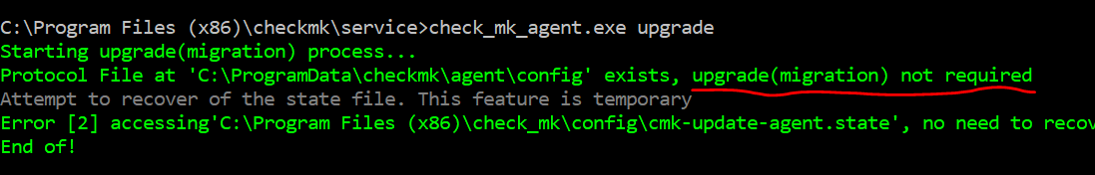
This situation is absolute normal, because the New Agent performs upgrade automatically during installation
- To upgrade forcefully, please, use -force parameter
- If both agent, Legacy and New are managed by WATO, then the new Agent SKIPS converting WATO generated INI to bakery YML. This is quite important and described in log output: 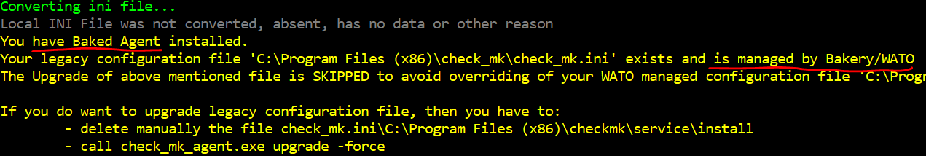
- The command is relatively safe
- Typical use case:
  - Install packaged New Agent
  - Install baked Legacy Agent
  - Upgrade to test configuration of the baked Legacy Agent
Commands: cap and restore
Those commands install/reinstall provided by MSI installer files into %ProgramData%\checkmk\agent
Usage
check_mk_agent.exe cap
check_mk_agent.exe restore
Where
cap – installs provided INI and CAP
restore – uninstall installed INI and CAP and install provided INI and CAP
Important:
- Installation of the New Windows Agent consists from the two steps
  - Windows Installer installs all in %ProgramFiles(x86)%\checkmk\service
  - New Agent installs some files in %ProgramData%\checkmk\agent\install. The list of the installed file
    - %ProgramFiles(x86)%\checkmk\service\install\plugins.cap
    - %ProgramFiles(x86)%\checkmk\service\install\check_mk.ini
    - %ProgramFiles(x86)%\checkmk\service\install\checkmk.dat
- The command cap executes 2-nd step
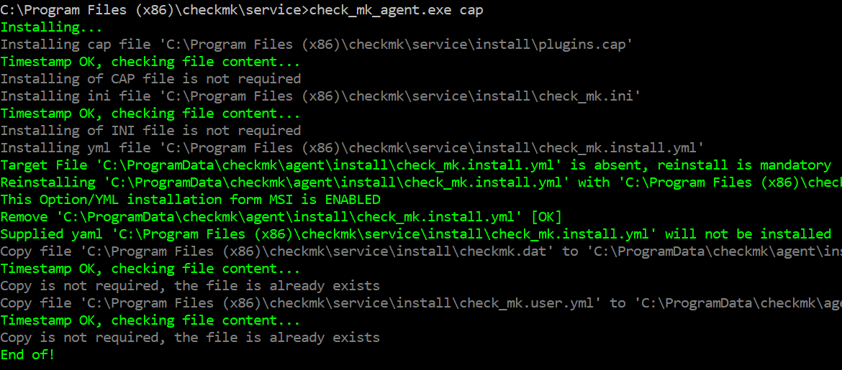
- The command restore undo 2-nd step( if it is possible) – this is de-facto uninstall and executes 2-nd step again
- The command are safe under condition you do not change something in the bakery YML configuration file and do not edit plugin files from CAP file in plugins, local or mrpe folders.
Command: section

This command displays output of the Windows agent as if only named section have been activated.
Usage
check_mk_agent.exe section <section name> [seconds [-show]]
where
section name – is the name of any section
seconds – timeout between screen update
-show – detailed log output

Important:
- The command output example for section df:
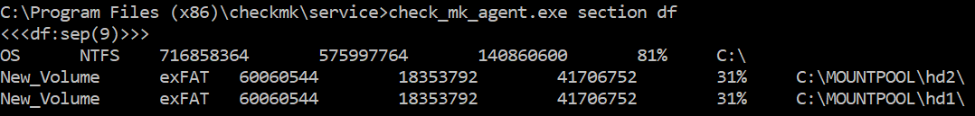
- If parameter seconds is provided, then agent will display output from the section every second infinite long
- If sub-parameter -show is provided, then agent will display output from the section every second infinite long and display also detailed logging output
- If for output asynchronous plugins are required, then functionality may be limited

Commands: install and remove

Those commands install or remove Windows Agent executable as Windows Service
Usage
check_mk_agent.exe install
check_mk_agent.exe remove

where
install – this executable is installed as Windows Service
remove – this executable is removed from the list of the Windows Services
Important:
- Those commands are intended only for experienced users. Do not use it if you are not sure.

Other

Windows Agent executable can be called from the any working directory. For example:
cd c:\
%ProgramFiles(x386)%\checkmk\service\check_mk_ageng.exe reload_config
The Windows Agent finds correct executable and correct configuration file.

Configuration of agent will be changed, asynchronous plugins will be restarted
Will remove legacy windows agent from the PC
Could interfere with already running agent service
Legacy agent may interferer with running Windows Agent Service
May stop Legacy Agent, therefore preventing sending data from the host to monitoring site

