Rowy, Chedrick F. ART APPRECIATION

BSIT-2J Assignment #1

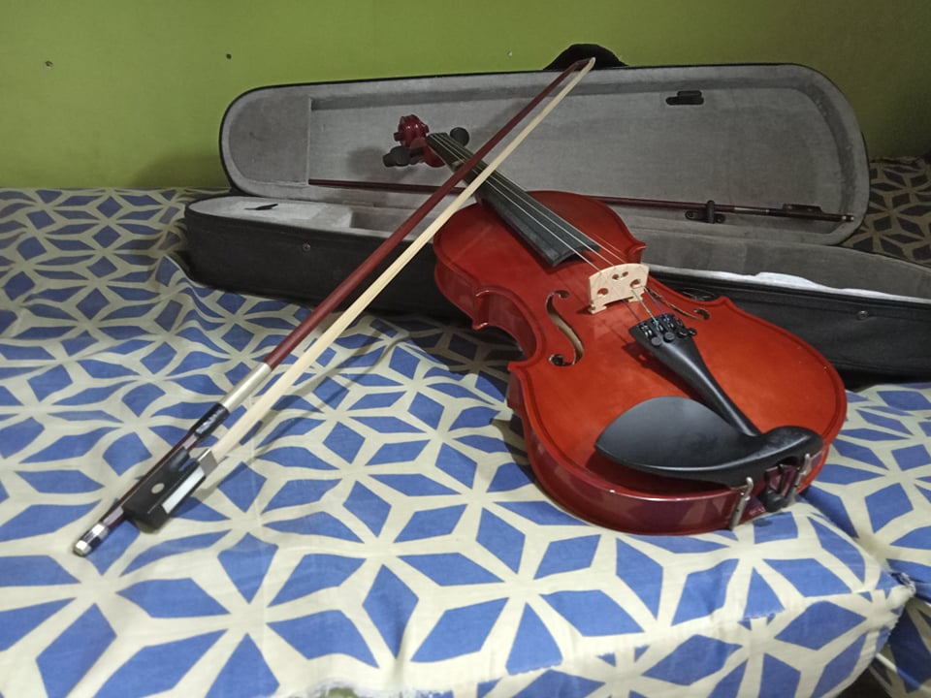

*This violin is made by “Baldwin Violins”. One of the instruments that I used to learn.*

**Violin**

This violin is made by “Baldwin Violins”. One of the instruments that I used to learn.

As for the history of the violin, the earliest two violin makers are from **Northern Italy** are **Andre Amati from Cremona and Gasparo di Bertolotti from Salon (Gasparo di Salon).** With these two violin makers, the history of the violin emerges from the fog of legend to hard fact. Violins produced by these two still exist today. In fact, the oldest violin in existence today is one built by **Andre Amati around 1565**.

Violin is one of the most popular music instruments in the world and it also part of the string category. Violins are also being played mostly on concerts and party even to this modern day.