WEEK 6: SYSTEM PROTOTYPE PRESENTATION

I. INTENDED LEARNING OUTCOME (ILO)
At the end of this laboratory activity, students should be able to:
Present and demonstrate the Alpha Version of the system to stakeholders, effectively communicate system functionalities, gather and analyze stakeholder feedback, and formulate an enhancement plan for system improvement prior to testing and deployment.

II. PERFORMANCE TASK
The Alpha Version of your capstone project has been completed and integrated. Before proceeding to formal testing and deployment activities, the system must undergo stakeholder evaluation.
Each group shall conduct a Prototype Presentation where stakeholders, advisers, and invited evaluators will assess the functionality, usability, and completeness of the system. Feedback gathered during this activity shall serve as the basis for system enhancement and refinement.

III. WEEK 6 ACTIVITIES
Activity 1 – Prototype Presentation Preparation
Activity 2 – Prototype Demonstration
Activity 3 – Stakeholder Evaluation
Activity 4 – Feedback Consolidation
Activity 5 – Minutes of Meeting Preparation
Activity 6 – Enhancement Planning
Activity 7 – Adviser Validation

ACTIVITY 1
PROTOTYPE PRESENTATION PREPARATION

Purpose
To organize the presentation, assign roles, and ensure readiness for stakeholder demonstration.
Procedure
- Review presentation slides prepared during Week 5.
- Assign presentation responsibilities.
- Rehearse system demonstration.
- Verify Alpha Version functionality.
- Complete Form 1.

FORM 1
PROTOTYPE PRESENTATION PREPARATION CHECKLIST

Directions
Check all items completed before presentation.
Requirement | Status
Presentation Slides Completed | ☑
System Prototype Functional | ☑
Demonstration Flow Prepared | ☑
Team Roles Assigned | ☑
Backup Files Prepared | ☑
Internet Connection Verified (if applicable) | N/A
Equipment Tested | ☑

Team Presentation Roles
Team Member | Assigned Role
Ched Nikko P. Pangilinan | Presenter
Naph Yvan P. Villamar | System Demonstrator
Joshkirby Tyler M. Bote | Documentation Officer

Readiness Notes
• Slides follow the manuscript: project context and statement of the problem (Ch. I), system architecture and security architecture (Ch. IV), then the live demonstration.
• Alpha Version verified with php bin/console doctor (PHP extensions, cryptographic keys, database, pending migrations, registered terminals and the realtime server) and with the automated suites: 44 passed, 0 failed.
• Demonstration flow rehearsed end to end: teacher fingerprint opens the session, student RFID taps record against it, dashboard updates live, report is generated and exported.
• Backup files prepared: encrypted database backup (php bin/console backup), the seeded demonstration database, and the compiled firmware for both terminals.
• Both classroom terminals bench-tested: ESP32-WROOM-32 with MFRC522 (SPI) and AS608 (UART 57600), onboard LED accept/refuse patterns confirmed.
• The system runs entirely on the school LAN, so the demonstration does not depend on an internet connection (internet connection marked N/A above); a local Wi-Fi router is carried as part of the kit.

Prepared by:
Ched Nikko P. Pangilinan
Group Leader

ACTIVITY 2
PROTOTYPE DEMONSTRATION

Purpose
To present the Alpha Version and demonstrate its features and workflows.

Procedure
- Introduce the project.
- Present the problem addressed by the system.
- Discuss system objectives and scope.
- Demonstrate major functionalities.
- Explain implemented modules and workflows.
- Conduct a question-and-answer session.
- Complete Form 2.

FORM 2
PROTOTYPE PRESENTATION RECORD

Directions
Document the details of the prototype presentation.

Project Title: L-SIAMS: A Local IoT-Based Multi-Layer Secured Attendance Monitoring System with RFID and Biometric Authentication

Date: September 17, 2026

Venue: Centrum Laboratory 3

Duration: 1 hour and 15 minutes

Presentation Coverage

Item Presented | Presented
Project Overview | ☑
Objectives | ☑
System Architecture | ☑
Database Design | ☑
User Interfaces | ☑
Core Functionalities | ☑
Reports and Outputs | ☑
Security Features | ☑

What each item covered
• Project Overview TAPS records attendance at a single gate terminal, which notifies parents but never validates classroom presence; 20–30 students queue at peak and teachers still spend 5–10 minutes of a 40-minute period on roll call.
• Objectives the general objective and the five specific objective groups (IoT hardware, locally hosted application, security mechanisms, evaluation and validation, penetration testing).
• System Architecture the six layers: Device, Network, Transport, Application, Database and Monitoring.
• Database Design relational schema in MariaDB; users, teachers, sections, students, attendance, devices, audit log and security log, with the invariants enforced by UNIQUE keys in the schema rather than by application checks.
• User Interfaces sign-in, administrator dashboard, teacher portal, student and section management, terminal registry, fingerprint enrolment, reports.
• Core Functionalities fingerprint-opened attendance sessions, RFID tap-in and tap-out, server-side status resolution, live monitoring.
• Reports and Outputs 16 report types exported to PDF, Excel and CSV, all generated without any third-party library.
• Security Features the six-step device request validation sequence (Manuscript Table 8), the 33 recorded security event types (Table 9), and the STRIDE mapping (Table 10).
Demonstrated Functionalities
Functionality | Demonstrated
Login and Authentication | ☑
Data Entry | ☑
Data Processing | ☑
Data Retrieval | ☑
Reporting | ☑

How each functionality was demonstrated
• Login and Authentication bcrypt cost 12, 12-character minimum password policy, account lockout after repeated failures, and the teacher fingerprint that opens an attendance session; the password failover was shown deliberately and the resulting BIOMETRIC_OVERRIDE_USED security event displayed.
• Data Entry a student RFID tap on the classroom terminal, plus administrative entry of students, sections, schedules and terminals.
• Data Processing the server, not the terminal, decides whether a tap is a time-in, a time-out or a rejection, from session state, schedule window and the terminal's configured role.
• Data Retrieval live attendance feed over WebSocket with Server-Sent Events and long polling as automatic fallbacks, and sequence-numbered replay after a reconnect.
• Reporting a daily attendance report and a section summary generated and exported during the session.
• Offline tolerance was shown by disconnecting the terminal mid-session: taps were held in the ESP32 RTC memory and replayed with their original timestamps on reconnection, marked synced_offline, with no duplicate rows
.
Presented by:
Ched Nikko P. Pangilinan (Presenter)
Naph Yvan P. Villamar (System Demonstrator)
Joshkirby Tyler M. Bote (Documentation Officer)

ACTIVITY 3
STAKEHOLDER EVALUATION

Purpose
To collect stakeholder feedback regarding system functionality, usability, and readiness.

Procedure
- Distribute evaluation forms.
- Allow stakeholders to observe and interact with the system.
- Collect completed forms.
- Consolidate evaluation results.
- Complete Form 3.

FORM 3
STAKEHOLDER EVALUATION FORM

Directions for Evaluators
Please evaluate the prototype using the scale below.

Rating | Description
5 | Excellent
4 | Very Good
3 | Good
2 | Fair
1 | Needs Improvement

Evaluation Criteria
Criteria | Rating
System Functionality
User Interface Design
Ease of Use
System Responsiveness
Completeness of Features
Relevance to Organizational Needs

Strengths of the System

Recommendations for Improvement

Evaluator Name: Garymar Carlo Cabrera
Position: IT/Computer Teacher

Signature: _________________
ACTIVITY 4
FEEDBACK CONSOLIDATION
Purpose
To summarize all stakeholder recommendations.

Procedure
- Review all evaluation forms.
- Categorize recommendations.
- Identify recurring concerns.
- Prioritize improvements.
- Complete Form 4.

FORM 4
FEEDBACK CONSOLIDATION MATRIX

Directions
Record all recommendations and corresponding actions.

Recommendation | Category | Priority | Proposed Action
Taps held on a terminal are lost if the classroom loses power before the link returns (40 taps in ESP32 RTC memory, which survives a reset but not a power cut) | Functionality | High | Evaluate a flash-backed queue (NVS/LittleFS) in place of RTC memory, or a small UPS per terminal; if deferred, state the residual risk explicitly in the user manual
Use of the teacher password failover instead of the fingerprint is recorded but not visible at a glance | Security | High | Surface a BIOMETRIC_OVERRIDE_USED counter on the administrator dashboard so the frequency is noticed without opening the security log
The terminal has no display, so a student cannot read why a tap was refused | UI | Medium | Onboard LED accept/refuse patterns are implemented (2 blinks accept, 5 blinks refuse, 160 ms); evaluate a small OLED for the deployment build
It was not obvious on the reports screen which filters had actually been applied to a generated report | UI | Medium | Completed before the presentation (September 8, 2026): filter state made explicit on both the administrator and teacher report tabs, and the Status column in previews coloured to match the dashboards
Operating an internal certificate authority requires certificate renewal and root distribution to terminals | Security | Medium | Document the renewal procedure in docs/HTTPS.md; reissuing the server certificate preserves the existing root so terminals need not be reflashed
Only two classroom terminals were constructed, which bounds the evaluation to two rooms | Functionality | Low | No technical action; recorded as a scope constraint in Chapter I and Chapter III, with rooms sequenced if wider coverage is requested

Summary of Findings
Major Strengths:

Major Areas for Improvement:

ACTIVITY 5
MINUTES OF MEETING PREPARATION

Purpose
To formally document discussions, comments, and agreements made during the prototype presentation.

Procedure
- Record all stakeholder comments.
- Record questions raised.
- Record agreed enhancement actions.
- Complete Form 5.

FORM 5
MINUTES OF MEETING

Project Title: L-SIAMS: A Local IoT-Based Multi-Layer Secured Attendance Monitoring System with RFID and Biometric Authentication

Date: September 17, 2026

Venue: Centrum Laboratory 3

Participants:

Ched Nikko P. Pangilinan (Presenter)
Naph Yvan P. Villamar (System Demonstrator)
Joshkirby Tyler M. Bote (Documentation Officer)
Project Adviser: Dr. Romero Dante C. Salum
Agency representative: Mr. Garymar Carlo Cabrera (IT/Computer Teacher)

Agenda
Prototype Presentation and Evaluation
1. Presentation of the project context, statement of the problem and objectives
2. Demonstration of the Alpha Version in the two-terminal classroom configuration
3. Stakeholder evaluation using Form 3 (ISO/IEC 25010 criteria, five-point Likert scale)
4. Open forum and question-and-answer
5. Consolidation of recommendations and agreement on enhancement priorities

Discussion Highlights

Stakeholder Recommendations

Agreed Action Items
Action Item | Responsible Person | Target Date
1. Consolidate all returned Form 3 evaluations and compute the mean per criterion | Joshkirby Tyler M. Bote | September 19, 2026
2. Finalise the Feedback Consolidation Matrix (Form 4) and the System Enhancement Plan (Form 6) | Ched Nikko P. Pangilinan | September 20, 2026
3. Implement the high-priority enhancements and re-run the automated test suites | Naph Yvan P. Villamar | Week 7
4. Submit the complete Week 6 documentation for adviser validation (Form 7) | Ched Nikko P. Pangilinan | Week 7, Day 1

Prepared by:
Joshkirby Tyler M. Bote
Documentation Officer

Verified by:
____________________________
Stakeholder Representative

ACTIVITY 6
ENHANCEMENT PLAN DEVELOPMENT

Purpose
To create a formal action plan for implementing stakeholder recommendations.

Procedure
- Review the Feedback Consolidation Matrix.
- Identify required revisions.
- Prioritize enhancements.
- Assign responsibilities.
- Complete Form 6.
FORM 6
SYSTEM ENHANCEMENT PLAN

Directions
Develop an action plan based on stakeholder recommendations.
Enhancement Required | Priority | Assigned Member | Target Completion
Persist the offline tap queue across a power loss, or document the residual risk in the user manual and the deployment checklist | High | Naph Yvan P. Villamar | Week 7
Expose biometric-override usage on the administrator dashboard so password failover is visible without opening the security log | High | Ched Nikko P. Pangilinan | Week 7
Complete unit and integration testing across all modules and resolve every defect rated High before User Acceptance Testing | High | Naph Yvan P. Villamar / Ched Nikko P. Pangilinan | Week 7
Make applied report filters explicit and colour the Status column in previews to match the dashboards | Medium | Ched Nikko P. Pangilinan | Completed – September 8, 2026
Prepare the user manual, installation guide and updated technical documentation for deployment | Medium | Joshkirby Tyler M. Bote | Week 8
Verify both classroom terminals under sustained load and confirm LED accept/refuse feedback in the actual rooms | Medium | Naph Yvan P. Villamar | Week 8
Incorporate the stakeholder recommendations returned on Form 3 that are not yet listed above |  |  | Week 7

Expected Outcomes
1. Every enhancement rated High is implemented, re-tested and committed to the project repository before User Acceptance Testing begins in Week 8.
2. The Alpha Version advances to an Enhanced Prototype whose unit and integration test results are documented in full, with no unresolved defect rated High.
3. Stakeholder recommendations are traceable end to end from the Form 3 evaluation, through the Feedback Consolidation Matrix, to a specific commit in the repository.
4. The system meets the acceptance thresholds set in the manuscript (§3.8): perceived quality grand mean ≥ 3.40, response time under 2 seconds, attendance accuracy ≥ 95%, authentication success ≥ 95%, data synchronisation success ≥ 95%, and no high-risk vulnerability.
5. The project team enters Week 8 able to conduct System Testing and User Acceptance Testing at TAPS without further development work outstanding.

Prepared by:
Ched Nikko P. Pangilinan
Project Leader

ACTIVITY 7
ADVISER VALIDATION

Purpose
To validate the results of the prototype presentation and approve enhancement activities.

Procedure
- Submit all prototype presentation documents.
- Present stakeholder feedback summary.
- Present enhancement plan.
- Obtain adviser approval.
- Complete Form 7.

FORM 7
ADVISER VALIDATION RECORD

Evaluation Areas
Area | Status
Prototype Presentation Conducted
Stakeholder Evaluation Completed
Minutes of Meeting Completed
Enhancement Plan Prepared
Readiness for Week 7 Enhancement Activities

Adviser Recommendations

Required Actions

Adviser Signature: Dr. Romero Dante C. Salum ____________________________
Date: September _, 2026

IV. REQUIRED WEEK 6 SUBMISSION
- Form 1 – Prototype Presentation Preparation Checklist
- Form 2 – Prototype Presentation Record
- Form 3 – Completed Stakeholder Evaluation Forms
- Form 4 – Feedback Consolidation Matrix
- Form 5 – Minutes of Meeting
- Form 6 – System Enhancement Plan
- Form 7 – Adviser Validation Record
- Prototype Presentation Slides
- Presentation Photos/Screenshots
- Attendance Sheet of Stakeholders

V. WEEK 6 DELIVERABLES
✓ Prototype Presentation
✓ Stakeholder Evaluation Forms
✓ Minutes of Meeting
✓ Enhancement Plan
✓ Feedback Consolidation Report

These outputs provide evidence that the Alpha Version has undergone stakeholder review and that the project team has identified specific enhancements required before proceeding to system refinement, testing, and deployment activities.

SUPPORTING EVIDENCE

Prototype Presentation Slides

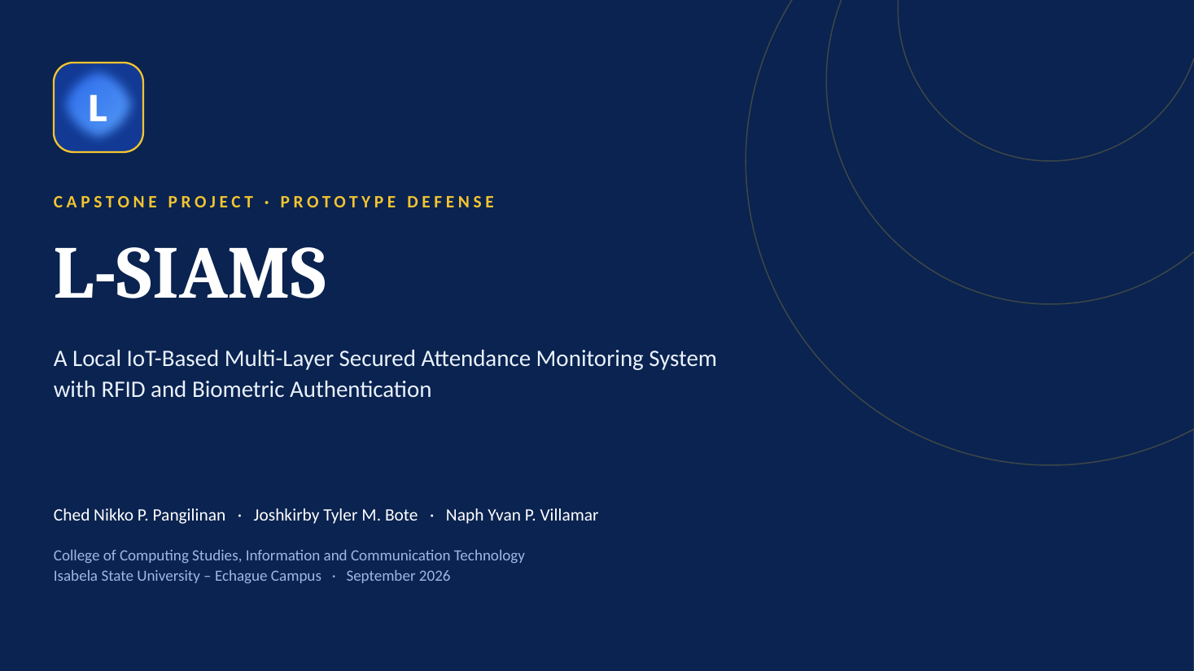
Figure 1. Slide 1, Title slide
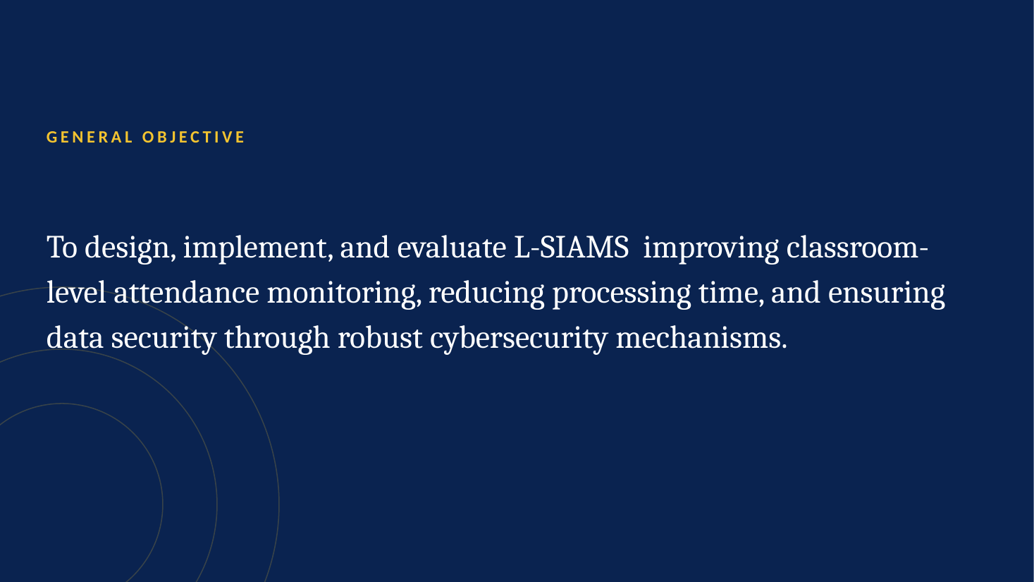
Figure 2. Slide 2, General Objective
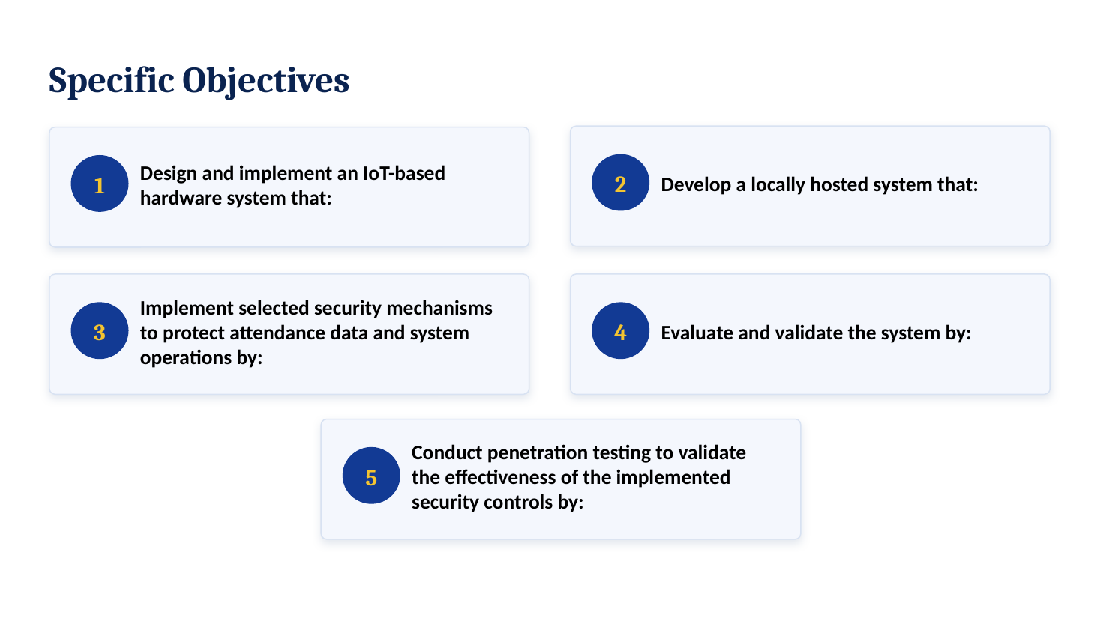
Figure 3. Slide 3, Specific Objectives
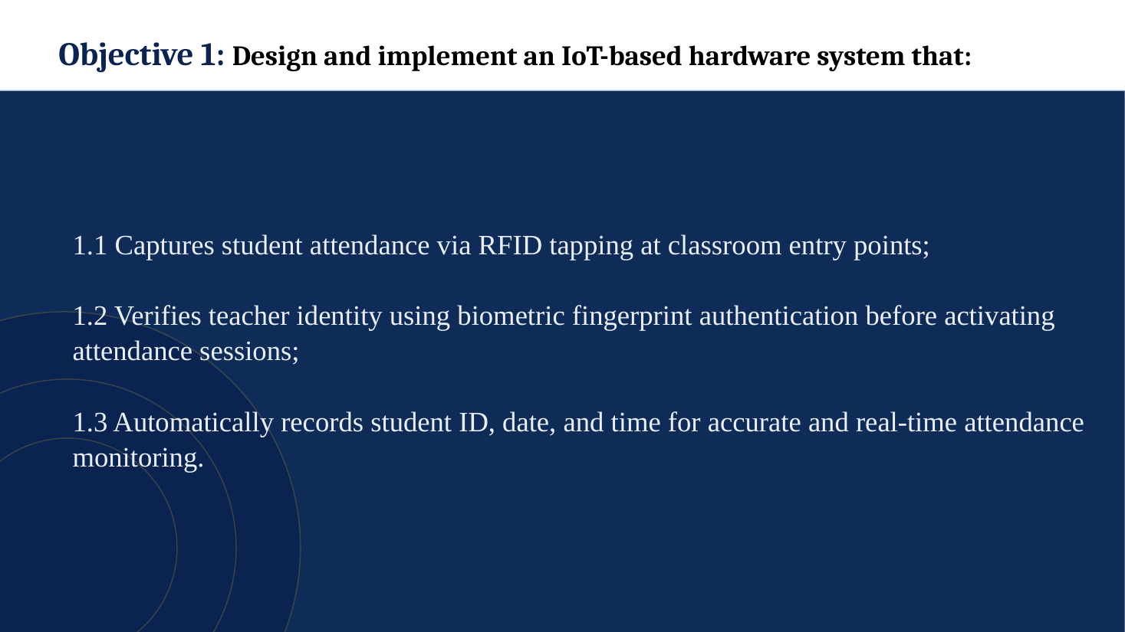
Figure 4. Slide 4, Objective 1: IoT-based hardware system
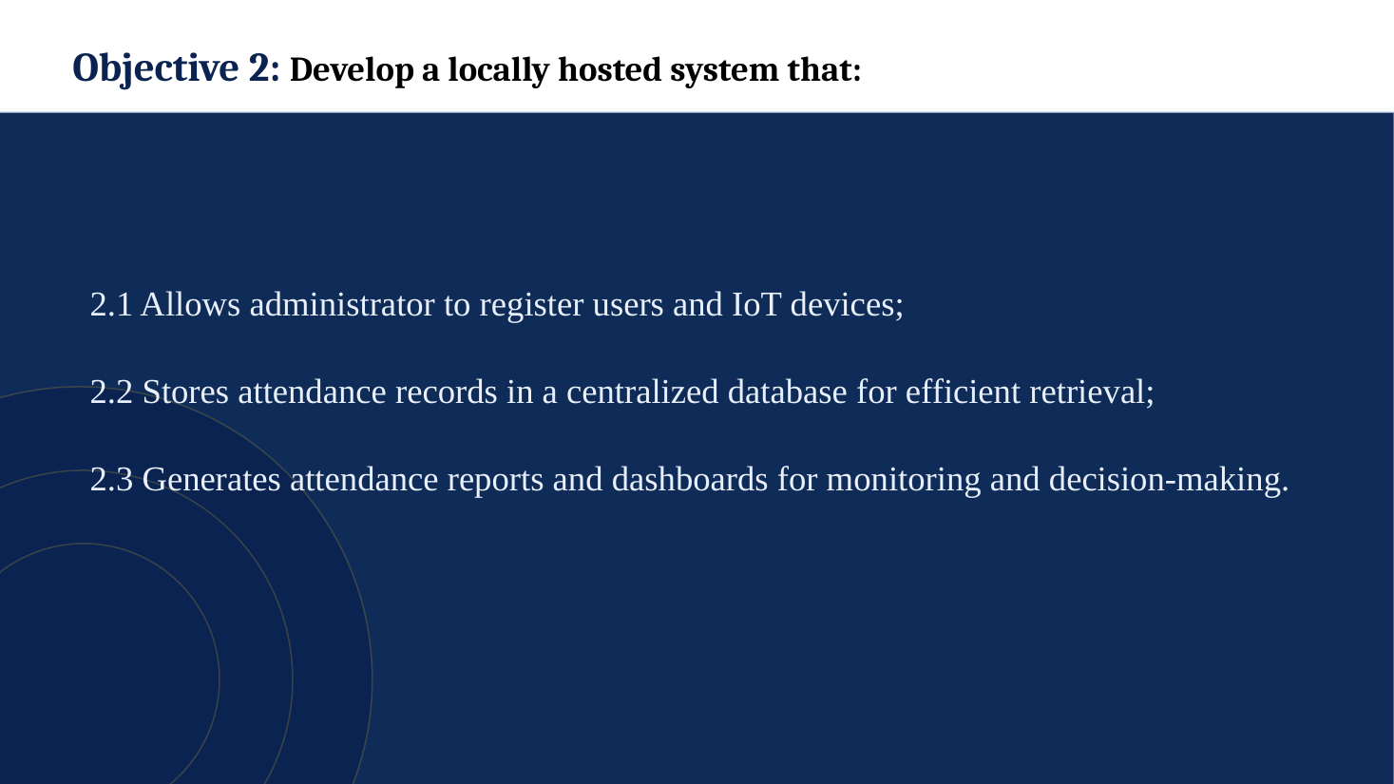
Figure 5. Slide 5, Objective 2: Locally hosted system
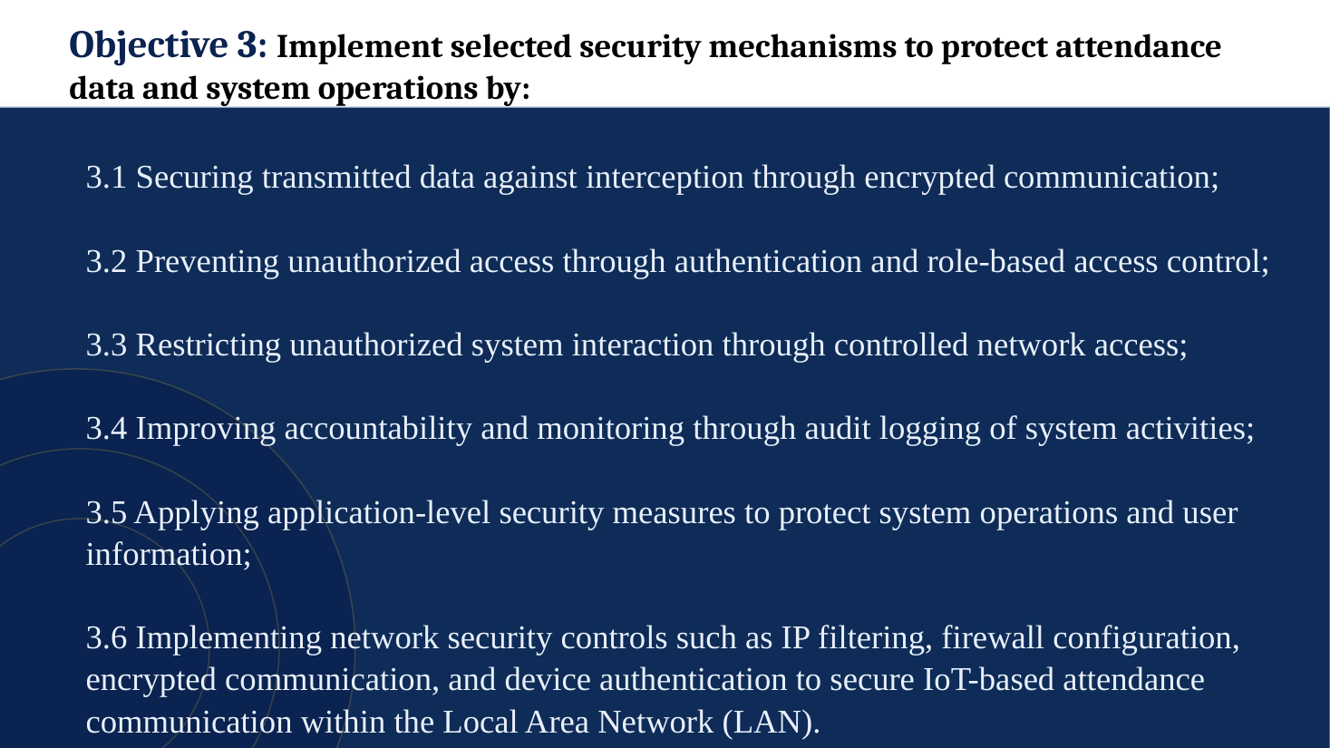
Figure 6. Slide 6, Objective 3: Security mechanisms
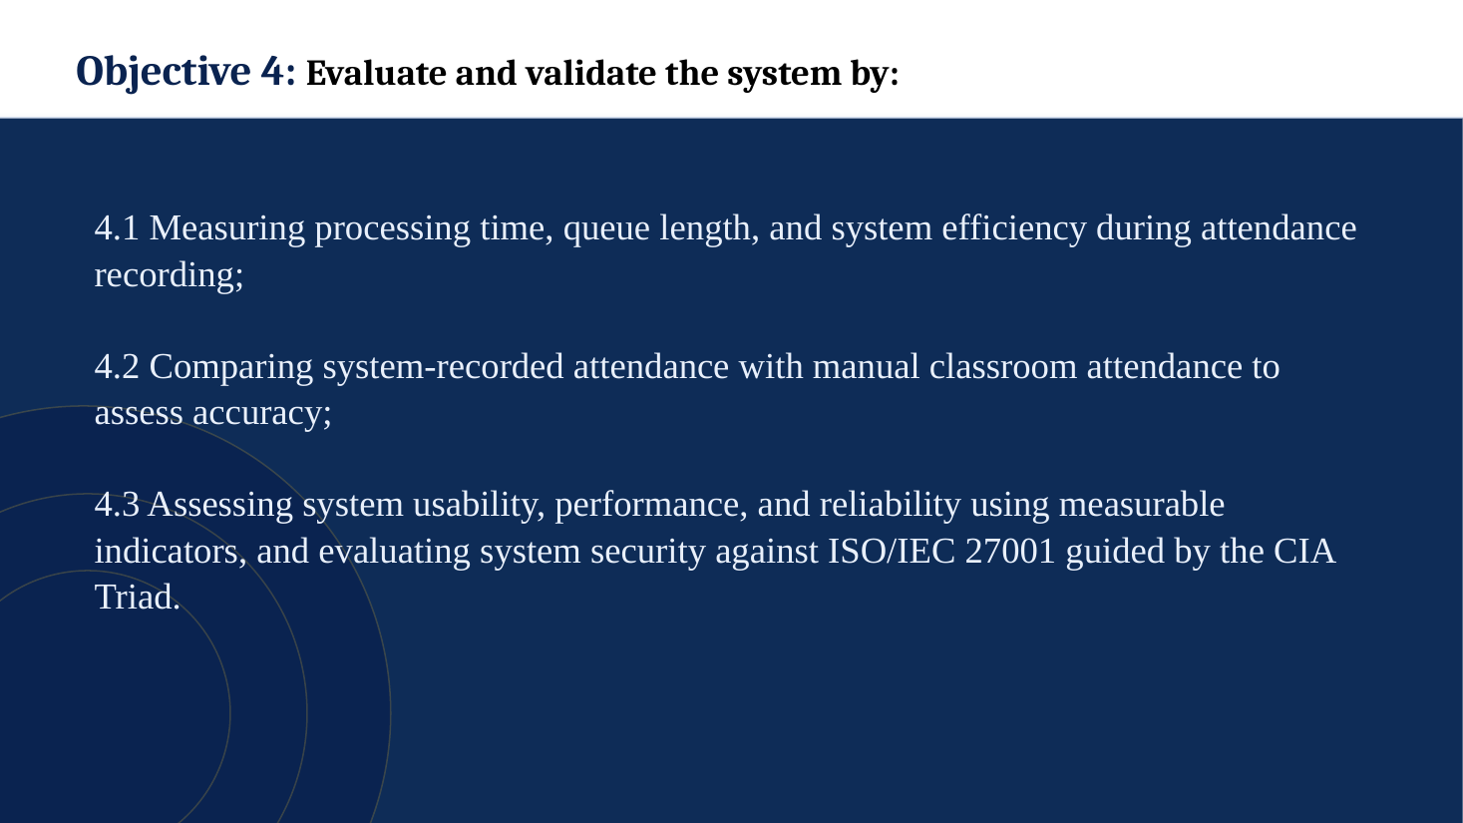
Figure 7. Slide 7, Objective 4: Evaluation and validation
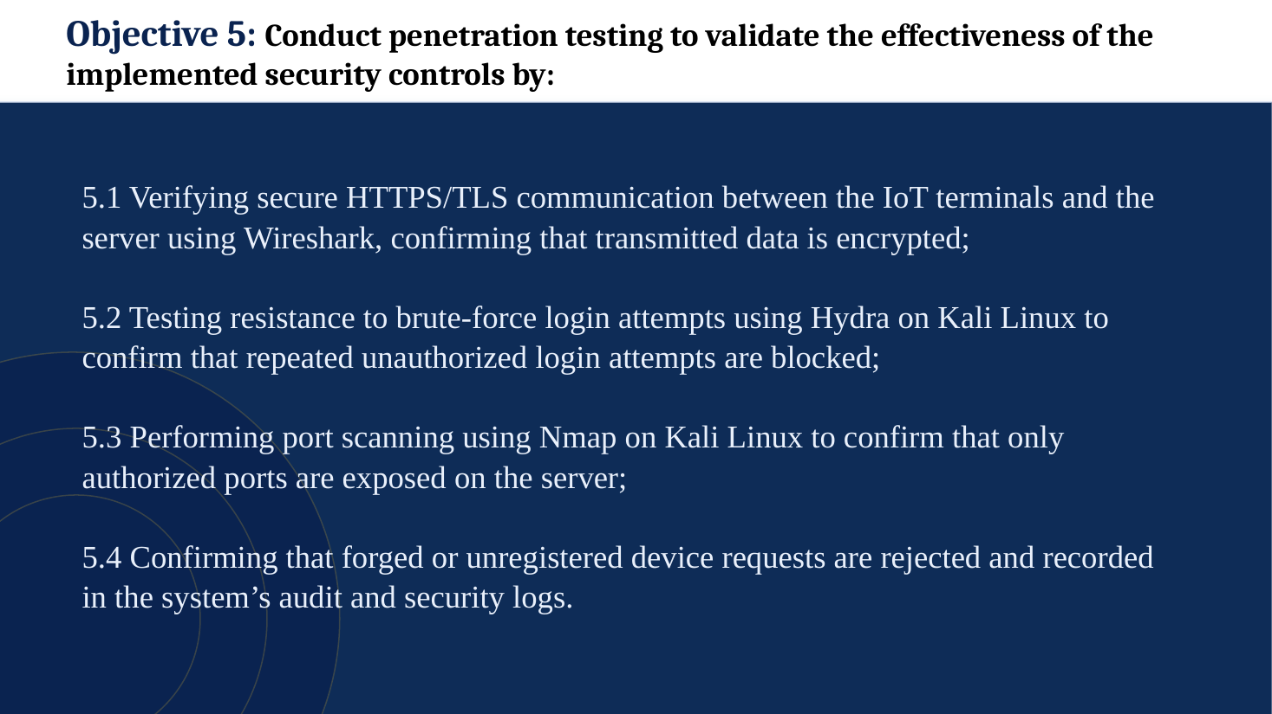
Figure 8. Slide 8, Objective 5: Penetration testing
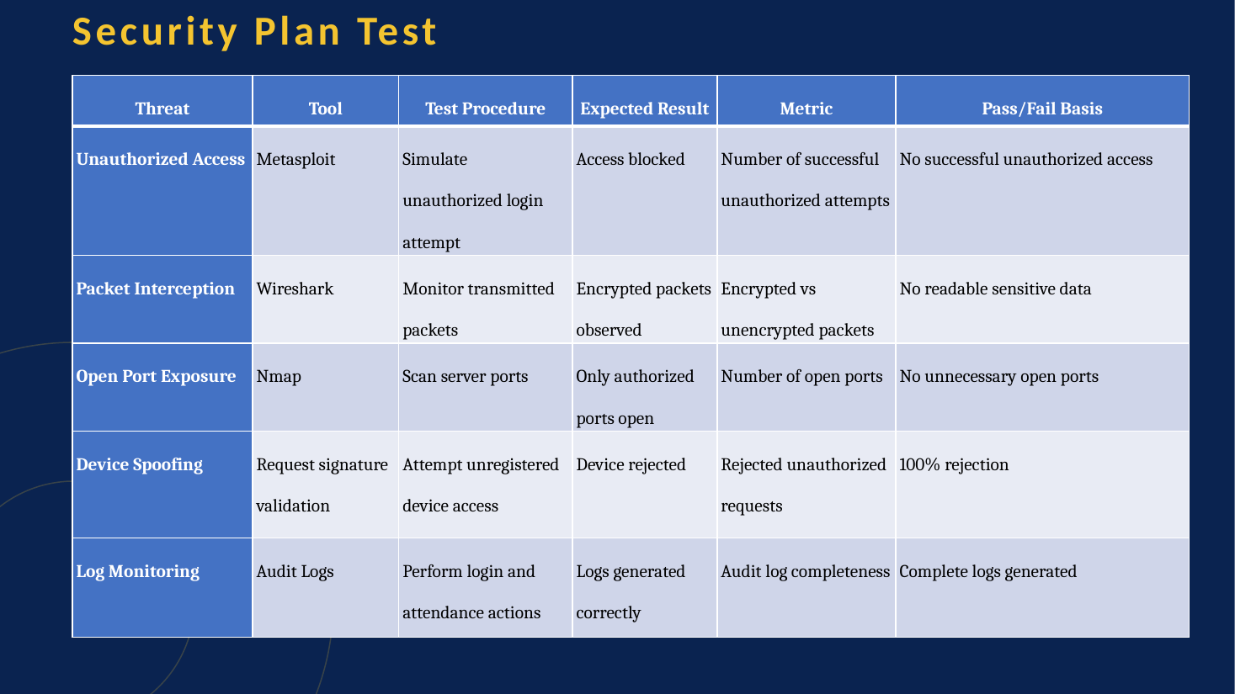
Figure 9. Slide 9, Security Plan Test
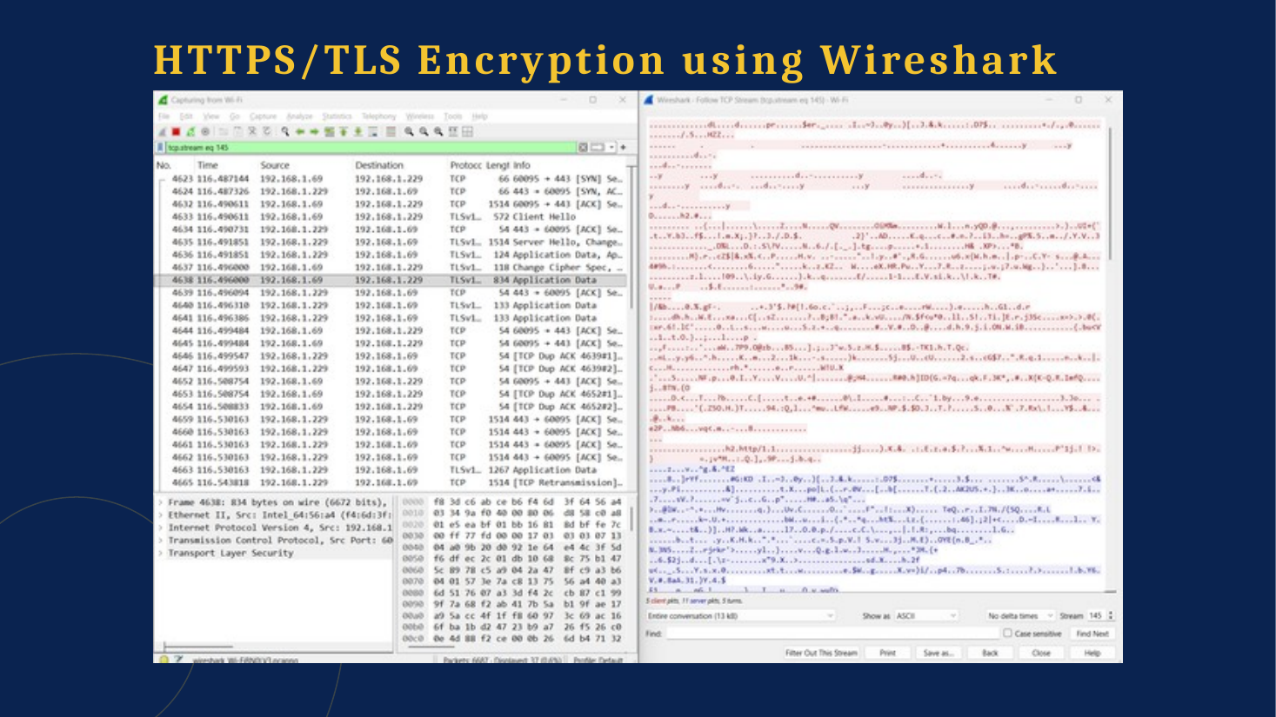
Figure 10. Slide 10, HTTPS/TLS Encryption using Wireshark
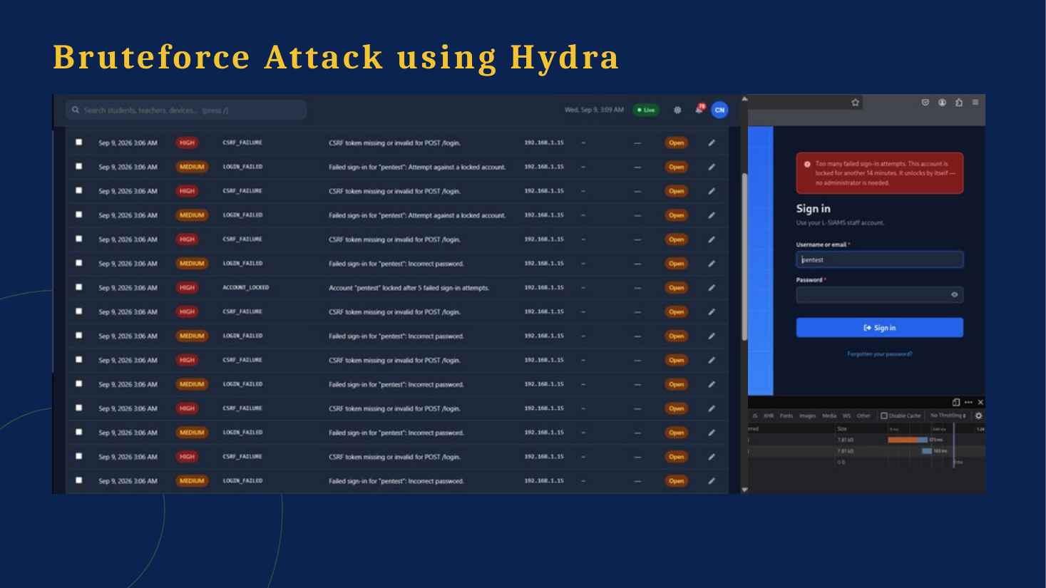
Figure 11. Slide 11, Bruteforce Attack using Hydra
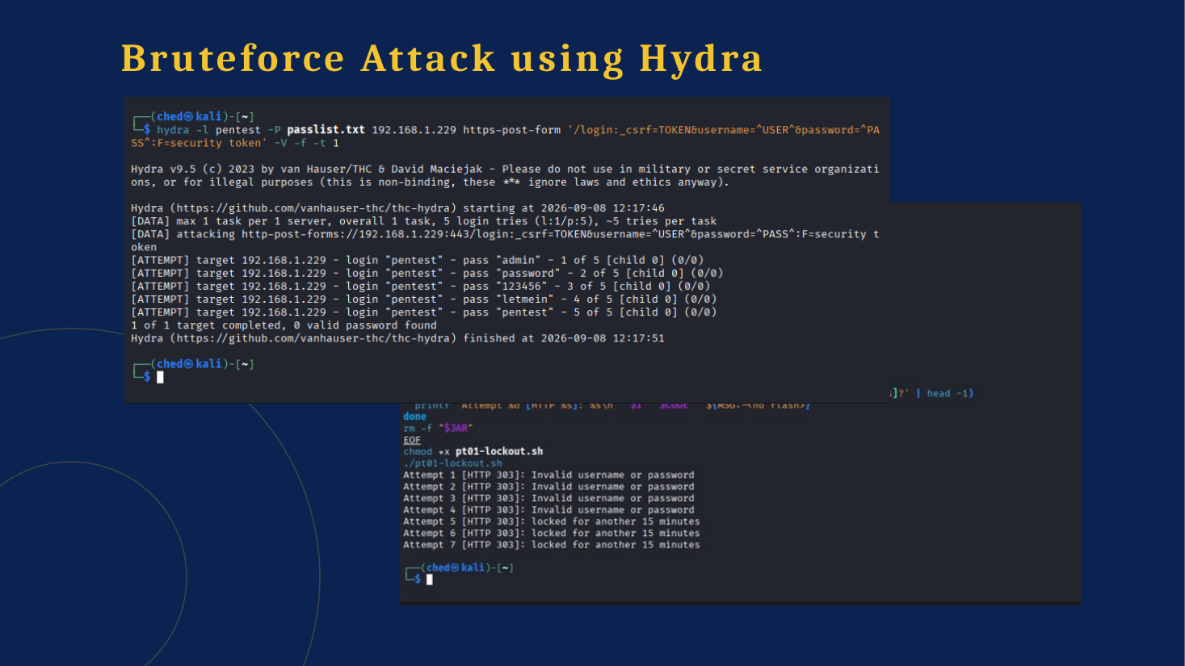
Figure 12. Slide 12, Bruteforce Attack using Hydra (lockout)
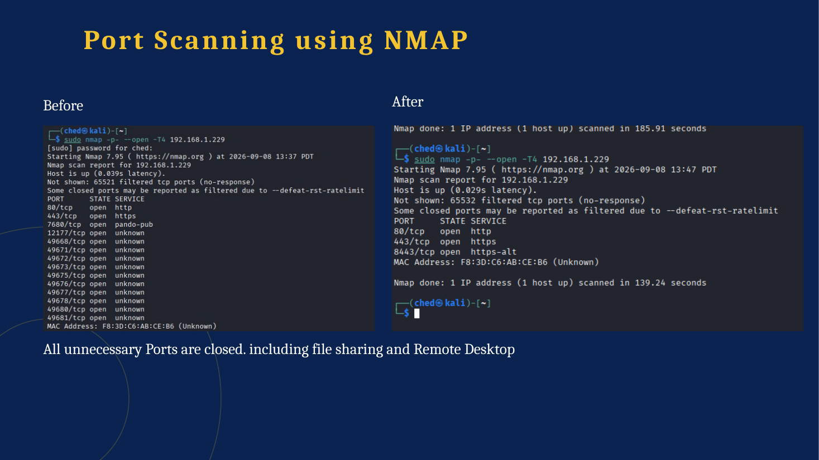
Figure 13. Slide 13, Port Scanning using NMAP
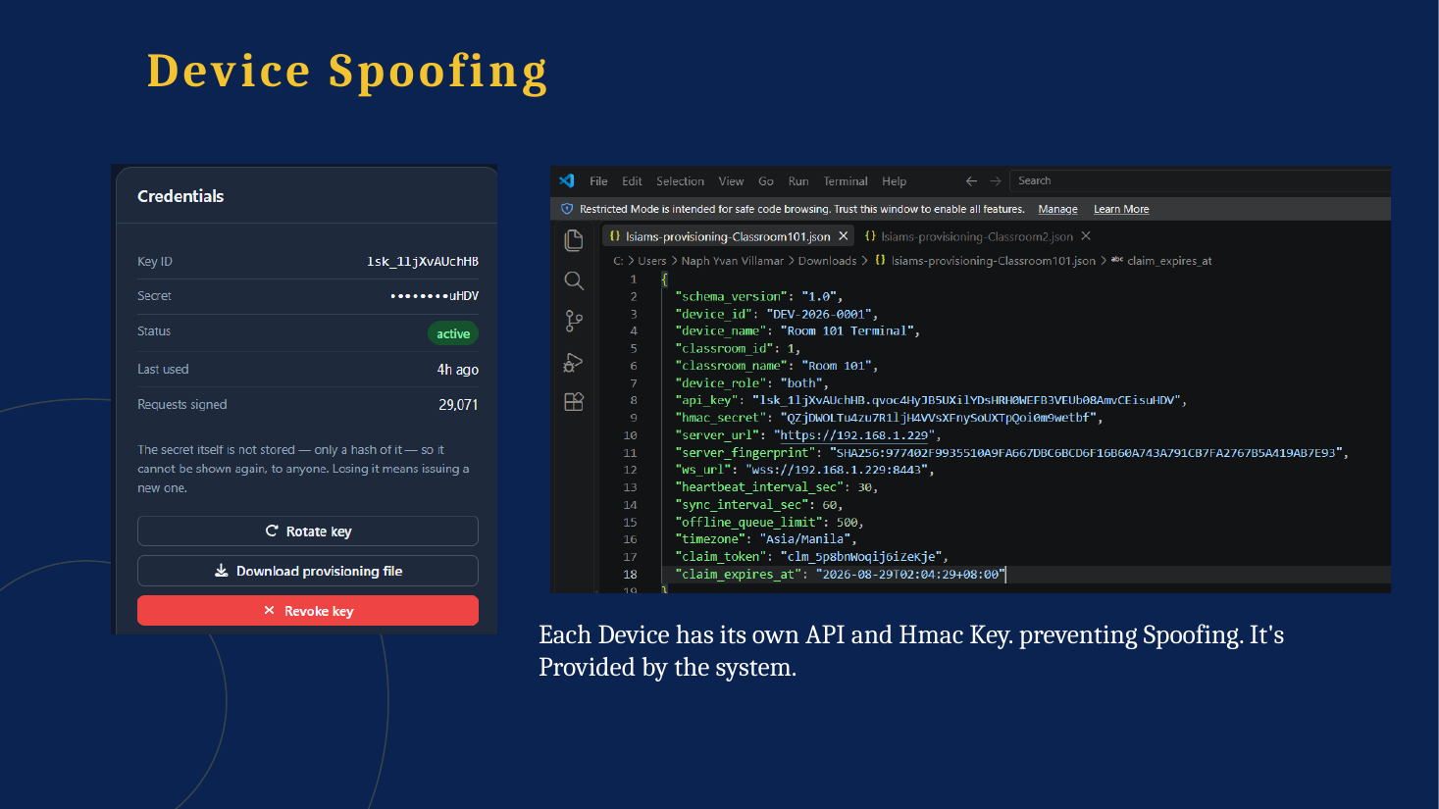
Figure 14. Slide 14, Device Spoofing
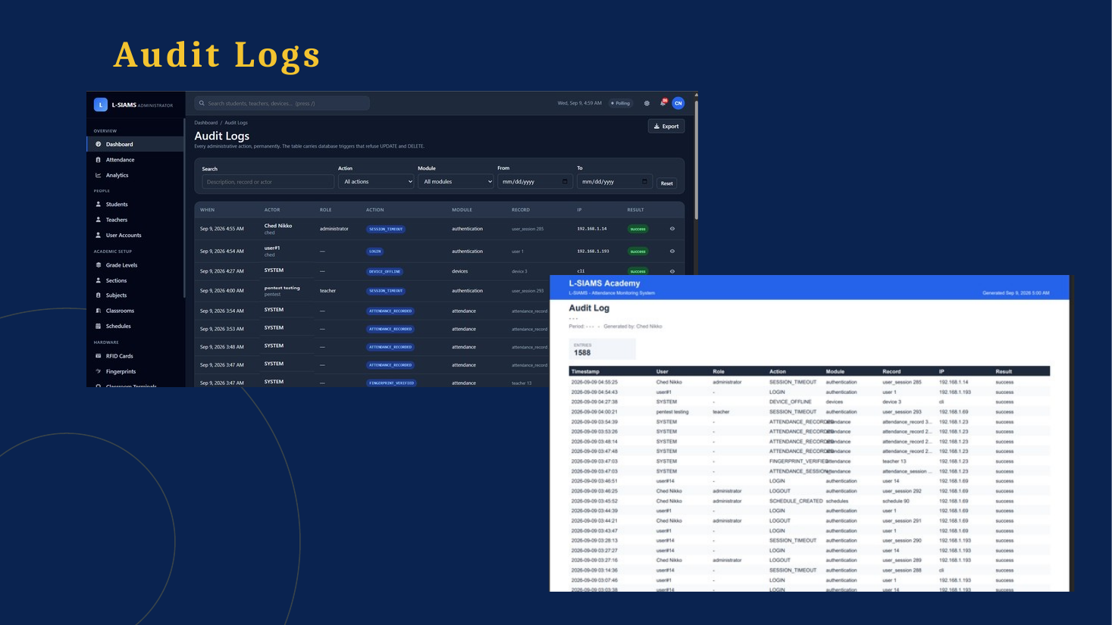
Figure 15. Slide 15, Audit Logs

