L-SIAMS: A Local IoT-Based Multi-Layer Secured Attendance Monitoring System with RFID and Biometric Authentication

A Manuscript Presented to the Faculty of the College of Computing Studies, Information and Communication Technology
Isabela State University – Echague Campus

In Partial Fulfilment of the Requirements for the Degree
Bachelor of Science in Information Technology

By:
Ched Nikko P. Pangilinan
Joshkirby Tyler M. Bote
Naph Yvan P. Villamar

September 2026

ABSTRACT
Classroom attendance at Top Achievers Private School Inc. (TAPS) was recorded through a manual roll call that consumed class time, while the school’s single radio-frequency identification (RFID) gate caused queues of 20 to 30 students and did not verify who opened each attendance record. This project aimed to design, implement and evaluate L-SIAMS, a locally hosted Internet of Things (IoT) attendance monitoring system that records student attendance by RFID at the classroom door, verifies the teacher’s fingerprint before an attendance session opens, and protects attendance data with multiple layers of security. The system was developed through an iterative system development life cycle using ESP32 terminals with MFRC522 RFID readers and AS608 fingerprint sensors, and a web application with an SQLite database running on the school’s local area network. It was deployed in two Grade 6 classrooms on October 12–15, 2026, and evaluated through the system logs, comparison with the manual roll call, penetration testing with Wireshark, Hydra and Nmap, a security evaluation questionnaire guided by ISO/IEC 27001 and the confidentiality, integrity and availability (CIA) triad, and user acceptance testing, involving 64 respondents. Across 19 class sessions, the system recorded attendance at 4.10 seconds per student, compared with 7.79 seconds for a stopwatch-timed manual roll call (47.4 percent faster), and needed no tapping or roll call in the following periods, in which attendance was carried over (100 percent faster); all 562 system records matched the manual roll call. All 18 fingerprint sign-ins by enrolled teachers were verified, the measured response time was 11.7 milliseconds, and every penetration test scenario was blocked and logged, with no high or critical vulnerability found. The staff rated the security controls 4.61 and user acceptance 4.86, both interpreted as Very High. Based on these findings, L-SIAMS addressed the attendance and security requirements of the partner school and was found acceptable to its intended users within the two-classroom scope of the October 12–15, 2026 deployment.
Keywords: RFID attendance monitoring, biometric authentication, Internet of Things, ISO/IEC 27001, CIA triad

TABLE OF CONTENTS
LIST OF TABLES 6
LIST OF FIGURES 7
LIST OF NOTATIONS 9
CHAPTER I: INTRODUCTION 11
1.1 Project Context 11
1.1.1 Background of the Study 13
1.1.2 Statement of the Problem 15
1.2 Objectives of the Project 16
1.3 Scope and Limitations 18
1.4 Significance of the Study 20
CHAPTER II: REVIEW OF RELATED LITERATURE AND STUDIES 22
2.1 Introduction 22
2.2 Review of Related Literature 22
2.3 Review of Related Studies 27
2.4 Synthesis of the Reviewed Literature and Studies 30
CHAPTER III: RESEARCH METHODOLOGY 32
3.1 Research Design 32
3.2 System Development Method 34
3.2.1 Requirement Analysis 35
3.2.2 System Design 38
3.2.3 System Development 40
3.2.4 System Testing 40
3.3 Participants/Respondents 43
3.4 Data Gathering Instruments 45
3.5 Evaluation Procedure 50
3.6 Experimental Design 51
3.7 Data Analysis Techniques 53
3.8 System Evaluation Criteria 54
3.9 Ethical Considerations 56
CHAPTER IV: TECHNICAL BACKGROUND 58
4.1 Introduction 58
4.2 System Architecture Overview 59
4.3 IoT Device Architecture 62
4.4 Network Architecture 65
4.5 Application Architecture 67
4.6 Database Design 68
4.7 Data Flow Diagram 71
4.8 Security Architecture 73
4.9 Threat Model and Security Considerations 81
4.10 Security Testing Approach 82
4.11 System Design Considerations 83
4.12 System Limitations 83
4.13 Prototype Implementation and System Interface 85
4.13.1 Hardware Prototype 85
4.13.2 Authentication and Access Control 86
4.13.3 Penetration Testing Results 97
CHAPTER V: RESULTS AND DISCUSSION 106
5.1 Results of Requirements Analysis 106
5.2 Results of System Design 107
5.3 Results of System Development 108
5.4 Testing Results 108
5.5 Evaluation Results 112
5.6 Agency Immersion and Deployment Results 119
Discussion 124
CHAPTER VI: SUMMARY OF FINDINGS, CONCLUSION AND RECOMMENDATIONS 125
6.1 Summary of Findings 125
6.2 Conclusion 127
6.3 Recommendations 129
REFERENCES 131
APPENDICES 133

LIST OF TABLES
Table 1 Comparison of Related Systems and L-SIAMS 29
Table 2 Security Plan Test 42
Table 3 Respondents and Their Role in the Evaluation 44
Table 4 Likert Scale Interpretation 46
Table 5 Instrument–Metric Mapping 48
Table 6 SOP–Objectives–Metrics–Instrument Mapping 49
Table 7 Interpretation of Mean Scores 54
Table 8 System Evaluation Criteria 55
Table 9 Device Request Validation Sequence 74
Table 10 Security Event Types Recorded by the System 78
Table 11 Threat, Description and Mitigation 81
Table 12 CVSS Score Interpretation 83
Table 13 Requirements and Implemented Features 106
Table 14 Module Development Status 108
Table 15 Penetration Testing Results 109
Table 16 Security Events Recorded During Attendance Recording (October 13–14, 2026) 109
Table 17 Teacher Identity Verification 111
Table 18 Recording Time in the Queue Sessions 112
Table 19 Comparison of the Manual Roll Call and L-SIAMS 113
Table 20 Attendance Records and Accuracy (19 Class Sessions) 115
Table 21 Profile of Respondents 116
Table 22 Security Evaluation by CIA Dimension 117
Table 23 Part D Technical Control Checklist 118
Table 24 User Acceptance Test Results 120
Table G1 Development Test Suites 151
Table G2 Recording Time of All Deployment Sessions 151
Table G3 Outcome of RFID Taps (All Sessions, October 13–14, 2026) 152

LIST OF FIGURES
Figure 1 Methodological Flow of the Study 34
Figure 2 Iterative System Development Life Cycle Diagram 35
Figure 3 System Design Diagram 39
Figure 4 Experimental Setup and Process Flow Diagram 52
Figure 5 Data Flow Across System Layers 59
Figure 6 System Architecture Diagram 60
Figure 7 IoT Device Diagram 63
Figure 8 Network Architecture 66
Figure 9 Entity Relationship Diagram 69
Figure 10 Data Flow Diagram 71
Figure 11 Security Architecture Diagram 79
Figure 12 Terminal Wiring and Connectivity 86
Figure 13 System Sign-In Screen 87
Figure 14 User Account and Role Management 87
Figure 15 Registered IoT Terminal Registry 88
Figure 16 Terminal Detail and Credential Management 90
Figure 17 Security Event Log 91
Figure 18 Audit Trail 92
Figure 19 Fingerprint Enrolment 93
Figure 20 Administrator Dashboard 94
Figure 21 Teacher Portal Dashboard 95
Figure 22 Student Register 96
Figure 23 Backup and Restore 97
Figure 24 Wireshark Capture of Terminal and Server Traffic 98
Figure 25 Hydra Brute-Force Test Against the Sign-In Page 99
Figure 26 Account Lockout Event in the Security Center 100
Figure 27 Nmap Scan of the L-SIAMS Server 102
Figure 28 Rejected Forged Device Requests 104
Figure 29 Device Authentication Events in the Security Center 104
Figure 30 Security Events Recorded During Deployment 110
Figure 31 Time per Student in the Queue Sessions 113
Figure 32 Time per Student of the Manual Roll Call and L-SIAMS in Periods With Tap-In and in Carried-Over Periods 114
Figure 33 Attendance Records by Type 116
Figure 34 Security Evaluation by CIA Dimension 118
Figure 35 User Acceptance Test Results 121
Figure 36 Orientation of Teachers and IT Administrators (October 12, 2026) 122
Figure 37 Classroom Terminal Deployed at Top Achievers Private School Inc. 123
Figure C1 Sample Student Import Template 137
Figure C2 Sample Terminal Import Template 138
Figure C3 Sample Student Attendance Report 139
Figure E1 Attendance Session Workflow of L-SIAMS 142
Figure F1 Session Opening on the Teacher Dashboard 145
Figure F2 Attendance Session Summary 145
Figure F3 Administrator Dashboard 146
Figure F4 Teacher Dashboard 147
Figure F5 Live Attendance Tapping on a Mobile Browser 148
Figure F6 Security Center 149
Figure F7 Audit Logs 150
Figure H1 Reports Page With Recently Generated Reports 154
Figure H2 Student Attendance Summary Report 155
Figure H3 Exported Attendance Spreadsheet 156
Figure I1 Consultation and Gathering of Data 158
Figure I2 User Orientation and Attendance Sheet 160
Figure I3 Installation of Classroom Terminals 162
Figure I4 Queue at the Classroom Door 163

LIST OF NOTATIONS
α: Cronbach’s alpha, a measure of internal consistency
AES: Advanced Encryption Standard
API: Application Programming Interface
CIA: Confidentiality, Integrity, and Availability
CSV: Comma-Separated Values
CVSS: Common Vulnerability Scoring System
GPS: Global Positioning System
HMAC: Hash-based Message Authentication Code
HTTP: Hypertext Transfer Protocol
HTTPS: Hypertext Transfer Protocol Secure
IoT: Internet of Things
IP: Internet Protocol
ISO/IEC: International Organization for Standardization / International Electrotechnical Commission
IT: Information Technology
LAN: Local Area Network
ms: milliseconds
PDF: Portable Document Format
PHP: PHP: Hypertext Preprocessor, the programming language of the web application
RBAC: Role-Based Access Control
RFID: Radio-Frequency Identification
s: seconds
SD: Standard Deviation
SDLC: System Development Life Cycle
SOP: Statement of the Problem
SPI: Serial Peripheral Interface
STRIDE: Spoofing, Tampering, Repudiation, Information disclosure, Denial of service, and Elevation of privilege
TAPS: Top Achievers Private School Inc.
TLS: Transport Layer Security
UART: Universal Asynchronous Receiver-Transmitter
UAT: User Acceptance Testing

CHAPTER I
INTRODUCTION

1.1 Project Context
Top Achievers Private School Inc. (TAPS) currently uses an RFID-based system installed at the main school entrance. Students tap their RFID cards upon arrival, primarily serving as a notification mechanism for parents to monitor whether their child has entered or left the school premises. However, the system does not record or validate actual classroom attendance.
Based on observation, TAPS accommodates approximately 300–500 students daily, with attendance-related tapping occurring through a single RFID terminal at the gate. During peak hours, an average queue of 20–30 students form at the RFID terminal, resulting in delays and congestion. In some cases, students bypass the RFID terminal to avoid long waiting times, reducing the reliability of attendance monitoring. Inside classrooms, teachers still conduct manual roll calls, consuming approximately 3–5 minutes of the 40-minute class period, depending on the number of students enrolled, while some teachers instead have the students record their attendance on a pen-and-paper attendance sheet. Either method is carried out by every teacher in every subject on a daily basis. The existing system also lacks classroom-level validation and teacher authentication mechanisms.
From a cybersecurity perspective, the current attendance setup lacks sufficient protection mechanisms for attendance data transmitted within the network. The absence of encrypted communication, device authentication, access control, and audit logging increases the risk of unauthorized access, data interception, and possible record tampering, which may compromise the confidentiality, integrity, and reliability of attendance information.
To address these issues, the researchers designed and developed L-SIAMS: A Local IoT-Based Multi-Layer Secured Attendance Monitoring System with RFID and Biometric Authentication. The developed system implements classroom-based RFID attendance recording combined with biometric teacher verification and multi-layer security mechanisms, improving attendance accuracy, reducing processing time, and strengthening the protection of attendance information within a controlled Local Area Network (LAN) environment. The system captures attendance through RFID readers positioned at classroom entry points rather than at the school gate, and uses fingerprint authentication to verify teacher identity before an attendance session can be opened.
Practical constraints were considered throughout development, including the cost of hardware deployment per classroom, maintenance of devices such as RFID readers and fingerprint sensors, network reliability within the LAN, and deployment feasibility in terms of installation and power requirements.
The system uses IoT-based components suitable for classroom attendance monitoring and local network communication. Fingerprint authentication prevents proxy attendance, which cannot be addressed by RFID alone. A LAN-based architecture was adopted to provide faster communication, reduced latency, and improved security by limiting exposure to external networks.
Through this implementation, the study sought to improve attendance accuracy, reduce processing time, minimize congestion, and enhance the security and reliability of attendance data.

1.1.1 Background of the Study
Educational institutions continue to adopt digital systems to improve operational efficiency; however, existing attendance practices still present limitations in accuracy, validation, and security. At present, the RFID system implemented in schools is primarily used as a notification tool to inform parents whether their son or daughter has entered or left the school premises. It does not record or validate actual classroom attendance, resulting in a gap between entry monitoring and real student presence during instructional time.
Existing attendance systems continue to face challenges related to attendance validation, operational efficiency, and data security. Although RFID-based systems improve entry monitoring, many implementations still lack classroom-level verification, teacher authentication, and sufficient protection mechanisms for attendance information.
In addition, existing systems lack essential security mechanisms such as encryption, access control, and audit logging. This creates vulnerabilities in attendance data, allowing potential unauthorized access or modification, which compromises data integrity and accountability.
To address these issues, this study developed L-SIAMS: A Local IoT-Based Multi-Layer Secured Attendance Monitoring System with RFID and Biometric Authentication, which enables automated, classroom-level attendance recording. The system uses RFID technology to capture student attendance at the point of instruction and integrates biometric fingerprint authentication to ensure that only authorized teachers can initiate attendance sessions.
The development of the system involved the design and integration of IoT components using the ESP32 microcontroller within a Local Area Network (LAN) to support real-time data transmission.
The system also implements a fallback mechanism in which attendance data is retained on the terminal during connectivity interruptions and synchronized automatically once the network is restored. Each held record carries the timestamp taken at the moment of the tap together with an idempotency key, so that a replayed or retried transmission cannot produce a duplicate attendance record.
To ensure data security and reliability, the system incorporates multi-layer security mechanisms, including encrypted communication for data protection, role-based access control for user authorization, per-device request authentication, and audit logging for traceability of system activities.
Following development, the system was deployed at the partner school and evaluated for system quality in terms of functionality, usability, and performance, and for security using ISO/IEC 27001, guided by the CIA Triad, in terms of confidentiality, integrity, and availability.
Through this development and evaluation, the study provides a more accurate, efficient, and secure approach to attendance monitoring by addressing the limitations of entry-based systems, reducing time consumption, and ensuring the reliability and integrity of attendance records.

1.1.2 Statement of the Problem
The current attendance monitoring system of Top Achievers Private School Inc. (TAPS) presents several operational and security issues that affect the accuracy, efficiency, and reliability of attendance recording within the school. In general, the study sought to answer the question: How can classroom attendance monitoring at TAPS be made faster, more accurate, and more secure through a locally hosted IoT-based system with RFID and biometric authentication?
Specifically, this study sought to answer the following questions:
1. How can manual classroom attendance checking, which consumes 3–5 minutes per session, be minimized to improve instructional time?
2. How can the system ensure accurate classroom-level attendance recording?
3. How can congestion at the RFID gate, measured by queue length (20–30 students) and waiting time, be reduced?
4. How can teacher identity verification be integrated to ensure secure and authorized attendance recording?
5. How can multi-layer security mechanisms be implemented to protect attendance data and ensure confidentiality, integrity, and availability?
1.2 Objectives of the Project
General Objective
The main goal of this study was to design, implement, and evaluate L-SIAMS: A Local IoT-Based Multi-Layer Secured Attendance Monitoring System with RFID and Biometric Authentication that improves classroom-level attendance monitoring, reduces processing time, and ensures data security through the application of robust cybersecurity mechanisms.

Specific Objectives
1. Design and implement an IoT-based hardware system that:
1.1 Captures student attendance via RFID tapping at classroom entry points;
1.2 Verifies teacher identity using biometric fingerprint authentication before activating attendance sessions;
1.3 Automatically records student ID, date, and time for accurate and real-time attendance monitoring.
2. Develop a locally hosted system that:
2.1 Allows administrators to register users and IoT devices;
2.2 Stores attendance records in a centralized database for efficient retrieval;
2.3 Generates attendance reports and dashboards for monitoring and decision-making.
3. Implement selected security mechanisms to protect attendance data and system operations by:
3.1 Securing transmitted data against interception through encrypted communication;
3.2 Preventing unauthorized access through authentication and role-based access control;
3.3 Restricting unauthorized system interaction through controlled network access;
3.4 Improving accountability and monitoring through audit logging of system activities;
3.5 Applying application-level security measures to protect system operations and user information;
3.6 Implementing network security controls such as IP filtering, firewall configuration, encrypted communication, and device authentication to secure IoT-based attendance communication within the Local Area Network (LAN).
4. Evaluate and validate the system by:
4.1 Measuring processing time, queue length, and system efficiency during attendance recording;
4.2 Comparing system-recorded attendance with manual classroom attendance to assess accuracy;
4.3 Assessing system usability, performance, and reliability using measurable indicators, and evaluating system security against ISO/IEC 27001 guided by the CIA Triad.
5. Conduct penetration testing to validate the effectiveness of the implemented security controls by:
5.1 Verifying secure HTTPS/TLS communication between the IoT terminals and the server using Wireshark, confirming that transmitted data is encrypted;
5.2 Testing resistance to brute-force login attempts using Hydra on Kali Linux to confirm that repeated unauthorized login attempts are blocked;
5.3 Performing port scanning using Nmap on Kali Linux to confirm that only authorized ports are exposed on the server;

1.3 Scope and Limitations
This study focused on the design, development, and implementation of L-SIAMS: A Local IoT-Based Multi-Layer Secured Attendance Monitoring System with RFID and Biometric Authentication. The system records student attendance at the classroom level using RFID technology integrated with IoT devices. It includes biometric fingerprint authentication for teacher verification and a locally hosted web-based platform for managing attendance data.
The study was conducted at TAPS. The system was deployed from October 12 to 15, 2026, in the Grade 6 Gold and Grade 6 Diamond classrooms: the orientation of the users was held on October 12, attendance was recorded during class sessions on October 13–14, and the evaluation and the penetration tests were conducted on October 15, following an earlier penetration test on September 26, 2026. The users of the web application were the teachers, the school administrator, and the IT administrators; the students interacted only with the classroom terminals through their RFID cards. The modules covered were attendance capture, session opening by fingerprint verification, the administration of users and devices, the dashboard and monitoring, reports, and the security functions. The data covered were the student and teacher records, RFID card and fingerprint references, class schedules, attendance records, and the audit and security logs. The system ran on one Windows computer that served as the server within the school’s LAN.
The system implements multi-layer security mechanisms such as encrypted communication, per-device request authentication, Role-Based Access Control (RBAC), network access control, and audit logging. It was evaluated using ISO/IEC 27001 and the CIA Triad.
The system is limited to classroom-based attendance monitoring within TAPS and does not include gate-level tracking, learning management systems, grading systems, facial recognition, GPS tracking, or mobile application integration. Only teachers and administrators have system access.
The system operates within a Local Area Network (LAN) and is not integrated with cloud-based or external systems. As a result, it has no remote access, limited data sharing, and is not scalable across multiple campuses. In cases of network failure, data is retained on the terminal and transmitted once the connection is restored, which may cause delays in real-time monitoring. The system was developed as a prototype comprising two classroom terminals, so the evaluation covered two classrooms and the results may not transfer uniformly to a full deployment in which every room is instrumented. Performance in large-scale deployment, where increased users and devices may affect efficiency, was therefore outside what this evaluation could establish.
Security testing was conducted through controlled procedures, including simulated attack scenarios; however, these did not cover all possible real-world attack variations. The evaluation results were based on a limited number of respondents in two classrooms over two days of attendance recording, which limits their generalizability.
Additionally, the system requires hardware installation per classroom and ongoing maintenance, which may impact cost and long-term deployment.

1.4 Significance of the Study
School Administrators
Provides accurate and real-time classroom attendance data, improving monitoring and decision-making through secure access and audit logging.
Teachers
Reduces attendance recording time by minimizing manual roll calls and ensures a more efficient and authenticated attendance process.
Students
Improves attendance recording by making it faster, more organized, and less time-consuming during class sessions.
IT Administrators
Enhances system management and strengthens network and data security through the implementation of selected security mechanisms that help protect attendance records and sensitive user information from unauthorized access and modification.

Cybersecurity and Future Researchers
Provides a reference for the development of secured IoT-based systems by demonstrating how selected security mechanisms can be applied to protect sensitive attendance data and improve network security within educational environments.

CHAPTER II
REVIEW OF RELATED LITERATURE AND STUDIES

2.1 Introduction
This chapter presents the review of related literature and studies that provide the technological and security foundations for the development of the proposed Multi-Layer Secured IoT-Based Attendance Monitoring System. The discussion is organized using a thematic approach, grouping related concepts into key areas such as IoT-based attendance systems, identification technologies, and multi-layer security mechanisms. Existing literature shows that automated attendance systems help reduce manual work, speed up attendance recording, and improve data accuracy. However, many systems still lack strong security implementation, especially in terms of multi-layer protection and teacher-level validation. These gaps highlight the need for a more secure, accurate, and integrated attendance monitoring system.
2.2 Review of Related Literature
IoT-Based Attendance Systems
The Internet of Things (IoT) refers to a network of interconnected devices that collect, process, and exchange data through communication networks. In educational systems, IoT is used to automate attendance monitoring by allowing devices to record and send attendance data in real time.
IoT-based attendance systems use hardware components such as RFID readers and microcontrollers to capture attendance data and send it to a centralized server. These systems reduce manual attendance checking, shorten recording time, and allow real-time monitoring of student presence in classrooms (Shrivastava et al., 2023).
However, many IoT-based attendance systems focus mainly on functionality and data transmission. Some systems do not include strong security features such as encryption, device authentication, and monitoring. This makes them vulnerable to unauthorized access, data interception, and system misuse. Recent studies explain that IoT systems are exposed to security risks because devices constantly communicate and exchange data over networks (Ferrag et al., 2022; Neshenko et al., 2019).
Identification Technologies in Attendance Systems
Attendance monitoring systems commonly use RFID and biometric authentication technologies to improve attendance accuracy and reduce manual recording. RFID enables fast identification through contactless card scanning, while biometric authentication provides stronger identity verification using unique physiological characteristics such as fingerprints (Shrivastava et al., 2023).
RFID Technology for Student Attendance
RFID (Radio Frequency Identification) is commonly used in attendance systems because it is fast and easy to use. Students are given RFID cards, and attendance is recorded when the card is tapped on a reader. The system records the student's identity along with the date and time.
RFID systems reduce the time needed to record attendance and remove the need for manual roll calls. This allows faster and more efficient attendance tracking inside the classroom.
Although RFID technology improves attendance efficiency, it has limitations in identity verification because RFID cards may be shared or used by unauthorized individuals. This creates risks of proxy attendance and inaccurate attendance records in educational environments (Shrivastava et al., 2023).
Fingerprint-Based Teacher Authentication
Fingerprint authentication uses the unique pattern of a person's fingerprint to verify identity. In attendance systems, it ensures that only authorized individuals can access or activate the system.
Biometric authentication strengthens attendance reliability by ensuring that only registered individuals can access or activate the attendance system. Fingerprint authentication is widely recognized as a secure authentication mechanism because fingerprint patterns are unique and difficult to duplicate (Ahmad et al., 2022).
However, most systems use fingerprint authentication for student attendance only. There are few systems that use fingerprint verification to confirm the presence of the teacher before attendance recording. Without teacher validation, attendance can be recorded even if the teacher is not present.
Applying fingerprint authentication for teacher-level verification improves accountability and ensures that attendance sessions are initiated only by authorized personnel. This additional authentication layer enhances attendance validity and reduces opportunities for unauthorized attendance recording (Ahmad et al., 2022).
Security in IoT-Based Systems
Security is an important part of IoT-based systems because data is sent through networks where it can be accessed or attacked. IoT systems are exposed to risks such as unauthorized access, data interception, and device misuse because devices continuously communicate with each other (Ferrag et al., 2022; Neshenko et al., 2019).
Common security problems include lack of encryption, weak authentication, and no monitoring system. These issues can allow attackers to access, modify, or misuse attendance data. To prevent these risks, modern systems use security mechanisms such as encryption, authentication, access control, and monitoring. These measures help protect data and ensure that the system works correctly and securely (Ferrag et al., 2022).
Multi-Layer Security Frameworks
Multi-layer security, also known as defense-in-depth, uses multiple security mechanisms across different parts of a system. This approach ensures that if one layer fails, other layers still protect the system.
In attendance systems, multi-layer security includes encrypting data during transmission, verifying users and devices, controlling access through roles, and recording system activities through audit logs.
These layers work together to protect attendance data and system operations. Using multiple security layers reduces the chance of system compromise by addressing different types of security risks at different levels (Ferrag et al., 2022).
Network Security in IoT Systems
Network security protects communication between devices and controls which devices are allowed to access the system. In IoT systems, devices constantly exchange data, making them vulnerable if network protection is weak.
Security controls such as IP filtering, firewall configuration, and port restriction are used to limit access to authorized devices only. These controls are important in Local Area Network (LAN) environments.
These mechanisms help prevent unauthorized access, packet interception, and network intrusion in IoT systems (Neshenko et al., 2019). Without network security, attackers may access the system and cause data breaches or disruptions.
A LAN-based deployment also reduces the attack surface of the system by limiting exposure to external internet-based threats compared to cloud-dependent architectures. This approach strengthens internal network control, improves communication speed, and enhances monitoring of connected IoT devices.
Application Security and Data Protection
Application security protects the system from internal threats by ensuring that only valid inputs and authorized users can access system functions. This includes input validation, password hashing, and secure session management. These controls prevent invalid data and unauthorized access.
Audit logging is also important because it records system activities such as login attempts and attendance transactions. These logs help administrators track system usage, detect unusual behaviour, and ensure accountability. These mechanisms ensure that attendance data is not changed, accessed by unauthorized users, or lost during system operation (Ahmad et al., 2022; Whitman & Mattord, 2021).
Security Standards and Evaluation Models
Standard frameworks are used to ensure that the system is reliable and secure. The CIA framework focuses on confidentiality, integrity, and availability, ensuring that data is protected, accurate, and accessible (Whitman & Mattord, 2021).
ISO/IEC 27001 provides guidelines for implementing security controls such as encryption, authentication, access control, and monitoring (International Organization for Standardization, 2022). These frameworks help ensure that the system is secure and performs properly.
2.3 Review of Related Studies
Foreign Related Studies
Studies such as those by Shrivastava et al. (2023) show that IoT-based attendance systems reduce manual work, improve accuracy, and allow real-time monitoring of attendance data.
However, many studies focus mainly on system functionality and do not include strong security features such as encryption, authentication, and monitoring. Some systems rely only on RFID, which makes them vulnerable to proxy attendance. Other systems use biometric authentication but focus only on student verification and do not confirm teacher presence. In addition, many systems do not implement multi-layer security, especially in network protection and audit logging.
Local Related Studies
Recent local and international implementations of digital attendance systems demonstrate improvements in attendance recording efficiency, data accessibility, and monitoring capabilities. However, many systems still focus mainly on automation and functionality while providing limited implementation of encryption, access control, audit logging, and network-level security protections.
Related Systems
This section reviews existing attendance systems that are similar to L-SIAMS in purpose or technology. Table 1 compares them with L-SIAMS in terms of target users, major features, technology, limitations, and relevance to the present project.
El Mrabet and Ait Moussa (2020) developed an IoT-based school attendance system that recorded student attendance through RFID, transmitted the attendance records to the school administration, and notified parents of absences by email or SMS, with the aim of reducing student dropout.
Khamaysah, Hijjeh, and Odeh (2024) designed an IoT-based attendance system that combined RFID tags with fingerprint authentication at the entrance of a classroom or workplace and sent the records through Wi-Fi to a central web-based database. The authors reported improved accuracy, efficiency, and security, although no numerical evaluation was presented in their abstract.
Locally, Dellosa (2011) developed a student monitoring system at the Lyceum of the Philippines University–Laguna that used low-frequency RFID and Short Messaging Service (SMS) to record the entry and exit times of students on campus, and that could send entry and exit times, account balances, and class schedules by SMS. The accuracy of the system was tested using a chi-square test.
Morallo (2015) developed the LPU-Laguna Student Electronic Attendance and Logging System (SEALS), which logged student entry and exit at the main gate using RFID cards, sent SMS messages to parents, and provided a web portal for logs and attendance. The system was built with VB .NET, PHP, and MySQL.
Table 1
Comparison of Related Systems and L-SIAMS
System | Target Users | Major Features | Technology | Limitation | Relevance
El Mrabet & Ait Moussa (2020), Morocco | Students, school administration, parents | RFID attendance; records sent to the administration; email or SMS notice to parents | RFID, IoT connected objects | Identity rests on the card alone; teacher verification not described | Shows that RFID attendance reduces manual recording
Khamaysah et al. (2024), Palestine | Students or employees, administrators | RFID combined with fingerprint at the entrance; central web database | RFID, fingerprint sensor, Wi-Fi modules, web database | Fingerprint authenticates each attendee; session control by a teacher not described; no numerical evaluation reported | Closest combination of RFID and fingerprint
Dellosa (2011), Philippines | Students, school, parents | Campus entry and exit logging; SMS of times, balances, and schedules | Low-frequency RFID, SMS | Campus-level logging; card must be presented at the reader; no biometric verification | Early local use of RFID for student monitoring
Morallo (2015), Philippines | Students, parents, school | Gate entry and exit logging; SMS to parents; web portal | RFID, SMS, VB .NET, PHP, MySQL | Gate-level rather than classroom-level; no biometric verification | Local precedent; L-SIAMS moves recording from the gate to the classroom
L-SIAMS (this study) | Teachers, school and IT administrators, students | Classroom RFID tap-in and tap-out; teacher fingerprint before each session; dashboard; reports; multi-layer security | ESP32, MFRC522, AS608, PHP, SQLite, HTTPS/TLS, LAN only | Evaluated in two classrooms over two days; LAN only | Addresses classroom-level recording, teacher verification, and security together

As Table 1 shows, the reviewed systems recorded attendance through RFID, and the two local systems logged students at the school gate or campus entrance with SMS notification to parents. Only Khamaysah et al. (2024) combined RFID with fingerprint authentication, and none of the reviewed systems, as described by their authors, required the teacher to be verified before attendance could be recorded or reported security controls such as encrypted communication, device authentication, and audit logging. L-SIAMS was developed to combine these elements at the classroom level.
2.4 Synthesis of the Reviewed Literature and Studies
The reviewed literature shows that modern attendance systems using IoT, RFID, and fingerprint technologies improve attendance recording by making it faster, more accurate, and easier to manage.
However, several gaps still exist. Many systems focus only on functionality and do not include strong security features. Most systems lack multi-layer security, including encryption, device authentication, network protection, and audit logging.
In addition, many systems use only one identification method. RFID systems can be misused through proxy attendance, while biometric systems are often limited to student verification only. Another major issue is the lack of teacher verification before attendance recording. Most systems do not ensure that attendance is recorded only when the teacher is present.
To address these gaps, this study developed L-SIAMS: A Local IoT-Based Multi-Layer Secured Attendance Monitoring System with RFID and Biometric Authentication that combines RFID-based student attendance with fingerprint-based teacher authentication. The system applies multi-layer security, including encryption, authentication, access control, network protection, audit logging, and application security.
This approach improves attendance accuracy, ensures teacher validation, and provides better protection of attendance data.

CHAPTER III
RESEARCH METHODOLOGY

3.1 Research Design
This study employed a multi-method research design, integrating Design and Development Research, Experimental Research, and Survey Research to ensure a comprehensive and systematic approach in developing and evaluating L-SIAMS: A Local IoT-Based Multi-Layer Secured Attendance Monitoring System with RFID and Biometric Authentication.
Design and Development Research served as the primary framework of the study, guiding the systematic process of designing, developing, and testing the system based on the problems identified in Chapter I, including manual attendance checking, lack of classroom-level validation, absence of teacher authentication, congestion during attendance, and weak security mechanisms. This phase has been completed, and its output is the working prototype documented in Chapter IV.
Experimental Research was used as a supporting method to compare the existing manual roll call with the developed system in terms of processing time, queue length, efficiency and accuracy, using the system’s own logs, stopwatch timing and observation during actual class sessions.
Survey Research was used to gather the users’ evaluation through two instruments: the Security Evaluation Questionnaire, adapted from a published study [Insert citation of the source study], whose items are mapped to the controls of ISO/IEC 27001:2022 Annex A and grouped under the CIA Triad, and the User Acceptance Testing (UAT) form.
The effectiveness of the implemented security controls was evaluated using ISO/IEC 27001, guided by the CIA framework (Confidentiality, Integrity, and Availability), through controlled security testing, the system’s security and audit logs, a technical control checklist completed by the IT administrators, and the questionnaire.
The methodological flow of the study followed this sequence: system design and development, system testing, deployment at the partner school, experimental comparison, survey-based evaluation, and data analysis. The system was deployed from October 12 to 15, 2026, in two Grade 6 classrooms of Top Achievers Private School Inc. (TAPS), where all evaluation data were collected.
The study involved the development and evaluation of three main components: IoT-based hardware for attendance capture, software systems for data processing and management, and security mechanisms for data protection. These components were integrated and evaluated collectively. The methodological flow of the study is presented in Figure 1.
Figure 1
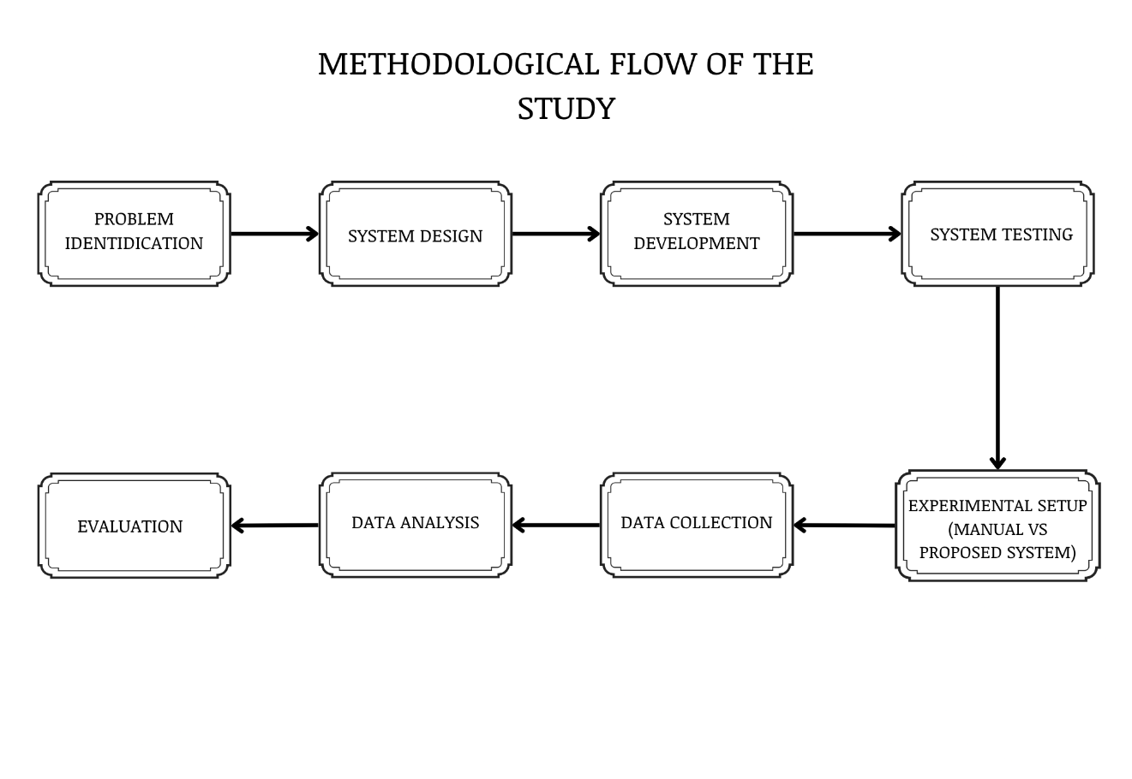
Methodological Flow of the Study
3.2 System Development Method
The study followed an Iterative Software Development Life Cycle (SDLC) model, in which the system was developed through repeated cycles of planning, design, development, testing, and refinement. This approach allowed continuous improvement based on testing results and user feedback. Security mechanisms were implemented consistently across all phases of development to ensure data protection and system integrity. The development cycle followed is presented in Figure 2.
Figure 2
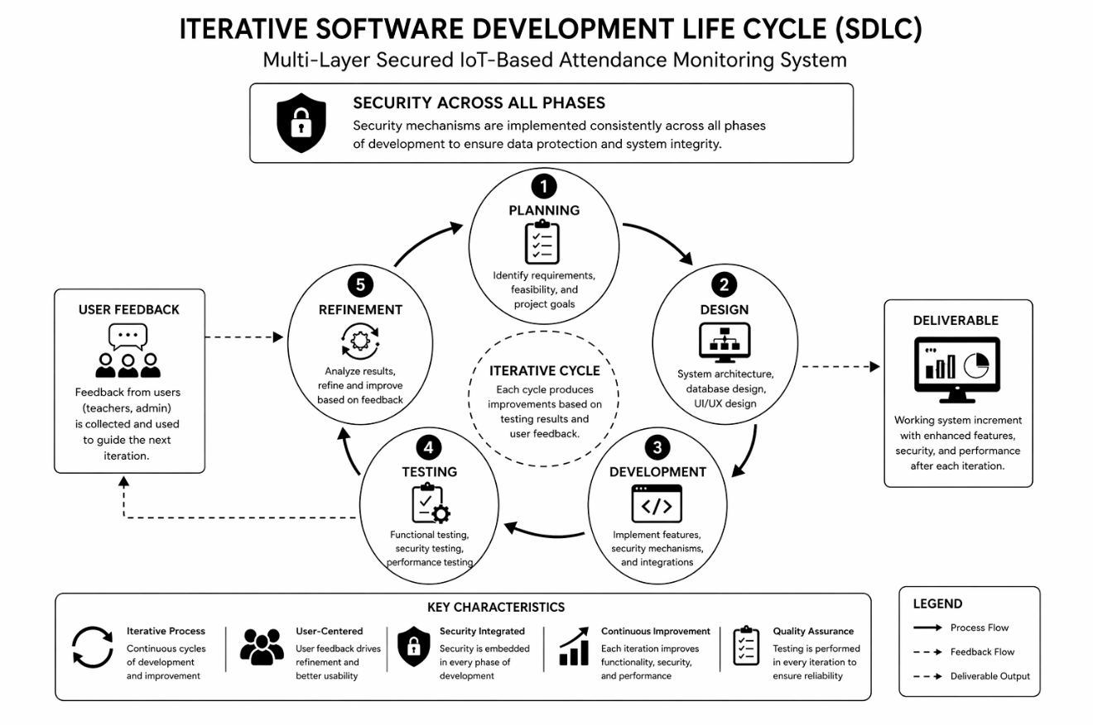
Iterative System Development Life Cycle Diagram
3.2.1 Requirement Analysis
In this phase, the researchers analyzed the existing attendance monitoring system and identified operational and security issues, including time-consuming manual attendance checking, lack of classroom-level validation, absence of teacher identity verification, congestion during attendance recording, and vulnerabilities in data security. To address these issues, the system introduced RFID-based attendance recording at classroom entry points and biometric fingerprint authentication for teacher verification, ensuring accurate attendance recording and authorized system usage. Multi-layer security mechanisms such as encrypted communication, authentication, access control, and audit logging were integrated to protect system data.
The stakeholders of the system were the school administration, the teachers, the IT administrators, and the students. The requirements were gathered through [insert the methods used, for example interviews with the school principal and the IT administrator and observation of the existing attendance process, with their dates]. The functional, non-functional, hardware, and software requirements identified are listed below; their implementation is traced in Chapter V, Table 13.
Functional requirements. The system shall:
FR1. Record student attendance by RFID tap-in and tap-out at the classroom terminal.
FR2. Open an attendance session only after verifying the fingerprint of the teacher scheduled for the class, with a logged password failover when the sensor cannot read the finger.
FR3. Store, for each record, the student, terminal, date, time-in, time-out, and attendance status.
FR4. Register and manage users, teachers, students, sections, subjects, schedules, classrooms, RFID cards, fingerprints, and terminals.
FR5. Keep all records in one centralized database on the school server.
FR6. Provide a dashboard and live monitoring of attendance and of terminal status.
FR7. Generate attendance reports exported as PDF, Excel, and CSV files.
FR8. Close expired sessions automatically and mark terminals offline when they stop reporting.
FR9. Record an audit trail of administrative and attendance activity and a log of security events.
FR10. Back up and restore the database in encrypted form.
Non-functional requirements.
Security. Encrypted communication through HTTPS/TLS, role-based access control with account lockout, a network address allowlist, and a signed request from every terminal.
Performance. A response time of less than two seconds for recording attendance (Table 8).
Reliability. No attendance record lost or recorded twice, including when a terminal briefly loses its network connection.
Usability. Operation of the terminal by tapping a card or placing a finger, without a screen or keyboard, and a web interface usable by teachers without training beyond an orientation.
Compatibility. Operation on a Windows computer with XAMPP and no internet connection.
Maintainability. No third-party runtime libraries, so that the system can be installed and updated on a network without internet access.
Hardware requirements.
Classroom terminal: ESP32-WROOM-32 development board, MFRC522 RFID reader (13.56 MHz), AS608 optical fingerprint sensor, and power supply, one per classroom.
Student identification: RFID cards issued to the students.
Server: one Windows computer within the school LAN [insert processor, memory (RAM), storage, and Windows version].
Network: Wi-Fi router connecting the terminals and the server [insert router model].
Client devices: computers or laptops of the teachers and administrators with a web browser.
Software requirements.
Server software: XAMPP with Apache 2.4 and PHP 8.1 or newer [insert the PHP version used], with the SQLite database built into PHP.
Firmware development: Arduino IDE with the ESP32 board package and the MFRC522, Adafruit Fingerprint Sensor, and ArduinoJson libraries.
Client software: a current web browser such as Google Chrome or Microsoft Edge.
Security testing: Wireshark, and Hydra and Nmap on Kali Linux.
3.2.2 System Design
The system was designed to operate within a secure Local Area Network (LAN) to ensure fast, reliable, and low-latency communication. The design includes a database structure for managing users, students, attendance records, and logs; a web-based dashboard for monitoring and administration; and a controlled workflow in which attendance recording occurs only after successful teacher authentication.
The network security design includes network-level access control by address range, controlled port access, firewall configuration, per-device request authentication using signed requests, and encrypted communication using HTTPS/TLS to minimize unauthorized access and reduce network exposure. The overall system design is presented in Figure 3.
Figure 3
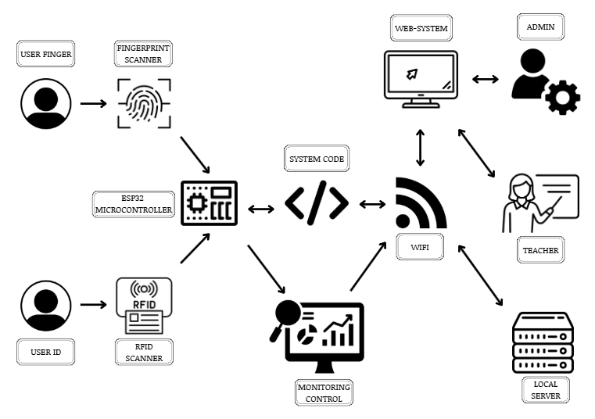
System Design Diagram

3.2.3 System Development
The system was developed using IoT-based hardware and software components, including the MFRC522 RFID reader module, the AS608 optical fingerprint module, and the ESP32 microcontroller, integrated with a web-based platform for monitoring and data management. The web application was implemented in PHP. The deployed edition, L-SIAMS-Lite, stores its data in a single SQLite database file on one server within the school’s Local Area Network, so no separate database server had to be installed or maintained at the partner school. Security features including encrypted communication, authentication, access control, and audit logging were implemented to ensure the confidentiality, integrity, and availability of data.
User passwords are secured using bcrypt hashing at cost factor 12, and a distinct cryptographic credential is generated for each registered IoT device to authenticate and sign its communication with the server.
3.2.4 System Testing
Structured testing was carried out in two stages. Development-time verification was performed alongside implementation to confirm the correctness and security of the system as it was built. Evaluation-stage testing was conducted during the deployment of the system at the partner school from October 12 to 15, 2026, as described in the remainder of this chapter.
Two automated test suites were developed and executed during implementation. A certificate and transport-security suite verifies the system’s TLS configuration, and returned 40 passing assertions covering encryption of the root key at rest, trust-chain validation, the certificate extensions that browsers and embedded TLS clients actually check, preservation of the root certificate across reissue so that deployed terminals continue to validate, and refusal of malformed hostname input. A concurrency and correctness suite exercises the live service layer against a real database to verify row locking, unique constraints, and deadlock retry behaviour when simultaneous taps are recorded. The output of the transport-security suite is presented in Chapter IV as evidence of the implemented transport protection.
Functional testing verified during deployment that the system components operated correctly, including attendance recording, session opening and teacher authentication, against a success criterion of at least 95 percent.
Performance testing measured the response time of the system during deployment against the criterion of less than two seconds, together with the recording time per student taken from the system logs and the responsiveness criterion of the User Acceptance Testing (UAT).
All security testing activities were limited strictly to owned and authorized LAN devices within a controlled academic environment, to simulate common security threats and evaluate the effectiveness of the implemented protection mechanisms without affecting external or real-world systems.
Penetration testing using Wireshark and the Kali Linux toolset (Hydra and Nmap) was limited strictly to authorized and owned Local Area Network (LAN) devices for academic and evaluation purposes only. Wireshark was used for packet inspection and verification of encrypted traffic between the IoT devices and the server. Nmap was used for port and service discovery to identify unnecessary open ports and evaluate network exposure within the LAN. Hydra was used to conduct controlled brute-force login attempts to assess the effectiveness of the account lockout and rate-limiting mechanisms against unauthorized access. No external systems or unauthorized networks were targeted. The test plan is presented in Table 2.

Table 2
Security Plan Test
Threat | Tool | Test Procedure | Expected Result | Metric | Pass/Fail Basis
Unauthorized Access | Hydra (Kali Linux) | Conduct brute-force login attempts against the authentication endpoint | Access blocked after lockout threshold | Number of successful unauthorized attempts | No successful unauthorized access
Packet Interception | Wireshark | Monitor transmitted packets | Encrypted packets observed | Encrypted vs unencrypted packets | No readable sensitive data
Open Port Exposure | Nmap | Scan server ports | Only authorized ports open | Number of open ports | No unnecessary open ports
Device Spoofing | Kali Linux (crafted HTTP request) | Attempt access with an unregistered device or missing request signature | Device rejected and event logged | Rejected unauthorized requests | 100% rejection
Log Monitoring | Audit Logs | Perform login and attendance actions | Logs generated correctly | Audit log completeness | Complete logs generated

These tools were selected for their effectiveness in analyzing network traffic, identifying vulnerabilities, and evaluating system security within a controlled academic environment. Usability was evaluated through actual use of the system and the UAT form. All testing was conducted in a controlled environment without affecting real-world systems.
3.3 Participants/Respondents
The scope of the evaluation was bounded by the hardware constructed for the prototype. Two classroom terminals were built, so two classrooms could be instrumented at any one time, and the study was conducted in the Grade 6 Gold and Grade 6 Diamond classrooms of Top Achievers Private School Inc. The two rooms were selected through purposive sampling, on the basis of scheduling availability and the practicality of installing and powering a terminal in each room. Within the two rooms the study used total enumeration, also called complete enumeration or a census, in which every member of the accessible population is included rather than a subset drawn from it. The study therefore combined two techniques: purposive sampling determined the study site, and total enumeration determined the respondents.
The respondents and their role in the evaluation are shown in Table 3. A total of 64 respondents took part: 51 students, 10 teachers, 2 IT administrators, and 1 school administrator.

Table 3
Respondents and Their Role in the Evaluation
Respondent group | Number | Role in the evaluation
Students (two classrooms) | 51 | Attendance capture by RFID during actual class sessions; respondents to Form 2 of the Security Evaluation Questionnaire
Teachers | 10 | Session opening through fingerprint verification; respondents to Form 1 of the questionnaire and to the UAT
School administrator | 1 | Monitoring and reporting; respondent to Form 1 and to the UAT
IT administrators | 2 | System administration and security controls; respondents to Form 1, the Part D control checklist, and the UAT
Total | 64

Total enumeration was appropriate for this study for three reasons. First, the accessible population was small enough to be included in full, so nothing was gained by drawing a sample from it. Second, attendance is a whole-class process: every student present had to pass through the terminal, and excluding any student would have understated the congestion that the study set out to measure. Third, the teacher, school administrator and IT administrator groups were already at their full size within the study site.
Since every member of the accessible population was included, the findings describe this site, as stated in the Scope and Limitations in Chapter I.
The student respondents are minors; the assent of each student was obtained before participation, as described in the Ethical Considerations in Section 3.9.
3.4 Data Gathering Instruments
The study used multiple instruments to collect quantitative data, each aligned with an evaluation objective. System-generated data (attendance records, tap timestamps, fingerprint logs and security logs) were extracted with the system’s read-only evaluation report and served as the primary instrument for processing time, accuracy, teacher verification and security events. A stopwatch and direct observation were used to time the manual roll call and to observe the queue at the classroom doors. Record comparison between the teachers’ manual roll call and the system-generated attendance was used to determine accuracy.
For the security component, Wireshark, Hydra and Nmap were used in controlled testing, together with the system’s security and audit logs. The users’ evaluation was gathered with two instruments answered on the five-point Likert scale in Table 4: the Security Evaluation Questionnaire, adapted from a published study [Insert citation of the source study], and the User Acceptance Testing (UAT) form.
Table 4
Likert Scale Interpretation
Scale | Description | Interpretation
5 | Strongly Agree | Very High
4 | Agree | High
3 | Neutral | Moderate
2 | Disagree | Low
1 | Strongly Disagree | Very Low

The Security Evaluation Questionnaire maps each item to a control of ISO/IEC 27001:2022 Annex A and groups the items under the CIA Triad. It was administered in two forms. Form 1, answered by the teachers, the school administrator and the IT administrators, has 27 security items in three parts, namely Confidentiality (Part A, 9 items), Integrity (Part B, 9 items) and Availability (Part C, 9 items), and a four-item Part E on the use of L-SIAMS compared with the manual method. Part D, a 15-item technical control checklist answered only by the IT administrators, rates each control Yes, Partial or No and records the evidence used. Form 2, answered by the students, has six items on keeping attendance safe (Part A) and six on using the terminal (Part B). The UAT form, answered by the 13 staff, rates six criteria: ease of use, accuracy, user interface, responsiveness, support for organizational requirements, and overall satisfaction. The instruments are presented in Appendix B.
Because the items of the Security Evaluation Questionnaire were adapted from a published study whose instrument had been validated by its authors [Insert citation of the source study], a separate expert content validation and pilot test were not conducted. Instead, the internal consistency of each part of the questionnaire was measured with Cronbach’s alpha computed from the actual responses, with 0.70 taken as acceptable.
Each evaluation objective was measured with corresponding metrics and instruments. Processing time, queue length and efficiency (Objective 4.1) were measured from the system logs, stopwatch timing of the manual roll call, and observation. Accuracy (Objective 4.2) was measured through record comparison. Usability, performance and reliability (Objective 4.3) were measured with the UAT form, the system response time, the recording time and the completeness of the session records, and the effectiveness of the security controls under ISO/IEC 27001 and the CIA Triad (also Objective 4.3) with the Security Evaluation Questionnaire and the Part D checklist. The penetration testing (Objective 5) used the test procedures in Table 2 and the security logs.
Teacher authentication was measured from the fingerprint logs as the proportion of sign-in scans by enrolled teachers that were verified, together with the scans and session attempts that the system refused.
Security effectiveness was evaluated based on the prevention of unauthorized access attempts, the protection of transmitted attendance data, the rejection of forged and replayed requests, and the completeness of the audit and security logs.
System reliability was evaluated from the completeness of the session records and the terminals’ recovery from lost connections. The fallback mechanism, in which taps are retained on the terminal during a network interruption and synchronized once the connection returns, was implemented, but a dedicated network-interruption test was not carried out.
Table 5
Instrument–Metric Mapping
Objective | Metric | Instrument
Reduce attendance time (4.1) | Processing time | System logs, stopwatch
Reduce congestion (4.1) | Queue length | Observation
Improve efficiency (4.1) | Efficiency (%) | Computation
Improve accuracy (4.2) | Accuracy rate | Record comparison
Verify teacher identity | Authentication success rate | Fingerprint logs
Penetration testing (5) | Attack outcome; vulnerability severity | Wireshark, Hydra, Nmap, security logs
Security controls, CIA (4.3) | Weighted mean; Part D compliance | Security Evaluation Questionnaire, Part D checklist
Usability and user acceptance (4.3) | UAT weighted mean | UAT form
Table 6
SOP–Objectives–Metrics–Instrument Mapping
Statement of the Problem | Objective | Metric | Instrument | Success Criterion
How can manual classroom attendance checking be minimized? | Reduce attendance recording time | Processing Time | System logs, stopwatch | Reduced processing time
How can accurate classroom level attendance recording be ensured? | Improve attendance accuracy | Accuracy Rate | Record comparison | ≥ 95%
How can congestion at the RFID gate be reduced? | Reduce waiting time and queue length | Waiting Time, Queue Length | Observation tools | Reduced congestion
How can teacher identity verification be integrated? | Verify authorized teacher access | Authentication Success Rate | System logs | ≥ 95%
How can multi-layer security mechanisms protect attendance data? | Implement network and application security | Vulnerability severity; rejected attacks; CIA weighted mean | Wireshark, Nmap, Hydra; security logs; questionnaire; Part D checklist | No High or Critical vulnerabilities

3.5 Evaluation Procedure
The system was deployed at Top Achievers Private School Inc. on two classroom terminals, one each in the Grade 6 Gold and Grade 6 Diamond rooms, from October 12 to 15, 2026. Attendance was recorded during actual class sessions on October 13–14, and the evaluation instruments were administered and the penetration tests performed on October 15. An orientation on the use of the system was conducted on October 12, 2026, for two hours, attended by all participating teachers, the IT administrators and the school principal. The evaluation followed this sequence: deployment and enrolment of the teachers’ fingerprints and the students’ RFID cards, attendance recording during actual class sessions, timing of the manual roll call, observation of the queue at the classroom doors, penetration testing (performed on September 26 and October 15, 2026), administration of the questionnaire and the UAT form, and extraction and analysis of the data.
Two sessions opened on October 13 were test sessions and were excluded from all results, leaving 19 class sessions. The system data for these sessions were extracted with the read-only report:evaluation command, which reads the attendance, fingerprint and security logs for a date range and exports the session and attendance records used for the record comparison.
The manual roll call of one class of 29 students was timed with a stopwatch by the researchers, and the teachers were interviewed about the time a roll call usually takes. The queue at the classroom doors was observed on October 14, 2026. The Security Evaluation Questionnaire and the UAT form were administered on October 15, 2026, after the respondents had used the system, and the IT administrators completed the Part D checklist using the evidence listed for each control.
The penetration tests in Table 2 were performed on owned devices within the school LAN. Every refused request, failed sign-in and override was recorded by the system in its security log, which was also used as evidence.
3.6 Experimental Design
The study compared the existing manual roll call and the developed system using measurable criteria derived from the objectives: processing time for the duration of attendance recording, queue length for congestion, accuracy for the correctness of attendance records, and efficiency for the improvement of the system over the manual method.
Processing time for the system was measured as the median interval between consecutive taps while a class was queuing at the terminal, which reflects the time per student; the time for a whole class was measured from its first to its last tap. Processing time for the manual method was the stopwatch time of the roll call divided by the number of students called. Accuracy was measured as the percentage of system records that matched the manual roll call, and efficiency as the percentage improvement of the system over the manual method.
Teacher authentication was evaluated from the rates of verified and refused fingerprint sign-ins, and security effectiveness from the system’s ability to refuse unauthorized and forged requests, detect abnormal activity, and keep a complete record of these events.
Both methods were observed in the same two classes, rooms and school days.
The experimental process used to compare the manual attendance system and the developed system is illustrated in Figure 4. The diagram presents the sequence of steps including setup, execution, data collection, and result comparison.
Figure 4
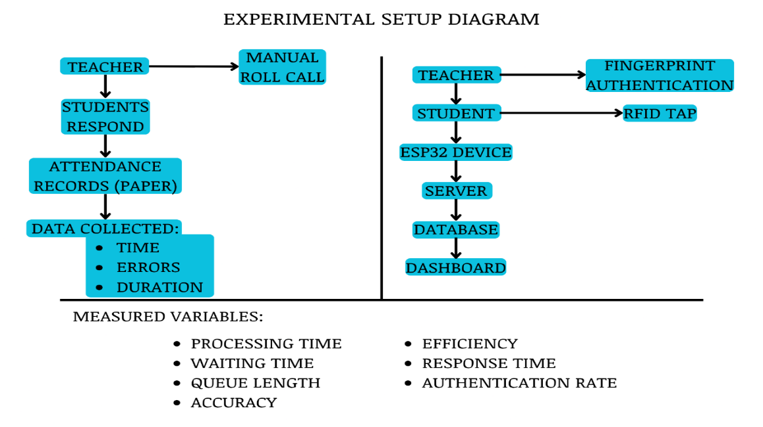
Experimental Setup and Process Flow Diagram

Treatment of the Manual and System Comparison
The study planned to test, with a paired sample t-test at the 0.05 level, the hypothesis that there is no significant difference between the manual attendance method and the developed system in terms of processing time, accuracy, and efficiency.
Because the manual roll call was timed with a stopwatch for one class only (3 minutes and 46 seconds for 29 students), and was otherwise known from the teachers’ estimate of 3 to 5 minutes, paired observations were not available and the paired t-test was not performed. The comparison is therefore reported descriptively.
Mathematical Models
The study used the following formulas to measure system performance:
Accuracy Rate: Accuracy (%) = (Number of Correct Attendance Records / Total Attendance Records) × 100
Processing Time: Processing Time = Total Time to Record Attendance / Number of Students
Efficiency: Efficiency (%) = ((Manual Attendance Time − System Attendance Time) / Manual Attendance Time) × 100
Time per Student (system): Median interval between consecutive taps while a class is queuing at the terminal
3.7 Data Analysis Techniques
The data were analyzed using descriptive statistics. Frequency and percentage were used for the respondent profile, the distribution of ratings and the system counts; the weighted mean and standard deviation for each item, part and dimension of the questionnaire and for the UAT criteria; and Cronbach’s alpha for the internal consistency of each part. Part D was scored Yes = 2, Partial = 1 and No = 0, and compliance was computed as points earned ÷ 30 × 100%. The staff (Form 1) and the students (Form 2) were reported separately, because they answered different items.
The results were interpreted against the success criteria in Table 8, and mean scores with the ranges in Table 7. The system was considered acceptable if it met the criteria for accuracy, teacher authentication, security testing, and the users’ evaluation of the security controls and of the system as a whole. Criteria that could not be measured during deployment are reported as such in Chapter V.
Table 7
Interpretation of Mean Scores
Mean Range | Interpretation
4.20–5.00 | Very High
3.40–4.19 | High
2.60–3.39 | Moderate
1.80–2.59 | Low
1.00–1.79 | Very Low

3.8 System Evaluation Criteria
Table 8
System Evaluation Criteria
Criteria | Indicator | Measurement | Success Criteria
Perceived system quality (usability) | UAT criteria | UAT form | Mean ≥ 3.40 (High)
Security controls (CIA) | Security Evaluation Questionnaire; Part D checklist | Questionnaire, IT administrator checklist | Mean ≥ 3.40 (High); controls rated Yes
Performance | Response Time | System logs | < 2 seconds
Accuracy | Attendance Records | Record comparison | ≥ 95%
Authentication | Success Rate | System logs | ≥ 95%
Reliability | Data Sync Success | System logs | ≥ 95%
Security | Vulnerability Severity | Security testing | No high-risk
Network Security | Open Ports | Nmap Scan | No unnecessary open ports
Access Control | Failed Unauthorized Requests | Security Testing | 100% rejection of unauthorized requests
Access Control | Encrypted Packets | Wireshark Analysis | No readable sensitive data
Monitoring | Audit Log Completeness | Audit Logs | Complete logs generated

The security criteria in Table 8 are organized under the CIA framework, following the guidance of ISO/IEC 27001. Confidentiality was assessed through the absence of readable sensitive data in captured traffic and the rejection of unauthorized requests. Integrity was assessed through the accuracy of attendance records, the completeness of the audit trail, and the system’s refusal of forged and replayed requests. Availability was assessed through Part C of the questionnaire, the availability controls of the Part D checklist, and the terminals’ recovery from lost connections. The study applied ISO/IEC 27001 as a guiding framework at the level of confidentiality, integrity and availability, not as a certification audit.
The success criterion for the Security Evaluation Questionnaire and the UAT is a mean of 3.40 or above, which Table 7 interprets as High. Each obtained mean is reported with its verbal interpretation, so that a result in the Very High band is recorded as such. The criterion is set above the midpoint of the scale, because a threshold that a merely Moderate rating could satisfy would not distinguish an acceptable system from an indifferent one.
Security performance was evaluated based on the effectiveness of the implemented protection mechanisms during controlled testing: high-risk vulnerabilities must not be present, medium-risk vulnerabilities must be minimized, and low-risk vulnerabilities are acceptable within controlled limits.
The selected thresholds follow standards commonly used in system performance, usability and security evaluation studies. High accuracy, fast response time and reliable authentication are necessary for the system to operate effectively within classroom environments.
3.9 Ethical Considerations
The study complied with Republic Act No. 10173, or the Data Privacy Act of 2012. Informed consent was obtained from the teachers, the IT administrators and the school administrator, and the assent of each of the 51 student respondents was obtained before data collection; participation was voluntary. All collected data were treated as confidential and used solely for academic purposes; respondents are identified by code in the dataset and in this manuscript. Sensitive information, including biometric and attendance data, is stored securely and is accessible only to authorized personnel.
In the developed system, fingerprint data is not stored as an image. The fingerprint sensor converts each enrolled fingerprint into a numeric template held in the sensor module, and the server stores only a reference to that template together with the identity it belongs to. This design limits the personal data held by the system and supports the confidentiality requirement of the Data Privacy Act.

CHAPTER IV
TECHNICAL BACKGROUND

4.1 Introduction
This chapter presents the technical design, system architecture, and implementation of L-SIAMS: A Local IoT-Based Multi-Layer Secured Attendance Monitoring System with RFID and Biometric Authentication for Top Achievers Private School Inc. (TAPS). The system integrates IoT-based hardware, a web-based application, and multi-layer security mechanisms to provide accurate, efficient, and secure attendance monitoring.
The system consists of three major components: the IoT device for attendance capture, the application system for data processing and management, and the security architecture for data protection. These components operate within a Local Area Network (LAN) to provide reliable communication, low latency, and reduced exposure to external threats. The movement of data through the layers of the system is presented in Figure 5.
Figure 5
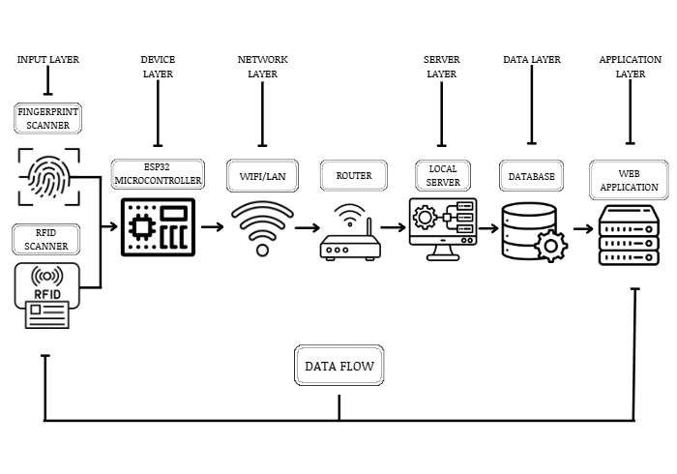
Data Flow Across System Layers

4.2 System Architecture Overview
The system adopts a multi-layer architecture composed of six main layers: the Device Layer, Network Layer, Transport Layer, Application Layer, Database Layer, and Monitoring Layer. Each layer performs a specific role while interacting with other layers to ensure overall system functionality.
The Device Layer captures attendance data using RFID readers and fingerprint sensors connected to the ESP32 microcontroller. The Network Layer manages secure communication between IoT devices and the server through the Local Area Network. The Transport Layer secures transmitted data using HTTPS/TLS encryption. The Application Layer processes attendance records, authentication requests, and system operations. The Database Layer manages secure storage of attendance records, user credentials, and audit logs. The Monitoring Layer handles activity logging, anomaly detection, and audit trail generation for accountability and security monitoring.
The architecture directly addresses the problems identified in Chapter I. Classroom-based RFID attendance reduces congestion at entry points, while automated recording minimizes manual attendance time. Biometric authentication provides teacher verification, and the integration of multi-layer security mechanisms protects attendance data from unauthorized access and modification.
The overall structure of the system is illustrated in Figure 6, showing the interaction between IoT devices, network components, application systems, and security layers.
Figure 6
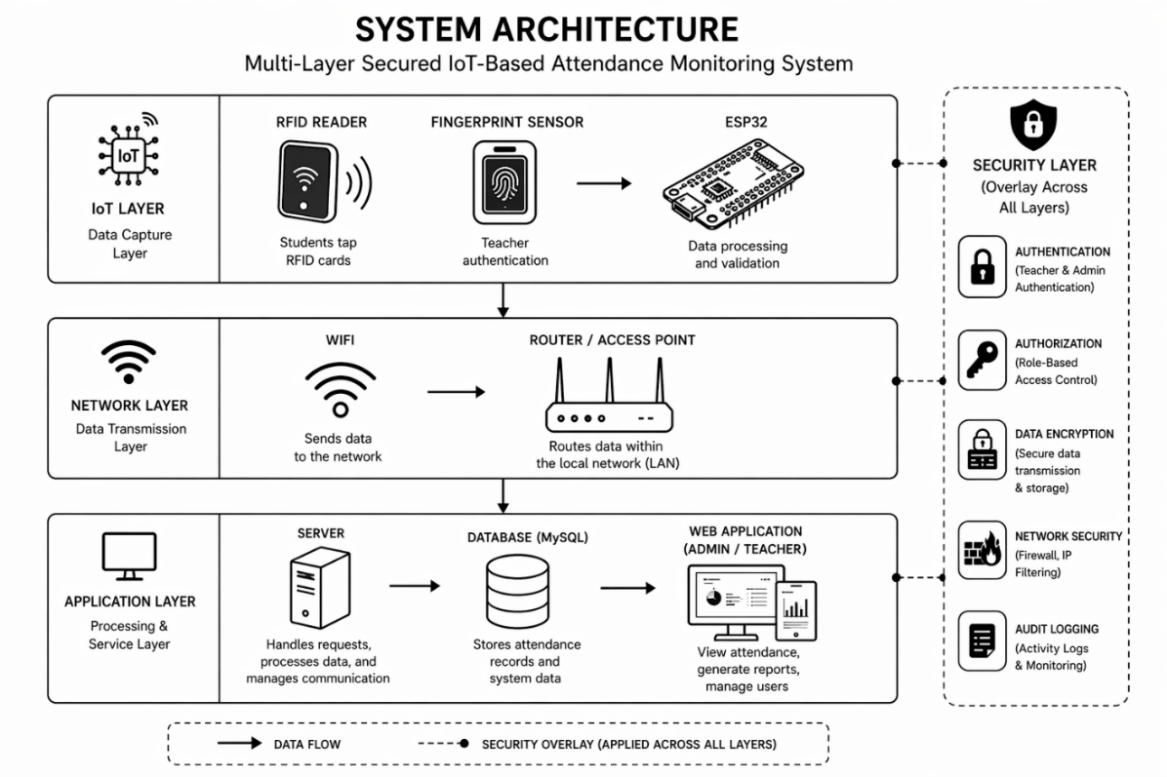
System Architecture Diagram

4.3 IoT Device Architecture
The IoT device is built using the ESP32 microcontroller, which serves as the central processing unit responsible for handling input, processing data, and transmitting information to the server. The ESP32 was selected for its cost efficiency, built-in Wi-Fi capability, and suitability for IoT applications.
The device integrates RFID technology to identify students and a biometric fingerprint sensor to verify teacher identity. RFID provides fast and contactless student identification, while fingerprint authentication prevents proxy attendance and ensures that only authorized teachers can initiate attendance sessions.
The system uses the MFRC522 RFID module for student identification due to its low cost, ease of integration, and compatibility with the ESP32 microcontroller. For biometric authentication, the AS608 optical fingerprint module is used for its reliability, built-in template storage, and suitability for embedded systems. These components were selected to ensure affordability, efficiency, and ease of deployment in classroom environments.
Since a fingerprint reader can fail to read a legitimate teacher, whether through a wet, dry or injured finger or a sensor fault, the system provides a controlled failover in which an assigned teacher may open a session using their own account password instead. The failover is deliberately not silent: it is recorded as a distinct security event so that an administrator can see how often biometric verification is being bypassed and by whom.
The IoT device captures student and teacher data, processes the information, and transmits it to the server in a structured format through the network. The structure of the device is presented in Figure 7.
Figure 7
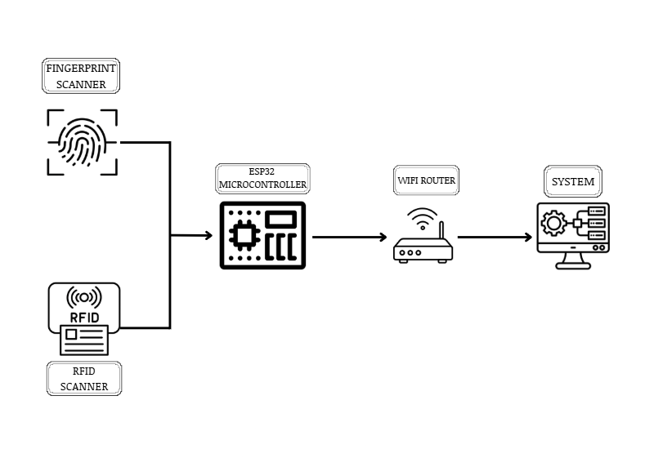
IoT Device Diagram

4.4 Network Architecture
The system operates within a Local Area Network (LAN) using a client-server model. The LAN-based setup was selected to provide faster communication, reduced latency, and enhanced security by limiting exposure to external networks.
Compared to cloud-based deployment, the LAN architecture reduces the system’s attack surface by restricting external internet exposure and allowing stricter internal network monitoring and access control.
The network connects IoT devices, the server, and client devices such as administrator and teacher computers. The Wi-Fi router acts as the central communication hub, enabling data transmission between devices.
Attendance data collected from IoT devices is transmitted to the server, where it is processed and stored. Client devices access the system through a web interface to view attendance records and generate reports.
Network access control is enforced at the application boundary in addition to the router. Every incoming request is checked against configured address ranges before any authentication is attempted: one range for browser access by staff, and a separate range for terminal traffic. A request originating outside its permitted range is refused and recorded as a security event, regardless of whether it carries valid credentials. This makes network position an independent condition of access rather than a consequence of the firewall alone. The network architecture is presented in Figure 8.
Figure 8
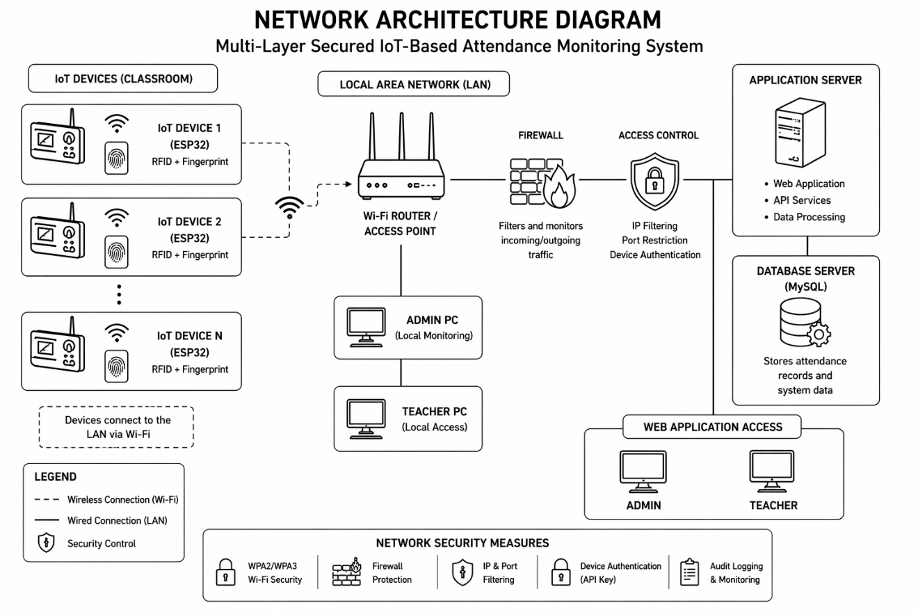
Network Architecture

4.5 Application Architecture
The system follows a three-tier architecture consisting of the presentation layer, application layer, and data layer. The presentation layer serves as the user interface, allowing administrators and teachers to interact with the system. The application layer processes requests, applies system logic, and enforces rules such as authentication and validation. The data layer stores system data, including user information, attendance records, and audit logs.
The backend is implemented in PHP with an SQLite relational database, kept in a single file in the deployed edition, L-SIAMS-Lite, and selected for its compatibility, lightweight footprint, and suitability for LAN-based deployment on modest server hardware. The application runs without third-party runtime dependencies: the class autoloader, the spreadsheet and PDF report writers, the WebSocket server, the chart renderer, and the icon set are all implemented within the project. This decision follows directly from the deployment constraint, since the target network may have no route to the internet from which packages could be installed or updated.
Requests that change attendance state carry an idempotency key. If a terminal retries a transmission because it did not receive a response, the server recognizes the repeated key and returns the original outcome instead of recording a second attendance entry. This protects record integrity across an unreliable link without requiring the terminal to reason about what the server already received.
Monitoring screens receive updates over a WebSocket connection, with Server-Sent Events and long polling as automatic fallbacks when a client or network path does not support the primary transport. Each event carries a sequence number, so a client that reconnects after an interruption requests only the events it missed rather than losing them or reloading the entire view.
The system generates measurable data such as timestamps, response time, authentication logs, and attendance records, which were used in the evaluation described in Chapter III and reported in Chapter V. These data outputs support the measurement of system performance, accuracy, and efficiency.

4.6 Database Design
The system database uses a relational structure to ensure efficient data storage, retrieval, and data integrity. It is implemented in SQLite and consists of multiple interrelated tables that support attendance recording, user authentication, and system monitoring.
The main entities include the user table, which stores login credentials and user roles; the teacher table, which is linked to user accounts and stores biometric references; the class table, which organizes students and assigns teachers; and the student table, which contains student identity information along with RFID unique identifiers.
The attendance table records all attendance transactions, while the device table stores information about registered IoT devices and their corresponding credentials. The audit log table records system activities for monitoring and accountability purposes, and a separate security log table records security-relevant events for investigation.
The relationships between these entities are structured to ensure proper data linkage and consistency. A one-to-one relationship exists between the user and teacher entities, while a teacher can handle multiple classes. Each class contains multiple students, and each student can have multiple attendance records. Similarly, a device can send multiple attendance records, and a user can generate multiple audit logs. This relational design ensures traceability, consistency, and secure management of attendance data throughout the system. The relationships between these entities are presented in Figure 9.
Figure 9
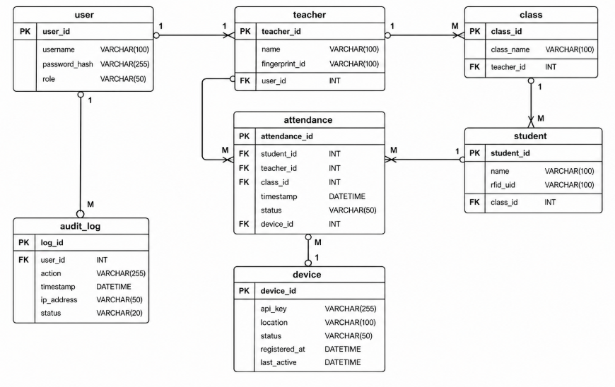
Entity Relationship Diagram

4.7 Data Flow Diagram
The Data Flow Diagram illustrates the internal processes of the system, including attendance capture, data validation, and storage. The process begins with teacher authentication, followed by student RFID scanning. The system validates the data and transmits it to the server, where it is processed and stored in the attendance database. The system also generates audit logs for monitoring and traceability, as shown in Figure 10.
Figure 10
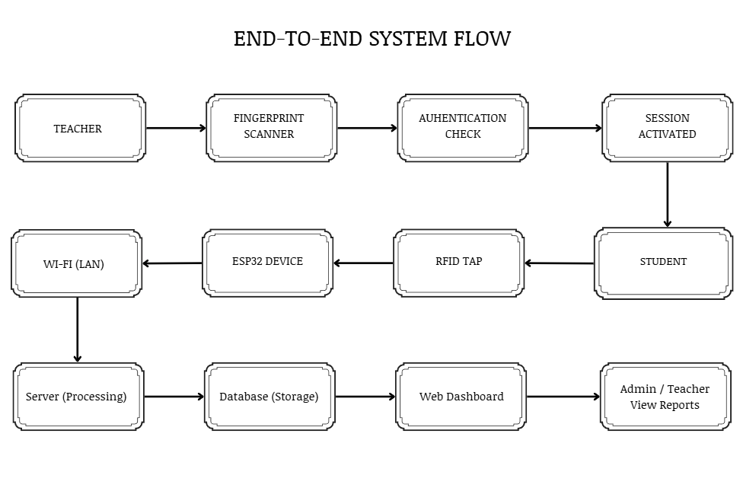
Data Flow Diagram

4.8 Security Architecture
The system implements a multi-layer security architecture to ensure data protection and system integrity. The security model comprises device authentication, network security, transport security, application security, database security, and monitoring mechanisms, as shown in Figure 11. Each layer is designed so that the failure of any single control does not by itself grant access to attendance data.

Device Layer Security
Each registered terminal holds two separate credentials: an API key that identifies it, and a 256-bit secret used to sign its requests. Identification and proof of identity are therefore distinct, so a key observed in transit or read from a device cannot by itself be used to impersonate that terminal. Every request from a terminal carries a signature computed over the request content using the device secret, together with a timestamp and a single-use value called a nonce.
The server validates every device request through a fixed six-step sequence, shown in Table 9. Each step has its own failure code, and every failure is written to the security log. The codes returned to the caller are deliberately coarse, so that a rejected request does not reveal which condition failed and therefore does not help an attacker map the system’s defences, while the log retains the precise reason for the administrator.

Table 9
Device Request Validation Sequence
Step | Condition checked | Failure code | Security purpose
1 | The device is registered and active | DEVICE_UNKNOWN | Rejects traffic from any terminal the school has not provisioned
2 | The API key is valid and unexpired | API_KEY_INVALID | Rejects revoked, expired, or fabricated credentials
3 | The request signature is valid | SIGNATURE_INVALID | Proves possession of the device secret; defeats key-only spoofing and detects tampering with the request body
4 | The timestamp is within ±30 seconds | TIMESTAMP_EXPIRED | Bounds the window in which any captured request could be reused
5 | The nonce has not been used before | REPLAY_DETECTED | Prevents a captured valid request from being replayed even inside the time window
6 | The device is bound to the classroom | DEVICE_CLASSROOM_MISMATCH | Prevents a terminal removed from one room from recording attendance for another

Credentials are managed over their whole life rather than issued once. Keys are generated during device registration, stored in protected form, validated on every request, and may be rotated, with a grace period during which the previous key remains valid so that rotation does not interrupt attendance capture. The system also revokes a device credential automatically when its behaviour indicates compromise: repeated signature failures, or use of the same key from several distinct network addresses within a short period.

Network Layer Security
Network security is enforced through controlled LAN access, including address-range filtering applied to every request before authentication, firewall configuration, and port restriction. Browser traffic and terminal traffic are governed by separate permitted ranges, so a compromised staff workstation does not inherit the network position of a classroom terminal. Requests arriving from outside the permitted range are refused and recorded, whether or not they carry valid credentials.
Transport Layer Security
HTTPS/TLS secures communication between the ESP32 terminals and the server within the LAN. Because the system is designed to run without internet access, it cannot obtain certificates from a public certificate authority. The system therefore operates its own internal certificate authority: it issues the server certificate, keeps the authority’s private key encrypted at rest, and provides the root certificate in a form the firmware compiles in, so that each terminal validates the server it connects to rather than trusting any host that answers. Reissuing the server certificate deliberately preserves the existing root, so that terminals already issued with the root certificate continue to validate without being reflashed.
The correctness of this arrangement was verified by an automated test suite during development. Its results are presented in Section 4.13 as Figure 18.

Application Layer Security
Application-level security combines several controls. User passwords are hashed with bcrypt at cost factor 12, a deliberately slow function chosen because human-chosen passwords are low in entropy and must be expensive to test. Password policy requires a minimum length of twelve characters with mixed character classes, rejects passwords appearing in a common-password blocklist, and prevents reuse of recent passwords. Repeated failed sign-in attempts lock an account for a fixed period.
Sessions are identified by cryptographically random tokens rather than predictable identifiers. Session cookies are restricted to the host, marked so that scripts cannot read them, and constrained so they are not sent with cross-site requests. A session expires both after a period of inactivity and at an absolute maximum age, and is additionally bound to the browser and network prefix it was created from, so that a stolen session identifier used from elsewhere is rejected. The number of concurrent sessions per user is capped.
State-changing requests require a cross-site request forgery token. Request rates are limited per terminal to contain a device stuck in a retry loop. Response headers restrict how the interface may be embedded, framed, or referenced, and a content security policy authorises the interface’s own scripts by nonce rather than permitting inline script execution generally, which closes the principal avenue for injected script.
Uploaded files are constrained by type and are stored in a location configured so that they cannot be executed by the web server, preventing an uploaded file from becoming a means of running code.

Database Layer Security
Database access is restricted to the application’s own account, which is granted only the privileges it requires. Passwords are stored as hashes and are never recoverable. Device signing secrets are stored encrypted rather than in plain text, so that read access to the database alone does not yield the ability to impersonate a terminal. All queries are parameterised, so that user-supplied values cannot alter the structure of a statement.
Attendance and audit records are treated as append-only history: corrections are recorded as new entries rather than overwriting earlier ones, so that the record of what was originally captured survives any later amendment.
Monitoring Layer Security
Monitoring is implemented through two complementary records. The audit log records ordinary administrative and attendance activity for accountability. The security log records events that carry a security meaning, each classified by severity and carried through a resolution workflow so that an administrator can mark an entry as investigating, resolved, or a false positive rather than merely observing it. The system records thirty-three distinct security event types, grouped in Table 10.

Table 10
Security Event Types Recorded by the System
Category | Recorded events
Device and request authentication | DEVICE_UNKNOWN, DEVICE_BLOCKED, DEVICE_SPOOFING, API_KEY_INVALID, API_KEY_EXPIRED, API_KEY_REVOKED_USE, API_KEY_IP_ANOMALY, SIGNATURE_INVALID, TIMESTAMP_EXPIRED, REPLAY_DETECTED, CLAIM_TOKEN_INVALID
Network access control | IP_NOT_ALLOWLISTED, BLOCKED_IP_ATTEMPT, RATE_LIMIT_EXCEEDED
Account and session security | LOGIN_FAILED, ACCOUNT_LOCKED, SESSION_HIJACK_SUSPECTED, UNAUTHORIZED_ACCESS, PERMISSION_VIOLATION
Application attack detection | CSRF_FAILURE, SQL_INJECTION_ATTEMPT, XSS_ATTEMPT, MALICIOUS_UPLOAD
Identity and biometric integrity | BIOMETRIC_OVERRIDE_USED, BIOMETRIC_OVERRIDE_REFUSED, FINGERPRINT_FAILURE_THRESHOLD, FINGERPRINT_SLOT_CROSS_DEVICE
Attendance and enrolment integrity | UNKNOWN_RFID, DEVICE_CLASSROOM_MISMATCH, SECTION_MISMATCH_REPEATED, GRADE_LEVEL_MISMATCH_BLOCKED, CROSS_DEPARTMENT_ASSIGNMENT_BLOCKED, UNAUTHORIZED_CHANNEL_SUBSCRIBE

These security mechanisms were evaluated during the evaluation phase to determine their effectiveness in preventing unauthorized access, detecting system vulnerabilities, and ensuring data confidentiality, integrity, and availability.
Figure 11
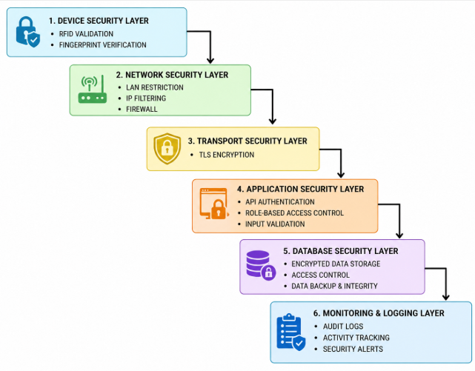
Security Architecture Diagram

4.9 Threat Model and Security Considerations
The system adopts a structured STRIDE-based threat model to identify and address common security threats. Table 11 maps each threat category to the specific controls implemented in the system.
Table 11
Threat, Description and Mitigation
Threat | Description | Mitigation implemented
Spoofing | Unauthorized impersonation of users or devices | Fingerprint verification for teachers; per-request signature proving possession of the device secret; address-range restriction on terminal traffic
Tampering | Unauthorized modification of attendance data | Signature computed over the request content; parameterised queries; append-only attendance and audit history; idempotency keys on state-changing requests
Repudiation | Denial of performed actions | Audit log of administrative and attendance activity; separate security log with severity and resolution workflow; recorded biometric override events
Information Disclosure | Exposure of confidential data | HTTPS/TLS with an internal certificate authority; role-based access control; device secrets stored encrypted; passwords stored only as bcrypt hashes
Denial of Service | Disruption of system availability | Firewall rules and address-range restriction; per-terminal rate limiting; offline capture on the terminal with automatic resynchronisation
Elevation of Privilege | Unauthorized privilege escalation | Role-based access control with per-route permission checks; session binding and concurrent session limits; automatic revocation of device credentials showing signs of compromise

4.10 Security Testing Approach
Penetration testing was conducted in a controlled environment, limited strictly to authorized and owned Local Area Network (LAN) devices, to validate the effectiveness of the implemented security controls. The activities were performed using Wireshark and the Kali Linux toolset.
Secure transport was verified using Wireshark. Traffic between the ESP32 terminals and the server was captured and inspected to confirm that communication is encrypted under HTTPS/TLS and that attendance and authentication data cannot be read in transit.
Resistance to brute-force attacks was tested using Hydra on Kali Linux. Repeated login attempts were directed at the authentication endpoint to confirm that the account lockout and rate-limiting mechanisms respond as designed, blocking access after the configured number of failed attempts rather than allowing unlimited credential guessing.
Network exposure was assessed through port scanning using Nmap on Kali Linux. The server was scanned to enumerate open ports and running services, confirming that only the authorized ports required for system operation are exposed and that no unnecessary services are reachable within the LAN.
In addition, device authentication was tested by submitting forged and unregistered device requests. Each request was rejected by the device-authentication layer and recorded in the system’s security log, demonstrating both real-time rejection and accountability.
All testing procedures were limited strictly to authorized and owned LAN devices to comply with ethical and legal cybersecurity standards.
The results of these tests were used to classify vulnerabilities based on severity levels using the Common Vulnerability Scoring System (CVSS). Vulnerabilities classified as High Risk (CVSS 7.0 and above) must not be present for the system to be considered acceptable.
Table 12
CVSS Score Interpretation
CVSS Score | Severity
0.1–3.9 | Low
4.0–6.9 | Medium
7.0–8.9 | High
9.0–10.0 | Critical

In addition to this evaluation, transport-layer security was verified during development using an automated certificate test suite, whose results are reported in Section 3.2.4.
4.11 System Design Considerations
The system design considers efficiency, scalability, reliability, and security. The use of IoT technology enables real-time attendance recording, while the LAN-based setup provides stable communication. The integration of RFID and biometric authentication improves attendance accuracy and prevents unauthorized session initiation. The use of a structured database and web-based interface supports efficient data management and reporting.
The design also supports the collection of measurable data required for evaluation, including attendance timestamps, authentication logs, and system response times. These outputs were used to validate system performance, accuracy, and efficiency based on the defined experimental metrics.
4.12 System Limitations
The system has several limitations. It depends on the stability of the Local Area Network, and any network interruption may affect real-time data transmission. RFID technology may experience misreads, while biometric authentication may fail to recognise a legitimate user under certain conditions, which is why the controlled password failover described in Section 4.3 exists.
The offline capture mechanism has a defined boundary that should be stated plainly. The terminal holds up to forty taps in the microcontroller’s real-time-clock memory while the server is unreachable, and replays them with their original timestamps once the link returns. That memory survives a reset or a watchdog reboot, but it does not survive a loss of power. If a classroom loses power before connectivity is restored, taps held at that moment are lost.
The system is limited to single-campus deployment and would require further development to support scalability across multiple campuses. The processing power, memory, and storage capacity of the ESP32 may affect performance when handling multiple simultaneous authentication and encryption operations.
Operating an internal certificate authority requires that certificates be renewed and that the root certificate be distributed to terminals when it changes, which adds administrative effort. Device credential rotation likewise adds maintenance as the number of registered terminals grows.
The system was developed as a prototype and was tested in two selected classrooms, which may not fully reflect large-scale deployment scenarios. Security testing was conducted in a controlled environment and did not cover all real-world attack variations.
4.13 Prototype Implementation and System Interface
This section presents the developed prototype as evidence of implementation. The screenshots that follow were captured from the running system, and are grouped by the security function they demonstrate, so that each figure supports a specific claim made earlier in this chapter. The database behind them holds seeded demonstration data, a full school of students, sections, schedules and terminals, so that each screen can be shown populated. The record counts and the number of registered terminals in these figures are therefore illustrative of the system at scale, and are not the two-terminal configuration described in Chapter III for the evaluation.
4.13.1 Hardware Prototype
The classroom terminal integrates the ESP32 microcontroller, the MFRC522 RFID reader and the AS608 optical fingerprint module into a single unit positioned at the classroom entry point. Two terminals were constructed for the prototype, which is what bounds the evaluation to two classrooms as described.
The connections between the microcontroller and the two peripheral modules are presented in Figure 12. The MFRC522 communicates over the SPI bus, while the AS608 uses the second hardware UART at 57600 baud, with its transmit line connected to the pin on which the ESP32 receives.
Figure 12
Terminal Wiring and Connectivity
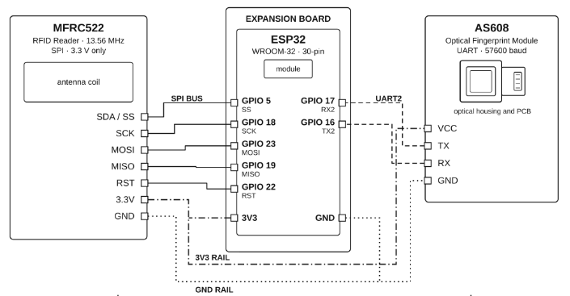

4.13.2 Authentication and Access Control
Access to the web application begins at a single authenticated entry point. The sign-in screen in Figure 13 is subject to the account lockout and password policy described in Section 4.8, and to the network address restriction described in Section 4.4, which is applied before credentials are examined.
Figure 13
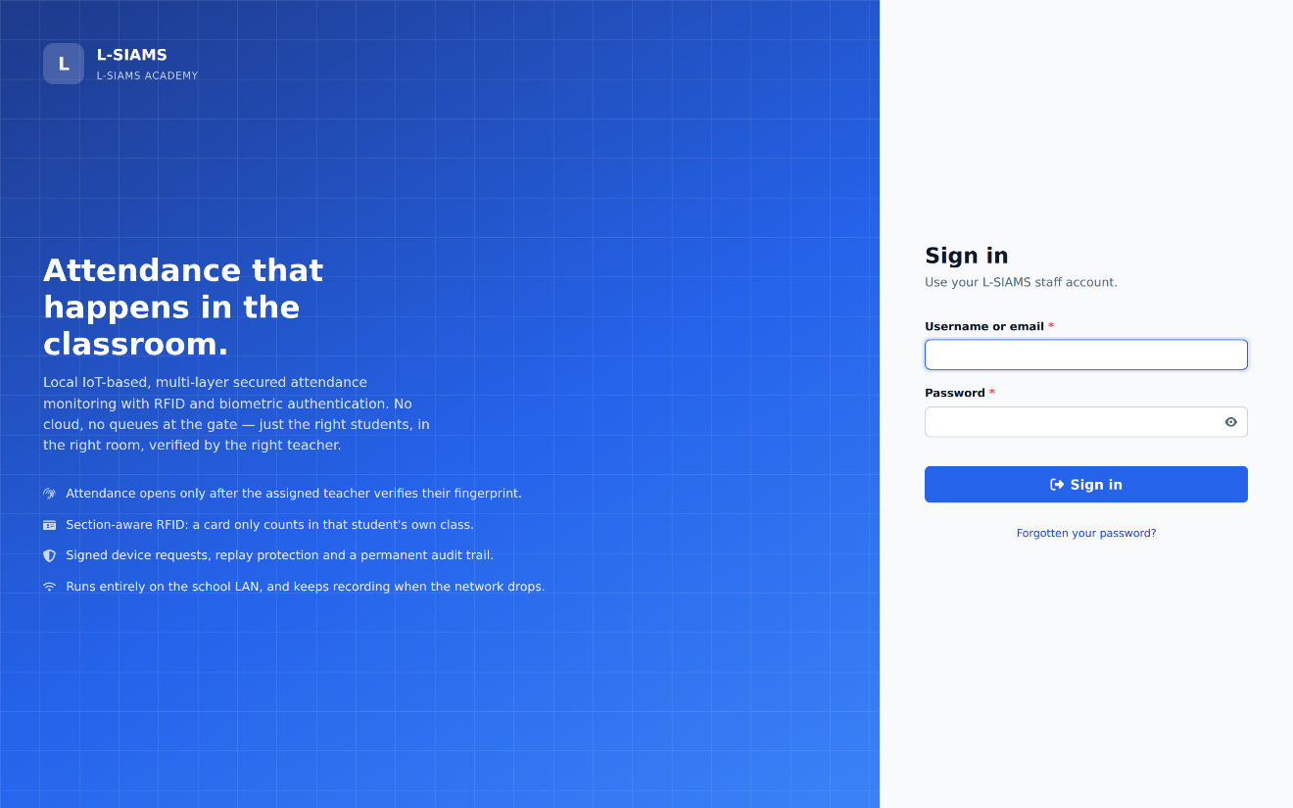
System Sign-In Screen

User accounts are governed by role-based access control. Figure 14 shows the account management interface, in which each account is bound to a role that determines the routes and operations available to it.
Figure 14
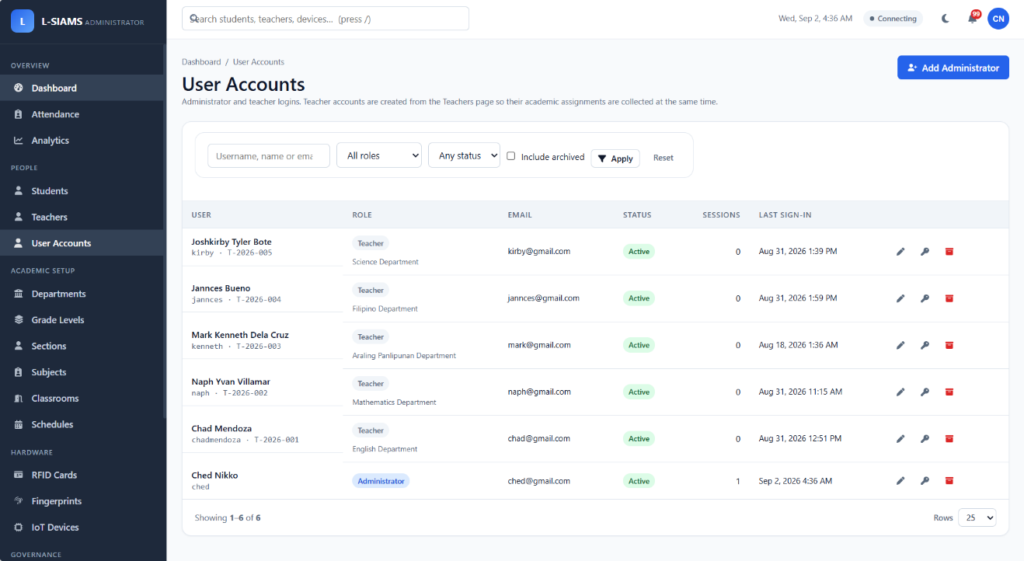
User Account and Role Management

Active sessions are visible to the administrator and can be terminated individually or in bulk, as shown in Figure 15. This provides a direct response capability if a session is believed to be compromised, supporting the session controls described in Section 4.8.

Figure 15
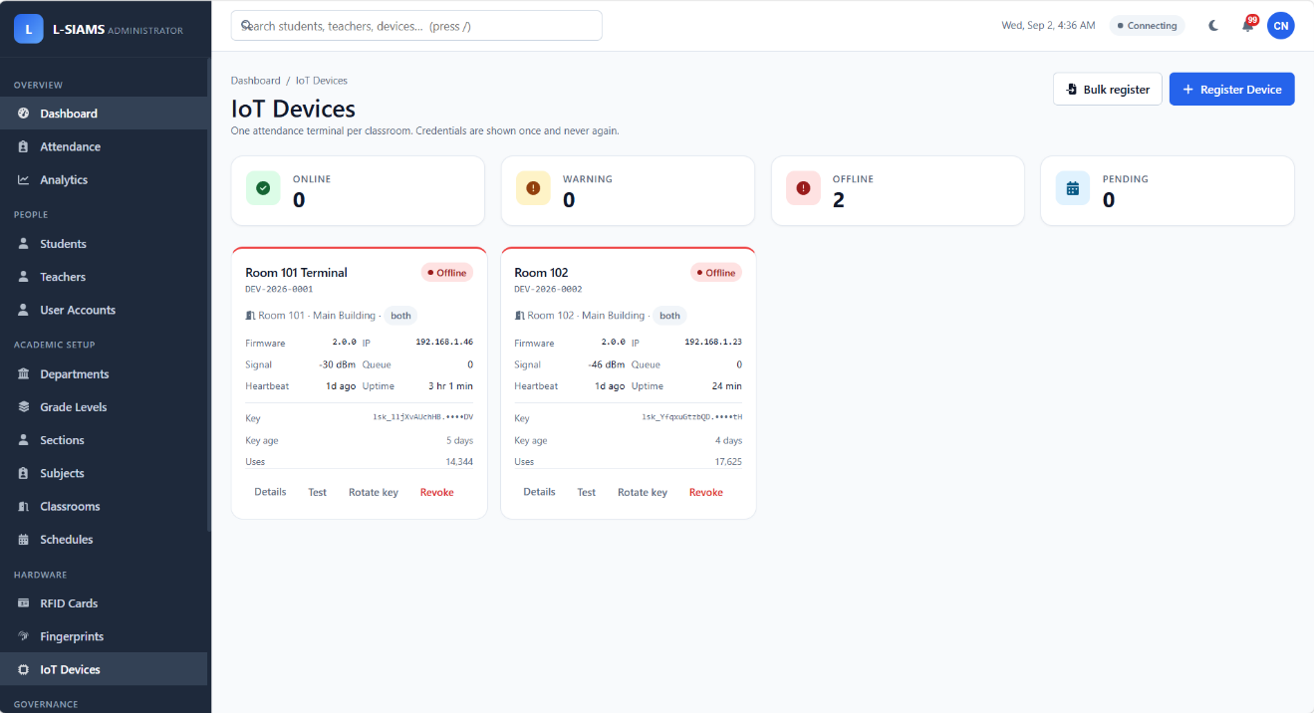
Registered IoT Terminal Registry
Every classroom terminal must be registered before it can transmit attendance data. Figure 16 shows the device registry, including each terminal’s identifier, assigned classroom, and connection state.

Figure 16
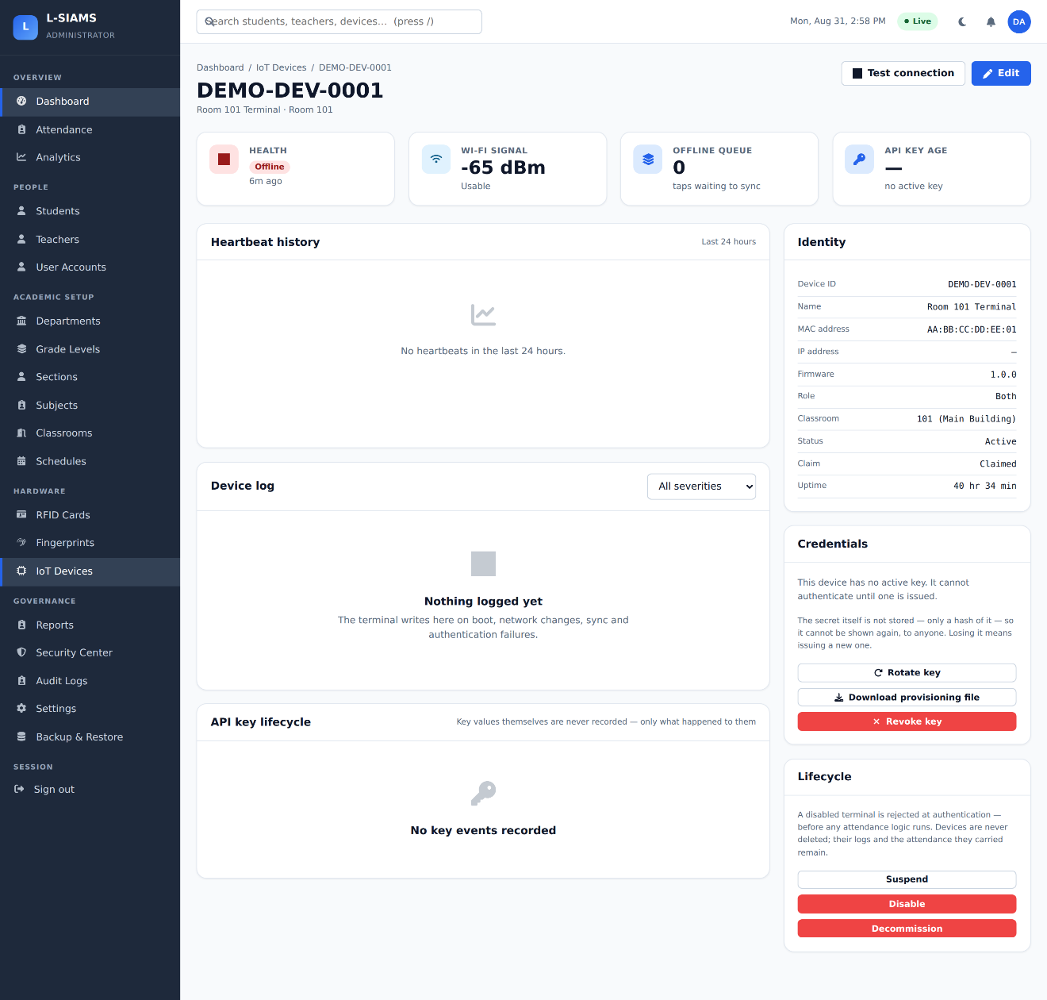
Terminal Detail and Credential Management
Figure 16 shows the detail view for an individual terminal, from which its credentials are issued, rotated, and revoked, and through which its recent activity and signature failures can be reviewed.

Figure 17
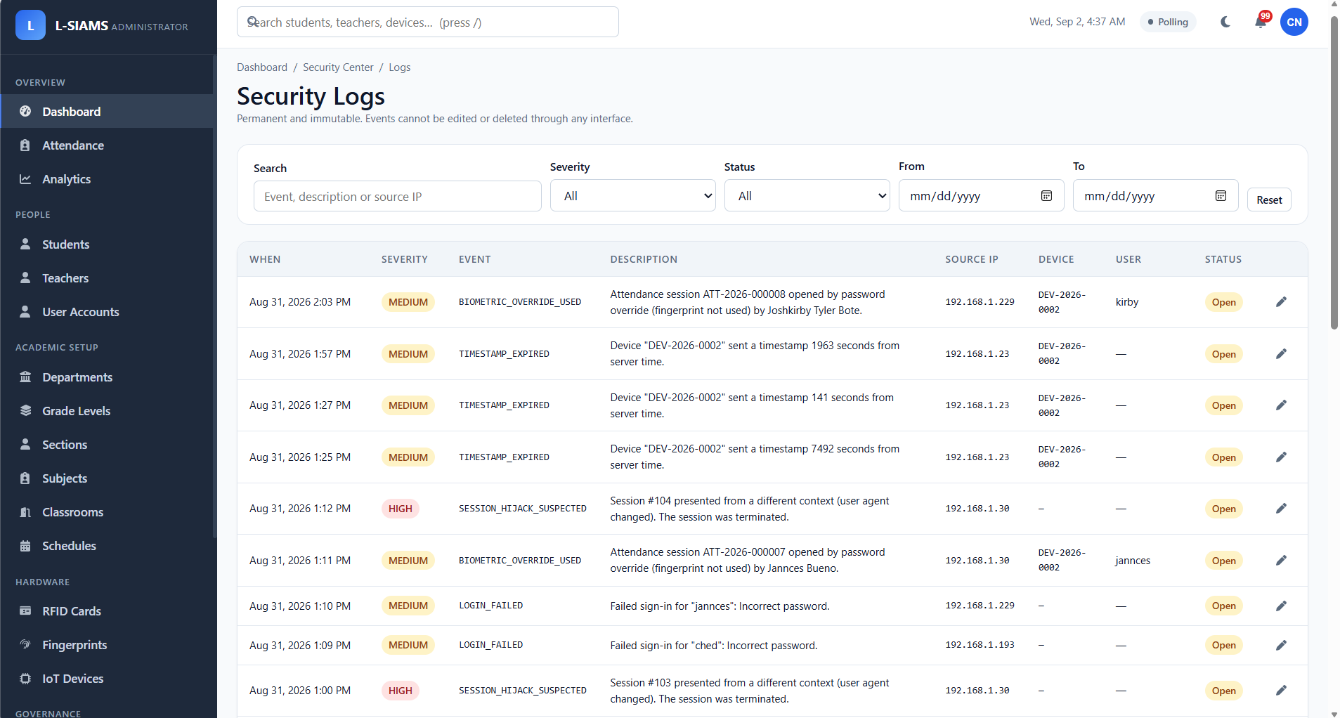
Security Event Log

Figure 17 shows the security event log, in which each recorded event carries its type, severity, source address, and resolution state, implementing the monitoring layer described in Section 4.8 and Table 10.

Figure 18
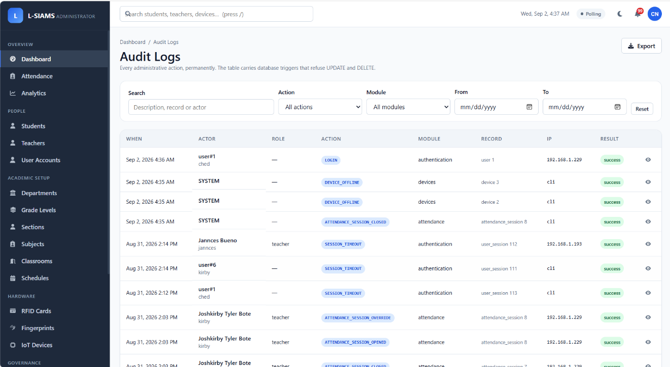
Audit Trail
Figure 18 shows the audit trail, which records administrative and attendance activity for accountability and provides the non-repudiation control mapped in Table 11.

Figure 19
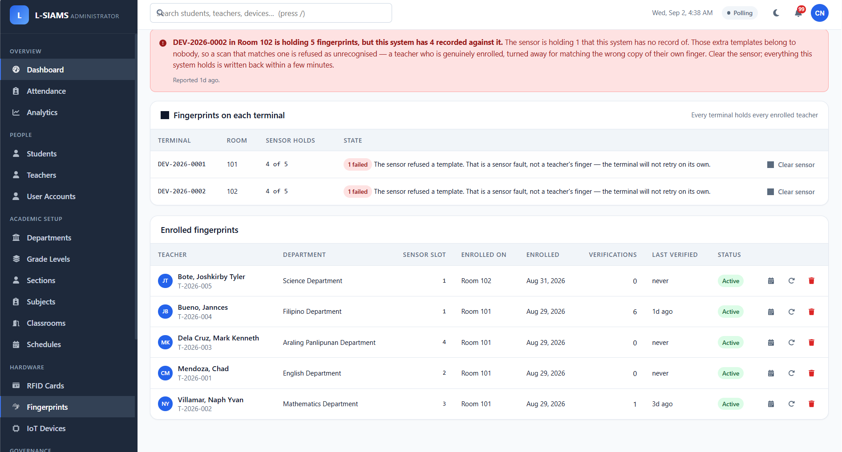
Fingerprint Enrolment
Figure 19 shows fingerprint enrolment for teaching staff, which establishes the biometric reference used to authorise the opening of an attendance session.

Figure 20
Administrator Dashboard
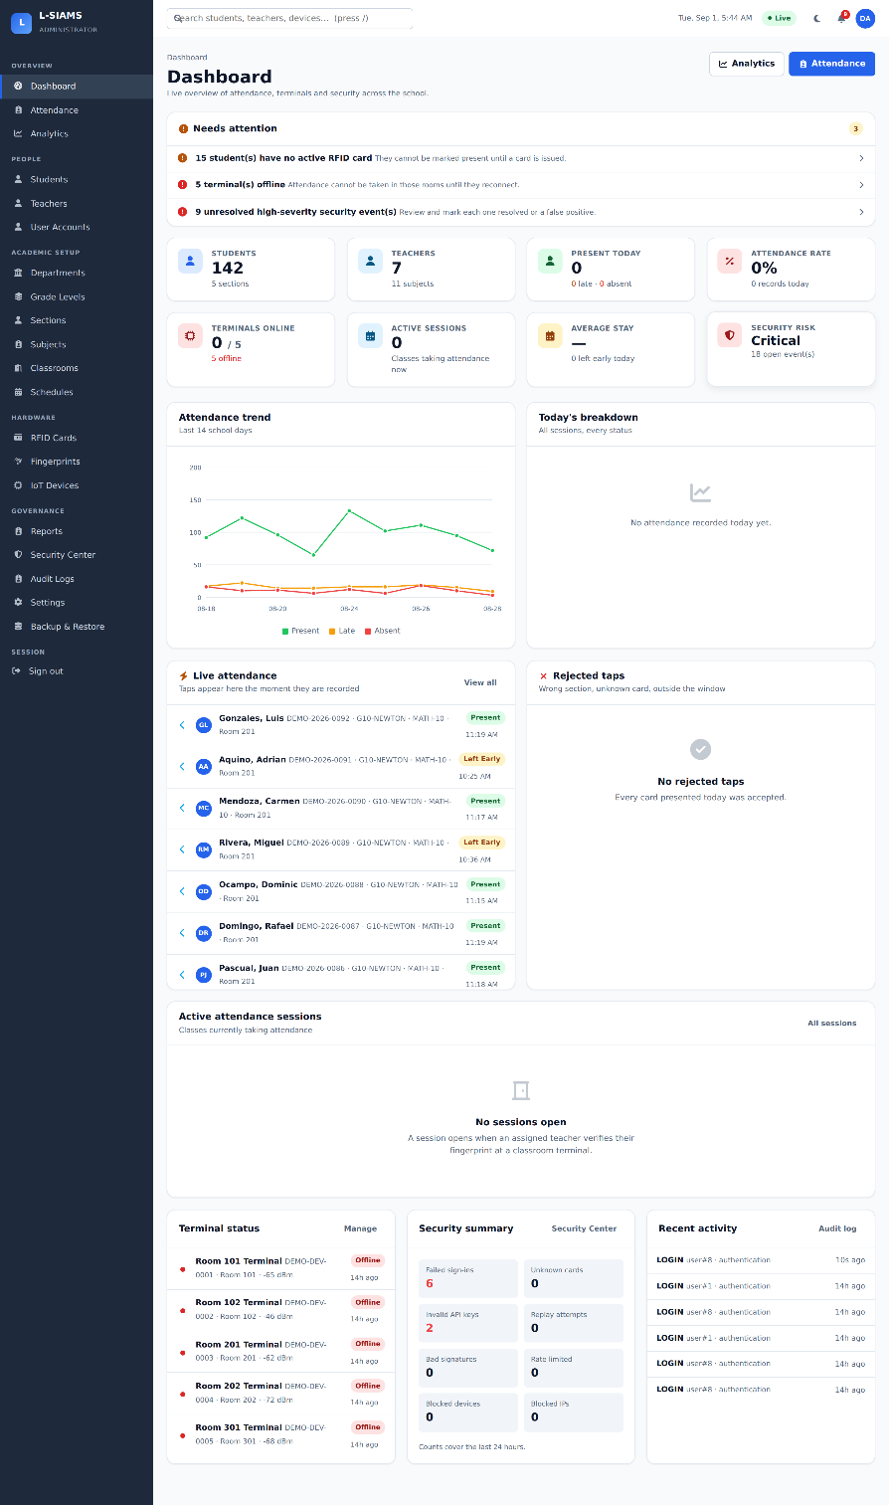

Figure 20 shows the administrator dashboard, which presents attendance trends, live tap activity, terminal connection status, and a security summary in a single view.

Figure 21
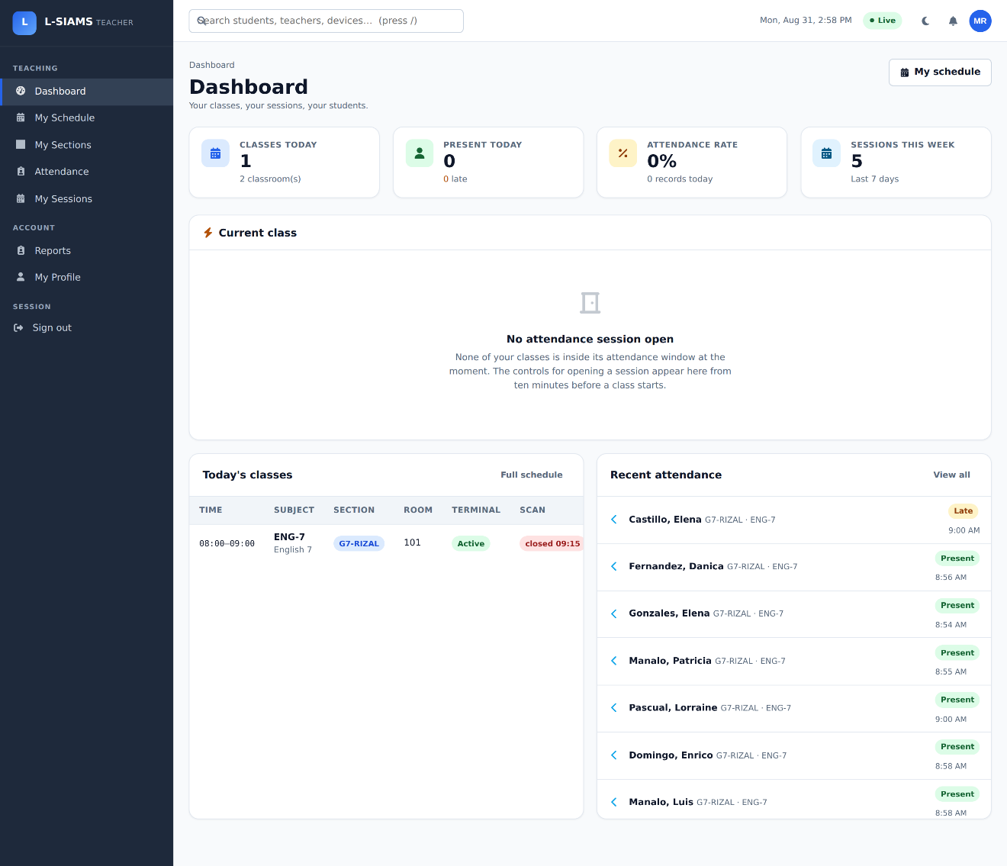
Teacher Portal Dashboard
Figures 21 show the teacher portal, which is restricted by role to the classes a teacher is actually scheduled to teach.

Figure 22
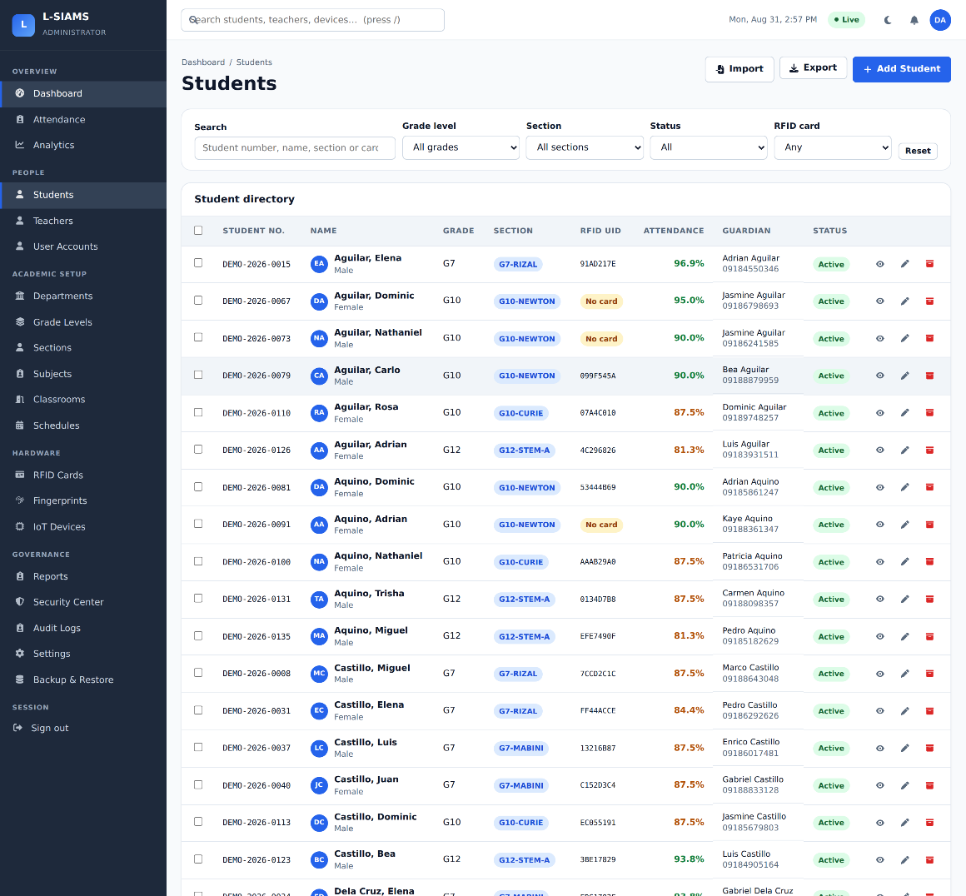
Student Register

Figures 22 show the student register configuration that determine which students are expected in which room at which time, and therefore which taps are valid.

Figure 23
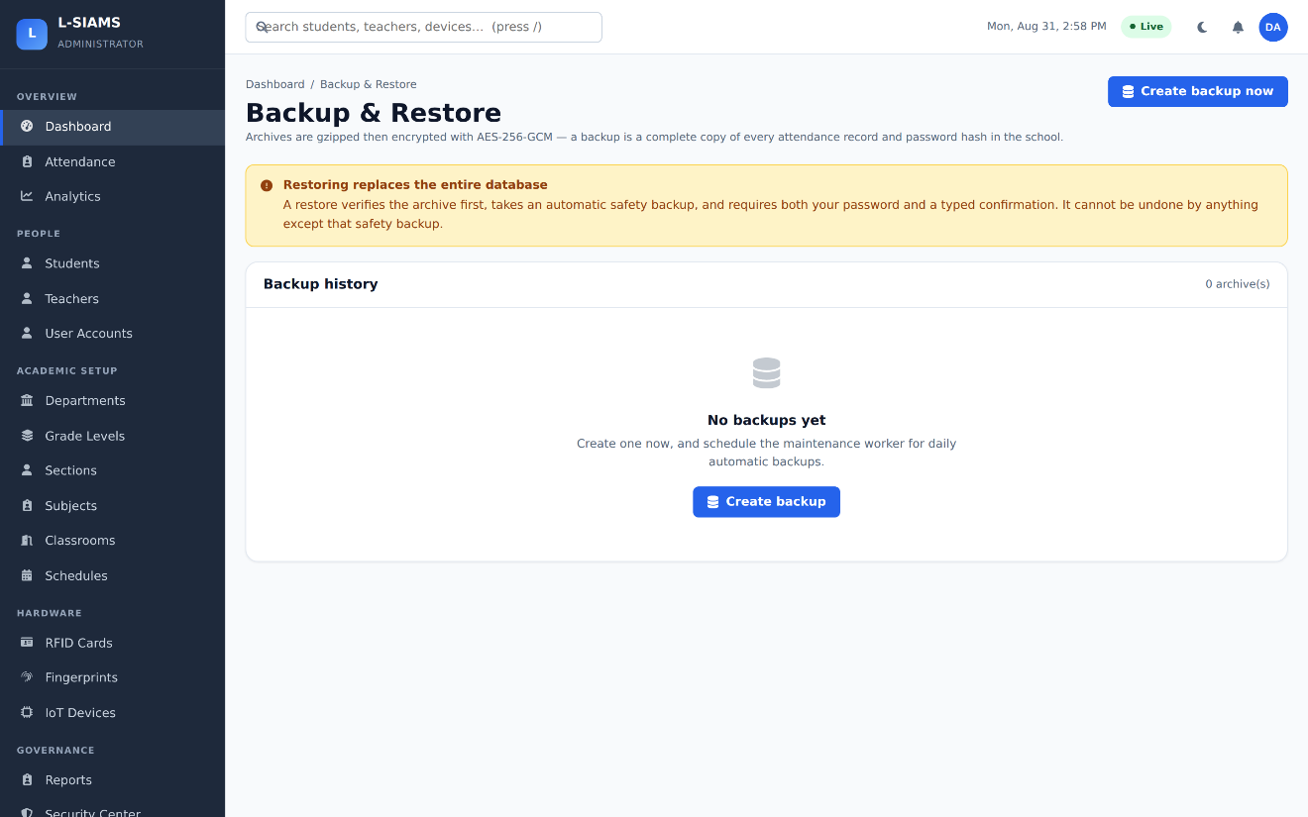
Backup and Restore

Figure 23 shows the backup and restore facility. Backups are encrypted, supporting the availability limb of the CIA triad by allowing the attendance record to be recovered after loss or corruption.

4.13.3 Penetration Testing Results
This section presents the results of the penetration testing described in Section 4.10. The tests were performed on September 26 and October 15, 2026, from a Kali Linux host on the same Local Area Network as the server, and were limited strictly to the owned and authorized system. Each test corresponds to a threat identified in the security plan (Table 2) and is presented here as evidence that the associated control operates as designed.
Secure transport (HTTPS/TLS). Figure 24 shows the traffic between an ESP32 terminal and the server captured in Wireshark. The TLS handshake is visible, after which all application data is transmitted as encrypted ciphertext. No card identifiers, credentials, or attendance records could be read from the captured stream, confirming that sensitive data is protected in transit.
Figure 24
Wireshark Capture of Terminal and Server Traffic
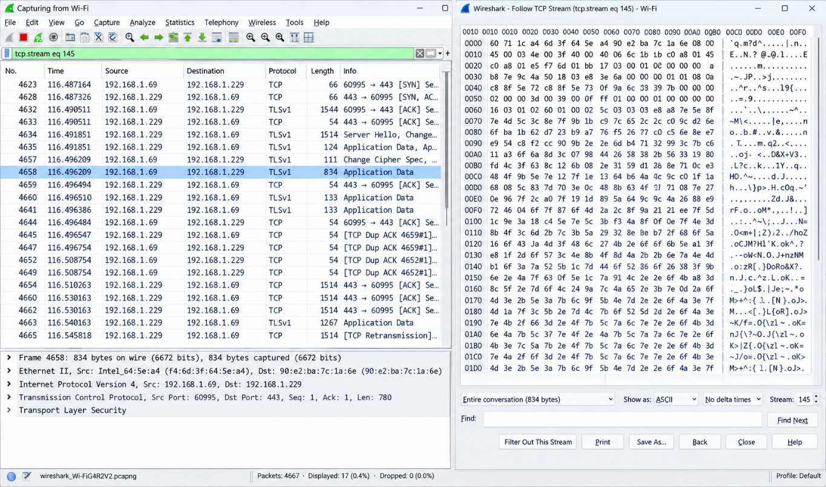

Brute-force resistance. Figure 25 shows the result of a controlled brute-force login test using Hydra. After the configured threshold of failed attempts, the account lockout and rate-limiting mechanisms blocked further attempts regardless of the password submitted, and no login succeeded. The corresponding lockout event recorded in the Security Center is shown in Figure 26, demonstrating that the attempt was both refused and logged.
Figure 25
Hydra Brute-Force Test Against the Sign-In Page
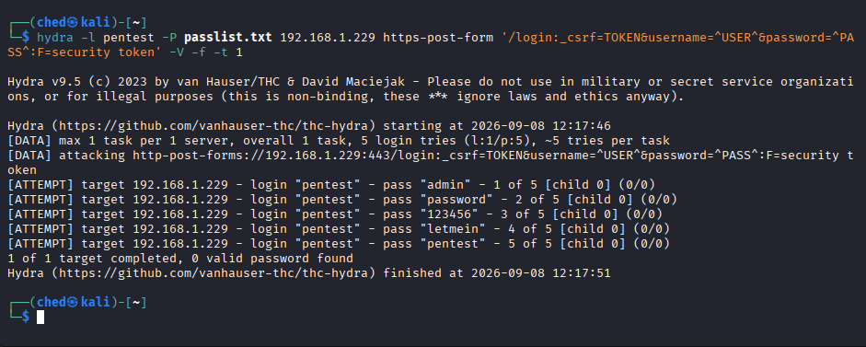
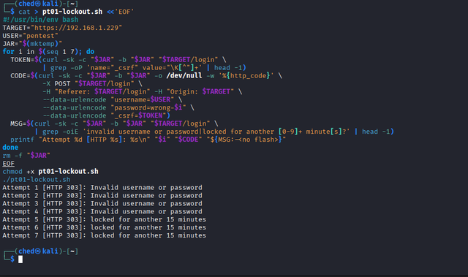

Account Lockout. Figure 26 shows the ACCOUNT_LOCKED event that the Security Center recorded during the Hydra brute-force test. After five failed sign-in attempts within 15 minutes, the configured threshold, the system locked the targeted account for 15 minutes, logged the event with a high severity together with the account name and the source IP address of the Kali Linux host, and notified the administrators. While the account was locked, every further attempt was refused even when the correct password was submitted. This confirms that the account lockout control both stopped the brute force attack and left a record of it, which satisfies the “no successful unauthorized access” and “complete logs generated” criteria of the security plan in Table 2.

Figure 26

Account Lockout Event in the Security Center

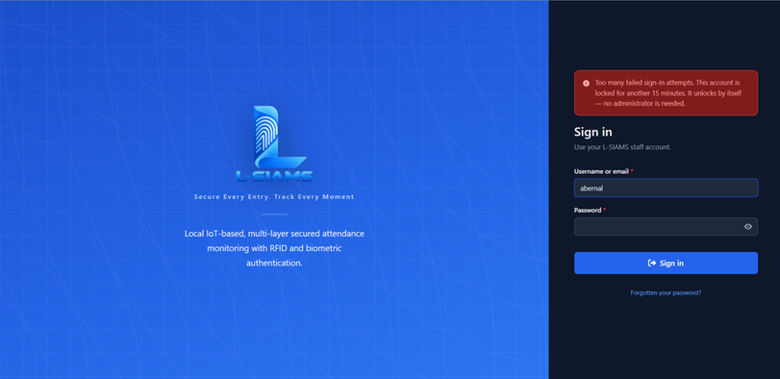

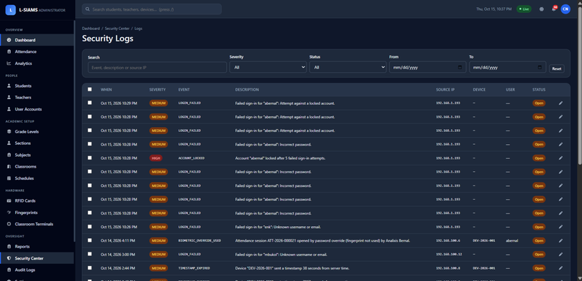

Port exposure. Figure 27 shows the Nmap scan of the server. Only the authorized ports required for system operation were found open: the HTTPS port serving the web application and the port serving the real-time monitoring channel - while the database port was not reachable from the LAN. No unnecessary services were exposed.
Figure 27
Nmap Scan of the L-SIAMS Server
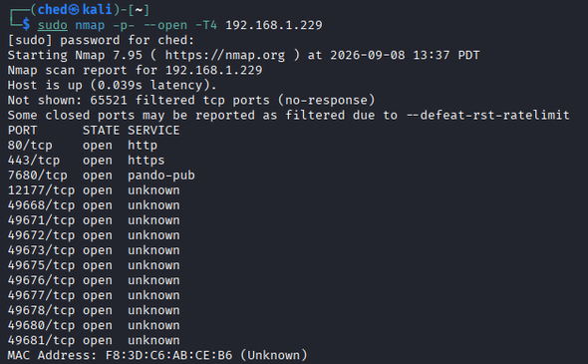
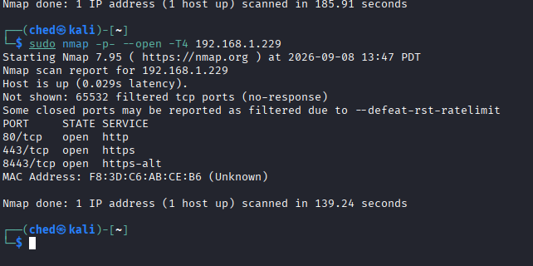

Device spoofing. Figure 28 shows attempts to access a device endpoint using an unregistered device identifier and a request without a valid signature. Each forged request was rejected by the device-authentication layer with an authentication error, and the matching security events are shown in the Security Center in Figure 29, confirming both real-time rejection and accountability.
Figure 28
Rejected Forged Device Requests
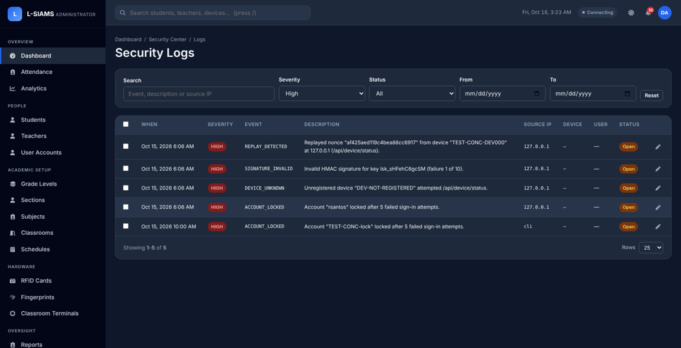
Figure 29
Device Authentication Events in the Security Center
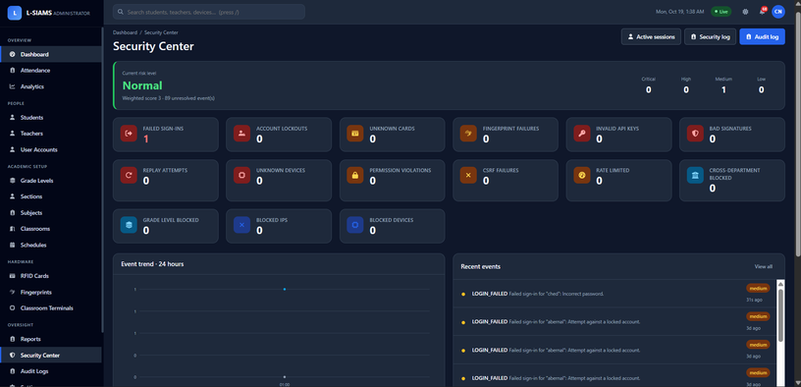
Summary. No vulnerabilities classified as High or Critical under the CVSS scale (Table 12) were identified during testing. Every security-relevant action performed during the tests produced a corresponding entry in the audit and security logs, satisfying the log-monitoring criterion of the security plan.

CHAPTER V
RESULTS AND DISCUSSION
This chapter presents what was accomplished and found in the development, testing, deployment and evaluation of L-SIAMS at Top Achievers Private School Inc. The system was deployed on two classroom terminals for Grade 6 Gold and Grade 6 Diamond from October 12 to 15, 2026, and attendance was recorded on October 13–14. Of the 21 sessions opened on those two days, the first two were test sessions and are excluded, leaving 19 class sessions. The results are presented in the order of the requirements, design and development of the system (Sections 5.1–5.3), the testing results, including the penetration testing of Objective 5 (Section 5.4), the evaluation results for Objectives 4.1 to 4.3 (Section 5.5), and the agency immersion and deployment results (Section 5.6), followed by a discussion.
5.1 Results of Requirements Analysis
The requirements identified in Chapter I were traced to the features implemented in the deployed system. Table 13 shows that every requirement under Objectives 1 to 3 was implemented and was exercised or evidenced during deployment.
Table 13
Requirements and Implemented Features
Requirement (Objective) | Implemented feature | Evidence
Capture attendance by RFID at classroom entry (1.1) | RFID terminal at each classroom door records tap-in and tap-out | 117 students tapped in during the 19 sessions (Table 20)
Verify teacher identity before a session opens (1.2) | Fingerprint verification opens a session only for the scheduled teacher; password failover | 18 of 18 enrolled-teacher sign-ins verified (Table 17)
Record student, date and time (1.3) | Each record stores the student, terminal, time-in, time-out and status | 562 complete records (Table 20)
Register users and devices (2.1) | Administration of users, teachers, students, RFID cards, fingerprints and terminals | Chapter IV, Section 4.13
Centralized database (2.2) | Single SQLite database on the school server | All records retrieved by the evaluation report
Reports and dashboards (2.3) | Dashboard, real-time monitoring, and reports exported as PDF, Excel and CSV | Chapter IV, Section 4.13
Encrypted communication (3.1) | HTTPS/TLS between terminals, browsers and server | TLS test suite; Table 15
Authentication and role-based access control (3.2) | Administrator and teacher roles; account lockout | 19 failed sign-ins refused (Table 16)
Controlled network access (3.3) | Network address allowlist; only required ports exposed | Table 15
Audit logging (3.4) | Audit trail and security event log | Every security event logged (Table 16)
Application-level security (3.5) | Cross-site request forgery protection, session timeout, session hijack detection | 2 session hijack attempts detected (Table 16)
Network and device security (3.6) | Per-device key, signed requests, timestamp and nonce checks | 4 invalid device claims and 27 replayed or expired requests rejected (Table 16)

5.2 Results of System Design
The finalized design is the one documented in Chapter IV: the layered architecture, the IoT terminal design, the network architecture, the application architecture, the database design, the data flow and the security architecture (Sections 4.2 to 4.8). Two aspects of the deployed form differ from the proposal and are reported here. First, the deployed edition, L-SIAMS-Lite, keeps its data in a single SQLite database file on the school server instead of a separate database server; the tables, the immutability of attendance and audit records, and the device API are unchanged. Second, the evaluation used two terminals, one per classroom, which bounds the scope of the results as stated in Chapter I.
5.3 Results of System Development
Table 14 lists the modules of the completed system, their status, and the evidence that each was developed and used.
Table 14
Module Development Status
Module | Status | Evidence
Classroom terminals (ESP32, MFRC522 RFID reader, AS608 fingerprint sensor) | Completed; 2 deployed | Chapter IV, Section 4.13.1
Session opening by fingerprint, with password failover | Completed | 10 sessions by fingerprint, 9 by password failover (Table 17)
Attendance recording: tap-in, tap-out, carry-over and automatic closing | Completed | 562 records (Table 20)
Administration of users, students, cards, fingerprints and terminals | Completed | Chapter IV, Section 4.13.2
Dashboard, real-time monitoring and reports | Completed | Chapter IV, Section 4.13.2
Security mechanisms: TLS, RBAC, device signing, network allowlist, audit and security logs, encrypted backups | Completed | Tables 15–16
Offline capture and synchronization | Implemented; not exercised during deployment | Section 5.6

5.4 Testing Results
During development, the transport-security test suite returned 40 passing assertions, and the concurrency and correctness suite verified that simultaneous taps of the same card produce a single record. The penetration testing of Objective 5 was performed on September 26 and October 15, 2026, from a Kali Linux host on the school’s Local Area Network (LAN), following the security plan in Table 2; the tests are described with their screenshots in Section 4.13.3. Their results are summarized in Table 15, and the security events that the system recorded during the two days of attendance recording are presented in Table 16 and Figure 30. Because the penetration tests were performed on September 26 and October 15, after the attendance data were collected, the events they produced are not included in Table 16.
Table 15
Penetration Testing Results
Threat | Tool | Result | Status
Unauthorized access | Hydra (Kali Linux) | Sign-in blocked after the lockout threshold; no attempt succeeded (Figures 25 and 26) | Pass
Packet interception | Wireshark | Only TLS-encrypted traffic observed; no readable sensitive data (Figure 24) | Pass
Open port exposure | Nmap (Kali Linux) | Only the HTTPS and real-time monitoring ports open; database port not reachable (Figure 27) | Pass
Device spoofing | Crafted HTTP requests (Kali Linux) | Unregistered and unsigned requests rejected and logged (Figures 28 and 29) | Pass
Log monitoring | Audit and security logs | Every test action recorded with its type, severity and source | Pass
Note. The tests follow the security plan in Table 2. Figures 24 to 29 are presented in Section 4.13.3.

Table 16
Security Events Recorded During Attendance Recording (October 13–14, 2026)
Event | Severity | Count | Meaning
TIMESTAMP_EXPIRED | Medium | 27 | Request with an expired timestamp (replay) rejected
LOGIN_FAILED | Medium | 19 | Sign-in with a wrong password refused
BIOMETRIC_OVERRIDE_USED | Medium | 9 | Session opened by password failover instead of fingerprint
CLAIM_TOKEN_INVALID | High | 4 | Device claim with an invalid token rejected
SESSION_HIJACK_SUSPECTED | High | 2 | Session used from a different client detected
FINGERPRINT_FAILURE_THRESHOLD | High / Medium | 1 / 1 | Repeated unmatched fingerprints on a terminal flagged
Note. Severity is the level the system assigns to the event when it is logged; it is not a vulnerability rating. The events were produced mainly by the researchers’ controlled tests and by deliberate use of the password failover.

Figure 30
Security Events Recorded During Deployment
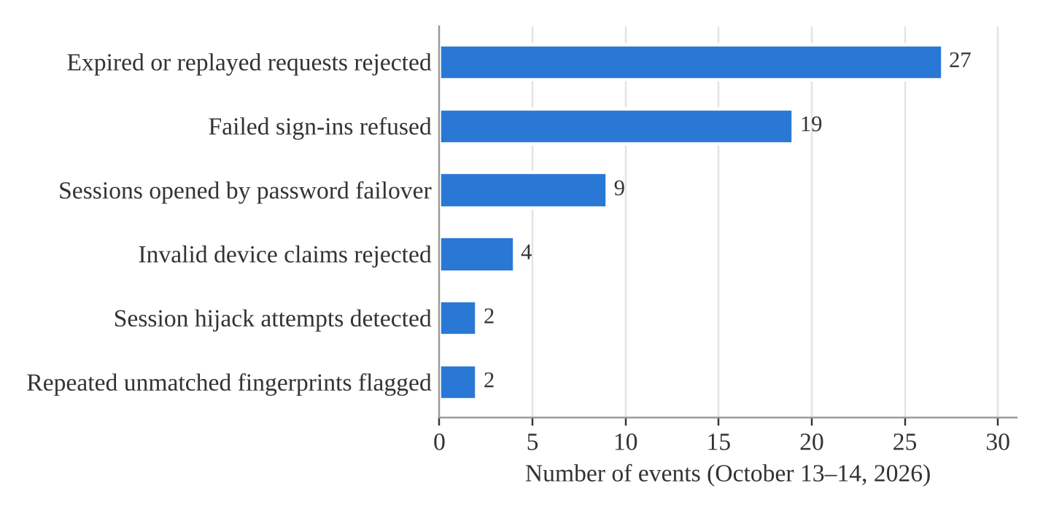
Figure 30 shows that expired or replayed requests (27) and failed sign-ins (19) were the most frequent events. Every one of them was refused by the system, and each was recorded with its type, severity and source.
Table 17
Teacher Identity Verification
Measure | Result
Class sessions opened | 19 (10 by fingerprint, 9 by password failover)
Fingerprint sign-in scans by enrolled teachers | 18 of 18 verified (100%)
Scans matching no active enrolment | 6, all refused
Verified teachers refused (class not theirs or not scheduled) | 10
Fingerprint enrolment attempts repeated | 2
Note. Fingerprint counts cover all scans on October 13–14, including enrolment and setup.

All five scenarios of the security plan passed, and no vulnerability classified as High or Critical under the Common Vulnerability Scoring System (CVSS) scale in Table 12 was identified. Each attack was stopped by a different control: signature, timestamp and nonce checks rejected forged and replayed terminal requests, account lockout and rate limiting refused password guessing, and session binding detected the reuse of a session from another client. Every fingerprint sign-in by an enrolled teacher was verified, meeting the 95% authentication criterion, while scans that matched no active enrolment and attempts to open a class a teacher was not scheduled to teach were refused. These results support Objective 5 within the scenarios tested; because the testing was controlled, they do not cover every real-world attack, as stated in the Scope and Limitations.
5.5 Evaluation Results
5.5.1 Processing Time, Queue Length and Efficiency
Table 18 presents the recording time of the five sessions in which a class queued at the terminal. Sessions with fewer than 10 taps were excluded because students arrived one at a time rather than in a queue.
Table 18
Recording Time in the Queue Sessions
Session | Date | Class | Students tapped | First to last tap (s) | Median interval (s)
ATT-2026-000003 | Oct 13 | G6 Diamond | 16 | 52 | 2.0
ATT-2026-000006 | Oct 14 | G6 Gold | 20 | 146 | 3.0
ATT-2026-000007 | Oct 14 | G6 Diamond | 14 | 89 | 6.0
ATT-2026-000012 | Oct 14 | G6 Diamond | 23 | 1,132* | 4.5
ATT-2026-000013 | Oct 14 | G6 Gold | 25 | 164 | 5.0
Mean |  |  |  |  | 4.10 (SD 1.60)
Note. *Includes students who arrived late after lunch; excluded from the whole-class time.

Figure 31
Time per Student in the Queue Sessions
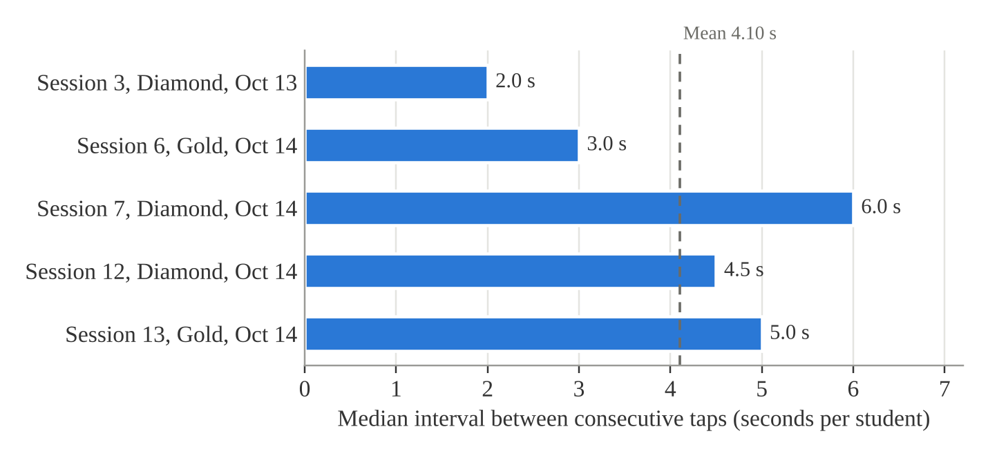
Figure 31 shows that the median interval between taps ranged from 2.0 to 6.0 seconds in the five queue sessions, around a mean of 4.10 seconds per student. Table 19 and Figure 32 compare this result with the manual roll call.
Table 19
Comparison of the Manual Roll Call and L-SIAMS
Measure | Manual roll call | L-SIAMS
Time per class | 3 min 46 s (226 s) for 29 students (stopwatch); 3–5 min (teachers’ estimate) | 52–164 s for 14–25 students in the queue
Time per student, periods with tap-in | 7.79 s | 4.10 s
Time per student, carried-over periods | 7.79 s (roll call repeated in every subject) | 0 s (attendance carried over; no tap needed)
Efficiency | Not applicable | 47.4% faster (periods with tap-in); 100% (carried-over periods)
Where students queue | Single RFID gate (Chapter I) | Each classroom door
Queue length | 20–30 at the gate (Chapter I) | 20–30 per classroom door (observed October 14)

Figure 32
Time per Student of the Manual Roll Call and L-SIAMS in Periods With Tap-In and in Carried-Over Periods
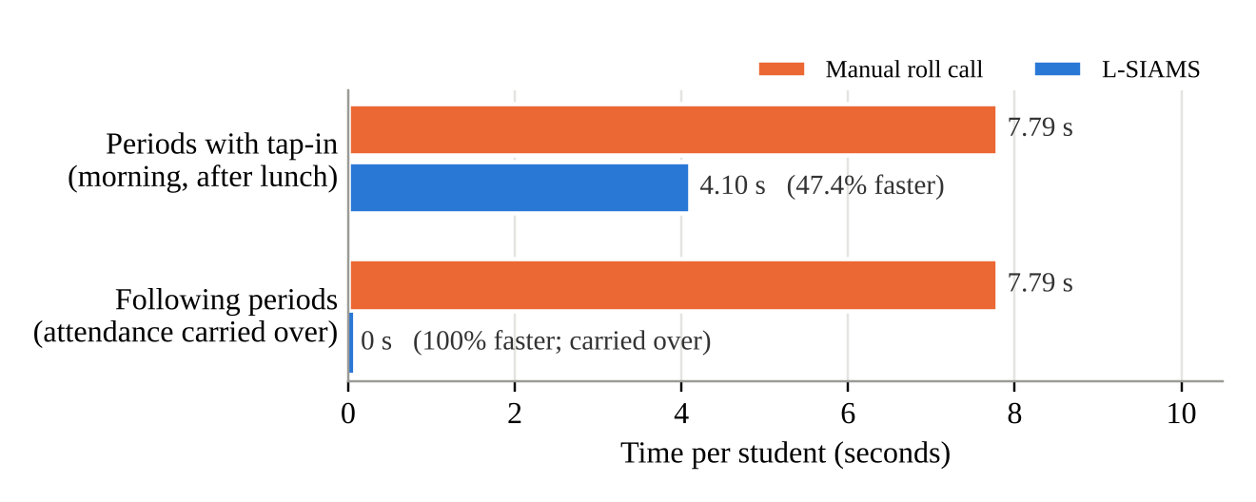
A whole class queuing at the door was recorded in 52 to 164 seconds, at a mean of 4.10 seconds per student, or about 15 students per minute. The stopwatch timing of a manual roll call recorded 3 minutes and 46 seconds (226 seconds) for a class of 29 students, or 7.79 seconds per student, which agrees with the teachers’ report in interviews that a roll call takes 3 to 5 minutes depending on the number of students. The system therefore recorded attendance 47.4 percent faster per student. This applies to the periods in which students tap in, which during the deployment were the first period of the morning and the first period after lunch. In the following periods of the day, students who stayed in the room were carried over automatically from the previous period, so neither tapping nor a roll call was needed; 303 of the 562 records were created this way (Table 20). Since the manual roll call is repeated by every teacher in every subject, these periods reduced the time spent on attendance from 7.79 seconds per student, or 3 minutes and 46 seconds for a class of 29, to none, a reduction of 100 percent, as Figure 32 shows. Because the manual roll call was timed for one class only, the comparison is descriptive and no paired t-test was performed. The stopwatch record of the manual roll call is presented in Appendix G, and the photographs of the queue in Appendix I. Congestion moved from the single school gate to the classroom doors: lines of 20 to 30 students still formed, but each line held only one class and cleared in under three minutes. The students’ ratings agree: tapping was rated faster than the roll call (Form 2, Q1, 4.45), while waiting in line received the lowest student rating (Q2, 3.65).
5.5.2 Accuracy of Attendance Records
Table 20
Attendance Records and Accuracy (19 Class Sessions)
Measure | Count | Percentage
Students who tapped in | 117 | 20.82%
Carried over from the previous period | 303 | 53.91%
Absent (no tap) | 142 | 25.27%
Total records | 562 | 100.00%
Records matching the manual roll call | 562 | 100.00%
Present students timed out by tapping out | 12 | 2.86% of 420
Present students released early by the teacher | 1 | 0.24% of 420
Present students closed automatically at session end | 407 | 96.90% of 420
Students recorded twice in one session | 0 | 0.00%

Figure 33
Attendance Records by Type
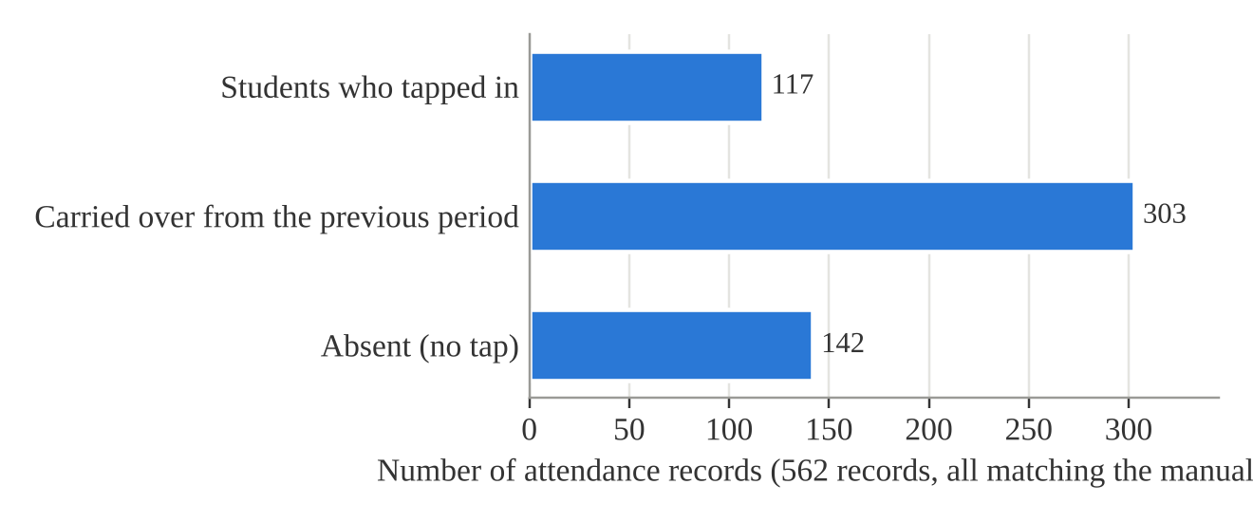
Figure 33 shows that more than half of the records (303) were carried over from the previous period, because students who stayed in the room for the next subject did not need to tap again; 117 were made by tapping in and 142 were absences.
All 562 attendance records of the 19 class sessions matched the teachers’ manual roll call, for an accuracy of 100 percent, exceeding the 95 percent criterion of Objective 4.2. No student was recorded twice: five repeat taps were ignored, and 34 taps made before a session was open were refused. Every present student received a time-out, but students rarely tapped out (12 of 420); departure was recorded mainly by the automatic closing of sessions.
5.5.3 Security Evaluation Using ISO/IEC 27001 and the CIA Triad
Table 21
Profile of Respondents
Respondent group | Frequency | Percentage
Students | 51 | 79.69%
Teachers | 10 | 15.63%
IT administrators | 2 | 3.13%
School administrator | 1 | 1.56%
Total | 64 | 100.00%

Table 22
Security Evaluation by CIA Dimension
Dimension | Respondents | Items | Mean | SD | Cronbach’s α | Interpretation
Confidentiality (Form 1, Part A) | 13 staff | 9 | 4.62 | 0.68 | 0.91 | Very High
Integrity (Form 1, Part B) | 13 staff | 9 | 4.67 | 0.63 | 0.92 | Very High
Availability (Form 1, Part C) | 13 staff | 9 | 4.56 | 0.65 | 0.85 | Very High
Staff security grand mean | 13 staff | 27 | 4.61 | 0.65 | 0.96 | Very High
Keeping attendance safe (Form 2, Part A) | 51 students | 6 | 4.25 | 0.92 | 0.62 | Very High

Figure 34
Security Evaluation by CIA Dimension
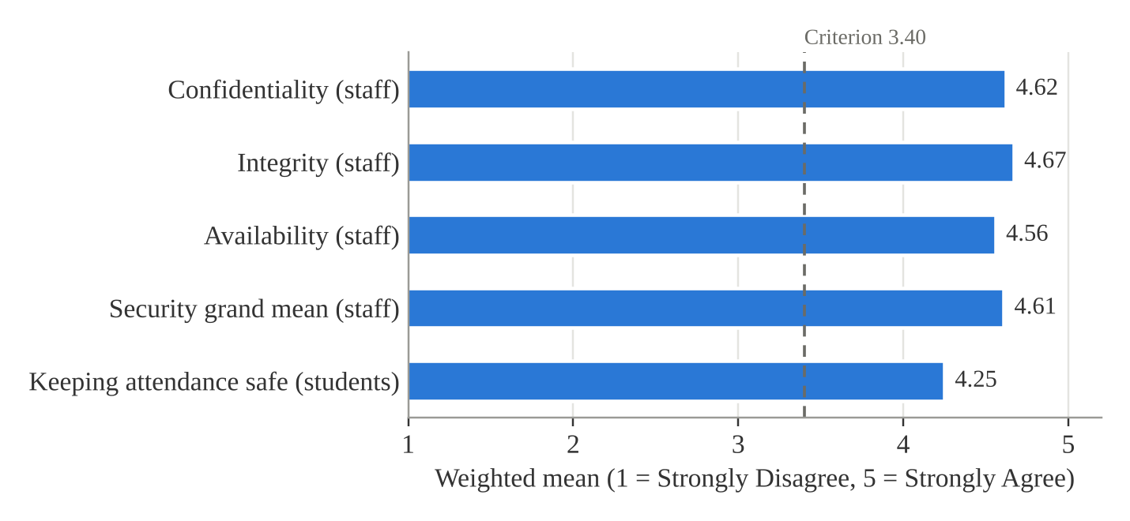
Figure 34 shows that every dimension, for both the staff and the students, lies well above the 3.40 criterion.
Table 23
Part D Technical Control Checklist
Measure | IT administrator 1 | IT administrator 2
Points earned (of 30) | 30 | 30
Compliance | 100% | 100%
Controls restating Table 8 criteria rated Yes | 6 of 6 | 6 of 6

The 13 staff rated all three dimensions Very High, with Integrity highest (4.67), Confidentiality next (4.62) and Availability lowest (4.56), for a security grand mean of 4.61; of their 351 ratings, 91.17 percent were Agree or Strongly Agree. The 51 students rated their part 4.25, also Very High. Both IT administrators rated all 15 technical controls Yes. Every result exceeds the 3.40 criterion, so the implemented controls are judged effective on all three dimensions of the CIA Triad (Objective 4.3). The highest-rated items were A1, only users with a valid account can sign in, and B8, terminal times match the school’s official time (both 4.92). The lowest were A5, account lockout, and B2, a tap is not recorded twice (both 4.31), and among students S3, the same protection against double taps (3.96), although the system logs show that no student was recorded twice. Internal consistency was acceptable for the staff dimensions (α 0.85 to 0.96) but below 0.70 for the student part (α 0.62), so the student result should be read with caution.
5.5.4 Usability, Performance and Reliability
Objective 4.3 also called for the assessment of usability, performance and reliability using measurable indicators. Usability was measured with the User Acceptance Testing (UAT) form: ease of use was rated 5.00 and the user interface 4.92, both Very High (Table 24). Performance was indicated by the recording time of 4.10 seconds per student (Table 18) and by the UAT rating for responsiveness, 4.85. The measured response time of the system was 11.7 milliseconds, well within the criterion of less than two seconds in Table 8. Reliability was indicated by the completeness of the records: every one of the 562 records in the 19 class sessions received a final status, the terminals reconnected after 15 lost connections without losing a tap, and the staff rated accuracy 4.85 and Availability 4.56. Because no tap was made while a terminal was offline, the offline synchronization was not exercised and the data synchronization criterion in Table 8 could not be measured.
5.6 Agency Immersion and Deployment Results
The system was deployed at Top Achievers Private School Inc. from October 12 to 15, 2026, with one terminal in each of the Grade 6 Gold and Grade 6 Diamond rooms. Teachers’ fingerprints and students’ RFID cards were enrolled before the class sessions; two sessions opened on October 13 served as tests. An orientation on the use of the system was conducted on October 12, 2026, for two hours, attended by all participating teachers, the IT administrators and the school principal; its attendance sheet is presented in Appendix I. Twenty-one sessions were opened on October 13–14, 19 of them for classes. The evaluation instruments were administered and the penetration tests performed on October 15, and 64 respondents took part in the evaluation.
The issues encountered and the actions taken were as follows. Two fingerprint enrolments failed because the two scans did not match or no usable image was captured, and were repeated. Six scans during setup matched sensor templates not linked to an active enrolment and were refused as designed. Nine sessions were opened through the password failover, each logged by the system. The terminals reported 15 lost connections, but no tap was made while a terminal was offline, so no attendance had to be synchronized later. Students rarely tapped out, so departure was recorded mainly by automatic closing.
Table 24
User Acceptance Test Results
Criterion | Mean | Interpretation | Rank
Ease of use | 5.00 | Very High | 1
User interface | 4.92 | Very High | 2
Accuracy | 4.85 | Very High | 3.5
Responsiveness | 4.85 | Very High | 3.5
Overall satisfaction | 4.83 | Very High | 5
Support for organizational requirements | 4.69 | Very High | 6
Grand mean (77 ratings) | 4.86 | Very High

Figure 35
User Acceptance Test Results
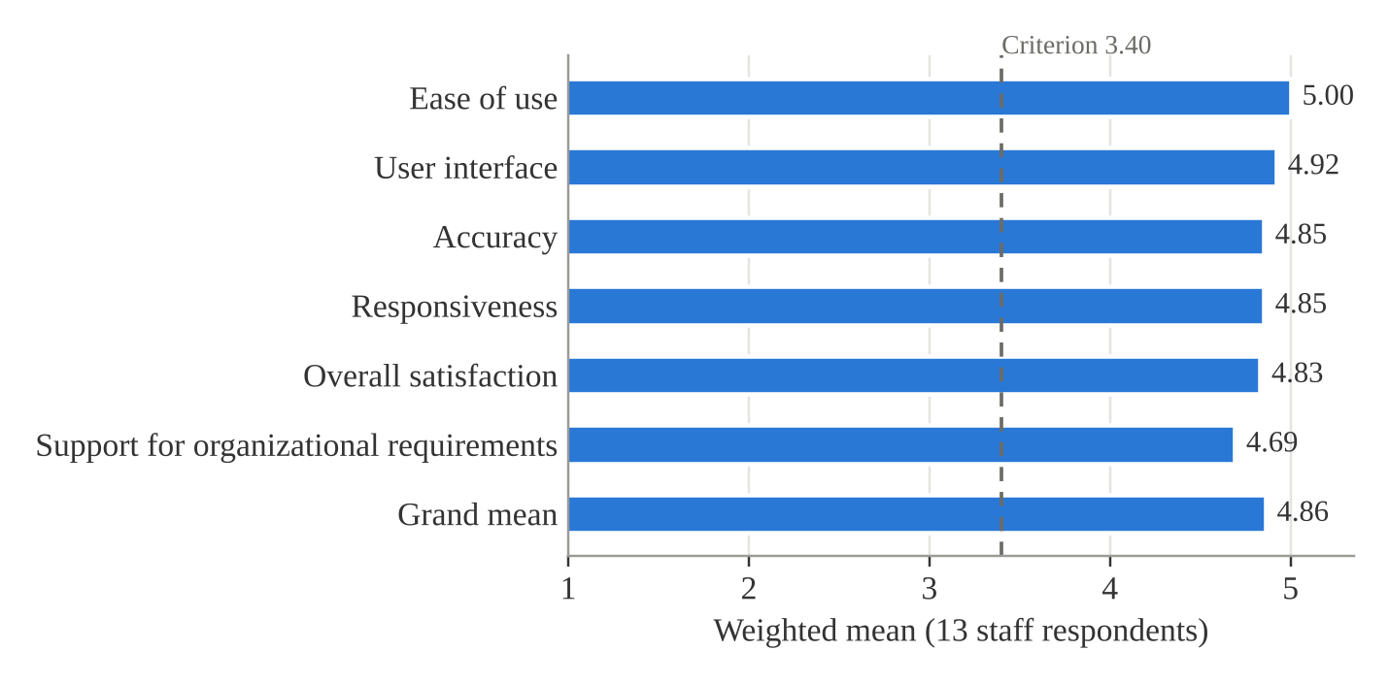
As Table 24 and Figure 35 show, the 13 staff accepted the system: every UAT criterion was rated Very High and the grand mean was 4.86, above the 3.40 criterion, with no rating below Agree. Teachers asked for a beep confirming that their fingerprint was recognized and for a quick user guide for faculty. In addition, the staff rated using L-SIAMS compared with the manual method at 4.96 (Form 1, Part E) and the students rated using the terminal at 4.26 (Form 2, Part B). After the evaluation, the terminals were removed from the classrooms, and the system is currently not in use at TAPS.
Figure 36 shows the orientation of the teachers, the IT administrators and the school principal on October 12, 2026, and Figure 37 shows one of the classroom terminals installed at the door during the deployment.
Figure 36
Orientation of Teachers and IT Administrators (October 12, 2026)
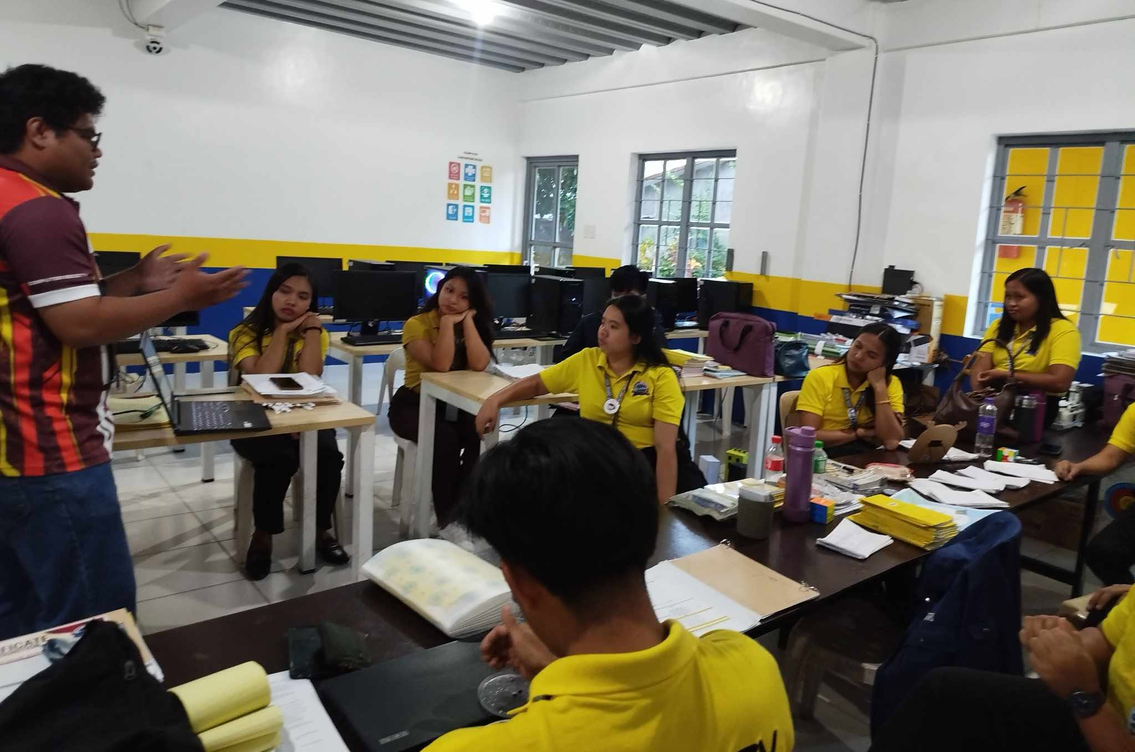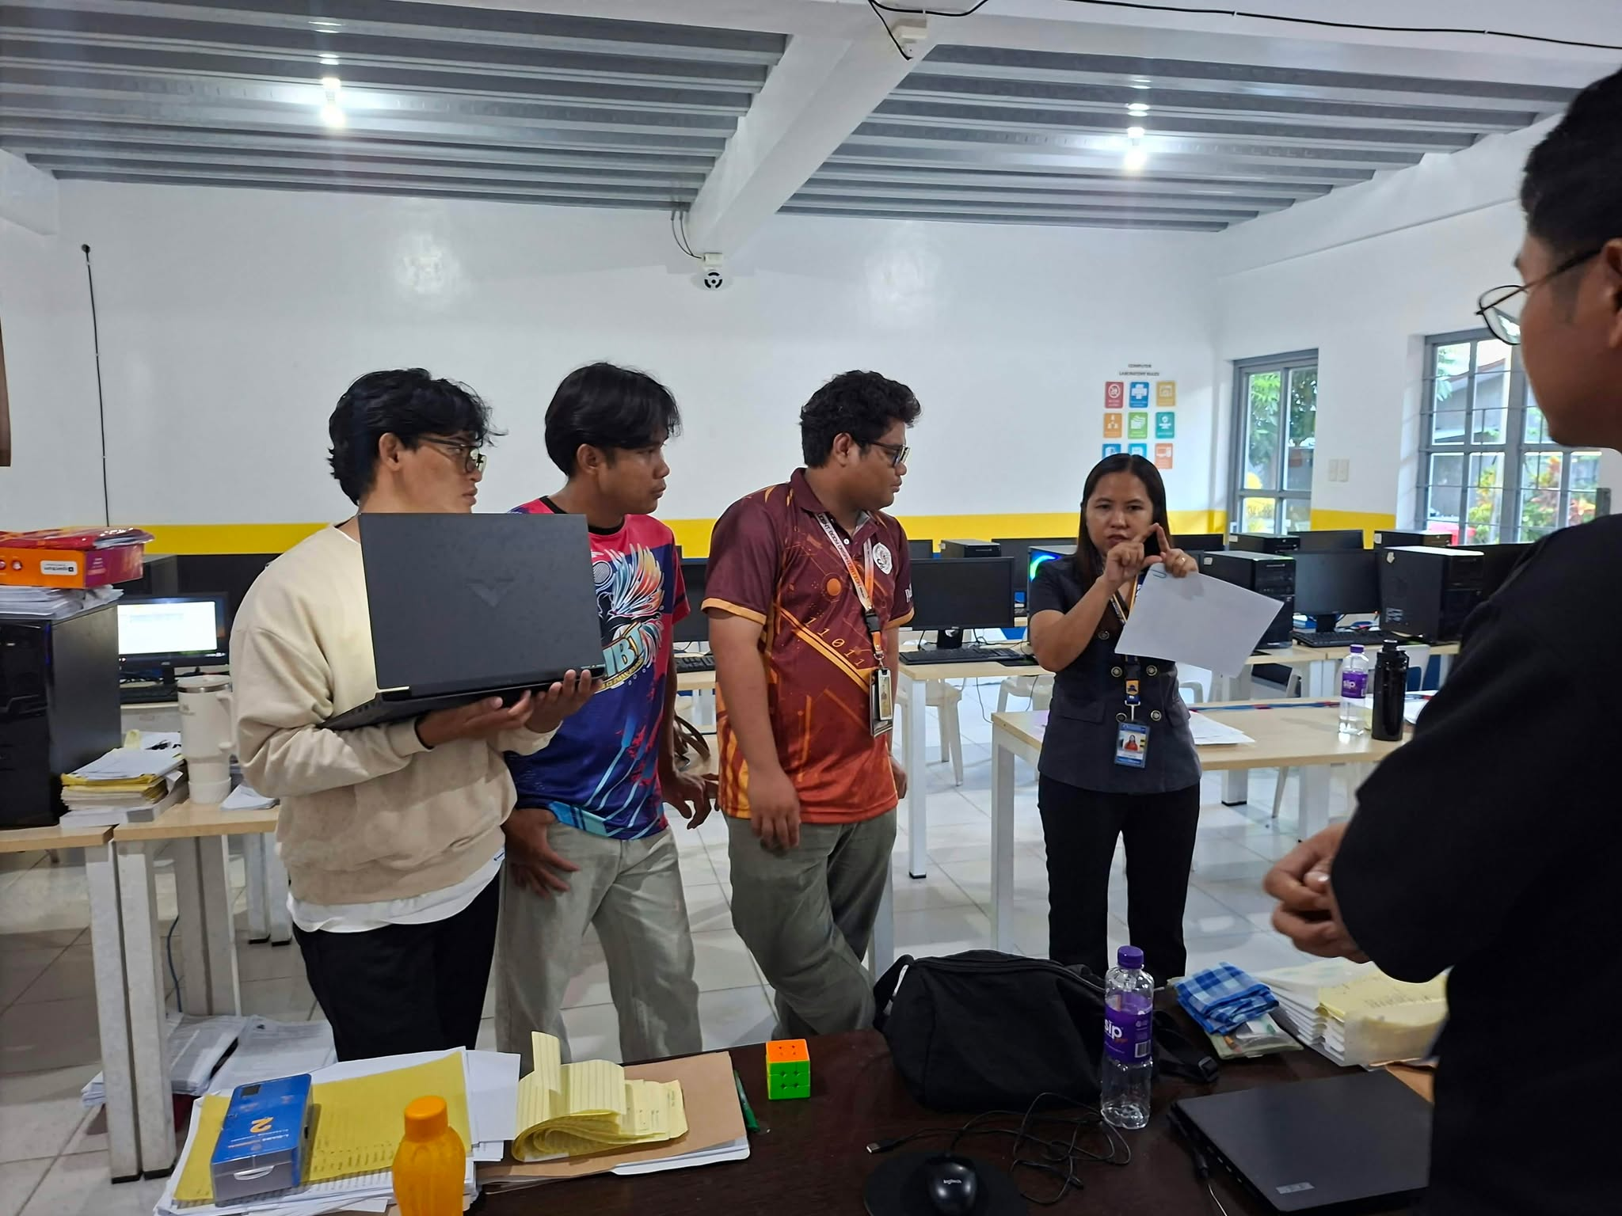
Figure 37
Classroom Terminal Deployed at Top Achievers Private School Inc.
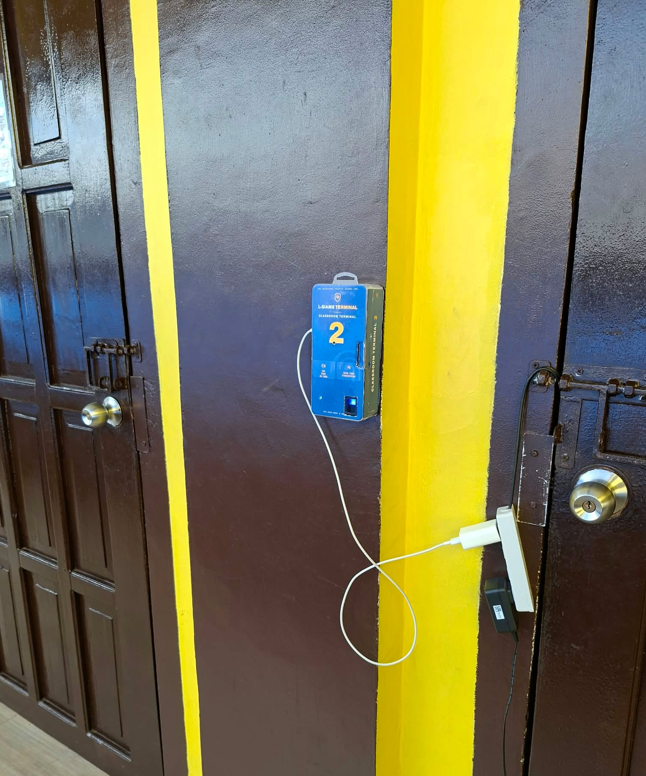

Discussion
The results show that L-SIAMS met the criteria set for it at the partner school. Recording attendance at the classroom door took 47.4 percent less time per student than the manual roll call in the periods in which students tapped in, and no time at all in the following periods, in which attendance was carried over; it also matched the manual record in all 562 cases, consistent with studies reviewed in Chapter II that found IoT-based attendance systems reduce manual work and improve accuracy (Shrivastava et al., 2023). The system went further than those studies in two respects that the literature identified as gaps: every session required the teacher to prove identity, by fingerprint or through the logged password failover, and the multi-layer security controls blocked every attack whose results were recorded.
The security results agree across three independent kinds of evidence: the controlled tests, the system’s own security logs, and the evaluation of the users and IT administrators. This supports the position of Ahmad et al. (2022) that encryption and role-based authentication are needed to protect IoT systems in educational environments, and it addresses the weaknesses of connected devices described by Neshenko et al. (2019). The lower ratings on double taps and lockout point to protections that work but are not visible to users, and the remaining line at the classroom door shows that one terminal per room still produces a short wait. Both findings are carried into the recommendations in Chapter VI.

CHAPTER VI
SUMMARY OF FINDINGS, CONCLUSION AND RECOMMENDATIONS
This chapter summarizes the findings of the study, presents the conclusions drawn from them for each objective, and gives recommendations for the school, the users of the system and future researchers.
6.1 Summary of Findings
The study developed and evaluated L-SIAMS, a secure IoT-based attendance monitoring system with RFID and fingerprint authentication, at Top Achievers Private School Inc. The system was deployed on two classroom terminals for Grade 6 Gold and Grade 6 Diamond from October 12 to 15, 2026. After two test sessions were excluded, 19 class sessions and 562 attendance records were evaluated, and 64 respondents (51 students, 10 teachers, 2 IT administrators and 1 school administrator) took part in the evaluation. The findings are summarized below by objective.
1. Design and implementation of the IoT hardware (Objective 1). Classroom terminals built on the ESP32 microcontroller, the MFRC522 RFID reader and the AS608 fingerprint sensor were completed and deployed. Students tapped in at the classroom door, and a session opened only after the scheduled teacher was verified. Of the 19 class sessions, 10 were opened by fingerprint and 9 by the logged password failover. All 18 fingerprint sign-ins by enrolled teachers were verified (100%), while 6 scans that matched no active enrolment and 10 attempts to open a class the teacher was not scheduled to teach were refused. Every record stored the student, terminal, time-in, time-out and status.
2. Development of the locally hosted system (Objective 2). The administration of users, teachers, students, RFID cards, fingerprints and terminals, the centralized SQLite database, the dashboard, real-time monitoring and the PDF, Excel and CSV reports were completed. All 562 records of the evaluation were retrieved from the database by the evaluation report.
3. Implementation of the security mechanisms (Objective 3). Encrypted communication over HTTPS/TLS, authentication with role-based access control and account lockout, the network address allowlist, audit and security logging, application-level protections and device authentication with signed requests were implemented. The transport-security test suite returned 40 passing assertions. During deployment the system refused and logged 19 failed sign-ins, 27 expired or replayed requests and 4 invalid device claims, and it detected 2 session hijack attempts (Tables 15 and 16).
4. Processing time, queue length and efficiency (Objective 4.1). A class queuing at the door was recorded in 52 to 164 seconds, at a mean of 4.10 seconds per student (SD 1.60), compared with 7.79 seconds per student for a manual roll call timed with a stopwatch (3 minutes and 46 seconds for 29 students). The system was 47.4 percent faster per student in the periods in which students tapped in, and 100 percent faster in the following periods, in which attendance was carried over without tapping or a roll call. Lines of 20 to 30 students still formed, but at each classroom door instead of the single school gate, and each line cleared in under three minutes.
5. Accuracy of attendance records (Objective 4.2). All 562 system records matched the teachers’ manual roll call, for an accuracy of 100 percent. No student was recorded twice; five repeat taps were ignored and 34 taps made before a session was open were refused. Students rarely tapped out (12 of 420 present students), so departure was recorded mainly by the automatic closing of sessions.
6. Usability, performance, reliability and security evaluation (Objective 4.3). The 13 staff rated every User Acceptance Testing (UAT) criterion Very High, with a grand mean of 4.86; ease of use was rated highest (5.00) and support for organizational requirements lowest (4.69). Under ISO/IEC 27001 and the CIA Triad, the staff rated Confidentiality 4.62, Integrity 4.67 and Availability 4.56, for a security grand mean of 4.61 (Very High, α 0.96), and the 51 students rated their part 4.25 (Very High, α 0.62). Both IT administrators rated all 15 technical controls in the Part D checklist Yes (100% compliance). The lowest-rated items concerned protection against double taps and account lockout. The measured response time of the system was 11.7 milliseconds, within the two-second criterion; all 562 records received a final status, and the terminals recovered from 15 lost connections without losing a tap, although the offline synchronization was not exercised. Teachers asked for a beep confirming that their fingerprint was recognized and for a quick user guide for faculty.
7. Penetration testing (Objective 5). All five scenarios of the security plan passed. Wireshark showed only TLS-encrypted traffic between the terminals and the server, Hydra brute-force attempts were blocked after the lockout threshold, the Nmap scan found only the authorized ports open, and forged device requests were rejected and logged. No vulnerability classified as High or Critical was identified.
6.2 Conclusion
Based on the findings, the following conclusions were drawn:
1. The IoT hardware met Objective 1. Attendance can be captured at the classroom door by RFID, and no session can be opened without verifying the teacher, either by fingerprint or through a password failover that the system logs. The number of sessions opened by failover (9 of 19) shows that fingerprint sign-in, though fully accurate for enrolled teachers, still depends on careful enrolment.
2. The locally hosted system met Objective 2. Users and devices can be registered, records are kept in one centralized database, and reports and dashboards are available for monitoring.
3. The security mechanisms of Objective 3 work as designed: during deployment they refused and logged every failed sign-in, replayed request and invalid device claim.
4. L-SIAMS is more efficient than the manual roll call (Objective 4.1). It reduced the time needed to record each student by 47.4 percent in the periods in which students tap in and removed it entirely in the periods in which attendance is carried over, and it moved congestion from the school gate to shorter lines at each classroom door. Because the manual roll call was timed for one class only, this conclusion is descriptive rather than statistical.
5. L-SIAMS records attendance accurately (Objective 4.2). Its 100 percent agreement with the manual roll call exceeds the 95 percent criterion, and its safeguards against duplicate and early taps worked in every case.
6. The system met Objective 4.3 for usability and security. The intended users accept the system, all acceptance criteria were rated Very High, and the security controls are effective on all three dimensions of the CIA Triad as guided by ISO/IEC 27001. The student security result should be read with caution because of its lower internal consistency. Its performance met the response-time criterion, and its reliability is supported by the complete records and the users’ ratings; only the offline synchronization remained untested.
7. The implemented security controls withstood the penetration tests of Objective 5. Each attack was stopped by a different control and left a trace in the logs, so the multi-layer approach of the system was effective within the scenarios tested.
Overall, L-SIAMS achieved its general objective: it provides secure, accurate and efficient classroom attendance monitoring at the partner school, within the two-classroom scope of the October 12–15, 2026 deployment.
6.3 Recommendations
Based on the findings and conclusions, the following are recommended:
For the school and the users of the system:
1. Add an audible beep and a clear on-screen message when a teacher’s fingerprint is recognized, as the teachers requested, and when a student’s repeated tap is ignored, so that protections that already work, such as protection against double taps and account lockout, become visible to users.
2. Prepare a short quick user guide for faculty and hold a brief orientation for new teachers and students before each school year.
3. Re-enrol teachers’ fingerprints with several good-quality scans and review the password failover log regularly, to reduce the number of sessions opened without a fingerprint.
4. Install a second reader or terminal at the doors of large classes, or stagger arrival by class, to shorten the remaining line at the classroom door.
5. Keep the automatic closing of sessions as the main way of recording departure, or remind students to tap out where time-out is needed for reporting.
6. Back up the database regularly using the encrypted backup feature, and keep the server and terminals on the school’s protected local network.
For future researchers:
7. Deploy the system in more classrooms and grade levels over a longer period, including a test of offline capture and synchronization, which was implemented but not exercised during this deployment.
8. Time the manual roll call with a stopwatch in more classes and sessions, under the same conditions as the system, so that a paired t-test or another inferential test can be used to compare the two methods.
9. Revise and pilot the student security items to raise their internal consistency to at least 0.70, and include more staff respondents.
10. Conduct a broader security assessment, such as an independent penetration test and tests of physical tampering with the terminals, to cover attack scenarios beyond those tested in this study.

References

Ahmad, S., Qureshi, T., & Jameel, H. (2022). Security challenges in smart educational environments: A case for AES and role-based authentication in IoT systems. International Journal of Advanced Computer Science and Applications, 13(4), 511–519. https://doi.org/10.14569/IJACSA.2022.0130460
Dellosa, R. M. (2011). Development of student monitoring system with the use of low frequency radio frequency identification (RFID) and short messaging service (SMS). Lyceum of the Philippines–Laguna Research Journal, 1(1). https://ejournals.ph/article.php?id=6683
El Mrabet, H., & Ait Moussa, A. (2020). IoT-school attendance system using RFID technology. International Journal of Interactive Mobile Technologies, 14(14), 95–108. https://doi.org/10.3991/ijim.v14i14.14625
Ferrag, M. A., Friha, O., Hamouda, D., Maglaras, L., & Janicke, H. (2022). Edge-IIoTset: A new comprehensive realistic cyber security dataset of IoT and IIoT applications for centralized and federated learning. IEEE Access, 10, 40281–40306. https://doi.org/10.1109/ACCESS.2022.3165809
International Organization for Standardization. (2022). ISO/IEC 27001:2022 information security, cybersecurity and privacy protection - Information security management systems - Requirements. https://www.iso.org/standard/27001
Khamaysah, S., Hijjeh, M., & Odeh, M. (2024). IoT-based attendance system using RFID and fingerprint [Undergraduate graduation project, Palestine Polytechnic University]. https://scholar.ppu.edu/items/c32869ac-5717-4a1e-a217-927b4315c35e
Morallo, I. M. (2015). Lyceum of the Philippines University–Laguna student electronic attendance and logging system (LPU-Laguna SEALS). LPU-Laguna Journal of Multidisciplinary Research, 4(3). https://ejournals.ph/article.php?id=10049
Neshenko, N., Bou-Harb, E., Crichigno, J., Kaddoum, G., & Ghani, N. (2019). Demystifying IoT security: An exhaustive survey on IoT vulnerabilities and a first empirical look on Internet-scale IoT exploitations. IEEE Communications Surveys & Tutorials, 21(3), 2702–2733. https://doi.org/10.1109/COMST.2019.2910750
Shrivastava, A., Sharma, P., & Gupta, R. (2023). IoT-based smart attendance monitoring system using RFID technology. International Journal of Innovative Research in Computer Science & Technology, 11(3), 45–50. https://doi.org/10.55524/ijircst.2023.11.3.9
Whitman, M. E., & Mattord, H. J. (2021). Principles of information security (7th ed.). Cengage Learning.
[Insert the full reference of the published study from which the Security Evaluation Questionnaire was adapted.]

APPENDICES

Appendix A
Relevant Source Code
This appendix presents representative source code of L-SIAMS-Lite, the deployed edition. Listing A1 shows how the server verifies every request from a classroom terminal: the timestamp window, the HMAC signature, and the single use of each nonce, which together rejected the forged and replayed requests reported in Chapter V. Listing A2 shows the authenticated encryption used for the secrets that the server must read back. The complete source code is kept in the project repository.
Listing A1. Device request verification (app/Middleware/DeviceAuthMiddleware.php)
// --- 4. Timestamp within the permitted skew --------------------------
// Checked before the signature so a device with a badly wrong clock gets
// an actionable answer rather than an opaque signature failure.
$skew = (int) Config::get('security.request.timestamp_skew_seconds', 30);

if ($timestamp === '') {
$this->reject('TIMESTAMP_EXPIRED', 'Request timestamp is missing.', 401, [
'event' => SecurityLogService::TIMESTAMP_EXPIRED,
'severity' => 'medium',
'message' => sprintf('Device "%s" sent a request without a timestamp.', $deviceId),
'device_id' => $deviceId,
'row_id' => (int) $device['id'],
]);
}

$requestTime = $this->parseTimestamp($timestamp);

if ($requestTime === null || abs(Clock::timestamp() - $requestTime) > $skew) {
$this->reject('TIMESTAMP_EXPIRED', 'Request timestamp is outside the permitted window.', 401, [
'event' => SecurityLogService::TIMESTAMP_EXPIRED,
'severity' => 'medium',
'message' => sprintf(
'Device "%s" sent a timestamp %s seconds from server time.',
$deviceId,
$requestTime === null ? 'unparseable' : (string) (Clock::timestamp() - $requestTime)
),
'device_id' => $deviceId,
'row_id' => (int) $device['id'],
], ['server_time' => Clock::atom(), 'server_epoch' => Clock::timestamp()]);
}

// --- 3. HMAC signature -----------------------------------------------
if ($signature === '' || $nonce === '') {
$this->reject('SIGNATURE_INVALID', 'Request signature is missing.', 401, [
'event' => SecurityLogService::SIGNATURE_INVALID,
'severity' => 'high',
'message' => sprintf('Device "%s" sent an unsigned request to %s.', $deviceId, $request->path()),
'device_id' => $deviceId,
'row_id' => (int) $device['id'],
]);
}

$canonical = ApiKeyService::canonicalString(
$request->method(),
$request->path(),
$deviceId,
$timestamp,
$nonce,
$request->rawBody()
);

if (!ApiKeyService::verifySignature($canonical, $signature, $verified['hmac_secret'])) {
// A valid key with a bad signature means either a firmware bug or an
// attack — never ordinary noise, so it escalates towards auto-revoke.
ApiKeyService::recordSignatureFailure(
(int) $verified['key']['api_key_id'],
(int) $device['id'],
(string) $verified['key']['key_id']
);

throw new HttpException(401, 'SIGNATURE_INVALID', 'Request signature verification failed.');
}

// --- 5. Nonce unused --------------------------------------------------
$this->consumeNonce((int) $device['id'], $nonce, $deviceId, $request);

Listing A2. HMAC and AES-256-GCM helpers (app/Core/Crypto.php)
public static function hmac(string $message, #[SensitiveParameter] string $key): string
{
return hash_hmac('sha256', $message, $key);
}

public static function verifyHmac(string $message, string $presented, #[SensitiveParameter] string $key): bool
{
return hash_equals(self::hmac($message, $key), $presented);
}

/**
* AES-256-GCM encryption for secrets the server must be able to read back
* (HMAC secrets used to verify device signatures). Output is
* base64(nonce || tag || ciphertext).
*/
public static function encrypt(#[SensitiveParameter] string $plaintext, ?string $key = null): string
{
$key = $key ?? self::appKey();
$nonce = self::randomBytes(12);
$tag = '';

$ciphertext = openssl_encrypt($plaintext, self::AEAD_CIPHER, $key, OPENSSL_RAW_DATA, $nonce, $tag, '', 16);

if ($ciphertext === false) {
throw new RuntimeException('Encryption failed.');
}

return base64_encode($nonce . $tag . $ciphertext);
}

Appendix B
Evaluation Tools and Test Documents
This appendix contains the instruments used in the evaluation described in Chapter III, Section 3.4.
[Insert Form 1 of the Security Evaluation Questionnaire (teachers, school administrator, and IT administrators), Parts A to C and E]
[Insert the Part D technical control checklist (IT administrators)]
[Insert Form 2 of the Security Evaluation Questionnaire (students)]
[Insert the User Acceptance Testing (UAT) form]
[Insert the penetration testing checklist based on Table 2]

Appendix C
Sample Input and Output Reports
This appendix shows sample input forms and outputs of the system, using anonymized or authorized data.
Figure C1
Sample Student Import Template
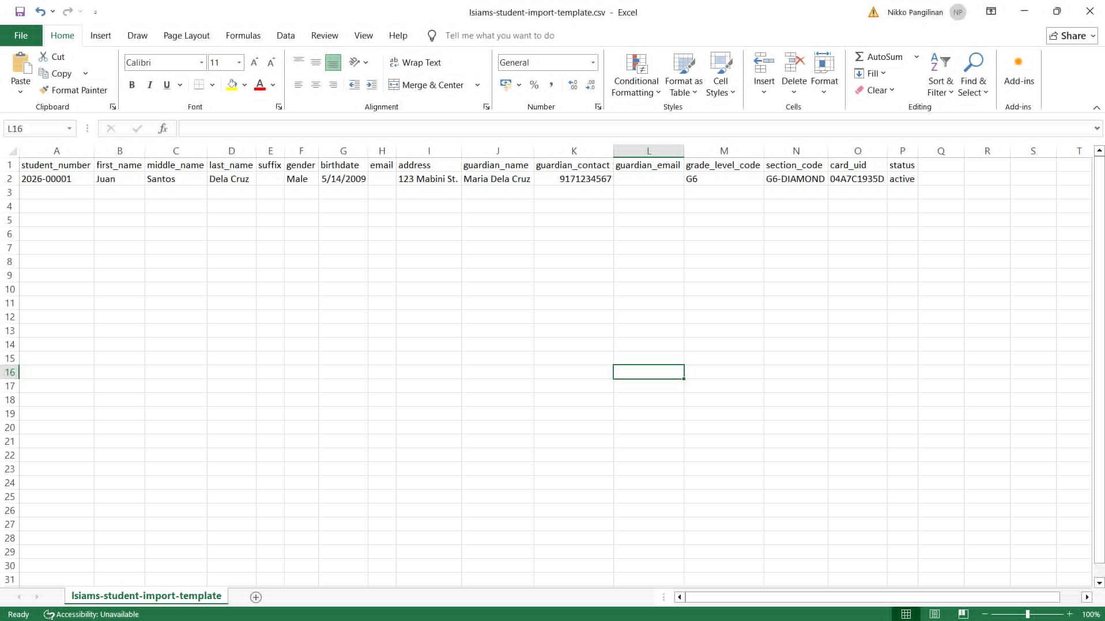
Figure C1 shows the spreadsheet template used to import student records into the system. Each row holds one student, including the student number, name, guardian contact, section code, and RFID card UID; the row shown is a sample.

Figure C2
Sample Terminal Import Template
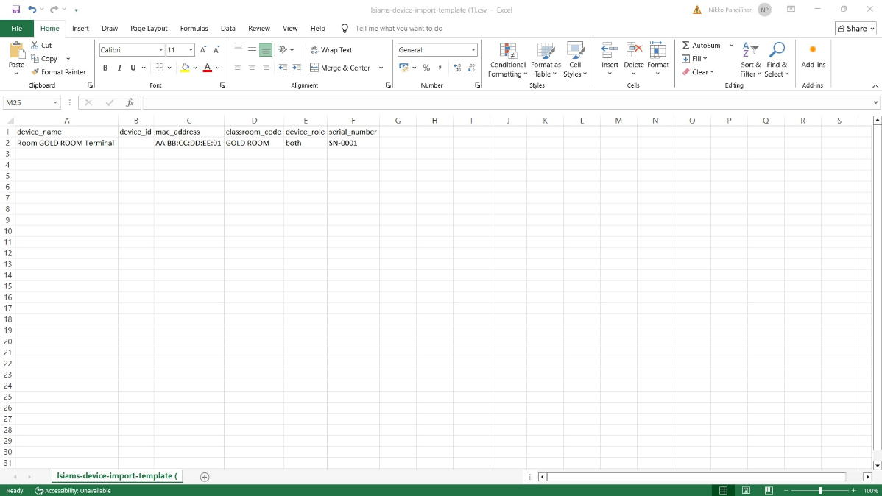
Figure C2 shows the spreadsheet template used to register classroom terminals in bulk, with the device name, device ID, MAC address, classroom, device role, and serial number of each terminal.

Figure C3
Sample Student Attendance Report
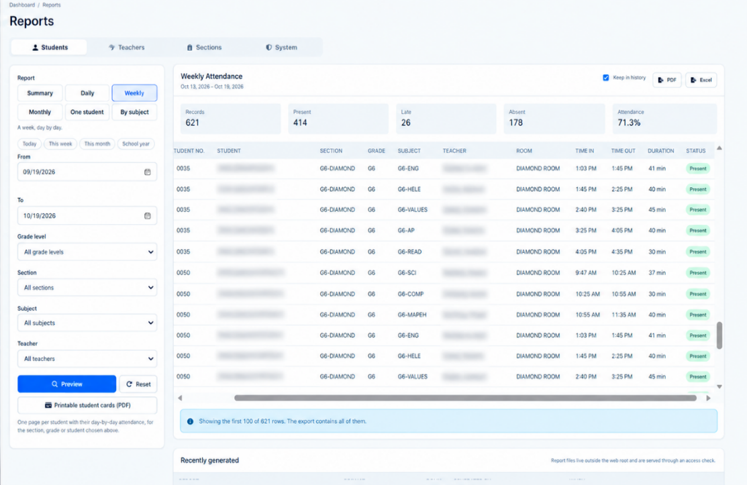
Figure C3 shows the Reports page previewing a weekly attendance report, with student names hidden. The totals in this preview (621 records, of which 178 were absences) cover all 21 sessions opened on October 13–14, 2026, including the two test sessions that are excluded from the 562 records analyzed in Chapter V.
Appendix D
User Guide
This appendix contains the user guide of L-SIAMS for teachers and administrators. It covers signing in, navigating the system, opening an attendance session at the terminal, managing students, cards, fingerprints, and terminals, generating reports, and signing out.
[Insert the L-SIAMS user guide]

Appendix E
Process, Data, and Information Flow
The finalized process and data flows of the system are presented in the main text: the methodological flow in Figure 1, the development cycle in Figure 2, the system design in Figure 3, the experimental process in Figure 4, and the data flow diagram in Figure 10. The attendance session workflow is shown below.
Figure E1
Attendance Session Workflow of L-SIAMS
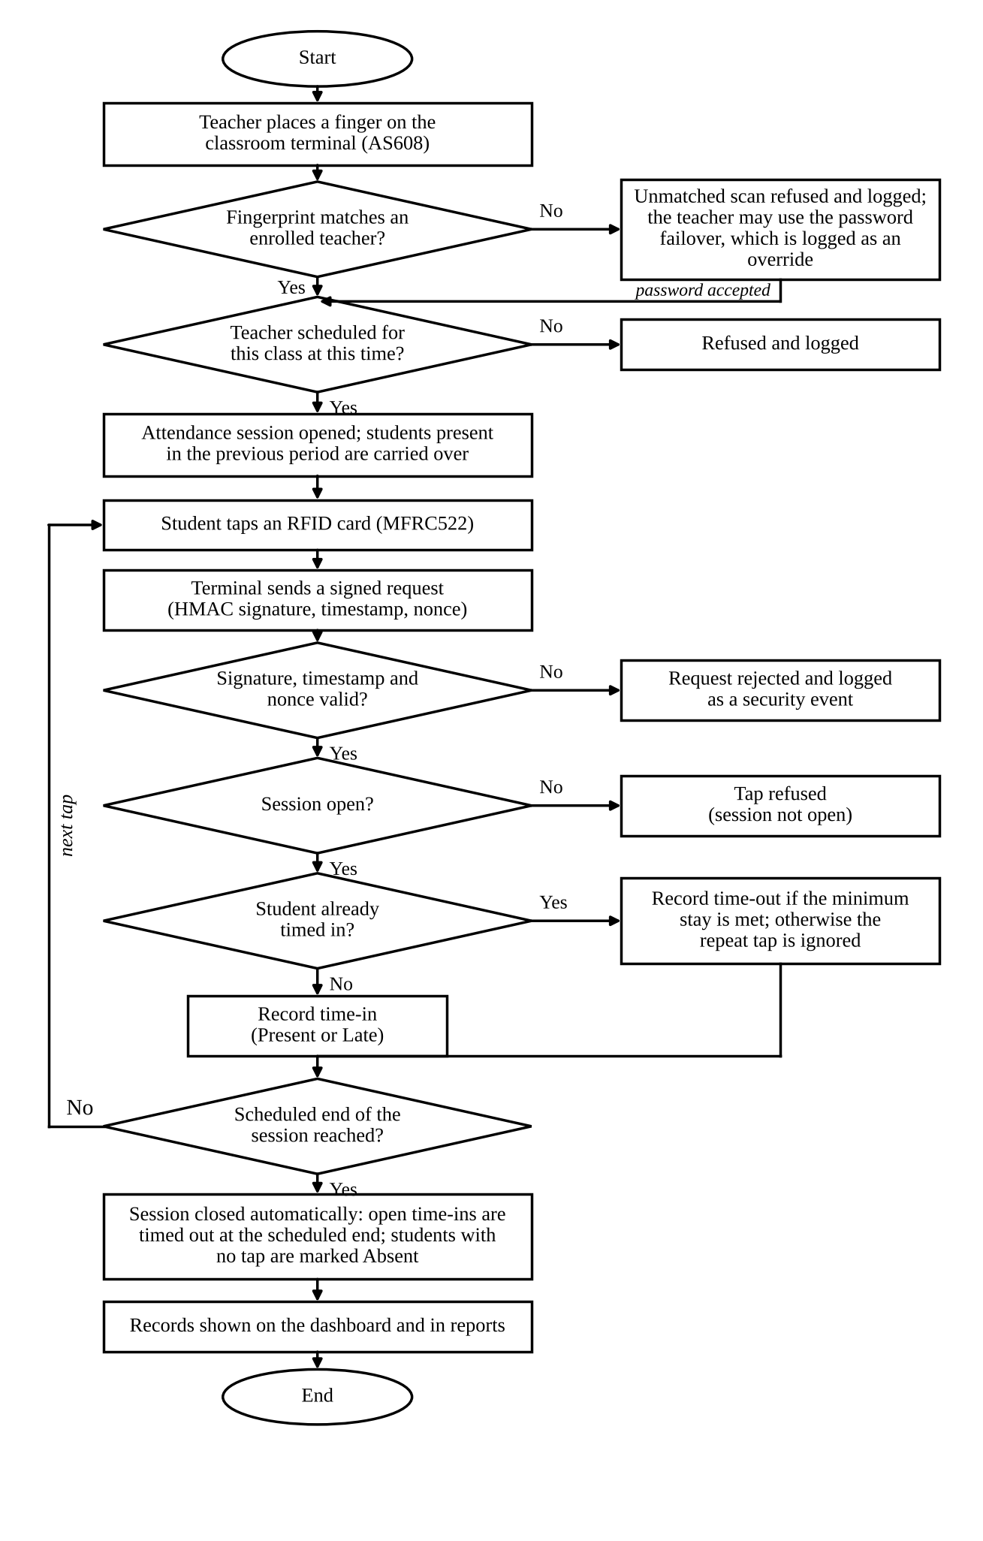
Figure E1 presents the attendance session workflow of L-SIAMS. A session opens only after the teacher’s fingerprint matches an enrolled teacher, or the teacher uses the logged password failover, and only for a class the teacher is scheduled to teach at that time. Each student tap is sent by the terminal as a signed request, which the server rejects and logs if its signature, timestamp, or nonce is invalid. Accepted taps record a time-in on the first tap and a time-out on a later tap once the minimum stay is met, while taps outside an open session are refused. At the scheduled end, the session closes automatically, outstanding time-ins are timed out, and students with no tap are marked Absent. The resulting records appear on the dashboard and in the reports.

Appendix F
Screen Layouts
The screen layouts of the completed system are presented in Chapter IV, Section 4.13, Figures 13 to 23. Additional screens are shown below.
Figure F1
Session Opening on the Teacher Dashboard
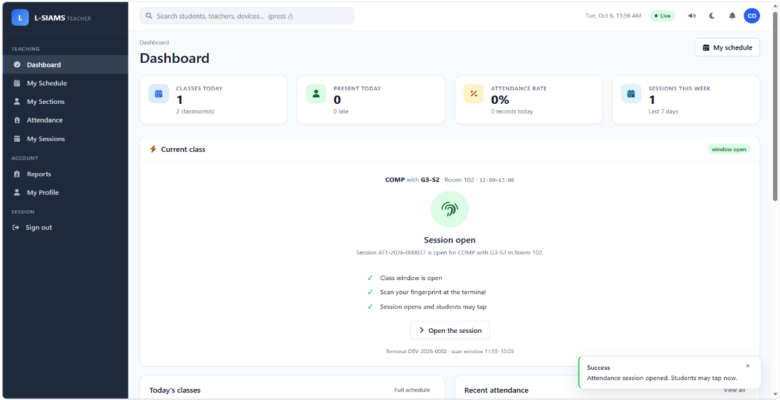
Figure F1 shows the teacher dashboard after the teacher’s fingerprint was verified at the terminal: the current class is shown with the message that the attendance session is open and that students may tap.
Figure F2
Attendance Session Summary
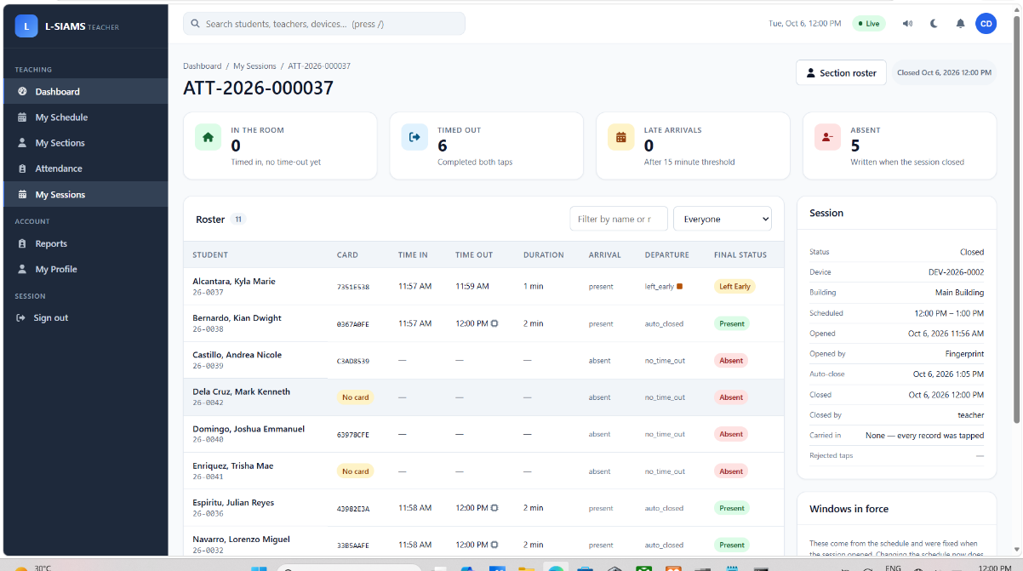
Figure F2 shows the summary of a closed attendance session, with the roster of students, their time-in and time-out, arrival and departure status, and the final status of each record.

Figure F3
Administrator Dashboard
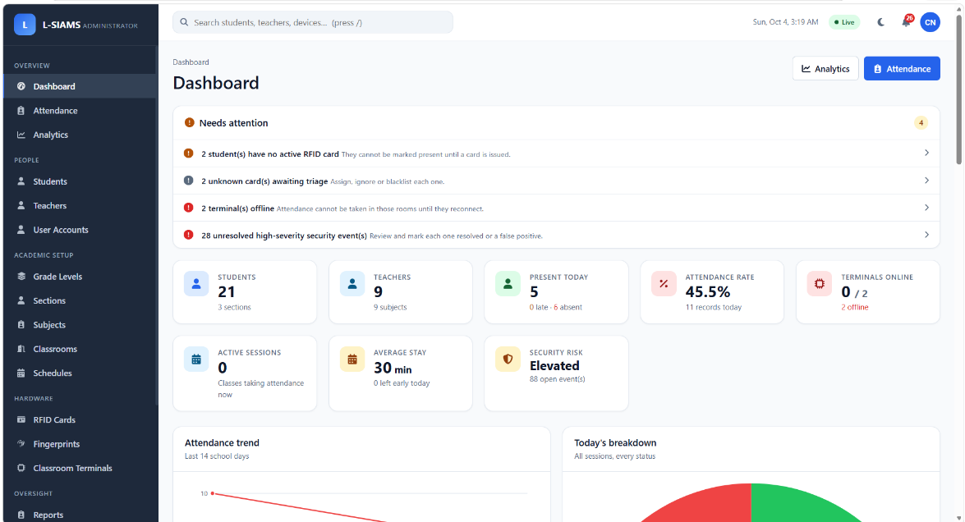
Figure F3 shows the administrator dashboard, which lists the items that need attention, the number of students, teachers, and terminals online, the attendance rate, and the security risk level.
Figure F4
Teacher Dashboard
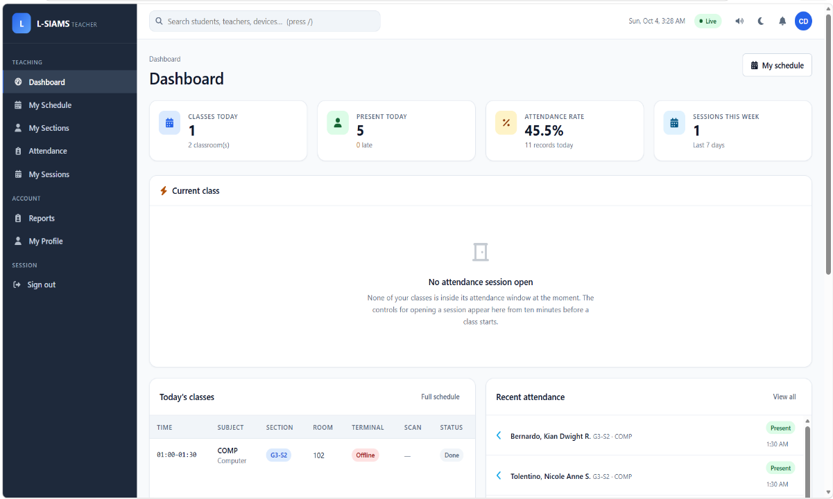
Figure F4 shows the teacher dashboard when no session is open, with the teacher’s classes for the day and the most recent attendance records.

Figure F5
Live Attendance Tapping on a Mobile Browser
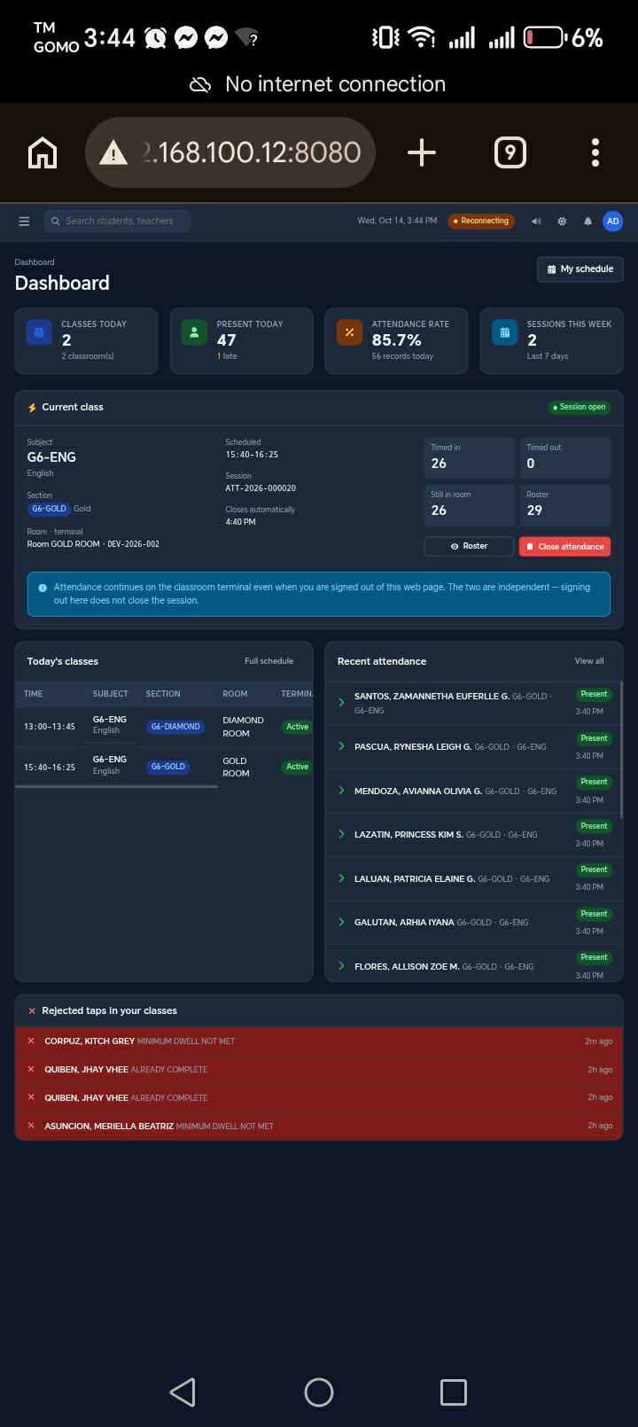
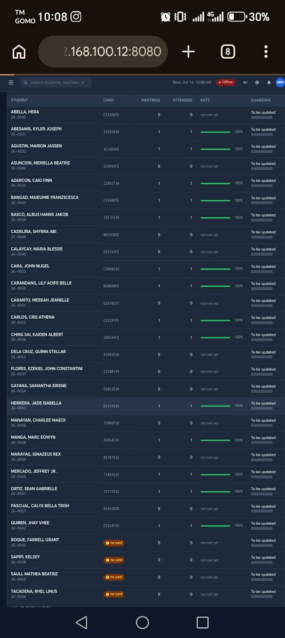
Figure F5 shows the live attendance view opened on a mobile phone within the school LAN, where taps appear as students record their attendance at the terminal.

Figure F6
Security Center
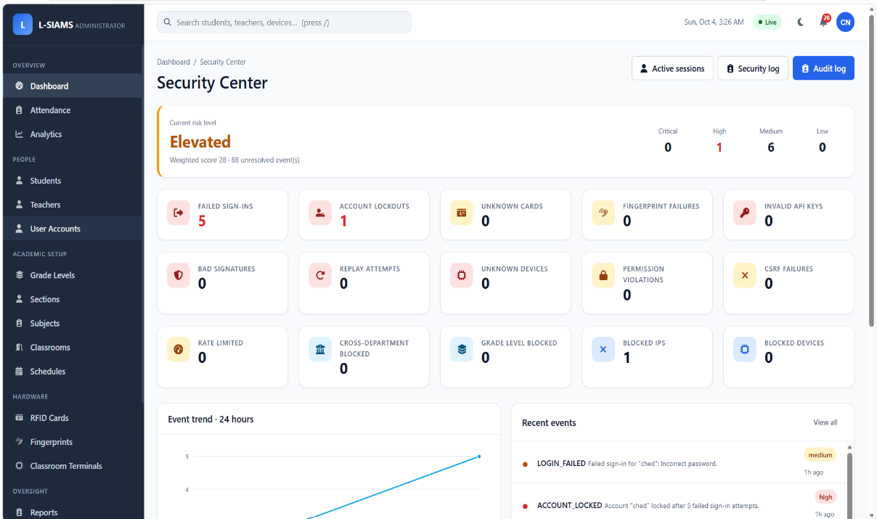
Figure F6 shows the Security Center, which summarizes the current risk level and the counts of failed sign-ins, account lockouts, replay attempts, and other security events, together with the most recent events.
Figure F7
Audit Logs
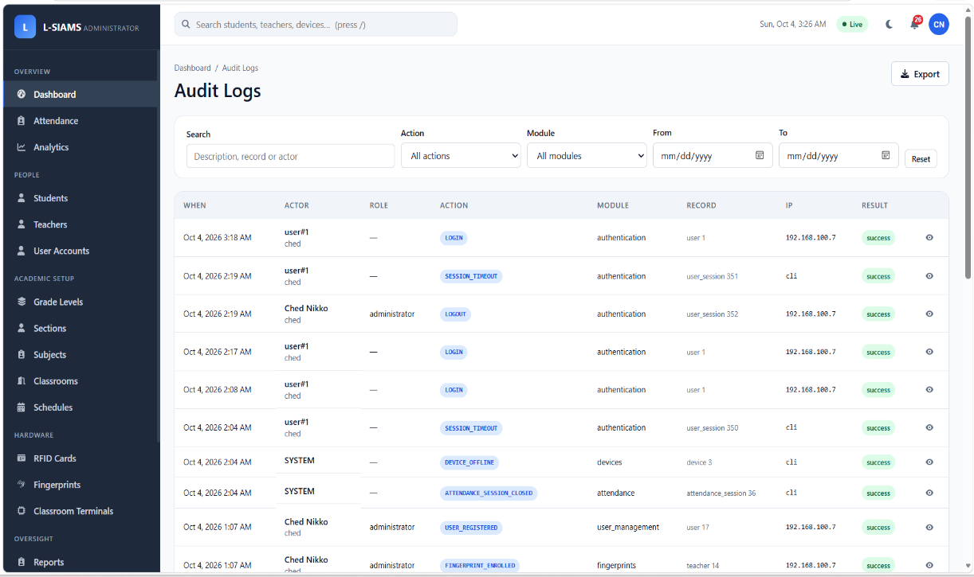
Figure F7 shows the audit log, which records each action with its time, actor, role, module, record, source IP address, and result.

Appendix G
Test Results
This appendix presents the detailed test results that support Chapter V. Table G1 lists the automated test suites run during development. Table G2 lists all 21 sessions opened during the deployment, with the reason each one was included in or excluded from the recording-time result in Table 18. Table G3 lists the outcome of every RFID tap on October 13–14, 2026, including the two test sessions.
Table G1
Development Test Suites
Test suite | What it verified | Result
Certificate and transport-security suite | TLS configuration, certificate chain, root key encryption, and refusal of malformed host names | 40 assertions passed
Concurrency and correctness suite | Row locking, unique constraints, and deadlock retry when the same card is tapped at the same time | A single record produced for simultaneous taps

Table G2
Recording Time of All Deployment Sessions
Session | Date | Class | Tapped / roster | Median gap (s) | First to last tap (s) | Use in Table 18
1 | Oct 13 | G6 Diamond | 0/30 | n/a | 0 | Excluded: test session
2 | Oct 13 | G6 Gold | 23/29 | 4.0 | 163 | Excluded: test session
3 | Oct 13 | G6 Diamond | 16/30 | 2.0 | 52 | Included
4 | Oct 13 | G6 Diamond | 9/30 | 15.0 | 1,009 | Excluded: fewer than 10 taps
5 | Oct 13 | G6 Diamond | 0/30 | n/a | 0 | No taps
6 | Oct 14 | G6 Gold | 20/29 | 3.0 | 146 | Included
7 | Oct 14 | G6 Diamond | 14/30 | 6.0 | 89 | Included
8 | Oct 14 | G6 Diamond | 0/30 | n/a | 0 | No taps
9 | Oct 14 | G6 Gold | 0/29 | n/a | 0 | No taps
10 | Oct 14 | G6 Diamond | 7/30 | 5.5 | 60 | Excluded: fewer than 10 taps
11 | Oct 14 | G6 Gold | 0/29 | n/a | 0 | No taps
12 | Oct 14 | G6 Diamond | 23/30 | 4.5 | 1,132 | Included
13 | Oct 14 | G6 Gold | 25/29 | 5.0 | 164 | Included
14 | Oct 14 | G6 Gold | 0/29 | n/a | 0 | No taps
15 | Oct 14 | G6 Diamond | 0/30 | n/a | 0 | No taps
16 | Oct 14 | G6 Gold | 1/29 | n/a | 0 | No taps to compare
17 | Oct 14 | G6 Diamond | 2/30 | 46.0 | 46 | Excluded: fewer than 10 taps
18 | Oct 14 | G6 Gold | 0/29 | n/a | 0 | No taps
19 | Oct 14 | G6 Diamond | 0/30 | n/a | 0 | No taps
20 | Oct 14 | G6 Gold | 0/29 | n/a | 0 | No taps
21 | Oct 14 | G6 Diamond | 0/30 | n/a | 0 | No taps
Note. Data from the system’s evaluation report (report:evaluation, October 13–14, 2026). Sessions without taps were periods in which the students were carried over from the previous period. The mean of the five included sessions is 4.10 s per student (SD 1.60).

Table G3
Outcome of RFID Taps (All Sessions, October 13–14, 2026)
Outcome | Count | Meaning
Accepted | 152 | Tap recorded as a time-in or time-out
Session not open | 34 | Tap made before the teacher opened the session; refused
Minimum stay not met | 14 | Tap-out made too soon after the tap-in; ignored
Tap-in closed | 7 | Tap-in made after the tap-in period had closed; refused
Already complete | 5 | Student already had both a time-in and a time-out; ignored
Note. Counts include the two test sessions; repeat taps never produced a second record.

Tables G1 to G3 show that every automated test passed, that the recording-time result rests on the five sessions in which a class queued at the door, and that every tap the system did not record was refused or ignored by a specific rule rather than lost.
[Insert the stopwatch record of the manual roll call, with dates and classes]
[Insert the completed UAT forms or their summary sheet]
[Insert any defect reports and corrective-action records]

Appendix H
Sample Generated Outputs
This appendix presents representative outputs generated by the system, using anonymized or authorized data.
Figure H1
Reports Page With Recently Generated Reports
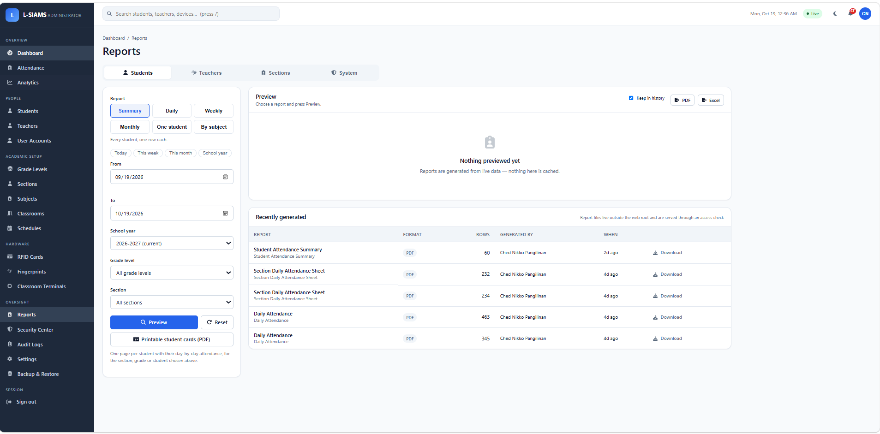
Figure H1 shows the Reports page, where reports are generated by student, teacher, section, or system scope and downloaded as PDF or Excel files; the list at the bottom shows reports generated recently.
Figure H2
Student Attendance Summary Report
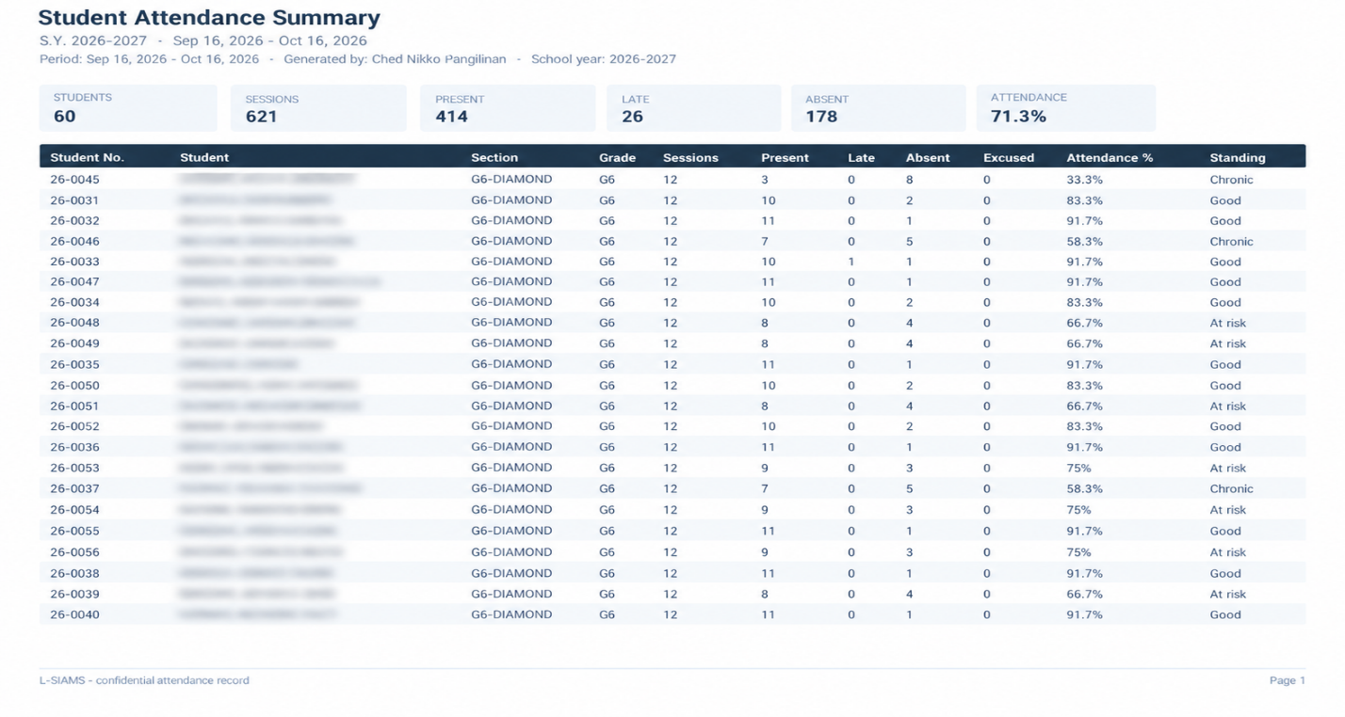
Figure H2 shows a generated student attendance summary in PDF form, with student names hidden. It lists, for each student, the sessions, present, late, and absent counts, the attendance percentage, and the standing; its totals cover the reporting period shown and include the two test sessions.
Figure H3
Exported Attendance Spreadsheet
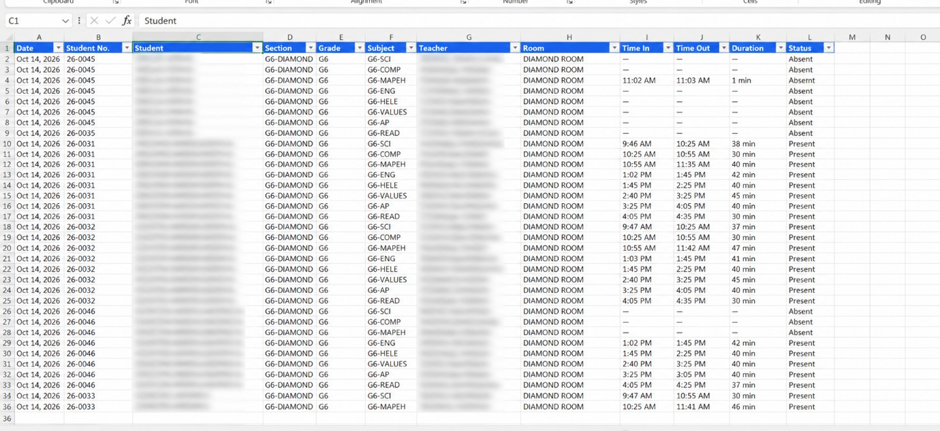
Figure H3 shows an attendance export opened in Excel, with student names hidden, listing each record’s date, student number, section, subject, teacher, room, time-in, time-out, duration, and status.

Appendix I
Project Documentation Photographs
This appendix presents authorized photographs of the project activities.
[Insert photographs of the user acceptance testing and the turnover]

Figure I1
Consultation and Gathering of Data
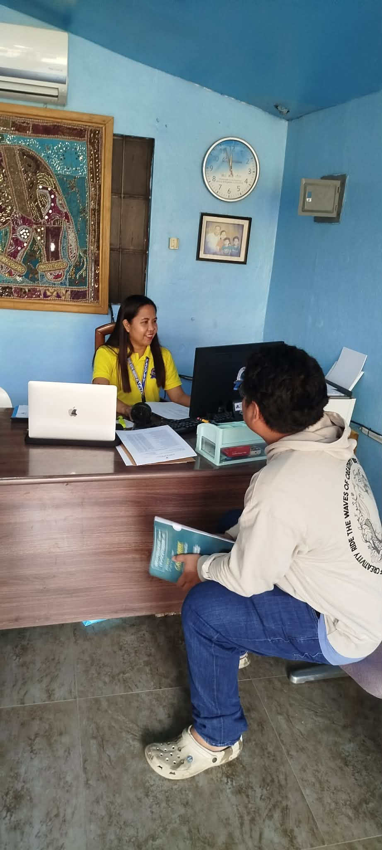
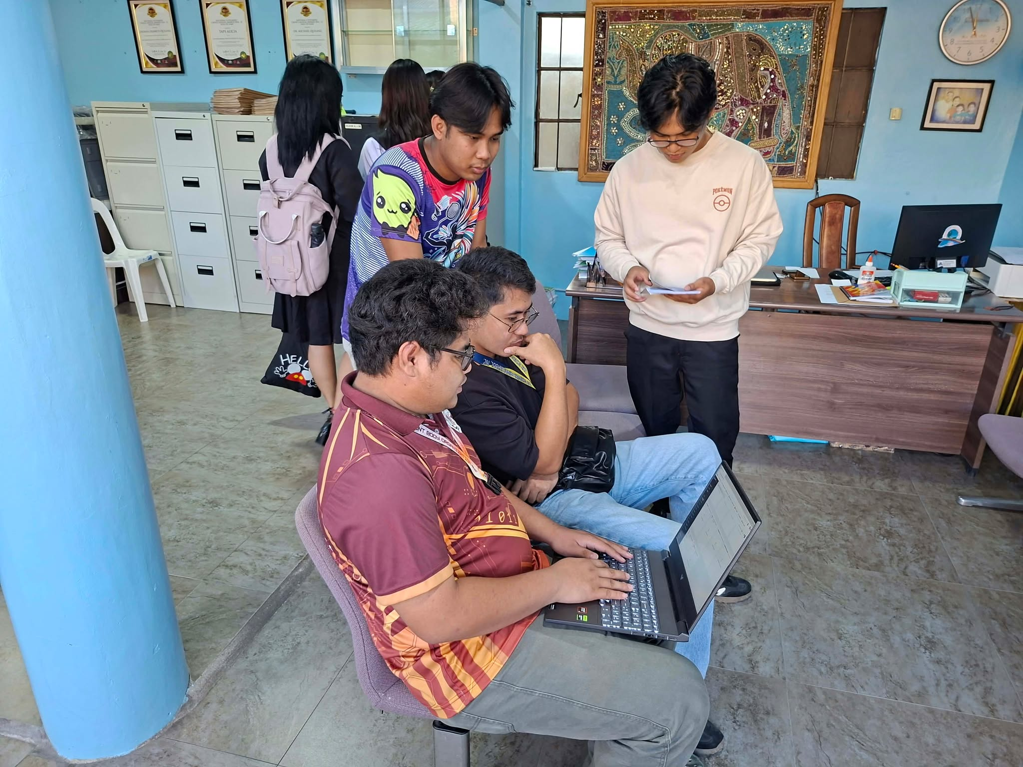
Figure I1 shows the researchers consulting the school staff and gathering the data used to identify the requirements of the system.
Figure I2
User Orientation and Attendance Sheet
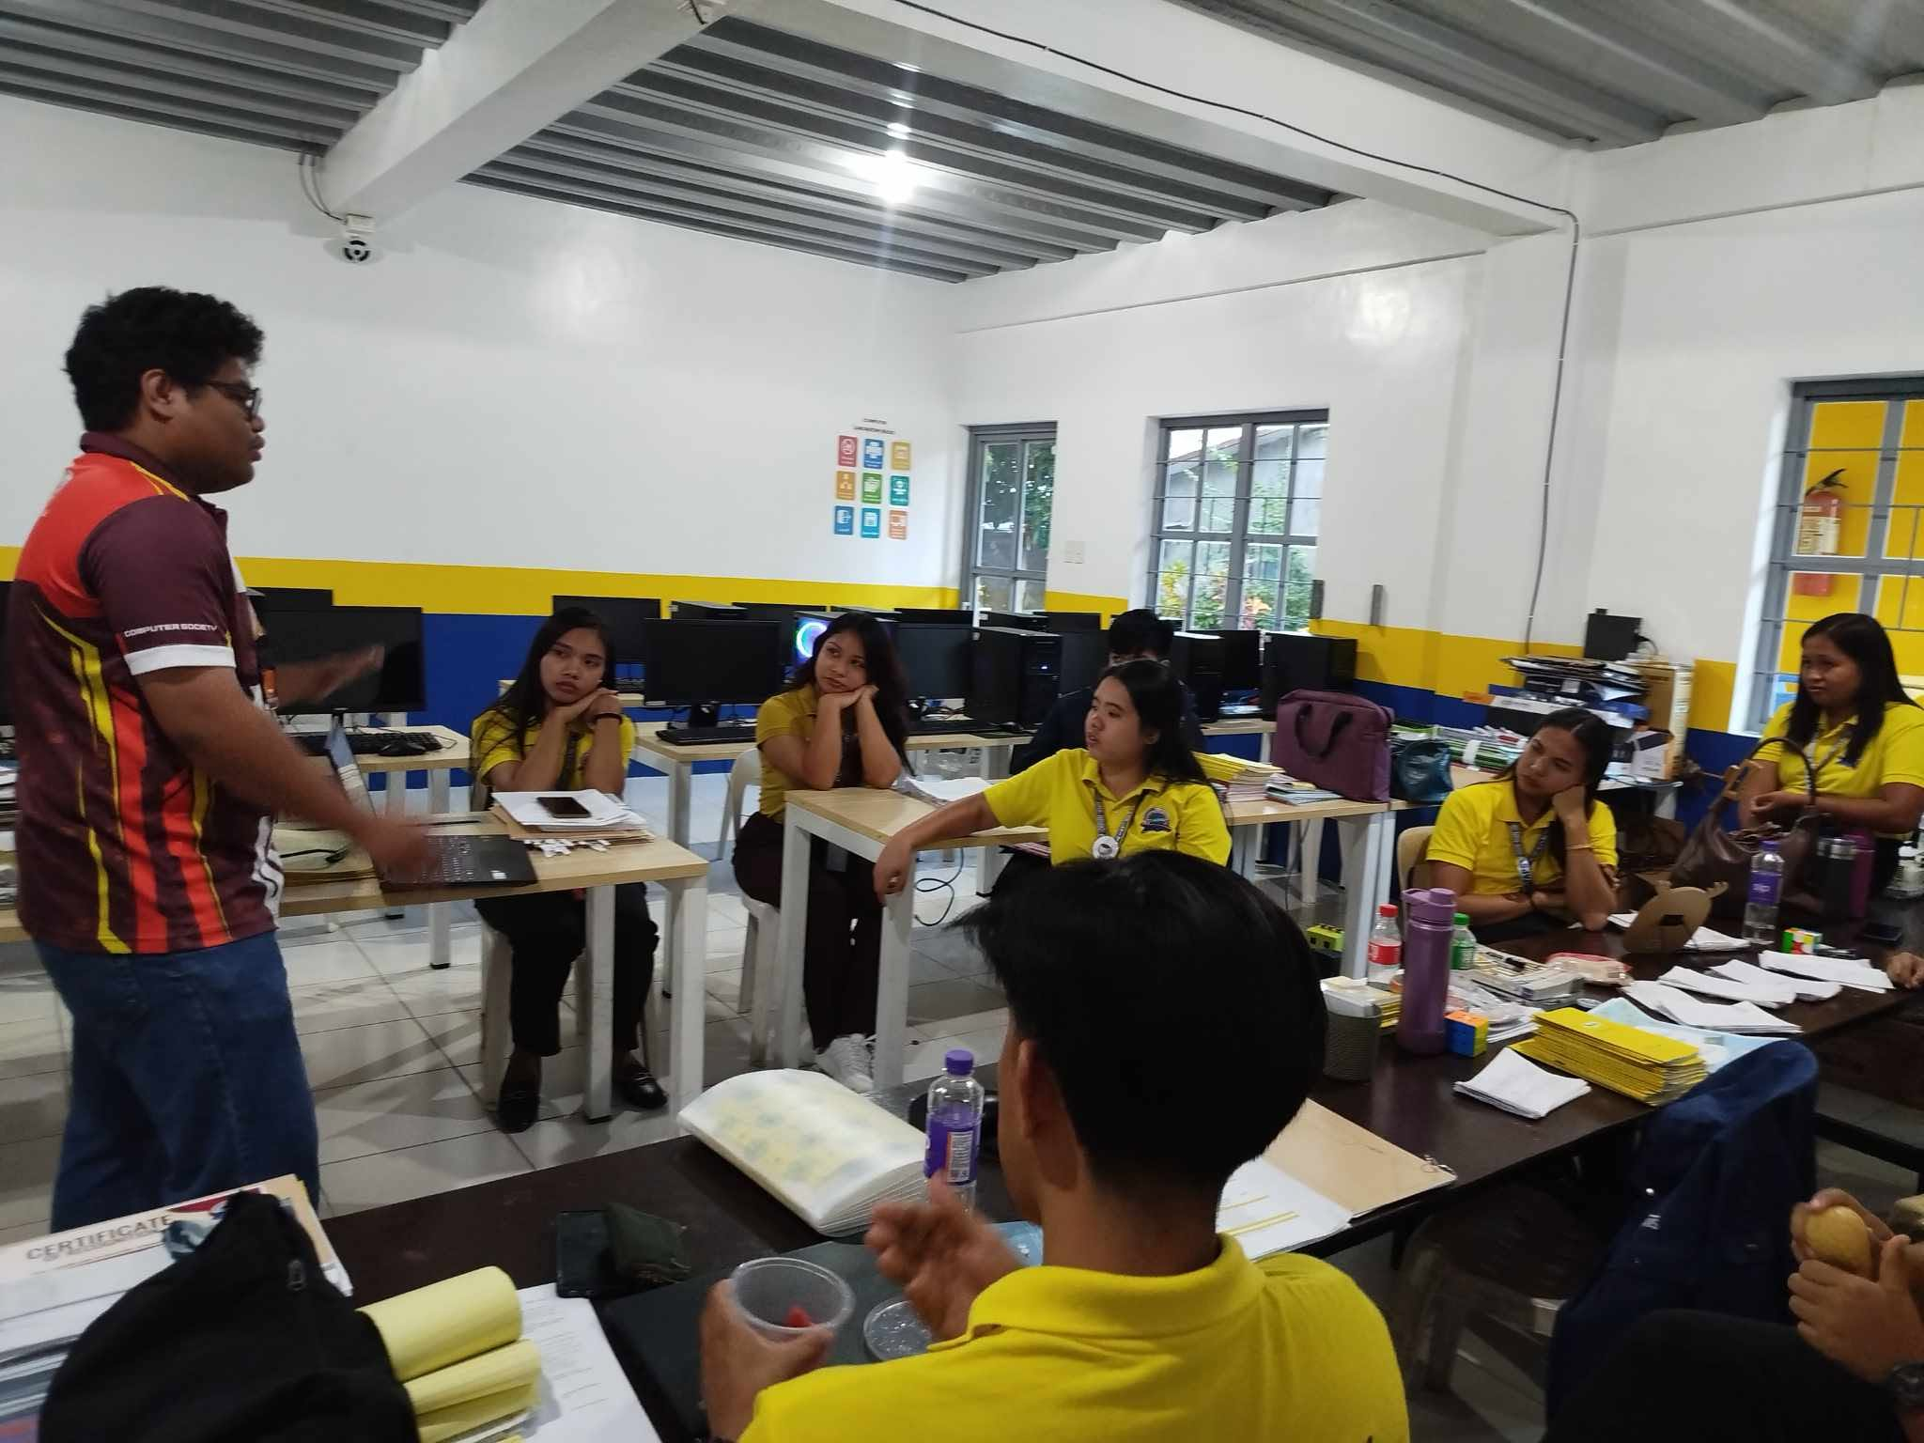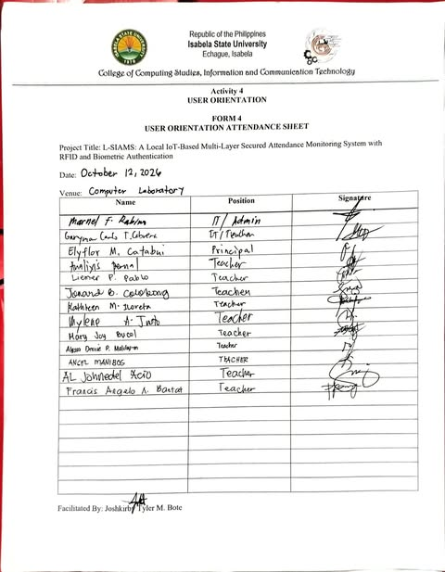
Figure I2 shows the orientation of the users and its signed attendance sheet, dated October 12, 2026, with the venue, the names and positions of the participants, and their signatures.
Figure I3
Installation of Classroom Terminals
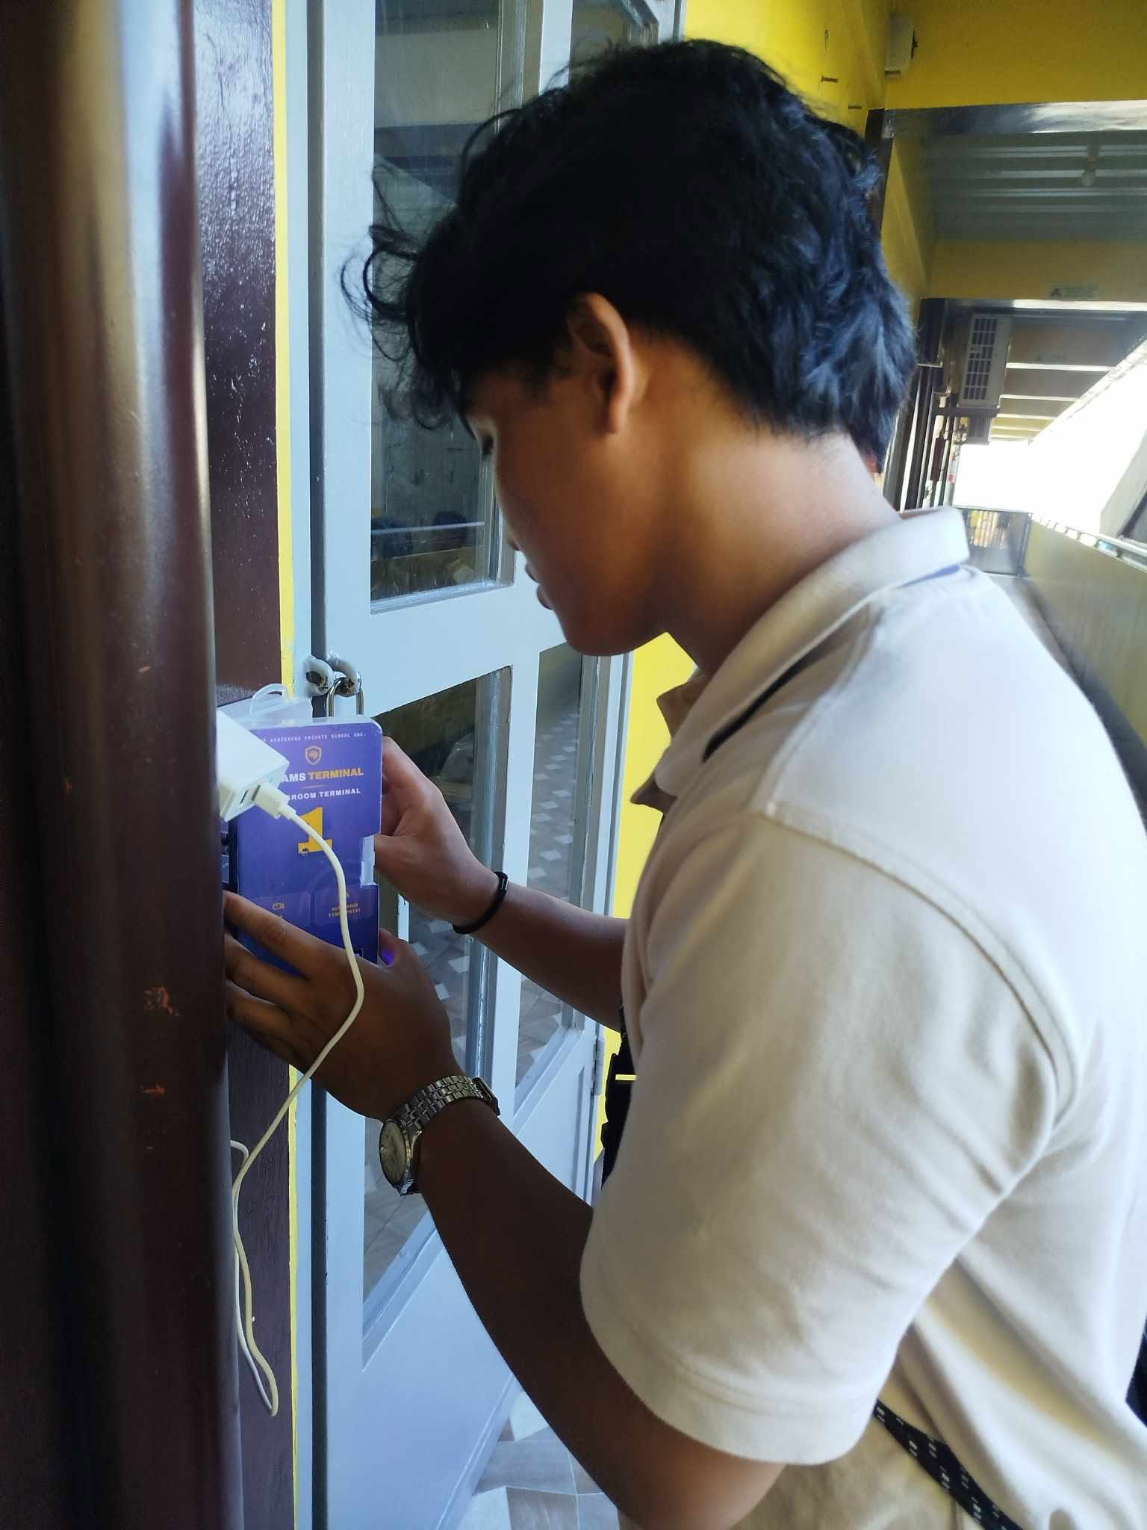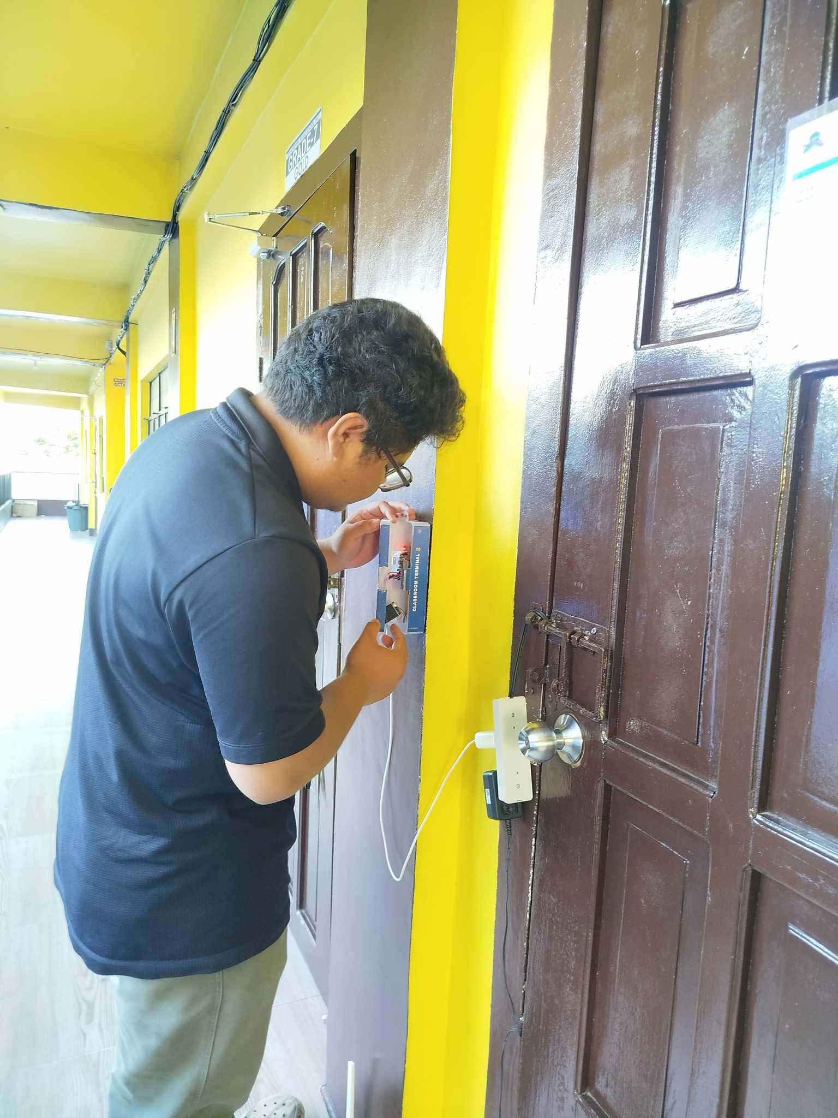
Figure I3 shows the researchers installing the classroom terminals beside the doors of the two Grade 6 classrooms.

Figure I4
Queue at the Classroom Door
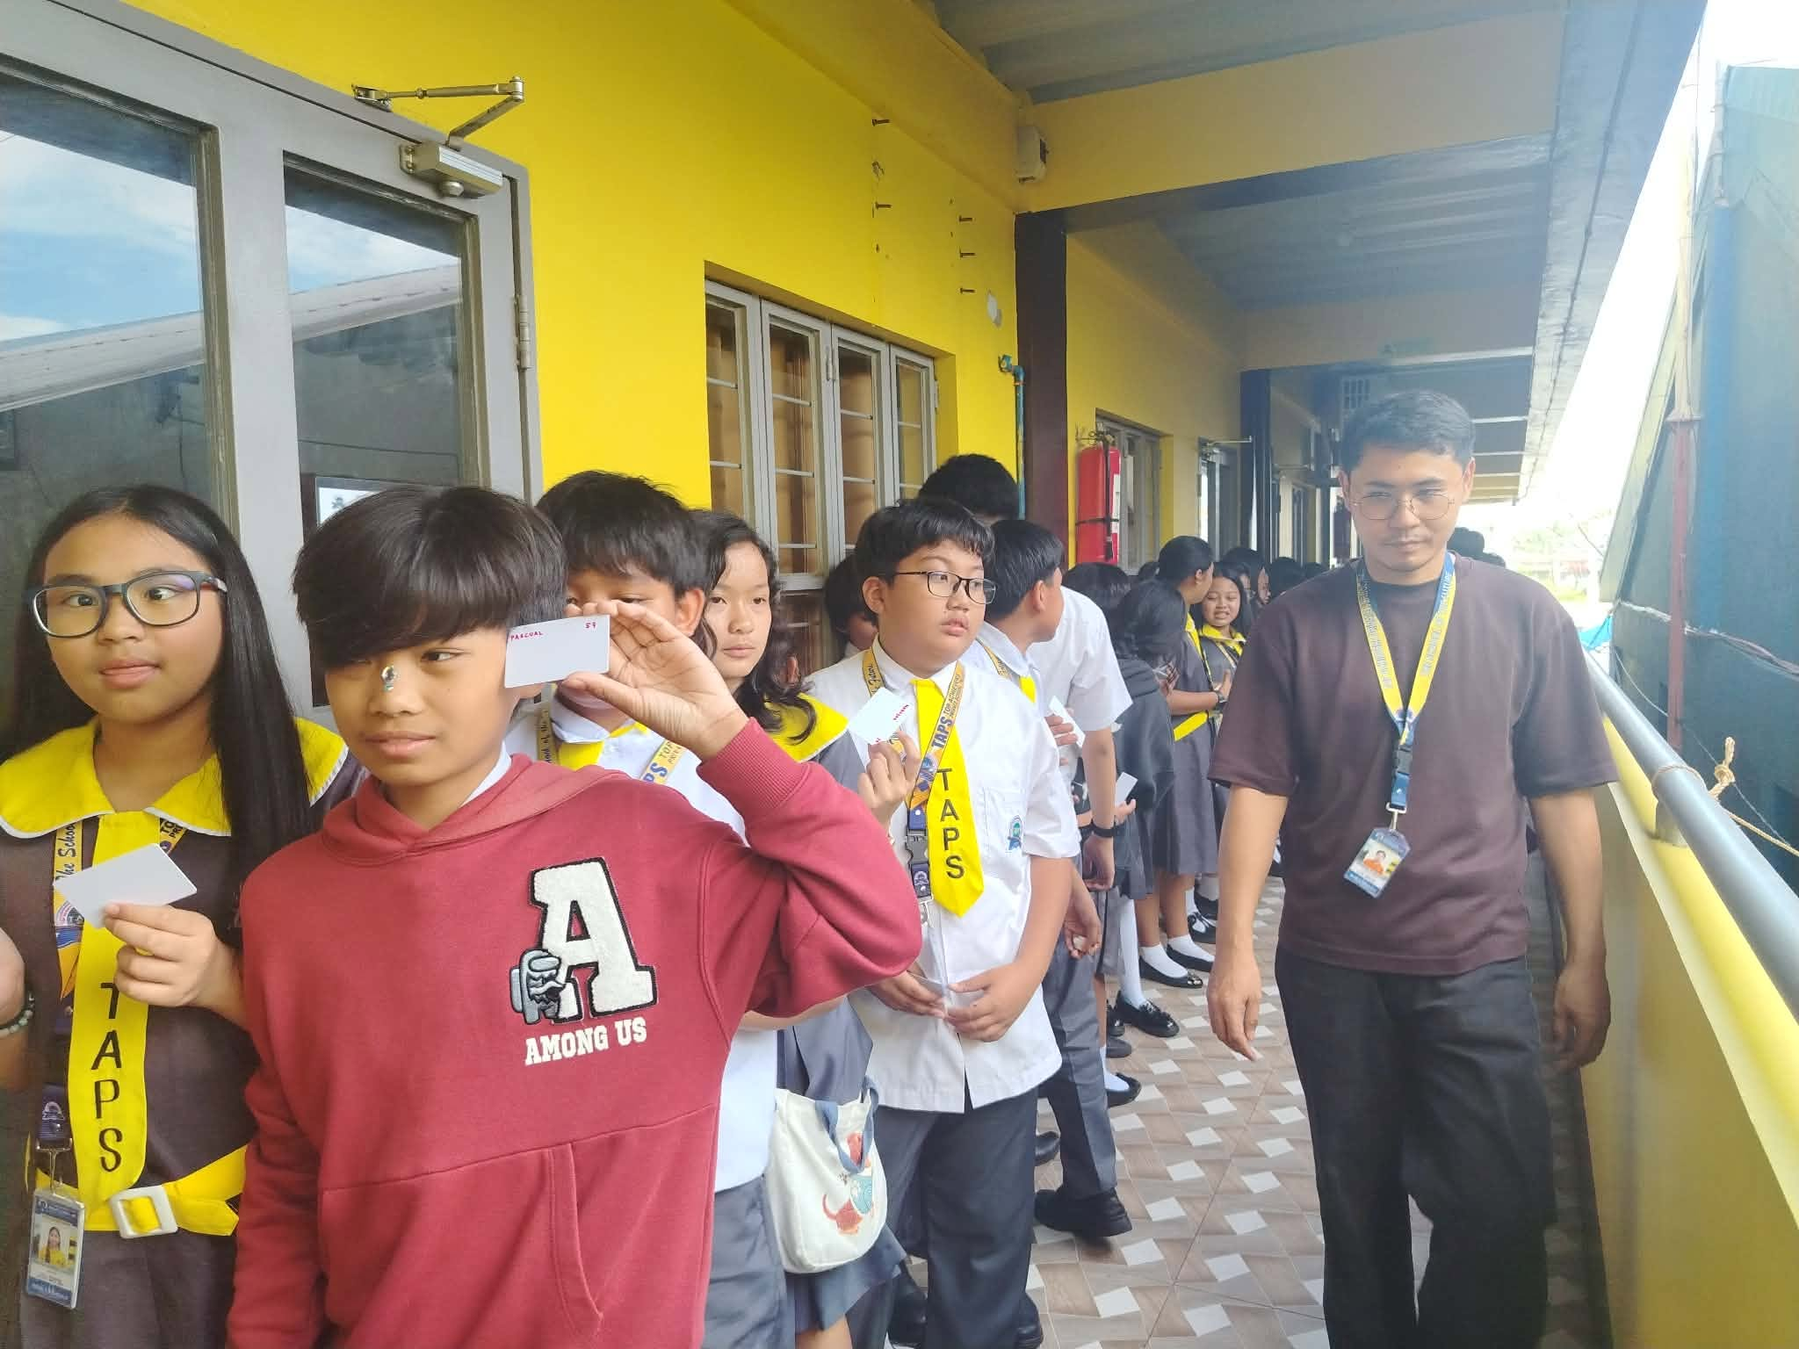
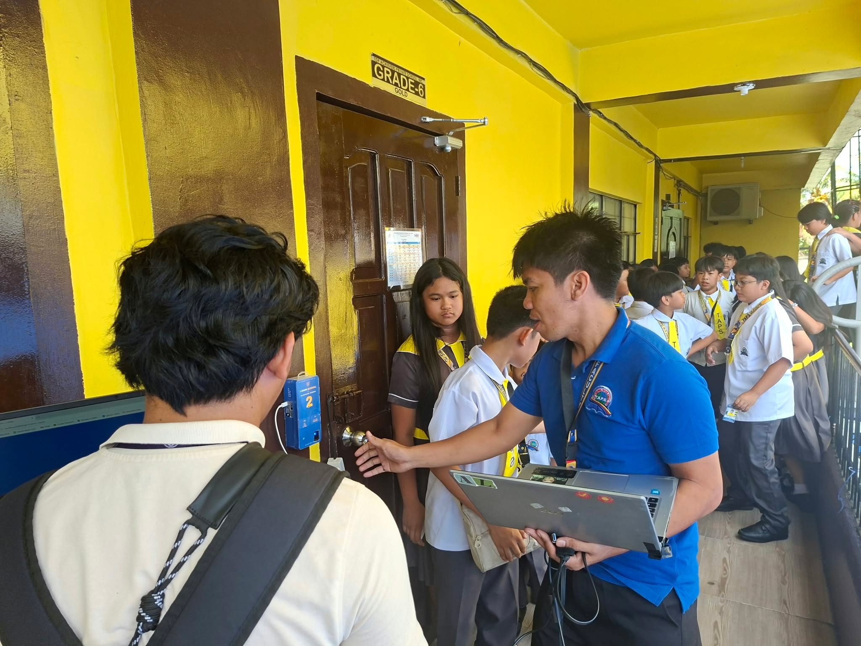
Figure I4 shows the students lining up to tap their RFID cards at the classroom door during the deployment.

Appendix J
Curriculum Vitae
[Insert the one-page curriculum vitae of Ched Nikko P. Pangilinan]
[Insert the one-page curriculum vitae of Joshkirby Tyler M. Bote]
[Insert the one-page curriculum vitae of Naph Yvan P. Villamar]

