CAPSTONE PROJECT
High-Fidelity Prototype
L-SIAMS
Local IoT-Based Multi-Layer Secured Attendance Monitoring System with RFID and Biometric Authentication
Capstone Project Members
No. | Name of Member | Role
1 |  | Project Leader
2
3
4
5
Adviser: ______________________________
Course / Section: ______________________________
Date submitted: September 2026

About This Prototype
This document presents the high-fidelity prototype of L-SIAMS. It covers two parts: the classroom terminal (the IoT device mounted in every classroom) and the web application used by administrators and teachers.
Every web screen in this document is a screenshot of the working system, running on the school network with demonstration data (7 teachers, 5 sections, 137 students, 5 classroom terminals and 30 school days of attendance). The classroom terminal is shown as a front-view design, a wiring diagram, an interaction flow, and the actual console output of its firmware.
Summary of the system:
- Students tap an RFID card on the classroom terminal to record arrival and departure.
- A teacher opens the attendance session by scanning a fingerprint on the same terminal, only for a class they are scheduled to teach.
- Everything runs on one server inside the school. No cloud service and no internet connection are needed.
- Attendance appears live on the dashboards, and 15 kinds of reports can be exported as PDF, Excel or CSV.
Contents
- Part 1. Classroom Terminal: hardware design, wiring, usage flow, console output and terminal management screens
- Part 2. Web Application (Administrator): dashboard, attendance, people, academic setup, reports, security and system
- Part 3. Web Application (Teacher Portal): dashboard, schedule, sections, attendance, sessions, reports and profile

Part 1. Classroom Terminal
The classroom terminal is an ESP32 microcontroller with an RFID reader and a fingerprint sensor. It is mounted beside each classroom door and talks to the school server over the school Wi-Fi. The terminal has no screen of its own. It captures the scan, the server decides the outcome, and the result appears live on the web dashboards shown in Parts 2 and 3.

1.1 Hardware Design

Classroom Terminal: Front View
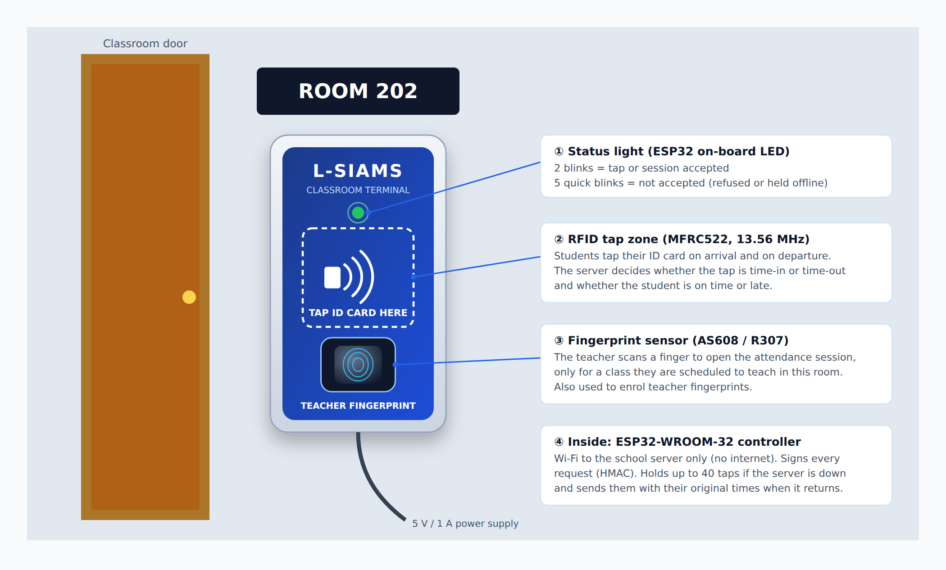
Figure 1. Classroom Terminal: Front View
Front of the terminal as installed beside the classroom door. It has a status light, a marked RFID tap zone for student ID cards, and a fingerprint sensor for the teacher. The ESP32 controller inside connects to the school server over Wi-Fi.

Classroom Terminal: Internal Components and Wiring
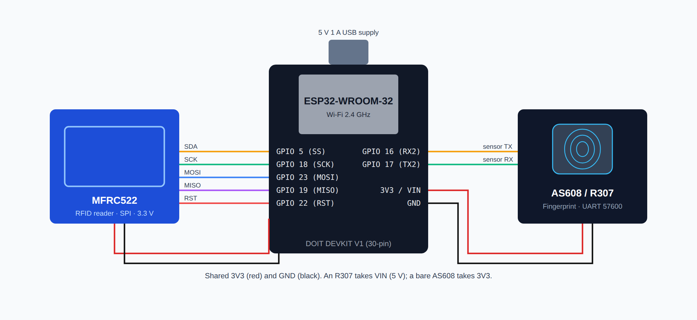
Figure 2. Classroom Terminal: Internal Components and Wiring
The ESP32-WROOM-32 board connects to the MFRC522 RFID reader over SPI (GPIO 5, 18, 23, 19, 22) and to the AS608/R307 fingerprint sensor over UART2 (GPIO 16 and 17). Both modules share the 3V3 and GND lines, with 100 µF + 100 nF capacitors at each module for stable power.

1.2 How the Terminal Is Used

Classroom Terminal: How a Class Session Works
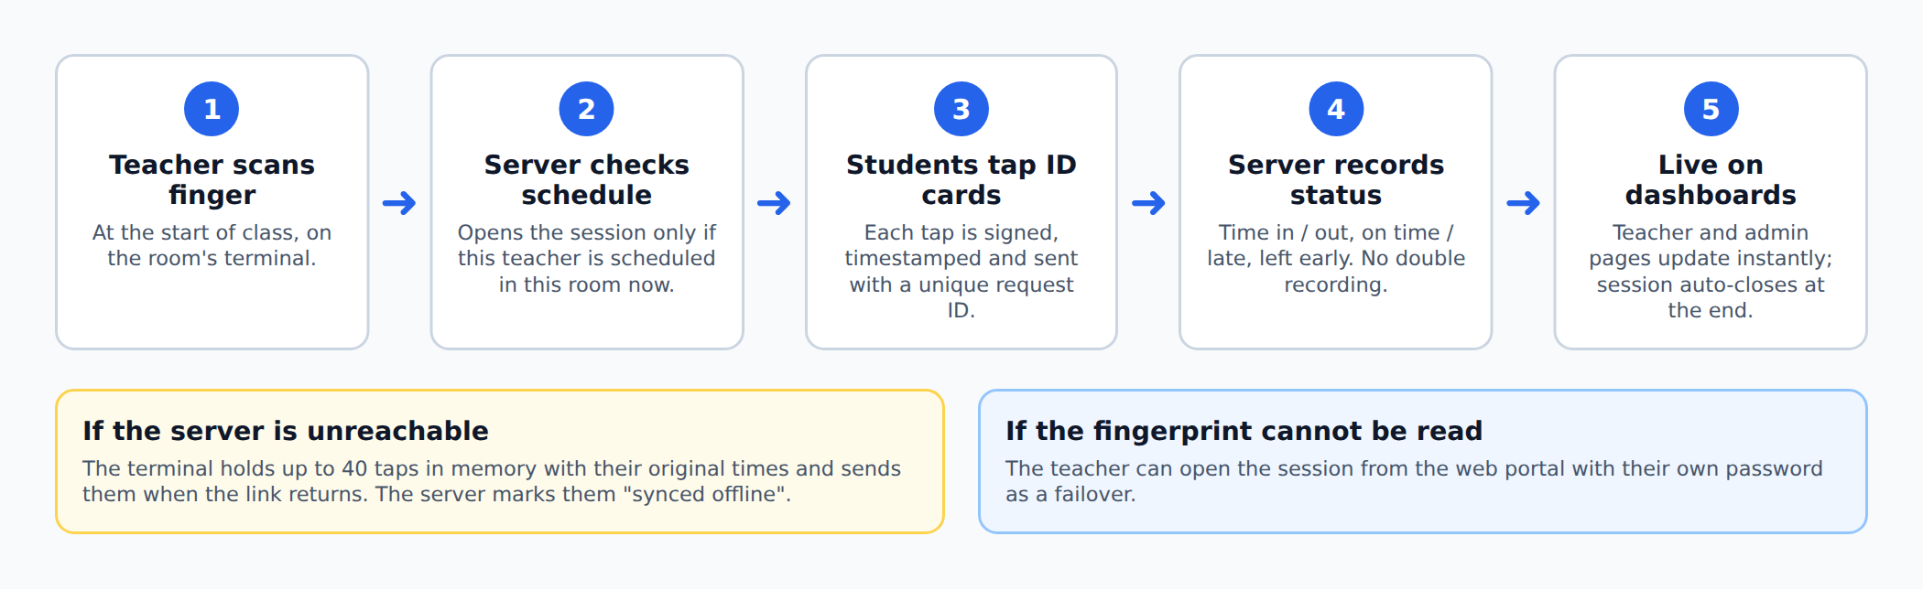
Figure 3. Classroom Terminal: How a Class Session Works
The teacher opens the session with a fingerprint, the server checks the class schedule, students tap their cards, and the server records each arrival or departure with its status. If the server is unreachable, the terminal holds up to 40 taps and sends them later with their original times. If the fingerprint cannot be read, the teacher can open the session with their password instead.

Classroom Terminal: Console Output
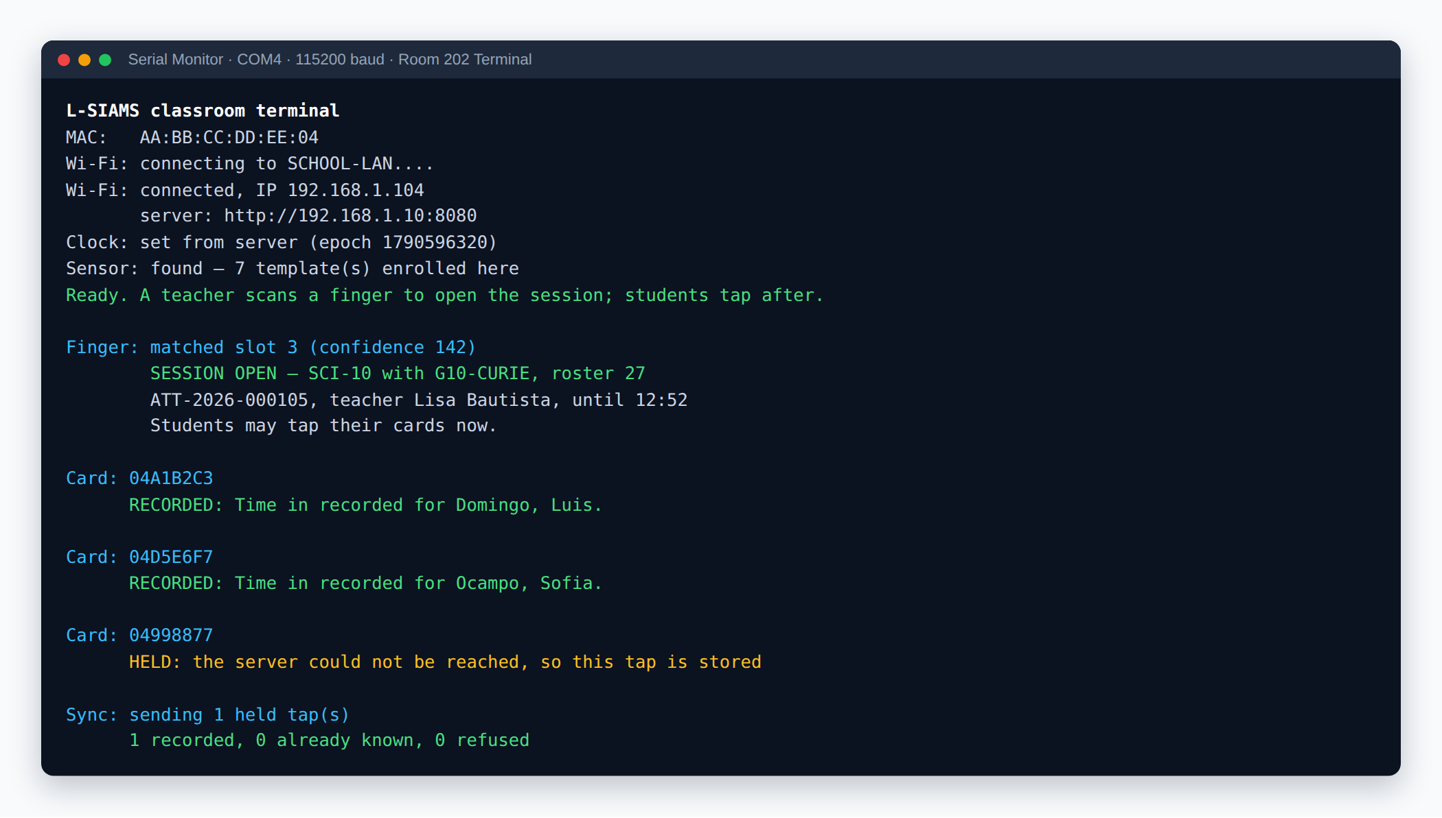
Figure 4. Classroom Terminal: Console Output
The messages the terminal prints from start-up to a student tap: joining the Wi-Fi, syncing the clock, finding the fingerprint sensor, a teacher opening the session, two students recorded, and one tap held while the server was unreachable and then sent when the connection returned.

1.3 Terminal Management Screens

Classroom Terminals (Admin)
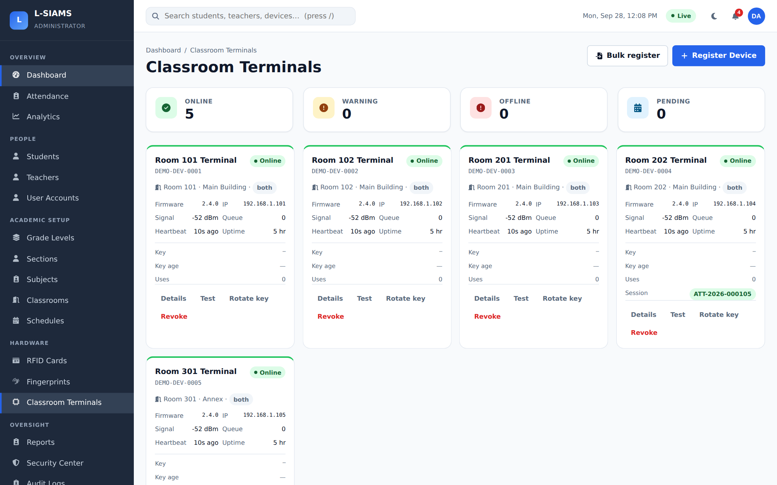
Figure 5. Classroom Terminals (Admin)
All classroom terminals in one view. Each card shows whether the terminal is online, its room, firmware version, IP address, Wi-Fi signal, offline queue and last heartbeat. The Room 202 terminal shows the session currently open on it.

Terminal Details (Admin)
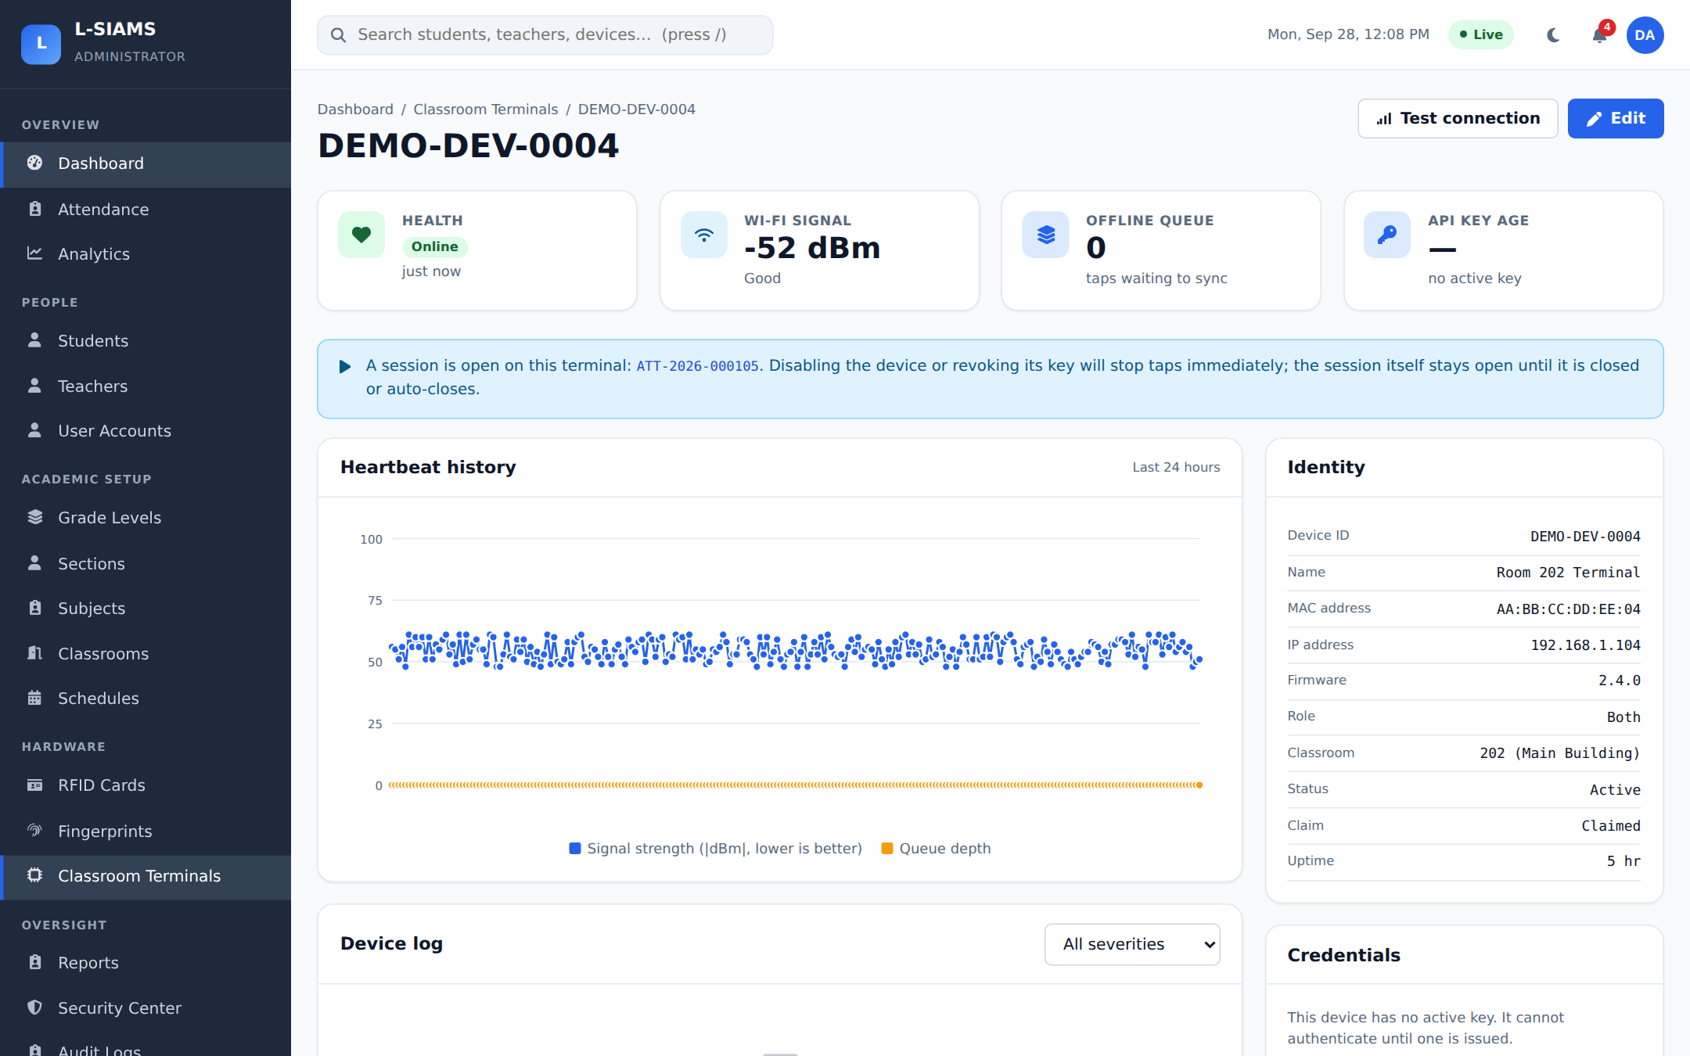
Figure 6. Terminal Details (Admin)
Details for one terminal: health, Wi-Fi signal, offline queue, and a 24-hour heartbeat history chart. It also shows the terminal identity (MAC, IP, firmware, room) and its security credentials, and has buttons to test the connection or edit the device.

Fingerprint Enrollment (Admin)
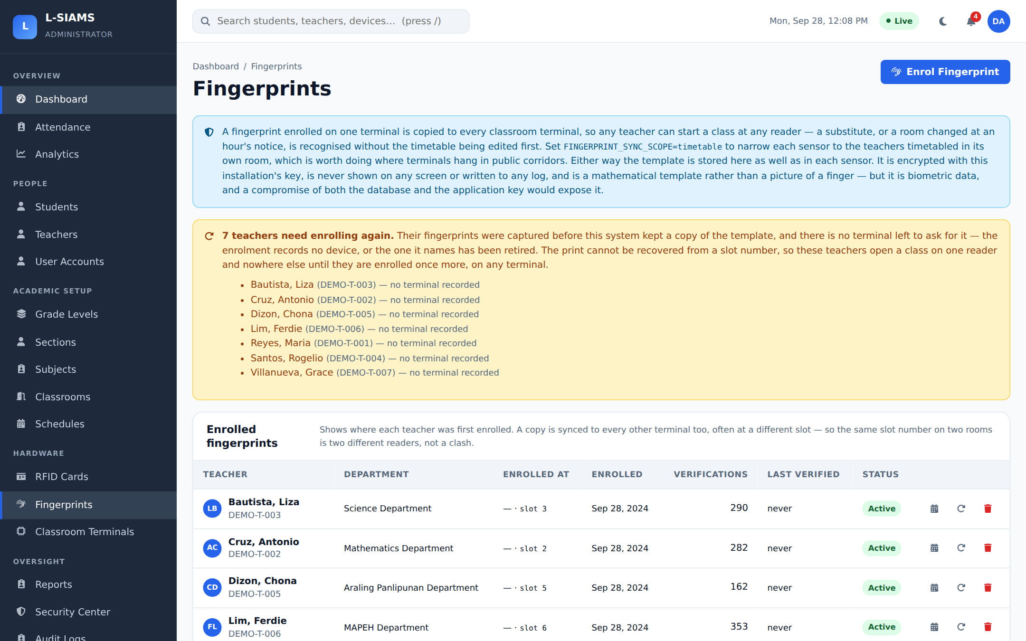
Figure 7. Fingerprint Enrollment (Admin)
Teacher fingerprints enrolled through the terminals. Shows each teacher's sensor slot, enrollment date and verification count. New fingerprints are enrolled from here by scanning on a chosen terminal.

RFID Card Management (Admin)
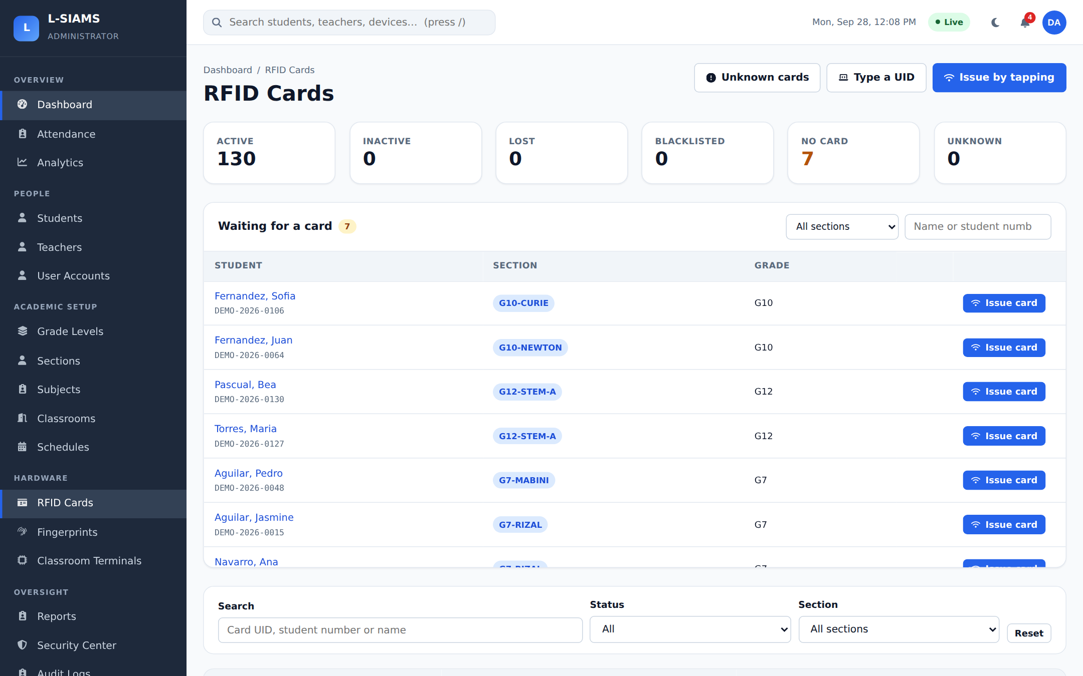
Figure 8. RFID Card Management (Admin)
Issuing and managing student RFID cards. Lists students still waiting for a card, and a card can be issued by tapping it on a terminal. Shows counts of active, lost and blacklisted cards and any unknown cards that were tapped.

Part 2. Web Application: Administrator

Sign In
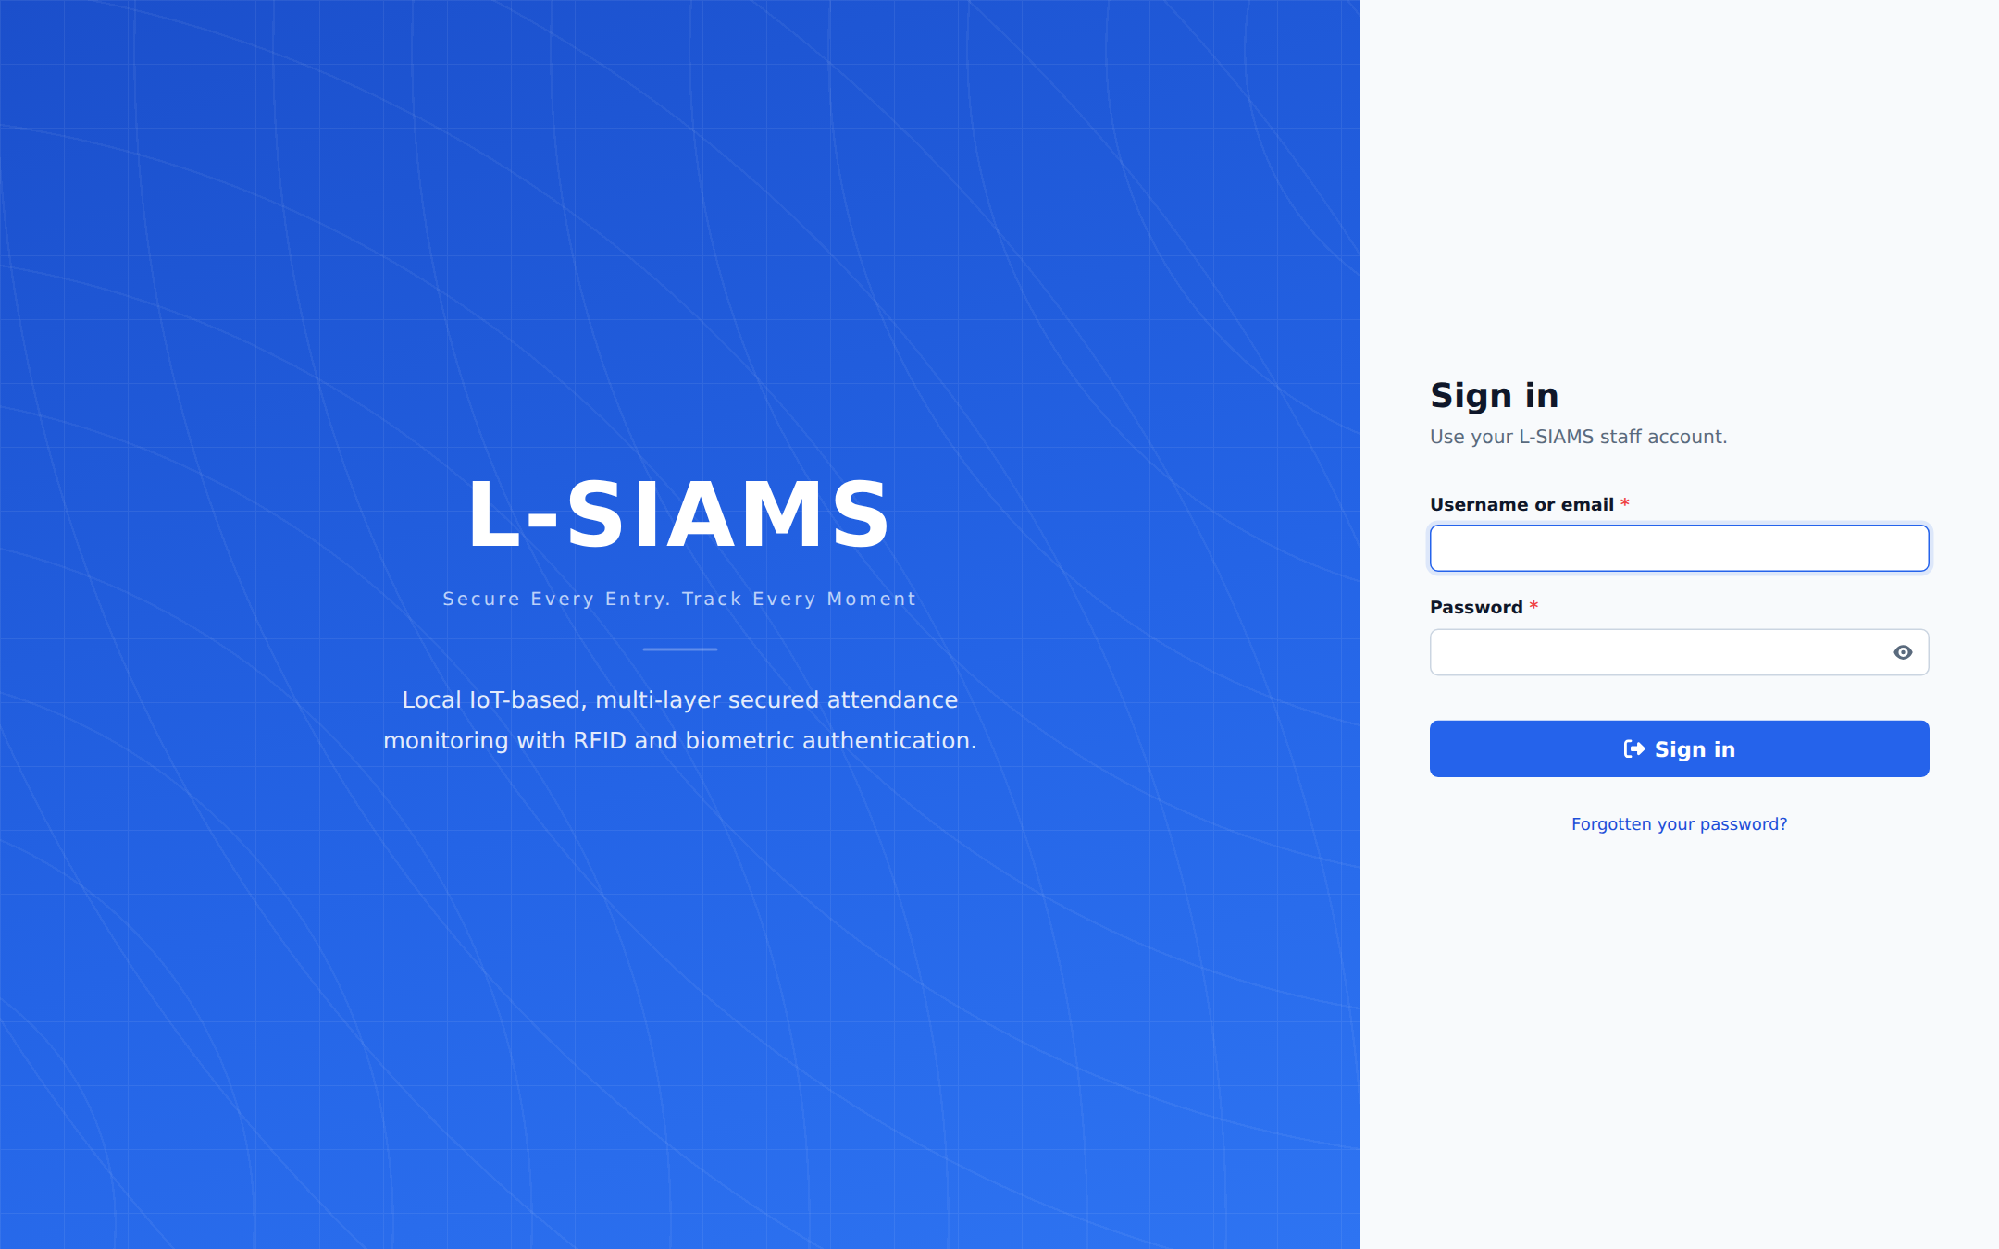
Figure 9. Sign In
Sign-in page for all staff (administrators and teachers). Accounts are protected with bcrypt password hashing, lockout after repeated failures, and session timeouts.

2.1 Overview

Administrator Dashboard
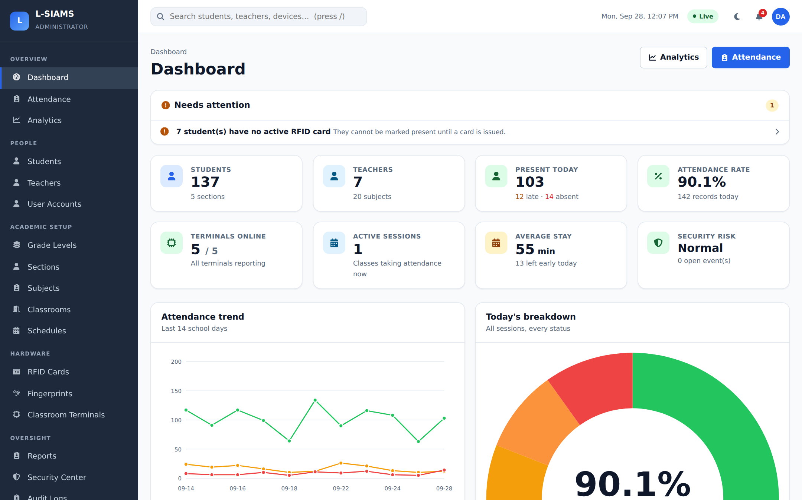
Figure 10. Administrator Dashboard
Today at a glance: students, teachers, present today, attendance rate, terminals online, active sessions, average stay and security risk. The "Needs attention" panel lists problems such as students without an RFID card. The "Live" badge shows the realtime connection is active.

Analytics
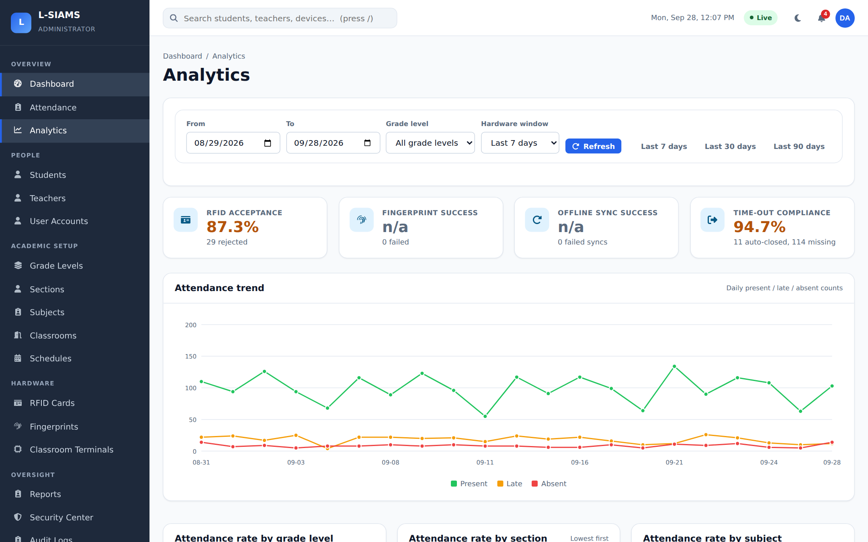
Figure 11. Analytics
Attendance trends over a chosen date range, with the attendance rate by grade level, section and subject.

2.2 Attendance

Attendance Records
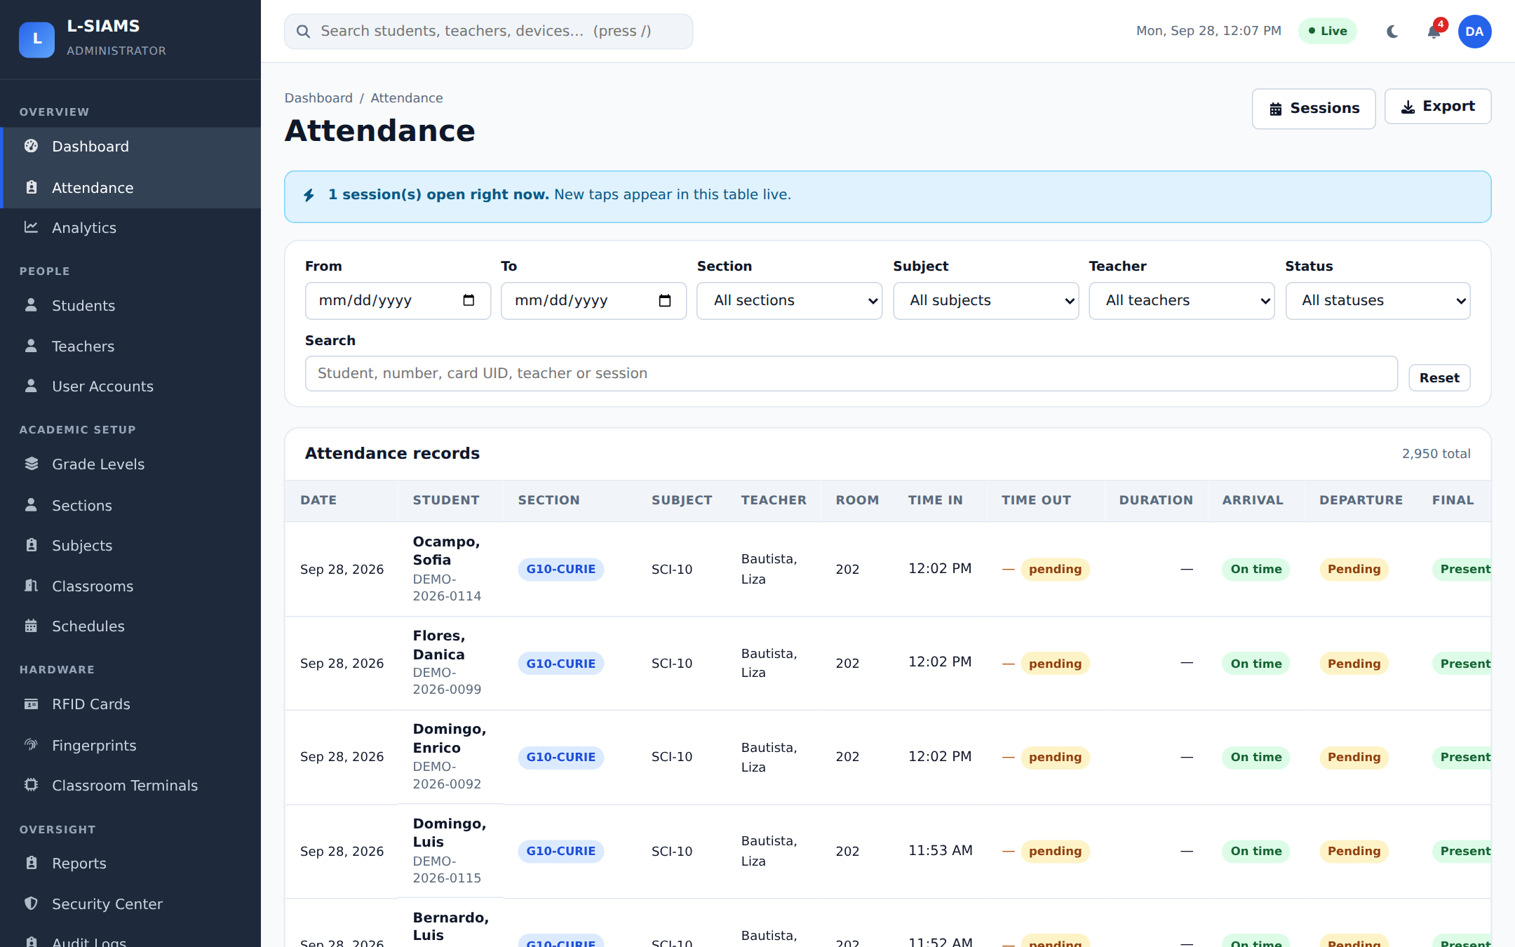
Figure 12. Attendance Records
Every attendance record, filterable by date, section, subject, teacher and status. Each row shows time in, time out, duration, and separate arrival, departure and final status.

Open Attendance Sessions
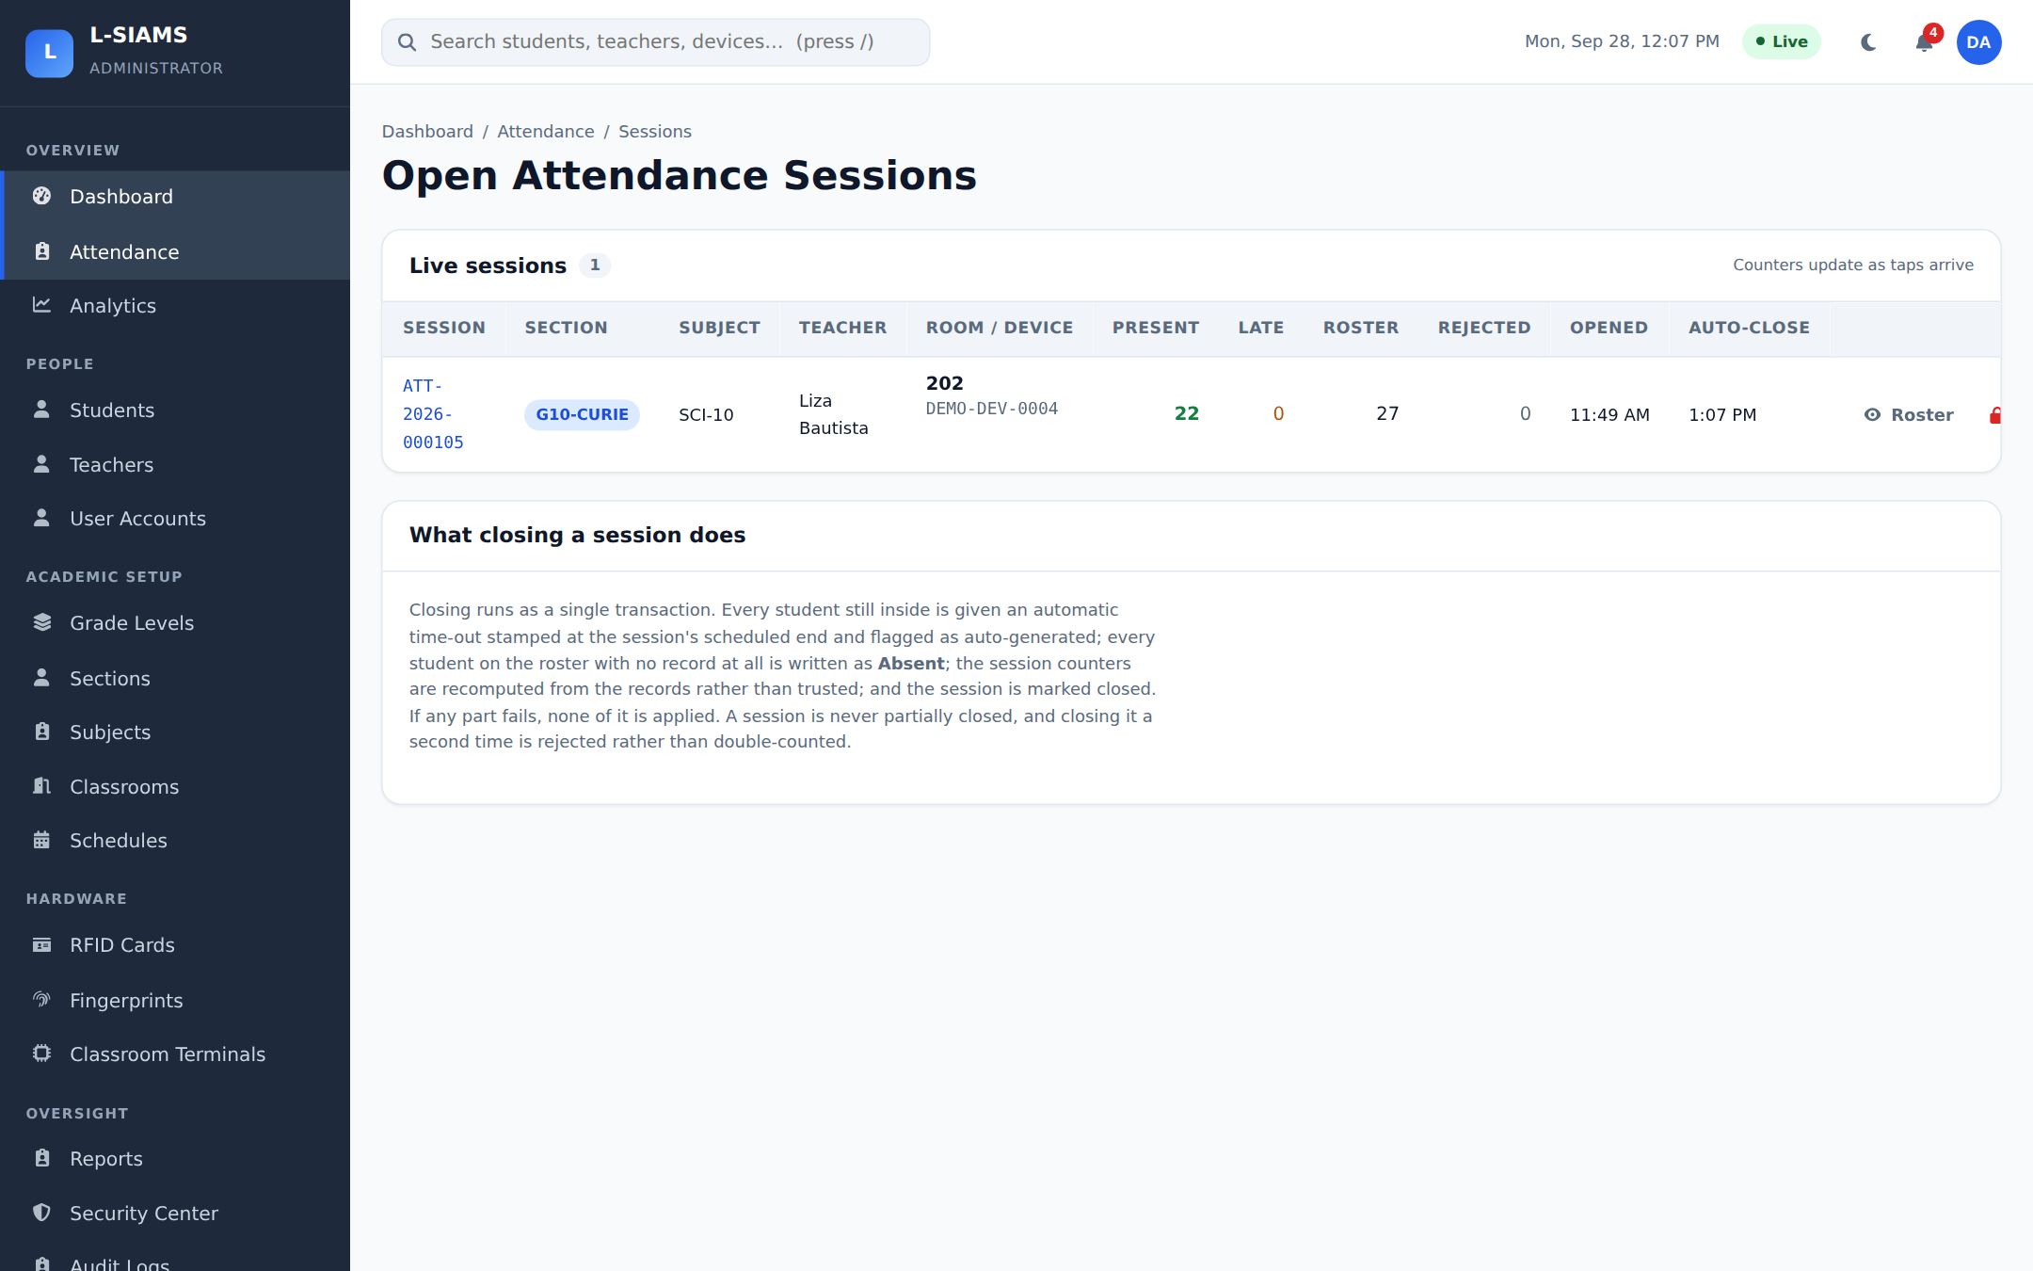
Figure 13. Open Attendance Sessions
Classes taking attendance right now, with present, late and roster counts and when the session auto-closes. Below that is the history of closed sessions.

Session Details
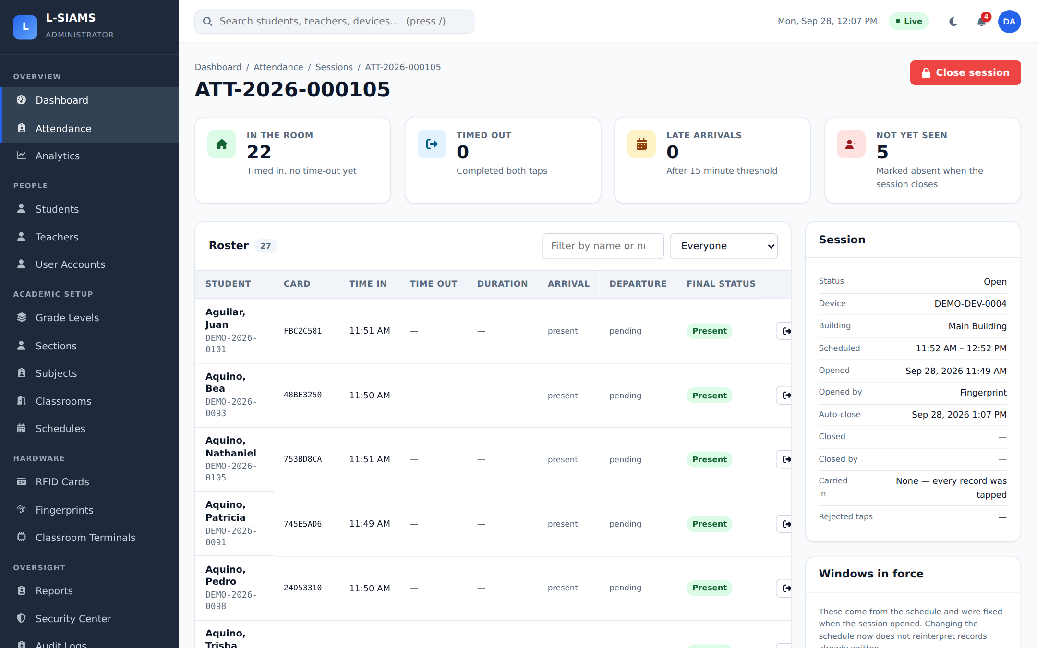
Figure 14. Session Details
A single class session: how many are in the room, timed out, late and not yet tapped, plus the full roster with each student's card, time in and status.

2.3 People

Students
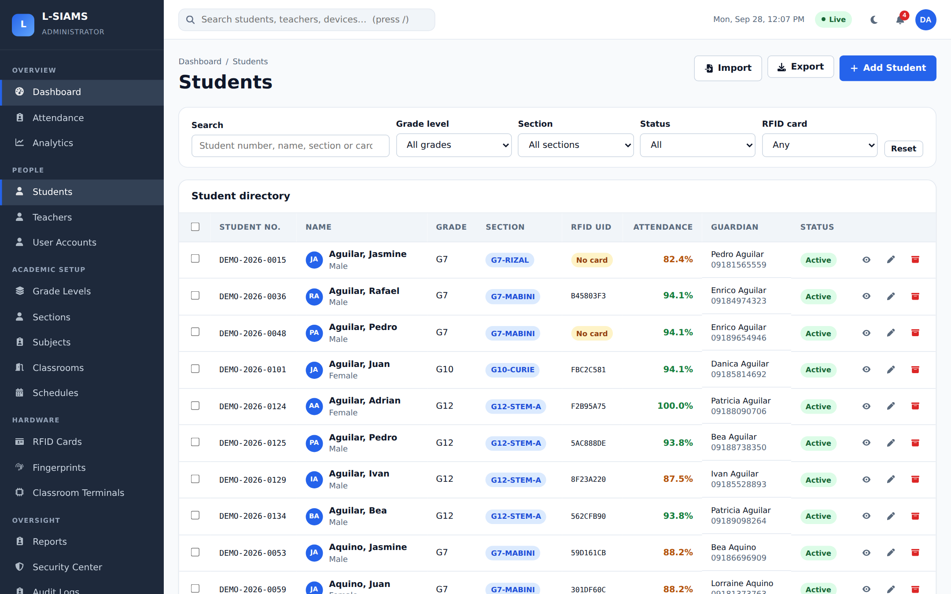
Figure 15. Students
Student directory with search and filters by grade, section, status and RFID card. Shows each student's section, card and attendance rate.

Student Profile
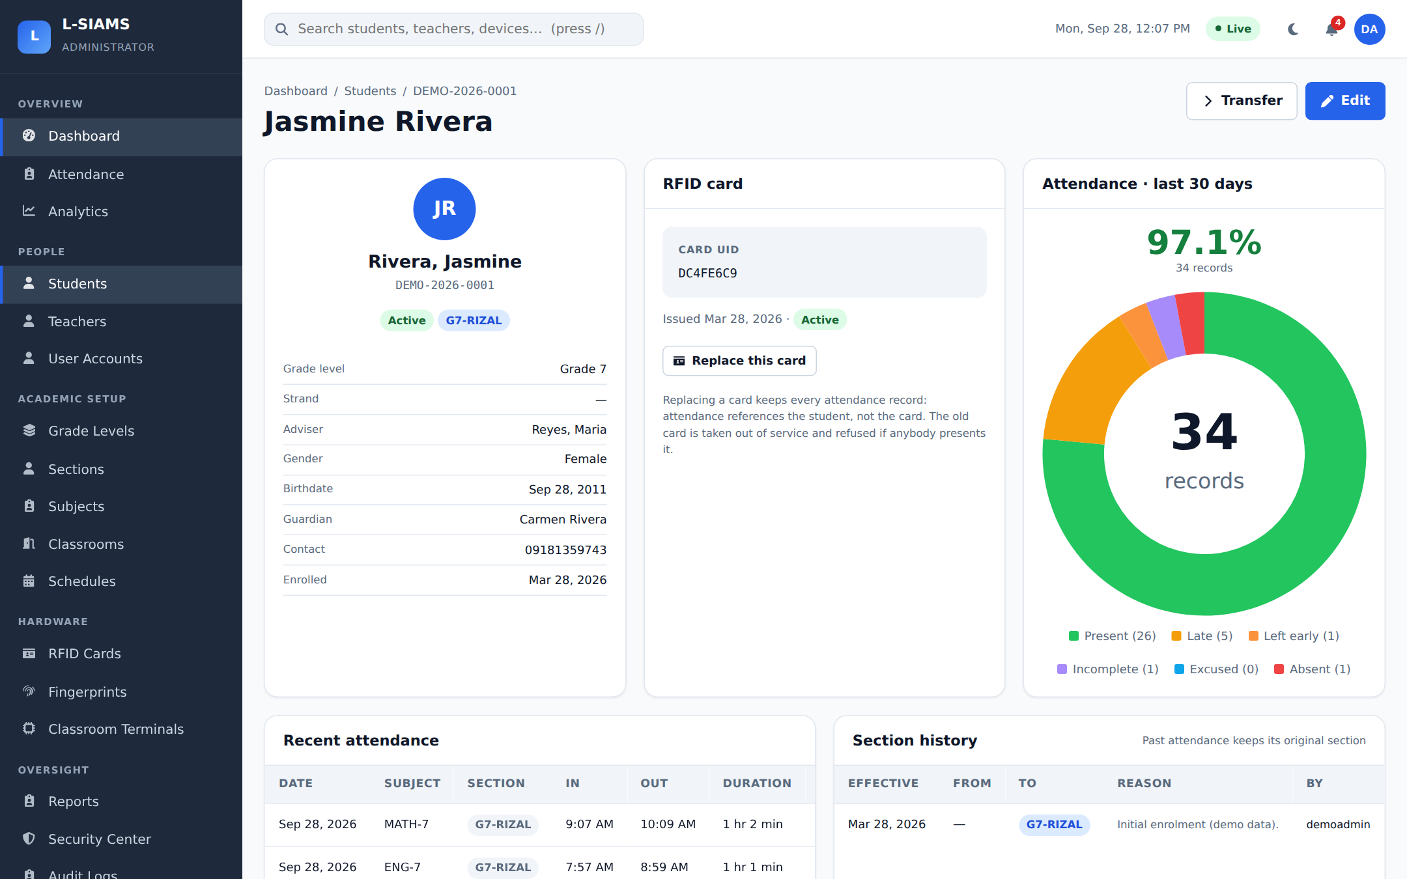
Figure 16. Student Profile
One student's profile: personal details, RFID card, 30-day attendance breakdown chart, recent attendance and section history.

Import Students
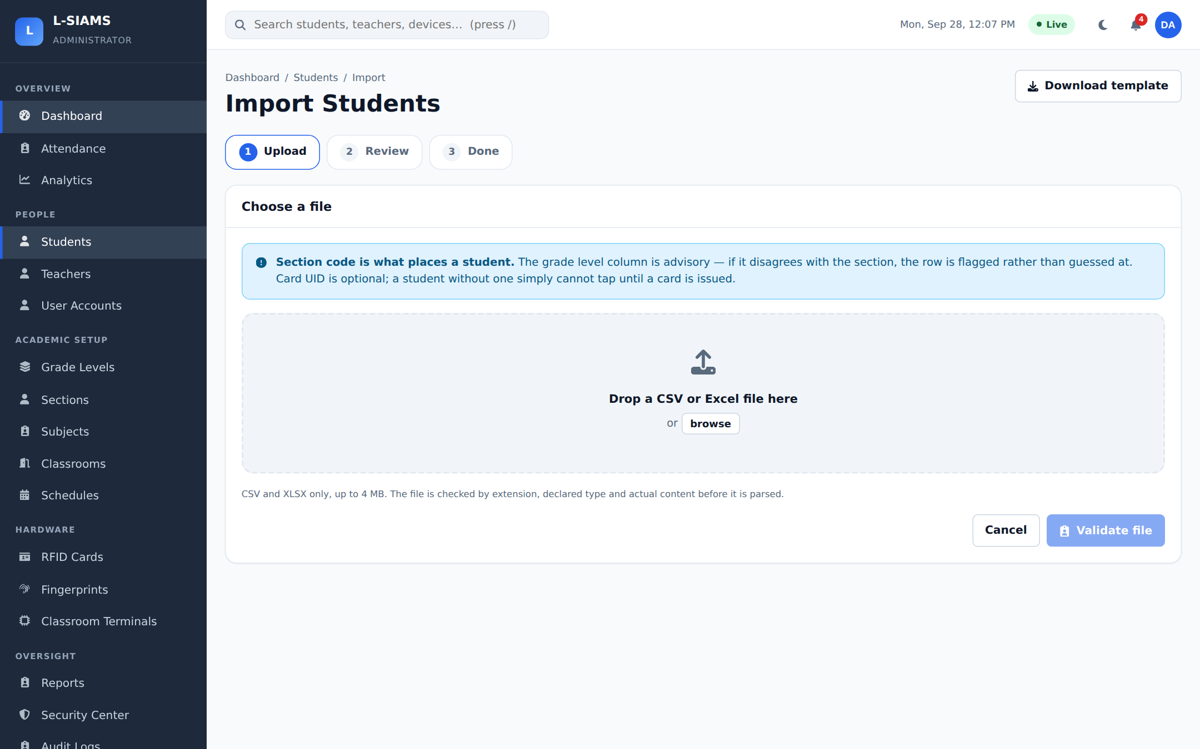
Figure 17. Import Students
Bulk import of students from a CSV or Excel file, in three steps: upload, review, done.

Teachers
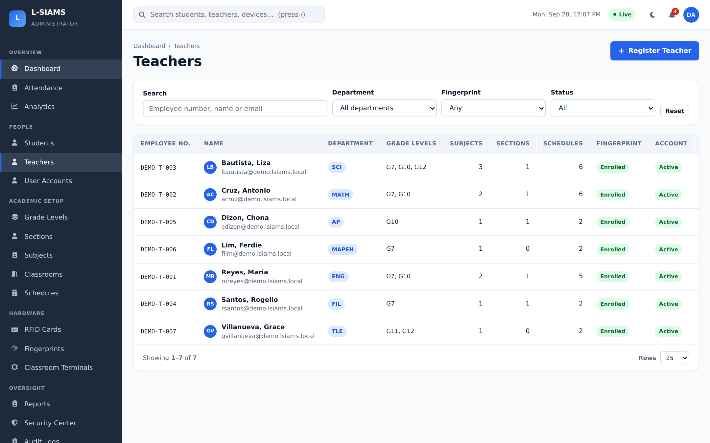
Figure 18. Teachers
Teacher list with department, grade levels, sections, schedules, fingerprint status and account status.

User Accounts
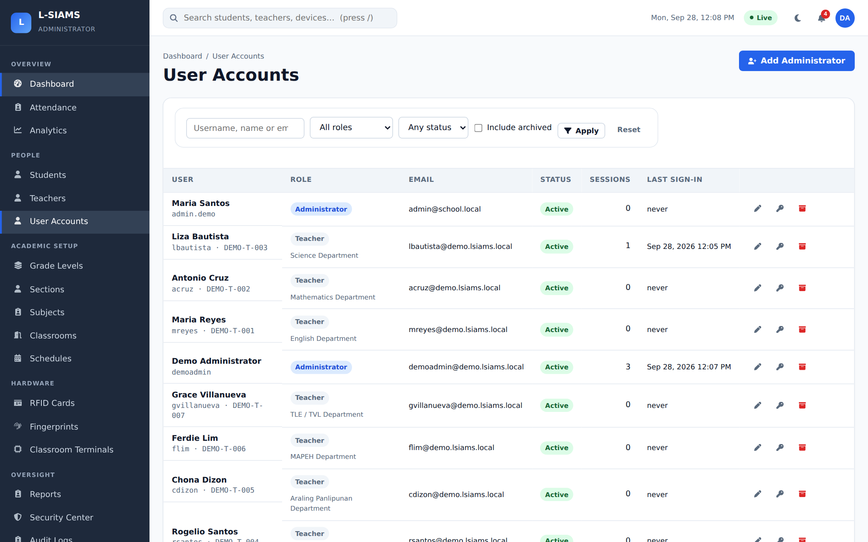
Figure 19. User Accounts
Staff login accounts and their roles, status, active sessions and last sign-in.

2.4 Academic Setup

Sections
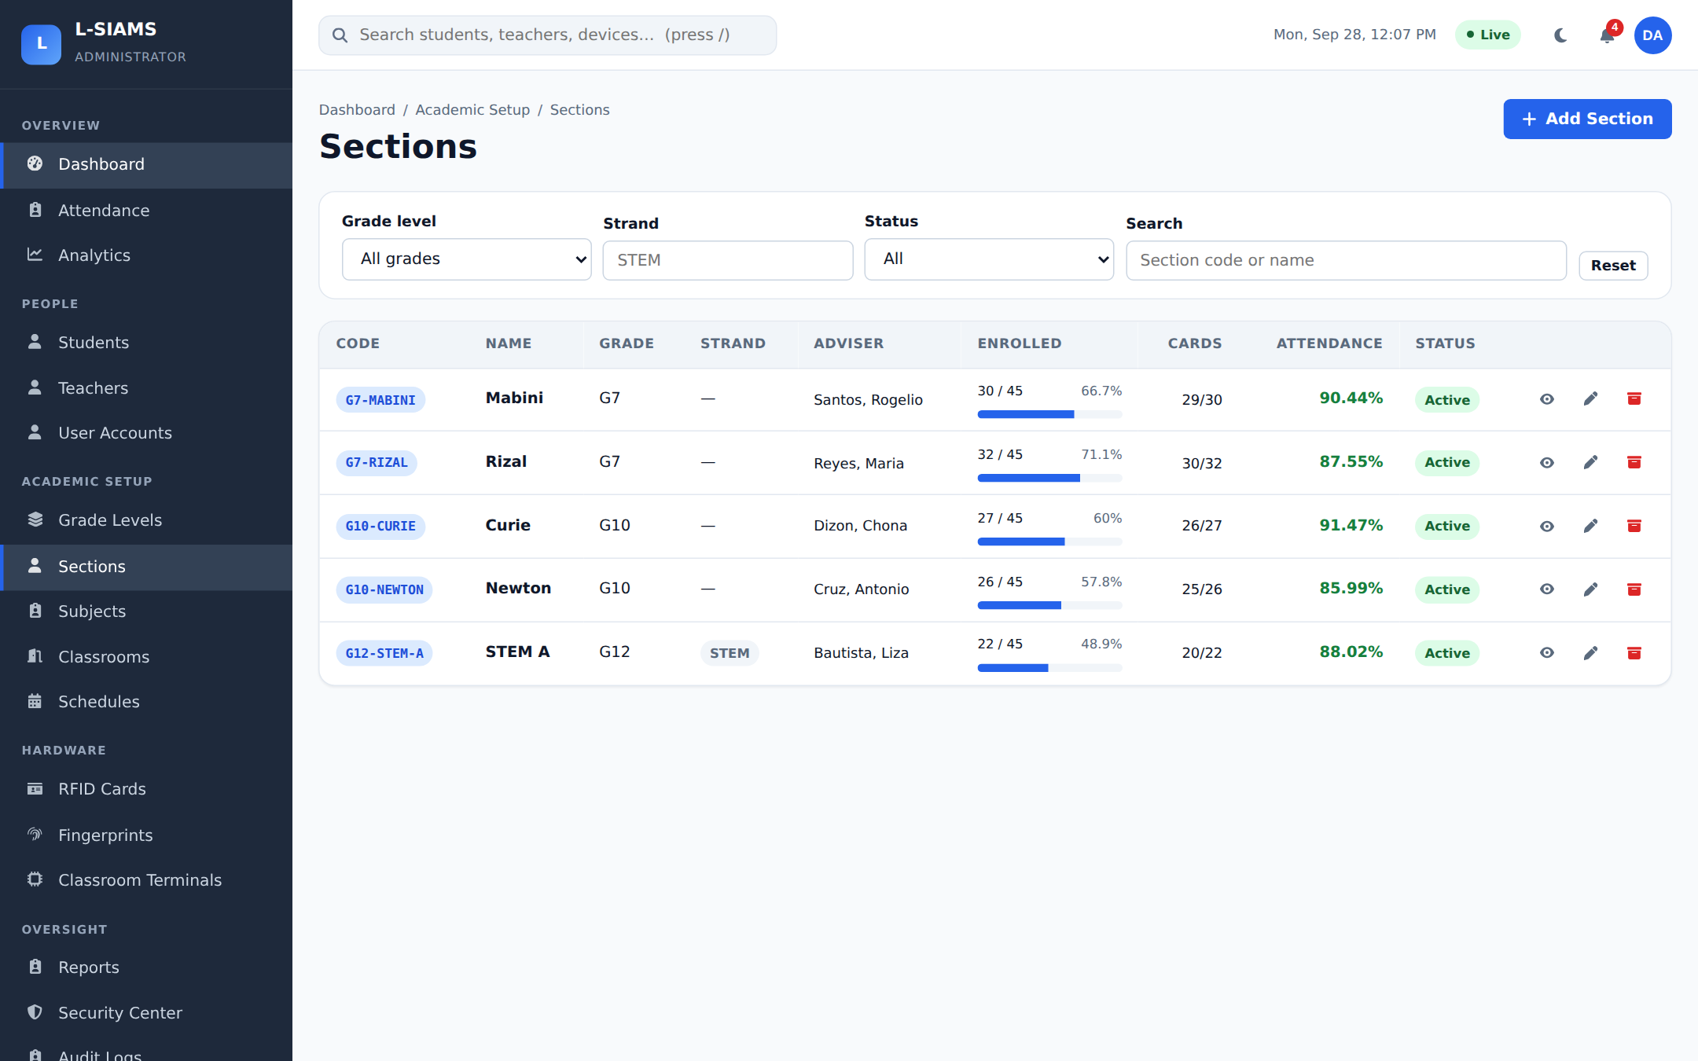
Figure 20. Sections
Sections with grade level, strand, adviser, enrolled students, card coverage and attendance rate.

Subjects
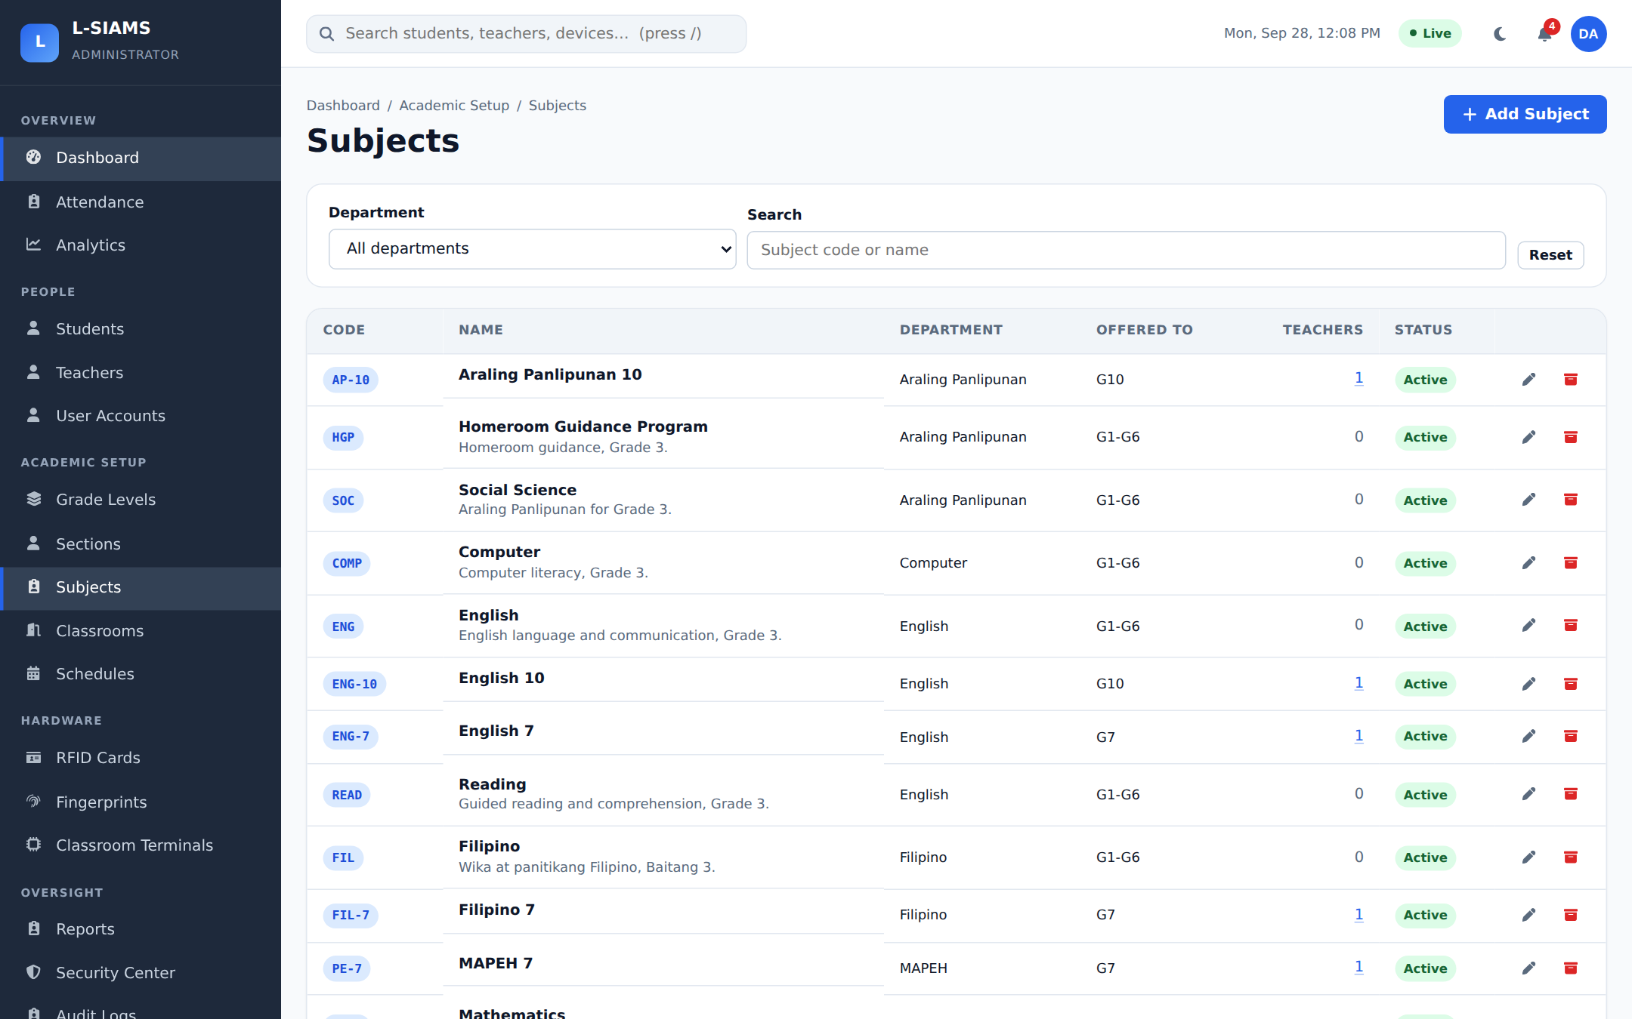
Figure 21. Subjects
Subjects offered, grouped by department, with the grade levels and teachers assigned to each.

Classrooms
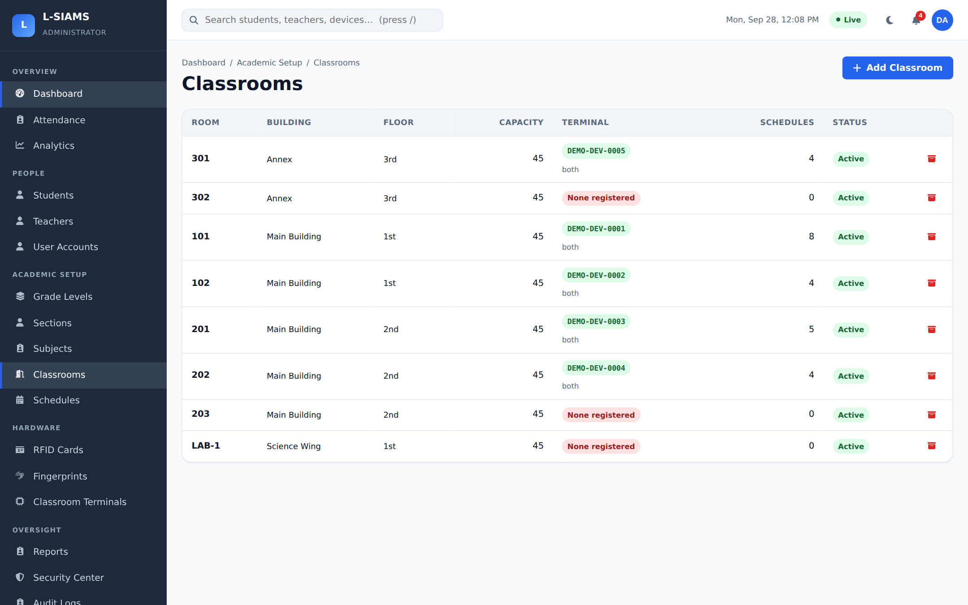
Figure 22. Classrooms
Classrooms and buildings, with the terminal installed in each room and its status.

Class Schedules
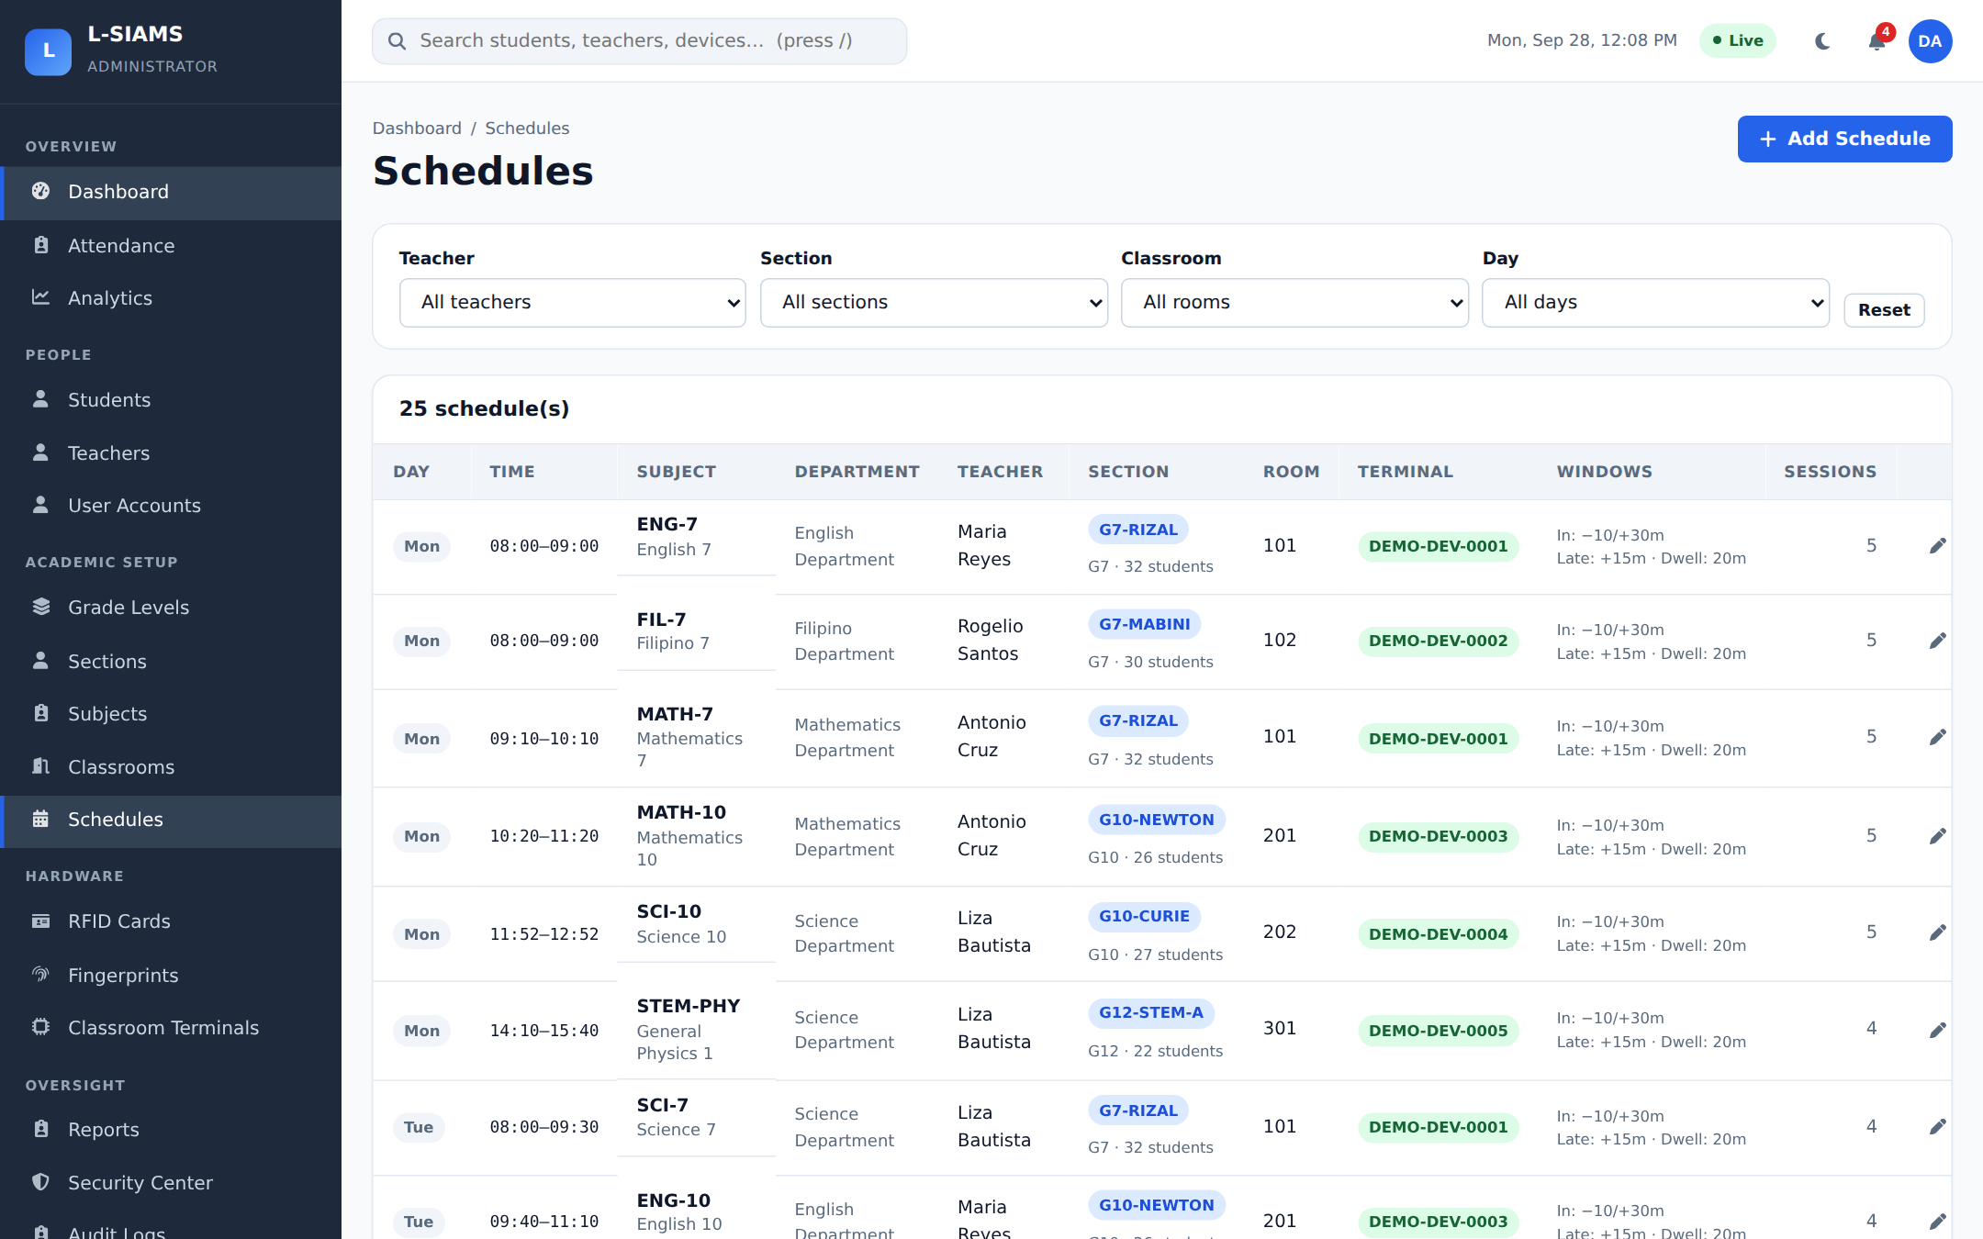
Figure 23. Class Schedules
Weekly class schedule: day, time, subject, teacher, section, room and terminal. A session can only be opened by the scheduled teacher during the scheduled time.

2.5 Oversight and System

Reports
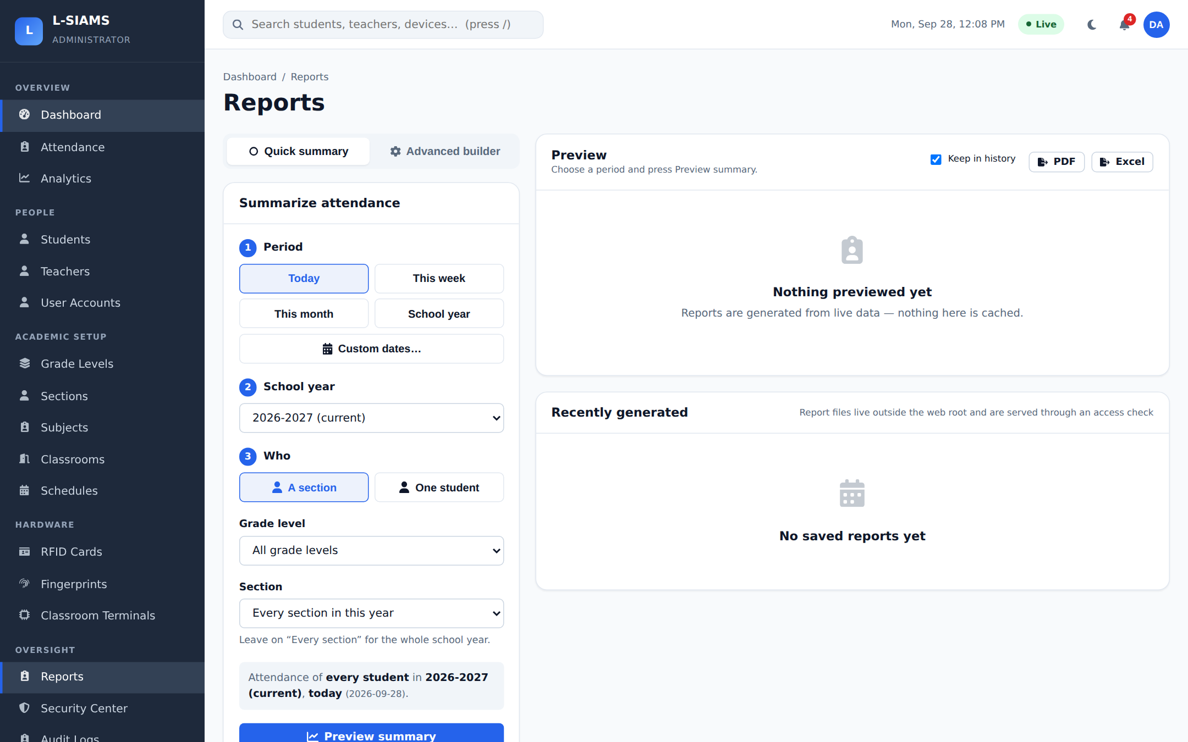
Figure 24. Reports
Report builder with 15 report types (daily, section, student, teacher and more), with a preview and export to PDF, Excel or CSV.

Security Center
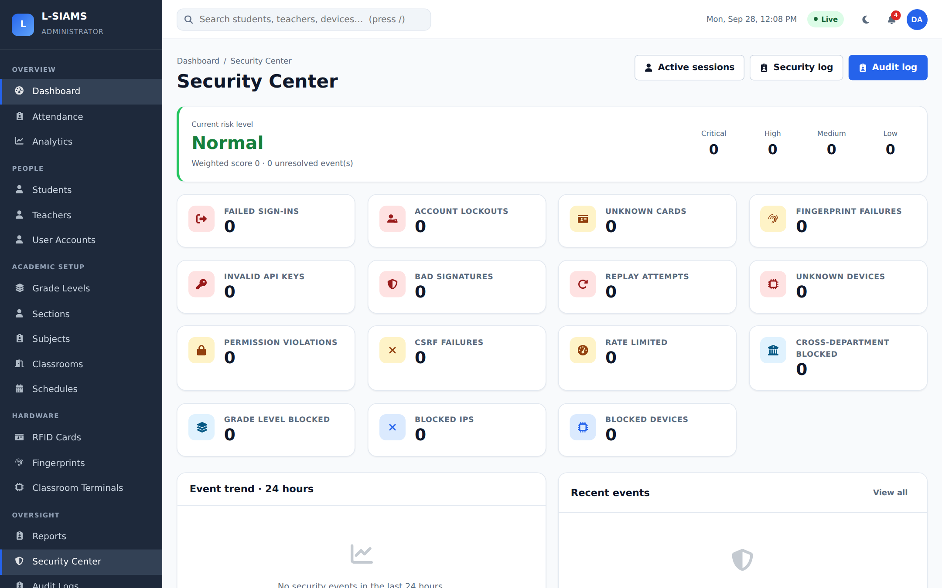
Figure 25. Security Center
Security overview: failed sign-ins, account lockouts, unknown cards, invalid device keys, bad signatures, replay attempts and blocked devices or IP addresses.

Audit Logs
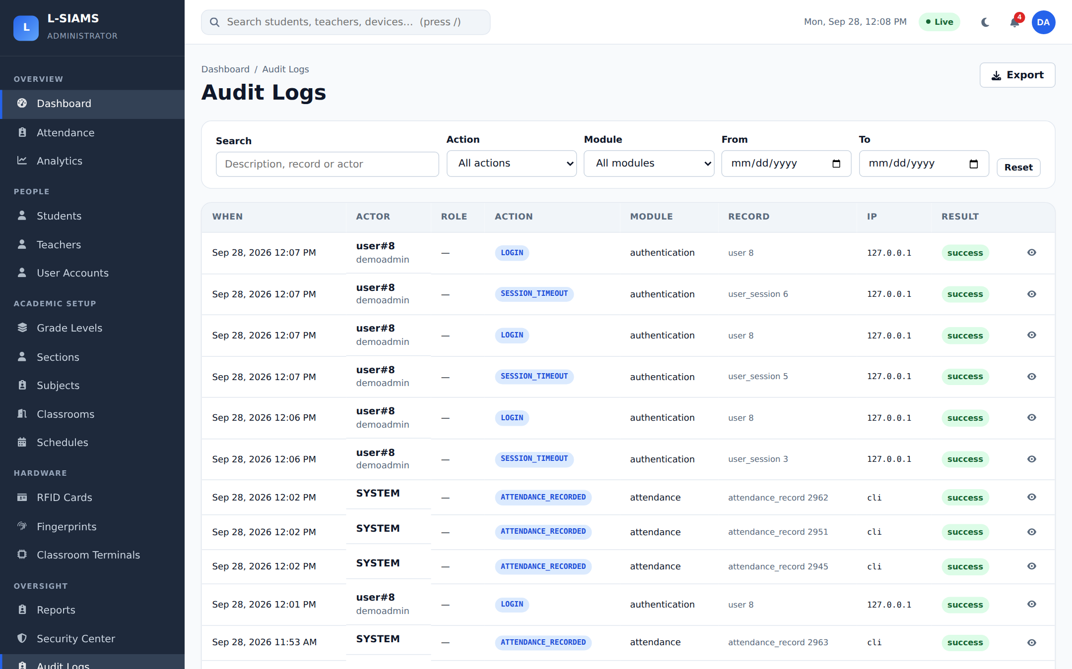
Figure 26. Audit Logs
A permanent record of who did what and when, filterable by action, module and date, and exportable.

System Settings
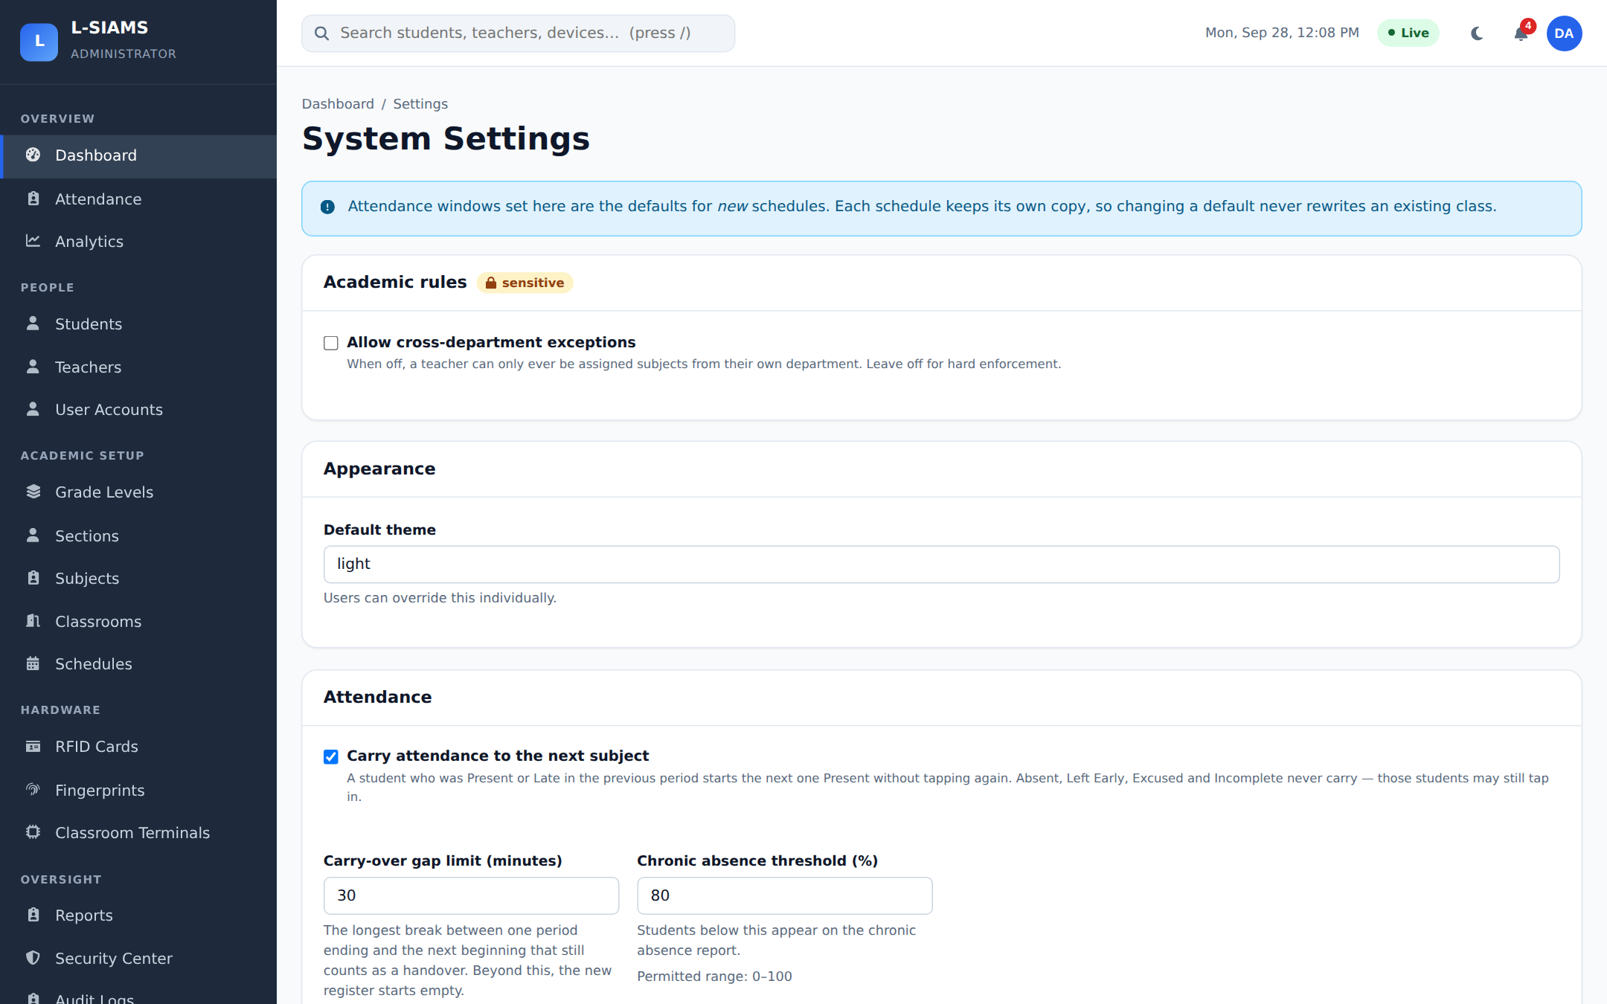
Figure 27. System Settings
School-wide settings: academic rules, appearance, and attendance rules such as carry-over between subjects and the chronic absence threshold.

Backup and Restore
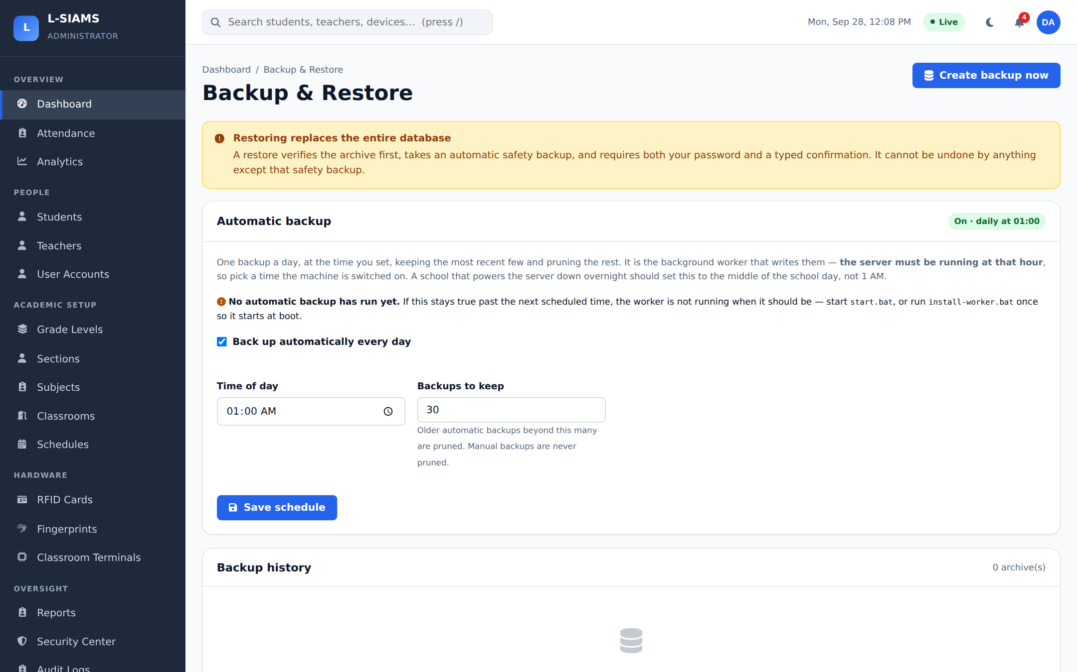
Figure 28. Backup and Restore
Encrypted database backups, the automatic backup schedule and restore from a previous backup.

Part 3. Web Application: Teacher Portal
Teachers sign in on the same page and see only their own classes.

Teacher Dashboard
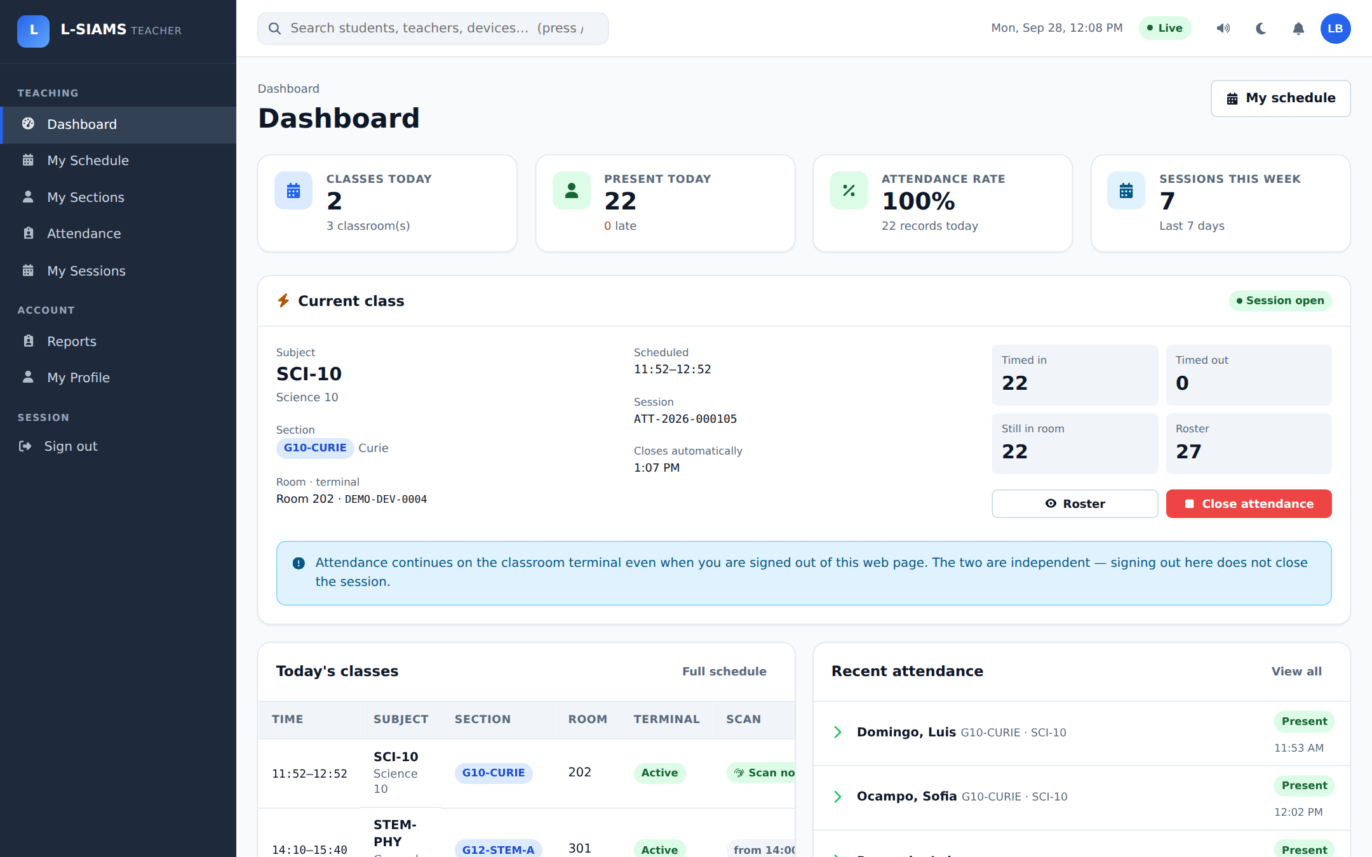
Figure 29. Teacher Dashboard
The current class with its session open on the Room 202 terminal: students timed in, still in the room, and the roster size, with buttons to view the roster or close attendance. Below are today's classes and the most recent taps, updated live.

My Schedule
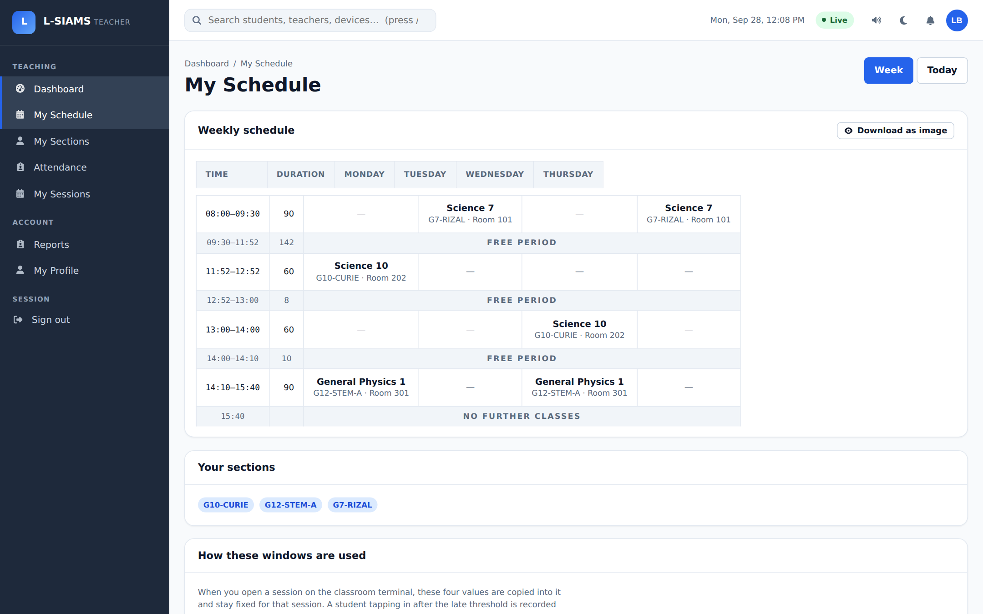
Figure 30. My Schedule
The teacher's weekly timetable with subject, section and room for each period.

My Sections
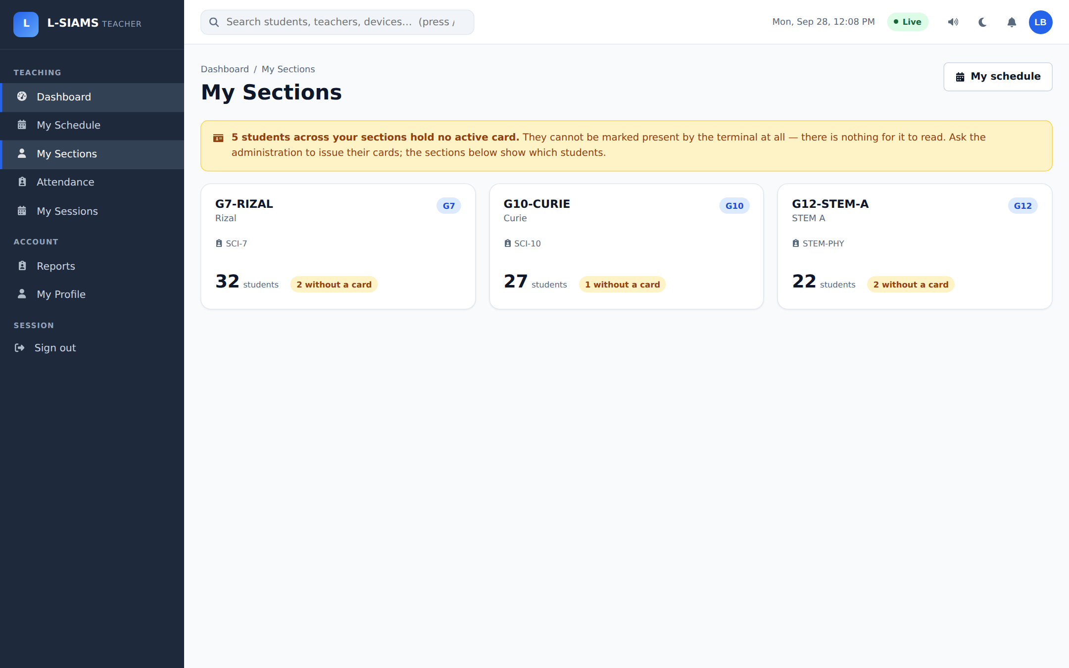
Figure 31. My Sections
The sections the teacher handles, with student counts and how many are still without a card.

Section Roster
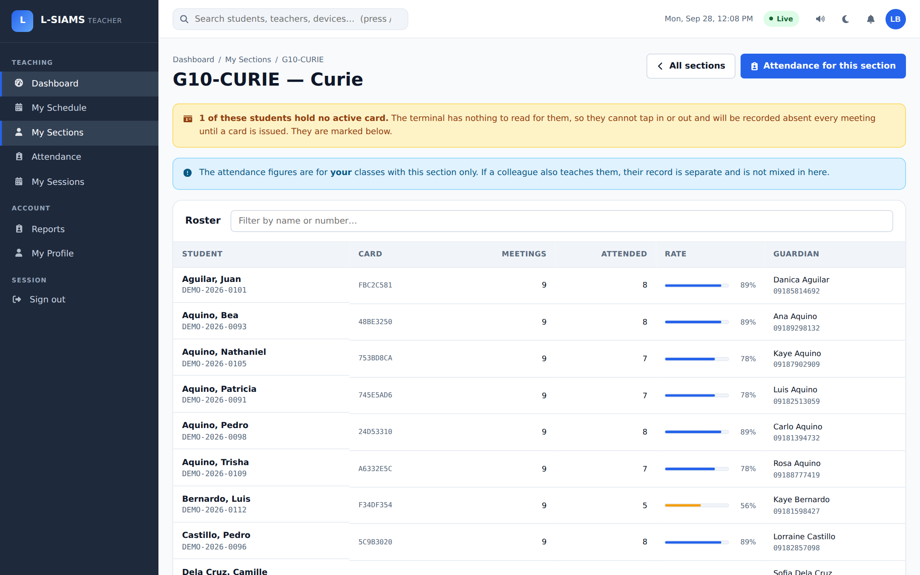
Figure 32. Section Roster
Students in one section, with their card, meetings attended and attendance rate.

Attendance (Teacher)
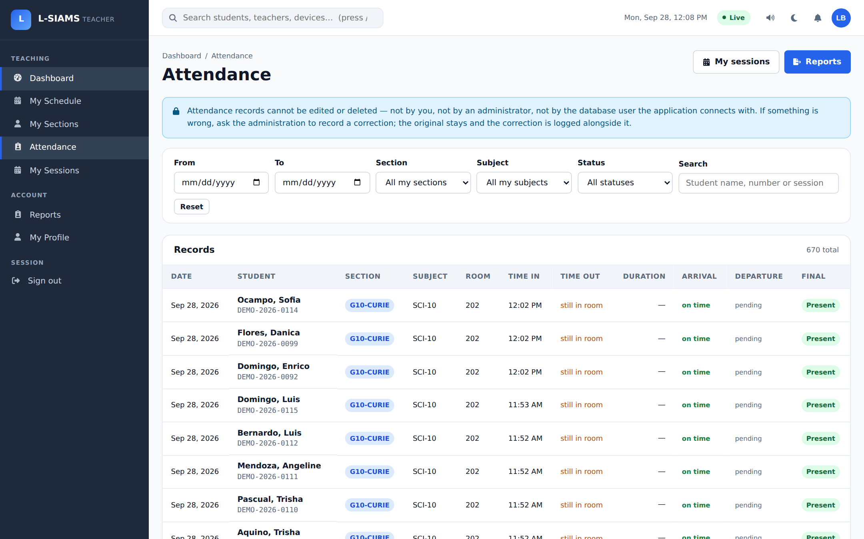
Figure 33. Attendance (Teacher)
Attendance records for the teacher's own classes, with filters.

My Sessions
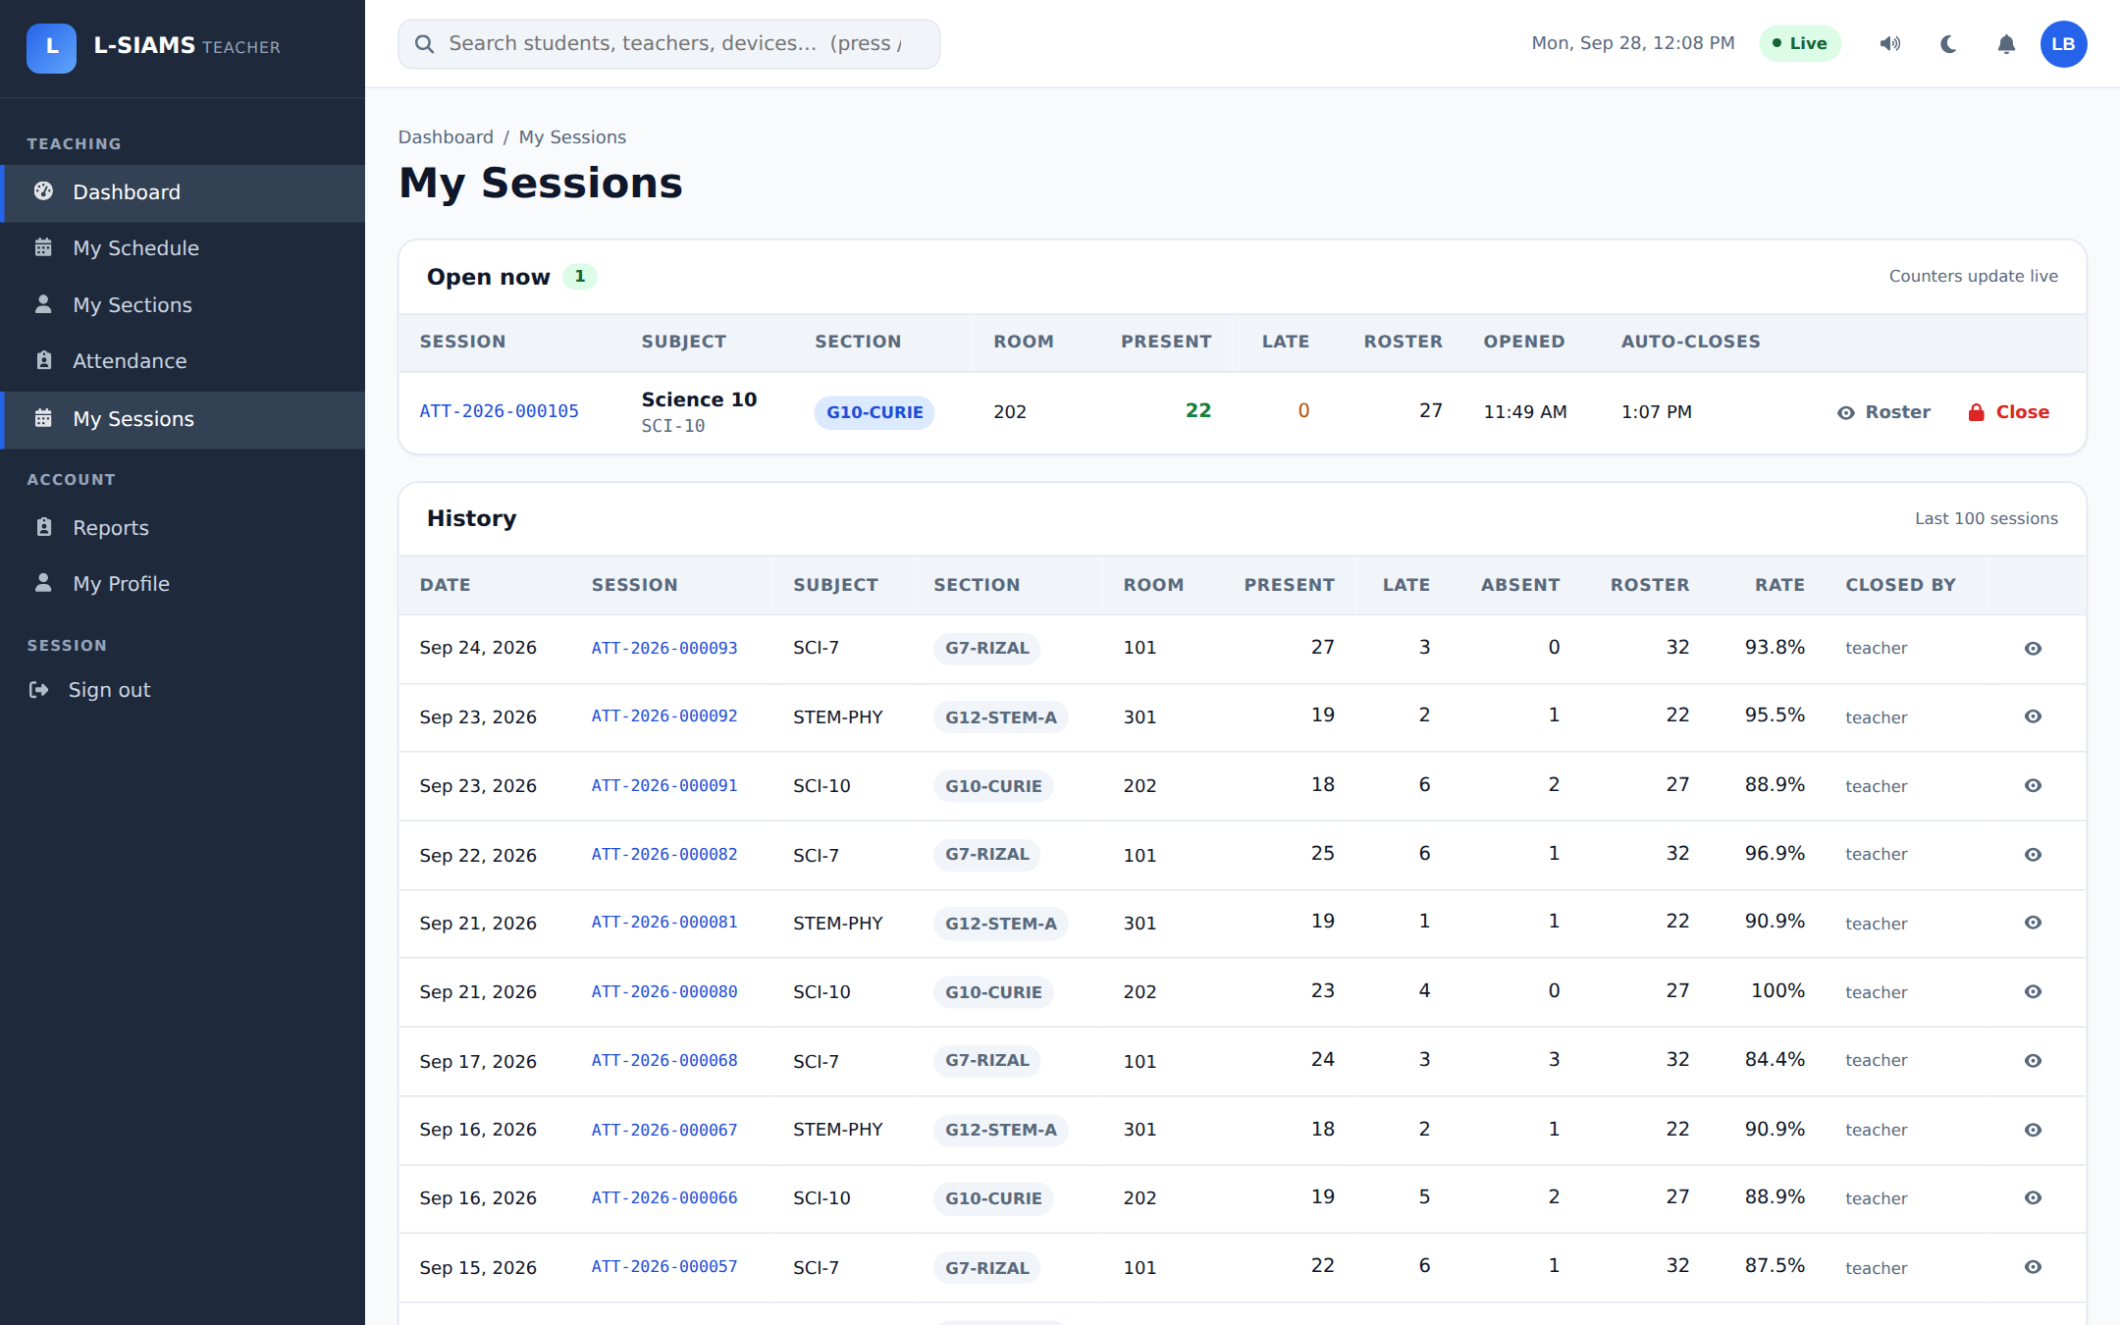
Figure 34. My Sessions
The teacher's open session and the history of past sessions with present, late and absent counts.

Reports (Teacher)
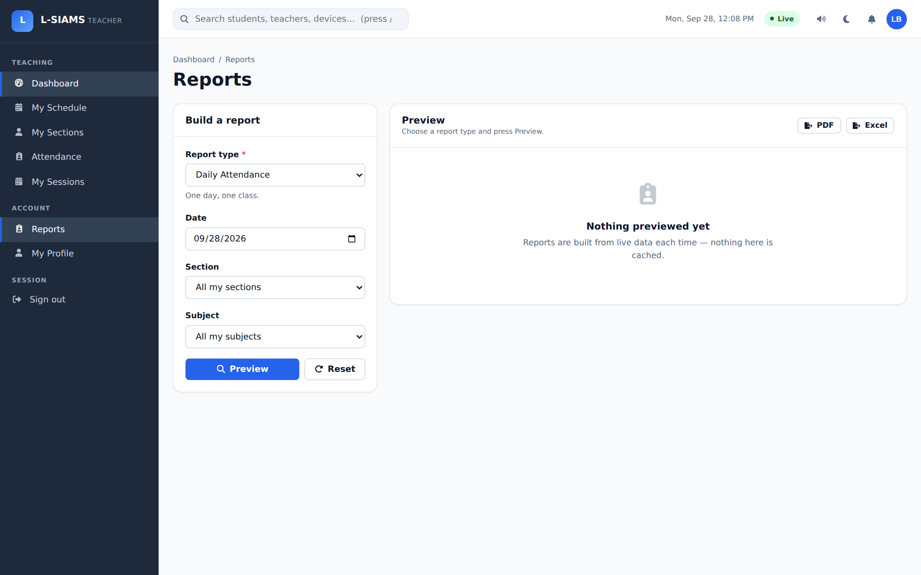
Figure 35. Reports (Teacher)
Reports for the teacher's own sections and subjects, with export to PDF or Excel.

My Profile
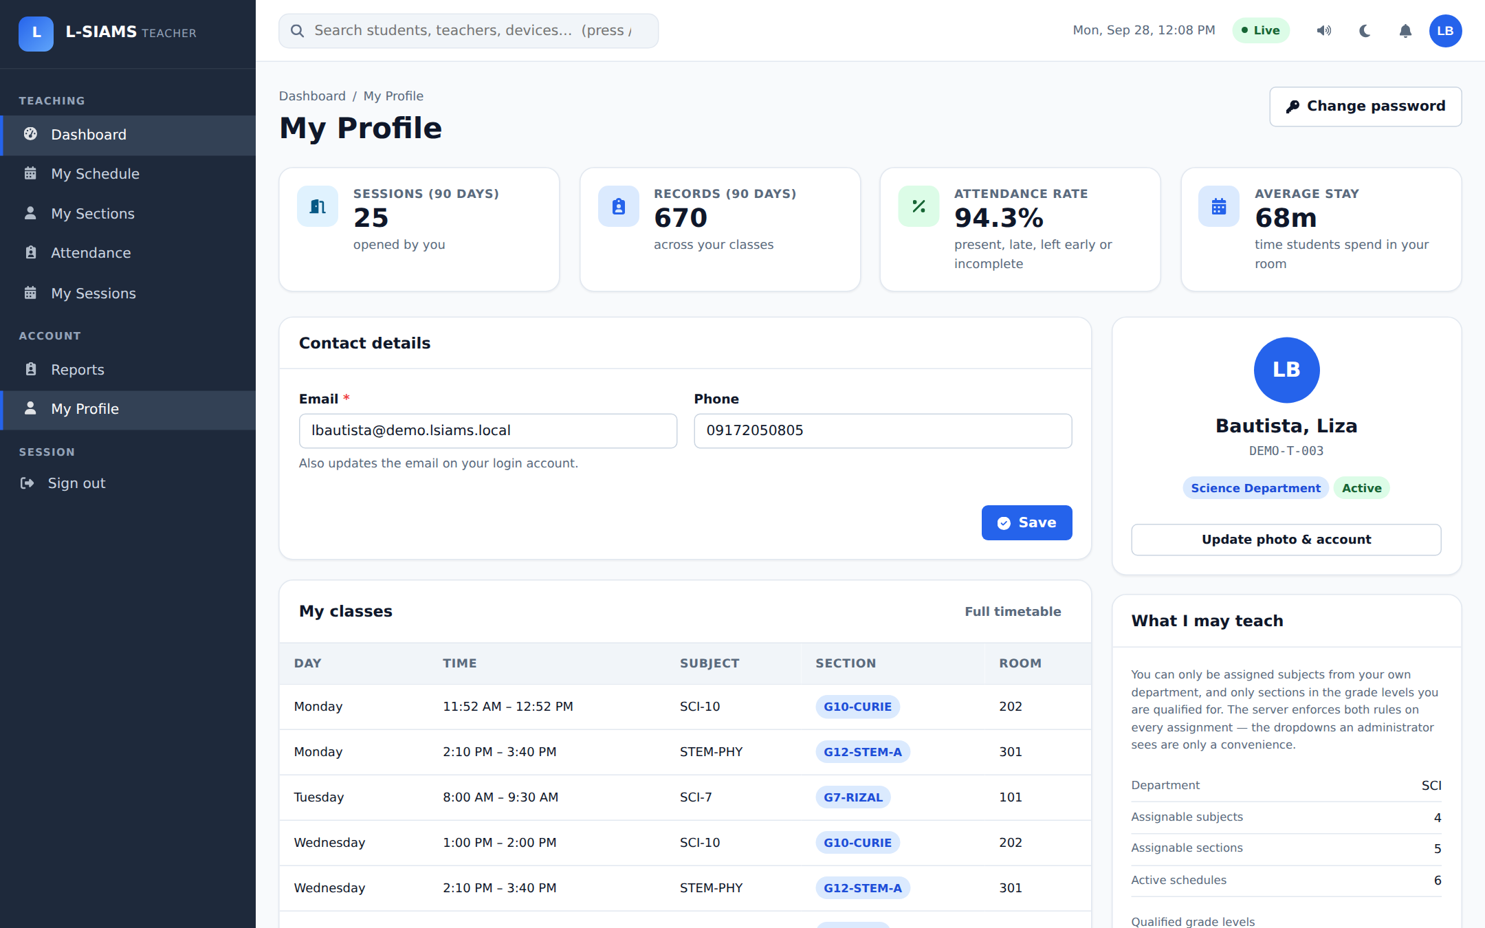
Figure 36. My Profile
The teacher's account details, contact information, assigned classes and teaching assignments.

